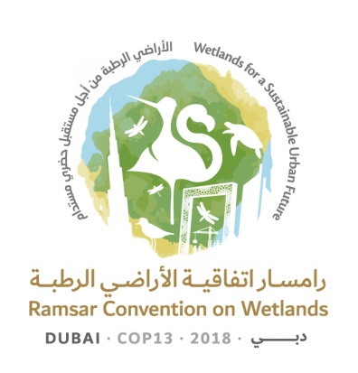
13th Meeting of the Conference of the Contracting Parties

to the Ramsar Convention on Wetlands

“Wetlands for a Sustainable Urban Future”

Dubai, United Arab Emirates, 21-29 October 2018

Resolution XIII.25

Thanks to the Host Country, the United Arab Emirates

1. HAVING MET for the first time in Western Asia, in Dubai, United Arab Emirates;

2. FULLY AWARE of the significant effort required for the organization of a meeting of the Conference of the Contracting Parties (COP), with, on this occasion, more than 1,000 participants, including delegations from 143 Contracting Parties, two observer States, 62 observer organizations, and visitors;

3. RECOGNIZING the United Arab Emirates’ long-term commitment to the conservation and wise use of wetlands through its actions for the implementation of the Ramsar Convention, including recent efforts such as:

a. the inclusion of sensitive wetland habitats into the 2030 Urban and Maritime Policy;

b. the implementation of natural habitat mapping and wetland satellite monitoring projects; and

c. the designation of the urban coastal wetland Jabal Ali Wetland Sanctuary in the Emirate of Dubai, on 25 October 2018, as the eighth Wetland of International Importance (Ramsar Site) of the United Arab Emirates;

4. NOTING the information provided by the United Arab Emirates about ongoing work to designate further Ramsar Sites; and

5. NOTING WITH SATISFACTION that 25 Resolutions considered at the present meeting of the Conference of the Parties were approved by consensus;

THE CONFERENCE OF THE CONTRACTING PARTIES

6. CONGRATULATES the United Arab Emirates for a successful 13th meeting of the Conference of the Contracting Parties (COP13); and RECORDS its thanks to the President, the Alternate President and the Vice-Presidents of COP13 for their commitment to ensuring efficient and effective conduct of the plenary sessions;

7. EXPRESSES its thanks and appreciation to the United Arab Emirates, and in particular to the Ministry of Climate Change and Environment and the Municipality of Dubai, for their efficient, comprehensive and thorough preparations which ensured that the meeting and all its associated events ran smoothly;

8. FURTHER EXPRESSES its heartfelt thanks to the people of the United Arab Emirates for their warm and gracious welcome and hospitality;

9. EXPRESSES its appreciation for the crucial role played by the COP13 volunteers who have contributed to the many aspects of the meeting’s success;

10. GREATLY APPRECIATES the numerous side events and cultural events that provided a wonderful opportunity for technical and cultural exchanges between delegates and citizens of the United Arab Emirates; and

11. LOOKS FORWARD to working ever more closely with the government and people of the United Arab Emirates to harness the interest and energy generated in the framework of COP13 for the benefit of wetland conservation locally, nationally, regionally and internationally.

