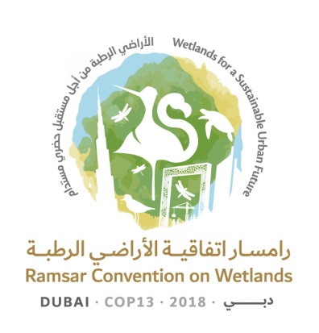
13th Meeting of the Conference of the Contracting Parties

to the Ramsar Convention on Wetlands

“Wetlands for a Sustainable Urban Future”

Dubai, United Arab Emirates, 21-29 October 2018

Resolution XIII.22

Wetlands in West Asia

1. RECALLING Resolution VII.18 on Guidelines for integrating wetland conservation and wise use into river basin management and Resolution XII.12 on Call to action to ensure and protect the water requirements of wetlands for the present and the future;

2. NOTING United Nations General Assembly Resolution 72/225 on Combating sand and dust storms, Decision 31/COP.13 of the 13th meeting of the Conference of the Parties to the United Nations Convention to Combat Desertification on Policy Advocacy Framework to combat Sand and Dust Storms (2017), and Resolution 2/21 of the second session of the United Nations Environment Assembly on Sand and dust storms (2016);

3. GREATLY APPRECIATING the generosity of the United Arab Emirates in hosting the 13th meeting of the Conference of the Contracting Parties to the Ramsar Convention on Wetlands, which is being held for the first time in West Asia and which can be used as an opportunity to raise awareness of the importance of the wetlands in the region, their status as well as the issues and opportunities that they face;

4. RECOGNIZING the range of unique wetland types in West Asia, such as sabkha (salt-flats), khor (tidal inlets), and oasis (desert springs or water sources);

5. BEARING IN MIND that bilateral, regional and multilateral agreements between Contracting Parties to the Convention are in place and that nothing in the present Resolution undermines the provisions of those agreements;

6. CONSCIOUS of the great importance of ensuring the conservation and wise use of wetlands in West Asia, and of encouraging cooperation among Contracting Parties in the region in this respect;

7. CONCERNED over the degradation and drying of many wetlands as a result of, inter alia, decreasing rainfall from a changing climate and/or over-extraction and/or unwise use of water resources; and NOTING that some Contracting Parties in the West Asia region have expressed their concerns about sand and dust storms in their wetland ecosystems and outlined the need for actions to be taken by concerned Contracting Parties to address the situation;

8. RECOGNIZING that the reduction of water in wetlands is a far-reaching global problem with serious consequences for ecosystems and people’s livelihoods, in particular in vulnerable communities that depend on wetlands; and NOTING WITH CONCERN that this problem will tend to be aggravated in the future by the growing demand for water and other natural resources, as well as by the potential effects of climate change (Resolution XII.12); and

9. ALERTED to the increasing pressure on urban wetlands as well as the loss of natural coastal wetlands caused by reclamation projects, among various other factors;

THE CONFERENCE OF THE CONTRACTING PARTIES

10. ENCOURAGES Contracting Parties in West Asia to cooperate in the wise use of wetlands;

11. ENCOURAGES Contracting Parties in the West Asia region to consider leveraging existing collaboration and regional initiatives within the context of sustainable development;

12. REQUESTS Contracting Parties in the West Asia region to carry out restoration of their ecosystem services as necessary so that wetlands can continue to provide benefits to populations impacted by their degradation;

13. ENCOURAGES greater cooperation among Contracting Parties in the West Asia region, International Organization Partners and related organizations to promote awareness of the importance of the region’s wetlands and to make practical efforts, based on concerned Contracting Parties’ consent, for their conservation and wise use, including through exchanges of experience and expertise, training and joint study; and

14. REQUESTS the Ramsar Regional Centre – Central and West Asia to follow up the provisions of the present Resolution, within the framework of its mandate, and report to the Conference of the Contracting Parties.

