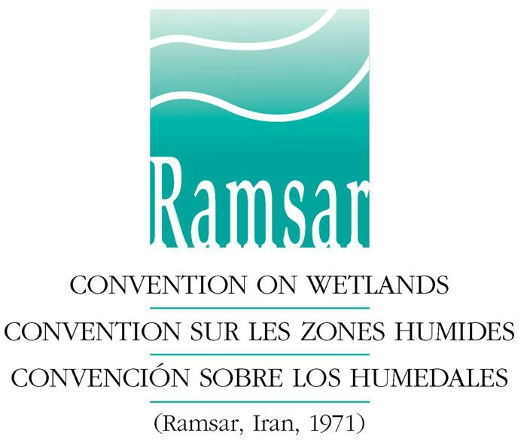

Scientific and Technical Review Panel of the Ramsar Convention

Nomination of candidates for appointment to the Scientific and Technical Review Panel (STRP) for 2019-2021

Nominator’s recommendation form

This form should be completed and signed by a representative of the Administrative Authority, International Organization Partner (IOP) or Observer Organization nominating a candidate for STRP appointment. The form should then be sent to the Ramsar Secretariat’s Scientific & Technical Support Officer Marcela Bonells (email: bonells@ramsar.org) along with the “Nominee’s form”, duly completed and signed by the Nominee, by 15 December 2018.

More than one nomination can be made by an organization; please complete a Recommendation form for each candidate nominated. Nominations are not restricted to people from the same country of origin or domicile as the nominator. Candidates may be nominated for more than one role in the panel.

Please note that nominations for the positions of six technical regional experts can only be made by the Administrative Authorities of Contracting Parties. Administrative Authorities may also identify candidates for the roles of STRP Chair and Vice-Chair.

IOPs and Observer Organizations may make nominations for the six scientific and six non-regional technical experts.

(See here the full text of Resolution XII.5: New framework for delivery of scientific and technical advice and guidance on the Convention, including Annex 1: How the Scientific and Technical Review Panel works).

- STRP position(s) for which the candidate is nominated

Full name of nominee:

Position for which the candidate is nominated: (delete as applicable)
- Scientific Expert
- Regional Technical Expert
- Technical Expert

Select if appropriate: (delete as applicable)
- STRP Chair
- STRP Vice-Chair
Provide a summary of the nominee's expertise and experience according to the nominated posts and the priority thematic work areas of the STRP for 2019-2021 (See here Resolution XIII.8: Future implementation of scientific and technical aspects of the Convention for 2019-2021 for the current thematic work areas of the Panel).

- Details of the body nominating the candidate:

This nomination is being made by: (delete as applicable)
- Ramsar Administrative Authority
- International Organization Partner
- Observer organization

Name of the Contracting Party, Organization or Institution making the nomination:

Name of nominator:

Position held in Contracting Party, Organization or Institution:

Mailing address:

Telephone :

E-mail:

Please print the form and sign here, and complete the date field below:

Date:

The information collected through this form will be held by the Ramsar Secretariat in manual and electronic format. The information will be processed in accordance with the applicable law and the privacy policy, by submitting this form you agree to the privacy policy available here.

