THE CONVENTION ON WETLANDS
59th Meeting of the Standing Committee
Resumed session
Gland, Switzerland, 23-27 May 2022

SC59/2022 Doc.24.1 Rev.1

Proposed draft resolution on
Protection, management and restoration of wetlands as Nature-based solutions to address the climate crisis

Submitted by Spain

Secretariat cover note:
The DR was submitted on 21 April 2021 by Albania for consideration at SC59/2021. The DR was subsequently resubmitted by Spain on 23 March 2022. On 30 March Spain notified the Secretariat that a technical annex was missing from its original submission. The revision 1 reflects the inclusion of this annex. The DR recalls Resolutions relevant for the Mediterranean region including Resolutions XI.14 on climate change and XIII.14 on Blue Carbon, and refers to other relevant multilateral environmental processes. The Secretariat invited the STRP to review the draft resolution and to inform the Standing Committee.

Actions requested:

The Standing Committee is invited to:

- Review, approve and then forward the attached draft resolution “Protection, management and restoration of wetlands as Nature-based solutions to address the climate crisis”

Introduction

Information for Standing Committee

1. The effects of global warming are now widely known and include sea level rise, periods of intense drought and flooding, and increase in number and intensity of storms and hurricanes. Climate change is accelerating and recognized as a serious threat to ecosystem and biodiversity. It is associated with alterations in the physical environment of the planet Earth. Climate impacts plants and animals, with consequences for the survival of the species. Climate change creates water and food insecurity, increased morbidity/mortality, and population movement. Vulnerable populations are disproportionately affected.

2. Personalized adaptation to the consequences of climate change and preventive measures are key challenges for society and ecosystems. Today there are several opportunities to reinforce adaptation in the face of the climate crisis. By shifting our attention to practice, there are more effective adaptation measures for the future, nature-based solutions (NbS) and among them “wetland-based solutions”.

3. Protection, management and restoration of wetlands represent effective nature-based solutions to maintain and enhance crucial functions of the crucial services provided by wetlands such as ensuring carbon sequestration, sound water resources management, disaster risk reduction, food security and biodiversity conservation.

4. Along with the polar regions, the Mediterranean basin is one of the locations in the world most impacted by the effects of climate change. Temperatures are rising 20% faster than elsewhere; already 1.5°C higher than pre-industrial temperatures.

5. In the last years, the Mediterranean Contracting Parties through their Ramsar Regional Initiative, MedWet, have progressed on defining priorities for wetlands restoration and, with the support of their partners, have defined a knowledge-based platform on wetland conservation, management and restoration.

6. The draft resolution urges all Contracting Parties to introduce and adopt appropriate policies and measures to conserve, sustainably manage and restore wetlands as long term and cost-effective nature based solutions.

7. Moreover, the resolution recommends the Mediterranean Contracting Parties and the MedWet Initiative to support the Secretariat to create the Wetland-based Solution Community of Practice to support climate mitigation and adaptation The Community is meant to be paving the way for more exchanges on wetlands restoration for climate mitigation and adaptation solutions across the region and will capitalise on lessons learnt from existing successful wetland restoration projects as NbS. The Community of Practice aims to better engage stakeholders by providing learning stories on how restoration projects help to mitigate and adapt to climate change. The Community is open to all actors identified as stakeholders for wetland restoration.

8. The draft resolution includes a Technical Annex on Mediterranean wetlands and acquired knowledge on wetland restoration

9. The draft resolution is written in a way that may fit outcome of the COP14, but changes might be needed accordingly to the total outcome, for example the names of other resolutions.

Financial implications of implementation

Paragraph (number and key part of text) | Action | Cost (CHF)
8. REQUESTS the Ramsar Secretariat, in collaboration with MedWet, to establish a Community of Practice on wetland protection, management and restoration as NbS for cooperation among regional initiatives and other stakeholders aiming at providing scientific and technical support as well as easing the access to financial resources for interested Contracting Parties. | the Ramsar Secretariat to promote an appropriate Community of Practice by involving regional initiatives on wetland protection, management and restoration as NbS with the support of MedWet | 15,000
9. INSTRUCTS the Ramsar Secretariat to liaise with relevant international conventions and organizations including UNFCCC bodies, within their respective mandates, to promote wetland protection, management and restoration as NbS for climate change mitigation and adaptation | the Ramsar Secretariat to liaise with relevant international conventions and organizations as appropriate, including exploring the development of formal links to promote wetland protection, management restoration as NbS for climate change adaptation | 0,0
11. REQUESTS that the STRP, if resources are available, consistent with its scope, mandate and priority thematic work areas for 2022-2025, consider continuing its work on climate change and wetlands, focusing on wetland restoration as NbS for climate mitigation and adaptation, as a high priority. | The STRP to work in collaboration with MedWet on the following activities:  - undertaking a desktop study of success stories of wetland as NbS for climate change of the Ramsar Sites of those Contracting Parties that express their interest in participating;  - developing a technical handbook o protection, management and restoration of Wetlands as NbS to provide accurate, detailed information on the full range of potentially applicable wetland-based solutions (WBS) for climate change mitigation and adaptation benefits; the Handbook is built on the desktop study and on the success stories of Ramsar sites. | 60,000

Annex 1. Draft Resolution XIV.xx

Submitted by Spain

- RECALLING
  - Resolution XI.14 on Climate change and wetlands: implications for the Ramsar Convention on Wetlands, which urges Contracting Parties to maintain or improve the ecological character of wetlands to promote the ability of wetlands to contribute to nature-based climate change adaptation;
  - Resolution XIII.14 on Promoting conservation, restoration and sustainable management of coastal blue-carbon ecosystems, highlighting the value of wetlands as natural carbon sinks
  - Resolution XII.13 on Wetlands and disaster risk reduction which welcomes initiatives that support the conservation and restoration of coastal wetlands and encourages engagement in such activities;
  - the Ramsar Strategic Plan 2016-2024 highlighting the important ecosystem services that wetlands provide, to contribute to food security, healthy living, water quality and supply, water security, disasters risk reduction, adaptation to climate change and biodiversity;
  - Resolution 031 adopted at the World Conservation Congress in September 2021, in Marseille, on the Implementation of nature-based solutions in the Mediterranean Basin.

- RECOGNISING
  - the Paris Agreement under the UN Framework Convention on Climate Change (UNFCCC), as well as the outcome of the 25th UNFCCC Conference of the Parties;
  - the final agreement of COP26 of the UNFCCC, known as the Glasgow Climate Pact, which recognized the importance of “protecting, conserving and restoring nature and ecosystem, (….) acting as sinks and reservoirs of greenhouse gases.”
  - the framework for defining Nature-based Solutions (NbS) adopted at the World Conservation Congress in 2016 by Resolution 6.069 and the IUCN Global Nature based Solutions adopted in 2020 (WCC-2020-Res-060);
  - the entry into force of the UN Decade for the restoration of ecosystems 2021-2030;
  - the process for the preparation of the post-2020 global biodiversity framework adopted by the conference of the parties to the convention on biological diversity (CBD/COP/DEC/14/34);
  - that the EU Green Deal and its post 2020 Biodiversity strategy, includes a strong EU restoration plan to reverse the degradation of land and sea ecosystems and thereby increase nature resilience to climate change, and that substantial financial support will be dedicated to restoration actions, both within the EU and for neighbouring countries including the Mediterranean Basin;

- AWARE that
  - climate change is already affecting every inhabited region across the globe, with human influence contributing to many observed changes in weather and climate extremes and that global temperature will continue to increase until at least mid-century under all emission scenarios considered by IPCC;
  - progress in adaptation planning and implementation has been observed across all sectors and regions, generating multiple benefits. However, adaptation progress is unevenly distributed with observed adaptation gaps;
  - according to IPCC, adaptation to water-related risks and impacts make up the majority of all documented adaptation;
  - enhancing natural water retention such as by restoring wetlands can reduce flood risk by storing water and slowing water flow, in most circumstances;
  - coastal wetlands protect against coastal erosion and flooding associated with storms and sea level rise;
  - by protecting and restoring wetlands, we are safeguarding crucial carbon sinks which can support countries in reaching mitigation targets and that wetlands are a cross-cutting tool for achieving their National determined contributions (NDCs) under the Paris Agreement;
  - the Mediterranean Basin is warming 20% faster than the rest of the world with a drop of 15% in the availability of freshwater by 2040 as well as an increase in the intensity and frequency of extreme weather events like floods, heatwaves and droughts;
  - the societal challenges Wetland-based Solutions aim to address (food security, climate change, water security, human health, disaster risks, economic and social development) are particularly acute in the Mediterranean Basin due to recent strong demographic developments, tremendous pressure on scarce water resources, and the concentration of economic activities and urban development in coastal regions;
  - due to the Mediterranean peculiarity, the Mediterranean Contracting Parties and their Ramsar Regional Initiative (MedWet) with its partners have acquired a valuable knowledge and know-how on wetland protection, management and restoration as presented in the Technical Annex;

- NOTING that
  - well-preserved and restored wetlands are a prerequisite for biodiversity to thrive in the coming decades and adapt to and mitigate the new conditions imposed by climate change as it has been demonstrated for Mediterranean water bird populations;
  - the key role played by wetlands in providing crucial ecosystem services and their potential role as NbS, and aware of the need to protect and restore wetlands;

THE CONFERENCE OF CONTRACTING PARTIES

- AFFIRMS the significant value of wetlands restoration as NbS, the “wetland-based solution”, for facing societal challenges, especially climate-change mitigation and adaptation, water and food security, risk reduction and health;

- URGES the Contracting Parties to
  - address simultaneously biodiversity loss, wetland degradation, water abstraction and scarcity and risks associated to climate change as urgent and to pursue policies and projects to conserve and restore wetlands in the coming years;
  - consider the conservation, sustainable management of wetlands and the restoration of degraded wetlands as long term and most cost-effective NbS when contemplating measures to regulate carbon emissions, to mitigate climate impacts, to secure sound water resources management as well as sustainable food production;
  - favour the conservation and the restoration of wetlands by promoting ambitious, ecosystem-based and integrated sustainable water management and hydro-morphological restoration measures of the whole connected watersheds;
  - put in place financial incentives to support the efforts of local stakeholders and their full involvement to sustainably manage, conserve and restore wetlands;
  - take NbS into account under the Ramsar convention to include them in their NDCs under the Paris Agreement on Climate Change, but also in all relevant sectoral policies as approved by the IUCN World Conservation Congress 2020 (WCC-2020-Res-031);

- RECOMMENDS Mediterranean Contracting Parties to support the MedWet initiative in promoting and implementing the following activities:
  - developing a Mediterranean-wide knowledge base on the wetland extent, based on a watershed and river basin approach, and their conservation status in the region as a regional reference base to assess progress and prioritize restoration actions;
  - calling for more research to provide a knowledge base on carbon fluxes in wetlands including blue carbon and on targeted restoration efforts that would co-benefit biodiversity and climate change adaptation and mitigation;
  - identifying, upscaling and replicating existing successful wetland restoration projects based on a NbS approach in the Mediterranean to other sites designated as priority for restoration and organise exchanges of good practices and lessons learnt;
  - promoting wetlands restoration capacity building for wetland managers, practitioners, and civil society;

- REQUESTS the Ramsar Secretariat, in collaboration with MedWet, to establish a Community of Practice on wetland protection, management and restoration as NbS for cooperation among regional initiatives and other stakeholders aiming at providing scientific and technical support as well as easing the access to financial resources for interested Contracting Parties;

- INSTRUCTS the Ramsar Secretariat to liaise with relevant international conventions and organizations including UNFCCC bodies, within their respective mandates, to promote wetland protection, management and restoration as NbS for climate change mitigation and adaptation;

- URGES the Secretariat of the Ramsar Convention to explore and mobilize, together with other international institutions promoting ecosystem restoration and other NbS, such as the European Union with the forthcoming restoration law, the UNFCCC, the Barcelona Convention, the Union for Mediterranean (UfM) or the International Union for the Conservation of Nature (IUCN), to identify a range of financial schemes (i.e. public-private partnerships, payments for ecosystem services, dedicated grants, private sector investments In carbon financing, etc.) to support the urgent large-scale wetland restoration efforts across landscapes that are required to tackle climate change in priority regions such as the Mediterranean;

- REQUESTS that the STRP, if resources are available, consistent with its scope, mandate and priority thematic work areas for 2022-2025, consider continuing its work on climate change and wetlands, focusing on wetland restoration as NbS for climate mitigation and adaptation, as a high priority, inter alia by:
  - undertaking a desktop study of success stories of wetland as NbS for climate change of the Ramsar Sites of those Contracting Parties that express their interest in participating
  - developing a technical handbook of Wetland protection, management and restoration as nature-based solutions to provide accurate, detailed information on the full range of potentially applicable wetland-based solutions (WBS) for climate change mitigation and adaptation benefits; the handbook being built on the desktop study and on the success stories of Ramsar sites.

Technical Annex

- KNOWLEDGE ON MEDITERRANEAN WETLAND TYPES AND EXTENT

There has been some recent progress in mapping the wetland ecosystem in the Mediterranean region, and assessing its condition. However, the integrated assessment of inland and coastal wetlands is not always possible due to misleading definitions of wetlands, scattered data availability for certain habitats and varying accuracies for the different parts of the basin. Whereas wetlands in some EU South-West and Balkan countries and Mediterranean islands have been assessed recently, more detailed information still to be collected for the Eastern and Southern parts of the Mediterranean.

- Need for comprehensive wetland habitat reporting

The major habitat types hosted by the Northern Mediterranean wetlands (figure 1a) are varied and reported by EEA countries in compliance with parallel policy frameworks and nomenclatures, depending on their association to the terrestrial or marine realms, which makes a comprehensive assessment of wetland habitats difficult to implement. Given the current mapping and reporting limitations, for the Southern Mediterranean wetlands (figure 1b), only three broad wetland types can be distinguished at present.
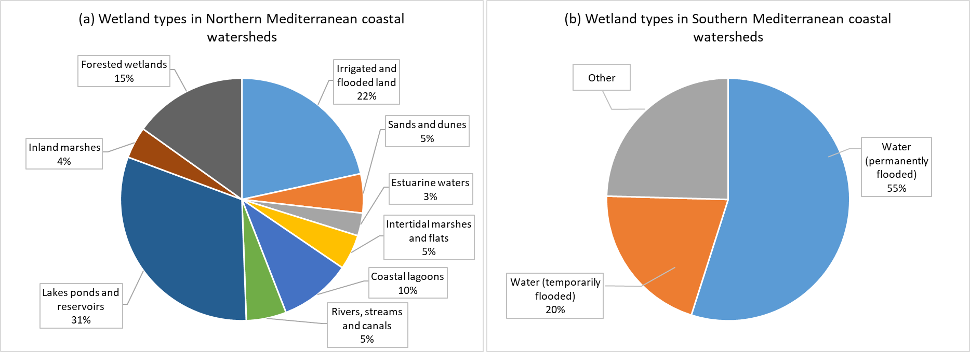
Figure 1: Percentage of wetland habitat typology in the coastal watersheds draining in the northern (a) and southern parts (b) of the Mediterranean basin².

- Need for more accurate Southern/Eastern Mediterranean data

The boundaries of the current Mediterranean wetland study area are defined by the watersheds which drain into the Mediterranean Sea according to the HydroSHEDS dataset and the wetland coverage is presented in Figure 2.
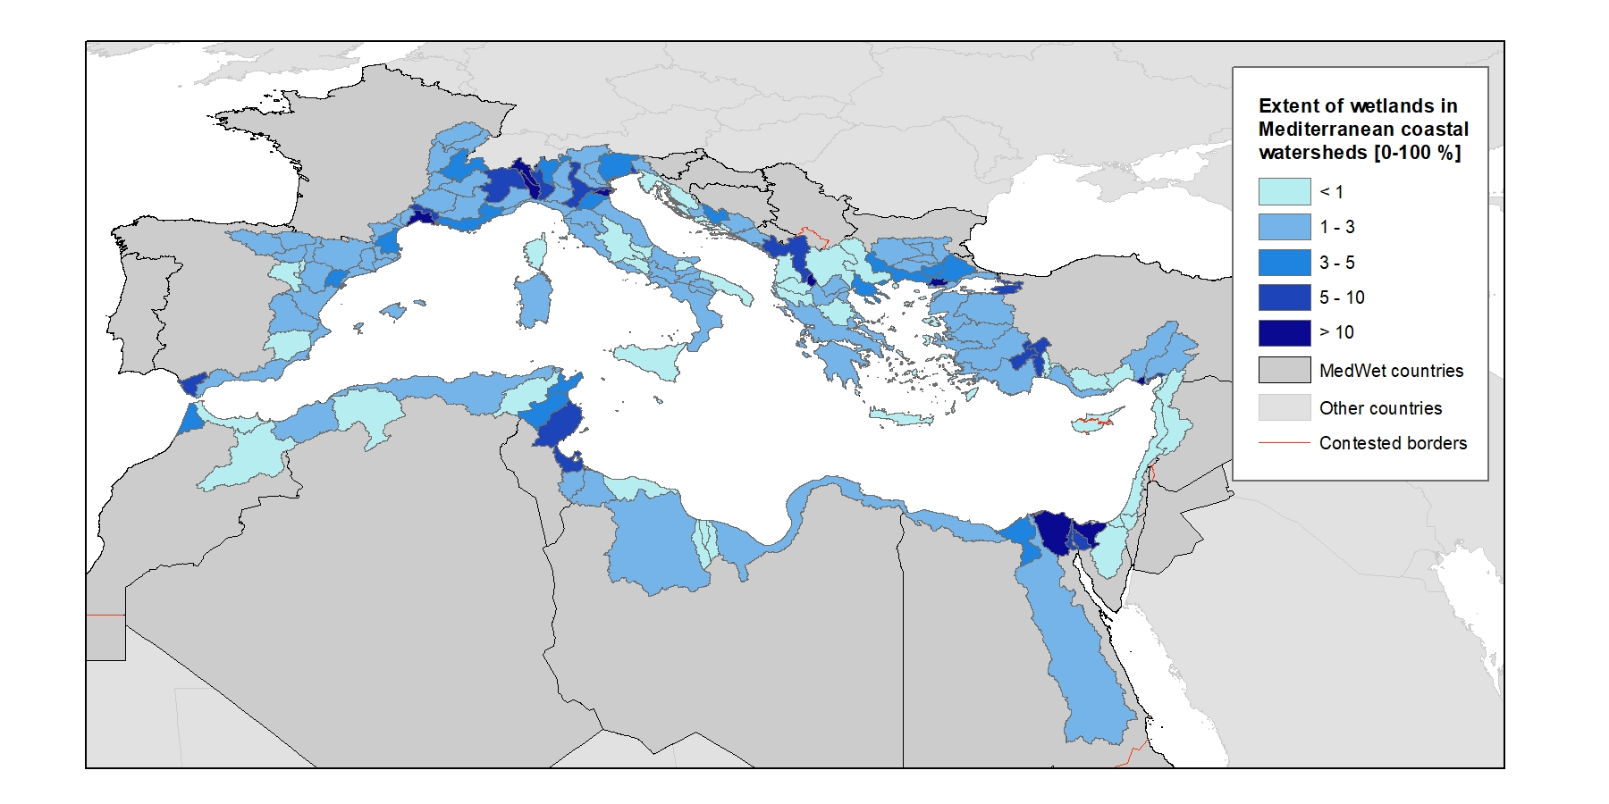 | Figure 2: The total area of the wetlands ecosystem delimited for this study² covers 45,035 km² in the whole basin for watersheds draining into the Mediterranean
This recent spatial assessment aims to answer the need for a Mediterranean-wide wetland ecosystem map and knowledge base. It is the result of a participatory effort by a partnership of key Mediterranean institutions and co-financed by the Interreg Mediterranean programme and the MAVA Foundation. This knowledge base constitutes a first basis to understand the condition of Mediterranean wetlands and, due to the limited availability of accurate and harmonised information especially for the Southern/Eastern regions, requires further dedicated and collaborative efforts to further enrich it in time as data become available.

Such an effort was done for the Balkan Mediterranean region within the project WetMainAreas, whose resulting database has been added to the regional knowledge base presented here. Among other things, its outcomes allowed to highlight the importance of small and medium-sized wetlands. Although they occupy only 3% of total wetland area in the monitored region (Albania, Bulgaria, Cyprus, Greece, North Macedonia), small wetland sites (below 8 ha) represent ¾ of the total number of wetland sites. These numerous small wetlands create a valuable network of corridors and stepping stones, essential for species movement, migration and dispersal. When they are found in heavily urbanised and agricultural areas, they form islands of biodiversity and natural green infrastructures offering multiple services (water storage, recreation, adaptation to climate change, habitat for species).

Also, 1/3 of total wetland in the Balkan Mediterranean region is located in unprotected land with very high value for biodiversity. These wetlands should be integrated in conservation action plans for protected habitats and species of Natura 2000 sites, Emerald sites, National Parks and OECMs.

- KNOWLEDGE ON THE CONDITION AND PRESSURES ON MEDITERRANEAN WETLAND HABITATS

- Need to decrease pressures to reverse declining and unfavourable trends for wetlands

At the pan-Mediterranean level (based on a sample of more than 400 sites), the Mediterranean Wetlands Observatory has reported that natural wetland habitats have decreased by 48% since 1970 (MWO-2, 2018). At the same time, since 1970, urbanisation increased by 294% and agricultural areas by 42%. Most of these losses were caused by urbanisation and agricultural expansion causing the transformation of natural wetlands into human-made wetlands, croplands, built-up areas and sea waters (respectively 47%, 46%, 5% and 2% of the conversions).

Human demography growth is considered as one of the main drivers leading to natural wetlands loss and degradation. The MWO has reported that, in the Mediterranean region, the population has increased by almost one-third since 1990 and is still on an upward trend. Coastal areas and especially coastal lagoons seem to be the most impacted (Figure 3).

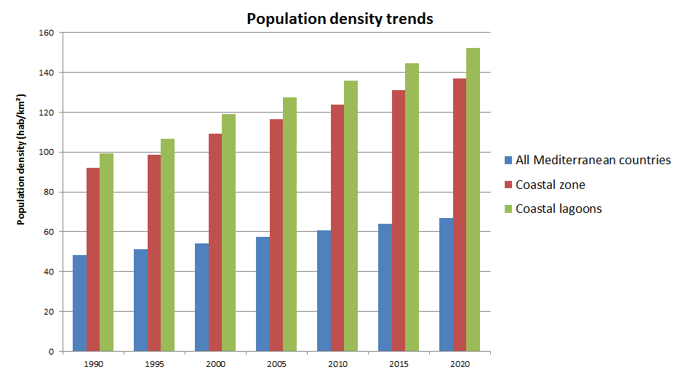
Figure 3: Trend in average density of human populations around the Mediterranean Basin (MWO, 2022)

- As pressures are maintained high, unfavourable condition of wetland habitats and species is still dominant, despite slight good signs at local scale

The condition of the EU-Mediterranean coastal wetland habitat types protected under the Habitat directive has been assessed from reported data under Art.17 of the Directive, for the period 2013-2018. EU Member States reported the information on the Conservation status and trends of the 8 habitat types associated with coastal wetland ecosystems in the Mediterranean bio-geographical region, using a standard methodology based on four parameters representing different aspects of the habitat conditions, namely: “Range”, “Area”, “Structure & Function”, and “Future Prospects”. The EU biogeographical conservation status for those habitats reflects their overall condition by combining the Member State data or by weighting the Member State assessments, in order to reflect the status and proportion of the habitat type present in each Member State. The indicator reflects the number of habitat types reported as Favourable, Unfavourable-Inadequate, Unfavourable-Bad, and Unknown.

The assessment of EU Mediterranean coastal wetland habitat types provides evidence on the dire condition of these habitats (figure 4a), where 69% of the assessed habitats show Unfavourable conservation status (Unfavourable-bad, Unfavourable-inadequate), with a high percentage of knowledge gaps (17% unknown) and only a small share (14%) of the assessed habitats showing signs of effective conservation.

Moreover, the conservation trends of the EU-Mediterranean coastal wetland habitats show an alarming declining (30%) and a majority of stable trends (31%), which indicate that the condition of ecosystems under legal designation under the EU´s Habitat directive assessed as unfavourable (figure 4b) presents worrying signs; in fact, improving trends are reported for only 5% of the reported assessments by EU Member States.

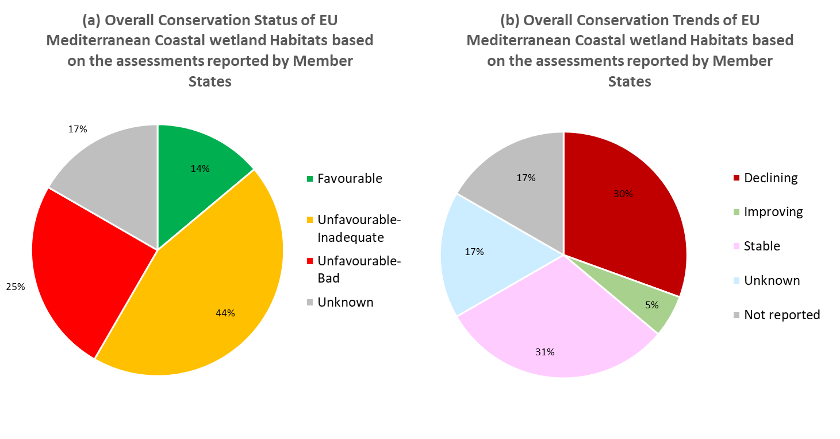 | Figure 4: Condition and conservation trends of the coastal wetland habitats in the Mediterranean part of the EU27 domain, for the period 2013-2018: percentage of Conservation status (a) reported as Favourable, Unfavourable-Inadequate, Unfavourable-Bad or Unknown, for the period 2013-2018. Conservation trends (b) reported as Improving, Stable, Declining or Unknown
These decreasing trends of natural wetland habitats, together with other factors like climate change, have negatively impacted the abundance and distribution of wetland-dependent species (MWO-2, 2018). The wetland related biodiversity in the region is at high risk, as almost half of the freshwater endemic species in the whole MedWet region is threatened with extinction. According to the MWO-2, 2018, the Living Planet Index calculated for these species in the Mediterranean region (LPI-Med) shows a long-term decline since 1990 (-15%), mainly driven by negative trends of the “Amphibian, Reptiles and Mammals” group (-35%) and the wetland-relevant “Fishes” group (-34%).

Nonetheless, the overall trend of the Living Planet Index seems to be improving since the mid-2000s, mostly due to increases in water-bird populations especially in regions where concrete conservation actions have been undertaken at local scale.

- More balanced protection figures across wetland habitat types and geographical regions are required to re-establish wetland functions

The analysis on the level of protection of watershed wetlands according to the type of habitats shows unbalance, with certain habitat types like estuarine waters, coastal lagoons and intertidal marshes and flats on the Mediterranean northern shore (figure 5) having a higher percentage of protection, including the overlapping of several protection figures and a lack of official designation for irrigated and flooded lands.

An equivalent analysis to include southern Mediterranean regions and achieve a regional assessment per habitat type is not possible with the current knowledge. Nevertheless, according to available data, the level of protection in the southern part of the basin is much lower than in the northern part (figure 6): only 21% of the wetland ecosystem area in the southern shores of the Mediterranean region is currently classified as protected area.

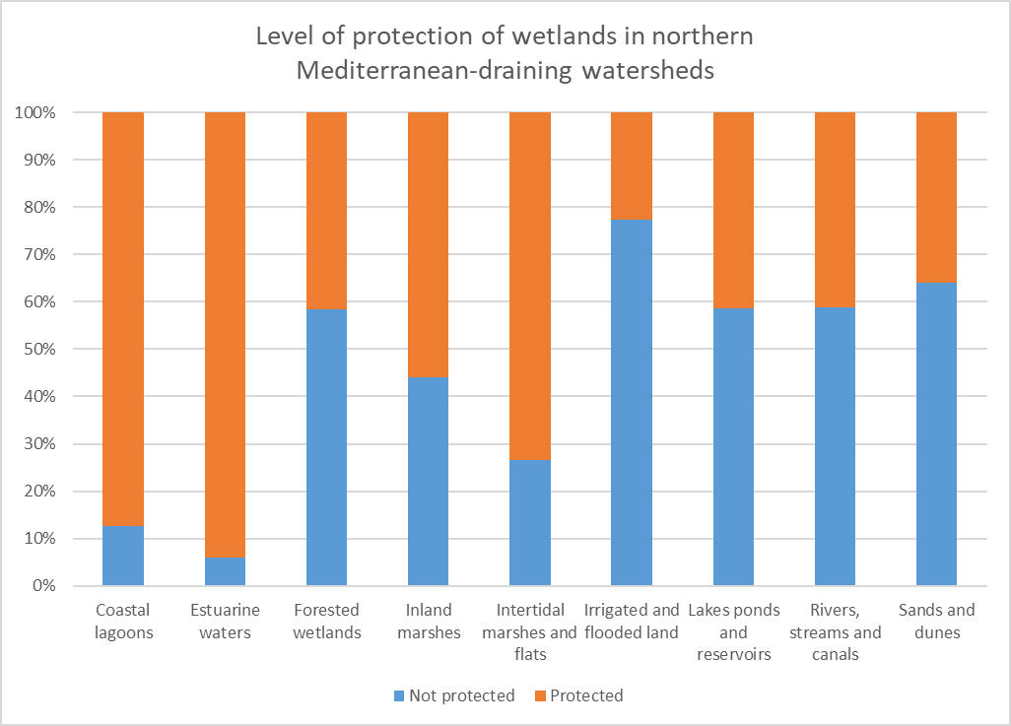 | Figure 5: Wetlands in watersheds draining from the northern part of the Mediterranean basin: percentage of protected areas (Protected Planet database) for each habitat type

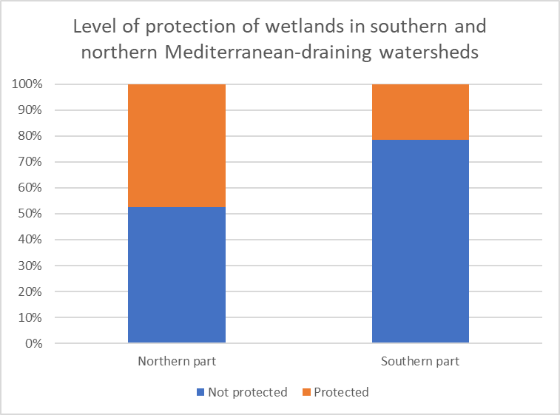
Figure 6: Wetlands in watersheds draining from the southern and northern part of the Mediterranean basin: percentage of protected areas (Protected Planet database¹⁰)

This assessment demonstrates that tangible improvements in the condition of Mediterranean coastal wetlands and the reestablishment of their functions to provide key services such as water provision and water purification to ensure food security requires an increase in the level of protection and therefore the associated management, monitoring and restoration measures.

- THE ROLE OF WETLANDS RELATED TO CARBON

Wetlands have demonstrated to be one of the most efficient long-term carbon stocks (figure 7) compared to other ecosystems. According to the meta-analysis developed by ETC-UMA, wetlands have a high blue carbon sequestration potential when in a good environmental status and effectively managed, particularly seagrass meadows and salt marshes, and are a powerful tool to address the environmental, climatic and socio-economic challenges in the region. Degraded wetlands on the contrary can become carbon emission sources, which proves that the conservation, effective management and restoration of wetlands are effective low-cost nature-based solutions against the impacts of climate change, including water scarcity.

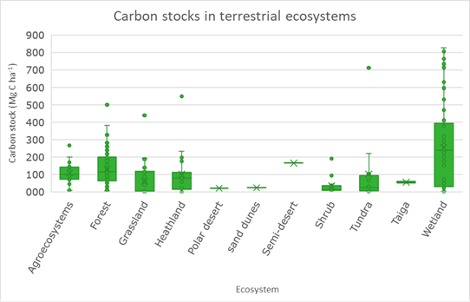 | Figure 7: Carbon stocks per type of terrestrial ecosystem (from Hendriks et al., 2020)

- POTENTIAL RESTORATION SITES IN THE MEDITERRANEAN REGION

A comprehensive pan-Mediterranean map of potential areas for wetlands restoration has been developed by the MWO. This result could be used as a baseline to locate and delineate the main transformed wetlands that could be regained, and to qualitatively estimate the needed effort for their restoration (Figure 8). This map is mainly based on the surface hydro-ecological characteristics of wetlands, combined with the current land use, the conservation status of the existing wetlands and the main management policy frameworks in place (e.g. protected areas). These results could also be downscaled at national levels.
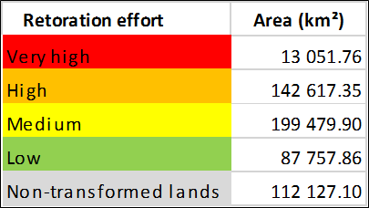
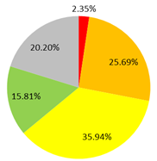
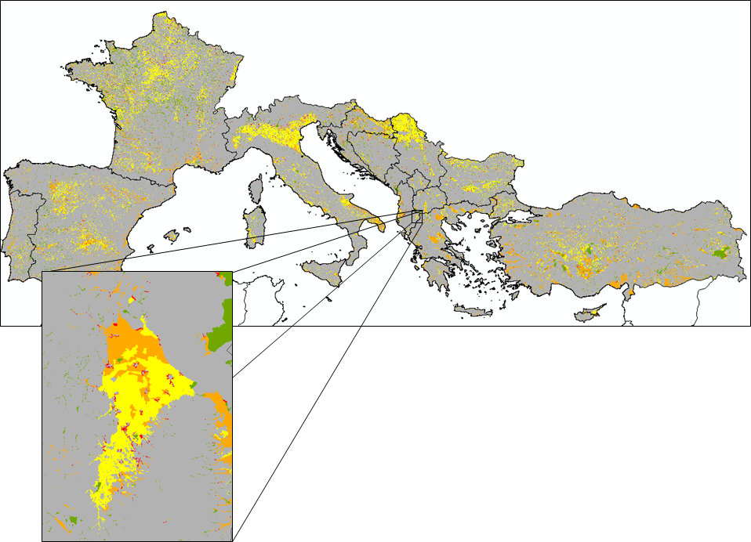
Figure 8: Wetlands restoration estimated efforts for the European Mediterranean countries, with a zoom on Maliqi Marshes, an ancient wetland in Albania that has been drained for crops development (MWO, 2022)

An online survey carried out in 2021 has identified over 220 wetland sites from 24 countries that have potential for restoration activities. This potential wetland restoration could improve over 230,000 ha of degraded wetlands in the Mediterranean basin. The details and potential sites from this 2021 survey can be found at: https://www.wwf.es/nuestro_trabajo/agua/humedales/potential_wetlands_to_be_restored_in_mediterranean_countries/.
Other institutions and initiatives are also increasingly addressing passive and active restoration good practices under the UN Restoration Decade to promote wetlands as Nature-based solutions to the current biodiversity, water and climate change crises in the Mediterranean that urgently need support.

V. EFFECTIVE MANAGEMENT AND RESTORATION PRIORITISATION

The multiple benefits of effective wetland protection, management and restoration are highlighted through the various Mediterranean cases as shown in the infographic below.

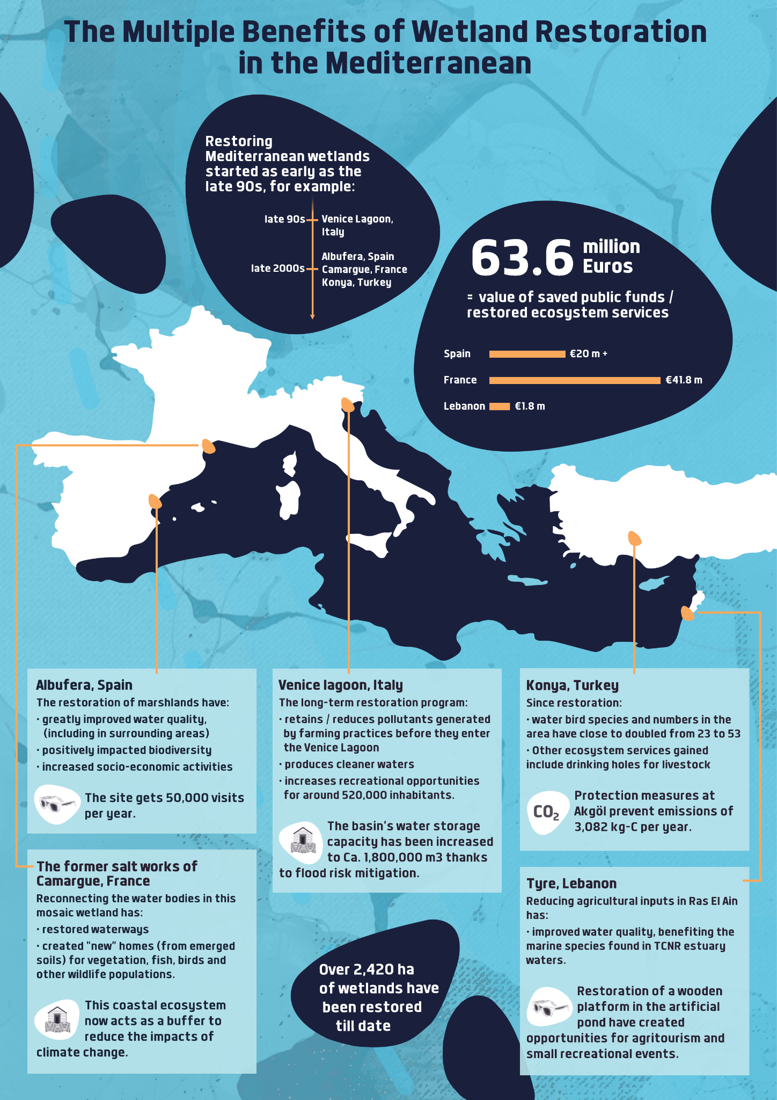

https://ec.europa.eu/jrc/en/publication/eur-scientific-and-technical-research-reports/mapping-and-assessment-ecosystems-and-their-services-eu-ecosystem-assessment
*Reference to the MBPC report on Mediterranean wetlands - permalink will be available on March 10, 2022*
Wetlands of the Balkan Mediterranean territory harmonised in a regional mapping. Greek Biotope - Wetland Centre (EKBY); University of Forestry, Sofia; National Environmental Agency of Albania; St. Kliment Ohridski University of Ohird; Terra Cypria; WWF-Greece. (Project WetMainAreas, co-funded by the European Union in the frame of INTERREG TNCP BALKAN-MEDITERRANEAN 2014-2020): http://185.17.146.157/maps/180
Mediterranean Island Wetlands Project, MedisWet: https://sites.google.com/view/mediswet
European Environmental Agency
https://www.hydrosheds.org
The representation of the Mediterranean countries includes all the contested and disputed borders in a different colour. These boundaries and names are those officially used by the United Nations Organization and the European Union and do not imply official endorsement nor acceptance by the authors. Country borders have been defined based on the “Countries 2020” dataset of the DG EUROSTAT “Geographic Information System of the Commission”
Collaborative work led by ETC-UMA under the Mediterranean Biodiversity Protection Community (MBPC) initiative with the support of Mediterranean Wetland Observatory, Tour du Valat, MedWet, Plan Bleu, and the partners of the WetMainAreas and MedIsWet projects
Data available at https://nature-art17.eionet.europa.eu/article17/
The data elaboration has been provided by the European Topic Centre on Biological Diversity (ETC/BD).
The Mediterranean Wetlands Initiative (MedWet; https://medwet.org/) brings together 28 Mediterranean and peri-Mediterranean countries and territories that are Parties to the Convention on Wetlands: Albania, Algeria, Andorra, Bosnia & Herzegovina, Bulgaria, Croatia, Cyprus, Egypt, France (overseas territories are not included), Greece, Israel, Italy, Jordan, Lebanon, Libya, Malta, Monaco, Montenegro, Morocco, Palestinian Authority, Portugal, Serbia, Slovenia, Spain, Syria, North Macedonia, Tunisia and Turkey
*Reference to the MBPC report on Mediterranean wetlands*
UNEP-WCMC and IUCN (2022), Protected Planet: The World Database on Protected Areas (WDPA) and World Database on Other Effective Area-based Conservation Measures (WD-OECM) [Online], February 2022, Cambridge, UK: UNEP-WCMC and IUCN. Available at: www.protectedplanet.net
Abdul Malak, D., Marin, A.I., Trombetti, M., San Roman, S., Carbon pools and sequestration potential of wetlands in the European Union, European Topic Centre on Urban, Land and Soil Systems, Vienna and Malaga, 2021, ISBN 978-3-200-07433-0.
Hendriks K, Susan Gubbay S, Arets E, Janssen J (2020) Carbon storage in European ecosystems; A quick scan for terrestrial and marine EUNIS habitat types. Wageningen, Wageningen Environmental Research, Internal Report. 66 pp.; 22 fig.; 22 tab.; 77 ref
Tomàs-Vives, P, T.Gil-Gil & C. Viada-Sauleda. Assessment and identification of potential wetlands to be restored in Mediterranean countries. WWF Spain & MAVA Foundation. 36 pp https://wwfes.awsassets.panda.org/downloads/final_report_survey_restoration_med_wetlands_2021.pdf
https://ec.europa.eu/environment/archives/greenweek2020/sites/default/files/2020-10/Public_Draft_Agenda_-_Green_Week__Final_Version.pdf

