THE CONVENTION ON WETLANDS
59th Meeting of the Standing Committee
Gland, Switzerland, 21-25 June 2021

SC59 Doc.11

Report of the Chair of the Effectiveness Working Group

Action requested:

The Standing Committee is invited to note the full body of work on the governance review of the Convention on Wetlands, which comprises three separate, linked reports, produced by a consultant, as tasked by the Effectiveness Working Group in accordance with Resolution XIII.3.

The Standing Committee is also invited to take note and comment on the suggested way forward.

Background

1. At its 13th meeting (COP13) the Conference of the Contracting Parties, through Resolution XIII.3, paragraph 14, requested the Effectiveness Working Group to review the governance structure of the Convention with the assistance of an independent consultant for the purpose of:

a. recommending revisions (as necessary) that further enhance the effectiveness, including cost effectiveness, and efficiency of the Convention in order to reduce administrative burden and speed up the processes to achieve the mission of the Ramsar Convention; and

b. proposing a process to implement its recommendations.

Results to date

2. The full body of work on the governance review of the Convention, produced by SRI Executive, comprises three reports as follows:

a. Ramsar Convention on Wetlands: Review of Governance Structures and Procedures – Findings: The Findings Report (based upon desktop analysis, 1:1 interviews with appropriate individuals, and the findings of an online survey for Contracting Parties. Completed on 09th June 2020). See Annex 1.

b. Ramsar Convention on Wetlands: The Comparison Report (comparing the Convention with six other Multilateral Environmental Agreements. Completed on 16th September 2020). See Annex 2.

c. Ramsar Convention on Wetlands: The Measures Report on Positive Indications and Measures (consolidating the previous two reports and recommending possible measures to enhance the Convention effectiveness for consideration by the Effectiveness Working Group. Completed on 31st March 2021). See Annex 3.

3. The three reports have also been published on the Convention website and can be accessed at the following addresses:

www.ramsar.org/sites/default/files/documents/library/sri_executive_review_findings.pdf

www.ramsar.org/sites/default/files/documents/library/sri_executive_review_measures.pdf

www.ramsar.org/sites/default/files/documents/library/sri_executive_ramsar_review_meas_comparison.pdf

4. The governance review of the Convention on Wetlands has been conducted in line with the terms of reference issued by the Effectiveness Working Group to SRI Executive following the mandate of Resolution XIII.3. The reports reflect the views of the authors following SRI Executive analysis of its governance review findings.
5. To date the Effectiveness Working Group have been focused on the development and findings set out in the reports produced by SRI. However, the recommendations agreed by the Effectiveness Working Group may seek to go beyond these points. Future discussions by the Effectiveness Working Group will focus on developing these recommendations.

Further Work to be undertaken by the Effectiveness Working Group

6. The Effectiveness Working Group, in line with Resolution XIII.3, is currently assessing the recommendations of SRI Executive, with the intention of drafting a Resolution setting out its recommendations. This draft Resolution, once agreed by the Effectiveness Working Group, will be submitted to Parties for consideration at the relevant meeting of the Standing Committee prior to COP14.

7. The Effectiveness Working Group – with support from the Secretariat – will deliver a virtual workshop for all interested Contracting Parties to present an overview of the governance review findings and an outline of the resulting draft Resolution, ahead of submitting its final recommendations to the Standing Committee.

Annex 1: The Findings Report

Annex 2: The Comparison Report

Annex 3: The Measures Report
Annex 1
The Findings Report

Ramsar Convention on Wetlands: Review of Governance Structures and Procedures

Findings

Presented by SRI Executive: April 2020

Contents
1
Ramsar Convention on Wetlands: Review of Governance Structures and Procedures 1
Findings 1
1. Context 3
Scope of Review 3
2. Methodology 4
3. Summary of Findings of overall governance of Ramsar Convention according to assessment criteria 7
3.1 Clarity 7
3.2 Legitimacy 8
3.3 Accountability 8
3.4 Effectiveness 9
3.5 Costs 9
4. Findings – Individual Governance Structures and Procedures 10
4.1 The Conference of Contracting Parties 10
4.2 Standing Committee 16
4.3 Management Working Group 19
4.4 Executive Team 20
4.5 Subgroup on Finance 21
4.6 Scientific and Technical Review Panel 23
4.7 Communication, Education, Participation, and Awareness (CEPA) Oversight Panel 24
4.8 Secretariat 27
5. Next Steps 30
Annex 1: Final Evaluation Questions 31

1. Context
Providing a critical framework for the conservation and wise use of wetlands, the Ramsar Convention and resulting organisation has ensured the provision of essential ecological services and freshwater supply since 1971. Promoting national action and international cooperation, Ramsar is the lead implementation partner on wetlands and contributes significantly to the Sustainable Development Goals, the Convention on Biological Diversity and to climate change mitigation and adaption globally. Ramsar’s operating environment has shifted dramatically during its history, with more actors, intense competition for resources and the rise in importance of nexus and systems approaches to sustainable development, of which wetlands plays a critical role. This landscape has also seen significant progress in terms of innovation around alternative structures, business models, integration of new technologies and demonstration of value for money with measurable impact. The risks linked to water security are ranked as some of the highest threats to social and economic development, year after year. Being able to take swift, effective, coordinated and informed action is therefore essential for all organisations who seek to advance sustainable development.
With 171 Contracting Parties and nearing its 50th anniversary, this intergovernmental organisation and multilateral convention has made the decision to review its governance structure and processes to ensure it is fit-for-purpose with effective and efficient, legitimate and accountable decision-making processes, which demonstrate cost-effectiveness with modern work methods. Ramsar’s governance should support the Convention in implementing its vision and mission on the ground as well as raising its global profile to increase its impact.

Scope of Review
The 13th Conference of the Parties adopted Resolution XIII.3, acknowledging the importance of an adequate institutional set-up for Ramsar, formulating the Effectiveness Working Group (EWG) to review the governance structure with the assistance of an independent and neutral third party. Resolution XIII.3 was in response to deliberations and decision on the two draft resolutions put forward to COP 13 on the Ramsar Governance. SRI Executive was selected to support this review, for the purpose of recommending revisions (as necessary) that further enhance the effectiveness, including cost effectiveness, and efficiency of the Convention. As indicated in the minutes and documentation, this review occurs in a back drop of an external environment that is focused on demonstrating value for money, reducing inefficiencies plagued by administrative burden and slow processes in order to ensure organizations and Conventions are focused on achieving their critical missions. In addition to assessing the effectiveness and efficiency of the Convention, this review also includes proposing a process by which the Effectiveness Working Group can implement the recommendations they deem suitable, practical and impactful to enhance the functioning of Ramsar’s governance moving forward in support of the conservation and wise use of wetlands. This first report focuses on independently assessing the effectiveness and efficiency of the Convention’s structure and processes in relation to the strategic plans of the Convention, and will be followed by an analysis of comparable MEAs, in order for the EWG to obtain a holistic picture prior to formulating the “so what” and potential recommendations for implementation.

It is noted that this review is not assessing the operational work, processes or impact of the Ramsar Convention as whole.

2. Methodology
Firstly, this review’s methodology has been designed to be truly participatory, noting the “ownership” of this review while independently carried out, is with the Effectiveness Working Group. Thus, as key stakeholders in this process, the EWG not only were informed of the methodology, but greatly contributed to it as well. This includes but is not limited to; the selection of the key informant interview sample, the key criteria, the survey and evaluation framework including the overarching evaluation questions (OEQ) and main evaluation questions (MEQ) this review sought to answer. The assessment criteria are defined in this report, and in line with international best practice, this review sought to understand the Clarity, Legitimacy, Accountability, Effectiveness and Cost Efficiency of Ramsar Convention’s Governance. This final evaluation framework and assessment criteria can be found in Annex 1: Final Evaluation Questions.
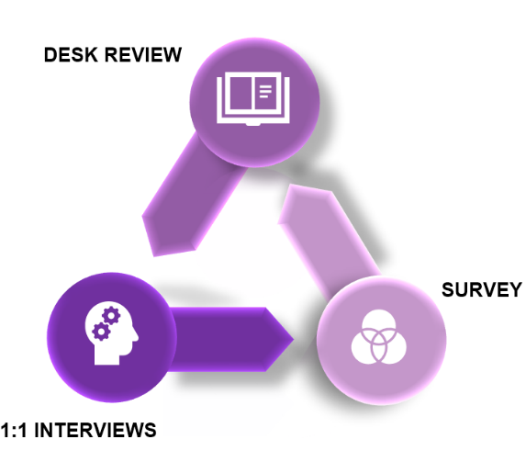
In order to ensure our independence, this review sought to triangulate, where possible and applicable, drawing on the strengths of both quantitative and qualitative data collection and analysis. Quantitative data is best collected with very clear yes or no questions or requests to rate or rank statements in order to show frequency of a specific finding, while qualitative data is best gained through open ended questions. The desk review provides clear findings as to express governance structures and processes. The 1:1 interviews were open ended questions, while the online survey posed both quantitative and open-ended questions. Triangulation is therefore achieved by using a mix of more than one method of gathering and analysing data against the same evaluation framework, to seek convergence and corroboration and to eliminate the inherent biases that could exist if we only used one method. Where possible in our findings by body, we have highlighted the % of interviews and survey respondents to demonstrate the level of evidence by modality, whilst not losing the nuance that bubbles to the surface when using multiple methods.
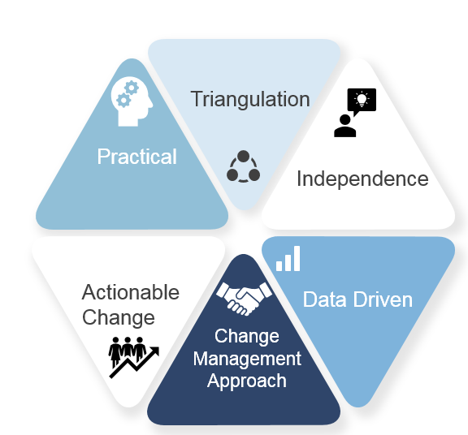
By utilising mixed methods, our team was also able to review the “what” against agreed upon criteria from both the desk research and quantitative survey responses, while using key informant interviews and open comments in the survey to better understand the context of why and how. In essence, this complementarity and use of different methods allowed the team to seek elaboration, enhancement, illustration and clarification with the results of the survey and evidence demonstrated in key literature. Integrating these sources throughout the different phases of our review process, SRI Executive were able to draw inferences from multiple sources, bringing together sometimes diverse perspectives from which to draw initial conclusions in context and understanding that these views may at times be subjective as processes are experienced by humans and thus, human behaviour. This approach is best practice in the field and draws upon both evaluation theory and change management approaches widely used in governance reviews and the implementation of any form of change within a system, including an intergovernmental organization.
In terms of sequence, SRI Executive first examined internal structures, drawing upon a desk review of the Convention’s significant documentation to review the scope and mandate of each subsidiary body as well as composition, reporting, structure and cost effectiveness (a full list of all documentation reviewed will be available in the Measures Report). Looking to understand how the structure comes to life, SRI Executive reviewed the Convention’s internal processes, examining key areas such as preparing and consolidating resolutions and how communications flow between and within bodies. As processes on paper may be experienced differently in practice, it is important to understand and assess ways of working, potential barriers and areas that influence the effectiveness and efficiency of Ramsar’s governance in reality. While this area in particular may not be as “scientific,” it is an important consideration as behaviours drive progress and thus, can inhibit effectiveness and efficiency in a governance context.
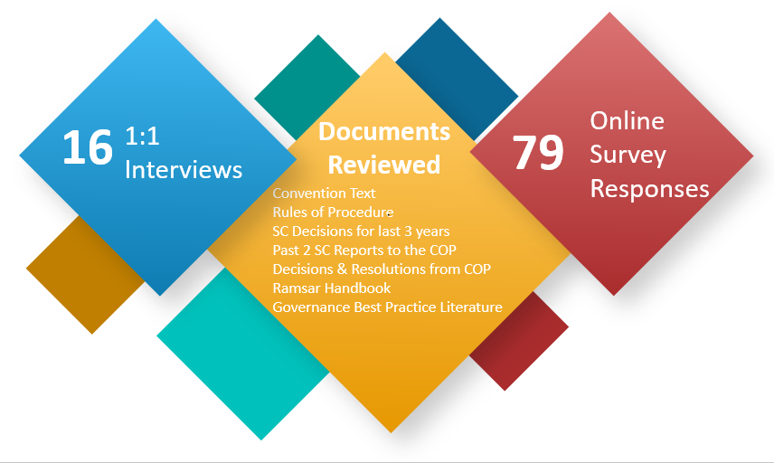
The graphic below shows an overall picture of how SRI Executive have gathered information about the Ramsar Convention. A full list of interviewees and documentation will be provided in the last report.

The table below shows the percentage of respondent CPs to the online survey per region.
Region | No. of Countries | No. Responding Countries for online survey | No. Countries which held 1:1 Interviews | % Responses per Region for online survey
Africa | 50 | 24 | 1 | 48%
Asia | 34 | 8 | 2 | 24%
Latin America & Caribbean | 27 | 7 | 3 | 26%
Europe | 48 | 36 | 3 | 75%
North America | 3 | 2 | 1 | 67%
Oceania | 9 | 2 | 1 | 25%
Total | 171 | 79 | 11

As aforementioned, the stakeholders that were invited to interview were considered and agreed with the EWG, as it was determined they were the most appropriate entry point to garner perspectives that would add value to this exercise. It is important to note that this set of interviews is meant to serve as a representative sample, geographically represented, of the Contracting Parties and it would be unusual to see a governance review that includes a majority or all CPs in order to draw initial findings or conclusions. SRI Executive supplemented these interviews with an open invitation to all CPs to complete a global survey, ensuring this process was inclusive and diverse, and most importantly, confidential. While collating and reviewing data in the back end of the survey tool, SRI also removed any duplicates to ensure fairness.
As follows, the scope of the review included the following bodies and processes: The Conference of the Parties (COP), Standing Committee (SC), subgroups, the Secretariat, the Scientific and Technical Review Panel (STRP), and CEPA Programme Oversight Panel. The review considered only the Ramsar Convention’s Governance structures, subsidiary bodies and governance processes, and not the Convention’s operations or impact performance.
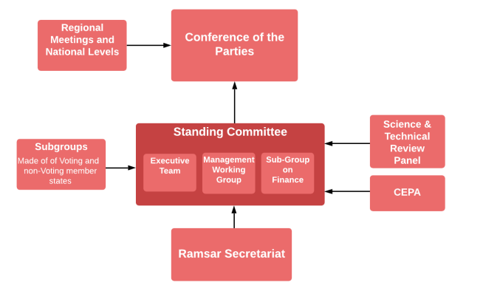

3. Summary of Findings of overall governance of Ramsar Convention according to assessment criteria
As is experienced by many organizations spanning all institutional types, the documentation that creates good governance on paper and in concept, when examined beyond terms of reference and how governance operates in practice, potential obstacles or barriers to effectiveness often arise. This report seeks to unearth some of those areas, not in judgment terms, but where attention can be pointed to by the Effectiveness Working Group to enhance the effectiveness and efficiency of Ramsar’s governance. In many occasions, this includes responses from both quantitative and qualitative responses and what the evidence on paper looks like, to see where the differences potentially lie.
The overall assessment of the Ramsar Conventions is that the foundation of good governance exists in the Convention, Resolutions and Rules of Procedure, but it is the implementation of the Rules of Procedure, decisions and processes which are at times weak. The sections below summarise the overall review findings for each assessment criteria of clarity, legitimacy, accountability, effectiveness and cost in relation to the Ramsar Convention’s overall governance. Section 4 then details the assessment criteria in relation to each governance body.

3.1 Clarity
CLARITY - Governance mandate, tasks and responsibilities for decisions and actions in the Convention are clearly delineated, allocated and accepted.
Clarity is fundamentally important for good governance as ambiguity, overlapping mandates or gaps in essential governance functions cause confusion for stakeholders. Governance needs to be clearly set out in the organisation’s governance documentation, drawing clear lines between mandates, tasks and decision-making between different governance bodies and offices.
Overall, the desk review showed that there is clarity in relation to all the governance bodies examined, although at times, many resolutions needed to be examined to pull together a full picture of the mandate of one body. The stakeholders interviewed considered that the governance documentation is clear on mandates, tasks, and functions for the COP and SC (which is also evidenced by the desk review), but clarity is reduced in relation to some of the subgroups. For the COP and SC, the mandates are felt to be wide enough in that they can take on a wide range of technical issues relating to emerging wetlands management challenges, thus allowing the Convention to be flexible and agile, and able to adapt to emerging issues within the scope of the Convention’s work.
However, even if the wide and unspecific wording allows for flexible and agile working, often the result of consensus driven decision making, the responses show that this wide language causes some lack of clarity in relation to implementation of tasks designated to the subsidiary governance bodies or CPs. This causes, at times, procedural issues to take prominence in agendas and deliberations in the place of substantive and technical discussions on wetland management. The findings from the interviews and survey also point to a lack of clarity due to limited information flows between the COPs, even though the desk review shows that meeting documentation is made available on the website and responsibilities for disseminating information from meetings is clearly set out in resolutions. There is therefore a mismatch between the express and clear governance tasks and functions and how these are understood and perceived by the stakeholders.

3.2 Legitimacy
LEGITIMACY - All parties to the Convention are fairly represented, whether directly or by a legitimate representative, and are informed and empowered to validate or question all decisions taken by the Convention.
Legitimacy is often referred to as participation and assesses whether all stakeholders of an organisation are able to have their voices heard, so that the organisation is seen to legitimately act for its stakeholders.
The governance of the Convention is viewed as legitimate throughout its governance bodies. All Contracting Parties are given representation either individually or representationally, and are given a vote, and thereby a voice. In accordance with the nature of multilateral agreements, each member country decides itself who is to be their representative for the Convention. The COP agrees on the composition of the countries that form the SC which represents it in the direction and management of the Convention’s work between the COPs. Subgroups are created by the COP or the SC and all CPs are free to engage in any subgroup or attend the SC as an observer (if not an appointed member).
The stakeholders interviewed all felt legitimacy of the Convention is strong. The concerns raised regarding legitimacy related to the varying levels of capacity and political will between the different CPs. This is a common concern and dilemma for any multilateral organisation that is dependent on the political will and engagement of its member states, but as a Convention and organisation, to stay independent of this political power and allow full participation by all its members.
Currently, the interviews and survey showed there is a perception that certain countries are able to more actively engage in the Convention’s governance with larger delegations, favourable logistics and language capacity. A CP’s actual ability to be represented and engage is of course completely dependent on its own delegate(s) participation and re-engagement with its own country after and in between COPs, which is applicable to both developed and developing countries. As the desk review and interview and survey responses show that the Convention is legitimate, the concern raised is a reflection of behaviours of engagement with the Convention, rather than a flaw in the governance structure.

3.3 Accountability
ACCOUNTABILITY - The decision-making bodies of the Convention are accessible to their stakeholders, who are informed and empowered to question decisions taken. All governance bodies are seen as responsible and accountable for the decisions they take.
Accountability is recognised as a fundamental factor for effective governance within all types of organisations, be it private or public. Legitimacy is often dependent on the two assessment criteria above with the addition of “answerability,” which is the factor assessed herein. While assessing the criteria of accountability, we have focused on the process of decision-making and the flow of information to stakeholders in relation to the decisions that are to be taken.
There are Rules of Procedure for the COP, as well as certain Resolutions, that set out the process for decision-making for the governance bodies, describing how issues are to be put forward, debated, negotiated and finally decided. Consensus is the preferred method of decision-making even if specific voting can be used according to the Rules of Procedure or Resolutions. The Rules of Procedure for the COP are used mutatis mutanda for the SC as well. There is therefore, on the face of documentation, the foundation for accountability.
The desk review showed that the Ramsar Convention has a high rate of submission of national reports to the COP, and with mechanisms in place in the Rules of Procedure to discuss and question any agenda item during meetings, accountability is possible. However, the main findings from the interviews and survey show that, again, comments on lack of accountability are based on perceived low internal flows of information on follow-up of implementation of resolutions and decisions which are taken at the COP and SC.
The practical consequences of this contrast between desk review and interview and survey findings is a possible “acceptance” of weak accountability resulting in responses criticising accountability but very few proposals for how this can be solved.

3.4 Effectiveness
EFFECTIVENESS - The governance bodies deliver, in a timely and effective manner, on the objectives set out by their mandates in the Convention.
This assessment criterion is, in essence, a reflection of the aforementioned assessment criteria taken as a whole.
The majority of CPs interviewed and surveyed feel that the governance of the Ramsar Convention supports the progress of work towards the Vision and Mission of the Convention. They also feel it could be better, which is expected as all respondents wish to highlight the areas of improvement that they feel are important. This is especially relevant in MEAs where Contracting Parties are sovereign countries which are free to engage with the Convention at their own discretion.
As the number of participants at the meetings is generally large, there is felt, in theory, to be a strong mix of skills and experiences at the COP and within the SC in order for there to be proper and efficient management of the governance.
The factors which are felt to reduce effectiveness are mainly the process related to putting forward resolutions, and the fact that the rules that govern this process are not the most effective manner of working. The different responses show that there are too many resolutions, too many steps within the preparation process, insufficient review of resolutions before they are finalised for the COP and insufficient support to CPs from the Secretariat to prepare resolutions.
Another factor influencing effectiveness is that the stakeholders interviewed perceive there to be a lack of communication between COPs. The desk review shows that all documentation relating to the Convention COP and SC meetings are available on the website and responsibility for reconnecting with CPs is expressed in Resolution XIII.4. However, there is still a perception that limited follow-up information is shared after these meetings and that communication is only picked up again when preparation for the next COP needs to start. This in turn, results in a gap in knowledge of the stakeholders and governance capacity in conjunction with the next COP meetings.

3.5 Costs
COST - The cost of governance is justifiable relative to its delivery of impact.
The Convention is funded by each Contracting Party contributing a minimum funding contribution which is agreed at the COP. The majority of the CPs do pay their minimum contribution, and some CPs also contribute in addition to this for specific activities and programs. The cost of the governance is very lean as the main costs for the COP and the developed country CPs’ own participation is borne by countries themselves, with developing country CPs receiving financial support to attend meetings.
The desk review shows that budget accountability, managed by the Secretariat and overseen by the Subgroup on Finance, is seen to have been improved. Also, it is evident in reports from the SC and the Subgroup on Finance that attempts are being made to explore how financing can be improved to increase the number of the minimum contributions being paid. However, no solutions have been found yet.

4. Findings – Individual Governance Structures and Procedures
Below we have provided the main findings for each assessment criteria for each governance body.
The speedometer
shows the overall summary of the different assessment criteria for the governance of any given body, where green is working well, amber is some concerns, but meeting requirements (as set out in governance documents) and red is major concerns.
As aforementioned in the methodology section of this report, this review and summary of findings sought to identify and nuance the assessment of a governance body by utilising mixed methods. While SRI Executive sees the value in triangulation and demonstrating key findings holistically, we recognize that Contracting Parties may wish to understand the extent to which these findings have been reflected across each method or medium of data collection. It is recognised that governance documentation is insufficient as the only source for a governance review as governance is implemented by behaviours and the perceptions of these behaviours. As such we have indicated below in the text and tables within each assessment criteria the main source of the conclusion drawn by our independent team, and the percentage of times this conclusion was raised within the sample. Rather than following scientific thresholds, it is common practice in a review such as this one or a stakeholder analysis to bring out and analyse the interesting findings that when combined across multiple mediums would see a threshold closer to 20-30% but show a regular reference to an issue that is noteworthy and should be taken on-board by the Effectiveness Working Group for further consideration.

4.1 The Conference of Contracting Parties
The mandate and task of the COP are very clearly set out in the Convention text, Article 6. Its mandate is:
a) to discuss the implementation of this Convention;
b) to discuss additions to and changes in the List (of Ramsar Sites);
c) to consider information regarding changes in the ecological character of wetlands included in the List provided in accordance with paragraph 2 of Article 3;
d) to make general or specific recommendations to the Contracting Parties regarding the conservation, management and wise use of wetlands and their flora and fauna;
e) to request relevant international bodies to prepare reports and statistics on matters which are essentially international in character affecting wetlands;
f) to adopt other recommendations, or resolutions, to promote the functioning of this Convention.
All Contracting Parties have a vote at the COP meeting, although the reports from the COP meetings and the interviews and survey responses confirm that resolutions are passed by consensus, with objections noted. IOPs and other observers who attend can request to speak, which provides legitimacy and accountability to the meeting. In our desk review of the last two COP meetings (2018 and 2015) 25 resolutions relating to the above mandate areas were passed at COP 13 and 16 at COP 12. Out of these total 41 resolutions, 15 related to procedural or internal management issues of the Convention and the other 26 related to substantive issues in relation to wetlands management.
Resolutions are made available to all CPs on the Ramsar website in all official convention languages.
The desk review shows that the mandate and tasks of the COP do not overlap with the other decision-making bodies of the Convention, particularly the Standing Committee (SC). Specifically, Resolution 3.3 which established the SC states in paragraph 1(a) that it shall “carry out, between one ordinary meeting of the Conference of the Contracting Parties and the next, such interim activity on behalf of the Conference as may be necessary, such activity being limited to matters on which the Conference has previously recorded its approval”.
The desk review also shows that one of the significant success factors of the COP is the high submission of national progress reports from CPs. In document 11.1 from the last COP 13 meeting, 140 national reports had been received prior to the meeting. This is one of the highest rates of reporting of the Multilateral Environmental Agreements (MEAs).
The responses in the interviews and survey show that the COP has a clear mandate and function (see figure 1 below). The COP is understood to issue resolutions which are clear .
100% of the responses in the interviews state that the mandate and function of the COP is clear and that it has full legitimacy, however 62% of the responses qualify that statement with issues which they feel would improve the clarity, legitimacy and function of the COP. 70% of the responses in the online survey state that CPs are all well informed in order to take decisions at the COP, but again, 45% of those responses qualify their “yes” with the fact that there is varying capacity of the delegates (language and knowledge of Ramsar), and a lack of follow-up information between the COPs.
Figure 1 – Online Survey result for COP
5. To what extent do you agree the governance bodies have clear delegated mandates allocated to them? (6 – Strongly Agree; 2 – Strongly Disagree;, 1 – not aware)
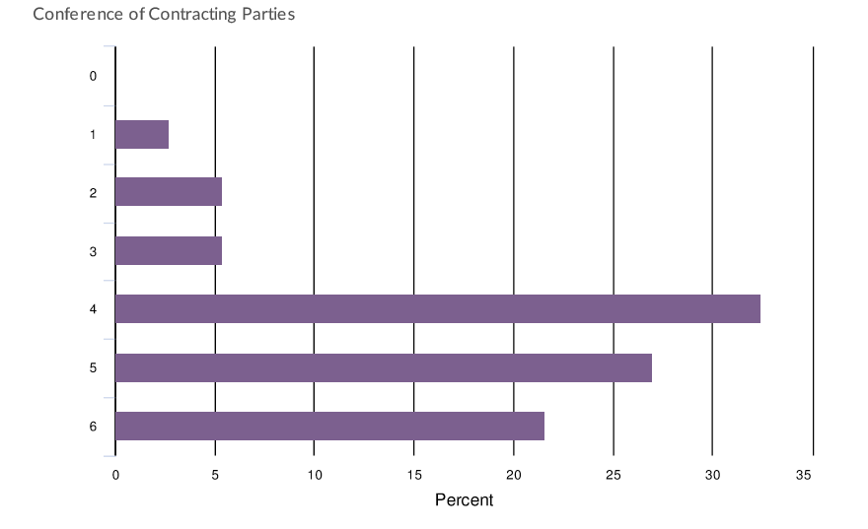
The Rules of Procedure are adopted at the beginning of each COP, as set out in Article 6(4) of the Convention and thereby prescribe the process for the submission and review of resolutions for the next COP. They also provide the rules of procedure for all other governance meetings carried out during the triennium as they are used mutatis mutandis for other governance bodies’ meetings. The Rules of Procedure can only be amended by the COP meeting itself. The current Rules of Procedure are in the process of being reviewed, as per resolution XIII.4 from COP 13.
The Rules of Procedure set out the requirements for providing notice of meetings, the submission of resolutions, how the meeting is to be held, the roles of the Chair and other governance roles, and how meeting documentation is published and shared. The Rules of Procedure are detailed on all these aspects.
A vital part of any Convention is the process for creating, adopting and then implementing resolutions, as they are one of the main mechanisms for interpreting and taking action under the convention. The figure below shows the overall process for submitting resolutions to the COP.
Informal regional meetings may take place to discuss the draft resolutions before the SC Pre-COP Meeting, and immediately prior to the COP regional meetings are schedules which provides the forum for convergence on issues relating to draft resolutions, although there is no decision-making power or rules on how these meetings are to be conducted.

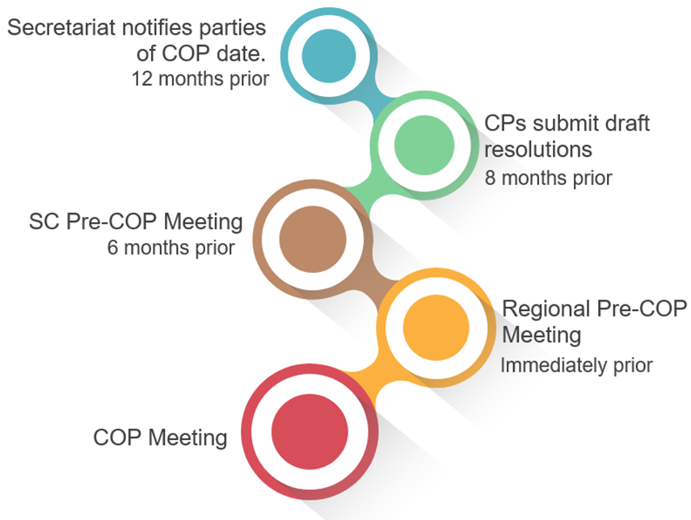

From the desk review it is noted that the timelines and steps of action set out in the Rules of Procedure for the COP meetings are adhered to well by the CPs and the Secretariat which provides the administrative support for the COP meetings. However, the interview and survey responses show that the processes set out in the Rules of Procedure are not seen as the most effective in relation to preparing resolutions. The comments relate mainly to the quality of the resolutions due to inadequate scrutiny before they come to the COP for approval.
The table below sets a summation of the conclusions we have been able to draw by looking at the documentation (desk review), the results of the face to face interviews and a review of the survey results and comments received in the online survey, in relation to each governance assessment criteria for each of the governance bodies. We have indicated in each criteria the main source of the conclusion and the percentage of responses. In relation to the interview and survey results, we have here below looked at the responses and comments which were given that directly relate to the governance role of the COP.

Governance assessment criteria | Conclusions from review
CLARITY  Mandate, tasks and responsibilities for decisions and actions in the Convention are clearly delineated, allocated and accepted. | - Mandate and tasks clearly set out in Convention and resolutions (desk review)  - Mandate and tasks clearly delineated from other governing bodies (desk review)  - Tasks and responsibilities assigned through resolutions generally understood to be clear and accepted by all Contracting Parties (100% 1:1, 62% with qualifying statements, 72% survey)  - Inconsistencies and contradictions in resolutions due to poor preparation creates lack of clarity in relation to how resolutions should be implemented (desk review and 53% 1:1, 31% survey)
LEGITIMACY  All parties to the Convention are fairly represented and are informed and empowered to validate or question all decisions taken by the Convention. | - Each Contracting Party given representation and a vote/voice at the COP (desk review)  - All Contracting Parties are informed with all relevant information prior to and during COPs and thereby given opportunity to carry out their responsibilities (desk review)  - Strong engagement at regional level during the regional pre-COP meetings (31% 1:1 interviews)  - Unequal levels of engagement and ability to fully engage in plenary deliberations as well as “corridor discussions” between Contracting Parties and contact groups resulting in actual imbalance of representation by the CPs at COP (62% 1:1, 28% survey)
ACCOUNTABILITY  The decision-making bodies of the Convention are accessible to their stakeholders, who are informed and empowered to question decisions taken. All governance bodies are responsible and accountable for the decisions they take. | - All decisions of COP and related documents relating to the COP are accessible online at the deadlines specified in the Rules of Procedure (desk review)  - Rules of Procedure allow for draft Resolutions to be questioned, debated and negotiated (desk review)  - Concern regarding follow-up of delegated work in resolutions and no mechanism of enforcement (desk review and 67% 1:1, 50% survey)  - Lack of communication between COPs to CPs results in difficulties to voice question on progress presented at next COP (38% 1:1, 34% survey)
EFFECTIVENSS  The governance bodies deliver, in a timely and effective manner, on the objectives set out by their mandates. | - Dependent on good chairing and informed participation of delegates (46% 1:1, 28% survey)  - Dependent on the participation and truthful self-assessment of implementation by Contracting Parties (desk review)  - Inequality of knowledge and capacity of delegates creates inefficiencies in both creation process and quality of resolutions submitted and participation in debates (62% 1:1, 28% survey)  - Lack of implementation enforcement mechanism and follow-up means difficult to assess effectiveness (desk review and 67% 1:1, 50% survey)
COST  The cost of governance is justifiable relative to its impact on delivering results for the Convention. | - Cost of COP meetings are carried by the host country and developed country CPs pay for their own participation. Developing country CPs receive financial support to attend (desk review)  - Financial stability is discussed (Finance Subgroup) and assessed regularly (desk review)

From the text and table above, we have drawn out the main findings.
Initial Findings and Next Steps
Process to prepare and submit resolutions to the COP: The process for preparing Resolutions for the COP is set out in the Rules of Procedure and although clear, the responses from the 1:1 interviews and online survey show that there is a need for the procedure to be amended so that the scrutiny of resolutions leads to them being clearer. All preparatory documentation is made available on the Ramsar website, but a common platform does not exist for all CPs to work on the documents. The process involves a number of steps as described above in order for Resolutions to be submitted to the COP.

Related to the process of preparing resolutions, there have been a number of “repeat issues” in resolutions which have already been decided on in previous COPs but have not been caught in the review prior to being submitted to a COP. Work has begun since the last COP (Resolution 13.4) to review all resolutions in order to find duplications and therefore be able to propose to the COP that resolutions are closed for future deliberation. However, CPs still perceive the support provided during the preparation process of resolutions as weak (see section 4.8 Secretariat), and therefore the risk of repetitive or poorly prepared resolutions is still very high.

Varying capacity and knowledge of delegates: The Convention is legitimate and fully represented by its stakeholders, the Contracting Parties, which are all given a voice through a vote at the meeting. However, as noted above, resolutions are approved by consensus with objections noted. The varying capacity and knowledge of the delegates, as well as language issues, means that it is not possible to conclude whether delegates, in reality, participate actively by exercising a vote, although meetings reports do, to some extent, note the CP that has commented or raised an objection. This may prevent all CPs from being able to participate fully (which is noted in responses in 1:1 interviews and online survey). Certain countries are able to send large delegations and can therefore participate in a greater part of the work of the COP, including in parallel contact groups or other informal groups undertaking work at the COP. There is also a large discrepancy between the institutional knowledge as the same delegate does not always attend several COPs.

As we move to suggestions for improvements, SRI Executive will look at the composition, mandates and procedures for other MEAs which could provide ideas for improving the procedural efficiency of preparing resolutions. SRI Executive will also look at suggestions for strengthening the capacity of the delegates to enhance their engagement in the COP.

4.2 Standing Committee
The Standing Committee (SC) was first established in 1987 in order to give the Ramsar Convention a body through which interim activities between the COPs could be carried out. The SC acts within the scope of what the COP meeting resolutions have approved and is given its tasks through a resolution at each COP. The Rules of Procedure for the Standing Committee are the Rules of Procedure for the COP and apply mutatis mutandis.
The Standing Committee is currently composed of 20 members (17 Regional members (voting), the host for the next COP meeting (voting) and 1 permanent observer for the host country of the Secretariat (not voting). Observers (this includes CPs which are not SC members, representatives of organisations that Ramsar has a co-operation with, and the Chair of the STRP) which wish to attend the Standing Committee meetings put forward a request to attend three months prior to the meeting. 75% of the online survey responses agree that the Standing Committee is legitimate and representative of the Convention members.
The desk review of the last eight SC meetings (SC 51-57) show that the notice of the meeting and publication of documents before and after the meeting were carried out according to the deadlines set out in the Rules on Procedure. The desk review also showed that the meetings adhered to the agenda and that all decisions are recorded in the reports of the meetings, which are available on the Ramsar website.
For a number of years, the Convention has had a practice of holding regional meetings, although there is no decision-making power or rules on how these meetings are to be conducted (the Secretariat does provide some support). For example, regional meetings held before the pre-COP SC meeting are used differently by various regions to exchange views and potentially reach convergence on issues relating to draft resolutions, but are also used to exchange technical knowledge and lessons-learnt.
The interview and online survey responses show that the Standing Committee has a clear mandate that is understood by the CPs and IOPs (over 50% in both interviews and survey), but the clarity is not as strong as with the COP (see Figure 2 below). The interview responses and survey comments indicate that the slightly lower result for clarity is based on views that the Standing Committee should have its own Rules of Procedure (31% responses in 1:1s and 28% online survey), that a new orientation is needed for the new members at each triennium, which affects continuity, that decisions are not always clear, and that the meeting reports are not detailed enough to be informative for those who have not attended.
Figure 2 – Online Survey result for the Standing Committee
5. To what extent do you agree the governance bodies have clear delegated mandates allocated to them? (6 – Strongly Agree; 2 – Strongly Disagree; 1- Not aware)
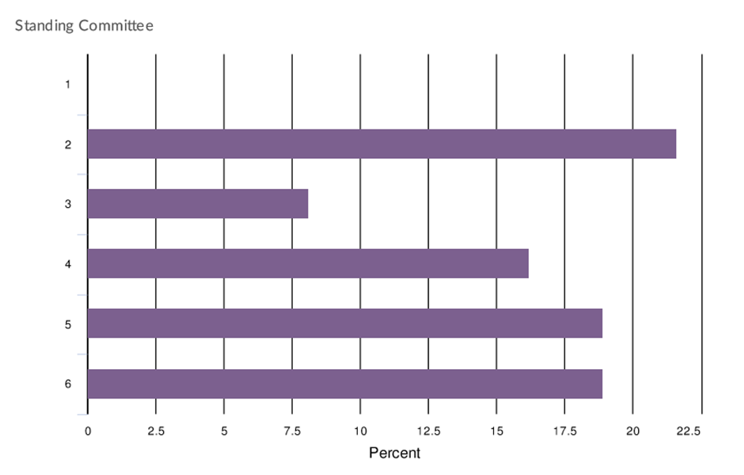

These comments should be seen against the background of the fact that the COP issues a Resolution at each of its meetings setting out the responsibilities, roles and composition of the Standing Committee and regional categorization of countries under the Convention (Resolution XIII.4). This resolution also places responsibility on the regionally appointed SC members to “maintain regular contacts and consultations with the Contracting Parties in their regional group”, and requests the Secretariat to provide induction training for the new SC members to support introduction of new members. It would therefore seem that the interview and survey responses indicate a lack of awareness.
The Standing Committee is also felt to be accountable (68 % survey) and that it has in the last couple of years become more effective in that more agenda time has been given to discussing substantive wetland management issues, rather than only procedural issues.
The table below sets a summation of the conclusions we have been able to draw by looking at the documentation (desk review), the results of the 1:1 interviews and a review of the survey results and comments received in the survey, in relation to each governance assessment criteria for the Standing Committee.

Governance assessment criteria | Conclusions from review
CLARITY  Mandate, tasks and responsibilities for decisions and actions in the Convention are clearly delineated, allocated and accepted. | - Mandate and tasks clearly set out in Convention and resolutions (desk review)  - Mandate and tasks clearly delineated from COP (desk review)  - Tasks and responsibilities assigned through resolutions to the SC generally understood to be clear and accepted (desk review and 68% survey)  - Level of understanding of mandate and tasks varies between Contracting Parties (62% 1:1s, 28% survey)
LEGITIMACY  All parties to the Convention are fairly represented and are informed and empowered to validate or question all decisions taken by the Convention. | - Regions are proportionally represented in Standing Committee and SC members are nominated by the regions, in a rotational manner or through voting (desk review)  - All Contracting Parties are informed with all relevant information prior to and during SC meetings and thereby given opportunity to carry out their responsibilities (desk review)
ACCOUNTABILITY  The decision-making bodies of the Convention are accessible to their stakeholders, who are informed and empowered to question decisions taken. All governance bodies are responsible and accountable for the decisions they take. | - SC reports on its activities at each convention (desk review)  - Material for SC meetings made available to all members on the Ramsar website (desk review)  - CPs see the SC as being accountable for its work (68% online survey)
Effectiveness  The governance bodies deliver, in a timely and effective manner, on the objectives set out by their mandates. | - General positive attitude that Ramsar Convention’s SC delivers “with respect to its current capacity” (100% 1:1, with 62% clarifying comments, 68% survey)  - Dependent on good chairing and informed participation of members (46% 1:1s, 28% survey)  - Lack of own rules of procedure and implementation enforcement mechanism means difficult for SC to respond to lack of responsiveness by Contracting Parties to its work (54% 1:1s, 33% survey)  - Decisions could be clearer and reports more detailed 46% 1:1s, 20% survey)
Cost  The cost of governance is justifiable relative to its impact on delivering results for the Convention. | - Has the impact it can afford in relation to its existing budget and Contracting Parties commitments to implement.  - Financial stability status is discussed (Finance Subgroup) and assessed regularly

From the text and table above, we have drawn out the main findings.
Initial Findings and Next Steps
The Standing Committee is overall functioning well with a clear and understood mandate, tasks outlined in COP resolutions from each COP meeting, and the Standing Committee’s work is seen to be carried out in a legitimate and accountable manner by the CPs. It should be noted that Resolution XIII.4 is dedicated to the function of the Standing Committee from COP 13, available on the Ramsar website, which clarifies and explains the responsibilities of the SC members clearly.
In contrast, there are sufficient qualitative responses that show the following:
1. Follow-up from previous meetings, specifically in relation to reporting of subgroups, is seen to be weak and therefore the ability of all the Standing Committee members to be prepared for the meeting is felt to be varied.
2. Separate Rules of Procedure for the Standing Committee: The Rules of Procedure for the COP sets out in Rule 25 that the Rules of Procedure for the COP shall apply mutatis mutandis to the SC (and all other subgroups). This means that the Rules of Procedure have to be re-interpreted for the SC meetings. This causes, at times, discussions on process taking up time which could otherwise be dedicated to discussing and developing the technical aspects of the wetland management.
As we move to suggestions for improvements, SRI Executive will look at the composition, mandates and procedures for other MEAs which could be used to see where the Standing Committee can improve on its procedural efficiency (possible own Rules of Procedure), disseminating information and building capacity of its members.

4.3 Management Working Group
Resolution IX.24 (2005), on Improving management of the Ramsar Convention, the Conference of the Parties established a Management Working Group (MWG) which reports to the Standing Committee and the COP. Its mandate was at the time set to examine and review the various management structures and systems in place within the Convention and to report back to the COP with their recommendations on:
- improving the existing terms of reference and/or operating procedures of the Standing Committee, the Subgroup on Finance, the Scientific and Technical Review Panel, Regional Meetings, and the Secretariat;
- establishing any new management structures that the Working Group concludes may be needed;
- strengthening linkages between the Contracting Parties and the International Organization Partners.
The desk review shows that in 2008, the MWG was reaffirmed by the COP meeting with the only amendment that it not be limited in time, but rather that reports be provided regularly to the SC on progress made and that report findings be provided to each COP. Subsequently, the MWG has also been given the mandate to oversee the work of the STRP replacing the full mandate of the STRP Oversight Committee as set out in Resolution IX.11.
The responses received during the interviews and in the online survey show a low level of clarity of the MWG’s mandate, function or tasks. The issue is based on the fact that there is no one document clearly setting out the MWG’s full mandate and purpose (55% 1:1 interviews, 37% survey). In contrast, the online survey shows that the MWG is seen to be accessible (79%) and accountable (72%).
Figure 3– Online Survey result for the Management Working Group
To what extent do you agree the governance bodies have clear delegated mandates allocated to them? (6 – Strongly Agree; 2 – Strongly Disagree; 1- Not aware)
Management Working Group
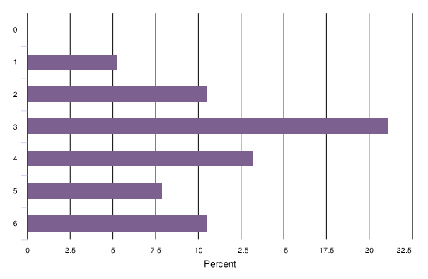

4.4 Executive Team
The Executive Team consists of the SC Chair, SC Vice Chair, and Chair of the Subgroup on Finance and provides oversight of the Secretariat’s work between the SC meetings. It defines its own Terms of Reference for each triennium, to be approved by the SC, the current terms of reference having been approved at SC57. It is mainly seen as a resource for the Secretary General to have quicker and more efficient access to the SC between the SC meetings in order to implement the decisions of the SC.
The Executive Team’s tasks are to:
- provide guidance and advice to the Secretariat on the execution of the Secretariat’s budget and the conduct of the Secretariat’s work programmes;
- provide guidance and advice to the Secretariat on the preparation of meetings, and on any other matters relating to the exercise of its functions brought to it by the Secretariat.

4.5 Subgroup on Finance
The Subgroup on Finance was established through Resolution VI.17 in 1996. It was given the mandate to deal with all financial matters of the Convention and report and make recommendations on these matters to the Standing Committee. Resolution XIII.2 altered the composition to consist of a CP member from each Ramsar Region, with one CP within this group appointed as Chair, plus the former Chair of the Finance Subgroup.
The desk review shows that the Subgroup on Finance has presented reports to all SC (SC 51-57) meetings that were reviewed.
Figure 4– Online Survey result for the Subgroup on Finance
To what extent do you agree the governance bodies have clear delegated mandates allocated to them? (6 – Strongly Agree; 2 – Strongly Disagree; 1- Not aware)
Subgroup on Finance

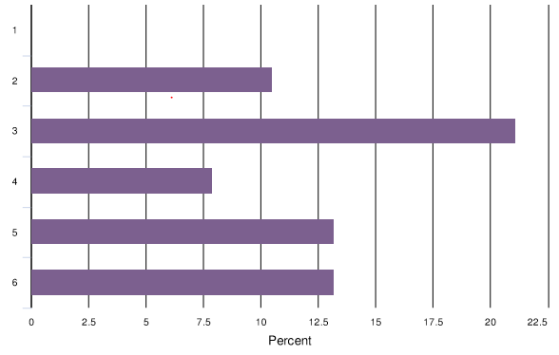

Summary for the conclusions about the convention bodies handled in chapter 4.3-4.5
The table below sets a summation of the conclusions we have been able to draw by looking at the documentation (desk review), the results of the 1:1 interviews and a review of the survey results and comments received in the survey, in relation to each governance assessment criteria for the Management Working Group, Executive Team and Subgroup on Finance.
Governance assessment criteria | Conclusions from review
CLARITY  Mandate, tasks and responsibilities for decisions and actions in the Convention are clearly delineated, allocated and accepted. | - Mandate and tasks for all subgroups clearly set out in Resolution but in very broad terms and no one place where all tasks are listed (desk review)  - For Secretariat, the distinction between the ET and the MWG is clear and an efficient mechanism to progress work (1:1 interviews)  - For CPs, very limited clarity of mandate and tasks of MWG (55% 1:1, 37% survey)  - Subgroup on Finance is clear in its mandate and function (desk review)
LEGITIMACY  All parties to the Convention are fairly represented and are informed and empowered to validate or question all decisions taken by the Convention. | - The members of the MWG, ET and Subgroup on Finance are clear and set out by COP resolutions (desk review)  - Regional and IOP representatives are included in MWG (desk review)
ACCOUNTABILITY  The decision-making bodies of the Convention are accessible to their stakeholders, who are informed and empowered to question decisions taken. All governance bodies are responsible and accountable for the decisions they take. | - MWG, ET and Subgroup on Finance acts within their mandates and report on their activities to each meeting of SC and can be questioned (80% survey)
EFFECTIVENESS  The governance bodies deliver, in a timely and effective manner, on the objectives set out by their mandates. | - Ambiguity as to MWGs mandate to suggest action to SC or provide guidance to the Secretariat causes confusion as to implementation of decisions and resolutions (55% 1:1 interviews).
COST  The cost of governance is justifiable relative to its impact on delivering results for the Convention. | - The meetings of these bodies are mainly carried out at the same time as SC meetings or during the COP (desk review).

From the text and table above, we have drawn out the main findings.
Initial Findings and Next Steps
The desk review shows that there is documentation that sets out the scope of the mandate for the MWG, Subgroup on Finance and the Executive Team. In contrast, the interview responses indicate that CPs would like a clearer description of the mandate of these groups so that it is in one place rather than pieced together in different resolutions, and therefore help CPs understand the work and support these subgroups provide.
As we move to suggestions for improvements, SRI Executive will review options for procedures so to ensure that mandates of all subgroups (permanent or temporary) are clearly stated for ease of reference and understanding for CPs.

4.6 Scientific and Technical Review Panel
The STRP was established by Resolution V.5 in 1993 with a mandate to provide scientific and technical guidance to the COP, SC and Secretariat. The STRP’s workplan, based on priorities set at COP meetings, is approved by the SC. The STRP is made up of 18 scientific and technical expert members, nominated by the Contracting Parties and other COP observer organisations, and who have appropriate scientific and technical knowledge. They are then appointed by the MWG which has oversight of the work of the STRP. The STRP meetings can also have observers representing the International Organisation Partners (IOPs), scientific and technical expert(s) recommended by Contracting Parties and other organizations recognized by the COP.
The desk review looked at STRP meetings since 2015 and based on the publications of agenda and other documentation on the Ramsar website, it is clear that the timelines set in the Rules of Procedure for meetings is not adhered to and that documentation is made available on a more ad hoc basis. In 2016 there was no STRP meeting and since 2017 there is no report published on the website under the headings STRP, as these are a part of the MWG reports to the SC meetings (and ultimately to the COP). The reports are therefore found in a different place on the website.
The STRP is understood by most CPs to have a clear mandate.
Figure 5– Online Survey result for the STRP
To what extent do you agree the governance bodies have clear delegated mandates allocated to them? (6 – Strongly Agree; 2 – Strongly Disagree; 1- Not aware)

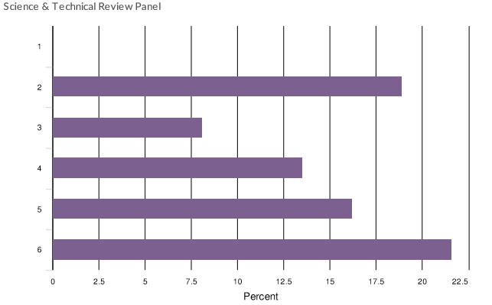
Resolution XII.5 sets out the process by which the COP will approve the STRP priority thematic work areas for each triennium. The responses in the 1:1 interviews and online survey were positive towards the support provided by the STRP to the COP and SC, noting that the STRP Chair is active at these meetings. The responses also indicated that a change of procedure in Resolution XII.5 means that the STRP now is more reactive to the urgent issues of the CPs. However, the desk review and the responses show that it takes more than 6 months (COP 13 in June 2018, STRP workplan approved at SC57 in June 2019) to approve the STRP workplan which reduces the amount of time it is able to work on its tasks significantly.

4.7 Communication, Education, Participation, and Awareness (CEPA) Oversight Panel
At the 7th meeting of the Conference of the Contracting Parties (COP7), Resolution VII.9 adopted the first programme of actions for promoting communication, education, participation, and awareness (CEPA) under the Convention. The Contracting Parties have named government and non-governmental National CEPA Focal Points who are expected to form part of a global network of experts. Each CP is free to set the precise roles and responsibilities of their CEPA Focal Points according to the suggested areas set out in Resolution XII.9.
The CEPA Oversight Panel was established at COP9 Resolution IX.18, to monitor and inform on CEPA issues within the Convention and the implementation of the CEPA programme set out above, advising the Standing Committee and Secretariat on priorities at national and international level including CEPA priorities of STRP.
In April 2019 the Secretariat proposed a revised structure and working mechanism for the CEPA Oversight Panel, which was approved by the Standing Committee inter-sessionally. The desk review shows that there are concerns that the mandate and appointment process for the CEPA Oversight Panel is not clear, however, as can been seen below, the online survey shows that respondents feel there is clarity.
Figure 6– Online Survey result for the CEPA Oversight Panel
To what extent do you agree the governance bodies have clear delegated mandates allocated to them? (6 – Strongly Agree; 2 – Strongly Disagree; 1- Not aware)
CEPA Oversight Panel
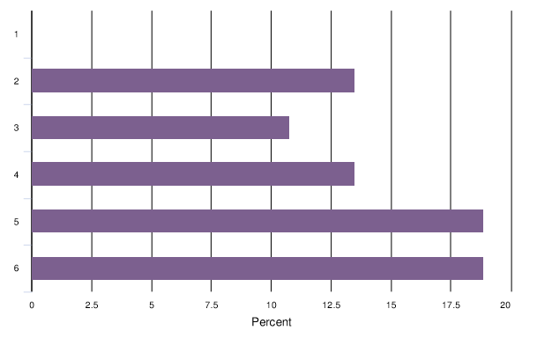
Summary for the conclusions about the STRP and the CEPA OP
The table below sets a summation of the conclusions we have been able to draw by looking at the documentation (desk review), the results of the 1:1 interviews and a review of the survey results and comments received in the survey, directly related to the STRP and CEPA Oversight Panel.
Governance assessment criteria | Conclusions from review
CLARITY  Mandate, tasks and responsibilities for decisions and actions in the Convention are clearly delineated, allocated and accepted. | - Mandate and tasks clearly set out in resolutions and understood by most CPs (desk review and 51% survey).  - Mandate and tasks clearly delineated from other governing bodies with clear reporting lines (desk review)  - Procedure for appointment of STRP and CEPA Oversight Panel to be reviewed by Secretariat as resolutions on process are unclear (desk review)
LEGITIMACY  All parties to the Convention are fairly represented and are informed and empowered to validate or question all decisions taken by the Convention. | - The members of the STRP are appointed by the MWG (desk review)  - Members of CEPA Oversight Panel appointed at SC 57 (desk review).
ACCOUNTABILITY  The decision-making bodies of the Convention are accessible to their stakeholders, who are informed and empowered to question decisions taken. All governance bodies are seen as responsible and accountable for the decisions they take. | - The key thematic areas are indicated by the COP meeting and then further elaborated in a STRP workplan, approved by the SC. (desk review)  - STRP is overseen by the MWG and submits a report on its activities to each meeting of the SC (desk review)  - There is a gap between what is asked/expected by COP Resolutions and actual capacity of STRP (46% 1:1, 12% online survey)
EFFECTIVENESS  The governance bodies deliver, in a timely and effective manner, on the objectives set out by their mandates. | - Chair of the STRP resigned in November 2019. A new Chair was appointed by the MWG in March 2020. (desk review)  - The process to appoint members and approve workplan and then implement it is too long (desk review and 24% survey responses)  - The mandate of the CEPA oversight panel is not very clear and it is currently under review (desk review & 1:1 interviews)
COST  The cost of governance is justifiable relative to its impact on delivering results for the Convention. | - Budget is accounted for in COP budget for each triennium and approved by SC.

From the text and table above, we have drawn out the main findings.
Initial Findings and Next Steps
The desk review shows that there is documentation that sets out the scope of the mandate and task of the STRP and CEPA Oversight Panel and it is clearly understood by the CPs, although the desk review and 1:1 interviews show that more clarity as to appointment process for members of the CEPA Oversight Panel is needed. The responses in the interviews and online survey, as well as desk review of COP and SC reports, show there is a lack of clarity on the process to choose members for the CEPA Oversight Panel and that the commencement of work for the STRP is delayed as their thematic priority areas of work is first set at the COP meeting, and then developed into a workplan, approved by the next SC meeting.
As we move to suggestions for improvements, SRI Executive will review options for procedures to ensure that appointment of members and workplans can be approved in a more expedient manner. The MEA comparison will also give examples of how other Conventions interact with their scientific and technical committees.

4.8 Secretariat
The Secretariat of the Ramsar Convention was originally referred to as the Bureau in the Convention text (Article 8) and its functions were undertaken by the International Union on Conservation of Nature (IUCN). The Secretariat manages the day to day operations of the Ramsar Convention. It is led by the Secretary General who is appointed by the Standing Committee (current Secretary General was appointed by SC52-05 decision). The staff of the Secretariat support the CPs to implement the Strategic Plan of the Convention. The current activities of the Secretariat are outlined in its Workplan 2019 – 2021 which was approved by the SC 57-21 decision. These activities are informed by its overall mandate set out in Article 8 as well as resolutions from the COP meetings and SC decisions.
In relation to this review, the main governance mandate and tasks of the Secretariat are (as outlined on the Ramsar Convention website):
- help convene and organize the Conferences of Contracting Parties (COP) and regional pre-COP meetings, the meetings of the Standing Committee and of the STRP;
- publish the Decisions, Resolutions, and Recommendations of the COP and the Standing Committee;
- inform the Contracting Parties and the public of developments related to the Convention.
Oversight of the Secretariat is carried out by the Executive Team (see section 4.4 Executive Team) and the budget is overseen by the Subgroup on Finance, both which report to the SC. The Secretary General provides a report to the SC at its meetings and to the COP (Rule of Procedure 26) as well.
From our desk review of governance documentation during the previous 3-6 years, we have noted that the Secretariat has carried out its function in relation to its governance tasks as listed above. It has convened and supported the organisation of the meetings listed above. It has published the documentation to prepare for the meetings and those which record the resolutions and decisions of the COP and SC meetings in accordance with the various timelines set out in the Rules of Procedure and other decisions of the COP and SC. We did note that the dates of publication of agenda and preparatory documents for the STRP have not been in accordance with the timeline set in the Rules of Procedure (no meeting was held in 2016) and it is evident that this meeting is therefore treated in a more ad hoc manner.
The Ramsar website is regularly populated with information of the work of the Ramsar Convention. From the Reports of the last two COPs, it is clear from the documentation that the Secretariat prepares the relevant documentation in the proper manner (to the extent possible as and when it is provided with it) and carries out its tasks during the COP and SC meetings in accordance with the Rules of Procedure.
Since 2014, The Secretariat has organised 2 COP meetings, 11 SC meetings and 5 STRP meetings, as well as supporting meetings of CEPA Oversight Panel and other subgroups.
From the responses in the interviews and survey, the clarity of mandate and function, legitimacy and accountability of the Secretariat is strong. The majority of responses in relation to the Secretariat’s support for the governance processes either in the interviews or the survey show that the mandate and function of the Secretariat is clear and that, through fulfilling the functions it has supported governance processes and dissemination of information in the correct and proper manner.
Figure 7– Online Survey result for the Secretariat
To what extent do you agree the governance bodies have clear delegated mandates allocated to them? (6 – Strongly Agree; 2 – Strongly Disagree, 1 – Not aware)
Secretariat
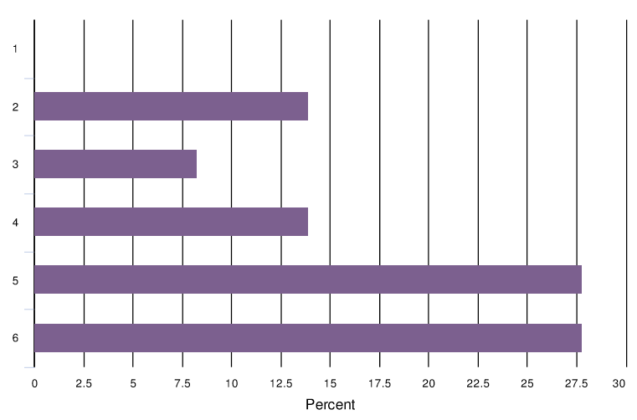
The table below sets a summation of the conclusions we have been able to draw by looking at the documentation (desk review), the results of the 1:1 interviews and a review of the survey results and comments received in the survey, in relation to each governance assessment criteria for each of the governance bodies. In relation to the interview and survey results, we have looked at the responses and comments which directly relate to the governance role of the Secretariat.
Governance assessment criteria | Conclusions from review
CLARITY  Mandate, tasks and responsibilities for decisions and actions in the Convention are clearly delineated, allocated and accepted. | - Mandate tasks and responsibilities outlined in the Ramsar Convention, Resolution, SC decision and the Secretariat’s Workplan approved by the SC are clear (desk review).
LEGITIMACY  All parties to the Convention are fairly represented and are informed and empowered to validate or question all decisions taken by the Convention. | - Secretary General is appointed by the SC (desk review).  - The rest of the Secretariat staff is appointed by the Secretary General.
Accountability  The decision-making bodies of the Convention are accessible to their stakeholders, who are informed and empowered to question decisions taken. All governance bodies are seen as responsible and accountable for the decisions they take. | - Secretariat is accountable to the Executive Team, on behalf of the SC and its financial management is overseen by the Subgroup on Finance. (desk review)  - The Secretary General provides a report to the SC and the COP of the activities of the Convention according to the SC approved Work Plan. (desk review)
Effectiveness  The governance bodies deliver, in a timely and effective manner, on the objectives set out by their mandates. | - The Secretariat has greatly improved its performance in relation to its mandate following the 10 years audit carried out in 2017-2018 (SC55. Doc 8.2). (desk review)  - Secretariat, together with a number of CPs, proposed amendments to the Rules of Procedure at COP 13, to enhance the support that the Secretariat can give during COP meetings (see section 4.1 The Conference of Contracting Parties).  - Secretariat is requested to be more pro-active to support to CPs in relation to their governance duties (50% 1:1 and 18% survey)
COST | - Cost of the Secretariat’s governance function is relative to the impact it has on delivering results.  - Secretariat needs more funding to increase support to CPs, specifically between COPs (15% online survey)

From the text and table above, we have drawn out the main findings.
Initial Findings and Next Steps

As noted above, the Secretariat’s role in the governance of the Convention is clear and should, therefore, be able to function well. There is understanding that the Secretariat is constrained (limited finances, limited staff & time) in the amount of additional support it can give to CPs in relation to governance meetings and processes, however, a majority of the responses show that the governance would be more effective with more pro-active and substantive support to CPs to help them understand the Convention’s governance and therefore be more effective in their own governance work (e.g. in the preparation of resolutions).

As we move to suggestions for improvements, SRI Executive will look at new tools and methods which can be used by the Secretariat to efficiently support the CPs in their governance work, as well as possible suggestions for amendments of the Rules of Procedure.

5. Next Steps
Following this report, SRI Executive will provide a report where a comparison with similar MEAs’ governance structures will be carried out, and subsequently an analysis of where changes to current governance structures or processes may be considered.
Also, in the interviews and the online survey, respondents were asked for their views on the top 3 governance practices which are felt to be needed overall for the effective governance of the Ramsar Convention to deliver on its Vision and Mission. The responses show that these are chairing of governance meetings (28%), communication between meetings (34%), and accountability 67% 1:1s, 50% online survey).
Respondents were also asked whether, in addition to the existing Rules of Procedure and processes set out in Resolutions, there were other processes needed within the operations of the Convention. The responses mostly referred to a need for an efficient process for preparation of resolutions (28%), individual rules of procedure for different governance bodies (33%), training within the aforementioned governance practices for delegates who take on governance (28%), and improved monitoring and follow-up of implementation of Resolutions and Decisions (50%). In the report it has been shown through the desk review that there are responsibilities and procedures set out in Resolutions which address these issues. However, despite this, CPs have responded that more is needed.
These views will also be taken into account when considering possible changes to the governance procedures.

Annex 1: Final Evaluation Questions
NOTE: The words “governance body/bodies” used below mean any of the entities within the Ramsar Convention which have a mandate and carry out tasks that are related to the governance of the Ramsar Convention, be they explicitly set out in the text of the Convention of created to support the governance of the Ramsar Convention.
Overall Questions
Overall Governance | OEQ1 What are the critical success factors and ways of working? | MEQ1.1 Which top 3 governance-related skills and/or practices do you feel the various governance bodies need to have and do well in order for them to best support Ramsar's ability to deliver on its Vision and Mission?
 |  | MEQ1.2 Beyond the Rules of Procedure, which standard governance-related procedures do you feel are needed within and between the governance bodies in order for them to best support Ramsar's ability to deliver on its Vision and Mission?
Clarity - Mandate, tasks and responsibilities for decisions and actions in the Convention are clearly delineated, allocated and accepted
 | OEQ2 What level of clarity exists around the bodies' roles and responsibilities? | MEQ 2.1 Do the governance bodies have clear delegated mandates allocated to them? Are there gaps or overlaps that you are aware of?
 |  | MEQ 2.2 Do the Party representatives of the governance bodies] clearly understand how, and the extent to which, they contribute to the governance of Ramsar?
 |  | MEQ 2.3 Do the Party representatives on the governance bodies understand the requirements and obligations of the positions they are filling based on clear information which is expressly stated and accessible for all?
 |  | MEQ 2.4 Are decisions that are taken, or recommendations made, by any of the governance bodies clear and enacted in a manner that follows agreed-upon rules?
Legitimacy - All parties to the Convention are fairly represented and are informed and empowered to validate or question all decisions taken by the Convention.
 | OEQ3 What is the perceived legitimacy of Ramsar's governance? | MEQ 3.1 Is each governance body representative of the Convention's Parties?
 |  | MEQ 3.2 Are all contracting parties informed and empowered to take decisions at Conference of CPs?
 |  | MEQ3.3 Are the Party representatives on the governance bodies chosen and appointed in a representative manner?
 |  | MEQ 3.4 Are decisions and actions clearly related to issues discussed at the meetings of the governance bodies and accepted by all parties?
Accountability - The decision-making bodies of the Convention are accessible to their stakeholders, who are informed and empowered to question decisions taken. All parties are seen as responsible and accountable for the decisions they take.
 | OEQ4 What is the extent to which the bodies are held accountable for fulfilling their mandates? | MEQ 4.1 Are decision-making bodies [COP, SC] of the Convention accessible and accountable for the decisions they take?
 |  | MEQ 4.2Does the governance structure include a review mechanism to objectively assess bodies' fulfilment of their functions?
 |  | MEQ 4.3 How successful are the mechanisms currently in place for supporting Parties’ abilities to enhance their implementation of the Convention including through its resolutions? Is there opportunity for improvement?
Effectiveness - The governance bodies deliver, in a timely and effective manner, on the objectives set out by their mandates
 | OEQ5 How well reflected in the Convention’s governance-related performance are the desired key skills or practices needed of high performing convention bodies? | MEQ 5.1 Were any of the major factors influencing the achievements of the Convention's objectives in the last trimester related to governance actions or practices?
 |  | MEQ 5.2 Do governance bodies have a good mix of skills, knowledge and experience to deliver on their duties? If not, what is missing.
 |  | MEQ 5.3 Do Parties have access to key information needed to make informed decisions, with information freely available and accessible to those who will be responsible for implementing such decisions and their respective enforcement?
 | OEQ6 What is the level of effectiveness of current governance-related processes in supporting Ramsar’s critical functions? | MEQ 6.1 Do the governance-related processes that are in place today support the governance bodies, and the Convention more broadly, to be effective?
 |  | MEQ 6.2 Where a governance body relies on subgroups to contribute on issues related to governance, are they used wisely, in a timely and effective manner?
Cost - The cost of governance is justifiable relative to its impact on delivering results for the Convention.
 | OEQ7 How does Ramsar's governance support the Convention's sustainability? | MEQ7.1 Do the mandates of the COP, SC, Sub-Group on Finance, and MWG allow for sufficient and robust discussion about the organisation's financial wellbeing?
 |  | MEQ7.2 Do the mandates and processes of the COP, SC, Sub-Group on Finance, and MWG permit (or encourage) regular reviews of current and future risks to the organisation's financial sustainability?
 |  | MEQ 7.3 Is the overall governance of the convention as cost-efficient as it could be? If you feel it is not, do you know of any tools or processes which would make the overall governance of the convention more cost-efficient?

Annex 2
The Comparison Report

We know who it takes to create lasting impact.
www.sri-executive.com

MEA Comparison Report
Ramsar Convention on Wetlands: Review of Governance Structures and Procedures

Contents
1. Background 3
2. Scope of MEA Comparison 4
3. Findings of MEA Comparison 5
Which challenges are shared, and which challenges have been improved by the MEAs? 5
3.1 Clarity 6
Finding #1.1 – Administration of Resolutions 6
Finding #1.2 – Mandates of Subgroups 7
Finding #1.3 – Separate Rules of Procedure 8
Finding #1.4 – Efficient commencement of Scientific Committee work 8
3.2 Legitimacy 9
Finding #2.1 – Diversity of delegates 9
3.3 Accountability 10
Finding #3.1 – Lack of enforcement mechanism 10
3.4 Effectiveness 10
Finding #4.1 – Support from Host Institution 10
Finding #4.2 – Review of resolutions 11
Finding #4.3 – Communication to CPs 11
4. Governance Reviews 12
5. Concluding Remarks and Next Steps 12
Annex A: Contacts Interviewed for MEA Comparison 14
Annex B.1: Organograms of MEAs 15
Annex B.2: Comparison Table of MEA Conventions 17
Annex C: Final Evaluation Questions 26
30

MEA Comparison Report

1. Background
As part of the Terms of Reference for the Review of the effectiveness and efficiency of the governance of the Ramsar Convention, SRI Executive was to undertake an external comparison of other multilateral environmental agreements (MEA Conventions) after the first Report on the Review of Ramsar’s Governance Structures and Procedures - Findings, using the assessment criteria of the Ramsar Convention Review.
The first Report mentioned above identified a number of Initial Findings in relation to the governance assessment criteria of Clarity, Legitimacy, Accountability, Effectiveness and Cost. These findings were drawn from a desk review of Ramsar governance documentation (attached as a separate document), one on one interviews with EWG approved stakeholders, and a survey sent to all Ramsar Convention Contracting Parties. The report presented these Initial Findings and Next Steps in relation to each governance body of the Ramsar Convention. Where relevant, this report refers to any of the Initial Findings of the first Report to show how other MEA Conventions have approached similar challenges with their own governance.
Together with the Effectiveness Working Group (EWG), a list of six MEAs were identified which were felt to be of comparable mission and mandate, as well as similar in governance structure and processes. These are:
- London Convention and London Protocol (LC/LP) - Its objective is to promote the effective control of all sources of marine pollution and to take all practicable steps to prevent pollution of the sea by dumping of wastes and other matter.
- Convention on International Trade in Endangered Species of Wild Fauna and Flora (CITES) - Its aim is to ensure that international trade in specimens of wild animals and plants does not threaten their survival.
- International Plant Protection Convention (IPPC) – Its aim is to protect the world's plant resources from the spread and introduction of pests, and promotion of safe trade.
- Convention Concerning the Protection of the World Cultural and Natural Heritage (UNESCO World Heritage) - Its objective is the protection, conservation and presentation of the cultural and natural heritage situated within its member state parties.
- Convention of Migratory Species (CMS) – Its objective is to provide a platform to ensure the conservation of migratory species, their habitats and migration routes.
- International Treaty on Plant Genetic Resources for Food and Agriculture (ITPGRFA) - It aims to establish a global system to provide farmers, plant breeders and scientists with access to plant genetic materials and ensuring that recipients share benefits they derive from the use of these genetic materials

To ensure as accurate a benchmarking exercise as possible, SRI Executive carried out a desk review of the current governance structures and processes of each of the MEA Conventions. The desk review consulted documents available publicly or shared with SRI Executive directly by the MEA Conventions.
This was coupled with semi-structured interviews with individuals holding governance roles within each MEA Convention. A full list of the persons interviewed can be found in Annex A: Contacts Interviewed for MEA Comparison. The interview questions (Annex C: Final Evaluation Questions) were the same as those used for the Ramsar Convention interviews, as approved by the EWG. The individuals interviewed were asked to give information in relation to governance aspects within their respective MEA Conventions which they felt were relevant for the question posed. In particular, interviewees were asked about challenges similar to those identified as Initial Findings in the first Report on the Review of Ramsar’s Governance Structures and Procedures. Interviewees were asked to reflect on challenges that were previously or currently being faced by the MEA Convention they worked for. The interviews were 1.5 hours in length. It was agreed with all interviewees that their responses would only be presented in this report in the form of collated and generalised findings across the MEAs, ensuring that no specific answer may be related back to a specific MEA, unless the information was already public.

2. Scope of MEA Comparison
The aim of the MEA Comparison is to compare and benchmark the Ramsar Convention against other MEAs and identify governance arrangements and processes that could be explored for consideration by the EWG and wider CPs. In particular, this review sought to understand:
The composition of governance structures,

The timing and management of key governance processes,
And the governance principles that different MEAs follow.

The EWG also intended for this analysis, backed by qualitative interviews, to shed light on common areas of difficulty and areas where Ramsar or the other MEAs have succeeded in improving governance structures or processes.
SRI Executive carried out a desk review of the official governance documents available on the MEAs’ websites to understand the governance structure and processes that are currently in place. As agreed with the EWG, interviews were then held with the MEA’s secretariat governance officer and, where possible, the Chair of each MEA’s Standing Committee or a Chair of an equivalent alternative governance body to provide further insight into how the governance bodies function in practice.
To be able to present as much data as possible to the EWG, as well as draw findings from the qualitative interviews, the governance information collected through both the desk review and qualitative interviews is presented in two formats.
1) Annex B.2: Comparison Table of MEA Conventions, is a table that sets out description of each MEA’s governance structure and processes (confirmed by the interviews) in columns next to each other for ease of comparison.
2) Findings of MEA comparison (below) elaborates on insights gained from the qualitative interviews.

3. Findings of MEA Comparison
Using the assessment criteria of Clarity, Legitimacy, Accountability, and Effectiveness, SRI Executive sets out the below findings from the MEA Conventions which show how the MEA Conventions have addressed their respective governance challenges. Where relevant, we indicate how these findings relate back to the findings in the first Report on the Review of Ramsar’s Governance Structures and Procedures – Findings. These findings will then be used to inform the list of measures and positive indications for the EWG to consider.

Which challenges are shared, and which challenges have been mitigated by the MEAs?
All the MEAs have similar governance structures to the Ramsar Convention, as can be seen in the diagrams set out in Annex B.1: Organograms of MEAs. For further information regarding the nature and role of specific bodies, and how their functions relate to those of Ramsar, see the table in Annex B.2: Comparison Table of MEA Conventions.
Each MEA has an ultimate governing body comprised of all the countries which have signed the Convention
Each have, in varying forms, an executive subordinate committee with representation from the member countries that takes decisions between the meetings of the ultimate governing body.

All the MEAs also have subgroups or subcommittees, either permanent or ad hoc, that deal with various specific operational or management issues for the respective Conventions.

All have, in varying forms, Rules of Procedures and internal guidelines that set out how the governance operates.

Decisions are overall taken by consensus and at times through voting according to the rules for voting. Detailed information is available in Annex B.2: Comparison Table of MEA Conventions.

Despite the similar structures, it should be noted that there is a difference between the missions of all the MEAs, which for some of them (LC/LP, CITES, IPPC) has an impact on the implementation of the governance of these conventions. We believe this is important to note and refer to when relevant in the findings below, as although all the conventions have their own complexities in relation to implementation, our review indicates from the responses from LC/LP, CITES and IPPC that their focused and narrow missions enable for resolutions and decisions that set out clear and narrow implementation measures; this could be an explanation as to why, according to their responses, they do not experience significant issues in relation to the implementation of their governance.
Similarly, we also note a difference in responses received to the interview questions and the indications as to whether MEAs had carried out governance reviews or significant governance changes in regard to LC/LP, CITES and IPPC. The delegates that participate are often well-informed, prepared and technically strong in relation to the substantive work of the convention’s governance meetings and often have a continuous engagement with the convention between major governance meetings. It should be noted that this does not indicate that these conventions have a stronger success of operational implementation, as this has not been reviewed.
Overview of Challenges & Successes Across MEAs
The table below sets out an overview of the main challenges that all MEAs have in common with Ramsar. Successes indicate how certain MEAs have found solutions to challenges. Please refer to the Findings below in the text for further details of these ongoing challenges and successes.
Overview of Challenges & Successes Across MEAs
Governance Assessment Criteria | Ongoing Challenges – challenges that are similar across all reviewed MEAs that have not been resolved | Successes – where some MEAs have overcome challenges experienced by all reviewed MEAs
Clarity |  | Finding #1.1 Administration of resolutions passed at COP (CITES and CMS)
 |  | Finding #1.2 Clarity of mandate of subgroups (All Conventions except Ramsar and UNESCO World Heritage)
 |  | Finding #1.3 Separate Rules of Procedure for the different governance bodies (CMS, IPPC, UNESCO World Heritage, CITES)
 |  | Finding #1.4 Clarity of mandate and efficient commencement of work for Scientific Committees (CITES, CMS)
Legitimacy | Finding #2.1 Diversity of delegates’ capacity and knowledge at COP
Accountability | Finding #3.1 No enforcement mechanism
 |  | Finding #3.1 Rate of national reporting (Ramsar)
 | DELETE THIS EMPTY ROW | DELETE THIS EMPTY ROW
Effectiveness | Finding #4.2 Process for preparation of Resolutions | Finding #4.1 Support from Host Institutions (CMS, ITPRGFA, LC/LP)
 | Finding #4.3 Lack of communication between COPs/GAs

3.1 Clarity

Finding #1.1 – Administration of Resolutions
Administration, follow-up and monitoring of Resolutions and Decisions passed at COP/GA is a significant factor in increasing clarity around governance structures and processes.
In the first Report on the Review of Ramsar’s Governance Structures and Procedures – Findings, Section 3.1 sets out that there is some lack of clarity in relation to implementation of tasks designated to the subsidiary governance bodies or CPs in resolutions passed at the COP of the Ramsar Convention. This causes, at times, procedural issues to take prominence in agendas and deliberations in the place of substantive and technical discussions on wetland management.
One of the main findings of the MEA Comparison is that CITES has an interesting practice for how it manages the resolutions of the Convention. It was referred to by several of the Conventions as having a very strong administration of their resolutions and three years ago CMS adopted the CITES system.
CITES introduced two types of decisions. Resolutions are only for interpretation of the Convention and the application of its provisions through policy direction. Meanwhile, decisions are for all activities directed to the CITES Committees, Contracting Parties or the Secretariat that are short term actions which end when the tasks they set out to achieve have been completed. All the resolutions are listed in reverse chronological order and classified per COP and decisions are listed on the website under thematic headings. Before each COP, a reconciliation is carried out of the list of decisions. Any decision with activities that should be continued (upon request of a CP) beyond the next COP must be expressly extended in a new decision. Otherwise the decision, and any subgroup/working group set up under it, is disbanded and removed.
As stated by CITES and CMS, this has provided a significant difference to the clarity of the activities that are to be undertaken after a COP. In addition, it has improved the clarity for the Contracting Parties and their delegates when communicating back to their home governments about decisions of the COP. In the respondent’s view, it also provides a good platform for anyone new to the Convention to quickly find and learn about any subject matter within the Convention.
It was noted that the administrative burden on these Conventions’ Secretariats is very heavy at times, but the level of clarity is felt to outweigh the burden of that work.

Finding #1.2 – Mandates of Subgroups
Clarity around mandates and reporting of Subgroups is recognised by all the Conventions as important for more efficient operations of the MEA Convention’s governance.
In the first Report on the Review of Ramsar’s Governance Structures and Procedures – Findings, sections 4.3-4.5 describe the Initial Findings for the Ramsar Convention Subgroups. These sections show that according to the desk review of Ramsar Convention documentation, subgroups’ mandates were found to be clear, although the interviews and survey responses showed a request by some CPs for easier and clearer access and understanding of the mandates.
All the MEA Conventions (except UNESCO World Heritage) stated that they have very clear mandates for their permanent subgroups, and that ad hoc working groups are only set up specifically for the duration of the sessions between the COPs/General Assemblies, and are disbanded once their reports are submitted to the COP. The Secretariat of UNESCO World Heritage stated that they have for the last 10 years become very involved in creating clarity regarding governance processes for subgroups, but that there is still a great challenge in keeping track of how many subgroups actually exist and are dormant.
The interviews with the MEA’s governance officers showed that CPs are often well-prepared and engaged quickly in the subgroups of which they are members or which are of interest to them due to the clarity gained in their creation of mandates through resolutions or decisions at the COP/GA. This is ultimately a contributing factor for more efficient support to governance processes of the MEA Conventions.

Finding #1.3 – Separate Rules of Procedure
A majority of the MEAs reviewed have Separate Rules of Procedure for the different governance bodies.
As stated above, all the MEAs have Rules of Procedure for their governance bodies.
Separate Rules of Procedure | One Rules of Procedure applied mutatis mutanda
CMS (Separate rules for COP, Standing Committee, and Scientific Committee) | ITPGRFA
IPPC (Separate rules for Commission, Standards Committee, and Implementation and Capacity Development Committee); | LC/CP
UNESCO World Heritage (Rules for General Assembly; and for Committee )
CITES (Separate rules for COP, Standing Committee, Animals Committee and Plants Committee)

Of the MEAs reviewed two thirds have adopted separate Rules of Procedure for their various governing bodies, as compared to the Ramsar Convention which applies its Rules of Procedure for its Conference of Parties mutatis mutanda to the other governing bodies (Report on the Review of Ramsar’s Governance Structures and Procedures – Findings, section 4.2, page 19).
All the MEA Secretariats’ interview responses show that a preference is for clear, separate rules of procedure for each governing body. The LC/LP Secretariat have just recently commenced an internal review of their Rules of Procedure to see how to include, as a separate and distinct section, the function of their Bureau, which has existed since the Protocol was adopted, but has not been expressly set out in the Rules of Procedure.
Responses from the interviews with CMS indicate that the introduction of a separate Rules of Procedure increased the clarity, and thereby the effectiveness of the work to be done. UNESCO World Heritage noted that this is an area of ongoing deliberation at their GA meetings, with their Rules of Procedure continuously evolving for the different governing bodies to improve running of meetings and nomination processes in particular. They noted that clarity of terms of reference and procedures for sub-committees and subgroups are clearly set out in decisions from the GA meeting.

Finding #1.4 – Efficient commencement of Scientific Committee work
Clarity of mandate and efficient commencement of work for Scientific Committees supports more informed debates and action at COP/GA meetings.
We have noted findings from the desk review and the interviews regarding the scientific support committees or subgroups which the reviewed MEAs have. The desk review shows that appointments to these committees or subgroups are made by the all the MEAs at COP/GA meetings.
Over the course of our review, we noted that CMS carried out a restructure of its Scientific Committee in 2014 as a response to the need for the Scientific Council to work more efficiently. In comparison to Ramsar, the CMS Scientific Council has members from all its Contracting Parties (130) and was found to be too large. Therefore, a Sessional Committee of the Scientific Council was set up with fewer members, appointed at each COP meeting, which meets between COP meetings and is responsible for the implementation of the mandate assigned to the Scientific Council at the COP. The workplan for the Scientific Council is also approved through a resolution at the COP.
Moreover, CITES has adjusted its Rules of Procedure to clarify the division of policy development and the support function of scientific advice and expertise. Their Scientific Council had previously reported directly to the COP which had the effect of blurring the line between science and policy in resolutions. Now, all Scientific Committee reports and proposals are first reviewed by the Standing Committee.
This is similar to the Ramsar Convention’s decision to shift the STRP workplan to be developed post-COP, and also to move the appointment of STRP members to the MWG (as part of the Standing Committee). However, in the first Report on the Review of Ramsar’s Governance Structures and Procedures – Finding 4.6, it was noted in the desk review and the survey responses that it takes more than 6 months (COP 13 in June 2018, STRP workplan approved at SC57 in June 2019) to approve the STRP workplan which reduces the amount of time it is able to work on its tasks significantly.
The representatives on the CITES Scientific Committees are appointed by the COP meeting, and their workplan is created through a decision of the COP in broad terms (with finalisation and budget provided by the Secretariat post COP meeting). This means they can begin clearly defined work very quickly after the COP meeting.
Overall, the desk review and the interviews did not highlight any other specific governance challenges for the reviewed MEAs in relation to their Scientific Committees (or similar committees).

3.2 Legitimacy

Finding #2.1 – Diversity of delegates
The challenge of diversity of the delegates’ capacity at COP/GA is common to all the MEA Conventions, and difficult to solve.
All of the MEA Conventions mention a similar struggle in relation to perceived legitimacy as set out in the first Report on the Review of Ramsar’s Governance Structures and Procedures – Findings in section 3.2 (page 8). The perception of a diversity of capacity of delegates has been voiced by most Conventions.
The only MEA Convention that noted it had a strong level of capacity of the delegates and therefore rich and fruitful debates in its COP was CITES. This strength was explained by the fact that there is financial interest in the trade that the Convention regulates, which in turn draws national attention and also high degree of interest from civil society.
CITES and CMS both noted their strong governance documentation management in relation to resolutions and decisions (as mentioned in Finding #1.1 above). They note that the way in which information is presented on their respective websites makes it easily accessible and CPs are able to inform themselves quickly of an area of interest.
LC/LP noted that the fact that they are hosted by the IMO (International Maritime Organisation) means that CPs have close access to their national experts within the larger IMO to support the work to prepare for LC/LP meetings. They also hold capacity building workshops for new delegates and participants.
None of the MEA Conventions had a faultless and effective solution to the challenge of individual delegate capacity, recognising it as a part of the nature and culture of multilateral agreements. However, as noted above, certain MEAs feel they have less of an issue in relation to legitimacy.

3.3 Accountability

Finding #3.1 – Lack of enforcement mechanism
The lack of an enforcement mechanism is common to all six MEA Conventions. The support of Compliance Committees and inspections help, but are not effective enough.
None of the MEA Conventions have enforcement mechanisms, except CITES, which can ban trade against a contracting party and to a certain extent LC/LP which gives permits for dumping waste and monitors the compliance of those permits. However, LC/LP cannot bring any enforcement action against a Contracting Party directly under the Convention or Protocol, another Contracting Party would have to bring enforcement action under international law.
The MEA Conventions, therefore, rely heavily on national reporting, and what some referred to as “name and shame” in the COP or Standing Committee meetings. Many of the Conventions (UNESCO World Heritage, LC/LP, CITES, and ITPGRFA) have compliance groups or committees which they feel are important in the role of monitoring, inspecting and guiding implementation. The reporting rates of the other Conventions were not as high as that of the Ramsar Convention (at last COPs/GA meetings, Ramsar had an 88% reporting rate; LC/LP had 50-60% of CPs report; CMS had a 70% reporting rate). All noted that reporting was not a satisfactory compensation for other ideas (such as “no fee – no vote”) for ensuring compliance with resolutions and decisions.

3.4 Effectiveness

Finding #4.1 – Support from Host Institution
Support from Host Institution is a significant factor for effective management of governance processes.
A factor that was identified as significant by some of the MEA Conventions (CMS, ITPRGFA, LC/LP) is the support services given by the Conventions’ host organisation. LC/LP is hosted by the International Maritime Organisation (IMO) which provides all meeting recording and reporting tools, meeting logistics and communication services. The interviewee stated that it helps the efficiency of the administration of LC/LP’s governance. ITPRGFA and CMS are hosted by FAO and both Conventions are very much integrated into FAO’s management tools and systems for reporting both for governance and operations. For these MEA Conventions, a great deal of the governance administrative burden is lessened (in relation to cost and efficiency), which is a great help.
This finding is being brought forward to highlight the importance of efficient support from host institutions to MEA Conventions and significantly their Secretariats. In the first Report on the Review of Ramsar’s Governance Structures and Procedures – Findings in section 4.8 (page 27) on the the Ramsar Secretariat, the CPs response showed that the Ramsar Secretariat is fulfilling its governance mandate and tasks in a proper manner. However, it was recognised that the Secretariat needed more resources to be more efficient, as it was often constrained in relation to time and manpower in relation to supporting the administration of the institution’s governance.

The MEAs are hosted as set out below:
MEA Convention | Host Institution
Ramsar | International Union for Conservation of Nature
CITES | UN Environment Program
CMS | UN Environment Program
ITPRGFA | Food and Agriculture Organisation
IPPC | Food and Agriculture Organisation
LC/LP | International Maritime Organisation
UNESCO World Heritage Convention | UNESCO

Finding #4.2 – Review of resolutions
Support from specific bodies in reviewing draft resolutions increases the effectiveness of passing the resolutions, and supports more effective post-COP/GA implementation.
UNESCO World Heritage, LC/LP, CITES, CMS and ITPGRFA have strong involvement from their respective Secretariats to try to review and manage resolutions and reports before they are submitted to the COPs or General Assemblies (and also review final resolutions after the COP or General Assembly meeting). They all mentioned that the need to ensure cross referencing to earlier resolutions or decisions to ensure consistency and limitation of overlap has become a strong focus in the last few years. This is not a kind of support authors for the proposed draft resolution in the Ramsar Convention gets as a standard procedure. The CITES has started a procedure on creating consolidated resolutions. The Ramsar Convention decided at COP 13 to create a process similar.
At UNESCO World Heritage, any resolution must refer to earlier resolutions or decisions of one of its subgroups that are relevant to it. The Secretariat of the LC/LP enforce strict deadlines for submission of documents to their General Assembly, with no documentation permitted after the deadline has passed (13 weeks prior to the COP).
All proposals submitted by CPs to be put forward to the CPM (Commission on Phytosanitary Measures) at IPPC are reviewed by a Task Force on Topics with members from its Bureau, Scientific Committee and Implementation Committee to help ensure the proposal can be adopted unanimously, or to be able to identify where further work is needed before the CPM meeting.
However, overall all MEAs still find this area challenging, with responses from the governance officers at the MEA secretariats referring to lack of time and resources as the main obstacle to being able to support CPs in a better way.

Finding #4.3 – Communication to CPs
Communication to CPs between COP/GA is a common challenge, where clear and helpful publication on websites is seen as the most used solution.
IPPC has a Communication Strategy recognised in the IPPC Strategic Framework 2020-2030 as a core activity. The IPPC Secretariat noted that this has increased engagement of CPs as it aims to highlight IPPC’s role within global plant health and improve the implementation of the Convention overall. The other MEA Conventions mentioned that all their information is available on their websites, and similarly to the Ramsar Convention, it is up to the Contracting Parties to access the information as and when they need it. All the MEA Conventions mentioned that they accept a certain level of disparity in which some CPs engage more than others. As such, one interviewee mentioned that it is an important role for the Chair of the meetings to ensure the members who may not be prepared are given the opportunity to speak as well.

4. Governance Reviews
All the 6 MEAs were asked if they had carried out governance reviews and/or reforms.
MEA | Recent Governance Reviews/ Reforms
UNESCO World Heritage | UNESCO General Assembly created an Open-Ended Working Group in 2015 to gather all the previous work on reviewing the governance structure and working processes of UNESCO. Since 2016 the progress of reviewing the governance is a fixed agenda item at the General Assembly and is ongoing. As can be seen, UNESCO is reviewing a large number of governance structures and practices including some for the World Heritage Convention. See the latest progress report here.
CMS | N/A
LC/ LP | N/A
IPPC | N/A
ITPGRFA | ITPGRFA is currently carrying out a review of their subsidiary bodies and how they work together to support the governing bodies, but no recommendations have been made so far.
CITES | CITES has ongoing review of governance procedures at its COP meetings (included as specific agenda items at each COP).

All the six MEA Conventions were also asked if smaller governance changes had taken place and all responded that smaller changes to procedures have occurred over time but none that stood out as significant changes. The governance officers interviewed stated that to their knowledge, audit reports had not highlighted significant governance issues which have had to be addressed. Through a spot check of audit reports for each of the reviewed MEAs, no significant governance changes have been noted.

5. Concluding Remarks and Next Steps
The following findings are seen to be most noteworthy from this MEA comparison. In relation to the findings in the first Report on the Review of Ramsar’s Governance Structures and Procedures – Findings, we would encourage that the EWG give these findings specific consideration when developing the Governance Draft Resolution, taking into consideration the specific context of the Ramsar Convention’s governance structures and processes, which differs at times from that of other the MEAs:
Finding #1.1: Administration of resolutions
Finding #1.3: Separate Rules of Procedure
Finding #1.4 – Efficient commencement of Scientific Committee work
Finding #4.1 Support from Host Institutions; and
Finding #4.2: Review of Resolutions.
Following this report, SRI Executive will be putting together a Report on measures and positive indications to the EWG for its deliberations, in order for the EWG to draft its proposal for a resolution to be submitted to Standing Committee 59.

Annex A: Contacts Interviewed for MEA Comparison

 | UNESCO | CMS | London Convention (LCLP) |  | IPPC |  | ITPGRFA | CITES
Contacts | - Miray Hasaltun Wosinski, Chair World Heritage Committee  - Frederique Aubert, Head of Unit Policy and Statutory Meetings Unit | - Melanie Virtue, Head Aquatic Species Team, CMS Secretariat  - No response from former Chair | - Azura Prempeh, Chair LCLP Bureau  - Fredrik Haag, Head of Office | - Javier Arriaga (Chair of Commission on Phytosanitary Matters)  - Artur Shamilov, Agricultural Officer, IPPC Secretariat |  | - Daniele Manzella (Policy and Legal Specialist), (FAO)  - Francisco Lopez and Aya Idemitsu (Treaty Technical Officers) |  | - Carolina Caceres, Chair Standing Committee  - David Morgan, Chief Governing Bodies and Meetings Services, Secretariat

Annex B.1: Organograms of MEAs

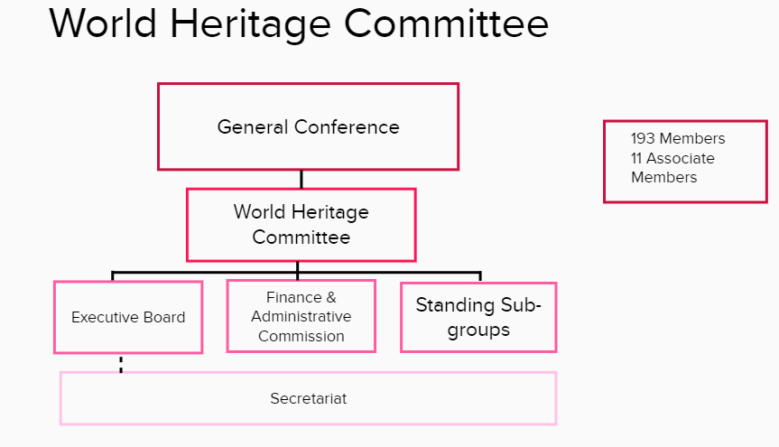

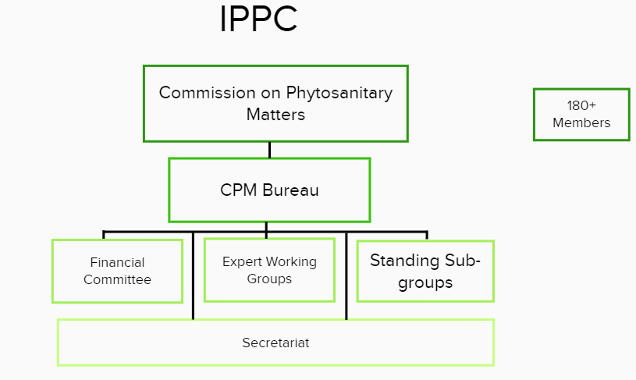
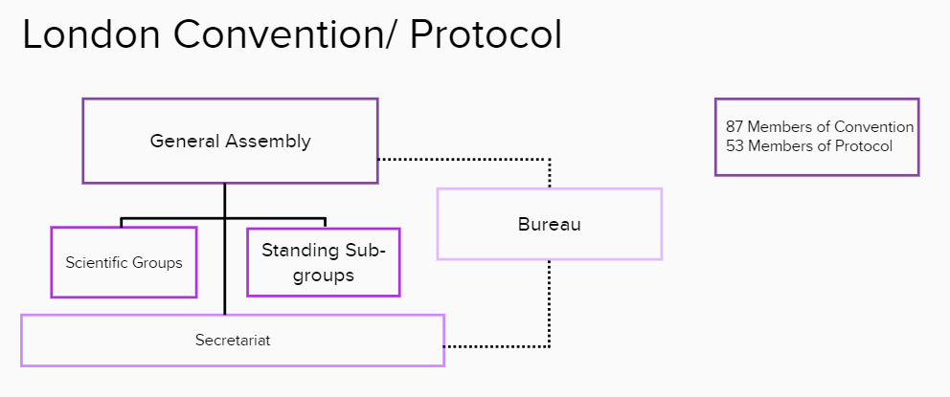

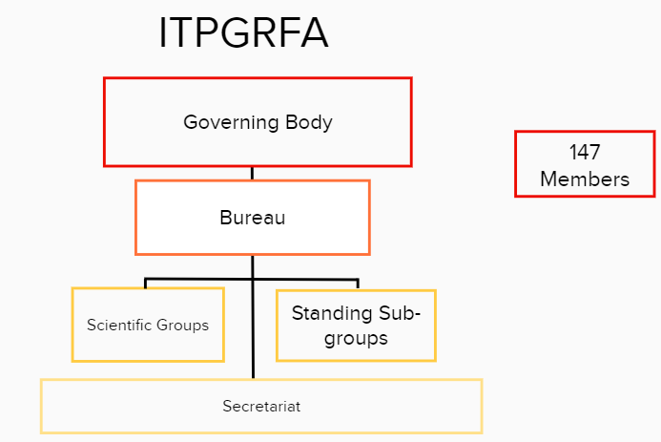

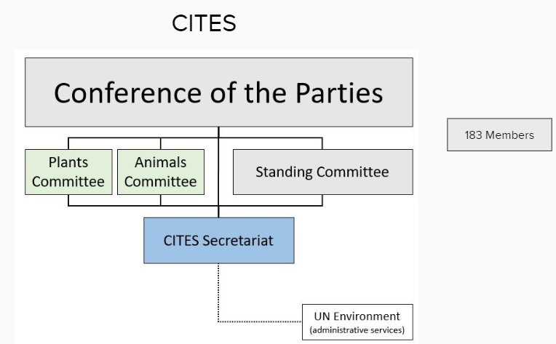

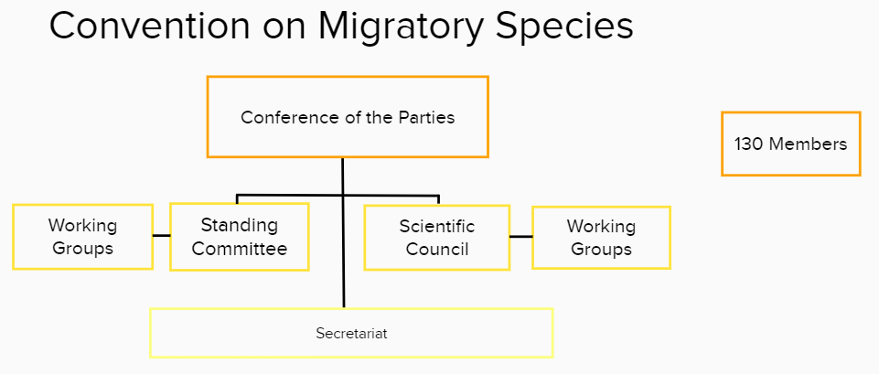

Annex B.2: Comparison Table of MEA Conventions

 |  | Ramsar |  | UNESCO World Heritage Convention |  | CMS |  | London Convention (LCLP) |  | IPPC |  | ITPGRFA | CITES
CONFERENCE OF THE PARTIES/GENERAL ASSEMBLY
Conference of the Parties | Body name & Mandate/ Scope | Conference of the Parties  - Determines policies and strategies for preserving wetlands | General Conference  - Determines policies and strategies of relevant to preservation of cultural heritage |  | Conference of the Parties  - Reviews implementation relating to conservation of migratory bird species |  | General Assembly  - Reviews implementation relating to marine dumping |  | Commission on Phytosanitary Matters  - Reviews implementation relating to protection of plant species |  | Governing Body  - Reviews and provides policy direction relating to food security & Agriculture |  | Conference of the Parties  - Reviews implementation relating to conservation of wildlife species
 | Composition | - 171 member states | - 193 members and 11 Associate members |  | - 130 member states |  | - 87 members of Convention and 53 members of Protocol |  | - Over 180 member states |  | - 147 member states |  | - 183 member states
 | Selection Process | - CoP host country acts as Chair | - Conference country acts as Chair. Vice chairs in alphabetical order among bureau members |  | - Chair and Vice Chair elected by the parties at previous CoP |  | - Candidates to be elected nominated by Secretariat  - Vice chair usually succeeds Chair in practice, so nomination practice is for Vice Chair to take Chair role |  | - Chair and up to two Vice Chairs elected by Commission for two-year term  - Chair rotates between regions |  | - Chairs elected at end of each session for following period |  | - The Chair of the Standing Committee acts as temporary Chair of the Conference until the Conference of the Parties elects a Chair
 | Other attendees? | - Observers for non-member states, IOPs and other organisations | - Observers for non-member states, IGOs, NGOs, with permission |  | - Observers for non-member states, IGOs, NGOs, with permission |  | - Observers for non-member states, IGOs, NGOs, with permission |  | - Observers for non-member states, IGOs, NGOs, with permission |  | - Observers for non-member states, IGOs, NGOs, with permission |  | - Observers for non-member states, IGOs, NGOs, with permission
 | Procedure for Decision Making | - 12 months: Secretariat notifies parties of COP  - 8 months: CPs submit draft resolutions  - 7 months: WGs submit proposed DR to the SC for consideration and adoption6 months: SC pre-COP meeting  - Regional pre-COP meeting immediately prior  - Rules of Procedure adopted with or without changes every COP | - 6 weeks: Draft proposals to DG  - 20 Days: DG considers draft proposals admissible  - 5 Days: Parties appeal against inadmissible draft proposals  - Rules of Procedure reviewed every two years |  | - 150 days: Draft amendments to Exec Sec  - 120 days: Exec Sec submits scientific amendments to Scientific Council  - 90 days: Non-technical draft amendments to Exec Sec  - 60 days: Exec Sec sends all documents to CoP |  | - Spring: Submission dumping statistics to Scientific groups  - 1 week: Reports to Compliance Group  - CoP: CPs approve report  - 13 weeks prior to CoP: Amendment to Protocol (Annexes) & Resolutions on Technical Guidance  - Decisions published beginning following year |  | - Proposals for new Standards usually brought by Standards Committee, at times by CPs but always through Standards Committee  - All proposals discussed and agreed at inter-sessional regional meetings before annual meeting  - Decisions taken by consensusOn average have 2 Conceptual standards, 5-7 Diagnostic Practices, and 4 Treatment Practices per meeting. |  | - 6 months: Draft amendments circulated to CPs by Secretary  - All amendments made by consensus at CoP  - 90 days after: Approved amendments actions |  | - 150 days: Sraft resolutions and decisions to Secretariat  - Secretariat monitors both resolutions and decisions, providing background docs to all resolutions and decisions  - Resolutions and Decisions are reviewed as to progress and are EXPLICITLY extended or removed.
a | Accountability Mechanism | - Rely on national reporting at COP  - A CP can list an endangered Ramsar site within their own territory on the Montreux record | - Can list a UNESCO site as ‘endangered’  - Effectiveness of this process affected by political will |  | - Introduced a review mechanism at COP 12 – inspection teams can be sent to a CP if notice is given of infringements of Convention |  | - Strict adherence to deadlines for submission of Resolutions or AmendmentsReporting of compliance with permits published and those who have not reported – “name and shame”. |  | - No specific enforcement mechanism.  - Introduced a surveillance activity but it takes up to 5 years for a standard to be reviewed globally  - Use the threat of not being able to trade as indirect enforcement of standards |  |  |  | - Can implement trade sanctions
 | National Reporting Figures | - 88% at last COP | - Rotational reporting per Region every 3 years |  | - 70% at last COP |  | - 50 – 60% at last COP |  | - 46% as of 2020 |  | - 39% as of 2017 |  | - <10% as of 2016
 | Meeting Frequency | - 3 years | - 2 years |  | - 3 years |  | - Annually |  | - Annually |  | - 2 years |  | - 3 years

 |  |  | Ramsar |  | UNESCO |  | CMS |  | London Convention (LCLP) |  | IPPC |  | ITPGRFA |  | CITES
OVERSIGHT BODY
Oversight Body | Body Name & Mandate/ Scope | Standing Committee  - Carries out interim CoP activities  - Ensures flow of information between parties  - Directs Secretariat, Committees and Working Groups |  | World Heritage Committee  - Carries out interim Conference activities |  | Standing Committee  - Carries out interim CoP activities  - Ensures flow of information between parties |  | No Equivalent  - Ad hoc ‘Bureau’ provides informal advice to Secretariat on how resolutions and decision are implemented |  | CPM Bureau  - Carries out interim CPM activities in coordination with Secretariat |  | Bureau  - Carries out interim activities of Governing Body as directed by the Body |  | Standing Committee  - Carries out interim activities of CoP  - Directs Secretariat, Committees and Working Groups
 | Composition  & Selection Process | - 20 regional members elected at the CoP |  | - 21 members (2 year terms)  - Each electoral group elected with fixed seats with some floating seats.  - Each group represented by 2 or more state parties who meet intersessionally |  | - Comprises the elected regional representatives of the Parties, plus the Depositary Government (Germany) and the Host Governments of the previous and next COPs |  | - Comprises of Chairs and Vice Chairs of Compliance Panel and any scientific subcommittees in existence |  | - 7 members elected by CPM, nominees selected among FAO regions  - Election at end of each regular session for two year terms |  | - 1 Chairperson and 6 Vice Chairpersons (one for each region), elected by the Governing Body |  | - Parties representing 6 regions, with the number of representatives weighted according to the number of Parties within the region.  - Regional caucus put forward representative which is approved by COP.

 |  | Ramsar | UNESCO | CMS | London Convention (LCLP) | IPPC | ITPGRFA | CITES
SECRETARIATS
Secretariat | Composition | - Led by Sec Gen, appointed by Standing Committee  - Administered by IUCN | - Led by DG and his/ her appointed staff  - ~700 staff members | - Led by Executive Secretary  - Administered by UNEP | - Led by Sec Gen and appointed staff  - Administered by IMO  - 250 staff members | - Led by Secretary appointed by DG of FAO  - Administered by FAO | - Led by Secretary appointed by DG of FAO  - Administered by FAO | - Led by Sec Gen  - Administered by UNEP
 | Mandate & Activities | - Carries out interim administrative functions (disseminates information, translates documents, etc.)  - Provides support for CPs  - Cooperates with observers and regional groups | - Carries out interim administrative functions (disseminates information, translates documents, etc.)  - Provides support for CPs  - Cooperates with observers and regional groups | - Carries out interim administrative functions (disseminates information, translates documents, etc.)  - Provides support for CPs  - Cooperates with observers and regional groups | - Carries out interim administrative functions (disseminates information, translates documents, etc.)  - Provides support for CPs  - Cooperates with observers and regional groups | - Carries out interim administrative functions (disseminates information, translates documents, etc.)  - Provides support for CPs  - Cooperates with observers and regional groups | - Carries out interim administrative functions (disseminates information, translates documents, etc.)  - Provides support for CPs  - Cooperates with observers and regional groups | - Carries out interim administrative functions  - Undertakes scientific & technical studies  - Provides support for CPs  - Cooperates with observers and regional groups  - Makes recommendations for the implementation of the aims and provisions of the present Convention – this is where they can put forward proposal to review, amend or remove decisions or resolutions

 |  | Ramsar | UNESCO | CMS | London Convention (LCLP) | IPPC | ITPGRFA | CITES
STANDING SUBGROUPS
Standing Subgroups | Equivalent Subgroups | - Management Working Group (MWG)
 |  | - Executive Team | - Executive Board
 |  |  | - Office of International Standards and Legal Affairs |  |  | - Standards Committee
 |  |  |  |  | - Compliance Committee  - Working Group on Compliance |  | - Compliance Committee | - Compliance Committee
 |  |  | - Bureau of Strategic Planning (BSP) |  |  | - Strategic Planning Group | - Strategy Planning Group  - Resource Mobilisation Committee
 |  | - CEPA Oversight Panel |  |  |  | - Implementation and Capacity Development Committee (IC)
 |  | - ad hoc working groups | - ad hoc working groups | - ad hoc working groups | - ad hoc working groups | - No ad hoc working groups – discussion groups in Strategic Planning Committee | - ad hoc working groups  - full list here. | - ad hoc working groups

 |  |  | Ramsar |  | UNESCO |  | CMS |  | London Convention (LCLP) |  | IPPC |  | ITPGRFA |  | CITES
SCIENTIFIC COMMITTEES
Scientific/Technical Body | Body Name | STRP |  | No equivalent |  | Scientific Council |  | Scientific Groups |  | Expert Working Groups (EWG) |  | Scientific Advisory Committee on the Global Information System |  | The Plants Committee & The Animals Committee
 | Composition  & Selection Process | - Made up of 18 scientific and technical expert members, nominated by the CPs and observers and appointed by the SC. |  |  |  | - Consists of 15 regional representatives (three from each CMS region) proposed by CPs and appointed at the COP.  - Open to all CPs who wish to attend |  | - In theory they are one LC and one LP group, but they meet as one, annually in spring and them report to autumn session of contracting parties.  - Composed of national delegations of scientists, chair rotates between countries |  | - Standards Committee selects experts from national and regional organisations  - 6–10 representative participants, including member of Standards Committee |  | - Up to 2 scientific experts from each Region, nominated by the Vice-chairpersons of the Governing Body of each respective Region  - 10 additional scientific and technical experts appointed by the Secretary |  | - Representative of CITES six regions, as well as one specialist on nomenclature on each of the two committees. Elected by the COP with consideration for regional diversity.
 | Mandate & Activities | - Mandated to provide scientific and technical guidance to the COP, SC and Secretariat |  | - Technical and Scientific input provided by external Advisory bodies (IUCN, ICCROM, ICOMOS) |  | - The Council makes recommendations to the COP on substantive and research issues related to conservation of migratory species. |  | - Annual obligation of CPs to report on waste dumped at sea. The scientific groups are not independent, they are made up of national delegations of scientists. |  | - Draft international plant standards which are approved for consultation by the Standards Committee |  | - Provides guidance on the development and strengthening of the Global Information System, to facilitate the exchange of information on scientific, technical, and environmental matters |  | - Fills gaps in biological and other specialized knowledge regarding species of animals and plants that are (or might become) subject to CITES trade controls. Their role is to provide technical support to decision-making about these species

 |  | Ramsar | UNESCO | CMS | London Convention (LCLP) | IPPC | ITPGRFA | CITES
Finance Mechanism | Body Name  & Composition | Subgroup on Finance  - 1 CP from each region, Chair elected from this group, incumbent Chair attending | Finance & Administrative Commission | The Finance & Budget Subcommittee  - Elected by and reports into the Standing Committee | No Equivalent | The Financial Committee | No equivalent | Subcommittee on Finance and budget
 | Mandate & Activities | - Mandated to deal with all financial matters of the Convention and report and make recommendations on these matters to the Standing Committee. | - Deals with financial and administrative questions. Reports to the Executive Board | - Deals with financial matters of the Convention and reports to the Standing Committee | - The LCLP is housed within the IMO, and IMO parties absorb cost of LCLP operations. | - Secures financial transparency and appropriateness throughout planning and budgeting processes  - 4 members selected by, and including at least one member of, the CPM Bureau | - Financial matters discussed in the Bureau during the inter-sessional period. Terms of reference for the in-session budget committee of the Governing Body are under development. | - Fee is paid by each party, mostly fundraising by Secretariat. ‘Voluntary’ contributions by parties that are assessed culturally, they are scaled. Some parties don’t pay, most do. Lots of additional contributions.

 |  | Ramsar | UNESCO | CMS | London Convention (LCLP) | IPPC | ITPGRFA | CITES
Evaluation | Has Conducted Past Governance Review? | - Yes | - Working Group on Governance, established by the Conference in 2015 (here) | - No governance review been carried out | - For IMO but not for LCLP specifically | - No governance review although discussions ongoing. | - Yes for subgroups, see details here. | - Has never carried out a full governance review  - Governance procedures reviewed  here

Annex C: Final Evaluation Questions
NOTE: The words “governance body/bodies” used below mean any of the entities within the Ramsar Convention which have a mandate and carry out tasks that are related to the governance of the Ramsar Convention, be they explicitly set out in the text of the Convention of created to support the governance of the Ramsar Convention.
Overall Questions
Overall Governance | OEQ1 What are the critical success factors and ways of working? | MEQ1.1 Which top 3 governance-related skills and/or practices do you feel the various governance bodies need to have and do well in order for them to best support Ramsar's ability to deliver on its Vision and Mission?
 |  | MEQ1.2 Beyond the Rules of Procedure, which standard governance-related procedures do you feel are needed within and between the governance bodies in order for them to best support Ramsar's ability to deliver on its Vision and Mission?
Clarity - Mandate, tasks and responsibilities for decisions and actions in the Convention are clearly delineated, allocated and accepted
 | OEQ2 What level of clarity exists around the bodies' roles and responsibilities? | MEQ 2.1 Do the governance bodies have clear delegated mandates allocated to them? Are there gaps or overlaps that you are aware of?
 |  | MEQ 2.2 Do the Party representatives of the governance bodies] clearly understand how, and the extent to which, they contribute to the governance of Ramsar?
 |  | MEQ 2.3 Do the Party representatives on the governance bodies understand the requirements and obligations of the positions they are filling based on clear information which is expressly stated and accessible for all?
 |  | MEQ 2.4 Are decisions that are taken, or recommendations made, by any of the governance bodies clear and enacted in a manner that follows agreed-upon rules?
Legitimacy - All parties to the Convention are fairly represented and are informed and empowered to validate or question all decisions taken by the Convention.
 | OEQ3 What is the perceived legitimacy of the governance? | MEQ 3.1 Is each governance body representative of the Convention's Parties?
 |  | MEQ 3.2 Are all contracting parties informed and empowered to take decisions at Conference of CPs?
 |  | MEQ3.3 Are the Party representatives on the governance bodies chosen and appointed in a representative manner?
 |  | MEQ 3.4 Are decisions and actions clearly related to issues discussed at the meetings of the governance bodies and accepted by all parties?
Accountability - The decision-making bodies of the Convention are accessible to their stakeholders, who are informed and empowered to question decisions taken. All parties are seen as responsible and accountable for the decisions they take.
 | OEQ4 What is the extent to which the bodies are held accountable for fulfilling their mandates? | MEQ 4.1 Are decision-making bodies [COP, SC] of the Convention accessible and accountable for the decisions they take?
 |  | MEQ 4.2Does the governance structure include a review mechanism to objectively assess bodies' fulfilment of their functions?
 |  | MEQ 4.3 How successful are the mechanisms currently in place for supporting Parties’ abilities to enhance their implementation of the Convention including through its resolutions? Is there opportunity for improvement?
Effectiveness - The governance bodies deliver, in a timely and effective manner, on the objectives set out by their mandates
 | OEQ5 How well reflected in the Convention’s governance-related performance are the desired key skills or practices needed of high performing convention bodies? | MEQ 5.1 Were any of the major factors influencing the achievements of the Convention's objectives in the last trimester related to governance actions or practices?
 |  | MEQ 5.2 Do governance bodies have a good mix of skills, knowledge and experience to deliver on their duties? If not, what is missing.
 |  | MEQ 5.3 Do Parties have access to key information needed to make informed decisions, with information freely available and accessible to those who will be responsible for implementing such decisions and their respective enforcement?
 | OEQ6 What is the level of effectiveness of current governance-related processes in supporting critical functions? | MEQ 6.1 Do the governance-related processes that are in place today support the governance bodies, and the Convention more broadly, to be effective?
 |  | MEQ 6.2 Where a governance body relies on subgroups to contribute on issues related to governance, are they used wisely, in a timely and effective manner?
Cost - The cost of governance is justifiable relative to its impact on delivering results for the Convention.
 | OEQ7 How does Ramsar's governance support the Convention's sustainability? | MEQ7.1 Do the mandates of the COP, SC, Sub-Group on Finance, and MWG allow for sufficient and robust discussion about the organisation's financial wellbeing?
 |  | MEQ7.2 Do the mandates and processes of the COP, SC, Sub-Group on Finance, and MWG permit (or encourage) regular reviews of current and future risks to the organisation's financial sustainability?
 |  | MEQ 7.3 Is the overall governance of the convention as cost-efficient as it could be? If you feel it is not, do you know of any tools or processes which would make the overall governance of the convention more cost-efficient?

S
Global HQ:
40 Grand Canal Street Upper
Dublin 4, Ireland

Phone: +353 1 667 5008
Email: info@sri-executive.com
Website: www.sri-executive.com

Annex 3
The Measures Report

We know who it takes to create lasting impact.
www.sri-executive.com

Final Report –
Positive Indications and Measures –
Ramsar Convention Governance Review
March 2021

This report has been prepared by SRI Executive in response to the Terms of reference issued by the Effectiveness Working Group based on the mandate of Resolution XIII.3. This report reflects the views of the authors and stems from SRI Executive analysis of the governance review findings following its underlaying data gathering exercise. It does not necessarily reflect the views of the Effectiveness Working Group.

Contents
1. Introduction 2
2. Executive Summary Error! Bookmark not defined.
3. Methodology 7
4. COP 13 Draft Resolutions COP 13 doc 18.1 and 18.2 10
5. Summary – Governance Review Assessment Criteria – Overall Findings 11
5.1 CLARITY 11
5.2 LEGITIMACY 12
5.3 ACCOUNTABILITY 12
4.4 EFFECTIVENESS 13
5.5 COST 13
6. Summary – Review Findings in relation to specific governance bodies or processes 13
7. Measures Suggested by SRI Executive for Consideration by the EWG 17
Measure #1 17
Measure #2 18
Measure #3 19
Measure #4 20
8. Proposed next steps 21

1. Introduction
This Final Report – Positive Indications and Measures, is the culmination of the Review of the Effectiveness and Efficiency of the Ramsar Convention which SRI Executive began together with the Effectiveness Working Group (EWG) in July 2019. At COP 13, two draft resolutions were presented to the Contracting Parties that focused on the effectiveness and efficiency of the Ramsar Convention (see further details in Section
Region | No. of Countries | No. Responding Countries for online survey | No. Countries which held 1:1 Interviews | % Responses per Region for online survey
Africa | 50 | 24 | 1 | 48%
Asia | 34 | 8 | 2 | 24%
Latin America & Caribbean | 27 | 7 | 3 | 26%
Europe | 48 | 36 | 3 | 75%
North America | 3 | 2 | 1 | 67%
Oceania | 9 | 2 | 1 | 25%
Total | 171 | 79 | 11

It is important to note that SRI Executive remains independent in this report, pointing to findings and positive indications that come directly from respondents with evidence to support the conclusions drawn from the desktop study and the accompanying analysis. Positive indications/measures in this report are for the EWG to consider.
4. COP 13 Draft Resolutions COP 13 doc 18.1 and 18.2). As a result of deliberations at the COP 13 meeting and due to a lack of consensus on adopting either of the draft resolutions’ options, COP Resolution XIII.3 tasked the Effectiveness Working Group to review the governance structure of the Convention for the purpose of recommending revisions (as necessary) that further enhance the effectiveness, including cost effectiveness, and efficiency of the Convention in order to reduce administrative burden and speed up the processes to achieve the mission of the Ramsar Convention and proposing a process to implement its recommendations.
The Ramsar Convention subsequently engaged SRI Executive to support the EWG with this review. SRI Executive presented an Inception Report to the EWG on 14th October 2019. This was followed by a review of the Ramsar Conventions’ governance structures and processes which was presented in the Report, Ramsar Convention on Wetlands: Review of Governance Structures and Procedures – Findings (hereinafter referred to as the “Findings Report”) on 9th June 2020. Following the terms of reference for the review, SRI Executive then carried out a comparison benchmarking of the Ramsar Convention with 6 other Multilateral Environmental Agreements (MEAs) identified by the EWG. This MEA Comparison Report (hereinafter referred to as the “Comparison Report”) was presented to the EWG on 16th September 2020.
The present Final Report in its entirety aims at providing a consolidation/overview of the overall findings in response to the EWG chosen agile approach to the work requesting 3 separate reports on the Governance Review:
- Findings Report,
- MEAs comparison Report,
- Final report (consolidating the previous 2).
The Final Report overview draws, often verbatim, from the underlying documents. The results of the review of the Ramsar Convention’s governance structure and processes are set out in in full in the Findings Report.

The Final Report presents SRI analysis of the review findings as a result of the underlying data gathering exercise using 3 different approaches as stated (desktop review, 1:1 interviews & online survey, MEAs comparison). SRI Executive’s analysis has been carried out through SRI chosen methodology of cross-referencing different data sets as the use of quantitative and qualitative approaches in combination provides a better understanding of problems than either approach alone. The methodology applies equal weight to all data sets .

SRI Executive analysed the collective data gathered to identify matters of concern and/or challenges to be presented for EWG consideration. SRI suggested measures in this report stem from this data analysis in response to the Terms of Reference for the Ramsar Governance Review requesting to provide positive indications to improve the Convention’s effectiveness.

2. Executive Summary

Overall objective:
The measures presented in this report are in response to the Terms of Reference for the Ramsar Governance Review requesting the consultant to provide positive indications for the EWG to consider which will support the initial stated context and aim of the review which is to review, for the purpose of recommending revisions (as necessary) that further enhance the effectiveness and efficiency of the Convention.

The Ramsar Governance Review
The governance review first assessed the Convention’s overall governance against 5 governance assessment criteria (Clarity, Legitimacy, Accountability, Effectiveness, Cost Efficiency).The review showed that governance structures and processes as set out in the governance documentation have clear mandates, there are processes in place to ensure accountability between the governance bodies, and legitimacy is achieved by providing representation and decision-making power to all Contracting Parties.
The review also used 16 1:1 interviews and an online survey with 79 respondents (regional breakdown viewable in 3. Methodology section in the full report) to gain insight into the Contracting Parties’ views. Here, respondents provided views that were at times in contradiction of the governance documentation (for more comprehensive data on the interview and online survey data please refer to the Findings Report). While the desk review of documents found the information to be readily available, some respondents considered that mandates and terms of reference were less clear for the subgroups, as several resolutions and decisions combined together ultimately set out the full or final mandate in some instances. This means that in practice, while the information exists and is available, comments on lack of accountability are based on some respondents’ perceived low internal flows of information on follow-up of implementation of resolutions and decisions which are taken at the COP and/or SC.
The stakeholders interviewed all felt that legitimacy of the Convention is strong. The concerns raised regarding legitimacy related to the varying levels of capacity and political will between the different CPs, which is a common concern and dilemma for any multilateral organisation that is dependent on the political will and engagement of its member states. Furthermore, effectiveness of the Convention is perceived by some CPs as reduced by the current processes, for example related to putting forward resolutions, which some CPs considered to have rules that prescribe a less than effective manner of working.
The Ramsar Convention’s governance processes are seen to promote and move the mission of the Convention forward, but it was also evident from the review findings that CPs’ comments on lack of accountability are based on perceived low internal flow of information on follow-up of implementation of resolutions and decisions which are taken at the COP and SC.
In addition to the review of Ramsar’s overall governance, the Findings Report identified a number of matters of concern for individual governance bodies by combining the responses to the 1:1 interviews, the online survey, and the desk review (in line with SRI methodology). In this Final Report, they have been used by SRI to identify possible changes and thereto related positive measures (outlined in full in section 7 of this Report). These were:
COP: the efficiency of the COP is most affected by the process to prepare and submit resolutions, and the varying capacity and knowledge of delegates. The review highlighted that there is a need for the procedure to be amended so that the scrutiny of resolutions leads to them being clearer. There is also need for a more effective process in reporting and follow-up on adopted resolutions. Varying capacity and knowledge of the delegates, as well as language issues, may prevent CPs from being able to participate fully at governance meetings.
Standing Committee: the lack of follow-up from previous meetings, specifically in relation to reporting of subgroups, is seen to need improvement. Also, there are reported variations in the ability of all the Standing Committee members to timely - prepare for SC meetings. In addition, the review highlights the need for more clarity on mandates and Rules of Procedure for the Standing Committee and subgroups. Responses in interviews and the online survey show there are still, at times, discussions on mandates and process taking up time which could otherwise be dedicated to discussing and developing the technical aspects of wetland management. Some CPs considered that that the Standing Committee should have its own Rules of Procedure.
Subgroups governance: CPs indicated they would like a clearer description of the mandate of subgroups so that mandate descriptions are in one place rather than pieced together in different resolutions. For example, the mandate of the MWG is set out in several different resolutions. Also, in examining the governance of STRP and CEPA Oversight Panel, it was found that more clarity is needed on the appointment process to these groups to improve their efficiency.
Secretariat: a majority of the responses indicate that the Secretariat fulfils its mandate well to the extent that it has the capacity to do so. The review also indicates that overall governance would be more effective if the Secretariat provided more pro-active and substantive support to CPs to build their capacity to (1) understand the Convention’s governance and (2) prepare draft resolutions.
In addition to the internal Ramsar governance review, The MEA comparative analysis showed the following findings:
Efficient administration, follow-up and monitoring of Resolutions and Decisions is a significant factor in increasing clarity around governance structures and processes. Furthermore, clarity around mandates and reporting of Subgroups is recognised by all the MEAs as important for more efficient operations of the MEA’s governance. As a result, a majority of the MEAs reviewed have Separate Rules of Procedure for the different governance bodies. Similarly, clarity of mandate and efficient commencement of work for Scientific Committees is found to support more informed debates and action at COP/GA meetings.
On matters of legitimacy, the challenge of diversity of the delegates’ capacity at COP is common to all the MEA Conventions, and difficult to resolve.
On matters of effectiveness, support from a Host Institution is found to be an impacting factor on efficient management of governance processes as it alleviates the often heavy burden of MEA governance processes from the MEAs’ own secretariat staff. Similarly, support from specific bodies in reviewing draft resolutions increases the effectiveness of passing those resolutions, and supports more effective post-COP implementation. Finally, Communication to CPs between COPs is a common challenge, where clear and helpful publication on websites is seen as the most used solution.
Measures
As requested in the Terms of Reference, SRI Executive has proposed the following measures for consideration and further refinement and addition by the EWG. More detail on these measures, including potential feasibility considerations, can be found in Section 7. Measures.
- Measure #1 Consolidation of Resolutions and Decisions: The EWG should support the ongoing process for reviewing the body of adopted Resolutions and Decisions, to retire and consolidate, where appropriate. In addition, it is proposed that separate governance documentation be produced from the consolidation, and that a structure for registering and communicating resolutions be established.
As also detailed in Section 7 of the Report, we suggest that the EWG consider proposing a new COP resolution that clearly sets out the mandate, member composition and nomination process of the CEPA OP, based on the consolidation work mentioned above.
- Measure #2 Fixed timeline for non-permanent sub- and working groups: Having retired all past non-permanent working groups, a draft Resolution could set out a process where all existing non-permanent subgroups/working groups are retired and all new non-permanent subgroups/working groups are given a fixed timeline for existence.
- Measure #3 Shift in sequence and timing of STRP workplan and members appointment: We suggest that the process for approving the STRP workplan priorities together with the selection process of its members are carried out within the triennium in between COPs ready to be adopted by the COP followed by immediate appointment of STRP members to afford the STRP a full triennium to carry out their work.
- Measure #4 Improved support and communication to CPs: There is no simple measure to ensure a change in the level of support from the Ramsar Secretariat to the CPs as this is very much reliant on the resources available. We do however feel that the EWG should explore several options, outlined in Section 7: Measure #4.

3. Methodology
SRI Executive takes a principles-driven and change management approach to governance reviews. Therefore, this review utilised multiple methods to collect data. The evidence could then inform practical discussion amongst the EWG to own the findings and come up with their own solutions that can enhance the effectiveness and efficiency of the Ramsar Convention.

These multiple sources included a significant desk and literature review, an online survey for all the Contracting Parties, and key informant interviews with individuals identified by the EWG who had insights into the Ramsar Convention. Interviews were also carried out with individuals holding a governance office of the comparative Multilateral Environmental Agreements (MEAs), as well as governance officers at the MEAs’ secretariats. Each source of evidence was designed collaboratively with the EWG. This ensured that the questions we posed and the framework for this review were fit for purpose. To ensure our independence, this review also sought to include data from multiple sources wherever possible to ground our findings. Prior to designing the main data collection tools, the EWG and SRI Executive agreed upon a set of key assessment criteria that formulated the framework for the review. Contributions included but are not limited to: The selection of the key informant interview sample, the key criteria, the survey and evaluation framework including the overarching evaluation questions (OEQ) and main evaluation questions (MEQ) this review sought to answer. The assessment criteria are defined in this report and are in line with international best practice. This review sought to understand the Clarity, Legitimacy, Accountability, Effectiveness, and Cost Efficiency of Ramsar Convention’s Governance. The final evaluation framework and assessment criteria can be found in Annex 1: Final Evaluation Questions.
The first source we used in this process was the desk and literature review, which included a review of internal Ramsar governance documents including, but not limited to, the scope and mandate of each subsidiary body, as well as the composition, reporting, structure, and previous governance resolutions (a full list of all documentation reviewed is available in Annex 4: Documents Reviewed). The scope of the review included the following bodies and their related processes: The Conference of the Parties (COP), Standing Committee (SC), subgroups, the Secretariat, the Scientific and Technical Review Panel (STRP), and CEPA Oversight Panel.

To get an understanding of how the broader Ramsar governance structure functions, SRI Executive reviewed the Convention’s internal processes, examining key areas such as preparing and consolidating resolutions and how communications flow between and within bodies. As processes on paper may be experienced differently in practice, it is important to understand and assess ways of working, potential barriers, and areas that influence the effectiveness and efficiency of Ramsar’s governance in practice. While this area may not be perceived as “scientific,” it is an important consideration as behaviours drive progress and thus, can inhibit effectiveness and efficiency in a governance context. To help answer those questions, and other key questions within the agreed upon governance criteria, we used an online survey that had closed and open style questions for respondents to answer; SRI Executive complemented this data with 1:1 key informant interviews. This approach is best practice in the field as it draws upon evaluation theory and allows for collection of diverse evidence, where the respondents are informed and able to speak to the questions at hand. It is widely used in governance reviews and the implementation of any form of change within a system, including an intergovernmental organization.
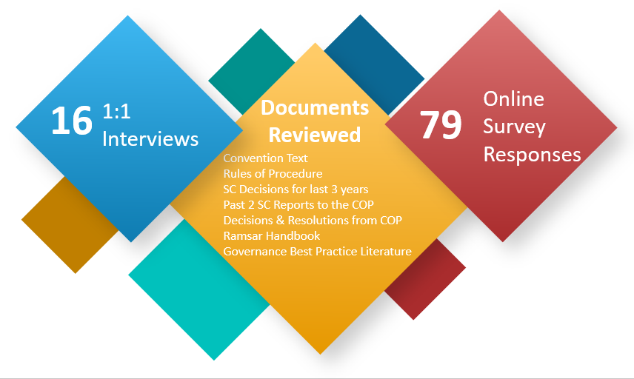
The stakeholders that were invited to interview were approved by the EWG in advance, as they were considered the most appropriate entry point to garner perspectives that would add value to this exercise. It is important to note that this set of interviews was meant to serve as a representative sample (geographically and according to area of expertise and experience) of the Contracting Parties. It would be unusual to see a governance review that includes a majority or all CPs to draw initial findings or conclusions. SRI Executive supplemented these interviews with an open invitation to all CPs to complete the global survey, ensuring this process was inclusive and diverse, and most importantly, confidential. While collating and reviewing data in the back end of the survey tool, SRI Executive also removed any duplicates to ensure fairness and accuracy of the data collected.
The graphic below shows the number of respondent CPs to the online survey per Ramsar region. The graphic merely shows that responses were received from CPs in all the Ramsar regions. It is understood by SRI Executive that the division of CPs into the different Ramsar Regions is a decision made by the COP and the percentage of responses is only to illustrate the geographical spread of the responses. All responses have been recorded and analysed in the same way and no varying weight has been placed on responses in relation to percentage answers in any way.
Table 1 – number of responses received from online survey and 1:1 interviews:
Region | No. of Countries | No. Responding Countries for online survey | No. Countries which held 1:1 Interviews | % Responses per Region for online survey
Africa | 50 | 24 | 1 | 48%
Asia | 34 | 8 | 2 | 24%
Latin America & Caribbean | 27 | 7 | 3 | 26%
Europe | 48 | 36 | 3 | 75%
North America | 3 | 2 | 1 | 67%
Oceania | 9 | 2 | 1 | 25%
Total | 171 | 79 | 11

It is important to note that SRI Executive remains independent in this report, pointing to findings and positive indications that come directly from respondents with evidence to support the conclusions drawn from the desktop study and the accompanying analysis. Positive indications/measures in this report are for the EWG to consider.

4. COP 13 Draft Resolutions COP 13 doc 18.1 and 18.2
At the Ramsar Convention COP 13 meeting in 2018, two draft resolutions focused on the effectiveness and efficiency of the Convention were presented for consideration by the Contracting Parties. The Standing Committee SC54 had discussed both proposals prior to the COP without reaching a conclusion on how to bring them together. The Standing Committee encouraged interested Parties to continue multilateral discussions on this issue in preparation for COP13 to seek mutually agreeable solutions to achieve a common goal and decided that COP13 could benefit from considering these two draft resolutions together.
As set out above in the Introduction, the Contracting Parties were unable to find consensus and mutually agreeable solutions in relation to the content of the two draft resolutions. SRI Executive considered the two draft resolutions at the start of the review to be informed on the initial intentions and suggestions for measures that the Contracting Parties had envisaged. As can be seen in the table below, the proposals vary from small adjustments to existing governance bodies or procedures to significant changes to the governance structure and procedures.
The two draft resolutions were considered during the review of the Ramsar Convention. A summary of the proposals set out in the Resolutions are set out below. We have also indicated where a proposal in the draft resolutions is linked to a Measure proposed in this report (6. Summary – Review Findings in relation to specific governance bodies or processesbelow).
Draft Resolution 18.1 | Draft Resolution 18.2
- Make use of “Friends of the Chair” processes, as appropriate, to seek to enhance efficiency and promote effective meetings by delegating matters  - Make better use of working group processes by delegating long term issues to be done by working groups inter-sessionally  - Retire duplicative/ inefficient working groups (CEPA Working Group, Facilitation Working Group, Language Strategy) (Measure #1) | - Dissolve the SC and all its subsidiary bodies (CEPA Oversight Panel, Subgroup of Finance, MWG, Executive Team, etc.)  - Establish a Bureau of the Conference of the Parties to act as oversight body between COP, liaise with Secretariat on administrative matters  - Establish an Open-Ended Working Group (OEWG) to carry out substantive interim work with support from the Science-Policy Interface  - Finance and Admin Committee sits underneath OEWG
- Revise and update the mandate of the MWG, specifically in relation to oversight of Memoranda of Understanding and Oversight of the STRP (Measure #1)
- Ensure that working group processes have clear mandates and scopes, are regionally representative and open (Measure #2)

- Include SC rep from each region in the MWG; SC and Executive Team may delegate additional administrative tasks to MWG | - Open-Ended Working Group to be the body for inter-COP communication and interim activities  - Requests the Secretariat to start a system of notifications /Call for information and follow-up on the decisions of the COPs (Measure #4)
- Dissolve the STRP
- Establish an open-ended Science-Policy Interface to generate scientific advice for the Convention related to policy recommendations
- Merge CEPA Oversight Panel with Science Policy Interface

In relation to the findings of the governance review of the Ramsar Convention, we can note from the responses in the online survey and interviews that respondents considered that clearer mandates and specific timelines for subgroups/working groups are necessary, which supports some of the proposals in draft Resolution 18.1. However, as evidenced in the Findings Report, draft Resolution 18.1 does not provide a full reflection of the change sought by Contracting Parties that responded. Nor did the findings provide sufficient evidence that the structural changes set out in draft Resolution 18.2 were requested or referred to by the CPs that responded.

5. Summary – Governance Review Assessment Criteria – Overall Findings
The Findings Report provides the full results of the review in relation to overall insights from the desk review, online survey responses and 1:1 interviews on the governance assessment criteria of clarity, legitimacy, accountability, effectiveness and cost. It provides an overall picture of where, within each assessment criteria, there is evidence of challenges. In the present Final Report, SRI summarises those findings to present an overview, however full details can be found in Section 3 of the Findings Report, pages 7-10.

5.1 CLARITY
Definition: Governance mandate, tasks and responsibilities for decisions and actions in the Convention are clearly delineated, allocated and accepted.
Ramsar Governance Review Finding #5.1
The desk review, 1:1 interviews and online survey all highlighted that the governance documentation is clear on mandates, tasks, and functions for the COP and SC but less clear for the subgroups.
The desk review showed that there is clarity in relation to all the governance bodies examined, although at times, many resolutions needed to be examined to pull together a full picture of the mandate of some subgroups, which affects clarity and effectiveness.
The 1:1 interviews and online survey showed that respondents considered that the governance documentation is clear on mandates, tasks, and functions for the COP and SC but that the language in resolutions and decisions can at times cause a lack of clarity in relation to implementation of tasks designated to the subsidiary governance bodies or CPs. This causes, at times, procedural issues to take prominence in agendas and deliberations in the place of substantive and technical discussions on wetland management.
There is also a mismatch between clear governance tasks and functions set out in documentation and how these are understood and perceived by CPs. A substantial number of CPs responded in interviews and in the online survey that they consider that there is a lack of clarity as to tasks and functions. It is perceived that not sufficient information is received about governance processes and progress on work between the COPs.

5.2 LEGITIMACY
Definition: All parties to the Convention are fairly represented, whether directly or by a legitimate representative, and are informed and empowered to validate or question all decisions taken at the COPs.
Ramsar Governance Review Finding # 5.2
Varying levels of capacity and political will between the different CPs affect the perceived legitimacy of the Ramsar Convention that is expressly granted in the Convention’s official documentation.

The desk review, 1:1 interviews and online survey highlighted that all CPs and observers (to the extent permitted) are provided the opportunity to participate in the fullest manner at all levels of governance of the Convention. Legitimacy as set out in the governance documents is strong.

Legitimacy concerns were raised about varying levels of capacity and political will between the different CPs and the subsequent impact on CPs’ ability to effectively participate during governance meetings. Interviews and surveys showed that there is a perception that certain countries are able to more actively engage in the Convention’s governance with larger delegations, favourable logistics and language capacity; these are all factors which can negatively affect CP’s actual ability to be represented and engage.

5.3 ACCOUNTABILITY
Definition: The decision-making bodies of the Convention are accessible to their stakeholders, who are informed and empowered to question decisions taken. All governance bodies are seen as responsible and accountable for the decisions they take.

Ramsar Governance Review Finding # 5.3
Lack of accountability within governance processes is based on perceived low internal flows of information on follow-up of implementation of resolutions and decisions which are taken at the COP and SC.
This is an area where strong operational accountability is evidenced by the high rate of submission of national reports to the COP. However, responses to 1:1 interviews and the online survey showed a thread highlighting little or no accountability in relation to implementation within the Ramsar Convention of the governance processes. The lack of accountability stems from the perception of CPs that they are not well informed of the work that is carried out by different governance bodies between the COP. The responses to the online survey showed that CPs therefore do not actively hold each other to account at governance meetings. We note that some accountability mechanisms exist and may be addressed as part of the measures’ narrative.

5.4 EFFECTIVENESS
Definition: The governance bodies deliver, in a timely and effective manner, on the objectives set out by their mandates in the Convention.
Ramsar Governance Review Finding #4.4
Factors that reduce effectiveness are mainly the administrative process related to drafting resolutions, and the fact that the rules that govern this process do not provide for the most effective manner of working.

The majority of CPs interviewed and surveyed felt that the governance of the Ramsar Convention supports the progress of work towards the Vision and Mission of the Convention as a whole. There is also a strong mix of skills and experiences at the COP and within the SC, which allows there to be proper and efficient management of the governance.
The 1:1 interviews and online survey responses show there is a perceived lack of communication between COPs, even though all documentation is available on the Ramsar website. There is still a perception that limited follow-up information is shared after these meetings and that communication is only picked up again when preparation for the next COP needs to start. This results in a gap in knowledge of the stakeholders and reduces ability to effectively engage and take decisions in conjunction with the next COP meetings.

5.5 COST
Definition: The cost of governance is justifiable relative to its delivery of impact.
Ramsar Governance Review Finding #5.5
The desk review shows that budget accountability, managed by the Secretariat and overseen by the Subgroup on Finance, is seen to have been improved.
It is evident in reports from the SC and the Subgroup on Finance that attempts are being made to explore how financing can be improved to increase the number of the minimum contributions being paid.

6. Summary – Review Findings in relation to specific governance bodies or processes
The Findings Report subsequently presented the review of each governance body within the Ramsar Convention against the five governance assessment criteria. We have set out below the main governance review findings that came out of this more specific review (presented in the Findings Report in boxes at the end of each subsection in section 4, pages 10-30). In addition, where relevant, the findings from the MEA Comparison Review are also noted against the Ramsar Review Findings.
Main Findings of the Ramsar Governance Review | MEA Review Findings
6.1 Process to prepare and submit resolutions to the COP:  Respondents considered that there is a need for the procedure for preparing draft Resolutions to be amended so that the scrutiny of resolutions becomes easier and leads to them being clearer.  It is noted that work has begun since the last COP (Resolution 13.4 and SC58 report) to review all resolutions in order to find duplications and therefore be able to propose to the COP that redundant resolutions and portions thereof are combined and outdated resolutions and portions thereof are retired. | Finding #1.1 Administration of Resolutions  Administration, follow-up and monitoring of Resolutions and Decisions passed at COP/GA is a significant factor in increasing clarity around governance structures and processes.  Finding #4.2 Review of resolutions  Support from specific bodies in reviewing draft resolutions increases the effectiveness of passing the resolutions and supports more effective post-COP/GA implementation.
6.2 Varying capacity and knowledge of delegates: The Convention is legitimate and fully represented by its stakeholders, the Contracting Parties, who all have the right to vote. As noted above, resolutions are approved by consensus with objections noted. However, the varying capacity and knowledge of the delegates, as well as language issues, means that it is not possible to conclude whether delegates, in reality, participate actively, although meetings reports do , to some extent, note the CPs that have commented or raised an objection. This may prevent CPs from being able to participate fully (which is noted in responses in 1:1 interviews and online survey). There is also a large discrepancy between the institutional knowledge as the same delegate of a CP does not always attend several COPs. | Finding #2.1 Diversity of delegates  The challenge of diversity of the delegates’ capacity at COP/GA is common to all the MEA Conventions, and difficult to solve.
6.3 Follow-up from previous meetings, specifically in relation to reporting of subgroups, is seen to be weak and therefore the ability of all the Standing Committee members to be prepared for the meeting is felt to be varied.  6.4 Separate Rules of Procedure for the Standing Committee: The Rules of Procedure for the COP sets out in Rule 25 that the Rules of Procedure for the COP shall apply mutatis mutandis to the SC (and all other subgroups). This means that the Rules of Procedure must be re-interpreted for the SC meetings. Proposals for changes to the Rules of Procedure at COP 13 attempted to clarify the rules relating to the COP processes, to distinguish them from the rule that would also apply to other governance body meetings. However, the responses in interviews and the online survey show there is still, at times, discussion on process taking up time which could otherwise be dedicated to discussing and developing the technical aspects of wetlands’ management. | Finding #4.3 Communication to CPs  Communication to CPs between COP/GA is a common challenge, where clear and helpful publication on websites is seen as the most used solution.  Finding #1.3 Separate Rules of Procedure  A majority of the MEAs reviewed have Separate Rules of Procedure for the different governance bodies.  We note that SC-48 made the decision not to take this approach and instead to continue with a single set of Rules that are applied mutatis mutandis as had been the practice since Ramsar’s inception. We also note how findings indicate that confusion still arises from having the same set of rules.
6.5 CPs would like a clearer description of the mandate of subgroups so that mandate descriptions are in one place rather than pieced together in different resolutions.  The desk review shows that there is documentation that sets out the scope of the mandate for the MWG, Subgroup on Finance and the Executive Team but there is no consolidation of the various additions to mandates which occur from resolutions and/or decisions subsequent to the subgroup being created. | Finding #1.2 Mandates of Subgroups  Clarity around mandates and reporting of Subgroups is recognised by all the Conventions as important for more efficient operations of the MEA Convention’s governance.
6.6 More clarity as to the appointment process for members of the STRP and CEPA Oversight Panel is needed to improve efficiency of work by these subgroups.  The desk review shows that there is documentation that sets out the scope of the mandate and appointments to the STRP and CEPA Oversight Panel and it is clearly understood by the CPs. However, the desk review and 1:1 interviews show there is a lack of clarity on the process to choose members for the CEPA Oversight Panel and that the commencement of work for the STRP is delayed as their thematic priority areas of work are first set at the COP meeting, and then developed into a workplan, approved by the next SC meeting. | Finding #1.4 Efficient commencement of Scientific Committee work  Clarity of mandate and efficient commencement of work for Scientific Committees supports more informed debates and action at COP/GA meetings.
6.7 A majority of the responses show that governance would be more effective with more pro-active and substantive support to CPs by the Secretariat to help them understand the Convention’s governance and therefore be more effective in their own governance work (e.g. in the preparation of resolutions).  At the same time there is understanding that the Secretariat is constrained (limited finances, limited staff & time) in the amount of additional support it can give to CPs in relation to governance meetings and processes. | Finding #1.1 Administration of Resolutions  Administration, follow-up and monitoring of Resolutions and Decisions passed at COP/GA is a significant factor in increasing clarity around governance structures and processes.  Finding #4.1 Support from Host Institution  Support from Host Institution is a significant factor for effective management of governance processes.

7. Measures Suggested by SRI Executive for Consideration by the EWG
The measures proposed below are designed to consider a change management approach. They also recognise that the Ramsar Convention has already established the EWG to assess options based on evidence, gain the necessary buy-in for any possible future change and support communication methods needed to achieve any changes effectively and transparently. Any measure outlined in this section is intended to support dialogue, the review of facts and findings, the drafting of proposals and ultimately to ensure each measure proposed is realistic and driven based on data uncovered through a variety of sources.
It should be noted that the Measures are not set out in direct connection to specific findings. This is because a single measure can provide possible solutions for a variety of challenges which the review has highlighted.
In addition, where possible, we have indicated how the MEAs reviewed experienced implementation of changes that they informed us about in our interviews. Recognising that all MEAs operate within different contexts, the information provided will have to be put into the Ramsar Convention’s own operational context by the EWG when considering proposals for recommendations to COP 14.
Finally, it is also indicated under each measure, whether implementing the measure would require short or long-term implementation and whether it would require a high or low level of resources (staff time and/or funding). As feasibility as a concept is highly dependent on internal resources, expertise, capacity, and readiness, these are indications that will need to be complemented with further internal information as to the capacity of, among others, the Ramsar Secretariat and then used by the EWG for the measures to be as realistic and pragmatic as possible.

Measure #1
SRI Executive suggests that the work currently being carried out on the review of resolutions/recommendations/Standing Committee decisions by the Ramsar Secretariat is a measure that should be continued, and concluded to a point where the COP can take the necessary decisions to retire obsolete resolutions/recommendations/Standing Committee decisions and set a structure for consolidating the remaining resolutions, recommendations and Standing Committee decisions.
Specifically, we would propose that the consolidation of resolutions and decisions results in specific documentation that sets out the mandate, appointment processes and reporting tasks of all subgroups (significantly the Executive Team, Subgroup on Finance, MWG, STRP and CEPA OP which were all specifically mentioned as subgroups with unclear mandates in the survey and interview responses).
In relation to the CEPA OP, SRI Executive suggest that based on the consolidation of the resolutions and decisions on the CEPA OP, a new COP resolution that clearly sets out the mandate and member composition of the CEPA OP be proposed by the EWG. It has already been recognised by the Secretariat and SC that the COP resolutions and SC decisions on the CEPA OP are contradictory and provide no means for clearly establishing the CEPA OP. SC57-5 tasked the Secretariat with providing a temporary composition and selection process which was adopted intersessionally by the SC in 2019 but did not provide a longer term solution, which a draft EWG resolution on this issue would do.
In addition, the EWG can consider whether to create separate Rules of Procedure for the Standing Committee, as a measure to provide clarity for the mandate and functioning of the Standing Committee. However, in doing so it should note that CPs considered having separate rules of procedure for different convention bodies and at SC-48 made the decision not to take this approach and instead to continue with a single set of Rules that are applied mutatis mutandis as had been the practice since Ramsar’s inception. It should also be noted that this analysis did not examine why or how Ramsar Contracting Parties made that decision in 2015.
Overall, we see this measure as providing the following effects:
- Stronger clarity to the structure and processes of the Ramsar Convention governance.
- Provide CPs with clearer information which will support a decrease in the varying capacity of delegates participating at governance meetings.
- Provide a clear and structured basis to support the Secretariat’s work when it supports CPs and the governance bodies in its review of draft resolutions.
- Reduce the need for clarification and interpretation of governance rules and procedures.
Specific MEA feedback: CITES and CMS noted that their reviews of resolutions and restructuring into a system of dividing decisions into Resolutions (policy direction) and Decisions (specific actions and tasks that are timebound) were a direct response to the difficulty of establishing clear mandates and follow-up processes on work being carried out by different governance bodies.
Both MEAs noted that it was a long and expensive process (it took close to 3 years for CITES to finalise and CMS is currently still undertaking the review). CITES has noticed a significant difference in efficiency of governance and an increase of engagement by CPs.
It is recognised that the Ramsar Convention has had a similar structure of Resolutions (policy direction and interpretation of the Convention) and Recommendations (actions requested by COP) until 1999. It would therefore be important for the EWG to consider if the nature of governance work has changed in a significant manner to warrant a re-consideration of the structure of the decisions made at the COP and SC meetings. Based on the work of consolidating all previous resolutions, recommendations and decisions, it may become clearer as to which option for categorising future resolutions and decisions is most efficient. For example, the EWG can consider:
- Establishing a categorisation that is noted in the title of a resolution
- Including time limitations or reporting deadlines in the title of resolutions
- Giving resolutions that provide Ramsar Convention policy direction and interpretation a specific name and giving resolutions that provide instructions for activities between COPs a different name.

Feasibility
As there is ongoing work by a consultant to review all of the Resolutions and Recommendations, this measure can be incorporated into the work that is already being carried out. The measure to establish dedicated documentation for mandates of all governance bodies and subgroups should be a short-term measure, implemented for the next COP. A proposal to introduce a new system for classifying resolutions in any manner may be introduced through the amendment of Rule 34 of the Rules of Procedure for the next COP (short-term measure). In addition, or alternatively, it would require a restructure of how the resolutions are presented on the Ramsar Convention website. This we understand may be a long-term project and require additional funding to adjust the website.

Measure #2
From COP 14, SRI Executive suggests that a Resolution be passed that retires all existing non-permanent subgroups/working groups (not permanent subgroups such as Subgroup on Finance, or Management Working Group, The Executive Team) and that specific resolutions be passed to create new, time limited subgroups/working groups as needed. It is recognised that Resolution XIII.3 retired all subgroups that did not have ongoing work. However, in order to eliminate evergreen subgroups, we suggest below that all existing and any new subgroups be given new mandates with fixed timelines.
The draft Resolution would set out a process where all new non-permanent subgroups/working groups are given a fixed timeline for existence. Alternatively, a blanket rule that any subgroup or working group created by the COP or SC may only be in existence until the next COP meeting and is automatically disbanded unless a new resolution or decision that expressly sets out its continuation can be put in place. We would also suggest that such extension of a subgroup or working group needs to have a “learning loop” within the draft resolution requesting its extension that sets out an assessment of:
- What worked well within the subgroup/working group?
- What worked less well, and why?
- How will the subgroup/working group improve going forward?
This will provide continuous clarity and efficiency for any subgroups or working groups that exist at any time. An automatic follow-up within the “learning loop” will cause contributions to substantive content of resolutions to be enhanced as reports have to be provided and closed for each COP.
Specific MEA feedback: Most of the MEAs responded that they have procedures whereby an ad hoc working group is only created during the period between COPs/GAs and needs to be specifically extended in a draft resolution to be able to continue in existence. None of the MEAs responded that the process was introduced due to a specific challenge, but all noted how much more efficient the work is for the secretariats to keep track of activities and tasks to be completed between each COP.

Feasibility
To implement this measure, Rule 25 of the Rules of Procedure would need to be amended to expressly set out the need for a fixed timeline for the non-permanent subgroup/working group’s existence, or to include a blanket rule that all non-permanent subgroups/working groups are dissolved at the next COP meeting. This is a short-term implementation that can be implemented at COP 14, in conjunction with the proposed draft resolution for the Rules of Procedure that is presented at each COP meeting.
A new, separate Rules of Procedure for the Standing Committee can be put forward to the COP 14 in conjunction with other changes to the current Rules of Procedure. We understand that this would require more staff time of the Secretariat to prepare the draft Resolutions for the new Rules of procedure.

Measure #3
This measure addresses the timeline of the STRP workplan priorities and appointment of its members for both to be completed/adopted at COP or immediately after. SRI Executive suggests that the timing and sequence for ultimately approving the STRP workplan and appointing its members, as set out in SC48.18 is carried so that approval can takes place immediately after the COP meeting.
This means that Stage 1, section 42 should also include a draft workplan (Stage 4) at a general level, as there would have been consultation with the Secretariat and Standing Committee (CPs’ regional representative). Based on this, the Secretariat can initiate a process for nominations for experts from CPs prior to the COP meeting and the MWG would meet immediately after the COP, appoint the members, giving their report to the SC meeting that takes place immediately after the COP (Stage 3).
It is recognised that the STRP’s membership and workplan are built on the priorities set by the CPs at the COP (Stage 2). However, the thematic priorities decided at the COP are drawn from the issues and topics which are raised by CPs through the discussion of draft resolutions at Stage 1, as well as interactions with the STRP throughout a triennium. It is therefore proposed that the second SC meeting of the triennium can begin to discuss and indicate overall strategic priorities/themes for the following triennium together with the STRP in a draft format based on an initial analysis provided by the STRP. It is proposed that the STRP review the initial draft of priorities during their meeting prior to the last SC committee of the triennium, including possible relevant draft resolutions as indicative of further priorities (if any) and thereby be able to also provide a high-level draft workplan.
The SC meeting prior to the COP would review the STRP draft workplan and therefore receive comments from CPs in that review. The resulting workplan will be discussed/endorsed by the SC and submitted to the COP where the CPs can further debate, negotiate and adopt.
It is proposed that a selection process for members can be started after the last SC meeting prior to the COP. A relevant list of candidates can be prepared for the COP meeting based on the STRP draft workplan priorities and resolution(s) indicated as priorities (if any). Once the workplan is debated/adopted by COP, the MWG can appoint the most appropriate STRP members during the SC meeting immediately after the COP meeting.
In essence, SRI Executive propose that the COP be presented a new STRP Package that consists of the STRP Draft Resolution that contains priority themes, workplan and list of nominations), which CPs have reviewed through the SC and pre-COP reviews, with final debate and decision at the COP, as well as subsequent implementation decisions by the post-COP SC. This would ensure that the basic framework for the STRP (members and workplan – Stages 1, 3, 4 and 5) are in place immediately after a COP meeting (Stage 2), and the STRP would have the full 3-year period between COPs to carry out the work it has been asked to do by the CPs (Stage 6). In addition, this would ensure that all CPs are able to consider and debate the STRP draft workplan at the COP meeting.
Specific MEA feedback: None of the MEAs noted a significant challenge in relation to the work of their Scientific Committees. It should be noted that the operational model for scientific input is not the same throughout the MEAs reviewed. In the review, SRI Executive noted that the description of the appointment process and workplan approval for scientific committees was finalised during a COP or GA meeting.

Feasibility
To implement this measure, short-term sequencing adjustments need to be agreed within the MWG to move its tasks of appointing members of the STRP and to support the preparation of allocating funds to the STRP workplan so that these tasks can be finalised at the SC meeting immediately after the COP. In addition, we believe that extra support from the Secretariat to prepare the STRP workplan would need to be provided. As this measure also requires more behavioural changes rather than specific changes to documentation to be implemented, we assess that it may be a more long-term goal, with a smooth procedure being established over the next triennium, to be further cemented after COP 15.

Measure #4
SRI Executive notes that there is no simple measure to ensure a change in the level of support from the Ramsar Secretariat to the CPs as this is very much reliant on the resources (technical skills, human resources, time, finances) available. We do however feel that the EWG should explore the following options:
  - Consider using a digital service/tool for all documentation preparation and meeting reporting from the COP and SC meetings (e.g. using IISD or commercial tools for conference and meeting management. We note this is a suggestion to scope possible different solutions).
  - Explore further support from IUCN in relation to administration of governance procedures (e.g. using IUCN’s system for drafting resolutions/motions. We note this is a suggestion to scope possible different solutions).
  - In the event the digital service/tool is not adopted as set out in the first bullet point, provide for an online platform (e.g. Share-point/Drop-Box) dedicated to sharing and collectively editing draft resolutions (
  - Strengthen capacity building tools (virtual workshops/training material) with a dedicated Communication Strategy for communication of governance work between COPs.
Specific MEA feedback: In the MEA Comparison Review, Finding 4.1 noted that the MEAs that have strong support from their host institutions, while Finding 4.2 that noted strong involvement of secretariats in the review of draft resolutions indicated a more efficient management of governance procedures.
However, it must also be noted that the MEAs reviewed are at times more fully imbedded in their host institutions’ own governance and operational structures (e.g. LC/LP, ITPRGFA) than the Ramsar Convention which operates semi-autonomously from IUCN. It is therefore difficult to assess the extent to which the Ramsar Convention CPs should, or can, increase the support from IUCN or its own secretariat.

Feasibility
The measures set out above are mainly dependent on the ability to provide significantly more financial resources as well as staff time to support the changes proposed. It also requires a decision to dedicate considerably more resources within the Secretariat to support CPs with their input and contribution to governance processes.

8. Proposed next steps
The EWG has been given a mandate by the COP to recommend revisions (as necessary) that further enhance the effectiveness, including cost effectiveness, and efficiency of the Ramsar Convention in order to reduce administrative burden and speed up the process to achieve the mission of the Convention and to propose a process to implement its recommendations. To support this, based on the change management approach that SRI Executive uses for all its governance reviews, as well as other organisational development support, the next stage of the process, would be for the EWG to ensure, with SRI support as needed:
- Understanding of findings and measures proposed in more detail in order not to open these findings and measures to multiple interpretations by the EWG members.
- Discuss the measures and the feasibility of the options within Ramsar’s own context and feasibility criteria, and
- Potentially reach an agreement on any recommended measures that the EWG may wish to take forward in its draft Resolution to the COP.
This would enable the EWG to agree on the parameters of the feasibility criteria, looking at Ramsar Convention’s resources in relation to staff skills and time, funding and readiness for change. This in turn would enable delivery of a roadmap in accordance with EWG/SRI ToR paragraph 9 points vi, vii and viii.
Where necessary, if identified by the EWG, SRI Executive can support with further fact-finding review/investigation within Ramsar and/or with the comparison of the MEAs should more data be needed to support certain proposals.

Global HQ:
40 Grand Canal Street Upper
Dublin 4, Ireland

Phone: +353 1 667 5008
Email: info@sri-executive.com
Website: www.sri-executive.com

London Convention and London Protocol (LC/CP), Convention on International Trade in Endangered Species of Wild Fauna and Flora (CITES), International Plant Protection Convention (IPPC), Convention Concerning the Protection of the World Cultural and Natural Heritage (UNESCO World Heritage), Convention of Migratory Species (CMS), International Treaty on Plant Genetic Resources for Food and Agriculture (ITPGRFA).
Draft Resolutions 18.1 and 18.2.
https://www.emeraldgrouppublishing.com/research/guides/methods/mixed_methods.htm?part=1
The division of countries according to Ramsar Convention’s website.
16 total interviews were undertaken to gain insight into the Contracting Parties’ views. 11 are included as country interviews while the additional 5 were undertaken with members of Ramsar’s governance.
Good Governance in International Organizations, Ngaire Woods, Global Governance, Vol. 5, No. 1 (Jan.–Mar. 1999), pp. 39-61
Resolution XIII.2 (3).
90% of 1:1 interview and 68% online survey responses agree that the resolutions are clear and enacted in a manner that follows agreed upon rules.
The latest Standing Committee composition and tasks for the triennium is set out in Resolution XIII.4.
XIII.4 Annex 3 paragraph 2.
New Standing Committee members are also encouraged to attend the Bureau meeting during the COP to gain insight into the current work of Standing Committee members and the overall work of the COP meeting.
COP9 determined that the Management Working Group would comprise: a) the Chair and Vice Chair of the Standing Committee of the previous triennium; b) the Chair and Vice Chair of the Standing Committee established for the forthcoming triennium; c) the Chairs of the Subgroup on Finance of the previous and forthcoming Standing Committees; d) the Chairs of the Scientific and Technical Review Panel in the previous and forthcoming triennia; e) any other interested Contracting Parties, keeping in mind the desirability of equitable regional participation; f) a representative of the International Organization Partners (IOPs); g) the Secretary General ex officio; and h) an appropriate expert on organizational review, as needed, to be determined by the Working Group, subject to there being no implications for the Convention’s budget;
i) to appoint the members of the STRP and appoint the Chair and Vice-Chair from among them; ii) to oversee the implementation of the STRP’s programme, and report progress to each Standing Committee with recommendations for action as required; iii) to guide and support the Panel as required; iv) to recommend the allocation of funds for STRP tasks to the Standing Committee Sub-group on Finance; and v) to work with the Secretariat to oversee STRP expenditures.
Except the post-COP SC56 that did not have financial issues on the agenda
The composition is the Vice-Chair of the Standing Committee, acting as Chair of the Oversight Panel, a maximum of six representatives of Contracting Parties, which may include CEPA Government Focal Points, Standing Committee representatives or other representatives of Parties (a maximum of one per region), the Vice-Chair of the Scientific and Technical Review Panel, a maximum of two NGO Focal Points (not from the same region), a maximum of two representatives of the IOPS; and a representative of the Convention Secretariat (ex officio).
a) to assist in the convening and organizing of Conferences specified in Article 6; b) to maintain the List of Wetlands of International Importance and to be informed by the Contracting Parties of any additions, extensions, deletions or restrictions concerning wetlands included in the List provided in accordance with paragraph 5 of Article 2; c) to be informed by the Contracting Parties of any changes in the ecological character of wetlands included in the List provided in accordance with paragraph 2 of Article 3; d) to forward notification of any alterations to the List, or changes in character of wetlands included therein, to all Contracting Parties and to arrange for these matters to be discussed at the next Conference; e) to make known to the Contracting Party concerned, the recommendations of the Conferences in respect of such alterations to the List or of changes in the character of wetlands included therein.
https://www.ramsar.org/about/the-secretariat
The literature review shows that high performing governance takes place when the main task of the Chair is efficiently chairing governance meetings and providing directional leadership.” Board Chairs’ Practices across Countries: Commonalities, Differences, and Future Trends”,
The Compliance Groups or Committees mentioned above are broadly mandated to consider information submitted regarding non-compliance with the Convention and offer advice or assistance to the Contracting Parties to better comply with obligations set out in the Convention. For full details on each body, please refer to the links in the text above.
London Convention and London Protocol (LC/CP), Convention on International Trade in Endangered Species of Wild Fauna and Flora (CITES), International Plan Protection Convention (IPPC), Convention Concerning the Protection of the World Cultural and Natural Heritage (UNESCO World Heritage), Convention of Migratory Species (CMS), International Treaty on Plan Genetic Resources for Food and Agriculture (ITPGRFA)
Why use mixed methods research
16 total interviews were undertaken to gain insight into the Contracting Parties’ views. 11 are included as country interviews while the additional 5 were undertaken with members of Ramsar’s governance.
This governance review has not at present examined the structures and processes of the hosting agreement between IUCN and the Ramsar Convention but it is recognized that this may have implications for the efficiency of the Ramsar Convention’s governance.
As part of this evaluation process, SRI Executive and the EWG developed seven broad, overarching evaluation questions (OEQs) that were used to measure the clarity of roles and responsibilities, perceived legitimacy of the governance bodies, accountability of governance bodies to the COP, effectiveness of governance bodies in practice, and the cost of Ramsar’s governance structure. The main evaluation questions (MEQs) are more specific sub-questions that seek to answer the overarching evaluation questions more specifically. These questions can be found in Annex 1: Final Evaluation Questions.
The division of countries according to Ramsar Convention’s website.
This figure is 2 less than the 81 online survey responses noted in the figure above as 2 countries responded twice and 1 reply for each was discarded.
16 total interviews were undertaken to gain insight into the Contracting Parties’ views. 11 are included as country interviews while the additional 5 were undertaken with members of Ramsar’s governance.
In comparison to the other MEA Conventions reviewed (for example LC/LP had 50-60% of CPs report; CMS had a 70%) Ramsar Convention has a reporting rate of over 80%.

