RAMSAR CONVENTION ON WETLANDS
55th Meeting of the Standing Committee
Dubai, United Arab Emirates, 21 October 2018

SC55 Doc.8.2

IUCN review of non-core finances

1. Through Decision SC53-33 (https://www.ramsar.org/document/decisions-of-the-53rd-meeting-of-the-standing-committee-sc53), the Standing Committee at its 53rd meeting “instructed the Secretariat to take steps to undertake a financial / management review of non-core funds”.

2. The Secretariat engaged the Oversight Unit from IUCN, International Union for Conservation of Nature and Natural Resources, to undertake the review.

3. The IUCN Oversight Unit presented an interim report to the Subgroup on Finance at the 54th meeting of the Standing Committee. The Subgroup on Finance provided feedback and recommendations approved in SC54-26 (https://www.ramsar.org/document/report-and-decisions-of-the-54th-meeting-of-the-standing-committee)

4. The report of the IUCN Oversight Unit is attached to the present document. It includes the Management Response from the Secretariat.

Advisory Report

Financial Management Review of Non-core (Restricted) Fund Accounts,
Ramsar Convention on Wetlands

No material inaccuracies were noted in the reported account balances for non-core funds from 2008 to 2017. However, continued improvements are needed to strengthen financial and project management, and governance processes.
Overall Rating: Partially Satisfactory
IUCN-OU-18-005
31 July 2018
Gland, Switzerland
Oversight Unit

Contents
I. EXECUTIVE SUMMARY 3
II. CONTEXT AND SCOPE 6
III. FINDINGS AND RECOMMENDATIONS 12
A. Governance 12
A higher level of assurance is needed to demonstrate effective systems of internal control in the Secretariat, including financial and operational control over non-core project funds
B. Change in Fund Designation and Use 16
Procedures are needed to better regulate transfers between core and non-core funds, and for change in use of non-core funds
C. Admin Project Fund Account 20
A standard cost recovery approach for management fees is needed; and project close-out procedures are also needed
D. Swiss Grant for Africa Fund Accounts 25
Higher quality project reporting is needed for donors; and donor approval is needed for change in use for unutilized balances
E. Small Grants Fund Accounts 28
No material issues were noted, however management fees should be regularly charged
F. WACOWET and African Voluntary Contributions 30
No material issues were noted, however CHF 33,000 is needed to replenish the account
G. Ramsar Advisory Missions 31
No material issues were noted
Annex 1 Summary of Recommendations 33
Annex 2 Secretariat Organizational Structure 35
Annex 3 Key Financial Statements 36
Annex 4 Example Non-core Close Out Procedure, UNDP 37

Report distribution:
Members of the Subgroup on Finance of the Ramsar Convention Standing Committee
Martha Rojas Urrego, Secretary General, Ramsar
Jonathan Barzdo, Deputy Secretary General, Ramsar
Sandra Ruecker, Finance Officer, Ramsar
Inger Andersen, Director General, IUCN
Members of the Office of the Director General
Mike Davis, Chief Financial Officer, IUCN Global Finance Group
Jean Deong, Head of Financial Services, IUCN Global Finance Group
Yves Cerutti and Fanny Chapuis, Pricewaterhouse Coopers (PwC)

EXECUTIVE SUMMARY

Introduction and opinion

- The Contracting Parties of the Ramsar Convention, its Secretariat, and other stakeholders are dependent on the availability of reliable financial information for non-core projects to make important business decisions on these activities.

- In September 2016, irregular financial management practices were identified during a cursory review of non-core funds by the Ramsar Secretariat and the findings were communicated to the Standing Committee. At the 53rd Meeting of the Ramsar Standing Committee, held from 29 May to 2 June 2017, the Standing Committee instructed the Secretariat to carry out a detailed review of non-core funds as described in the following decision:
Decision SC53-33: The Standing Committee instructed the Secretariat to take steps to undertake a financial / management review of non-core funds.

- The Secretariat engaged the Oversight Unit from IUCN, International Union for Conservation of Nature and Natural Resources, to undertake the review.

- No material deficiencies came to the attention of the Oversight Unit (OU) during the review of non-core financial account balances covering a ten-year period from 2008 to 2017. However, several areas were identified where the Standing Committee and Secretariat should focus attention to strengthen financial and operational controls, as well as governance processes.

Key achievements and good practices

- Since September 2016 the Secretariat acted decisively to solidify a robust control environment, including setting a stronger tone-at-the-top, promoting and demonstrating high standards of ethical conduct and integrity, developing a collaborative corporate culture within the Secretariat and ensuring rigorous compliance to policies, procedures and norms.

- The Secretariat is enhancing and streamlining its financial management processes and practices. Team collaboration in financial management is being emphasizing as part of the “whole-of-Secretariat” initiative. Capacities and skills in functional areas are being enhanced through staff training, for example on procurement processes and contract management; and key business processes such as project management processes are being continuously improved. Accountability is also being enhanced through systematic feedback mechanisms from performance indicators and the staff appraisal process.

- The bottom line is that the Secretariat has made good progress over the past two years in addressing historical weaknesses in financial management processes and associated corporate culture, although additional efforts are needed to embed these practices and to further develop robust monitoring mechanisms to continuously check and report on the effectiveness of the system of financial and operational internal control. With these mechanisms in place the Secretariat will be in a stronger position to regularly demonstrate to the Standing Committee, and other stakeholders, the effectiveness of risk management, operating procedures, and internal control for non-core funds and administration in general.

- During the review, the Oversight Unit observed proactive actions being taken by the Secretariat to correct identified deficiencies (both from the OU’s review and from management’s oversight and monitoring) and to continuously strengthen non-core financial and project management processes and controls. The Oversight Unit is of the view that the Secretariat’s ongoing incremental improvement approach is effective and this has significantly reduced the need for a separate review of management processes for non-core projects as previously discussed with the Secretariat and Standing Committee on Finance.

Key issues and risks

- The Secretariat’s financial and project management processes had deteriorated in some areas over time due to combined factors including past weaknesses with executive management oversight, turnover of finance staff, fragmented accounting systems, lack of standard financial and project management processes, and insufficient management monitoring. This report provides insight into several of these issues as an ancillary part of the review of the non-core financial account balances.

Rating

- Partially satisfactory. While nothing came to the attention of the Oversight Unit during the review that would indicate material inaccuracies with reported non-core fund balances, certain internal control deficiencies were observed with financial management processes, use of the official accounting system to monitor projects, and application of good project management practices. These deficiencies were known by the Secretariat and action to address the most pressing issues is in progress.

Recommendations

- This report contains ten (10) formal recommendations of which four (4) recommendations are rated as high priority and therefore these should be addressed first by the Secretariat. The Secretariat has fully implemented two recommendations and the remaining recommendations are being addressed. Annex 1 provides a summary table of the recommendations and the status.

Acknowledgement

- The IUCN Oversight Unit wishes to express its appreciation to the management and staff of the Ramsar Secretariat and IUCN Global Finance Group for their assistance and cooperation extended to the internal auditor and consultant during the review.

Response by Ramsar Secretariat

The Ramsar Secretariat very much welcomes the review of non-core fund accounts carried out by the IUCN Oversight Unit and more broadly the Secretariat expresses its appreciation for the ongoing professional support provided by the Oversight and other units in IUCN to ensure that best practice policies, procedures and internal controls are embedded in Ramsar’s management and governance systems.

The Ramsar Secretariat agrees that the financial management situation that the Secretary General found upon taking office in August 2016 showed serious weaknesses and exposed Ramsar to extensive risks. While immediate steps were taken at the time and work has continued to address the situation (as reported to the Standing Committee and its subsidiary bodies since October 2016 and up to the 54th meeting of the Standing Committee in April 2018), the Secretariat appreciates the further clarity that this Review provides in confirming the issues that require specific actions to bring Ramsar’s systems and reporting to a high standard. The Secretariat further appreciates the validation of the non-core balances that the Oversight Unit reviewed and that the Secretariat had reported on, including the balances of the Admin Project Account R100100.

Overall, and without exception, the Secretariat agrees with the observations and recommendations of the Review. The following Management Response provides details of the extent to which actions have already been taken, and what remains to be done in 2018 and beyond.

The Ramsar Secretariat thanks the IUCN Oversight Unit as well as IUCN and the Ramsar Contracting Parties for their support and guidance to strengthen its financial management in line with IUCN policies and procedures. It welcomes and agrees with the recommendation made in the Review that there is no further need for a Phase 2 of the management review in light of the steps that have been and are being taken by the Ramsar Secretariat.

CONTEXT AND SCOPE

Ramsar Convention and administrative structure

- The Convention on Wetlands, called the Ramsar Convention, is an intergovernmental treaty that provides the framework for national action and international cooperation for the conservation and wise use of wetlands and their resources.

- The Convention’s Secretariat is constituted under Article 8 of the Convention and administered as an independent unit by and from the offices of IUCN, Gland, Switzerland. The Secretariat’s functions include the provision of administrative, technical and scientific support to the Contracting Parties, maintaining a List of Wetlands of International Importance, notifying Contracting Parties of additions to that List, and performing all the tasks required by the Conference of the Contracting Parties. The Secretary General administers Convention funds and administrative matters other than those requiring the exercise of legal personality. For those latter matters, formal responsibility rests with the Director General of IUCN.

Administrative and financial structure and operations

- The Secretariat has a complement of 24 staff. The policy and technical staff comprise of the Secretary General, Deputy Secretary General, Director of Resource Mobilization and Outreach, Director of Science and Policy, Senior Regional Advisors and Assistants to assist the Contracting Parties (in Africa, the Americas, Asia-Oceania, and Europe). Corporate services are provided by staff from Finance, Executive support, and a Human Resources Partner from IUCN (50 percent). Annex 2 shows the Secretariat’s current organizational structure.

- Revenue for the fiscal year ending 31 December 2017 was CHF 5.489 million (Swiss Francs) of which 92 percent or CHF 5.059 million was core (unrestricted) funding and eight percent or CHF 430,000 was funding for non-core (restricted) projects. The balance of funds for non-core projects at year-end 2017 was CHF 2.317 million.

- Core funds form the regular budget which is controlled through oversight from the Conference of the Parties and Standing Committee and this includes review and approval of the work plan and budget. The Secretary General is empowered by the Standing Committee of the Convention to apply these funds in accordance with the approved budget. Core funds are not subject to any externally imposed restrictions on their use.

- Non-core funds are those funds provided by donors for specific ‘earmarked’ projects, geographical regions, specific activities or other externally imposed restrictions as to their use. These funds are applied only in accordance with the donor agreement.

- Members of the Standing Committee and the Secretariat have fiduciary responsibilities to make certain that core and non-core funds are used as intended ensuring good governance, transparency, systems are in place to reduce fraud or corruption, and risk management is embedded in the project cycle.

- The Convention’s external auditors, PricewaterhouseCoopers (PwC), provides assurance on the annual financial statements. Their opinion for the year ending 31 December 2017 was that the Statements complied with Swiss law.

- The OU review found that the terms ‘core’ and ‘non-core’ were used in practice to describe the type of funds, whereas the terms ‘unrestricted’ and ‘restricted’ were used in the Convention’s financial statements. Inconsistent use of these terms could cause confusion with the readers of the financial statements (recommendation 1).

- Recommendation 1
The Secretariat should consider adopting standard terms to describe its funds, either ‘core and non-core’ funds or ‘unrestricted and restricted’.
Priority: Low
Due Date/Status: May 2019/In progress
Owner: Secretary General
Management response:
The Secretariat agrees and welcomes measures that could increase consistency and help readers of financial statements. The Secretariat will draft a proposed set of standardized terms to bring to the Standing Committee 57 for its consideration and decision, taking into account practices of other Conventions as well as external audit requirements and Swiss Law.

Operational challenges impacting financial reporting and management of non-core funds

- Over the past several years the Secretariat has experienced several events that have impacted the effectiveness of financial and project management control over non-core funds. A higher rate of staff turnover in finance and executive management led to loss of corporate knowledge and contributed to inconsistent financial and project management practices. Financial information systems and corporate culture had not readily supported transparency and sharing of information between finance officers and regional advisers which resulted in use of parallel accounting systems. The official accounting systems, SunSystems (SUN) and Navision (NAV), were/are used primarily to record, monitor, and report on economic transactions and financial performance through management’s operational reports and the annual financial statements. However, the official accounting system, now Navision, is not being fully utilized by the Secretariat for financial management of non-core projects. This resulted in off-book accounting systems (e.g. Excel spreadsheets, Access database) developed by Senior Regional Advisers to track project transactions and support donor reporting (recommendation 2).

- Recommendation 2
The Secretariat should provide programme managers with access to the Navision financial accounting system in order to facilitate monitoring of non-core project financial transactions and budgets, and to produce financial reports from the official accounting system for donor reporting purposes.
Priority: Medium
Due Date/Status: May 2019/In progress
Owner: Secretary General
Management response:
The Secretariat agrees on the need to better link the programmatic and financial management of projects, including the development of procedures and processes as well as enabling programme managers to have access to the information and capacity needed to facilitate timely and high quality monitoring and reporting to donors.

The following actions have been taken:
- Guidelines where issued by the Secretary General in May 2017 and discussed in Senior Management Team meetings to ensure that all financial reports were developed in a consistent way and verified by the Finance Officer before being submitted to the donors.
- Procedures were further strengthened in June 2018 requiring that financial reports to donors should be prepared / cleared and signed by the Finance Officer.
- Since May 2017, the official accounting system Navision is utilized to record and monitor non-core projects constituting the official income and expenditure that has been reported to donors (examples include donor reports sent to the Swiss government on the 2016 Swiss Grant on Africa, Danone project, NORAD project and MAVA project).

The following actions will be taken:
- Implementation of the same approach used in IUCN which consists of having automated reports sent to all project managers on a monthly basis (by March 2019). In a second phase, project managers will also be supported to access relevant JetReports of the Navision financial accounting system to facilitate monitoring of their projects (by May 2019).

- Staff turnover in key positions, fragmented accounting and reporting systems, and a lack of standard project management practices resulted in several deficiencies with processes and internal controls, impacting effective management of non-core fund projects. The transition from the SUN legacy accounting system to NAV in 2014 also added additional complexity for effective financial management processes.

- In 2016 the Secretariat committed to strengthening organizational efficiencies and effectiveness with a guiding objective “to organize to deliver”. This included a cursory review of financial and project management processes in September 2016, led by the Secretary General. The review identified irregularities with financial management practices, including an unexplained accumulated balance in the Admin Project Account R100100 of about CHF 865,000 as of 31 December 2016. The below table provides a high-level breakdown of this account balance.

Table 1 Admin Project Account, Breakdown of Balances at 31 December 2016
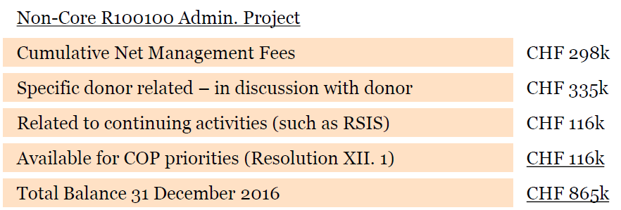
Source: Excerpt, Management Letter – Audit 2016, Detailed findings and recommendations 2016-1

- More specifically the Secretariat’s cursory review identified irregular financial management practices and account balances as follows:
- CHF 298,000. Earned management fees and non-core fund surplus/deficit were reclassified from various non-core project funds to the Admin Project Account R100100 without appropriate project close-out procedures and approvals to transfer balances.
- There was inconsistent accounting treatment and lack of transparency with inter-fund transfers moving balances between core and non-core funds.
- CHF 335,000. The description in the above table, “Specific donor related – in discussion with donor” refers to a cumulative net surplus balance of CHF 335,000, mainly in the Swiss Grant for Africa non-core fund accounts which was not adequately disclosed to the donor until late 2016.

- The Secretary General consulted with the Convention’s Executive Team, Facilitation Working Group, Subgroup on Finance, IUCN and PwC on the issues identified from the 2016 review. At the 53rd Meeting of the Ramsar Standing Committee, held from 29 May to 2 June 2017, the Committee instructed the Secretariat to carry out a more detailed review of non-core funds as described in the following decision:
Decision SC53-33: The Standing Committee instructed the Secretariat to take steps to undertake a financial / management review of non-core funds.

- The Secretary General requested the IUCN Oversight Unit (OU) to undertake the review and a consultant was contracted to assist the OU with the engagement.

Objectives, scope, and approach of this review

- The primary objective of the review was to provide assurance on the accuracy of financial account balances reported in Appendix A: Projects Financed by Restricted Funds of the audited financial statements, for the ten-year period from 2008 to 2017. It included a review of selected non-core funds such as the Admin Project fund account R100100, Swiss Grant for Africa fund accounts, and other project accounts. The review also identified financial and project management controls, and governance processes, that needed strengthening.

- An assessment of each non-core project at the transaction level was beyond the scope of the review; however, detailed analysis was carried out in several of the accounts of greatest concern. The OU leveraged prior transaction level analysis carried out by Secretariat on such accounts as the Admin Project fund account R100100.

- The review was carried out primarily through a data collection and construction phase to gather non-core information over the ten-year period from 2008 to 2017. This information was then examined, analyzed, cross-checked and reconciled from the general ledger detail recorded in SUN and NAV accounting systems to Appendix A: Projects Financed by Restricted Funds, and further checked to the audited Statement of Income and Expenditures. Standing Committee and Secretariat documents were also reviewed, interviews were carried out with Ramsar and IUCN management and staff, and discussions were held with the external auditor. The sample of funds selected for review was based on a judgmental approach and considered specific requests for assurance from the Secretariat, Contracting Parties, and the Subgroup on Finance. The assessment utilized criteria from relevant Ramsar and IUCN policies and procedures, the Swiss Code of Obligations, COSO Internal Control – Integrated Framework, and best practices identified in similar organizations.

- The review required substantial analysis and research due to the ten-year coverage period, linking information between two accounting systems (SUN 2008-2013; NAV 2014-2017) and gaining an understanding of transactions recorded in a somewhat fragmented financial information system. The proliferation of multiple project accounts established for certain non-core funds (e.g. Swiss Grant for Africa, Small Grants Fund) over the years as well as inconsistent general ledger transaction descriptions also added complexity in carrying out the analysis.

- Given the challenges in collating the financial information over the 10-year period, the review was designed as an advisory engagement which provides a lower level of assurance than an internal audit. The complexities in organizing financial information led to delays in completing the review and issuing the final report.

- Substantive work for the review was undertaken from January 2018 to July 2018. The review was carried out in accordance with the Institute of Internal Auditor’s international Standards for the professional practice of internal auditing, and the IUCN Internal Audit Policy.

Progress update provided to the Subgroup on Finance at SC54, April 2018

- On 23 April 2018, at the Convention’s 54th Standing Committee meeting (SC54), the IUCN Oversight Unit presented its Progress Report on the Financial Management Review of Ramsar Non-core Funds to the Subgroup on Finance. The OU described substantive work performed to validate non-core fund balances and that nothing had come to the attention of the internal auditor, at that time, that would indicate material inaccuracies in the account balances reported during the period 2008 to 2017.

- The Subgroup on Finance took note of the Oversight Unit’s presentation and requested further analysis on the fund accounts for Swiss Grant for Africa, the African Voluntary Contributions, and the Small Grants Fund.

Independence of the review

- The Oversight Unit did not encounter issues in discharging its work in an independent manner.

Other

- The OU would encourage the Secretariat and Subgroup on Finance to focus attention on utilizing the results of the review as a forward-looking exercise to further strengthen operational procedures and the system of internal control to increase confidence on financial management and reporting of non-core project funds.

- Tables in this report include possible rounding differences.

FINDINGS AND RECOMMENDATIONS

Governance

A higher level of assurance is needed to demonstrate effective systems of internal control in the Secretariat, including financial and operational control over non-core project funds

- The primary responsibility for oversight, establishing and maintaining financial and operational internal control rests with the Standing Committee and the Secretary General.

- The Convention’s external auditor considers the system of internal control to assess risk as part of the planning process for the financial audit engagement, as stated in the Report of the auditor and shown in the below box, however the external auditor does not provide assurance over the Convention’s system of internal control.

Figure 1 Excerpt, Report of the auditor, 2017 financial statements (highlights added)
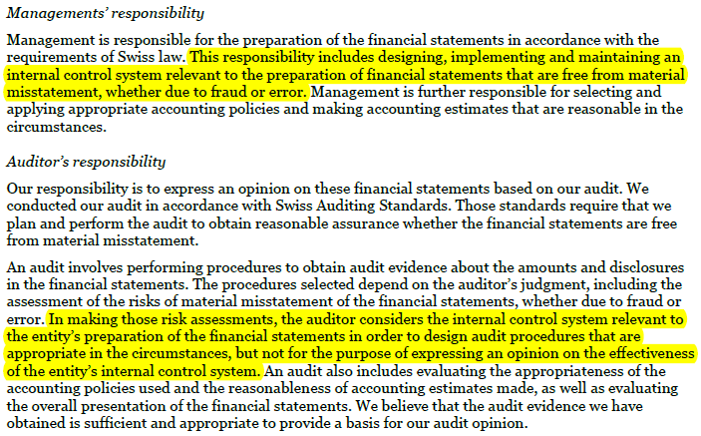
Source: Ramsar’s audited financial statements, 2017

- The review found that Appendix A: Projects Financed by Restricted Funds, appended to the Convention’s financial statements, provides readers with relevant information on non-core fund balances and trends. Appendix A is a management report and it is not audited by the external auditor as described in the below box.

Figure 2 Excerpt, Report of the auditor, 2017 financial statements
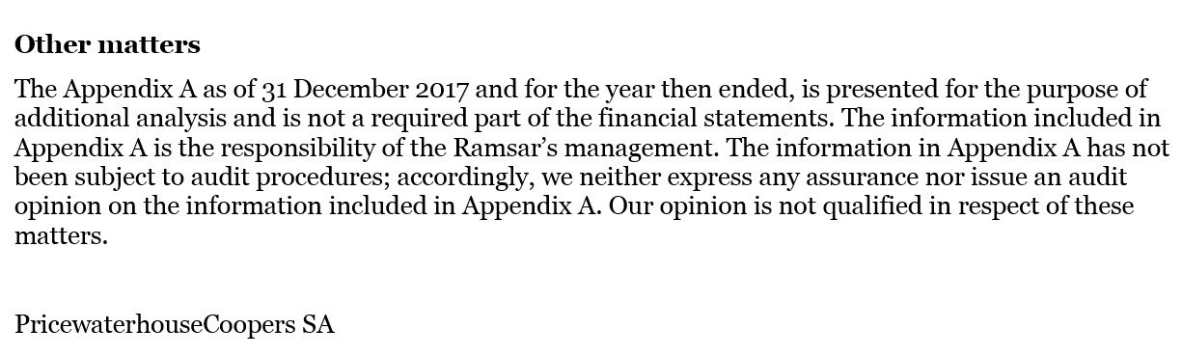
Source: Ramsar’s audited financial statements, 2017

- Therefore, no independent assurance is provided on the information in Appendix A, including individual non-core fund accounts. However, the external auditor does provide assurance on the overall account balances for Total Income, Expenditure, and Fund Balances for Restricted Funds (non-core funds), as these balances form part of the audited Balance Sheet and Statement of Income and Expenditure (see Annex 3).

- The inclusion of the unaudited Appendix A management report in the audited financial statements caused confusion for several readers as it was interpreted that independent audit assurance was provided. The OU discussed this matter with the Ramsar Secretariat, IUCN Global Finance Group, and the external auditor, and all parties were in agreement that removing the statement from the audited statements and presenting it to the Standing Committee (through the Subgroup on Finance) as a separate management report would add greater clarity (recommendation 3). The Subgroup on Finance took this into consideration during SC54, in April 2018, and the Standing Committee supported the action.

- The review also noted that the external auditor did not provided an annual briefing to the Standing Committee, through the Subgroup on Finance. The external auditor welcomed the opportunity to meet with the Subgroup. A briefing by the external auditor would provide a forum for the Members of the Subgroup to ask challenging questions on the financial audit, gain a fuller understanding on financial risk, and help to effectively discharge fiduciary responsibilities on risk management and internal control (recommendation 4).

- The review found that the Secretariat has significantly improved mechanisms to keep the Standing Committee informed of emerging financial and operational risks, and the Standing Committee, through the Subgroup on Finance, engages in a healthy level of challenge on financial matters and provides advice and direction to the Secretariat.

- However, the Secretariat does not provide overall assurance on the system of internal control and this includes financial control over non-core funds. This makes it more challenging for the Standing Committee and Subgroup on Finance to effectively discharge fiduciary responsibilities. It can also lead to overreach into the Secretariat’s operational affairs, normally under the delegated responsibility of the Secretary General.

- The Secretariat should consider developing a systematic and regular assessment of internal control that demonstrates to key stakeholders (e.g. Standing Committee, Subgroup on Finance, auditors) that key financial and operational controls are present and functioning as intended. A systematic assessment can be accomplished by first adopting an internal control framework, such as the COSO internal control framework as described in IUCN’s Policy on Internal Control (2018), and then undertake a regular self-assessment of the system of internal control at the entity-level and for key business processes, such as non-core project funds (recommendation 5). The OU and the external auditor have recommended that the Secretariat adopts a more systematic approach towards demonstrating how it monitors internal control. The self-assessment of internal control is now mainstreamed in many international organizations and this process can add significant value in providing assurance to stakeholders, particularly the Standing Committee.

- It should also be noted that IUCN’s recently issued Policy on Internal Control and Policy on Enterprise Risk Management adopts the Three Lines of Defense model which can assist the Standing Committee and Secretariat in clarifying risk control responsibilities between the governing bodies, senior management, operational management, auditors, and regulators.

- Recommendations:

Recommendation 3
The Secretariat should present Appendix A: Projects Financed by Restricted Funds to the Standing Committee as a separate management report and remove it from the Convention’s financial statements starting with the fiscal year 2018.
Priority: Medium
Due Date/Status: December 2018/In progress
Owner: Secretary General
Management response:
The Secretariat agrees with this recommendation and will fully implement this recommendation with the 2018 Financial Statements, in line with the decision 25 of Standing Committee 54 that approved the report and recommendations of its Finance Subgroup (SC54-WG.4 par 1 iii.) following the interim report of the IUCN Oversight Unit to the Subgroup on Finance. Current Appendix A will be removed from the financial statements and presented as a separate management report.

Recommendation 4
The Secretariat should invite the external auditor to provide the Standing Committee, through the Subgroup on Finance, with an annual presentation and briefing on the audited financial statements.
Priority: Medium
Due Date/Status: May 2019 /In progress
Owner: Secretary General
Management response:
The Secretariat welcomes this recommendation, and will propose it to the Standing Committee for its consideration and decision at the 57th meeting, taking into account practices of other Conventions as well as possible cost implications.

Recommendation 5
The Secretariat should: (i) develop an internal control self-assessment process; (ii) undertake an annual entity-level self-assessment of the internal control system and this should include a process-level assessment over non-core project funds; and (iii) present the self-assessment of internal control to the Standing Committee on an annual basis.
Priority: High
Due Date/Status: September 2019/In progress
Owner: Secretary General
Management response:
The Secretariat welcomes and agrees with this recommendation.
The following actions have been taken:
- The need for stronger internal controls has been consistently brought for consideration of the Ramsar Standing Committee and its Subgroup on Finance since early 2017, and work to strengthen internal controls has been ongoing with IUCN and the external auditors. In particular, it has been agreed with IUCN, the external auditors and the Subgroup on Finance to complete the parts in Ramsar which are not covered by IUCN’s internal controls. Therefore, following the 2017 external audit, internal control allocation between IUCN and Ramsar Finance has been further defined, with additional work pending on the outcomes of the IUCN Oversight Unit review.
- In parallel, the Secretariat has improved financial management processes and procedures, developed guidelines, provided training and included performance objectives in the annual work plans of managers to enhance its internal controls.

Actions that will be taken:
With the IUCN Oversight review being completed, the Secretariat will continue to strengthen its internal controls, using the recommendations provided on the internal control framework and process. The Secretariat will work to:

- Seek concurrence from the Subgroup on Finance on the proposed framework and process of internal controls to take the proposed next steps;
- Develop an internal control self-assessment process, preferably aligning with IUCN’s recently introduced self-assessment;
- Undertake an annual entity-level self-assessment of the internal control system, including a process-level assessment over non-core project funds; and
- Present the self-assessment of internal control to the Standing Committee on an annual basis.

Change in Fund Designation and Use

Procedures are needed to better regulate transfers between core and non-core funds, and for change in use of non-core funds

- The OU review began with a high-level verification and cross-check of the total balances for Income, Expenditure, and Project Transfers and Cross Charges as found in the (i) general ledger accounts, (ii) Appendix A, and (iii) the audited Statement of Income and Expenditure for the ten-year period 2008 to 2017. The below table provides a summary of the balances.

Table 2 Non-core Income Statement Balances from Appendix A, 2008 – 2017 (CHF ‘000s)
Accounts | 2008 | 2009 | 2010 | 2011 | 2012 | 2013 | 2014 | 2015 | 2016 | 2017 | Total
Income | 2,023 | 1,780 | 1,322 | 1,486 | 1,925 | 705 | 2,059 | 1,231 | 723 | 442 | 13,696
Expenditure | (2,479) | (1,531) | (1,623) | (1,588) | (2,060) | (1,195) | (1,633) | (2,803) | (1,237) | (734) | (16,883)
Project Transfers & Cross Charges | 146 | 287 | 326 | 151 | (12) | 815 | 729 | 287 | 277 | 0 | 3,006
Source: Appendix A

- Total amounts for Income, Expenditure, and Project Transfers and Cross Charges for non-core funds are reported in the Statement of Income and Expenditures of the audited statements and therefore the external auditor provides assurance on these balances. Furthermore, detailed balances are also reported in this Statement, for example in the Expenditure category, accounts for Communications (Outreach), Regional Advice, Initiatives and Support etc. are reported and therefore the external auditor also provides assurance on these account balances.

- To effectively discharge fiduciary responsibilities over non-core funds the Standing Committee and Secretariat place reliance on the audited financial statement balances, including non-core funds. It is therefore important that the external auditor formally presents their annual findings to the Standing Committee, through the Subgroup on Finance (see previous recommendation 4).

- The reported balances for Income, Expenditure and Project Transfers and Cross Charges were cross checked and agreed to the SUN general ledger detail from 2008 to 2013 and with the NAV general ledger detail from 2014 to 2017. Therefore, the overall reported balances for the 10-year period are considered highly reliable.

- As discussed earlier in this report, irregular financial management practices (e.g. lack of adequate approvals for inter-fund transfers between core and non-core) were noted by the Secretariat in its 2016 cursory review, therefore this review carried out further analysis on Project Transfers and Cross Charges.

- A total of CHF 3.006 million was transferred from core to non-core project funds during the 10-year period ending 31 December 2017. A breakdown of transfers is shown in the below table.

Table 3 Project Transfers and Cross Charges, Core to Non-core Funds, Total 2008 – 2017
Description of Transfers (Core to Non-core) | Amount CHF (‘000s)
Core Reserves and Annual Core Surplus | 909
Net amount to Regional Initiatives | 822
To Ramsar Sites Information Services (RSIS) and Web Development | 551
To Scientific and Technical Review Panel (STRP) | 308
All other categories | 416
Total | 3,006
Source: Ramsar documents and general ledger accounts

- The review cross-checked the detailed categories of Project Transfers and Cross Charges, shown in the Table 4, below, from the general ledger detail in SUN (2008-2013) and NAV (2014-2017) to totals shown in Table 3, above, and to Appendix A.

Table 4 Project Transfers and Cross Charges, Core to Non-core Funds, Detail 2008 – 2017 (CHF ‘000s)
From Core to Non-core (unless otherwise stated) | 2008 | 2009 | 2010 | 2011 | 2012 | 2013 | 2014 | 2015 | 2016 | 2017 | Total
2008 Excess Reserve | 59 |  |  |  |  |  |  |  |  |  | 59
2009 Reserve Fund Release |  | 25 |  |  |  |  |  |  |  |  | 25
2013 Allocate Excess Reserve |  |  |  |  |  | 366 |  |  |  |  | 366
2014 Surplus |  |  |  |  |  |  | 459 |  |  |  | 459
Regional Initiatives | 52 | 121 | 112 | 151 | 93 | 52 | 120 | 107 | 120 |  | 927
Regional Initiatives to Core |  |  |  |  | (105) |  |  |  |  |  | (105)
RSIS and Web Development |  |  |  |  |  | 174 | 120 | 140 | 117 |  | 551
STRP | 36 | 46 | 87 |  |  | 30 | 30 | 40 | 40 |  | 308
Science Review |  |  |  |  |  | 80 |  |  |  |  | 80
Strategic Plan SC46-23 |  |  |  |  |  | 30 |  |  |  |  | 30
Reach out SG Campagne |  |  |  |  |  | 110 |  |  |  |  | 110
CEPA |  | 8 |  |  |  |  |  |  |  |  | 8
Partnership |  | 87 | 142 |  |  |  |  |  |  |  | 229
Other (to Core) |  |  | (15) |  |  | (28) |  |  |  |  | (43)
Total | 146 | 287 | 326 | 151 | (12) | 814 | 729 | 287 | 277 | 0 | 3,006
Source: Ramsar documents, general ledger accounts

- While no irregular balances were noted when comparing general ledger balances to Appendix A, the review confirmed the Secretariat’s September 2016 findings that not all inter-fund transfers between the core cost center and non-core projects were clearly communicated and approved by the Standing Committee. The Standing Committee has the authority to approve the Convention’s core budget and clear procedures should be in place for transfers between unrestricted core funds and restricted non-core funds, as they impact the Standing Committee’s overall decisions on use of funds (recommendation 6).,

- In addition, only the donor can determine if a donation is restricted or not, and for what particular programme or purpose the donation is used for. It is not only a moral obligation for Convention to honor a donor’s wishes, but also it is normally required by the contract or agreement to do so. If a donor restricts a donation to a particular purpose and the Convention does not comply, the donor can demand a refund. Therefore, any change in designation or use should follow contractual stipulations set out in the documentation that accompanies the award. It is good practice, and usually a contractual requirement, to obtain agreement when there is a change of designation or use of a non-core fund by a letter from the donor or through an explicit agreement between the donor and the Convention (recommendation 7).

- Recommendations:

Recommendation 6
The Secretariat should develop a standard procedure for inter-fund transfers between the core and non-core budgets and include a ‘fund transfer approval request’ process requiring approval (this could be designed as post-facto approval) from the Standing Committee.
Priority: Medium
Due Date/Status: Fully implemented
Owner: Secretary General
Management response:
The following actions have been taken:
- The Secretariat agrees and notes that this recommendation has already been implemented. Transfers between core and non-core budgets have been discontinued in 2017 following a recommendation made by the Secretariat to SC53 and subsequent approval by SC53. Any transfer between core and non-core budgets if justified in particular circumstances since then requires prior approval by the Standing Committee and its subsidiary bodies as appropriate.
- The Secretariat has reported since 2017 all balances to the Finance Subgroup and the Standing Committee has taken a decision on their allocation. Further, the Secretariat has introduced a new way to present the budget in 2018, adding a column with the approved use of the previous year’s surplus.

Recommendation 7
The Secretariat should develop a standard procedure to obtain a donor’s agreement, in writing, when non-core funds are being considered for a change in use, including transfers to the core cost center.
Priority: High
Due Date/Status: Fully Implemented
Owner: Secretary General
Management response:
The Secretariat agrees and notes that this recommendation has already been implemented.
The following actions have been taken:
Since May 2017, following various discussions within the Ramsar Secretariat and the issuance of instructions by the Secretary General, balances of donor agreements are used in accordance with what is stipulated in the respective donor agreements and the use of balances, where applicable, reported to and authorized by respective donors before any actions are taken by the Secretariat. Examples include donor reports for the 2016 Swiss Grant on Africa, Danone project, NORAD project and MAVA project.

Actions that will be taken:
The instructions issued will be integrated in the Standard Operating Procedures (SOP) being developed by the Secretariat, covering the whole project life-cycle until its closure.

Admin Project Fund Account

Develop a standard cost recovery approach for management fees, and project close-out procedures are needed

- The non-core account, Admin Project Fund Account R100100, has been primarily used for transferring management fees earned from supporting non-core projects, transferring surplus/deficits of closed projects, and for recording miscellaneous income and expenditure transactions.

- A concern raised by the Secretariat and Subgroup on Finance was the significant increase in the Admin Project Account starting in 2015 with a year-end balance of CHF 625,000, which had not been adequately scrutinized until the cursory review in September 2016. Table 5 below provides the summary of account balances and trend over a ten-year period. Table 6 categorizes the changes to the Admin Project Account by major type.

Table 5 Admin Project Account Balances, Ten-year Detail 2008 – 2017 (CHF ‘000s)
Accounts | 2008 | 2009 | 2010 | 2011 | 2012 | 2013 | 2014 | 2015 | 2016 | 2017 | Total
Opening balance | 65 | 114 | 142 | 221 | 235 | 122 | 170 | 7 | 625 | 865
Income | 0 | 34 | 25 | 35 | 0 | 0 | 2 | 0 | 6 | 4 | 107
Expenditure | (46) | (73) | (18) | (27) | (19) | (2) | (223) | 123 | 122 | 0 | (163)
Transfers / Cross charges | 95 | 68 | 71 | 6 | (94) | 50 | 58 | 495 | 112 | (74) | 787
Closing balance | 114 | 142 | 221 | 235 | 122 | 170 | 7 | 625 | 865 | 795
Source: Appendix A

- The significant increase in Project Transfers and Cross Charges in 2015 and 2016 were largely due to closing out multiple aged and dormant project accounts from the Swiss Grant for Africa funds. These transfers were reported in the 2015 Appendix A, as shown in the below box. As previously recommended (recommendation 7), change in use of non-core funds requires the donor’s explicit agreement.

Figure 3 Excerpt, Report of the auditor, 2015 financial statements, Appendix A
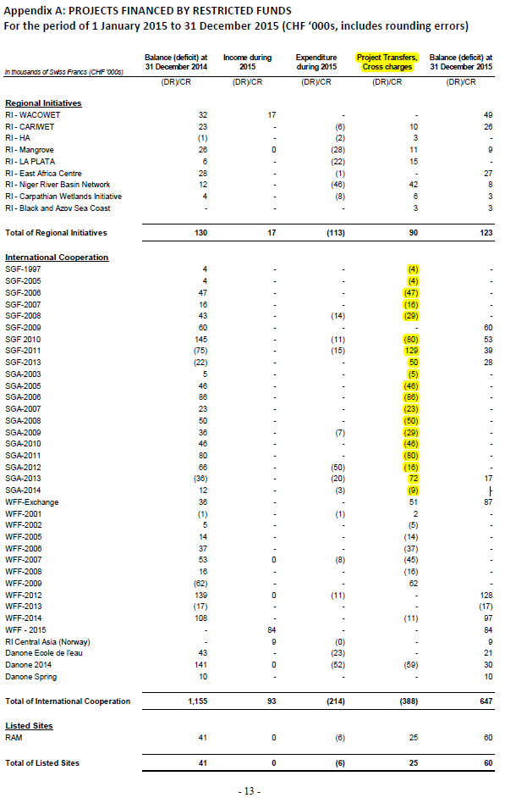

Table 6 Admin Project Account, Summary of Changes by Type, 2008 – 2017 (CHF ‘000s)
Description | Balance  2008 | 2008-2016 Change | Balance 2016 | 2017  Change | Balance  2017
Opening balance at 1 January 2007 | 37 |  | 37 |  | 37
Net Management Fees | 28 | 234 | 262 | 38 | 299
Specific donor related – in discussion with donor, FEON regarding SGA | 0 | 335 | 335 | 6 | 341
Related to continuing activities (such as RSIS) | 0 | 116 | 116 | (116) | 0
Available for COP priorities (Resolution XII.1) | 2 | 114 | 116 | 0 | 116
Projects closed in 2017 |  |  | 0 | 3 | 3
Total | 66 | 799 | 865 | (70) | 795
Source: Oversight Unit
- The OU review validated the balances in Table 5 and 6 to the general ledgers in both accounting systems and no discrepancies were found with the accuracy of balances.

- As shown in Table 6, a total of CHF 299,000 from 2008 to 2017 was reported as Net Management Fees earned by the Secretariat based on grant or contract agreement conditions with the donors. The OU review assessed the Secretariat’s transaction level review of the Admin Project Account carried out in September 2016, including a list of management fees charged from 2005 to 2016. No irregularities were noted other than a transaction for CHF 177,000 in 2012, which was found to be part of a journal entry to allocate funds from the Admin Project Account to Web, RSIS and Development Projects. The transaction allocated some earned Management Fees to projects for their use and was accepted. Also, the Secretariat provided an explanation as to why the 2015 Management Fees were higher than 2013 and 2014, which was due to fees for Danone in 2012, 2013 and 2015 were taken in the same year.

- The review noted that Management Fees for projects were not being charged on a regular basis during the 10-year period, for example the Swiss Grant for Africa and Small Grants Funds, and therefore the Secretariat should take action to recover Management Fees not previously invoiced and collected, and ensure going-forward that Fees are charged in accordance with donor agreements (recommendation 8).

- The question as to whether Management Fees should be recorded to a non-core account (i.e. Admin Project Account) or to a core cost center account was discussed with the Secretariat and IUCN Global Finance Group. However, the discussion led to more fundamental questions as to what ‘Management Fees’ represents for Ramsar, for example what proportion of recovery applies to direct project costs and indirect project costs, and what is the cost recovery framework used for non-core projects (e.g. full cost recovery method, pooled non-core funds). Over the past several years’ other international organizations have also explored these questions driven by the change in balance between core and non-core funding, and the increasing effect of core funding subsidizing non-core projects. These organizations have now developed fit-for-purpose cost recovery policies and frameworks with principles of simplify, transparency, and a harmonized methodology. The OU review recommends that the Secretariat follows this approach by designing and applying a standard cost recovery framework that aligns with its constituents’ expectations, and operational realities (e.g. transaction costs, consistency with IUCN’s cost recovery methodology) (recommendation 8).

- The balance of CHF 341,000, shown in Table 6, relates to transfers from the non-core Swiss Grant for Africa (SGA) fund accounts. The analysis of SGA is presented in the next section of this report.

- As previously discussed, surpluses or deficits from aged dormant projects were closed out by recording final balances to the Admin Project Account. However, some projects were closed without providing the donor with a final report and seeking direction/approval to retain ‘unutilized’ project funds. This practice does not reflect prudent financial and project management practices, nor does it comply with most donor agreements. The surplus/deficit of the closed project should be recorded to the appropriate account which best reflects the donor’s instructions. The review recommends that a project close out procedure is developed to provide needed guidance and establishes a standard process (recommendation 9). Annex 4 provides an example of a close out procedure from the UNDP Non-core Better Practice Guide.

- Recommendations:

Recommendation 8
The Secretariat should: (i) compute and charge outstanding management fees from prior years to non-core projects, where possible; (ii) develop a process to ensure management fees are charged in accordance with donor agreements on a regular basis and at least annually; and (iii) develop and apply a standard cost recovery approach for management fees.
Priority: Medium
Due Date/Status: June 2019/In progress
Owner: Finance Officer
Management response:
The Secretariat agrees with the recommendation and has already done / implemented the following:

- All known management fees for the last two years have been charged. We note that currently not all projects include management fees in the donor agreement and therefore, not all projects incur management fees. For past cases where there is lack of clarity and consistency, the Secretariat finds it difficult to charge management fees retroactively and therefore proposes to focus on clarifying the approach for the future. For example, no management fees are charged for Ramsar Advisory Missions and not all grants for the Swiss Grants for Africa foresee management fees. For example, no management fees are foreseen in the 2016 SGA grant and as such, no management fees were charged.
- The process of charging management fees is being done on an annual basis before finalizing the yearly financial statements, starting with the 2016 financial statements. This is now part of the year-end accounting checklist and is cross-checked by IUCN.
- The Secretariat agrees with the need to have a standard cost recovery approach for management fees and actions are being taken in this regard. The Secretariat has brought to the attention of the Finance Subgroup the need for clearer guidance on the use of non-core funding including management fees since SC53. SC54 instructed the Secretariat to use IUCN policies and procedures as well as guidelines for the management of non-core funds, especially in regards to the capacity to implement projects and the use of management fees (SC54-WG.4 par 3x). In accordance with decisions taken at SC54, a respective paragraph was included in the Draft Resolution on financial and budgetary matters for consideration and decision by COP13.

Actions to be taken:
With a view to developing and applying a standard cost recovery approach for management fees, the Ramsar Secretariat will review IUCN’s methodology as well as the practices of other Conventions regarding management fees and will propose possible approach(es) including its / their implications to SC57 for its consideration and decision.

Recommendation 9
The Secretariat should develop a project close out procedure for non-core projects. The procedure should include timely project close outs (e.g. within one year of project closure) and a final report, both narrative and financial, be prepared, reviewed and submitted to the donor. Any unspent balances should be treated in line with the terms agreed upon with the donor(s) (e.g. agreed to refund any ‘unutilized’ balance).
Priority: High
Due Date/Status: July 2019/In progress
Owner: Secretary General
Management response:
The Secretariat agrees and actions are being taken to implement project close out procedures.

Specifically, actions already taken are:
- Instructions have been issued the latest in June 2018 by the Secretary General and Senior Management is taking ownership and following-up on reporting and submitting both narrative and financial reports, whereas financial reports are being prepared and/or verified and signed by the Finance Officer.
- Since May 2017, all unspent balances have been reported and treated in line with terms stipulated in the donor agreements, in line with this recommendation.

Actions to be taken:
Moving forward, the Secretariat will review the UNDP non-core Better Practice Guide and develop in 2019 further guidance as part of its work in developing Standing Operating Procedures.

Swiss Grant for Africa Fund Accounts

Higher quality project reporting is needed for donors, and donor approval is needed for change in use for unutilized balances

- The Swiss Grant for Africa non-core fund is a contribution offered by the Federal Government of Switzerland to support wetland conservation and wise use and implementation of the Convention in Africa. This annual contribution began in 1989 and has been extremely useful in financing suitable emergency action, or for specific activities.

- A major concern raised by the Secretariat and Subgroup on Finance was the existence of a significant surplus balance in the SGA Project fund accounts. At 31 December 2014, the accumulated surplus balance totaled CHF 416,000, as shown in the below table. A related concern identified in the 2016 cursory review was the transfers in the amount of CHF 335,000 from the SGA Account to the Admin Project Account in 2015 and 2016. The transfers were not approved by the donor nor was the Subgroup on Finance appropriately advised on the transfers. As previously discussed, this is a significant departure from proper financial management practices.

- Table 7 shows a closing balance at 31 December 2017 of a CHF 49,000 surplus. The actual surplus is CHF 390,000, comprising of CHF 49,000 plus pre-2017 transfers to the Admin Project Account totaling CHF 341,000 (see Table 6).

Table 7 Swiss Grant for Africa Fund Account, Income Statement Detail 2008 – 2017 (CHF ‘000s)
Accounts | 2008 | 2009 | 2010 | 2011 | 2012 | 2013 | 2014 | 2015 | 2016 | 2017 | Total
Opening balance | 267 | 195 | 381 | 391 | 423 | 402 | 473 | 416 | 17 | 52
Income | 0 | 319 | 149 | 90 | 70 | 125 | 124 | 0 | 120 | 0 | 996
Expenditure | (58) | (112) | (93) | (58) | (75) | (54) | (181) | (80) | (68) | 1 | (779)
Transfers / Cross charges | (15) | (20) | (46) | 0 | (16) | 0 | 0 | (318) | (17) | (6) | (436)
Closing balance | 195 | 381 | 391 | 423 | 402 | 473 | 416 | 17 | 52 | 49
Source: Appendix A and general ledger accounts

- Table 7 was developed from a detailed matrix consisting of the 15 SGA project accounts from 2008 to 2017. The balances for each project account was validated from the general ledger details in SUN and NAV to Appendix A. The below table provides total balances.

Table 8 Swiss Grant for Africa Fund Account, Income Statement Total 2008 – 2017
Description | Amount CHF (‘000s)
Opening balance 1 January 2008 | 267
Income | 996
Expenditure | (779)
Project Transfers and Cross Charges | (436)
Closing balance 31 December 2017 | 49
Source: Oversight Unit
- As shown in Table 8 above, the opening SGA surplus at 1 January 2008 was CHF 267,000.
CHF 68,000 was spent after 1 January 2008 and related to pre-2008 SGA Projects. The remaining pre-2008 SGA surplus was CHF 199,000. The pre-2008 surplus of CHF 199,000 was included as part of the total surplus amount that was transferred to the Admin Project Account.

- Total income for the SGA Fund was CHF 996,000 over the ten-year period. The Swiss Federal Office for the Environment (FOEN) contributed CHF 962,000, or 97 percent, World Wildlife Fund (WWF) contributed CHF 30,000, and CHF 4,000 was from other sources.

- From 2008 to 2017, CHF 47,000 in Management Fees were paid from the Fund, as shown in Table 9. The review found that Management Fees were not charged each year and therefore the Secretariat should take action to recover the Fees due (recommendation 8).

Table 9 Swiss Grant for Africa, Project Transfers / Cross Charges, Total 2008 – 2017
Description | Amount CHF (‘000s)
Management Fees | (47)
Transfer from SGA to Admin Project Account | (341)
Other | (48)
Total 2008 - 2017 | (436)
Source: Oversight Unit

- From 2008 to 2017 CHF 341,000 in transfers were made from the SGA Fund Account to the Admin Project Account, consisting of CHF 318,000 (2015), CHF 17,000 (2016), and CHF 6,000 (2017). The transfers were made by the Secretariat without full donor knowledge and approval and without clear communication to the Standing Committee. The Secretariat took steps to correct this by first notifying FOEN, then discussing this issue with the Standing Committee through Facilitation Working Group. The FOEN was also provided with official correspondence in May 2017, explaining the finding.

- The review traced ‘Other’ transfers of CHF 48,000 out of the SGA fund mainly relate to: (i) CHF 20,000 in 2009 to project 7200 – Cote d’Ivoire Judiciares W shop, and (ii) CHF 30,000 in 2010 to project 7145 STRP Africa Meeting.

- The OU reviewed donor reports sent to the Swiss Federal Office for the Environment (FOEN) for the years 2008 to 2014, and 2016, and found that the Secretariat had provided progress reports, however final reports for closed projects were not provided. The Secretariat should work towards providing higher quality progress and final reports to the FOEN that include full financial and programmatic information on the activities undertaken utilizing their contributions (recommendation 10).

- The Subgroup on Finance inquired as to whether transactions had been made between the Africa Voluntary Contributions fund and SGA Project Account. The review did not find any transfers from the African Voluntary Contributions (AVC) to the Swiss Grant for Africa Project Account.

- The review found inconsistent coding of transactions and use of descriptions, for example the different descriptions “Donat.08 from Switzerland”, “SGA 2009 from Switzerland” and “Suisse SGA 2011 Inv 1111” were used for SGA income from FOEN. This adds unnecessary complexity, creates inefficiencies and reduces transparency. Also, improved consistency of coding is needed when entering transactions into NAV. The review noted that the Secretariat’s Finance Officer took action to address these issues by developing guidelines for Ramsar Secretariat staff on proper use of code combinations and descriptions.

- Recommendation 10
The Secretariat should provide higher quality progress and final donor reports for the Swiss Grant for Africa Projects including narrative and financial information on the activities undertaken utilizing the contributions. Financial information should be reviewed and validated by the Finance Officer, prior to issuing the report. Final reports should be issued in a timely manner (e.g. within one year of project closure). Any unspent balances should be treated in line with terms agreed upon with the donor(s). To enhance quality, the report should be peer reviewed prior to issuance to the donor(s). And consideration should be given to adopting a common donor reporting format/template for all non-core projects.
Priority: High
Due Date/Status: March 2019/In progress
Owner: Secretary General
Management response:
The Secretariat agrees with this recommendation.

The following actions have been already taken:
- Instructions have been issued by the Secretary General in November 2017 and June 2018 and discussions have been held in various Ramsar Senior Management Team meetings on project management including donor reporting. Indicators for financial management have also been including in the performance objectives of all managers.
- All financial reports since May 2017 have been established and/or reviewed and validated by the Finance Officer and Senior Management has been following-up on the timely issuance of final reports and has reviewed final reports prior to their issuance.
- Since May 2017, all balances have been reported on and treated in line with donor agreements.

Actions to be taken:
- The Ramsar Secretariat will include guidance on donor reporting in its Standard Operating Procedures. It will develop a common donor reporting template for those donors who do not require specific templates, drawing on any such templates and practices developed by IUCN.
- The Secretariat will also further strengthen compliance with donor reporting requirements in a timely manner, including the peer review process recommended.

Clarifications:
- The Secretariat wishes to clarify that the CHF 6K transferred from the 2016 SGA to the admin project in 2016 (see paragraph 79 above) relates to an unspent part of a grant related to WA RegPark which was returned to Ramsar beginning of 2016 and erroneously credited to SGA 2016 project whereas it related to an earlier SGA project. In 2017, this error was corrected by moving the amount to the admin account where all prior SGA2016 balances are located and reported to the donor.
2. The Standing Committee will need to decide at SC57 on the recommendation of the IUCN Oversight Unit to replenish the African Voluntary Contributions (see paragraph 107) taking into account: i) the decision taken by the SC46-12.2 which allocated CHF 45K from African Voluntary Contributions accumulated from 2009-2012 to Regional Initiatives within the core budget (see paragraph 104); and ii) the authorization from SC54 to use of the balance of CHF29K of the WACOWET Regional Initiative where African Voluntary Contributions were previously transferred to for funding of sponsored delegates to COP13 (see SC54-WG.4, table 1).

Small Grants Fund Accounts

No material issues noted, however management fees should be regularly charged

- The Small Grants Fund (SGF) was established in 1990 to help developing countries support the conservation and wise use of wetland resources. As its name indicates, the SGF is intended for small-scale projects and offers a maximum of CHF 40,000 per project. The Fund is financed from voluntary contributions and any additional revenues received by the Ramsar Bureau.

- The primary reason for selecting this non-core account was due to questions raised as to whether funds were transferred into this account in error, particularly funds from the African Voluntary Contributions. It was also selected as part of a judgmental sample, selecting at least one account from the fund category ‘International Cooperation’.

- The opening balance for SGF at 2008 was CHF 501,000. From 2008 to 2017, total Income was CHF 834,000, Expenditure CHF 1,185,000, and Project Transfers and Cross Charges amounted to CHF 13,000 from the Fund, as shown in the below table.

Table 10 Small Grants Fund, Income Statement Account, Detail 2008 – 2017 (CHF ‘000s)
Accounts | 2008 | 2009 | 2010 | 2011 | 2012 | 2013 | 2014 | 2015 | 2016 | 2017 | Total
Opening balance | 501 | 442 | 357 | 500 | 507 | 422 | 318 | 221 | 181 | 137
Income | 64 | 154 | 298 | 158 | 150 | 10 | 0 | 0 | 0 | 0 | 834
Expenditure | (104) | (247) | (181) | (138) | (221) | (113) | (98) | (40) | (44) | 1 | (1,185)
Transfers/Cross Charges | (20) | 8 | 25 | (13) | (13) | (1) | 0 | 0 | 0 | 0 | (13)
Closing balance | 442 | 357 | 500 | 507 | 422 | 318 | 221 | 181 | 137 | 138
Source: Appendix A and general ledger accounts
- The review validated the Opening balance, Income, Expenditure and Transfers/Cross Charges to the general ledger detail in SUN (2008-2013) and NAV (2014-2017), and to Appendix A for each of those years. No discrepancies were noted.

Table 11 Small Grants Fund, Income Statement, Total 2008 – 2017
Description | Amount CHF (‘000s)
Opening balance at 1 January 2008 | 501
Income 2008 - 2017 | 834
Expenditure 2008 - 2017 | (1,185)
Project Transfers/Cross Charges 2008 - 2017 | (13)
Closing balance at 31 December 2017 | 138
Source: Oversight Unit

- Income over the ten-year period for SGF totaled CHF 834,000. The Government of Japan contributed CHF 145,000 with CHF 689,000 in voluntary contributions from other donors such as the Governments of Norway, Sweden, Germany and Canada. There was not enough detailed information in the accounting systems to determine whether the full CHF 145,000 from the Government of Japan was fully spent due to mixing of donations.

- Evidence of other voluntary contributions made by the Government of Japan were observed during this review. Contributions were made for the Nagao Wetland Fund, Regional Initiative Workshop in Central Asia and the Bhutan project.

- The review found that the reported closing balance of CHF 138,000 at 31 December 2017 was a result of accumulated balances from 2009, 2010, 2011, and 2013 SGF projects.

- The review investigated the details of Project Transfers and Cross Charges.

Table 12 Small Grants Fund, Project Transfers / Cross Charges, Total 2008 – 2017
Description | Amount CHF (‘000s)
Management Fees | (75)
Transfer to other open SGF Projects | (410)
Transfer from other SGF Projects | 410
Other (Transfers from other Projects) | 62
Total Transfers / Cross Charges | (13)
Source: Oversight Unit

- Similar to the Swiss Grant for Africa fund, management fees were not charged in all years for the Small Grants Funds (recommendation 8).

- During the ten-year period there was CHF 410,000 transferred between SGF project years.

- The CHF 62,000 of ‘Other’ transfers to SGF include: (i) CHF 24,000 in 2009 from the Japan Vol. Contr. for 1997-99 (Asia Fund) project, and (ii) CHF 38,000 in 2010 from the Evian project.

- The Subgroup on Finance requested assurance on whether funds were transferred between the Africa Voluntary Contributions and SGF Project Account. The review did not find any transfers from the African Voluntary Contributions (AVC) to the SGF.

WACOWET and African Voluntary Contributions

No material issues noted, however CHF 33,000 is needed to replenish the account

- The West African Coastal Zone Wetlands Network (WACOWET) and the African Voluntary Contributions (AVC) are initiatives to foster cooperation and capacity-building on wetland-related issues in the region.

- The Subgroup on Finance requested additional assurance on WACOWET and AVC non-core account balances at the SC54 in April 2018.

- The two tables below provide a trend analysis of the main income statement accounts for WACOWET Fund Accounts 7125 and R100132 (2009 – 2015), and for AVC, R100200 (2016 – 2017).

Table 13 WACOWET Income Statement Accounts, Detail 2009 – 2017 (CHF ‘000s)
Accounts | 2009 | 2010 | 2011 | 2012 | 2013 | 2014 | 2015 | 2016 | 2017 | Total
Opening balance | 17 | 13 | 22 | 38 | 8 | 19 | 32 | 49 | 49
Income | 6 | 9 | 16 | 17 | 11 | 13 | 17 | 0 | 0 | 88
Expenditure | (10) | 0 | 0 | (1) | 0 | 0 | 0 | 0 | 0 | (11)
Transfers / Cross charges | 0 | 0 | 0 | (46) | 0 | 0 | 0 | 0 | 0 | (46)
Closing balance | 13 | 22 | 38 | 8 | 19 | 32 | 49 | 49 | 49
Source: Appendix A

Table 14 African Voluntary Contributions, 2016 – 2017 (CHF ‘000s)
Accounts | 2016 | 2017 | Total
Opening balance | 0 | 14 | 0
Income | 14 | 15 | 29
Expenditure | 0 | 0 | 0
Project Transfers / Cross charges | 0 | 2 | 2
Closing balance | 14 | 31 | 31
Source: Appendix A

- Income was recorded in the WACOWET Project fund account from 2009 to 2015 and the AVC Project Account for 2016 and 2017. The only exception is CHF 2,000 which was originally recorded in the Admin Project Account in 2017 and was subsequently corrected to the AVC Project Account in the same year.

- The annual Opening Balances, Income, Expenditure, Cross Charges and Closing Balances in the general ledger detail for 2009 to 2013 (SUN) and 2014 to 2017 (NAV) were reviewed and cross checked to Appendix A for the nine-year period. No irregularities were noted.

- Total AVC income for the period reviewed was CHF 113,000.

- Expenditures for the WACOWET Project relate to the 2009 opening balance. Otherwise there were no expenditures incurred and relating to AVC.

- In 2012, a CHF 46,000 transfer was made from WACOWET to the core budget. The transfer was reported at the SC46 Financial and budgetary matters 2012/2013 as follows:

“Regional Initiatives (line C) – allocations were made as agreed at SC44 (utilizing core budget and CHF 45,000 from 2009-2012 accumulated African voluntary contributions and CHF 32,000 of other non-claimed Regional Initiative allocations during 2009-2012).”

- The review noted a CHF 10,000 transfer was a correcting entry, reversing a provision originally made in the core cost center and then reversed back to WACOWET project.

- At 31 December 2017 the WACOWET and AVC surplus totaled CHF 80,000 (CHF 49,000 + 31,000).

- To replenish the AVC surplus to CHF 113,000, it will be necessary to either: (i) transfer CHF 33,000 from core back to the AVC project or (ii) transfer CHF 33,000 from the Admin Account Project to the AVC project.

Ramsar Advisory Missions

No material issues noted

- Where a Ramsar Site’s ecological character is threatened, the Contracting Party can request a Ramsar Advisory Mission (RAM). This mechanism was formally adopted in 1990. It enables both developed and developing countries to apply global expertise and advice to the problems and threats that could lead to a loss in ecological character to a wetland.

- RAM non-core accounts are categorized under ‘Listed Sites’ in Appendix A, and transactions are recorded in accounts 7002 and R100110.

- The annual Project Opening Balance, Income, Expenditure, Project Transfers/Cross Charges and Closing Balance amounts were reviewed, and cross checked from the SUN and NAV general ledger detail for 2008 to 2013, and 2014 to 2017, respectively, to Appendix A.

Table 15 Ramsar Advisory Missions, Income Statement, Detail 2008 – 2017 (CHF ‘000s)
Accounts | 2008 | 2009 | 2010 | 2011 | 2012 | 2013 | 2014 | 2015 | 2016 | 2017 | Total
Opening balance | 26 | 5 | 28 | 15 | 7 | 35 | 85 | 41 | 60 | 90
Income | 8 | 17 | 0 | 0 | 32 | 0 | (24) | 0 | 47 | 81 | 162
Expenditure | (29) | (4) | (13) | (9) | (4) | 0 | (19) | (6) | (18) | (73) | (174)
Project Transfers / Cross Charges | 0 | 10 | 0 | 0 | 0 | 50 | 0 | 25 | 0 | 0 | 85
Closing balance | 5 | 28 | 15 | 35 | 35 | 85 | 42 | 60 | 90 | 98
Source: Appendix A

- The review covered the account balances from 1 January 2008, with an opening RAM balance of CHF 26,000 surplus, to the 31 December 2017 closing balance of CHF 98,000.

- The Net Income balances were validated over the ten-year period totaling CHF 162,000. The negative balance in 2014 was traced to a return of unused funds of CHF 24,000.

- Project Transfers and Cross Charges, totaling CHF 85,000, were traced to transfers from the core budget to RAM in 2009, 2013 and 2015, and related to surplus from the core fund.

- The review investigated as to whether any AVC funds were transferred into RAM and found no evidence of such transactions.

Annex 1 Summary of Recommendations
Recommendations | Priority | Owner(s) | Management  Response | Status / Date | Risk  Category
- The Secretariat should consider adopting standard terms to describe its funds, either ‘core and non-core’ funds or ‘unrestricted and restricted’. | Low | Secretary General | Agreed. To be put forward to SC57 for decision. | In progress  May 2019 | Financial
- The Secretariat should provide programme managers with access to the Navision financial accounting system in order to facilitate monitoring of non-core project financial transactions and budgets, and to produce financial reports from the official accounting system for donor reporting purposes. | Medium | Secretary General | Agreed. Guidance already issued in May 2017, procedures strengthened. The official accounting system is being used for donor reporting. Actions to be taken include the provision of the same information to programme managers as in IUCN. | In progress  May 2019 | Operational  Financial
- The Secretariat should present Appendix A: Projects Financed by Restricted Funds to the Standing Committee as a separate management report and remove it from the Convention’s financial statements starting with the fiscal year 2018. | Medium | Secretary General | Agreed. Recommendation to be implemented with 2018 financial statements. | In progress  December 2018 | Financial  Governance
- The Secretariat should invite the external auditor to provide the Standing Committee, through the Subgroup on Finance, with an annual presentation and briefing on the audited financial statements. | Medium | Secretary General | Agreed. To be put forward to SC57 for decision. | In progress  May 2019 | Governance  Financial
- The Secretariat should: (i) develop an internal control self-assessment process; (ii) undertake an annual entity-level self-assessment of the internal control system and this should include a process-level assessment over non-core project funds; and (iii) present the self-assessment of internal control to the Standing Committee on an annual basis. | High | Secretary General | Agreed. Work to strengthen internal controls has been ongoing since early 2017 with IUCN and the external auditors and consideration by SC. The IUCN Framework issued in 2018 will be presented for concurrence to the Subgroup on Finance and subsequently SC57, an internal control self-assessment process developed and an annual entity-level self-assessment undertaken to be presented to the Standing Committee. | In progress  September 2019 | Operational  Financial  Governance
- The Secretariat should develop a standard procedure for inter-fund transfers between the core and non-core budgets and include a ‘fund transfer approval request’ process requiring approval (this could be designed as post-facto approval) from the Standing Committee. | Medium | Secretary General | Agreed. Recommendation has been fully implemented. Such transfers were discontinued in 2017, and if needed, will require approval from SC. All balances since 2017 reported to SC which has approved allocations – approved allocations included in budget presentation. | Complete. Fully implemented in 2017 | Financial
- The Secretariat should develop a standard procedure to obtain a donor’s agreement, in writing, when non-core funds are being considered for a change in use, including transfers to the core cost center. | High | Secretary General | Agreed. Recommendation has been fully implemented. All donor reporting since May 2017 includes balances and request authorization for their use. Instructions issued will be combined in a Standard Operating Procedure. | Complete. Fully implemented in May 2017 | Operational  Financial
- The Secretariat should: (i) compute and charge outstanding management fees from prior years to non-core projects, where possible; (ii) develop a process to ensure management fees are charged in accordance with donor agreements on a regular basis and at least annually; and (iii) develop and apply a standard cost recovery approach for management fees on non-core projects. | Medium | Finance  Officer | Agreed and already partly implemented: Known management fees already charged and yearly process of charging management fees is in place. SC54 gave guidance to the Secretariat. Standard approach to be developed and presented to SC57 for decision. | In progress  June 2019 | Operational
- The Secretariat should develop a project close out procedure for non-core projects. The procedure should include timely project close outs (e.g. within one year of project closure) and a final report, both narrative and financial, be prepared, reviewed and submitted to the donor. Any unspent balances should be treated in line with the terms agreed upon with the donor(s) (e.g. agreed to refund any ‘unutilized’ balance). | High | Secretary General | Agreed. Recommendation has been partially implemented already: Instructions have been issued and unspent balances have been reported appropriately since May 2017. The Secretariat will formally include the project close out procedure in the Standard Operating Procedures which are being developed. | In progress  July 2019 | Financial
- The Secretariat should provide higher quality progress and final donor reports for the Small Grant for Africa Projects including narrative and financial information on the activities undertaken utilizing the contributions. Financial information should be reviewed and validated by the Finance Officer, prior to issuing the report. Final reports should be issued in a timely manner (e.g. within one year of project closure). Any unspent balances should be treated in line with terms agreed upon with the donor(s). To enhance quality, the report should be peer reviewed prior to issuance to the donor(s). And consideration should be given to adopting a common donor reporting format/template for all non-core projects. | High | Secretary General | Agreed. Recommendation has been partly implemented: Instructions were issued in November 2017 and June 2018, financial reports have been established and/or reviewed by Finance Officer and all balances have been treated in line with donor agreements since May 2017. The part remaining is the possible development of donor reporting templates which will be looked at jointly with IUCN. | In progress  March 2019 | Operational  Financial

Annex 2 Secretariat Organizational Structure

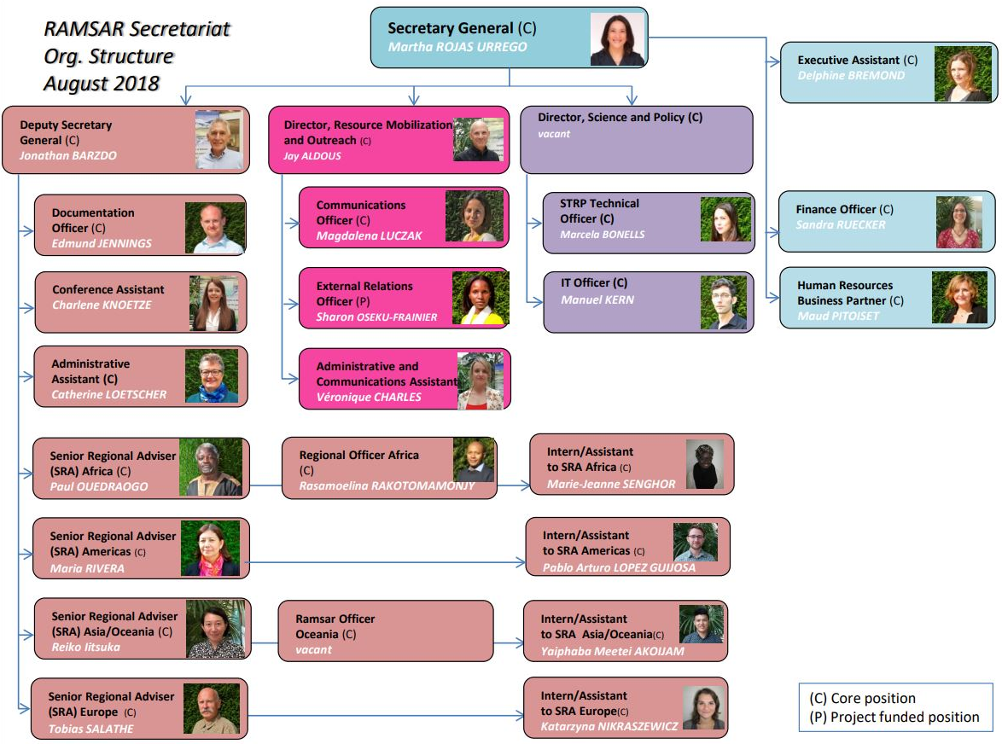

Annex 3 Key Financial Statements

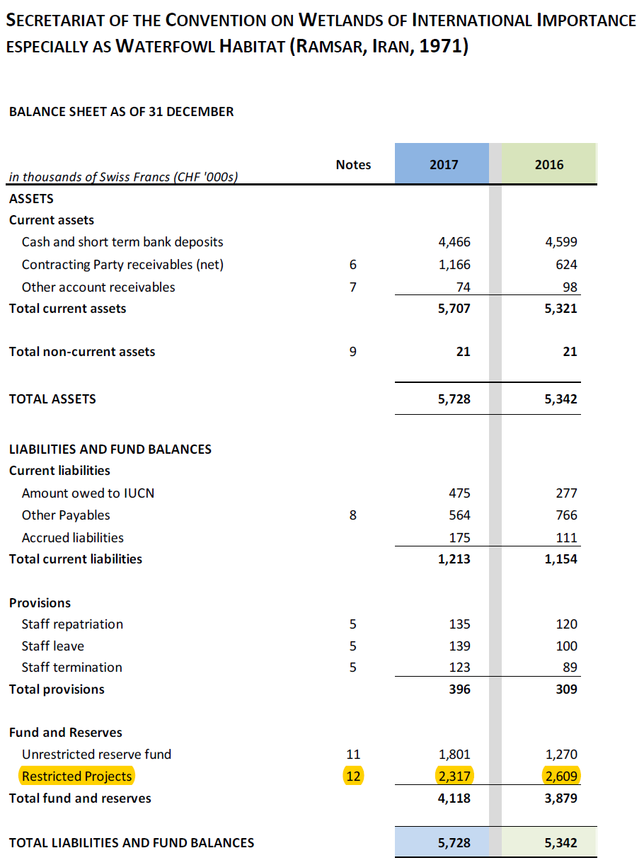
Balance Sheet (Audited) Statement of Income and Expenditure (Audited)
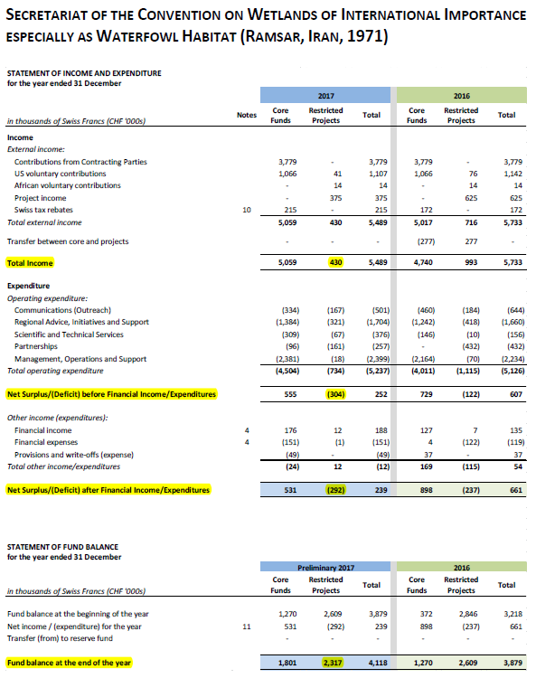

Annex 4 Example Non-core Close Out Procedure, UNDP

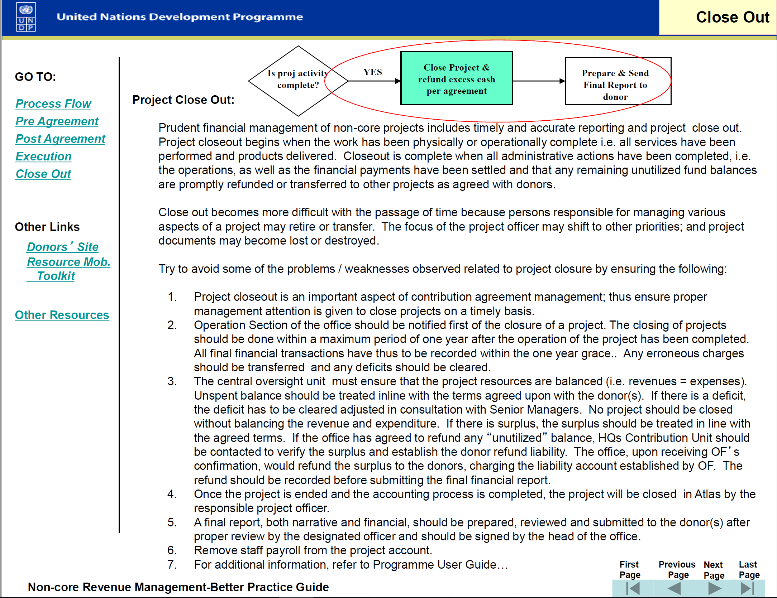

The Standing Committee of the Ramsar Convention oversees Convention affairs and the activities of the Secretariat. It represents the Conference of the Contracting Parties (the COP) between its three-yearly meetings, within the framework of the decisions made by the COP.
The opinion provides ‘negative’ assurance (i.e. nothing came to the auditor’s attention) rather than reasonable assurance, as the engagement was designed as an advisory assignment and not an internal audit assignment due to scope limitations resulting from challenges in compiling financial data for a 10-year period.
The IUCN Oversight Unit has committed to working with the Ramsar Secretariat to map and assess its entity-level system of internal control, and key process-level controls such as project management processes for non-core funds.
A rating of ‘partially satisfactory’ means that important (but not critical or pervasive) deficiencies exist in governance, risk management or control processes, such that reasonable assurance may be at risk regarding the achievement of control and/or business objectives under review.
About Ramsar
Report of the auditor on the financial statements 2017, page 7; Delegation of Authority to the Secretary General, Ramsar 1993
Report of the auditor on the financial statements 2017, page 14
Convention on Wetlands of International Importance especially as Waterfowl Habitat, Article 6, para. 5; Resolution 5.2: Financial and budgetary matters, 1993; Delegation of Authority to the Secretary General, Ramsar 1993
The Swiss Code of Obligations establishes the statutory framework for accounting and auditing in Switzerland.
SC53-02, Report of the Secretary General, 29 May – 2 June 2017
The current Secretary General was appointed at SC52 on 22 August 2016.
SC53, May-June 2017. The Subgroup on Finance discussed the Secretariat’s proposal to discontinue the practice of transfers from core to non-core funds from 2017 onwards and carry-forward any balances within the triennium as per Res. V.2 Annex 3, par. 8 and, if necessary, create a designated reserve.
In late 2016, the Secretariat took steps to inform the Swiss Government, Federal Office for the Environment (FOEN) of the surplus balance of CHF 335,000. This was followed by discussion with the Standing Committee through Facilitation Working Group. The FOEN was also provided with official correspondence in May 2017, explaining the finding.
Joint Inspection Unit, JIU/REP/2017/7,Review Of Donor Reporting Requirements Across The United Nations System, 2017
An advisory engagement aims to provide value-added advice using the professional skills of the OU. An audit engagement provides an opinion on an assessment of internal control, risk management and/or governance processes on the audited area. The scope of the review and fragmented financial information systems did not support assurance being provided at an audit level.
SC54-WG.4 Report of the Subgroup on Finance, April 2018
Convention on Wetlands of International Importance especially as Waterfowl Habitat, Article 6, para. 5; Resolution 5.2: Financial and budgetary matters, 1993; Delegation of Authority to the Secretary General, Ramsar 1993
SC54-WG.4 Report of the Subgroup on Finance, April 2018 “The Subgroup on Finance recommend that Appendix A, of the 2016 and 2017 audits, containing an overview of non-core funding should be – in future – excluded from the financial statements and published in separate reports to the Standing Committee.”
COSO Internal Control – Integrated Framework
Management Letter – Audit 2016, Detailed findings and recommendations 2016-1 Recommendation by external auditor: We recommend to finalise the review of non-core projects and ensure that balances are reviewed on a regular basis to prevent re-occurrence of this.
For example, the UN adopted a formal risk control management approach and the Three Lines of Defense United Nations System, Action on the Risk Management, Oversight & Accountability Model, 2014
SC53-20, May-June 2017, para. 20.“The Subgroup on Finance discussed the Secretariat’s proposal to discontinue the practice of transfers from core to non-core funds from 2017 onwards and carry-forward any balances within the triennium as per Res. V.2 Annex 3, par. 8 and, if necessary, create a designated reserve.
Convention on Wetlands of International Importance especially as Waterfowl Habitat, Article 6, para. 5; Resolution 5.2: Financial and budgetary matters, 1993
According to documents reviewed, it was a long standing practice to transfer unutilized fund balanced into the Admin Project non-core fund account without explicit approval from the donor nor adequate communication of these transactions to the Standing Committee. In 2016, this was recognized as an unacceptable practice and corrective action was taken.
In 2018 the donor, Swiss Government, Federal Office for the Environment (FOEN), agreed to allocate up to CHF 100,000 of the surplus for the African Preparatory Meeting for COP13.
In 2017 the 2016 surplus balance of CHF 116,000 was transferred to RSIS, CEPA, AVC, COP 2018 and SC54. 2017 Journal Entries GJ000631, 632, 642 & 643 and 654 for AVC.
For example, 2010 UNEP Programme Support Costs; Analysis of funding of operational activities for development of the United Nations system for 2011, C. Non-core funding and cost recovery, pg. 48
According to documents, the former Finance Officer discussed the SGA transfers from 2015 with the external auditor.
On 26 May 2017, the Secretary General officially informed the Swiss Government, Federal Office for the Environment (FOEN) of the cumulative surplus of in the Swiss Grants for Africa in the amount of CHF 335,000 (SG2017-87 /MRU/SR/deb).
The review found that the Secretariat issued instructions to Ramsar staff on 02 November 2017 and a reminder was issued on 01 June 2018 that all financial reports required review and sign-off by the Finance Officer.
SC54-7 Financial and budgetary matters Status of annual contributions, para. 15-17 and Annex 2; Some discrepancies with total of CHF 113,000 due to non-AVC income included in CHF 88,000 due to WACOWET accrual reversal; and the AVC “Project Transfers/Cross charges” CHF 2,000.
After the CHF 46,000 transfer from WACOWET to core, the net remaining amount of CHF 33,000 is needed back in AVC to replenish AVC to CHF 113,000 (80,000 + 33,000 = 113,000).

