**Using the Ramsar Sites Information Service**

These instructions are intended to help Contracting Parties designate a new Wetland of International importance, update the information on an existing Ramsar Site, and check the status of an ongoing designation.

The instructions cover:

* Definitions and roles
* Getting started
* Designating a new Ramsar Site
* Updating an existing Ramsar Site

# Definitions and roles

Ramsar Site: Contracting Parties to the Ramsar Convention undertake to designate at least one wetland site for inclusion in the List of Wetlands of International Importance (the Ramsar List). There are over 2,000 of these Ramsar Sites on the territories of 168 Contracting Parties across the world.

RSIS: The Ramsar Sites Information Service provides online information on Ramsar Sites. Until 2014 it was hosted by Wetlands International. It now has its own dedicated web site managed by the Ramsar Convention Secretariat at rsis.ramsar.org.

RIS: The Ramsar Information Sheet is the form used for compiling information on new and updated Ramsar Sites. Until 2014 it was a Microsoft Word form; now the RIS is an online form within the new RSIS.

The National Focal Point of the Administrative Authority (AA) leads the designation and updating of Ramsar Sites for the Contracting Party. He/she is responsible for launching the designation/update process and submitting the completed form to the Secretariat’s Regional Team.

The RIS Compiler (RC) puts together the information needed to designate a new Site or update an existing one.

The Ramsar Secretariat’s Regional Teams (RTs) review the information submitted and work with the Contracting Parties to ensure it is correct and complete. They also provide support on using the new RSIS and RIS.

# Getting started

1. **Logging in**

To add or update information on the RSIS, you need to log in. At rsis.ramsar.org, select the ***Log in*** button in the top right corner to access the restricted *MANAGE MY SITES* section. Enter your unique username and password, following the instructions which were sent to you by the Secretariat.

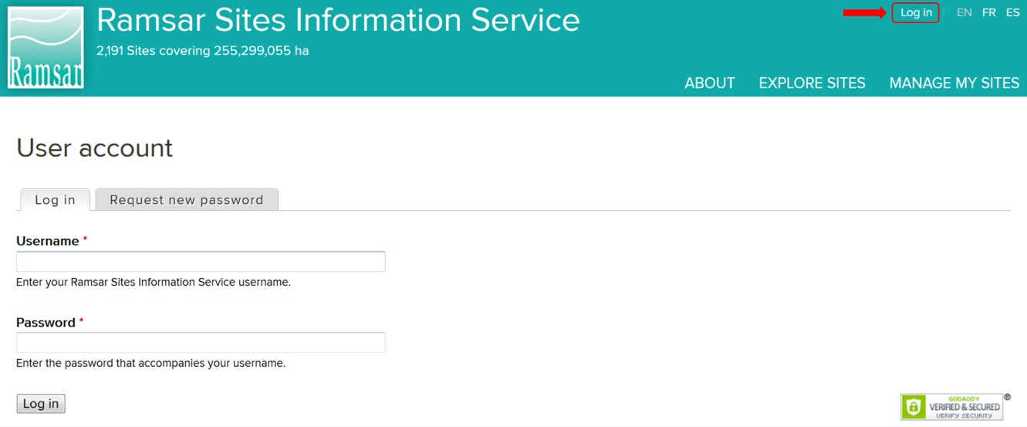

If you have not received this message or would like it to be sent again, please send us an email at [rsisadmin@ramsar.org](mailto:rsisadmin@ramsar.org), including your name and country.

The AA is responsible for choosing the RIS compilers. If you need an additional RIS Compiler account, send an e-mail to [rsisadmin@ramsar.org](mailto:rsisadmin@ramsar.org) indicating your country name, the e-mail address and the first and last names of the new RIS Compiler. The Ramsar Secretariat will create a new account.

# Designating a new Ramsar Site

The flow chart summarizes the process of designating a new Ramsar Site. Each step is outlined in the paragraphs below. You are responsible for the steps allocated to your role, marked either ‘AA’ or ‘RC’.



1. **Creating a new Ramsar Site**

Click on ***Create new Ramsar Site***.

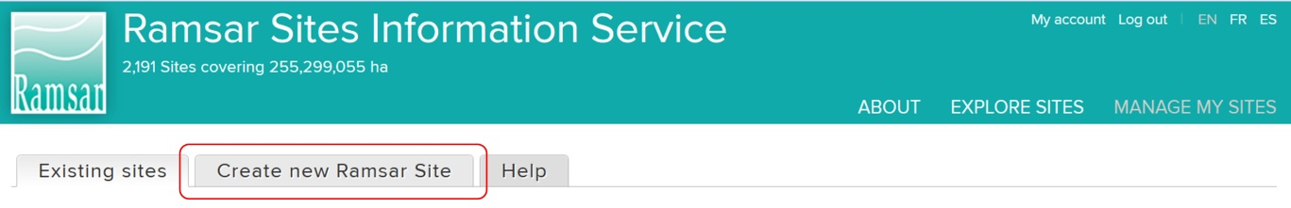

Your name and your role will appear at the top right corner of the page. Submit the following information in the drop-down menus:

* Country
* Language
* RIS Compilers – choose which RC or RCs can edit the RIS.

Insert the name of the new Ramsar Site and click on ***Create new Site***. The name should be in English, French or Spanish, except for place names which can remain in the local language. Take care to use this ‘official’ name consistently throughout the designation process.

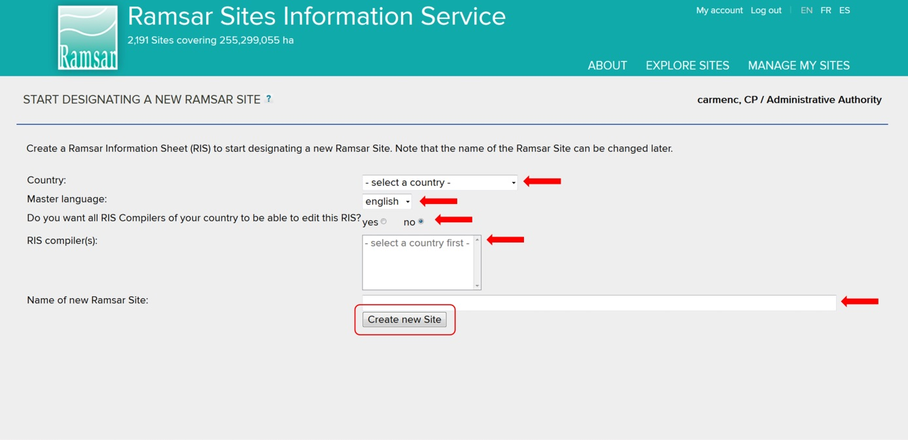

The designation process has been launched, and the form is now accessible to you and to the RC or RCs who you have selected.

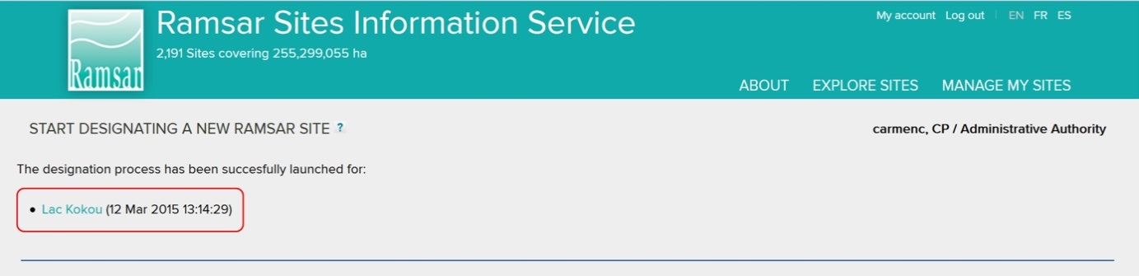

Note: The system does not include an automatic email alert. Send the RC or RCs an email to let them know that the Site is ready for them to start compiling!

1. **Compiling the RIS**

You will receive an email from your AA. Log in (following the instructions in step 1) to access the *MANAGE MY SITES* section with a list of pending and designated Ramsar Sites.

In the list of pending Sites for which the RIS is not yet finalized, the Site which the AA has just created for you to compile will have the status ***Opened***. To start compiling the information on the Site, click on the triangle in the ***Actions*** column, then select ***Edit***.

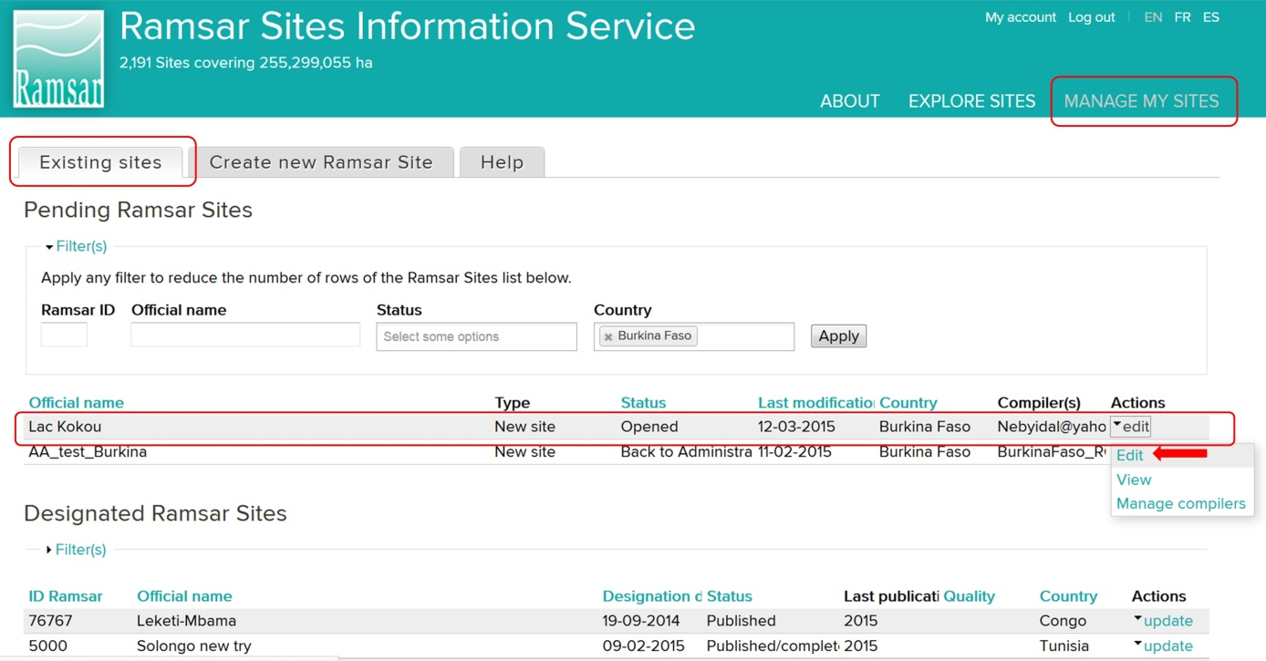

The home page of the RIS for the new Site will open (see below). It includes four boxes with background information:

* About the online Ramsar Information Sheet
* The designation process
* How to compile the RIS
* What if information is missing?

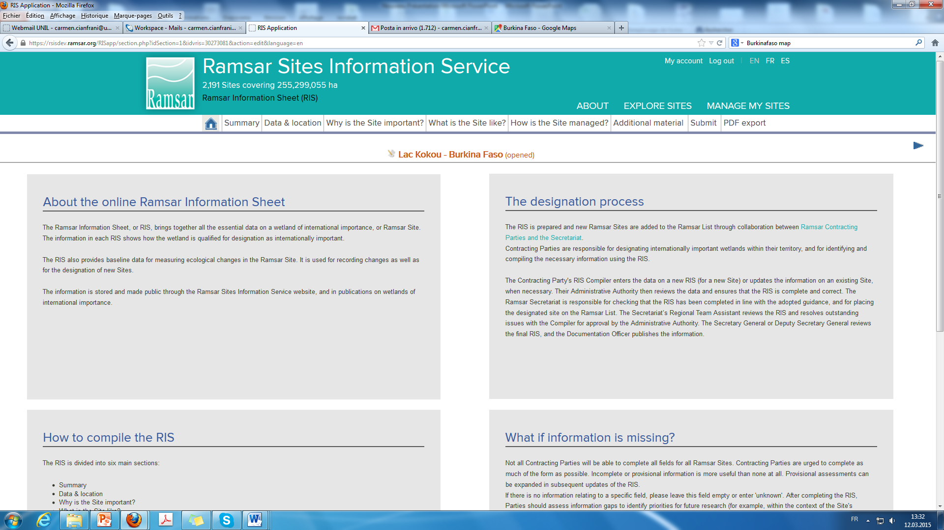

The RIS form is made up of six sections, which are in the tabs below the green banner:

* Summary
* Data & location
* Why is the Site important?
* What is the Site like?
* How is the Site managed?
* Additional material

Complete all the sections carefully.

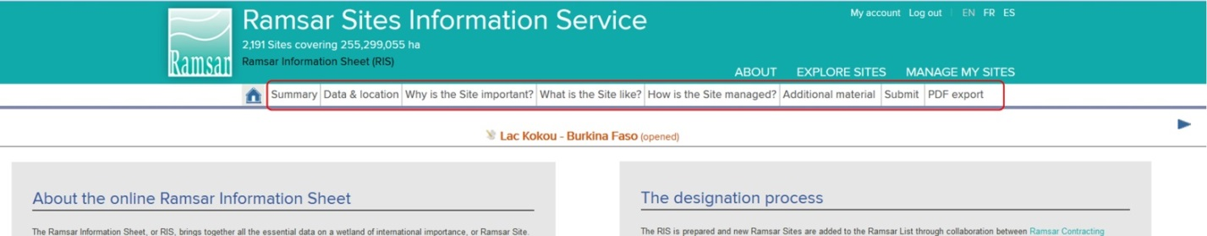

On each page you can view:

* the name of the Site, the country and the status of the RIS
* a bar that indicates the progress of the current RIS section

There is also:

* a button to save your work. Remember to always press save before leaving a page, otherwise any new inputs will be lost!
* buttons to go to the previous or next section. Don’t forget to save your work first!
* help buttons for fields if required. These will open context-sensitive guidance which may include a link to the *Strategic Framework and guidelines for the future development of the List of Wetlands of International Importance of the Convention on Wetlands.* The *Framework*, which was approved by Parties at COP11, has been amended to reflect the new online RIS format. In addition, for a wide range of information and guidelines for the application of the Ramsar criteria in designating new Sites, please refer to Ramsar Handbook 17, “Designating Ramsar Sites”, which is available online at [www.ramsar.org/sites/default/files/documents/pdf/lib/hbk4-17.pdf](http://www.ramsar.org/sites/default/files/documents/pdf/lib/hbk4-17.pdf).

Click on ***PDF export*** to make a copy in pdf format of all the sections of your RIS.

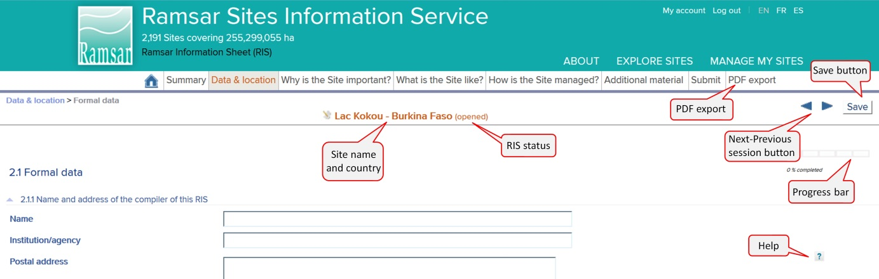

1. **Submitting the form to the AA**

After completing all the necessary information, click on the ***Submit*** tab. Summary bars will indicate the percentage of the possible information completed, in total and for each of the six sections. Note that it may not be necessary to complete 100% of each section to submit the form, as some fields may not be applicable.

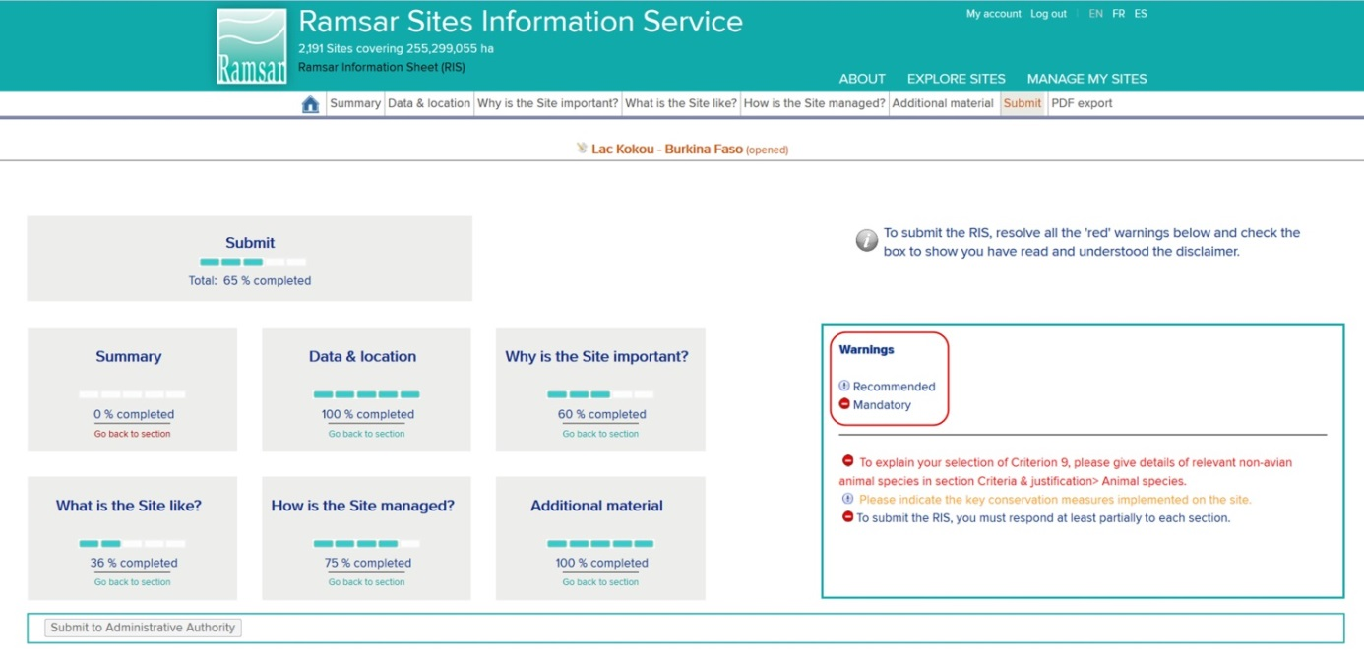

On the right hand side, the ***Warnings*** box lists any fields which have not been completed according to the requirements of the system. If they are not mandatory, they are listed in **orange**. Mandatory fields are listed in **red**. You must complete these mandatory fields before you submit the RIS to the AA.

PLEASE NOTE: Submitting a Site where the GIS shape file generates a surface area that differs from the official Site area will automatically generate a red warning, if the discrepancy between the two areas is greater than 3% of the Site area.

Click on the warning phrase to go to the relevant section: once you have completed the missing information, save the page and click on the ***Submit*** tab again to review the new status.

Once all mandatory information has been provided, the red warning messages will no longer appear. At this point a ***Submit to Adminstrative Authority*** button appears in the bottom left corner. Click on the button to send the information to the AA for review.

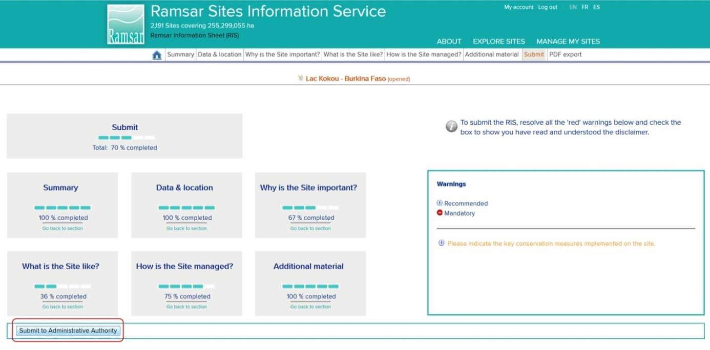

****Note: The system does not include an automatic email alert. Send the AA an email to let them know that you have finished compiling information on the Site.

1. **Reviewing and approving the content of the RIS**

When you receive an email from the RC, you can review the compiled RIS. Log in, and select the *MANAGE MY SITES* section(see Step 1). You will find in the list of pending Sites the Site which has been compiled by the RC or RCs and submitted to you for review. This Site will appear with the status of ***Submitted to Administrative Authority***.

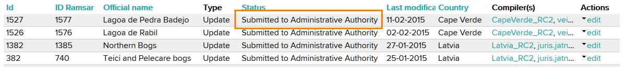

Review the information submitted and decide whether further input by the RC or RCs is required. If you decide that the RIS form need further input, send it back to the RC or RCs. Click on the ***Submit*** tab and select the button ***Back to RIS Compiler****.*  Tick the disclaimer box.

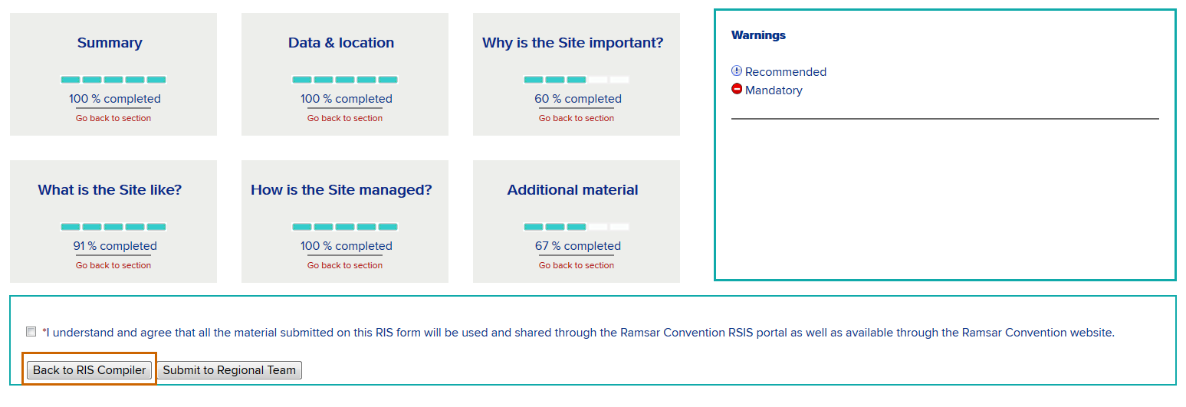



Send an e-mail to the RC or RCs listing the issues and indicating what further input is needed.

1. **Refining the RIS**

When the AA sends back the RIS form for further input, and you receive the email indicating the required information, you must add the missing information (see step 3) and resubmit it (as in step 4) until the AA is satisfied and submits the RIS to the RT.

1. **Submitting the RIS**

Ifyou decide thatthe information added by the RC or RCs is sufficient, send the form to the Secretariat’s Regional Team (RT) by clicking on the button ***Submit to Regional Team.***

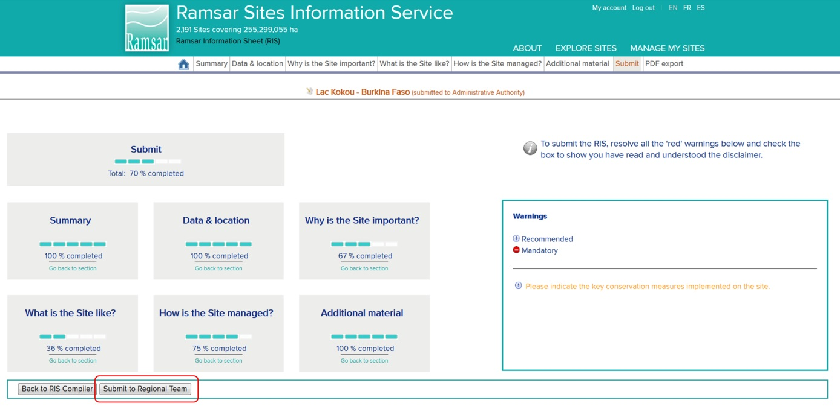

The Site will now be listed in the PENDING RAMSAR SITES list with the status ***Submitted to Regional Team***.

****The Regional Team will receive an automatic alert that the RIS has been submitted. You do not have to send an email yourself.

1. **Checking of the RIS by the Secretariat’s Regional Team**

The Regional Team (RT) verifies that the RIS is complete, by reviewing and validating each field. If further work is required, the RT adds comments to the fields for which more information or changes are needed, saves the amended RIS, and sends it back to the AA.

1. **Managing RT feedback**

The Site now appears in the PENDING RAMSAR SITES list with the status ***Back to Administrative Authority***. You will receive an email from the Regional Team to let you know that the RIS is again ready for your review.

You may resolve the outstanding issues of the RIS yourself, or work with RCs to do so. Log in to the *MANAGE MY SITES* section, select the Site and click on ***edit*** in the ***Actions*** column.

The fields which the RT has validated can no longer be edited. Fields which the RT has not validated will be highlighted in the *SUBMIT* section. The sections with outstanding issues will be listed at the bottom right hand side, under the heading ***Unvalidated Comments***.

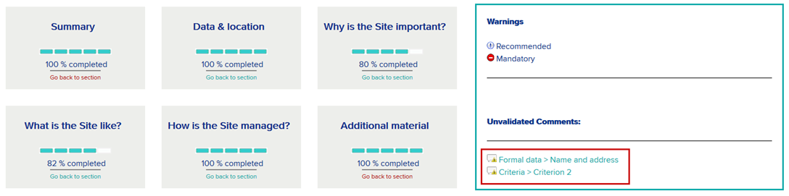

If you are able to resolve the issues yourself, you can do so following the instructions in step 10 below, and resubmit to the RT in the same way as before (see step 7 above). Otherwise, you can send it on to the RC or RCs by clicking on the button ***Back to RIS Compiler***.



Send an e-mail to the RC or RCs listing the issues and indicating what further input is needed.

1. **Reviewing RT comments**

When the RC or RCs receive an email from the AA asking for further input, they can find the Site in the PENDING SITES list with the status ***Back to RIS Compiler***. They should select ***edit*** and view the unvalidated comments in the ***Submit*** section. As noted above, the AA may also be able to resolve issues directly.

When one of the sections highlighted in the ***Unvalidated comments*** list is selected, the relevant page will open.



Unvalidated fields are highlighted in yellow, and show this icon: If you click on the icon a comments box will open, in which the RT has explained the issue and how to resolve it.

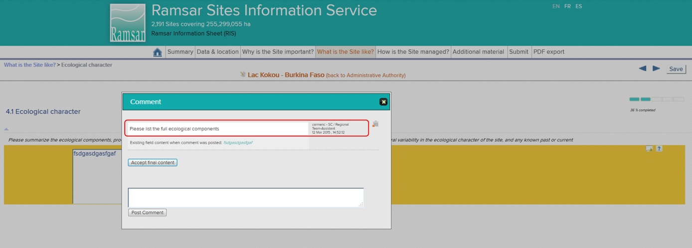

If appropriate, amend the field and post a new comment in the comments box to clarify what you have done. Otherwise, you can keep the original text in the field and explain it in the comments box.

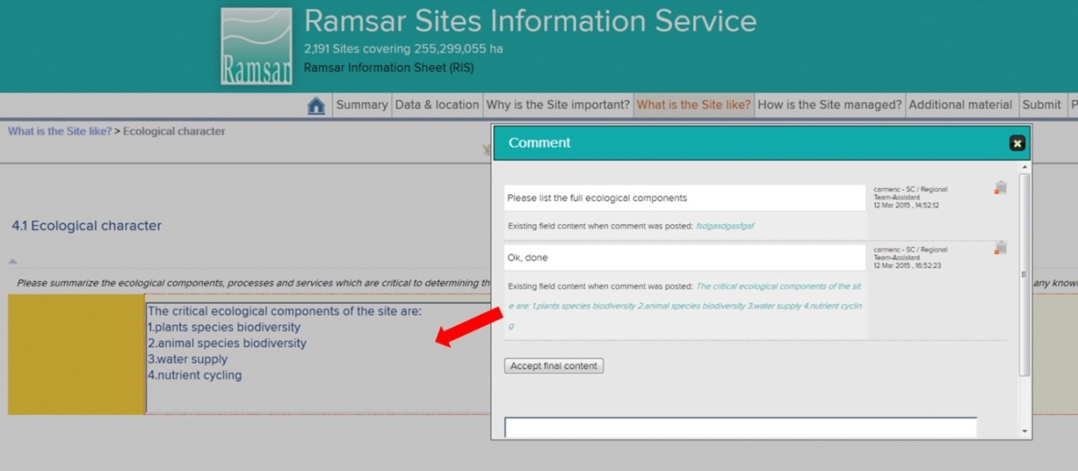

1. **Resubmitting to AA**

When the RC has responded to all the outstanding issues, they should resubmit the RIS to the AA, following the instructions at step 4.

1. **Checking and resubmitting to RT**

The AA checks the latest content of the RIS. If the RC or RCs have still not resolved any of the outstanding issues, add a comment on the field in question and send the RIS back (see step 5). If you are satisfied that the issues have been resolved, add any comments you think helpful and submit the RIS again to the RT (as in step 7).

The RT will then review the amendments and comments, validate fields, and if any issues are still not resolved, send the RIS back to the AA with new comments on any fields that remain unvalidated. The AA and RC or RCs will then repeat steps 9 - 12 until all the fields are validated.

The RT will then forward the RIS to the Deputy Secretary General who will screen the application, and may at this stage send the RIS back to the RT with questions for clarification. Once the RIS has been given final approval by the Deputy Secretary General, it is forwarded to the Documentation Officer for assignation of a new Ramsar Site number and publishing of the Site summaries in the official languages of the Convention. The official Ramsar Site certificate can then be issued.

# How to update an existing Ramsar Site

To update an existing Ramsar Site, it is necessary to start the process with some specific actions. Each of these steps is outlined in the paragraphs below. The remaining actions are also required for designating new Sites, and so you will be directed to the relevant steps in the previous section. You are responsible for the steps allocated to your role, marked either ‘AA’ or ‘RC’.

1. **Launching the update process**

Log in following the instructions at step 1 above. In the restricted *MANAGE MY SITES* section, the list of DESIGNATED RAMSAR SITES for your country will appear. Identify the Site to be updated, click on the triangle in the ***Actions*** column and then select ***Update****.*

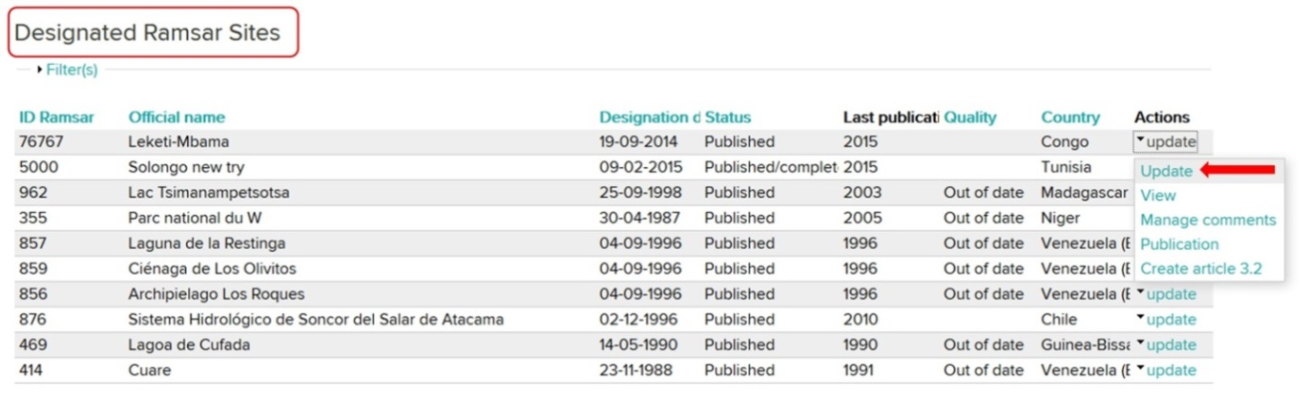

A warning message will appear: to continue the process, click ***OK***.

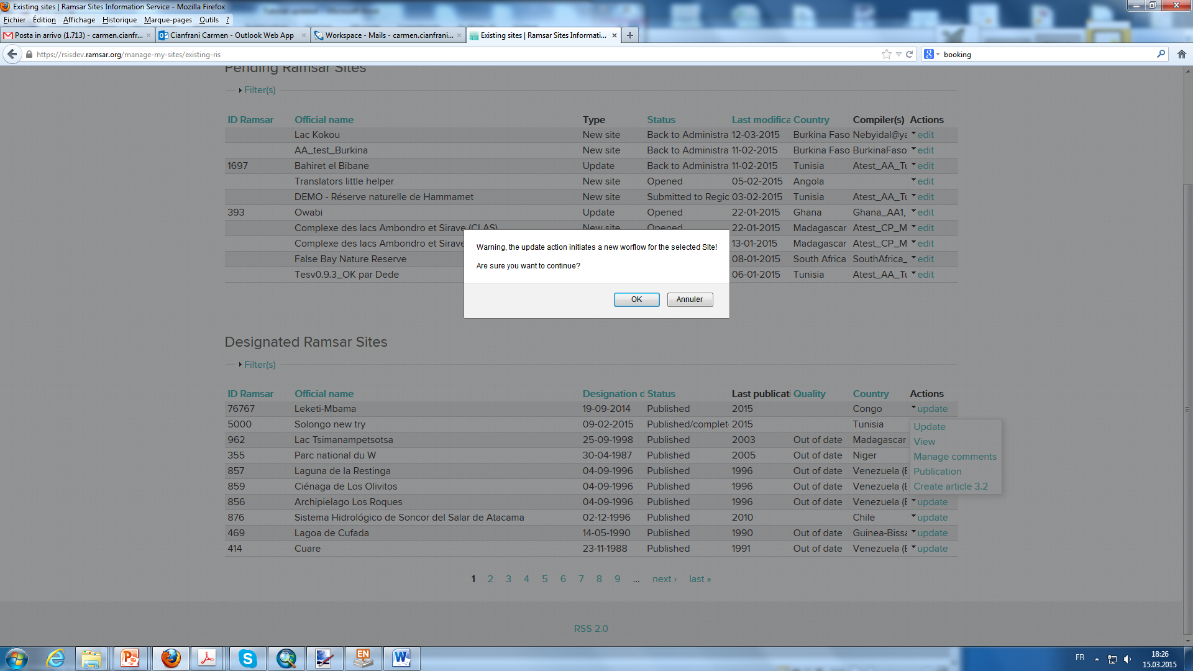

The Site to be updated is now also listed among the PENDING SITES with the type ***Update*** and status ***Opened***. Until the updating process is completed, the previous version of the RIS for this Site will still also be included in the DESIGNATED RAMSAR SITES list.

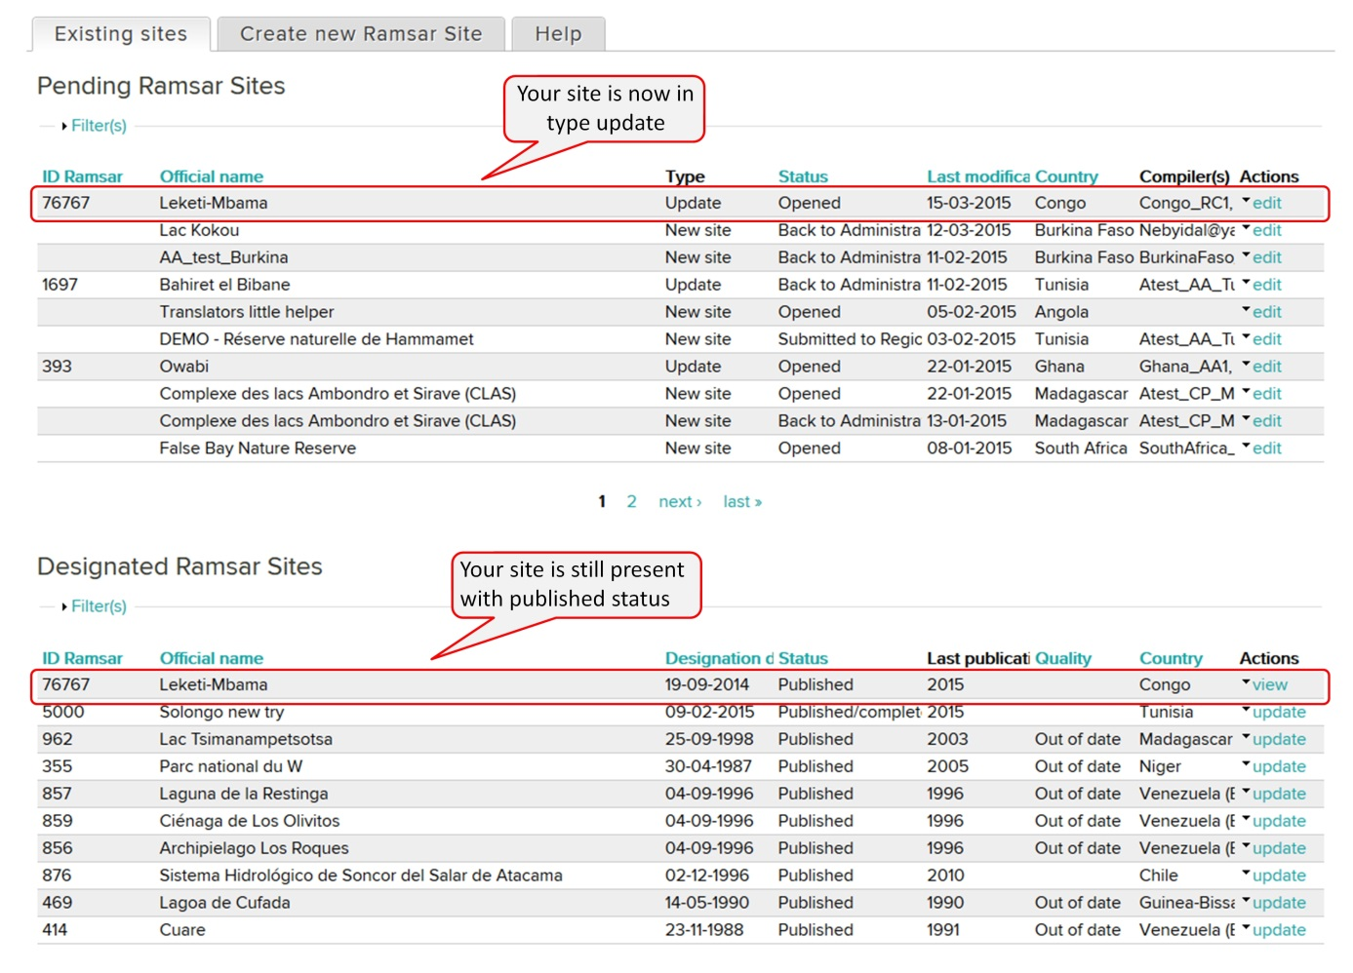

By default, all the Ramsar Compilers (RCs) in your country will be able to edit the RIS to be updated. Decide which of them you would like to contribute to the process; click on the triangle in the ***Actions*** column, and select ***Manage compilers***. In the page which opens, select the compilers’ names from the list.

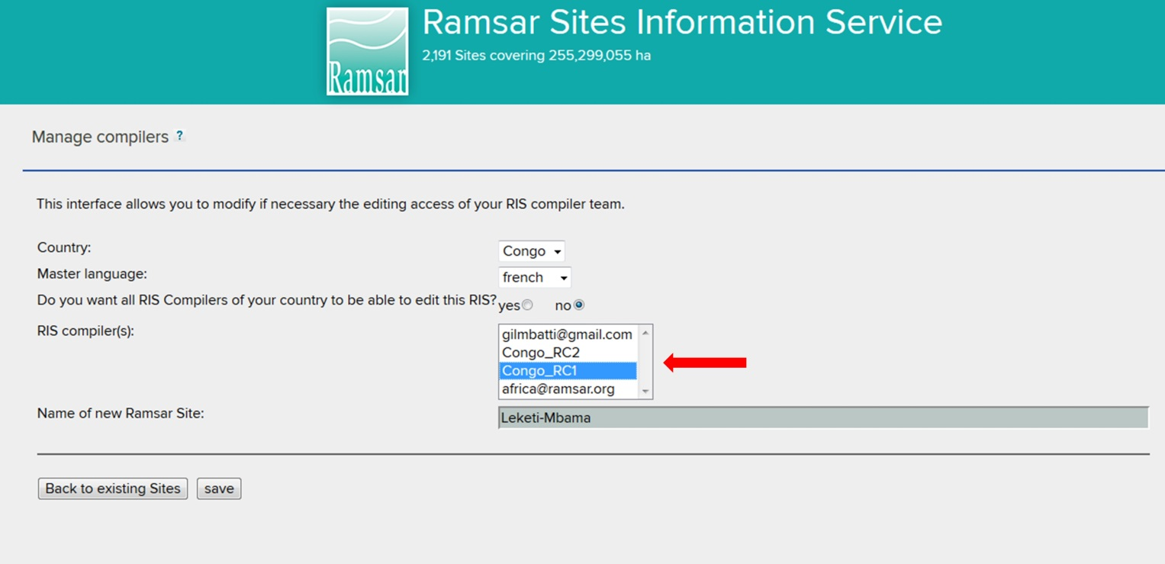

Send each of the compilers who you select an email indicating the Site and outlining the input required.

1. **RC modifies the RIS**

You will receive an e-mail from the AA. Log in following the instructions at step 1 above. In the restricted *MANAGE MY SITES* section, the list of PENDING RAMSAR SITES (Ramsar Sites which are not yet finalized) for your country will appear.

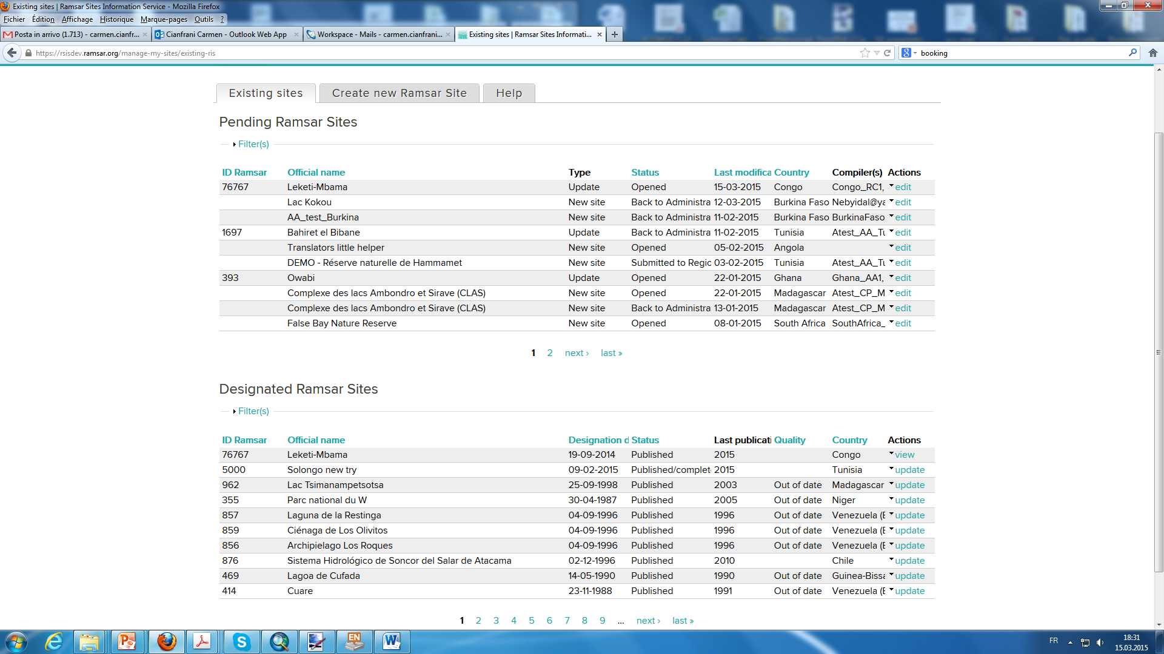

Every site can be viewed with its status. The update which has been launched by the AA and which you must update is listed with type ***Update*** and status ***Opened***. Click on the triangle in the ***Actions*** column of the correct Site, and select ***edit***.

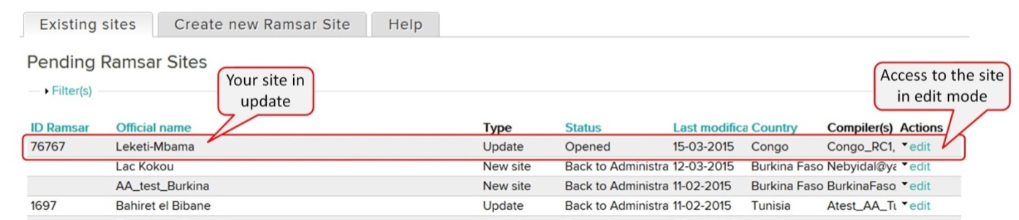

1. **RC andd AA complete the updating process**

From this point onwards, the updating process is the same as the process for creating a new Ramsar Site. Follow the instructions from step 3 onwards in the previous section.

Note that, even for updates with existing information, the progress bar for each section will indicate 0% until the RC or AA clicks to save the information.