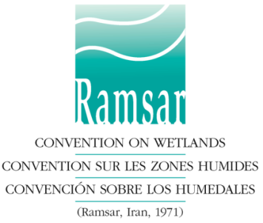
NOMINATION FORM

Ramsar Wetland Conservation Awards

Deadline for submission of nominations: 30 September 2017

Before completing this form, nominators are advised to read the information on the Award categories and the selection criteria and procedures at: http://www.ramsar.org/document/ramsar-awards-2018-about.

Please select only ONE of the following categories :

a) Ramsar Convention Award for Wetland Wise Use ☐ or
b) Ramsar Convention Award for Wetland Innovation ☐ or
c) Ramsar Convention Award for Young Wetland Champions ☐

I: Nominee

Name:
Title /Position:
Mailing address:
Telephone: |  | Fax:
E-mail:

II: Nominator

Name:
Title /Position:
Mailing address:
Telephone: | . | Fax:
E-mail:

III: Referees

Nominations must be accompanied by letters of recommendation from two independent individuals other than the nominator, who are not related to the nominee and do not work in the same organization, who can assess the nominee’s contributions and who can be contacted by the evaluation panel.

N.B. Without these letters, a nomination will be considered incomplete and will not be accepted.

Referee 1:

Name:
Title /Position
Mailing address
Telephone: |  | Fax:
E-mail:
Referee 2:

Name:
Title /Position
Mailing address
Telephone: |  | Fax:
E-mail:

IV. Summary of the nomination (maximum 250 words)

On the basis of the selection criteria, I/we recommend the nominee in consideration of the following actions/achievements.

Click here to enter text.

V. Attachments :

- This summary must be accompanied by a document of not more than 2,500 words providing the necessary background, explaining how the nomination corresponds to the objectives and criteria of the category of Award, and providing an assessment of the results achieved.
- Nominations must be accompanied by two letters of recommendation (see III above)
- Nominations must be accompanied by at least one high resolution Photograph of the nominee (person or team) in electronic form (min. size 1920 x 1080 pixels).

VI. Having considered the Categories, Criteria and Procedures for the Ramsar Wetland Conservation Awards, I/we wish to submit the following nomination for the consideration of the Standing Committee of the Convention on Wetlands:

Signature of nominator: |  | Date:

Please send this Form to the Ramsar Convention Secretariat,
E-mail: award@ramsar.org
Or
Rue Mauverney 28, CH-1196 Gland, Switzerland
Fax: +41 22 999 0169

