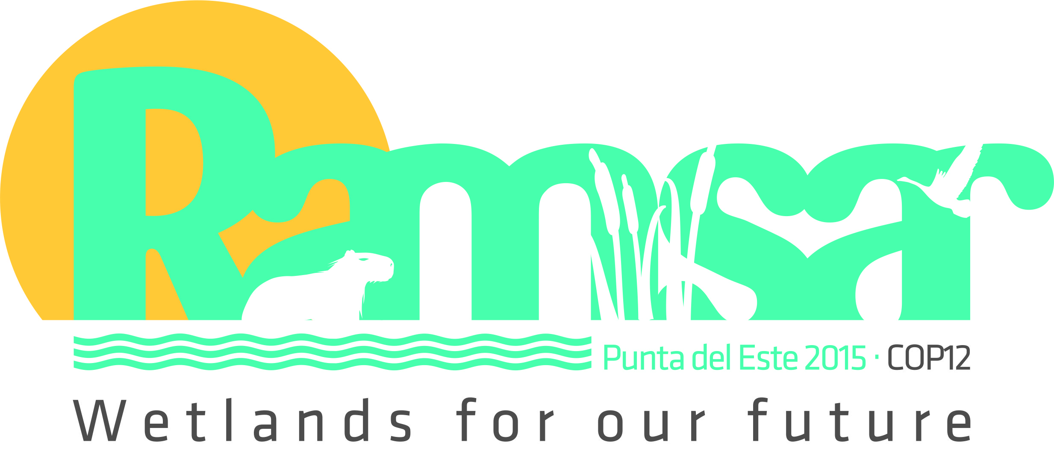
African Meeting for preparation of Ramsar COP12
17-21 November 2014 - Hammamet, Tunisia

Pre-Registration Form

The purpose of this form is to confirm your participation at the African meeting for preparation of Ramsar COP12 which will take place in Hammamet, Tunisia from 17 to 21 November 2014; and facilitate other related logistics for the delegates. It is recommended that you use service passport in order to facilitate the issuance of visa.
You are requested to complete this form and return it via email by 15th October 2014, to the following addresses: africa@ramsar.org and ouedraogo@ramsar.org
This registration form is also available on the Ramsar website at www.ramsar.org

Surname: _______________________________Other names: _____________________________________
Passport number: _______________________Type of passport*: ___________________________________
Date of issue: ___________________________Place of issue: ______________________________________
Expiry date: __________________________Organization: _________________________________________
Position/Title: _______________________________Country: ______________________________________
Nationality: ____________________________Present Address: ____________________________________
Email Address: ___________________________________________________________________________
Telephone: ___________________________________Fax: _______________________________________
Interest on putting up posters and side event: __________________________________________________
Signature: __________________________________Date: ______________________________________
Possible date of arrival in Tunis: _____________________________________
Departing Town/city : ________________________________

The deadline for submitting this pre-registration form is 15 October 2014!

* For the passport types: national passport, diplomatic passport, service passport, other travel document (please specify)

