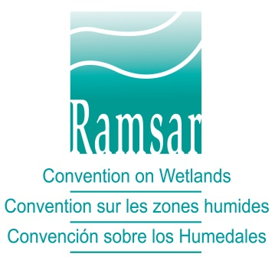

The Convention on Wetlands
(Ramsar, Iran, 1971)

Montreux Record - Questionnaire

(as adopted by the Conference of the Contracting Parties in Resolution XII.6, 2015)

Section One: Information for assessing possible inclusion of a listed Ramsar Site in the Montreux Record

Nature of the change

- Name of Site.

- Ramsar Criteria for listing the Site as internationally important.

- Summary statement of ecological character description.

- Ecological components, processes and services affected by adverse human-induced change/likely change (list relevant code numbers from the ecological character description).

- Nature and extent of the change / likely change to ecological character (use threat categories in RIS Guidance Appendix F, Resolution XI.8 Annex 2).

- Reason(s) for the change / likely change described above.

Management measures in place

- Date when the latest Ramsar Information Sheet (RIS) was submitted.

- Monitoring programme in place at the Site, if any (description of technique(s), objectives, and nature of data and information gathered) – refer to RIS section 5.2.7 (Resolution XI.8 Annex 1 RIS field 34).

- Assessment procedures in place, if any (how is the information obtained from the monitoring programme used).

- Ameliorative and restoration measures so far in place or planned, if any.

- Any other analogous or linked Site intervention processes activated or planned, e.g. under other multilateral environmental agreements.

- List of attachments provided by the Contracting Party (if applicable).

- List of attachments provided by the Ramsar Secretariat (if applicable).

Section Two: Information for assessing possible removal of a listed Site from the Montreux Record

Management measures in place

- Date when the latest Ramsar Information Sheet (RIS) was submitted.

- Monitoring programme in place at the Site, if any (description of technique(s), objectives and nature of data and information gathered) – refer to RIS section 5.2.7 (Resolution XI.8 Annex 1 RIS field 34).

- Assessment procedures in place, if any (how is the information obtained from the monitoring programme used).

- Ameliorative and restoration measures so far in place or planned, if any.

Assessment for removal of the Ramsar Site from the Montreux Record

- Success of ameliorative, restoration or maintenance measures (if different from those covered in Section One of this questionnaire).

- Proposed monitoring and assessment procedures (if different from those in Section One of this questionnaire).

- Extent to which the ecological components, processes and services of the Site have been restored or maintained (provide details).

- Rationale for removing the Site from the Montreux Record (refer to Guidelines for Operation of the Montreux Record, the specific issues identified in Section One of this questionnaire, and any advice given by the STRP or arising from a Ramsar Advisory Mission, where applicable).

- Status of any other analogous or linked Site intervention processes, e.g. under other multilateral environmental agreements, and details of how Montreux Record removal will be harmonized with these.

- Measures that the Contracting Party will implement to maintain the ecological character of the Site with clear indicators for follow up.

- List of further attachments (if applicable).

