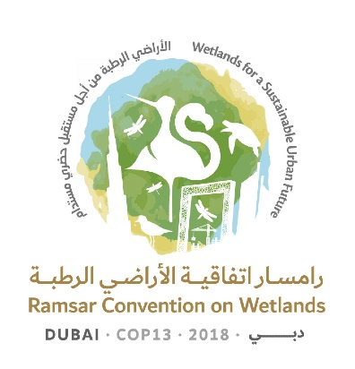
13th Meeting of the Conference of the Contracting Parties

to the Ramsar Convention on Wetlands

“Wetlands for a Sustainable Urban Future”

Dubai, United Arab Emirates, 21-29 October 2018

Ramsar COP13 Rep.8

Draft Daily Report
Day 5 – Friday 26 October (Afternoon plenary session)

Friday 26 October 2018

15.15–17.30 Plenary session

1. The session was chaired by the Vice-President from Uganda (Mr Paul Mafabi).

Agenda item 18: Consideration of the draft resolutions and recommendations submitted by Contracting Parties and the Standing Committee (continued)

18.23 Draft Resolution on the conservation and management of small wetlands

2. China introduced the draft resolution in document COP13 Doc.18.23.

3. Interventions were made by Bahrain, Bangladesh, Botswana, Canada, Chile, Colombia, Djibouti, Dominican Republic, Ecuador, Finland on behalf of the Member States of the European Union, Grenada, Honduras, India, Iran, Jordan, Lesotho on behalf of the Africa region, Malaysia, Mexico, Oman, Thailand, the United Republic of Tanzania, the United States of America and Zimbabwe, as well as the observer from the United Nations Educational, Scientific and Cultural Organization (UNESCO). These were broadly in support of the draft resolution with some Contracting Parties requesting clarity concerning the definition of a small wetland.

4. The Vice-President asked all those with proposed amendments to forward these to the Secretariat within two hours of the close of the session and requested Finland to co-ordinate the production of a revised draft resolution for consideration at a later session.

18.24 Draft resolution on wetlands in West Asia

5. Iraq introduced the draft resolution in document COP13 Doc.18.24.

6. Azerbaijan, Bahrain, Canada, Iran (Islamic Republic of), Jordan, Lebanon, Malaysia, Oman, Turkey, and United States of America made interventions. Some were broadly in support of the draft resolution, others strongly opposed, believing that aspects of it were outside the remit of the Convention. Several of those intervening stated that they had amendments to propose.

7. The Vice-President asked all those with proposed amendments to forward these to the Secretariat and requested the United States of America to co-ordinate the production of a revised draft resolution for consideration later in the meeting.

18.3 Draft resolution on the responsibilities, roles and composition of the Standing Committee and regional categorization of countries under the Convention

8. The Vice-President invited the United Kingdom of Great Britain and Northern Ireland, in its capacity as chair of the working group on the draft resolutions contained in documents COP13 Doc.18.1 and Doc.18.2, to comment on whether the outcomes of the group’s work could inform consideration of the draft resolution contained in document 18.3.

9. The United Kingdom reported that the working group had engaged constructively and that a compromise text on the draft resolutions in documents Doc. 18.1 and Doc. 18.2, enjoying broad support, had been forwarded to the Secretariat. The working group had briefly discussed the implications of this compromise text for the draft resolution in document Doc.18.3, especially with regard to the Executive Team, but had been unable to reach consensus.

10. The Secretariat confirmed that the working group’s compromise text was now available online in English as document Inf.6 and would be translated into French and Spanish as soon as it was confirmed as the final outcome from the group.

11. Interventions were made by: Australia, Austria, Chile, China, Colombia, Cuba, France, Gabon, Guinea, Japan, Jordan, the Netherlands, New Zealand, Senegal, Switzerland, the United Kingdom, Uruguay and the United States of America.

12. At the conclusion of the debate, the Vice-President observed that there appeared to be consensus on the draft resolution contained in document COP13 Doc.18.3, subject to inclusion of an amendment proposed by the United Kingdom requesting the Executive Team to define its terms of reference for approval at the 57th meeting of the Standing Committee.

13. The Vice-President requested the Secretariat to prepare a revised text of the draft resolution in document COP13 Doc.18.3, taking account of the amendment proposed by the United Kingdom as well as other amendments already submitted by Contracting Parties.

Agenda item 19. Report of the Credentials Committee

14. The Chair of the Credentials Committee (Armenia), gave an interim report, noting that credentials of 20 delegations had been accepted and that some were awaiting translation or clarification.

15. The session concluded with progress reports from working groups and agreement on working arrangements for groups to continue their work during the evening of 26 October.

