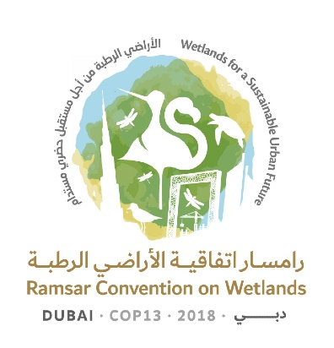
13th Meeting of the Conference of the Contracting Parties

to the Ramsar Convention on Wetlands

“Wetlands for a Sustainable Urban Future”

Dubai, United Arab Emirates, 21-29 October 2018

Ramsar COP13 Rep.6

Draft Daily Report
Day 4 – Thursday 25 October (Afternoon plenary session)

Thursday 25 October 2018

15.00–18.15 Plenary session

Agenda item 15.2 Wetland City Accreditation – Presentation of certificates

1. The Secretary General presented certificates to representatives of the accredited cities to enthusiastic applause.

Agenda item 18: Consideration of the draft resolutions and recommendations submitted by Contracting Parties and the Standing Committee (continued)

18.13 Draft Resolution on guidance on identifying Wetlands of International importance (Ramsar Sites) for global climate change regulation as an additional argument to existing criteria

2. The Chair of the Scientific and Technical Review Panel (STRP) introduced the draft resolution in document COP13 Doc.18.13

3. Interventions in support of the draft resolution but requesting some specific amendments were made by Belarus, Bolivia (Plurinational State of), Canada, Colombia, Costa Rica, Dominican Republic, Ecuador, Germany on behalf of the Member States of the European Union, Malaysia, Philippines, South Africa, the United States of America, and Uruguay, as well as the observers from the Food and Agriculture Organization of the United Nations (FAO) and the China Biodiversity Conservation and Green Development Foundation.

4. The President asked all those with proposed amendments to forward these to the Secretariat and asked Germany to co-ordinate the production of a revised draft resolution for consideration later in the meeting.

18.14 Draft resolution on restoration of degraded peatlands to mitigate and adapt to climate change and enhance biodiversity

5. A representative of the Scientific and Technical Review Panel (Germany) introduced the draft resolution in document COP13 Doc.18.14.

6. Belarus, Canada, Germany on behalf of the Member States of the European Union, Mongolia, New Zealand, South Africa on behalf of the Africa region, the Philippines and the United States of America, as well as the observer from FAO supported the draft resolution, also proposing minor amendments.

7. The President asked all those with proposed amendments to forward these to the Secretariat and asked Austria to co-ordinate the production of a revised draft resolution for consideration later in the meeting.

18.15 Draft resolution on promoting conservation, restoration and sustainable management of coastal blue carbon ecosystems

8. Australia introduced the draft resolution in document COP13 Doc.18.15.

9. Interventions were made by Algeria on behalf of the Africa region, Argentina, Austria on behalf of the Member States of the European Union, Bahrain, Bolivia (Plurinational State of), Brazil, Canada, China, Colombia, Costa Rica, Cuba, Dominican Republic, Fiji, Indonesia, Malaysia, Myanmar, New Zealand, Peru, Philippines, Republic of Korea, South Africa, Sudan, United Arab Emirates, the United States of America, Uruguay and Venezuela (Bolivarian Republic of), as well as the observer from FAO. Some were supportive, while others believed that at least some aspects of the draft resolution were outside the remit of the Convention or were concerned that there was no settled international definition of “blue carbon ecosystems”.

10. The President asked all those with proposed amendments to forward these to the Secretariat and asked Australia to coordinate the production of a revised draft resolution for consideration later in the meeting.

18.16 Draft resolution on cultural values, indigenous peoples and local communities, and climate change mitigation and adaptation in wetlands

11. Tunisia presented the draft resolution in document COP13 Doc.18.16.

12. Interventions were made by Bolivia (Plurinational State of), Botswana, Canada, Chile, Colombia, Ecuador, Lesotho, New Zealand, Slovenia on behalf of the Europe region, South Africa, Turkey, the United States of America, and Uruguay. Whilst there was broad support for the draft resolution in principle, most Contracting Parties also proposed specific amendments or indicated that they would do so.

13. The Secretary General sought guidance on two points: the operative paragraph that requested the Secretariat to present regular reports to the Standing Committee on work undertaken by Contracting Parties in response to the resolution, if approved; and the need for clarity about the Secretariat’s future engagement with the Ramsar Culture Network.

14. The President asked all those with proposed amendments to forward these to the Secretariat and asked Australia to co-ordinate the production of a revised draft resolution for consideration later in the meeting.

18.17 Draft resolution on sustainable urbanization, climate change and wetlands

15. The United Arab Emirates presented the draft resolution in document COP13 Doc.18.17.

16. Interventions were made by Australia, Botswana, Canada, Chile, Colombia, Costa Rica, Cuba, Dominican Republic, Ecuador, Hungary on behalf of the Member States of the European Union, Lesotho, Libya, Norway, Peru, Philippines, South Africa, Uganda, the United States of America, and Uruguay. Whilst there was broad support for the draft resolution in principle, several of these Contracting Parties also proposed specific amendments or indicated that they would do so.

17. The President asked all those with proposed amendments to forward these to the Secretariat and asked the United Arab Emirates to co-ordinate the production of a revised draft resolution for consideration later in the meeting.

