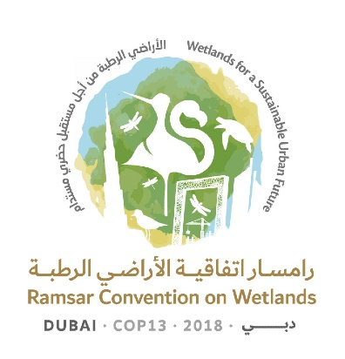
13th Meeting of the Conference of the Contracting Parties

to the Ramsar Convention on Wetlands

“Wetlands for a Sustainable Urban Future”

Dubai, United Arab Emirates, 21-29 October 2018

Ramsar COP13 Rep.3

Draft Daily Report
Day 3 – Wednesday 24 October (Morning plenary session)

Wednesday 24 October 2018

10.15 – 13.05 Plenary session

Agenda item 18: Consideration of the draft resolutions and recommendations submitted by Contracting Parties and the Standing Committee

1. The Conference established a small group of Contracting Parties, to be nominated by the regional groups, and with participation of the Chair of the Scientific and Technical Review Panel (STRP), to examine requests to the STRP contained in the draft resolutions and to determine whether these accorded with the STRP’s mandate.

18.5 Draft resolution on financial and budgetary matters

2. The President recalled that the draft resolution in document COP13 Doc.18.5 would be considered by the COP13 Committee on Finance and Budget established during the discussion of agenda item 14.

18.9 Draft resolution on World Wetlands Day

3. The United Arab Emirates introduced the draft resolution on World Wetlands Day (document COP13 Doc.18.9).

4. Azerbaijan, Bahrain, Bangladesh, Bolivia (Plurinational State of), Burkina Faso on behalf of the Africa region, Cameroon, Canada, Central African Republic, Chad, Chile, Cuba, Dominican Republic, Ecuador, Finland on behalf of the Europe region, Gabon, Guatemala, Guinea Bissau, Honduras, Indonesia, Jordan, Kuwait, Nepal, Niger, Oman, Panama, Peru, Rwanda, South Africa, Sri Lanka, Sudan, Thailand, the United States of America, Uruguay and Zimbabwe all expressed support for the draft resolution.

5. Thailand observed that it would useful if the Secretariat could evaluate the outcomes and effectiveness of initiatives undertaken for World Wetlands Day and publish the results of this analysis.

6. The Conference approved the draft resolution in document COP13 Doc.18.9 on the understanding that the Secretariat would work with the United Arab Emirates and other Contracting Parties to bring the matter forward to the United Nations.

18.1 Draft resolution on enhancing the effectiveness of the Convention

18.2 Draft resolution on improving the efficiency of structures and process of the Convention

18.3 Draft resolution on the responsibilities, roles and composition of the Standing Committee and regional categorization of countries under the Convention

7. The United States of America, as co-chair of the Facilitation Working Group, introduced document COP13 Doc.18.1, explaining that it was an outcome of the Working Group’s deliberations.

8. Switzerland introduced document COP13 Doc.18.2, noting that it had informally circulated a revised version of the text to participants.

9. The United Kingdom of Great Britain and Northern Ireland proposed the establishment of a working group to look at documents COP13 Doc.18.1 and COP13 Doc.18.2 and to recommend ways forward to the Conference of the Parties. This was supported by Australia, Austria on behalf of the Member States of the European Union, Cameroon, Chile, Colombia, Cuba, Dominican Republic, France, Honduras, Jordan, New Zealand, Oman, Senegal, the United Arab Emirates and Uruguay.

10. The Conference established a working group, to be chaired by the United Kingdom, to take forward discussion of documents COP13 Doc.18.1 and COP13 Doc.18.2 and to report back to plenary at a later session. Further discussion of document COP13 Doc.18.3 was deferred until this had occurred.

18.4 Draft resolution on language strategy for the Convention

11. The Secretariat introduced the draft resolution on language strategy for the Convention, document COP13 Doc.18.4, explaining the background to its development.

12. Tunisia on behalf of the African region, and supported by Algeria, Djibouti, Libya, Sudan and Uganda, welcomed the draft resolution as an important first step to making Arabic an official language of the Convention.

13. Bahrain, Jordan, Kuwait, Oman and Peru supported the draft resolution, though Jordan noted that it would not yet reach the goal of Arabic becoming an official language.

14. Dominican Republic, Ecuador and the Bolivarian Republic of Venezuela recognized the importance of incorporating Arabic into the work of the Convention, but stressed that this should not be at the expense of resolving gaps in provision for the existing official languages.

15. The United Arab Emirates underlined the importance of the draft resolution and advised that it would be forwarding proposed amendments to the Secretariat.

16. Austria of behalf of the Member States of the European Union recognized the significance of the draft resolution but had concerns about potential financial implications; it would communicate proposed amendments to the Secretariat.

17. The Conference established a working group to finalize the text of document COP13 Doc.18.4, taking into consideration amendments proposed during the plenary discussion, and to report back to plenary at a later session.

