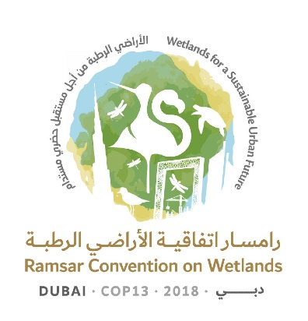
13th Meeting of the Conference of the Contracting Parties

to the Ramsar Convention on Wetlands

“Wetlands for a Sustainable Urban Future”

Dubai, United Arab Emirates, 21-29 October 2018

Ramsar COP13 Rep.10

Draft Daily Report
Day 6 – Sunday 28 October (Afternoon plenary session)

Sunday 25 October 2018

15.15 – 17.10 Plenary session

Agenda item 18: Consideration of the draft resolutions and recommendations submitted by Contracting Parties and the Standing Committee (continued)
Agenda item 20: Report on the discussions, conclusions and recommendations in the preceding sessions (continued)
Agenda item 21: Adoption of resolutions and recommendations (continued)

18.13 Draft resolution on guidance on identifying peatlands as Wetlands of International Importance (Ramsar Sites) for global climate change regulation as an additional argument to existing Ramsar criteria
1. The President introduced the revised draft resolution in document COP13 Doc.18.13 Rev.1.

2. An intervention was made by Canada.

3. The draft resolution in document COP13 Doc.18.13 was adopted by acclamation subject to the inclusion of an amendment to Table 1, tabled by Canada.

Agenda item 24: Adoption of the report of the 13th Meeting of the Conference of the Contracting Parties

4. The Secretariat introduced document COP13 Rep.1.

5. Japan requested a correction. At the request of United Kingdom of Great Britain and Northern Ireland, the President agreed to postpone approval of COP13 Rep.1 until the Annex to the report was available.

6. The daily reports contained in documents COP13 Rep.2, COP13 Rep.3, COP13 Rep.4, COP13 Rep.5 and COP13 Rep.6 were adopted, without amendment, by acclamation.

Agenda item 18: Consideration of the draft resolutions and recommendations submitted by Contracting Parties and the Standing Committee (continued)
Agenda item 20: Report on the discussions, conclusions and recommendations in the preceding sessions (continued)
Agenda item 21: Adoption of resolutions and recommendations (continued)

18.17 Draft resolution on sustainable urbanization, climate change and wetlands
7. The President introduced the revised draft resolution in document COP13 Doc.18.17 Rev.1.

8. The United Arab Emirates proposed amendments.
9. The draft resolution in document COP13 Doc.18.17 Rev.1 was adopted by acclamation subject to the inclusion of amendments to two paragraphs, tabled by the United Arab Emirates.

18.10 Draft resolution on the status of Sites in the Ramsar List of Wetlands of International Importance
10. The President introduced the revised draft resolution in document COP13 Doc.18.10 Rev.1, which was adopted by acclamation without further amendment.

18.14 Draft resolution on restoration of degraded peatlands to mitigate and adapt to climate change and enhance biodiversity and disaster risk reduction
11. The President introduced the revised draft resolution in document COP13 Doc.18.14 Rev.1.
12. An intervention was made by Austria to propose amendments to 10 paragraphs.
13. The draft resolution in document COP13 Doc.18.10 Rev.1 was adopted by acclamation with the amendments tabled by Austria.

14. The Secretary General provided an update on the status of the 11 draft resolutions for which final approval and adoption by the Conference was still pending.

