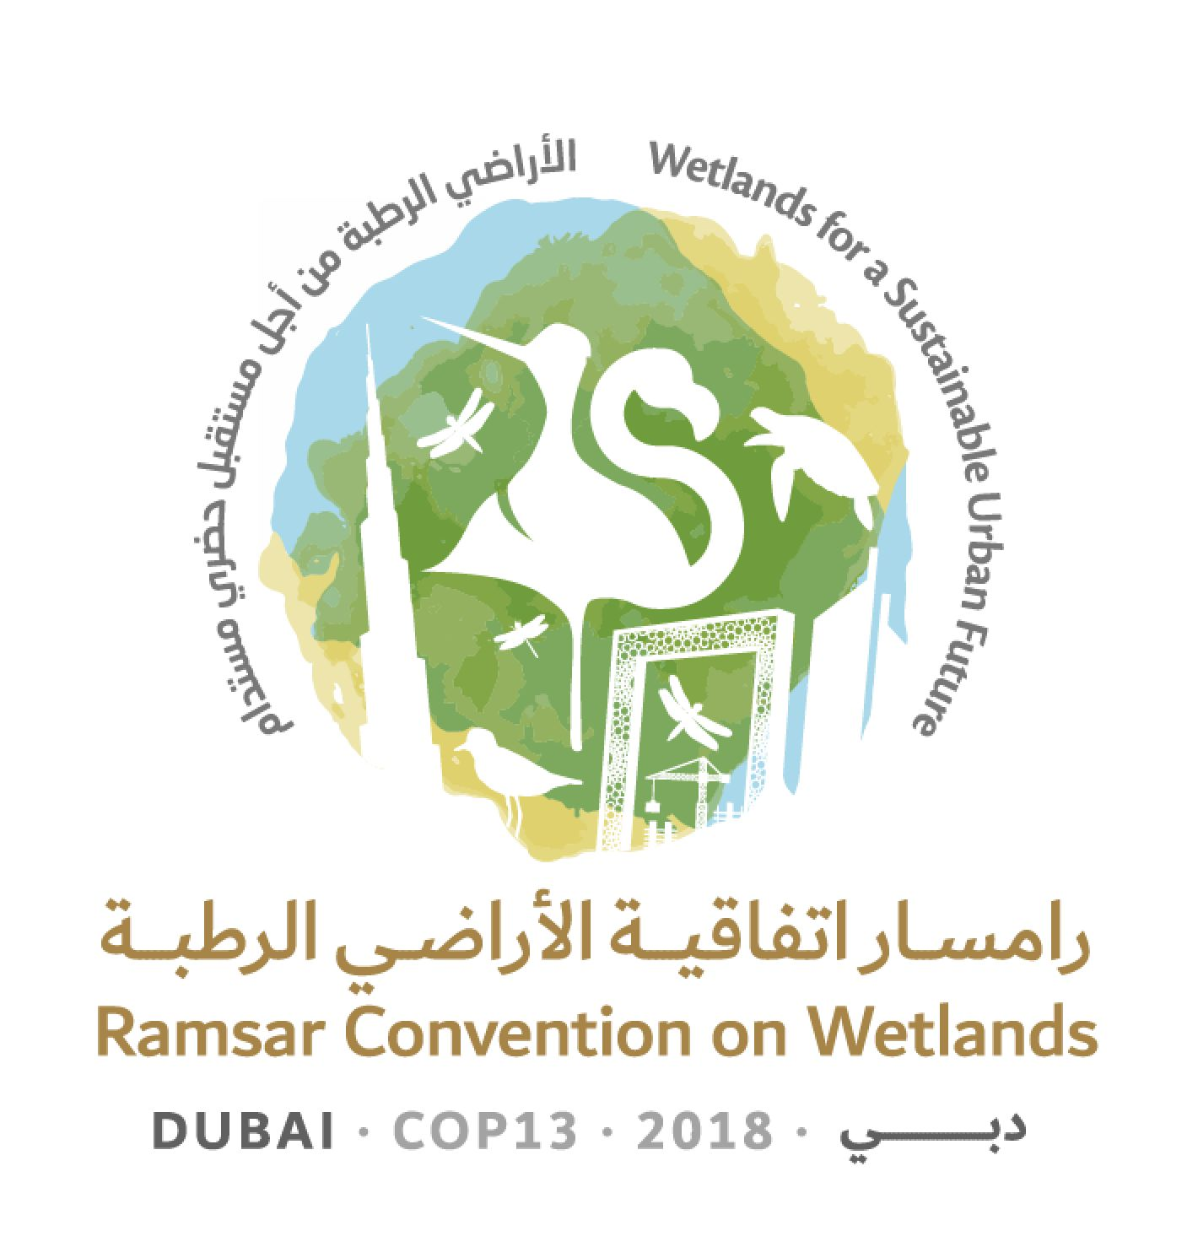
13th Meeting of the Conference of the Contracting Parties

to the Ramsar Convention on Wetlands

“Wetlands for a Sustainable Urban Future”

Dubai, United Arab Emirates, 21-29 October 2018

Ramsar COP13 Doc.3.2

Provisional working programme

Sunday 21 October 2018

08:30 – 12:30, 14:00 – 18:00 Registration of delegates (continues each day to 29 October)

10:00 – 13:00 55th Meeting of the Standing Committee

14:00 – 18:00 Regional meetings
(including discussions on Contracting Parties to be proposed for election to the Standing Committee, under agenda item 16)

18:15-21:00 Meetings of Regional Initiatives

Monday 22 October 2018

08:30 – 12:30, 14:00 – 18:00 Registration (continued)

09:00 – 12:00 Regional meetings

12:00 – 13:30 Special event “UN Ocean Conference Community of Ocean Action on Mangroves: Progress and opportunities”

14:00 – 16:00 Regional meetings

17:00 – 19:00 Opening ceremony and welcoming statements

1. Opening of the Meeting

2. General statements and keynote addresses

Ramsar Awards ceremony

19:00 – 21:30 Welcome reception

Tuesday 23 October 2018

07:45 – 09:45 Regional meetings

08:30 – 12:30, 14:00 – 18:00 Registration (continued)

08:30 – 09:45 Meeting of the Conference Bureau

10:00 – 13:00 Plenary Session

5. Election of the President and Vice-Presidents and remarks by the President

3.1 Adoption of the provisional agenda and working programme: Provisional agenda

3.2 Adoption of the provisional agenda and working programme: Provisional working programme

4.1 Adoption of the Rules of Procedure: Provisional Rules of Procedure

4.2 Adoption of the Rules of Procedure: Proposed amendments to the Rules of Procedure

6. Appointment of the Credentials Committee and any other committees

7. Admission of observers

8. Report of the Chair of the Standing Committee

13:00 – 15:00 Lunch break

15:00 – 17:45 Plenary Session

11.1 Report of the Secretary General on the implementation of the Convention: Global implementation

11.2 Report of the Secretary General on the implementation of the Convention: Work of the Secretariat

10. Report on implementation of the CEPA Programme 2016-2018 and recommendations on future directions

9. Report of the Chair of the Scientific and Technical Review Panel (STRP)

12. Report of the Secretary General pursuant to Article 8.2 on the List of Wetlands of International Importance

13. Issues arising from Resolutions and Recommendations of previous meetings of the Conference of the Contracting Parties

17:45 – 18:15 Presentation of the Global Wetland Outlook
Wednesday 24 October 2018

07:45 – 09:45 Regional meetings

08:30 – 12:30, 14:00 – 18:00 Registration (continued)

08:30 – 09:45 Meeting of the Conference Bureau

10:00 – 13:00 Plenary Session

14. Financial report for 2016-2018 by the Chair of the Subgroup on Finance of the Standing Committee, and proposed budget for the 2019-2021 triennium

17. Secretariat’s report on administrative and financial implications of draft resolutions

18. Consideration of the draft resolutions and recommendations submitted by Contracting Parties and the Standing Committee

15.1 Wetland City Accreditation: Report of the Standing Committee

13:00 – 15:00 Lunch break

15:00 – 18:00 Plenary Session

18. Consideration of the draft resolutions and recommendations submitted by Contracting Parties and the Standing Committee (continued)

Thursday 25 October 2018

07:45 – 09:45 Regional meetings

08:30 – 12:30, 14:00 – 18:00 Registration (continued)

08:30 – 09:45 Meeting of the Conference Bureau

10:00 – 13:00 Plenary Session

18. Consideration of the draft resolutions and recommendations submitted by Contracting Parties and the Standing Committee (continued)

13:00 – 15:00 Lunch break

15:00 – 18:00 Plenary Session

15.2 Wetland City Accreditation: Presentation of certificates

18. Consideration of the draft resolutions and recommendations submitted by Contracting Parties and the Standing Committee (continued)
Friday 26 October 2018

07:45 – 09:45 Regional meetings

08:30 – 12:30, 14:00 – 18:00 Registration (continued)

08:30 – 09:45 Meeting of the Conference Bureau

10:00 – 13:00 Plenary Session

16. Election of Contracting Parties to the Standing Committee 2019-2021

18. Consideration of the draft resolutions and recommendations submitted by Contracting Parties and the Standing Committee (continued)

13:00 – 15:00 Lunch break

15:00 – 18:00 Plenary Session

18. Consideration of the draft resolutions and recommendations submitted by Contracting Parties and the Standing Committee (continued)

18:30 – 20:00 Preparatory meeting of the appointees to the incoming Standing Committee 2019-2021

Saturday 27 October 2018

08:30 – 09:45 Meeting of the Conference Bureau (if needed)

Free time

Sunday 28 October 2018

07:45 – 09:45 Regional meetings

08:30 – 12:30, 14:00 – 18:00 Registration (continued)

08:30 – 09:45 Meeting of the Conference Bureau

10:00 – 13:00 Plenary Session

19. Report of the Credentials Committee

20. Report on the discussions, conclusions and recommendations in the preceding sessions

13:00 – 15:00 Lunch break

15:00 – 18:00 Plenary Session

21. Adoption of Conference resolutions and recommendations

Monday 29 October 2018

08:30 – 12:30, 14:00 – 18:00 Registration (continued)

08:30 – 09:45 Meeting of the Conference Bureau
(with Standing Committee 2019-2021 appointees as observers)

10:00 – 13:00 Plenary Session

21. Adoption of Conference resolutions and recommendations (continued)

13:00 – 15:00 Lunch break

15:00 – 18:00 Plenary Session

22. Date and venue of the next ordinary meeting of the Conference of the Contracting Parties

23. Any other business

24. Adoption of the report of the 13th Meeting of the Conference of the Contracting Parties

25. Close of the meeting

18:30 – 19:30 56th Meeting of the Standing Committee (incoming members to elect officers and subgroup members, and agree the date and venue of the first full meeting)

