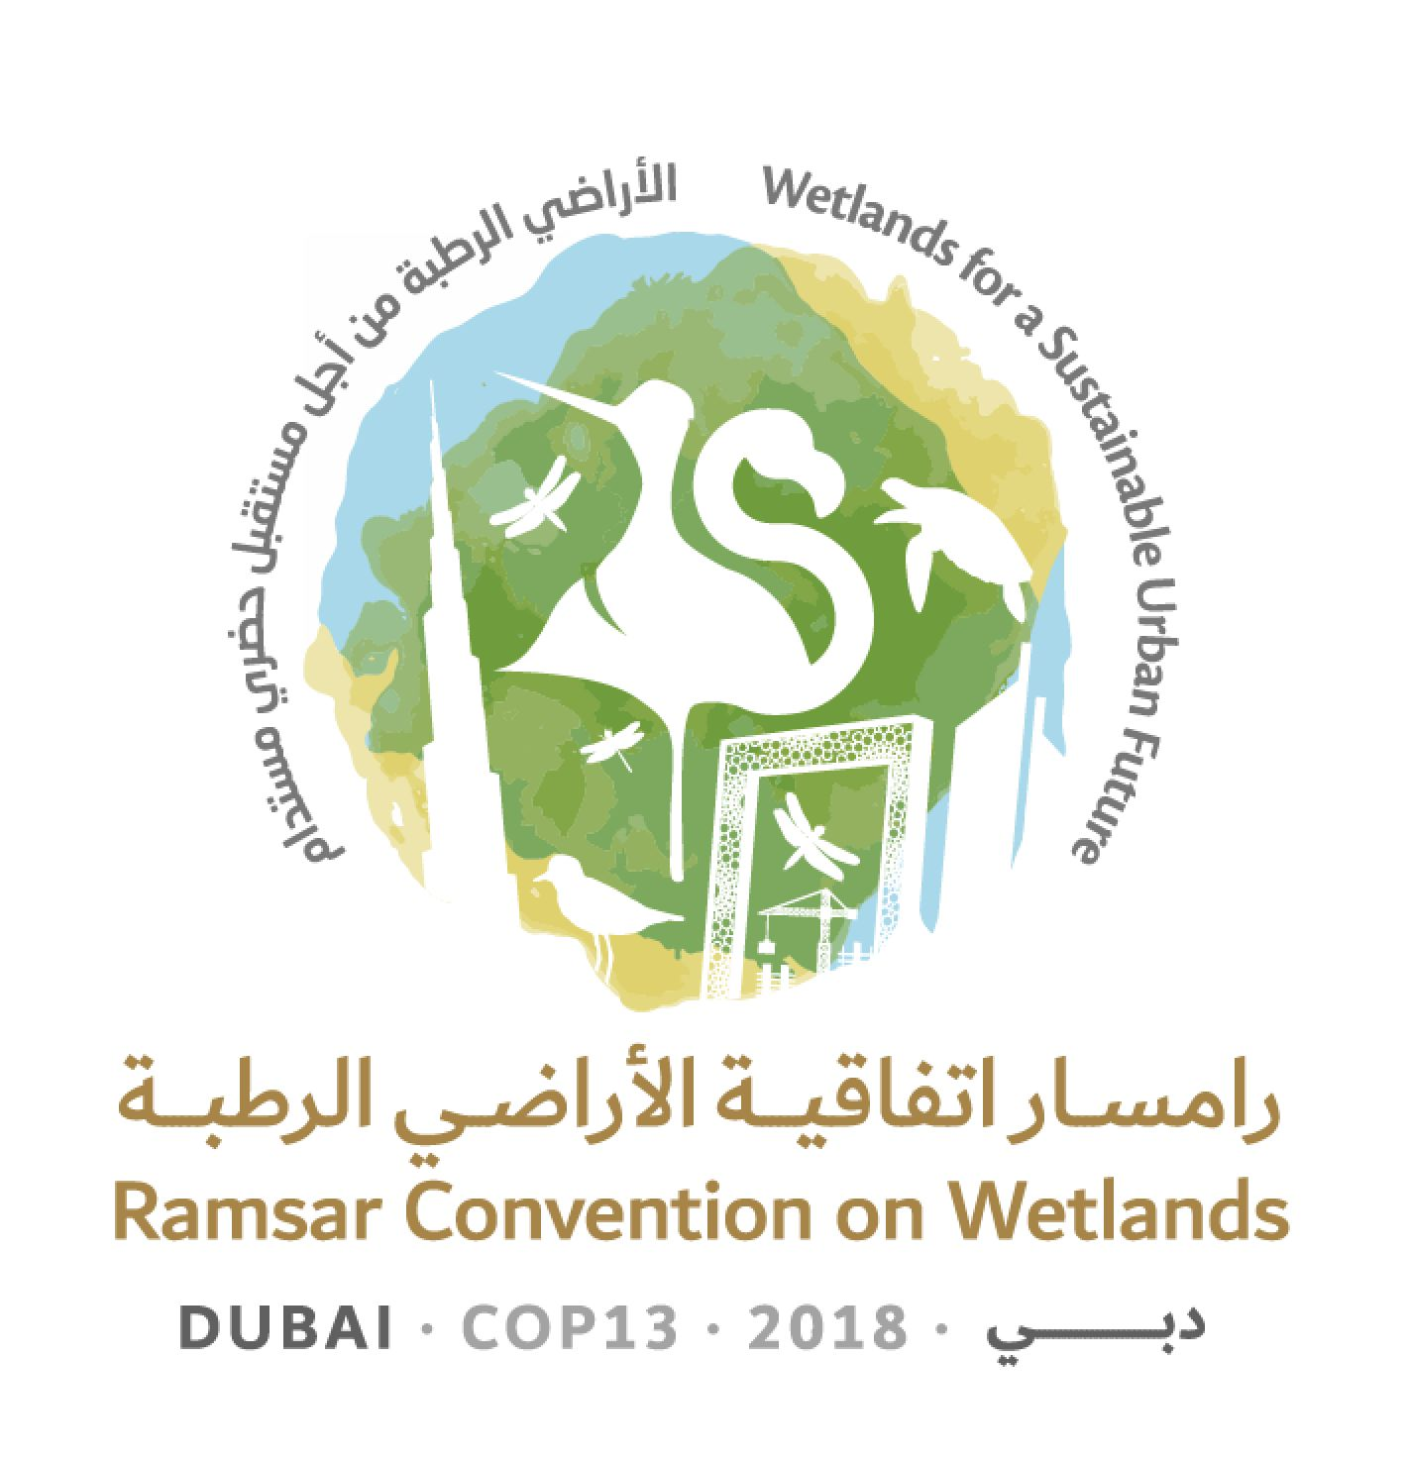
13th Meeting of the Conference of the Contracting Parties

to the Ramsar Convention on Wetlands

“Wetlands for a Sustainable Urban Future”

Dubai, United Arab Emirates, 21-29 October 2018

Ramsar COP13 Doc.3.1

Provisional agenda

 | Agenda item |  | Document
1. | Opening of the Meeting |  | no document
2. | General statements and keynote addresses |  | no document
Procedural matters
3. | 3.1 | Adoption of the provisional agenda  (Annotated provisional agenda) | COP13 Doc.3.1  (COP13 Doc.3.1 bis)
 | 3.2 | Provisional working programme | COP13 Doc.3.2
4. | 4.1 | Adoption of the rules of procedure | COP13 Doc.4.1
 | 4.2 | Proposed amendments to the rules of procedure | COP13 Doc.4.2
5. | Election of the President and Vice-Presidents and remarks by the President |  | no document
6. | Appointment of the Credentials Committee and any other committees |  | no document
7. | Admission of observers |  | COP13 Doc.7
Administrative matters
8. | Report of the Chair of the Standing Committee |  | COP13 Doc.8
9. | Report of the Chair of the Scientific and Technical Review Panel (STRP) |  | COP13 Doc.9
10. | Report on implementation of the CEPA Programme 2016-2018 |  | COP13 Doc.10
11. | Report of the Secretary General on the implementation of the Convention |  | COP13 Doc.11
12. | Report of the Secretary General pursuant to Article 8.2 on the List of Wetlands of International Importance |  | COP13 Doc.12
13. | Issues arising from Resolutions and Recommendations of previous meetings of the Conference of the Contracting Parties |  | no document
14. | Report on financial and budgetary matters |  | COP13 Doc.14
15. | Review of the Wetland City Accreditation |  | COP13 Doc.15
16. | Election of Contracting Parties to the Standing Committee 2019-2021 |  | no document
Draft resolutions
17. | Secretariat’s report on administrative and financial implications of draft resolutions |  | COP13 Doc.17
18. | Consideration of the draft resolutions and recommendations submitted by Contracting Parties and the Standing Committee
 | 18.1 | Draft resolution on enhancing the effectiveness of the Ramsar Convention | COP13 Doc.18.1
 | 18.2 | Draft resolution on improving the efficiency of structures and processes of the Convention | COP13 Doc.18.2
 | 18.3 | Draft resolution on the responsibilities, roles and composition of the Standing Committee and regional categorization of countries under the Convention | COP13 Doc.18.3
 | 18.4 | Draft resolution on language strategy for the Convention | COP13 Doc.18.4
 | 18.5 | Draft resolution on financial and budgetary matters | COP13 Doc.18.5
 | 18.6 | Draft resolution on review of the fourth Strategic Plan of the Ramsar Convention | COP13 Doc.18.6
 | 18.7 | Draft resolution on enhancing the Convention’s implementation, visibility and synergies with other multilateral environmental agreements and other international institutions | COP13 Doc.18.7
 | 18.8 | Draft resolution on Ramsar Regional Initiatives 2019-2021 and their Operational Framework | COP13 Doc.18.8
 | 18.9 | Draft resolution on World Wetlands Day | COP13 Doc.18.9
 | 18.10 | Draft resolution on the status of Sites on the List of Wetlands of International Importance | COP13 Doc.18.10
 | 18.11 | Draft resolution on Ramsar Advisory Missions | COP13 Doc.18.11
 | 18.12 | Draft resolution on future implementation of scientific and technical aspects of the Convention for 2019-2021 | COP13 Doc.18.12
 | 18.13 | Draft resolution on guidance on identifying Wetlands of International Importance (Ramsar Sites) for global climate change regulation as an additional argument to existing Ramsar criteria | COP13 Doc.18.13
 | 18.14 | Draft resolution on restoration of degraded peatlands to mitigate and adapt to climate change and enhance biodiversity | COP13 Doc.18.14
 | 18.15 | Draft resolution on promoting conservation, restoration and sustainable management of coastal blue carbon ecosystems | COP13 Doc.18.15
 | 18.16 | Draft resolution on cultural values, indigenous peoples and local communities, and climate change mitigation and adaptation in wetlands | COP13 Doc.18.16
 | 18.17 | Draft resolution on sustainable urbanization, climate change and wetlands | COP13 Doc.18.17
 | 18.18 | Draft resolution on the rapid assessment of wetland ecosystem services | COP13 Doc.18.18
 | 18.19 | Draft resolution on the importance of wetlands for peace and security | COP13 Doc.18.19
 | 18.20 | Draft resolution on gender and wetlands | COP13 Doc.18.20
 | 18.21 | Draft resolution on agriculture in wetlands | COP13 Doc.18.21
 | 18.22 | Draft resolution on promoting the conservation and wise use of intertidal wetlands and ecologically associated habitats | COP13 Doc.18.22
 | 18.23 | Draft resolution on conservation and management of small wetlands | COP13 Doc.18.23
 | 18.24 | Draft resolution on wetlands in West Asia | COP13 Doc.18.24
 | 18.25 | Draft resolution on wetlands in polar and subpolar regions | COP13 Doc.18.25
 | 18.26 | Draft resolution on the enhanced conservation of sea turtle breeding, feeding and nursery areas and the designation of key areas as Ramsar Sites | COP13 Doc.18.26
Procedural matters
19. | Report of the Credentials Committee |  | COP13 Doc.19
Draft resolutions
20. | Report on the discussions, conclusions and recommendations in the preceding sessions |  | no document
21. | Adoption of resolutions and recommendations
Procedural matters
22. | Date and venue of the next ordinary meeting of the Conference of the Contracting Parties |  | no document
23. | Any other business
24. | Adoption of the report of the 13th Meeting of the Conference of the Contracting Parties
25. | Close of the meeting

