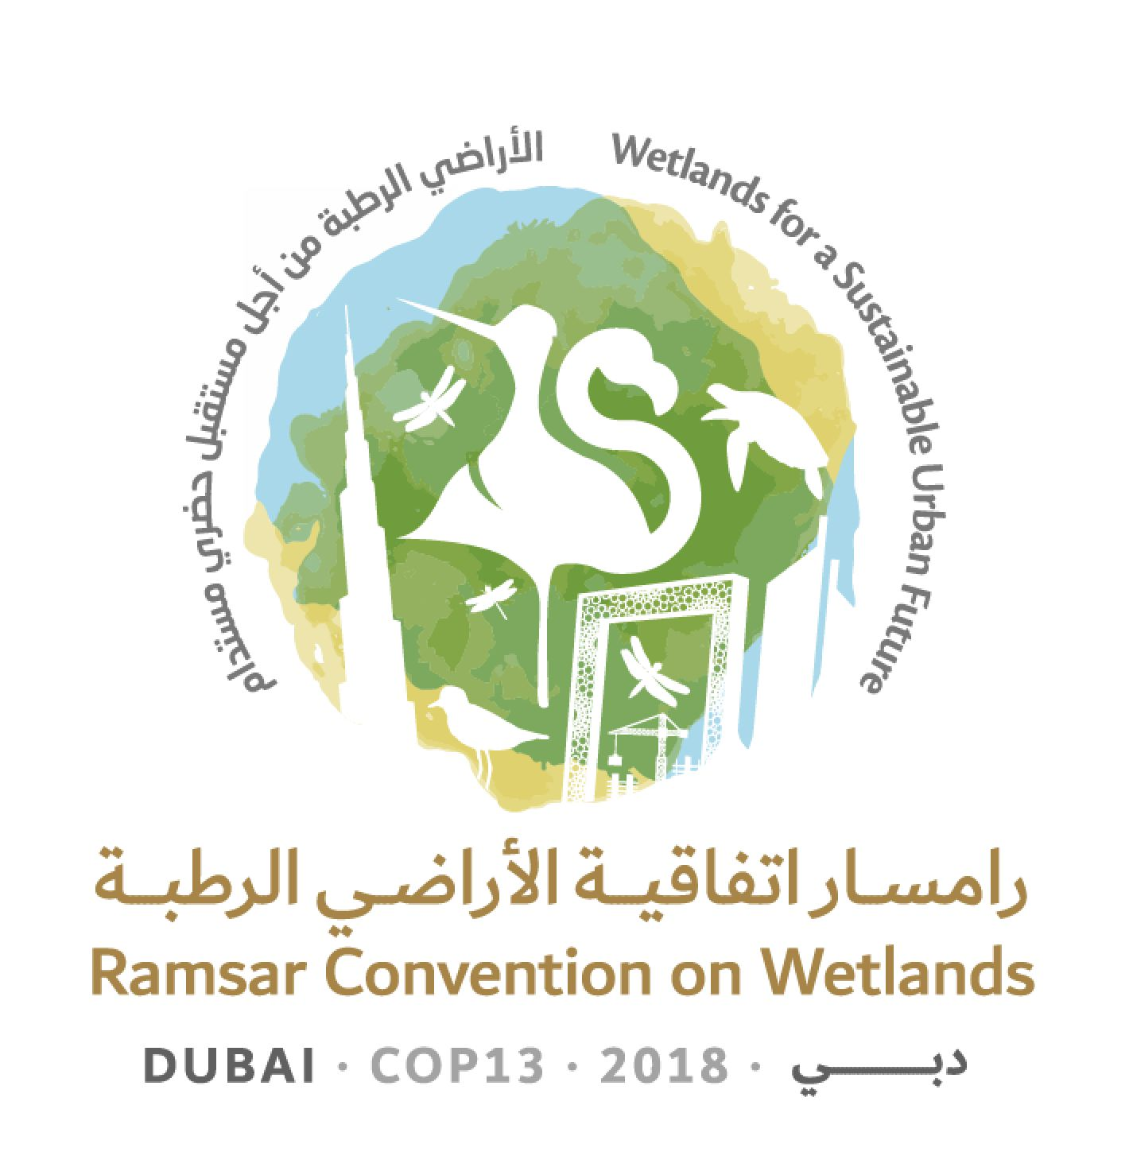
13th Meeting of the Conference of the Contracting Parties

to the Ramsar Convention on Wetlands

“Wetlands for a Sustainable Urban Future”

Dubai, United Arab Emirates, 21-29 October 2018

Ramsar COP13 Doc.18.20

Draft resolution on gender and wetlands

Submitted by Colombia

1. RECALLING United Nations General Assembly Resolution 70/1 on Transforming our world: the 2030 Agenda for Sustainable Development, which recognizes that women play a vital role as agents of development and acknowledges that realizing gender equality and the empowerment of all women and girls is crucial to making progress across all Sustainable Development Goals and targets;

2. EMPHASIZING the importance of coherence between gender-responsive climate and biodiversity policies and the balanced participation of women and men in the implementation of the Convention;

3. HIGHLIGHTING that the Convention on Biological Diversity (CBD), the UN Framework Convention on Climate Change (UNFCCC) and the UN Convention to Combat Desertification (UNCCD) have recognized the importance of addressing gender equality and women’s empowerment in their implementation;

4. NOTING the Convention on the Elimination of All Forms of Discrimination against Women, the Beijing Declaration and Platform for Action and their related outcomes, among others;

5. HAVING IN MIND the agreed conclusions from the 62nd session of the Commission on the Status of Women, entitled Challenges and opportunities in achieving gender equality and the empowerment of rural women and girls;

6. RECOGNIZING that women play a crucial role in the provision, management and safeguarding of wetland resources, especially water, as well as in conserving the culture, folklore, music, mythology, oral traditions, customs, and traditional knowledge around wetlands, among others, and that special attention should be paid to the specific needs of women because they are disproportionately affected by inadequate water facilities;

7. FURTHER RECALLING that the 4th Strategic Plan 2016-2024 of the Convention anticipates the relevance that the Sustainable Development Goals will have on wetlands and makes clear that the plan should be implemented as a contribution to the other internationally agreed environmental goals and targets; and

8. ACKNOWLEDGING that the 4th Strategic Plan 2016-2024, in paragraph 38, encourages Contracting Parties to synergize their efforts aimed at implementing the Convention with measures taken to implement the CBD, the UNFCCC and the UNCCD, among other global multilateral environmental agreements, as they deem appropriate;

THE CONFERENCE OF THE CONTRACTING PARTIES

9. ENCOURAGES Contracting Parties to mainstream a gender perspective in their implementation of the Convention, in particular with respect to their implementation of the Strategic Plan 2016-2024 and the Programme on Communication, Capacity Building, Education, Participation and Awareness (CEPA) 2016-2024, considering the crucial role of women in the provision, management and safeguarding of wetlands, and paying special attention to their specific needs;

10. REQUESTS that the Conference of the Contracting Parties include, as part of the process for the mid-term review of the Strategic Plan, ways in which Parties might mainstream a gender perspective in their implementation of the Convention;

11. ENCOURAGES also the Secretariat to support Contracting Parties mainstreaming a gender perspective in the Strategic Plan 2016-2024 and in the CEPA Programme 2016-2024, including through financial and non-financial resources;

12. REQUESTS that the Scientific and Technical Review Panel analyse the benefits to wetland management and wise use that derive from taking a gender perspective, develop guidance on how to integrate gender issues in the implementation of the Convention, and submit proposals to the Conference of the Contracting Parties for its consideration;

13. INVITES Contracting Parties, in collaboration with the Secretariat, to:

a. train and raise awareness of all delegates on issues related to gender and wetlands; and

b. strengthen the skills and capacity of all delegates to achieve equal participation of women and men in Ramsar Convention meetings through training on, inter alia, negotiation skills, the drafting of legal documents and strategic communication;

14. REQUESTS that the Secretariat conduct mandatory training for all staff regarding gender equality and mainstreaming and designate a staff member as the Secretariat’s lead expert on gender issues responsible for assisting all Contracting Parties on this topic, providing additional training as needed to enhance his/her expertise;

15. REQUESTS that the Secretariat explore means by which it can generate aspirational goals consistent with the UN Secretary General’s System-wide Strategy on Gender Parity and report back to the Contracting Parties at the 14th Meeting of the Contracting Parties on this effort;

16. INVITES Contracting Parties to consider increasing the participation and representation of women in their national delegations and as chairs/facilitators of formal and informal negotiating groups;

17. ENCOURAGES Contracting Parties to give due consideration to a balanced gender representation among representatives within each region as well as in the bodies of the Convention;

18. ALSO ENCOURAGES Contracting Parties to include, where applicable, sex-disaggregated data and gender analysis in their national reports, including information on differentiated impacts and benefits accrued by women and men as a result of wetland management and conservation actions, taking into account Sustainable Development Goals information;

19. REQUESTS the Secretariat to support Contracting Parties, upon request, to strengthen their national statistics systems to improve the incorporation of sex-disaggregated data and gender analysis in their national reports; and

20. ALSO REQUESTS the Secretariat to prepare a synthesis report on the gender-relevant and sex-disaggregated information provided by Contracting Parties in national reports, including the actions of the Secretariat in this regard.

The 4th Strategic Plan 2016-2024. The Ramsar Convention on Wetlands (2015). At: https://www.ramsar.org/sites/default/files/documents/library/4th_strategic_plan_2016_2024_e.pdf
Ibid, para. 15.
Ibid, para. 37.

