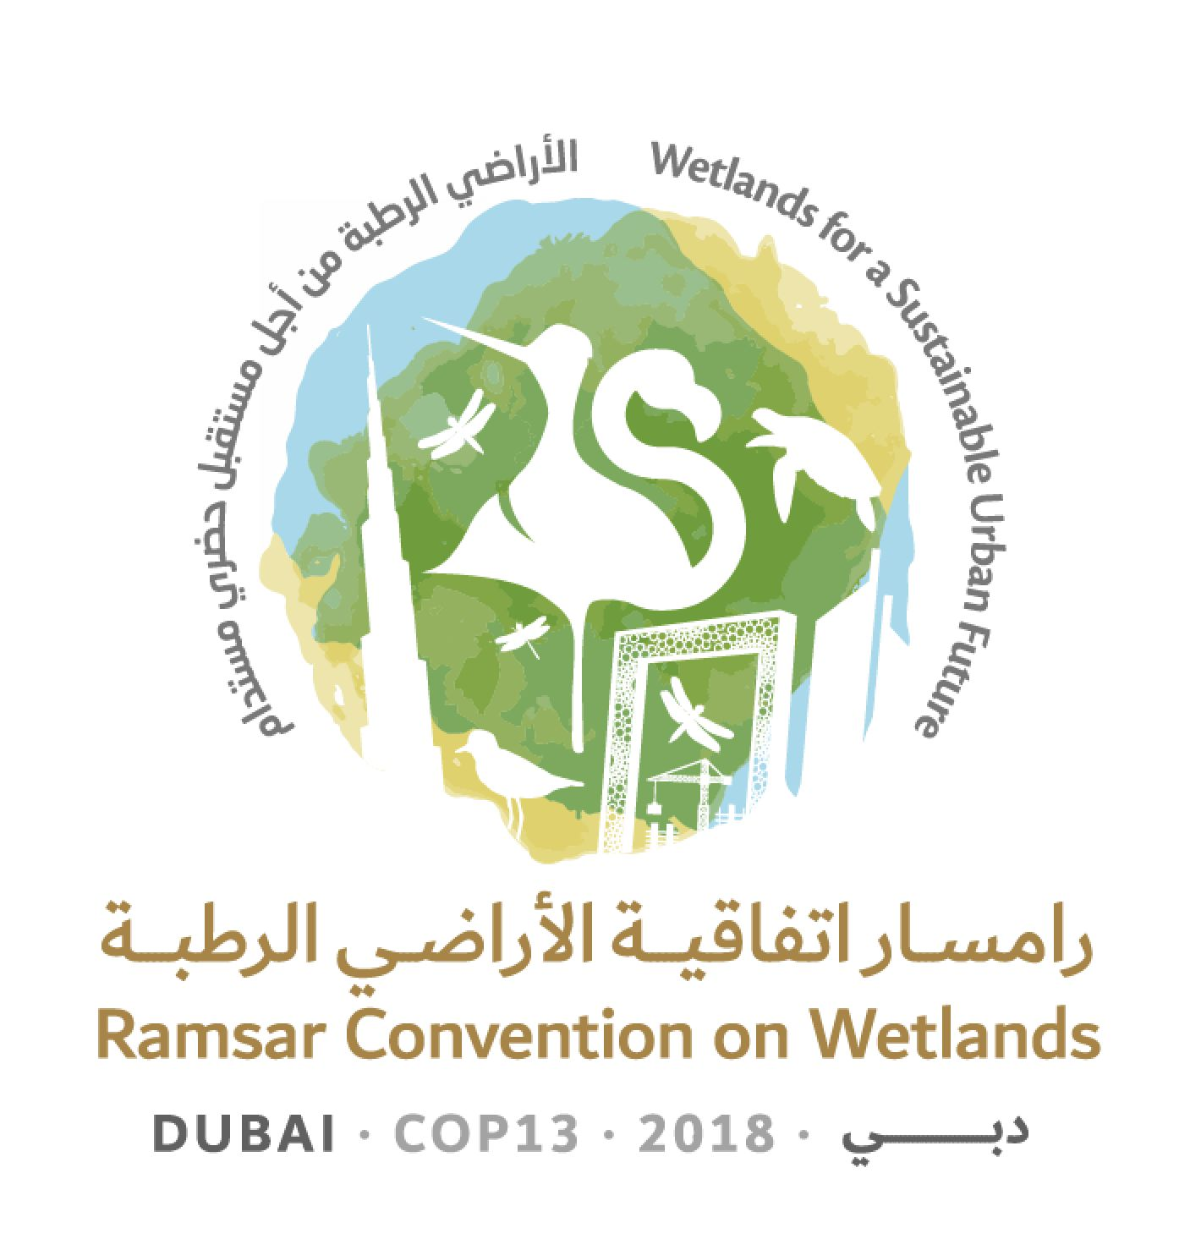
13th Meeting of the Conference of the Contracting Parties

to the Ramsar Convention on Wetlands

“Wetlands for a Sustainable Urban Future”

Dubai, United Arab Emirates, 21-29 October 2018

Ramsar COP13 Doc.18.19

Draft resolution on the importance of wetlands [for] [in the context of]
peace and [human security] [security]

Submitted by Senegal and the Central African Republic

Note from the Secretariat

At the 54th meeting of the Standing Committee a number of Parties expressed that they were unable to support the draft resolution as written.

The Standing Committee noted in Decision SC54-28 that a number of Parties have concerns about the draft resolution and requested that the draft resolution be further developed at COP13.

1. NOTING that there is widespread recognition of the link between water insecurity and human insecurity, driven by anthropogenic and climatic factors, as reflected in the World Bank Group report Turbulent Waters : Pursuing Water Security in Fragile Contexts, 2017; The Global Risks Report 2018 of the World Economic Forum; the report of the Global High-Level Panel on Water and Peace A Matter of Survival, 2017; and The Hague Declaration on Planetary Security of the Planetary Security Conference, The Hague, December 2017;

2. RECOGNIZING that wetlands are critical infrastructure that regulate and provide water to society and are of direct relevance to the achievement of water security and the sustaining of livelihoods;

3. NOTING the increasing recognition that reversing wetland degradation and implementing wise use of wetlands is an important condition that helps maintain stable, peaceful and inclusive societies that can underpin measures for improving water security as a basis for sustainable development, as reflected in The Global Land Outlook of the United Nations Convention to Combat Desertification, 2017; the Freshwater Strategy 2017 – 2021 of the United Nations Environment Programme (UNEP), 2017; and Water Shocks: Wetlands and Human Migration in the Sahel, Wetlands International, 2017;

4. NOTING that human security highlights “the right of people to live in freedom and dignity, free from poverty and despair (…) with an equal opportunity to enjoy all their rights and fully develop their human potential”, as reflected in Resolution 66/290 adopted by the UN General Assembly 66th Session of 25 October 2012 on Follow-up to paragraph 143 on human security of the 2005 World Summit Outcome (A/RES/66/290), and that many areas of growing human insecurity are centred around internationally important wetlands;

5. RECALLING Resolution IX.14 on Wetlands and poverty reduction, that recognizes the importance of wetland ecosystems for human health and well-being, especially for people in less developed countries, and calls for action to contribute to poverty reduction through the sustainable use and restoration of wetlands;

6. RECALLING Resolution XI.12 on Wetlands and health: taking an ecosystem approach, which affirms the dependency of human health and well-being upon ecosystems, stresses the key role of wetlands in determining human health and well-being and calls for an ecosystem approach to health in wetlands and their catchments in order to bring health benefits to all;

7. CONSIDERING the Changwon Declaration on human well-being and wetlands of 2008, which notes that declining access to freshwater can increase societal conflict, that the degradation of wetlands makes geopolitical stability less secure, and that the benefits of wetlands are essential for the future security of human kind;

8. RECALLING Resolution XII.13 on Wetlands and disaster risk reduction, which highlights the devastating impacts of disasters on the maintenance of healthy wetlands, the serious effects that disasters have had on the lives and livelihoods of millions of people and on biodiversity and the role of fully functioning wetland ecosystems in enhancing local resilience, and calls for the integration of wetland-based disaster risk reduction into national strategic plans and relevant policies and planning;

9. RECALLING Resolution IX.1 Annex C on An Integrated Framework for the Ramsar Convention’s water-related guidance, which affirms the interdependency between water and wetlands and highlights the importance of effective governance for water resources management in relation to ecosystems;

10. RECALLING that the 4th Ramsar Strategic Plan 2016-2024 aims for wetland benefits to be featured in national policy, strategies and plans relating to key sectors such as water, energy, agriculture, infrastructure and forestry; and that it promotes the prioritization of the restoration of degraded wetlands that are relevant for biodiversity conservation, disaster risk reduction, livelihoods and climate change mitigation and adaptation;

11. RECOGNIZING the Security, Stability and Sustainability initiative launched by African governments at the Climate Change Conference in Morocco on 16 November 2016;

12. ACKNOWLEDGING that climate change and environmental degradation exacerbate potential conflict, in light of their impact on desertification, land degradation, and water and food scarcity, as noted in the European Union’s Global Strategy for the EU foreign and security policy Shared Vision, Common Action: A stronger Europe, 2016;

13. ACKNOWLEDGING that armed conflict contributes to the degradation of the environment and natural resources and can exacerbate the emissions of greenhouse gases impacting on climate change, as evidenced in dialogues in the Environment and Emergencies Forum, Nairobi, Kenya, September 2017, the Planetary Security Conference, The Hague, December 2017, and the United Nations Environment Assembly’s December 2017 resolution on Pollution mitigation and control in areas affected by armed conflict or terrorism;

14. ACKNOWLEDGING the interdependency between Sustainable Development Goal 6 on water, SDG11 on sustainable cities and communities, SDG13 on climate action, SDG15 on life on land and SDG16 on peace, justice and strong institutions, and that the status of wetlands is relevant to targets under these goals; further NOTING that SDGs 13 and 16 will be reviewed in depth during the United Nations High-Level Political Forum on Sustainable Development in 2019;

15. AWARE that participants in the Global Platform for Disaster Risk Reduction in Cancun, Mexico, 2017, recognized the priority needed to manage water risks and the need for nature-based solutions for successful disaster preparedness, disaster risk reduction and climate change adaptation;

16. NOTING that the multidimensional fragility framework of the Organisation for Economic Co-operation and Development recognizes environmental fragility as one of the five dimensions of fragility, next to economic, political, security and societal fragility, and recognizes inter alia strong rule of law and governance as mechanisms to effectively address environmental fragility;

17. NOTING that the Peace Promise launched at the World Humanitarian Summit in Istanbul, Turkey, 2016, contains five commitments to more effective synergies among peace, humanitarian and development actions in complex humanitarian situations, including the commitment to conduct context, risk or conflict analysis regularly, and the commitment to do no harm and ensure conflict-sensitive programming; and

18. RECOGNIZING that, if managed well, freshwater ecosystems contribute to mitigating risks, promoting stability and trust-building measures, as reflected in the UNEP Freshwater Strategy 2017 – 2021, and in the UNEP Environmental Peacebuilding initiative;

THE CONFERENCE OF THE CONTRACTING PARTIES

19. REQUESTS that the Scientific and Technical Review Panel (STRP) develop guidance on “wetland security hotspots” mapping and vulnerability assessment, drawing on the experience of major programmes on resilience;

20. INVITES Contracting Parties to identify and map the wetland security hotspots, where wetlands are contributing to the maintenance of peace, through supporting livelihoods and sustainable development, and those where loss of wetlands is contributing to insecurity;

21. INVITES Contracting Parties to assess the current condition of wetland security hotspots and their vulnerability to future changes in climate and natural resource management in the wider landscape and the related risks to peace;

22. INVITES Contracting Parties in a position to do so, as well as International Organization Partners (IOPs) and other relevant organizations, to assist Contracting Parties in post-conflict situations to review the status of their wetlands and to carry out restoration of their ecosystem services while involving local stakeholders, including displaced people;

23. ENCOURAGES Contracting Parties to prioritize the safeguarding of wetland security hotspots by resolving natural resource use trade-offs using best practices such as integrated river basin management and an integrated landscape approach while involving local stakeholders;

24. ENCOURAGES relevant national and international organizations to gather and share information on the specific peace benefits that may be gained by managing wetland ecosystem services wisely, and on the consequent impacts on conflict prevention, aiming to generate a wider commitment to the wise use of wetland security hotspots;

25. INVITES Contracting Parties, and relevant national and international organizations as appropriate, to commit to doing no harm and to applying a conflict-sensitive approach in the development and implementation of wetland management and restoration projects and investments programmes, while involving local stakeholders;

26. URGES the Secretariat to nurture and establish partnerships between the wetland community and peace, humanitarian and development actors, to highlight the importance of wetlands for peace and security, and to create the synergies and complementarities that are required to ensure that wetlands underpin peace and security;

27. ENCOURAGES Contracting Parties to wisely use wetlands as part of strategies to maintain and restore peace, by incorporating them into national planning processes and financing mechanisms, such as Nationally Determined Contributions (NDCs) and National Adaptation Plans (NAPs);

28. ENCOURAGES Contracting Parties to integrate ecosystem management related considerations, in particular relating to water management and wetland security hotspots into strategies of regional economic integration organizations in relation to, inter alia, migration, security, climate action, land degradation and development assistance;

29. ENCOURAGES Contracting Parties to work with relevant conventions , the Ramsar IOPs, national and international non-governmental organizations and others to look for synergies, to integrate relevant issues into the strategies and plans of these conventions, and to drive commitments and action together, for example by working through existing memoranda;

30. INVITES Contracting Parties to use the 2019 review process of Sustainable Development Goal 16 to highlight the link between wetlands, peace and security and to underline the need for wise use of wetlands to promote peaceful and inclusive societies for sustainable development, and to use the review process of SDG13 to add the relevance of wetlands to strengthening resilience and adaptive capacity to climate related hazards and natural disasters;

31. REQUESTS that Contracting Parties, together with the Convention’s IOPs and other key partners, raise awareness of this resolution on wetlands, peace and security in dialogues and political processes at all levels, and take needed actions to conserve and sustainably use wetlands;

32. REQUESTS that the STRP monitor the discussions, developments and trends in international fora on the role of wetland conservation, restoration and wise use in peacekeeping and in conflict prevention in the development of their work, and to develop guidance and facilitate knowledge sharing about this, drawing on the experience of other conventions such as the Convention on Migratory Species; and

33. FURTHER REQUESTS that the STRP keep Contracting Parties informed of these discussions, developments and trends through the STRP report at future meetings of the Standing Committee.

Interventions in conflict-affected areas can have both positive and negative impacts on conflict dynamics. “Do No Harm” is an approach that seeks to analyse how an intervention may be implemented in a way that addresses the underlying causes of conflict rather than exacerbating conflict. Conflict sensitivity is the ability of an organization to: i) understand the contexts it operates in, ii) understand the interaction between its intervention and the context and iii) act upon this understanding in order to minimize negative impacts and maximise positive impacts on conflict (Conflict Sensitivity Consortium, 2012: How to guide to conflict sensitivity)
In 2019 the HLP will review SDGs 4 on education, 8 on work, 10 on inequality, 13 on climate action, 16 on peace and 17 on partnerships.

