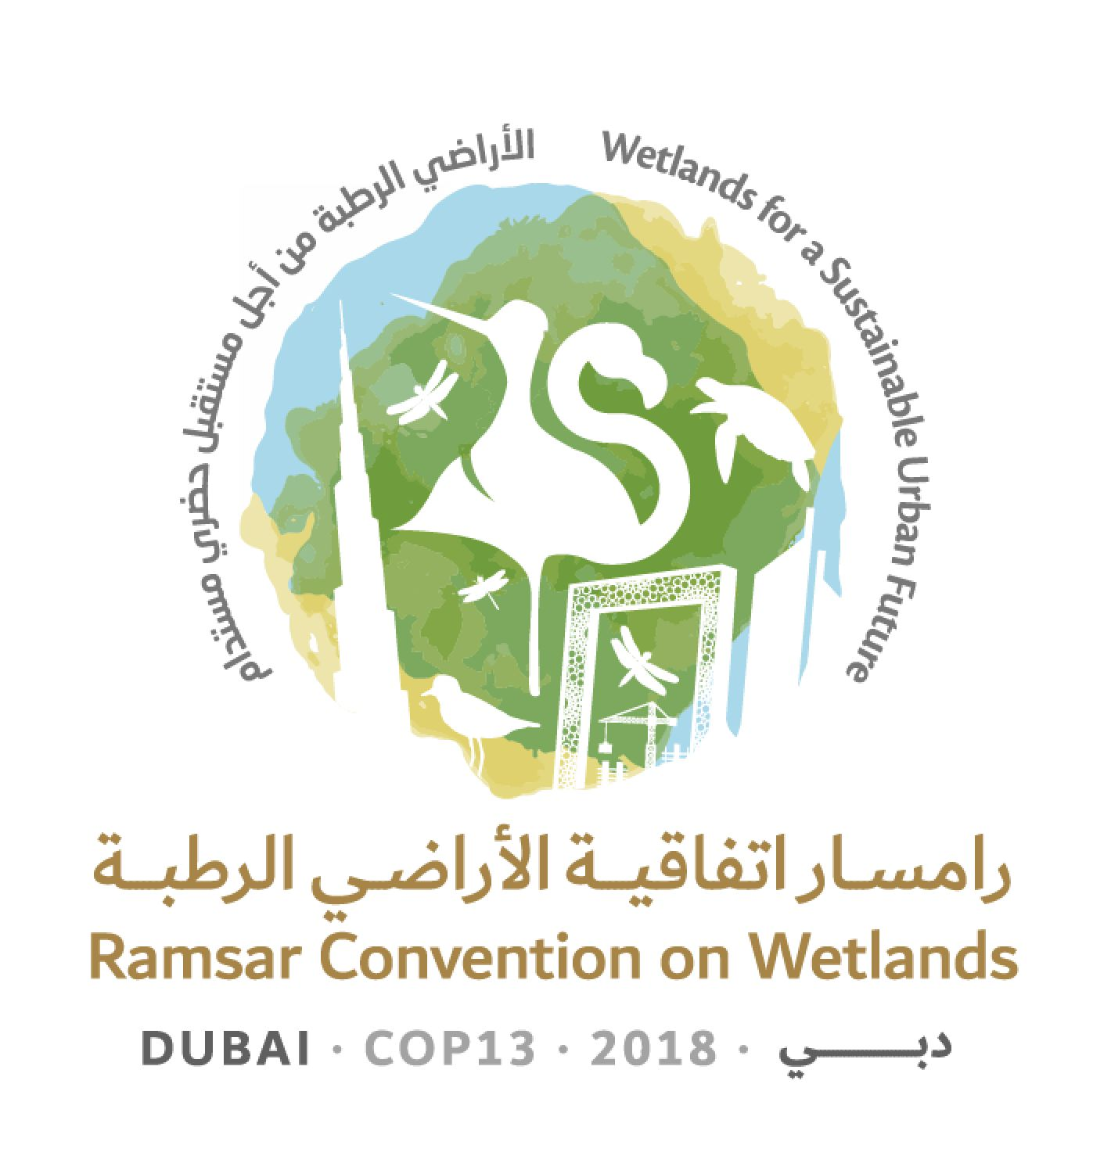
13th Meeting of the Conference of the Contracting Parties

to the Ramsar Convention on Wetlands

“Wetlands for a Sustainable Urban Future”

Dubai, United Arab Emirates, 21-29 October 2018

Ramsar COP13 Doc.18.11

Draft resolution on Ramsar Advisory Missions

Submitted by Burkina Faso

1. RECALLING Recommendation 4.7, on Mechanisms for improved application of the Ramsar Convention, which established that, when the Secretariat becomes aware that a Ramsar Site is facing change in ecological character, where appropriate it shall propose a Ramsar Advisory Mission (RAM) to assist Contracting Parties to address such changes;

2. NOTING that, up to December 2016, across all Ramsar Regions, there had been 82 applications of this procedure, with positive results; and COMMENDING those Parties that have used RAMs in order to seek constructive solutions to challenges they face and as a contribution to their efforts towards effective implementation of the Convention;

3. RECOGNIZING the need to underpin and promote the greater application of the RAM as an important and useful tool for assisting Parties to implement the Convention;

4. FURTHER ACKNOWLEDGING the important contribution that the Scientific and Technical Review Panel (STRP), the International Organization Partners (IOPs) and other stakeholders have made to implementation of the RAM process over its 30-year history;

5. WELCOMING the STRP’s work in the past triennium to comprehensively review and analyse the body of reports from 82 RAM missions, and FURTHER WELCOMING the STRP’s derived briefing note and policy brief on RAMs published in 2018;

6. NOTING that there has been no allocation from the core budget to support implementation of the RAM process since the 7th meeting of the Conference of Contracting Parties, in 1999, but that non-core funding has been expended since this time; and

7. RECOGNIZING the value of RAMs also in terms of raising the Convention’s visibility, highlighting the commitment of Contracting Parties, and contributing to public awareness concerning wetland conservation and wise use;

THE CONFERENCE OF THE CONTRACTING PARTIES

8. REAFFIRMS that the Ramsar Advisory Mission (RAM) mechanism is one of the key tools available to Parties to assist with implementation of the Convention, constituting a means for providing independent advice relevant to addressing actual and potential change in ecological character at Ramsar Sites;

9. ENCOURAGES Contracting Parties to consider more frequent application of RAMs in appropriate cases;

10. ENCOURAGES the operation of RAMs in synergy with missions from other conventions when applicable;

11. URGES diligent follow-up by Contracting Parties hosting RAMs, to foster implementation of the recommendations made in RAM reports and to evaluate and report on the outcomes;

12. REAFFIRMS that RAM reports are public documents once the Party concerned has had an opportunity to approve them;

13. INSTRUCTS the Secretariat, in consultation with the Scientific and Technical Review Panel (STRP) and having regard to its findings in the briefing note and policy brief on RAMs published in 2018, to prepare operational guidance for RAMs, covering inter alia the issues listed in Annex 1 to the present Resolution, to be submitted for adoption by the Standing Committee at its 57th meeting;

14. ENCOURAGES Contracting Parties to consider making an allocation for the RAM mechanism from the core budget; CALLS ON Parties, the private sector and others to consider making additional voluntary contributions in support of RAMs; and FURTHER INSTRUCTS the Secretariat to consider the funding needs of the RAM mechanism in its Resource Mobilization Work Plan;

15. THANKS the STRP for its significant work during the 2015-2018 triennium to review past RAM experiences; and

16. REQUESTS that the Secretariat develop an informational, downloadable brochure in all official languages explaining the opportunities presented by RAMs to assist Parties with implementing the Convention.

Annex 1

Development of practical and technical operational guidance for Contracting Parties, the Secretariat and other stakeholders in the form of a simple “how to” step-by-step manual covering inter alia the following topics

• Circumstances that trigger the proposed use of a Ramsar Advisory Mission (RAM)

• Links with Article 3.2

• Links with the Montreux Record

• Pre-RAM investigations and advice

• Prerogative of the Contracting Party to invite RAM/approve Terms of Reference (ToR)

• Developing ToRs – standard good practice

• Scope of the RAM

• Coordination and team composition of mission team

• Timeframe considerations

• Role of the Secretariat

• Role of the STRP

• Role of IOPs and other stakeholders

• Resourcing the RAM

• Application to candidate Ramsar Sites and other undesignated wetlands

• Application in transboundary contexts

• Operation on a joint basis with mechanisms of other MEAs

• Structure and contents of RAM reports

• The process for following up a RAM report

• Reporting on the activities of the RAM, including a review of outcomes an appropriate time after completion of the mission (typically about six years)

