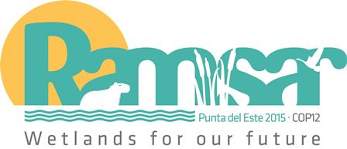12th Meeting of the Conference of the Parties to
the Convention on Wetlands (Ramsar, Iran, 1971)

Punta del Este, Uruguay, 1-9 June 2015

Ramsar COP12 DOC.10
English and Spanish only

Regional overview of the implementation of the Convention and its Strategic Plan in the Americas (Neotropics and North America regions)

National Reports upon which this overview is based can be consulted at:
www.ramsar.org/library/field_date/%5B2015-01-01T00%3A00%3A00Z%20TO%202016-01-01T00%3A00%3A00Z%5D/field_document_type/contracting-party-documents-418/field_document_type/national-reports-532/field_tag_countries/neotropics-15?search_api_views_fulltext= (Neotropics) and
www.ramsar.org/library/field_date/%5B2015-01-01T00%3A00%3A00Z%20TO%202016-01-01T00%3A00%3A00Z%5D/field_document_type/contracting-party-documents-418/field_document_type/national-reports-532/field_tag_countries/north-america-16?search_api_views_fulltext= (North America)

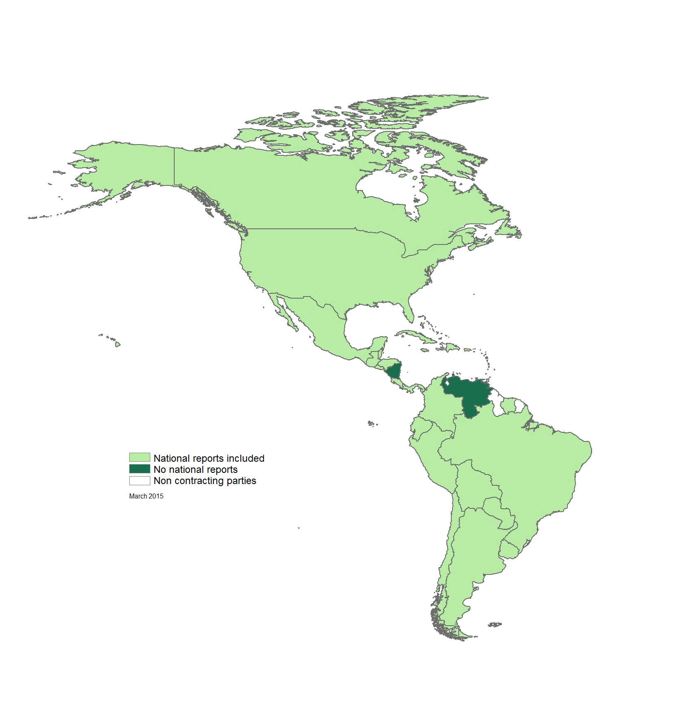

Figure 1 National Reports received for COP12

- Contracting Parties in the Americas as of 31 March 2015: Antigua and Barbuda, Argentina, Bahamas, Barbados, Belize, Bolivia, Brazil, Canada, Colombia, Costa Rica, Chile, Cuba, Dominican Republic, Ecuador, El Salvador, Guatemala, Grenada, Honduras, Jamaica, Mexico, Nicaragua, Panama, Paraguay, Peru, Saint Lucia, Suriname, Trinidad and Tobago, United States of America, Uruguay, and Venezuela (30).

- Contracting Parties whose National Reports are included in this analysis: Antigua and Barbuda, Argentina, Bahamas, Barbados, Belize, Bolivia, Brazil, Canada, Chile, Colombia, Costa Rica, Cuba, Dominican Republic, Ecuador, El Salvador, Guatemala, Grenada, Honduras, Jamaica, Mexico, Panama, Paraguay, Peru, Suriname, Trinidad and Tobago, United States of America and Uruguay (27).

- Contracting Parties that have not yet submitted their National Reports: Nicaragua, Saint Lucia and Venezuela (3).

- There are 35 countries in the Americas, of which 30 are already Contracting Parties. Since COP11 no new countries have acceded to the Convention. Dominica, Guyana, Haiti, Saint Kitts and Nevis, and Saint Vincent and the Grenadines are not yet members of the Convention.

Summary and ways forward 2015-2018

- Based on the priorities set for 2009-2015, since COP11 the whole American region has made considerable progress towards the implementation of the Strategic Plan of the Convention, chiefly through the continued designation of Ramsar Sites, preparation of inventories, adoption and implementation of wetland policies, and consolidation of National Wetlands Committees and of Regional Initiatives.

- The threats to wetlands in the Western Hemisphere still persist, from urban development, infrastructure, extractive industries and unsustainable tourism and productive activities, mainly in fresh water and coastal wetlands, from the coast of Mexico to South America and particularly in Central America and the Caribbean.

- As indicated in previous reports, one of the most urgent priorities for the maintenance of the ecological character of Ramsar Sites is the implementation of legal frameworks, such as policies and specific wetland regulations, and the application of strategic land use planning and the use of environmental impact assessments (EIAs) and strategic environmental assessments (SEAs) in decision-making processes.

- Ramsar Regional Initiatives, both centres and networks, have given different Contracting Parties and interested stakeholders in the Americas a good opportunity to engage and implement collaborative actions on the ground, and to increase the visibility of the Convention, but efforts have to be focused to maintain the Initiatives’ political and financial sustainability in the upcoming years.

- Outreach on Ramsar-related matters and engagement with wetland stakeholders continues to be a challenge for Administrative Authorities, Ramsar Focal Points and STRP and CEPA National Focal Points, especially communication with and among Ramsar Site managers across the Americas.

- In summary, the main challenge for the Contracting Parties in the coming years to stop wetland loss and degradation will be to raise awareness at all levels – national, regional and local – about wetland benefits and services, so that decision makers have a full understanding of what is really at stake for wetlands. Likewise, governments at all levels must show the political commitment to support, technically and financially, the effective management of their Ramsar Sites and other wetlands.

Main achievements since COP11 and priorities for 2016-2018

- The main achievements indicated by the Contracting Parties in the Americas region according to the National Reports submitted to the 12th Meeting of the Conference of the Parties are described below.

What have been the five most successful aspects of implementation of the Convention? (A)

- In the Americas the five most successful aspects of implementation of the Convention by Contracting Parties have been:
- preparation of national wetlands inventory;
- establishment and operation of National Wetland Committees;
- preparation of wetland policy;
- designation and extension of Ramsar Sites; and
- adoption and adjustment of technical and legal frameworks.

What have been the five greatest difficulties in implementing the Convention? (B)

- The greatest difficulties reported by the Contracting Parties are:
- insufficient funds for implementation of the Convention (and limited human and financial resources, infrastructure, control and monitoring);
- the lack of a specific wetlands policy or other legal tools such as SEAs;
- the lack of knowledge of Ramsar guidelines and Resolutions at different national levels which make implementation difficult, as does the lack of awareness of the importance of wetland benefits and services;
- pressure on wetlands due to economic empowerment and development and the lack of land use planning; and
- difficulties in the coordination of efforts to align multiple constituencies (focal points, national agencies, site managers) in spite of shared visions and interests.

What are the five priorities for future implementation of the Convention? (C)

- The Contracting Parties have set the following priorities for the 2016-2018 triennium based on the National Reports:
- the development or implementation of a national wetland policy;
- the designation and management of Ramsar Sites, including wetland inventory and monitoring plans for wetlands;
- an increase in CEPA activities through public awareness raising, communication and outreach, capacity building for wetland managers and formation or reinforcement of National Wetland Committees to improve communications between the Administrative Authority, STRP National Focal Point, Ramsar Site managers and other wetland stakeholders;
- restoration of priority wetlands; and
- consolidation of Regional Initiatives.

- During the Pan-American meeting held in Bogotá, Colombia, in October 2014, the Contracting Parties also established priorities the following priorities for mobilization of resources by the Partnership Unit of the Ramsar Secretariat for the 2016-2018 triennium:
- Ramsar Advisory Missions;
- funding of COP12 delegates;
- reserve for COP;
- translation of STRP technical documents;
- staff (Regional Officer for the Americas); and
- Regional Initiatives.

Recommendations concerning implementation assistance from the Ramsar Secretariat (D)

- In general the Contracting Parties highlighted the efficiency and positive attitude of the Secretariat staff in providing support, and indicated the relevance of the role of the Senior Regional Advisors in national processes.

- The main recommendations from National Reports are:

- There must be increased alignment between the STRP and CEPA, and STRP efforts and products must be shaped to become increasingly more effective training and education tools.

- Increased financial assistance should be sought to undertake a global agenda on wetlands for the next 15 years, for specific projects for restoration and management of wetlands.

Recommendations concerning implementation assistance from the Convention’s International Organisation Partners (IOPs) (E)

- Contracting Parties consider that the IOPs should collaborate to provide sponsorship of small projects and sources for case scenarios and according to national priorities. They also consider that IOPs should be in closer contact with the governments’ Ramsar focal points in relation to the activities in the countries that are aligned with the application of the Convention.

- It was also mentioned that while the IOPs are able to sit in on meetings with the Parties and so receive greater access and information than other NGOs or IGOs, it is not currently very clear what benefit the Parties and the Convention itself receive from the special status of the IOPs. The expertise and resources of the IOPs should be leveraged to benefit Parties’ work to implement the Convention, and if this is not being done greater efforts should be made to ensure that this is occurring. If it is already happening it is not visible and better efforts need to be made to publicize the benefits the IOPs bring to the Convention and the Parties. In addition, Ramsar must consider broadening its partnership base in order to engage wetland constituencies more broadly and effectively. One option would be to create a global ‘friend of Ramsar’ constituency which smaller organizations sharing Ramsar’s goals can join.

How can national implementation of the Ramsar Convention be better linked with implementation of other multilateral environmental agreements (MEAs)? (F)

- The Contracting Parties provided the following suggestions:

- To prepare a common reporting format and develop collaboration between the various national agencies.

- To improve the communication and synergies that promote the articulation of plans, programmes or projects for the conservation and wise use of wetlands, as well as to strengthen the work with the regional agreements or regional mechanisms.

- To develop a common agenda between the focal points of Ramsar and other MEAs to agree on actions and financial resources to implement the environmental agreements. Some Contracting Parties suggested exploring ways to avoid duplication, advancing synergies, promoting opportunities for mutual recognition and involvement as well as the sharing of information between government departments and agencies involved in biodiversity and climate change. The National Biodiversity Strategy and Action Plan update process could represent a good opportunity to establish closer coordination between biodiversity-related conventions, including the Ramsar Convention.

How can implementation of the Ramsar Convention be better linked with the implementation of water policy/strategy and other strategies in the country? (G)

- Some of the suggestions of the Contracting Parties relate to the collaboration of all relevant agencies which should be included in the national wetlands committee or subcommittees. The link between the ecosystem goods and services of wetlands and sustainable development, poverty reduction and other strategies should continue to be researched and communicated to decision makers both to influence such strategies and to incentivize conservation of wetlands.

- It was also mentioned that one of the mechanisms could be the formulation of National Development Plans, and the reinforcement of programmes for technical capacity at all levels, especially on political management, covering local governments and the different national authorities, and applying an ecosystem approach.

General comments on the implementation of the Convention (H)

- The comments from the Contracting Parties cover different areas. With regards to National Reports, the Contracting Parties consider that they should be interpreted in the light of a governance perspective, and decentralized, participative, collaborative decision making. The role of government is then to:
- develop methods to monitor status and trends that can be easily disseminated;
- provide for the establishment of problem-solving communities where structured decision making takes place;
- identify gaps and needs for higher-level policy guidelines;
- develop long-term strategies; and
- develop incentives and collaborative pathways to address identified tactical issues and implement long-term strategy that is sustainable through education, empowerment and adaptive change.

- The strength of the current Ramsar Strategic Plan (2009-2015) is the theme of partnerships. This theme should continue into the next Strategic Plan. Communications and outreach should also be an integral component of a new plan, including guidance for dissemination of information from the STRP to Contracting Parties for distribution to on-the-ground practitioners. Ramsar’s STRP needs to increase collaboration and leverage the expertise of other bodies (e.g. Convention on Biological Diversity, Intergovermental Platform on Biodiversity and Ecosystem Services, International Organization Partners) in order to undertake tasks with minimal resources. It was also mentioned that is important that the STRP works on the priorities of the Contracting Parties and their guidelines and that products are distributed in the three official languages of the Convention.

Organisations which have been consulted on or have contributed to the information provided in the reports (I)

- Most of the Contracting Parties prepared their reports with the collaboration of national and regional agencies and authorities, National Wetlands Committees, NGOs, academia and private sector partners.

Activities undertaken since COP11 to implement the Convention

- In order to paint an overall picture of the Convention’s progress in the Americas, the ensuing analysis follows the structure of the Strategic Plan 2009-2015, drawing upon information from 27 (90%) National Reports submitted by Contracting Parties in the Neotropics and North America regions as well as from regional processes under the Convention.

Goal 1: The Wise Use of Wetlands

National wetland inventories and assessment (Strategy 1.1)

- Under this strategy, there have been continued actions to complete national wetland inventories (indicator 1.1.1). Since COP11 the the number of Parties in the Americas working on wetland inventories has increased (to reach 36%). However these regions have not achieved the key Result Area of the Strategic Plan 2009-2015 that by 2015 all Parties are to have completed national wetland inventories, and therefore some Parties still need to continue making efforts in this area for the next triennium.

- Regarding the status of the ecological character of Ramsar Sites in general (indicator 1.1.3), the Americas present less progress than the global average, as 48% of the Parties reported that the status had not changed and 28% reported that it had deteriorated (Figures 2 and 3).

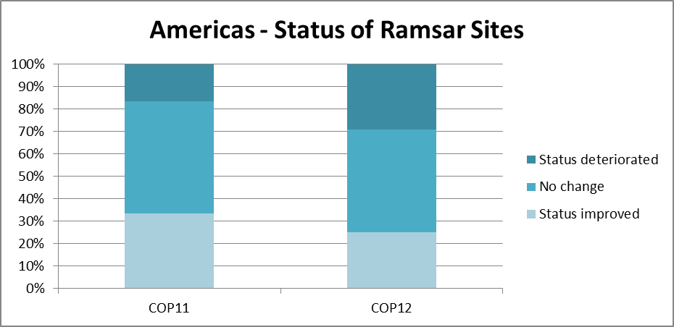
Figure 2. Status of ecological character of Ramsar Sites in the Americas

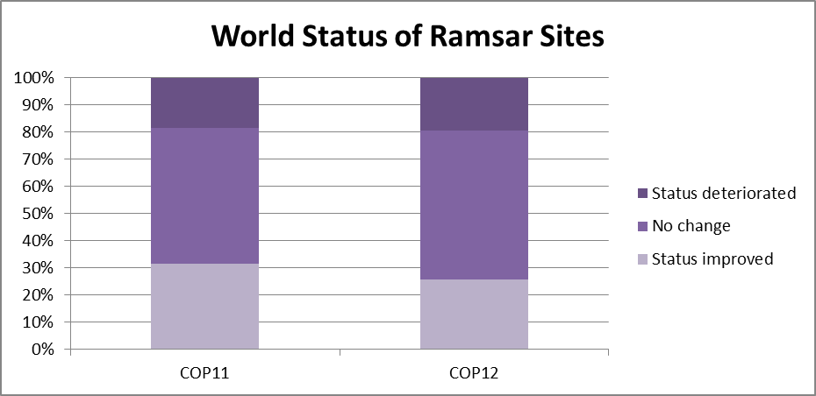
Figure 3. Status of ecological character of Ramsar Sites worldwide

- These results suggest that Site designation has brought benefits for the protection or improvement of the condition of Ramsar Sites. For wetlands in general, 40% of the Parties reported that the condition had deteriorated and 32% reported that it had not changed. In both cases and especially for the Neotropics this can be related to the threats that wetlands are facing, which will be discussed under ‘Ramsar Sites status’ (Strategy 2.6).

Policy, legislation and institutions (Strategy 1.3)

- The results on the preparation of wetland policies in the Americas continue to indicate significant progress since the last three COPs and also relative to the global average, as there are now 18 wetland policies or similar instruments for wetland conservation in place (60% of all 30 Contracting Parties) and three more in preparation (12%). During the triennium Mexico and Peru prepared a wetlands policy for the conservation and wise use of wetlands. The adoption and implementation of these policies is a priority for the Parties as a means to implement integrated actions for wetland conservation and wise use but also to evaluate the progress in the fulfillment of the Convention goals.

- Wetland issues have been incorporated into other national strategies and planning processes (indicator 1.3.2) mainly in coastal and marine resource management plans, national biodiversity action plans, water resource management/water efficiency plans, and national forest programmes, with a minor influence in national strategies for sustainable development and national policies or measures in agriculture. However, only 36% of the Contracting Parties have made amendments to legislation to reflect Ramsar commitments.

- The application of strategic environmental assessment (SEA) practices (indicator 1.3.3) has decreased in the Americas since COP11 and is below the overall global level: 28% of the Parties reported that they have applied this instrument when reviewing policies, programmes and plans that may impact upon wetlands, and 48% have applied it partially.

- In contrast, 92% of the Parties undertake environmental impact assessments (EIAs – indicator 1.3.4) for any project development that might affect wetlands. However, as many of the Ramsar Sites and other wetlands are threatened by different economic developments, it is really relevant to use these mechanisms in the decision-making processes in such a way that Contracting Parties take measures to guarantee that any project, plan or programme with the potential to affect the ecological character of wetlands in the Ramsar List is subject to sound EIA and SEA.

Cross sectoral recognition of wetland services (Strategy 1.4)

- Regarding assessments of the ecosystem benefits of Ramsar Sites (indicator 1.4.1), which are important for the decision-making process, the Americas show a similar trend to that of COP11 and at the global level, as only four Parties (16%) have conducted such assessments and 44% are working on gathering this information. For the next triennium, it is recommended that the Parties continue to work on this important issue.

Integrated water resources management (Strategy 1.7)

- 68% of the Parties treat wetlands as natural water infrastructure integral to water resources management at the river basin scale (indicator 1.7.1), recognizing that this approach is relevant for the effective management of wetlands.

Wetland restoration and rehabilitation (Strategy 1.8)

- The Americas regions have shown important progress since COP10 and COP11 on the issues of wetland restoration and rehabilitation (indicator 1.8.1), as 80% of the Parties reported the identification of priority wetlands for restoration as well as the implementation of actions of some kind (1.8.2). These actions are related in some cases, as in the Dominican Republic, to the restoration of urban wetlands with the involvement of the local communities and schools. It is recommended that such actions should be components of specific programmes or plans and not occasional.

Private sector (Strategy 1.10)

- 48% of the Parties in the regions have made or continue to make efforts to encourage the involvement of the private sector (indicator 1.10.1) in applying the wise use principles in activities concerning wetlands.

Invasive alien species (Strategy 1.9)

- The issue of a national inventory of invasive alien species is of major interest in the Americas. However, there has been less progress since COP11 on this matter as only 32% of the Contracting Parties have taken actions, while 24% have acted in the development of control and management policies or guidelines for wetlands.

Goal 2: Ramsar Sites or Wetlands of International Importance

Ramsar Site designation (Strategy 2.1)

- In the Americas, as in the previous triennium, nine Contracting Parties (36%) have established a strategy and priorities for designation of Ramsar Sites. The establishment or setting of these priorities is important not only to identify sites that require measures for conservation and management, including restoration, but also in terms of identifying sites with types of wetlands that are under-represented in the Ramsar List.

- The Ramsar regions of the Neotropics and North America have designated 398 Ramsar Sites that cover around 64,372,039 hectares. This represents 30% of the world’s Wetlands of International Importance.

- With regards to new designations since COP11, 24 new Sites covering a surface area of 8,327,570 hectares have been designated in the Americas regions. One Ramsar Site has been extended in Canada (Alaksen Ramsar Site), and four more are in the process of evaluation for extension: one in Colombia (Ciénaga Grande de Santa Marta) and three in Mexico (La Mancha y el Llano, Playa Tortuguera Chenkán and Parque Nacional Sistema Arrecifal Veracruzano).

- Contracting Parties that have made new Site designations in the triennium are Argentina (1), Bolivia (3), Brazil (1), Chile (1), Colombia (1), Dominican Republic (2), Ecuador (4), El Salvador (1), Honduras (3), Mexico (4) and United States of America (3) (see Annex 1). Six new Ramsar Sites in Brazil, one in Paraguay and one in Uruguay are in process of evaluation by the Secretariat.

- Bolivia designated the Blanco River, Mato River and Yata - a total surface of 6.9 million hectares - as Wetlands of International Importance in 2013. By naming these three Sites, Bolivia has contributed to the designation of Amazon wetlands, which are under-represented in the List of Wetlands of International Importance, and with 14.8 million hectares of Ramsar Sites has become the country with the largest area designated under the Convention.

- Within the Americas Mexico is clearly in first place in terms of the number of Ramsar Site designations, with 142 Sites so far, which globally is second only to the United Kingdom.

- There has also been good success in the designation of under-represented wetlands for the List (Amazon wetlands, mangroves and coral reefs) as well as an increase in the cooperation and participation of local communities in the designations.

- Regarding the updating of Ramsar Information Sheets for existing Ramsar Sites, only Bahamas, Costa Rica, Cuba, Granada, Honduras and Nicaragua are fully up to date since COP11. The Ramsar Information Sheets for 201 of 398 Ramsar Sites in the Americas regions (50%) are pending for update (Annex 2) and 107 (26%) are under review by the Secretariat or the Contracting Party.

- The Americas Secretariat team has requested updates on several occasions for either RISs older than six years, incomplete RIS files, and/or Sites with deficient maps. However, it is particularly important that the Parties give priority to Sites that have been on the Ramsar List for more than six years and to the RISs of which have never been updated. It must be a priority for the next triennium to provide more current information.

Ramsar Site ecological character (Strategy 2.4)

- In the Americas, 238 (61%) Ramsar Sites have management plans or strategies in place (Strategy 2.4.1) that are also being implemented.

- According to the National Reports, 129 Sites (33%) have a cross-sectoral site management committee (indicator 2.4.4) as a mechanism for working on the preparation of management plans or in the decision-making process for management of the Sites.

- Regarding the assessment of Ramsar Site management effectiveness (Strategy 2.5, indicator 2.5.1), the percentage of Contracting Parties taking actions has increased notably since COP11 to reach 48% , which is higher than the global average of 27% (Figures 4 and 5).

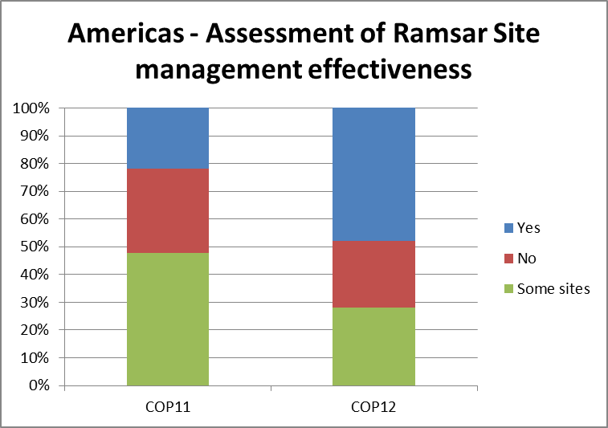
Figure 4. Assessment of Ramsar Site management effectiveness in the Americas regions, COP11 and COP12 reports

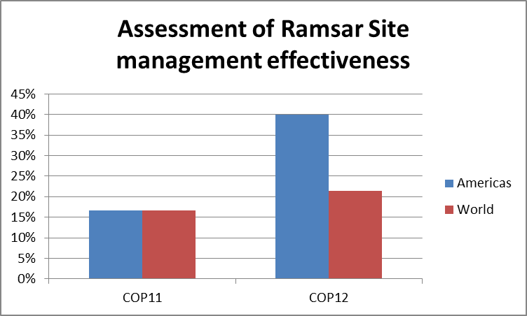
Figure 5. Assessment of Ramsar Site management effectiveness in the Americas regions and worldwide

- In summary, it is strongly recommended that the Parties continue to prioritize and implement the preparation and follow up of management plans, and conduct assessments of the effectiveness of their Ramsar Sites management as a way to maintain their ecological character and promote their wise use.

Ramsar Sites status (Strategy 2.6)

- Regarding arrangements in place for the Administrative Authorities to be informed of changes or likely changes in the ecological character of Ramsar Sites, pursuant to Article 3.2 of the Convention (indicator 2.6.1), 92% of the Contracting Parties reported having such a mechanism in place, a notable increase since COP11.

- However, only five Contracting Parties (20%: Chile, Costa Rica, Honduras, United States of America, and Uruguay) reported that they have informed the Secretariat of cases of negative human-induced change or likely change in the ecological character of Ramsar Sites (indicator 2.6.2).

- As was the case for COP10 and COP11, in the 2012-2015 triennium the Secretariat usually received such reports of change from third party individuals or organizations. 11 reports of threats to the ecological character of 11 Ramsar Sites were received, regarding eight countries (Brazil, Chile, Jamaica, Nicaragua, Mexico, Panama, Trinidad and Tobago, and the United States). The main threats are related to the expansion of urban areas, development of tourism projects, dams, mining and ports (see tables 1 and 2 below).

- Since COP11 in 2012, there are a total of 11 Ramsar Sites where ecological change is occurring or likely to occur and eight cases of change in the ecological character that were closed.

Table 1: Americas Ramsar Sites where ecological change is occurring or likely to occur (Article 3.2) since COP11 (Party reports)

Country | Sites | Actions
Chile | Laguna Santa Rosa y Negro Francisco | Communication to the Secretariat.
Mexico | Marismas Nacionales | Report by AA. Last report in COP12 National Report.
Nicaragua | Humedales de San Miguelito | Communication to the Secretariat. Ramsar Advisory Mission.
United States | Kakagon and Bad River Sloughs | Communication to the Secretariat.

Table 2: Americas Ramsar Sites where ecological change is occurring or likely to occur (Article 3.2) since COP11 (third party reports)

Country | Sites | Actions
Brazil | Pantanal Matogrossense State Park | Communication sent to AA. Report by AA received. Closed
Brazil | Reserva Particular del Patrimonio Natural SESC Pantanal | Communication sent to AA. Report by AA received. Closed.
Brazil | Reserva Particular del Patrimonio Natural (RPPN) Fazenda Rio Negro | Communication sent to AA. Report by AA received. Closed.
Jamaica | Portland Bight | Communication sent to AA. Last report in National Report to COP12. Secretariat addressing the issue with AA.
Mexico | Parque Arrecifal Veracruzano | Communication sent to AA. Last report in COP12 National Report.
Panama | Bahía de Panama | Communication sent to AA. Report received. Closed.
Trinidad and Tobago | Bon Accord Lagoon | Communication sent to AA. Report by AA received. Closed.

- Many Ramsar Sites in the region are threatened by the expansion of urban areas, the development of tourism projects, dams, golf courses, and pollution. The Ramsar Advisory Mission has been shown to be a very useful tool to support the Contracting Parties in addressing and resolving problems in Ramsar Sites and has also contributed to making the Convention more visible at the national and international levels. In the last triennium three Ramsar Advisory Missions were conducted, in Costa Rica, Nicaragua and Paraguay.

- The Americas currently have six Sites on the Montreux Record, in Argentina, Chile, Costa Rica, Guatemala, Nicaragua and the United States. All the Contracting Parties have been taking actions to address the issues for which the Sites have been listed in the Montreux Record and have sent updated reports of these actions. In the case of Argentina, measures for the removal of the Site from the record are under way. In Chile, actions continue for the restoration of the Site and the building of an interpretative centre. Costa Rica is implementing the recommendations of the Ramsar Advisory Mission to Palo Verde. For the Everglades in the USA, the National Park continues to implement restoration measures.

- Since COP11, one Ramsar Site - Bañados del Este y Franja Costera in Uruguay - has been removed from the record, after 24 years on the record.

- It is extremely important to aid in monitoring the conditions of Ramsar Sites, that the Contracting Parties take steps to be informed of changes or likely changes in the ecological character of Ramsar Sites, so they can undertake appropriate responses when necessary, including requesting a Ramsar Advisory Mission if appropriate. In the case of Sites on the Montreux Record, the Contracting Parties are strongly encouraged to continue taking actions to address the issues for which Sites have been listed and to send update reports to the Secretariat.

Goal 3: International Cooperation

Synergies with MEAS and IGOs (Strategy 3.1)

- Concerning mechanisms in place at the national level for collaboration between the Ramsar Administrative Authorities and the focal points of other multilateral environment agreements (indicator 3.1.2), as for COP11, 15 (60%) of the Parties reported that they have some national mechanisms such as National Ramsar or Wetland Committees, environmental committees, national coordinating mechanisms, same agencies or ministries in charge of the different MEAS, and work plans for cooperation with the United Nations Conventions CBD, UNFCCC, CMS, and UNCCD.

Regional Ramsar Initiatives (Strategy 3.2)

- There are five Regional Initiatives in the Americas – the Ramsar Regional Center for Training and Research in the Western Hemisphere-CREHO, and four regional networks: the Initiative for the Conservation and Sustainable Use of the High Andean Wetlands, the Initiative for the Conservation of Mangroves and Coral Reefs, the Initiative for Caribbean Wetlands, and the Initiative for La Plata River Basin.

- Almost all of the Contracting Parties in the Americas are active members of one or more Regional Initiative in the region. Three initiatives have received financial support for their activities from the Ramsar core budget according to the eligibility criteria.

- During the last triennium, the Caribbean Wetland Initiative and the Initiatives for Mangroves and Coral Reefs and La Plata River Basin worked on the consolidation of financial strategies for their financial sustainability. The High Andean Initiative focused its activities on meetings of the coordination committee and the formulation of a joint project to be submitted to GEF6.

- The Board of Directors of CREHO led by the Government of Panama focused on solving administrative issues and financial sustainability mechanisms. Some of the main activities during the triennium were the training-for-trainers course organized by the Ramsar Secretariat for CREHO staff and associated trainers on Ramsar frameworks and guidelines to support the regional capacity of CREHO, and the International Workshop on the relevance of Environmental Impact Assessment in the wise use of wetlands organized by the National Environmental Authority of Panama, CREHO, the City of Knowledge and the Ramsar Secretariat.

- In financial terms, through the core budget of the Convention, the Regional Initiatives eligible for funding from the region received CHF 152,700 from the Convention during 2012-2014. The allocation of funding for 2015 will be made by Standing Committee 49 in June 2015.

Table 3. Core budget allocations for Regional Initiative during 2012-2014 (all amounts in CHF)

Regional Initiatives eligible for funding during the triennium | Allocation (CHF)
La Plata River Basin | 46,700
Caribbean | 46,000
American Mangroves | 60,000
Total | 152,700

- Bolivia, Brazil, Chile, Colombia, Nicaragua, Panama and Suriname provided financial support for the different regional workshops of the Initiatives. Likewise, the Contracting Parties provided political support by endorsement letters.

- At the Pan-American meeting in preparation for COP12, the Contracting Parties through the Bogotá Declaration recognized the importance of strengthening Regional Initiatives in the framework of the Convention on Wetlands, and of providing sufficient resources for their execution, as these Initiatives give effective support for an improved implementation of the objectives of the Convention and its Strategic Plan in specific geographical regions. They also welcomed the interest of the countries of the Amazon Basin in developing a proposal for a regional initiative, to facilitate integrated actions for the wise use of wetlands.

- Regarding the main challenges ahead, the Parties will need to continue taking priority actions for the financial sustainability of Regional Initiatives over the long term, provide political support and find mechanisms for the effective involvement of stakeholders in the development of the Initiatives. CREHO must work to establish its own new institutional frameworks after the agreement between the Government of Panama and the Secretariat ended in July 2014.

International Assistance (Strategy 3.3)

- Canada and the United States are the two main countries in the region providing funding support for wetland conservation and management in other countries (indicator 3.3.1). In the case of Canada, the support is helping developing countries implement their environmental priorities through the Department of Foreign Affairs, Trade and Development Canada. Examples of currently funded initiatives involving wetland conservation include:
- Nicaragua: Integrated Watershed Management;
- Niger, Burkina-Faso, Benin, Côte d'Ivoire, Cameroon, Guinea, Mali, Nigeria, Chad: Niger Basin Authority Capacity-Building Program;
- Malawi: Coastal Resource Management Through Enhanced Stewardship; and
- Cuba: Integrated Coastal Zone Management Capacity Building.

- Environment Canada has also contributed to wetland conservation in developing countries through an investment in the Ramsar Small Grants Fund designed to support the conservation and wise use of wetland resources and the sustainable development of communities which depend on and care for them.

- The United States partners with developing countries around the world to support some USD 300 million in biodiversity conservation and management, including for wetlands.

- 56% of the Parties in the Neotropics (Antigua and Barbuda, Argentina, Brazil, Colombia, Costa Rica, Dominican Republic, Ecuador, El Salvador, Guatemala, Honduras, Jamaica, Mexico, Panama, and Uruguay) reported that they have received development assistance for in-country wetland conservation and management. The agencies that are mentioned providing financial support are GEF, UNEP, UNDP, OAS, EU, CaMPAM, IDB, World Bank, UNDP, IICA, USAID, and CIDA/Canada Caribbean Disaster Risk Management (CCDRM) Fund.

Sharing information and expertise (Strategy 3.4)

- At least eight Contracting Parties in the Americas have made efforts to establish networks or twinning arrangements nationally or internationally for knowledge sharing and training for wetlands that share common features. A good example is the work of the Contact Group of the High Andean Flamencos Network involving Argentina, Bolivia, Chile and Peru. Since 2011, Argentina organizes meetings with the Ramsar Site managers to exchange experience and strength the implementation of the Convention. Costa Rica has also organized two training courses for Site managers. Brazil has established three main wetland networks: Pantanal, MangueMar and Aguapé.

- Under the North American Waterfowl Management Plan, there are regional networks between Canadian, United States and Mexican partners for sharing knowledge specifically related to wetlands that support waterfowl. Canada is a member of the Arctic Council, and Canada's Hay-Zama Lakes Ramsar Site was ‘twinned’ with Dalai Lake National Nature Reserve Ramsar Site (Inner Mongolia Autonomous Region, China) in 2008.

- In Ecuador, AVINA leads a national network for community water management and under the bilateral agreement between Colombia and Ecuador activities are focused on the Mira and Santiago Cayapas Mataje watersheds. Chile and Mexico also exchanged experiences and information for the management of Ramsar Sites under a bilateral agreement.

- In general terms, most Parties in the Americas (18 Parties / 72%: Argentina, Bahamas, Brazil, Canada, Chile, Colombia, Cuba, Dominican Republic, El Salvador, Guatemala, Honduras, Mexico, Jamaica, Panama, Suriname, Trinidad and Tobago, United States of America, and Uruguay) reported that they have made publicly available the information about the country’s wetlands and/or Ramsar Sites and their status (indicator 3.4.2). Most of the activities include the posting of information on websites, leaflets or brochures, TV and radio programmes and in newspapers. It is desirable that the Parties continue to raise public awareness about their wetlands, because too frequently this information is not published or accessible in the region.

Shared wetlands (Strategy 3.5)

- Since COP11 the percentage has increased of Contracting Parties (52%) in the Americas that have indicated that there is an effective cooperative management in place for shared wetlands. Some of these mechanisms are binational or trilateral agreements for the management of watersheds, as for Canada, Mexico and the United States, or committees, commissions and national coastal management plans in the countries of La Plata River Basin and among the Central American countries (Guatemala, Honduras, Nicaragua).

Goal 4: Implementation Capacity

CEPA (Strategy 4.1)

- Regarding the establishment of a national action plan for CEPA (indicator 4.1.1), only Bahamas, Bolivia, Costa Rica, Jamaica, Mexico, the United States of America and Uruguay (28%) have formulated a plan at the national level. However, 48% of Parties reported that they have or have implemented CEPA plans or actions at the site level. In most of the cases these activities are related to the implementation of education and awareness programmes in Ramsar Sites.

- In the region, 84% of the Contracting Parties show significant progress, as in the past triennium, in matters of public participation in decision-making with respect to wetland planning and management and local stakeholders’ involvement in the selection of new Ramsar Sites and Ramsar Site management (indicator 4.1.3).

Identify training needs of institutions and individuals (Strategy 4.10)

- In the region 170 training opportunities have been offered for wetland site managers or other staff dealing with wetlands issues. The training opportunities have been implemented through specific workshops, short courses, and exchange experiences.

- The region leads at the global level the establishment of National/Ramsar Wetland Committees (indicator 4.1.6) with 17 (68%: Barbados, Bahamas, Brazil, Chile, Colombia, Costa Rica, Ecuador, Honduras, Jamaica, Mexico, Panamá, Peru, Suriname, Trinidad y Tobago , United States, Uruguay and Venezuela). In most of the cases the committees act as advisory bodies to Ramsar Administrative Authorities and Focal Points. For the next triennium it is important that the Parties continue taking steps to reinforce their committees with the involvement of relevant stakeholders, or to make them fully operational.

- The Americas region is very active in the implementation of activities to celebrate World Wetlands Day and to raise awareness about wetlands. During the reporting period, all Contracting Parties in the region have carried out activities such as workshops, seminars and symposiums, dissemination of materials, field trips, and Ramsar Site designations.

- The Contracting Parties are strongly encouraged to continue implementing educational activities as a mechanism to raise awareness about the Ramsar Convention and wetland values at national, regional and local levels.

Convention financial capacity (Strategy 4.2)

- 64% (16) of the Parties reported having paid their contributions in full (indicator 4.2.1) in the last triennium. Some of the difficulties in payment are related to the financial crisis in a number of countries in the region, but in other cases a lack of coordination between the Administrative Authority/ Focal Point and the agency in charge of the payment has caused delays.

- Besides the core budget contributions, Bolivia, Brazil, Chile, Nicaragua and Suriname made in-kind and cash contributions during the triennium to Regional Initiative meetings, and Colombia did so for the organization of the Pan-American Meeting in 2014.

- The United States has provided USD 311,238 through Wetlands for the Future during the last triennium to fund projects in Bolivia, Belize, Brazil, Chile, Colombia, Ecuador, Guatemala, Mexico, Peru, Suriname and Uruguay in the Neotropics Region. The 2015 cycle will open in August. The fund has proved to have a great impact in support of the implementation of the Convention through training, awareness raising, conservation and management activities for wetlands in the region.

- Canada has also supported (CAD 40,000) the Americas COP12 preparations, to strengthen international collaboration in the implementation of the Ramsar Convention.

Convention bodies’ effectiveness (Strategy 4.3)

- 18 (72%) of the Parties have used their previous Ramsar National Reports in monitoring their implementation of the Convention over time (indicator 4.3.1). However, it is recommended that all Parties in the region continue or begin to use the National Reports as a guideline to assess their progress in the implementation of the Convention as well as to define priority work areas and areas that need further development in light of the new Strategic Plan 2016-2021.

- In the Americas Ramsar regions, 16 (53%) of Contracting Parties (Antigua and Barbuda, Argentina, Bahamas, Barbados, Bolivia, Colombia, Cuba, Dominican Republic, Ecuador, Honduras, Jamaica, Mexico, Panama, Peru, Suriname and the United States) have designated all their Focal Points. Contracting Parties for whom the designation of any of the Focal Points (such as STRP or CEPA) is pending include Belize, Brazil, Canada, Costa Rica, Chile, El Salvador, Grenada, Guatemala, Nicaragua, Paraguay, Saint Lucia, Trinidad and Tobago, Uruguay and Venezuela.

Table 4. Countries that have not designated STRP, CEPA(government), or CEPA (non-governmental) Focal Points

STRP | Belize, Brazil, Chile, Grenada, Guatemala, Saint Lucia, Trinidad and Tobago
CEPA (G) | Belize, Canada, Chile, El Salvador, Grenada, Nicaragua, Saint Lucia, Trinidad and Tobago
CEPA (NG) | Belize, Brazil, Canada, Chile, Costa Rica, El salvador, Grenada, Guatemala, Nicaragua, Paraguay, Saint Lucia, Trinidad and Tobago, Uruguay, Venezuela

- It is important to mention that in many cases the Secretariat is not aware or not officially notified of the changes in the Administrative Authority or in the different Focal Points, making effective communication to support the implementation of activities very difficult. Likewise other difficulties in communication are related to the lack of notification of changes in contact details such as e-mail addresses, and frequent changes in focal points.

- The appointment of competent Focal Points for the Convention is very important not only in terms of communications, but also to ensure an active role in making regional contributions to the different Convention processes.

Working with IOPs and others (Strategy 4.4)

- Only 11 (44%) of the Parties have received assistance from one or more of the Convention’s International Organization Partners in their implementation of the Convention (indicator 4.4.1). The type of assistance has been, in most of the cases, to support projects or programmes related to wetlands wise use, livelihoods and conservation of wetlands or species. The IOPs that have provided valuable support to the Parties are Birdlife, IUCN, Wetlands International, and WWF.

- Besides the more general support that Ramsar IOPs provide for wetland conservation and wise use in the region, some of them, especially BirdLife, are actively involved in some of the ongoing Regional Initiatives as well. For the next triennium it is important that they continue to play an active role in the Regional Initiatives, as well as in the designation of Ramsar Sites and other activities related to wetland management and wise use.

- Under the framework of the MOU with the Inter-American Convention for the Protection and Conservation of Sea Turtles (IAC), joint activities were undertaken to support the IAC’s Scientific Committee to prepare an informative document as a tool for Contracting Parties and the general public about the benefits that Ramsar Site designation offers to the conservation of sea turtles and their critical habitats.

Goal 5. Membership of the Convention

- During the last triennium all non-Contracting Parties in the region (Dominica, Guyana, Haiti, Saint Kitts and Nevis, and Saint Vincent and the Grenadines) have been invited to participate in the different Ramsar processes in the Americas, such as the Caribbean Regional Initiative and the Pan-American meeting in preparation for COP12. Besides that, the Ramsar Secretariat visited Guyana in 2013 to explain the framework of the Convention.
Annex I

Table 1.Neotropics and North American Ramsar Sites designated since COP11

 | Designation date | Area (ha) | Dominant Wetland type
ARGENTINA
1.Humedales de Península Valdés | 20/07/2012 | 42,695 | Sand, shingle or pebble shores; includes sand bars, spits and sandy islets; includes dune systems and humid dune slacks | E
BOLIVIA
2. Río Blanco | 02/02/2013 | 2,404,916 | Seasonal/intermittent freshwater lakes (over 8 ha); includes floodplain lakes | P
3. Río Matos | 02/02/2013 | 1,729,788 | Seasonal/intermittent freshwater lakes (over 8 ha); includes floodplain lakes | P
4.Río Yata | 02/02/2013 | 2,813,229 | Seasonal/intermittent/irregular rivers/streams/creeks | N
BRAZIL
5. Cabo Orange National Park (Parque Nacional do Cabo Orange) | 02/02/2013 | 657,328 | Seasonal/intermittent freshwater lakes (over 8 ha); includes floodplain lakes | P
CHILE
6.Salinas de Huentelauquen | 02/02/2015 | 2,772 | Coastal freshwater lagoons; includes freshwater delta lagoons | K
COLOMBIA
7. Complejo de Humedales de la Estrella Fluvial Inírida (EFI) | 08/07/2014 | 250,159 | Freshwater, tree-dominated wetlands; includes freshwater swamp forests, seasonally flooded forests, wooded swamps on inorganic soils | Xf
DOMINICAN REPUBLIC
8. Parque Nacional Manglares del Bajo Yuna | 02/02/2013 | 77,518 | Irrigated land; includes irrigation channels and rice fields | 3
9. Humedales de Jaragua | 04/07/2014 | 32,979 | Marine subtidal aquatic beds; includes kelp beds, sea-grass beds, tropical marine meadows | B
ECUADOR
10.Reserva Ecológica El Ángel (REEA) | 12/07/2012 | 17,003 | Non-forested peatlands; includes shrub or open bogs, swamps, fens. | U
11. Sistema Lacustre Lagunas del Compadre | 15/12/2012 | 23,952 | Permanent freshwater lakes (over 8 ha); includes large oxbow lakes | O
12. Sistema Lacustre Yacuri | 15/12/2012 | 27,762 | Permanent freshwater lakes (over 8 ha); includes large oxbow lakes | O
13.Manglares del Estuario Interior del Golfo de Guayaquil “Don Goyo” | 15/12/2012 | 15,337 | Intertidal forested wetlands; includes mangrove swamps, nipah swamps and tidal freshwater swamp forests | I
EL SALVADOR
14.Complejo Barra de Santiago | 16/01/2014 | 11,519 | Intertidal forested wetlands; includes mangrove swamps, nipah swamps and tidal freshwater swamp forests | I
HONDURAS
15.Sistema de Humedales Cuyamel-Omoa | 02/02/2013 | 30,029 | Permanent rivers/streams/creeks; includes waterfalls | M
16. Sistema de Humedales de la Isla de Utila | 02/02/2013 | 16,226 | Intertidal forested wetlands; includes mangrove swamps, nipah swamps and tidal freshwater swamp forests | I
17. Sistema de Humedales Laguna de Zambuco (SH-LZ) | 22/04/2013 | 649 | Coastal freshwater lagoons; includes freshwater delta lagoons | K
MEXICO
18.Humedales de la Laguna La Cruz | 02/02/2013 | 6,665 | Intertidal marshes; includes salt marshes, salt meadows, saltings, raised salt marshes; includes tidal brackish and freshwater marshes | H
19. Manantiales Geotermales de Julimes | 30/10/2013 | 368 | Geothermal wetlands | Zg
20.Humedales de Guachochi | 30/10/2013 | 58 | Permanent freshwater lakes (over 8 ha); includes large oxbow lakes | O
21. Laguna La Juanota | 30/10/2013 | 232 | Permanent freshwater lakes (over 8 ha); includes large oxbow lakes | O
UNITED STATES OF AMERICA
22. San Francisco Bay/Estuary (SFBE) | 02/02/2013 | 158,711 | Salt exploitation sites; salt pans, salines, etc. | 5
23.Missisquoi Delta and Bay Wetlands | 20/11/2013 | 3,102 | Freshwater, tree-dominated wetlands; includes freshwater swamp forests, seasonally flooded forests, wooded swamps on inorganic soils | Xf
24. Door Peninsula Coastal Wetlands | 10/06/2014 | 4,631 | Freshwater, tree-dominated wetlands; includes freshwater swamp forests, seasonally flooded forests, wooded swamps on inorganic soils | Xf

Note: the following Contracting Parties submitted sites for designation but the RIS need further clarification to finalize the process of designation: Brazil (six ), Paraguay (1) and Uruguay (1).

Table 2. Update Status of Ramsar Information Sheets (RIS) and Maps

 | Area | Designation date | RIS last update | What needs to be updated
Antigua & Barbuda
1.Codrington Lagoon | 3,600 | 02.06.05 | 2006 | RIS and Map
Argentina
2.Laguna de Llancanelo MR | 65,000 | 08.11.95 | 1995 | RIS and Map
3.Bahía de Samborombón | 243,965 | 24.01.97 | 1997 | RIS and Map
4.Lagunas de Vilama | 157,000 | 20.09.00 | 2000 | RIS and Map
5.Jaaukanigás | 492,000 | 10.10.01 | 2001 | RIS
6.Bañados del Río Dulce y Laguna de Mar Chiquita. | 996,000 | 28.05.02 | 2002 | RIS and Map
7.Reserva Provincial Laguna Brava | 405,000 | 02.02.03 | 2003 | RIS and Map
8. Humedales Chaco | 508,000 | 02.02.04 | 2004 | RIS and Map
9. Reserva Ecológica Costanera Sur | 353 | 22.03.05 | 2005 | RIS and Map
10. Río Pilcomayo | 51,889 | 04.05.92 | 2006 | RIS and Map
11. Reserva Natural Otamendi | 3,000 | 22/03/08 | 2008 | RIS and Map
12. Humedal Laguna Melincué | 92,000 | 24/07/08 | 2008 | RIS and Map
Barbados
13. Graeme Hall Swamp | 33 | 12.12.05 | 2005 | RIS and Map
Belize
14. Crooked Tree Wildlife Sanctuary | 6,637 | 22.04.98 | 2000 | RIS and Map
15. Sarstoon Temash National Park | 16,955 | 19.10.05 | 2005 | RIS and Map
Bolivia
16. Lago Titicaca (Sector Boliviano) | 800,000 | 26.08.98 | 1998 | RIS
17. Cuenca de Tajzara | 5,500 | 13.06.00 | 2000 | RIS
18. Bañados de Izozog y el Río Parapetí | 615,882 | 17.09.01 | 2001 | RIS and Map
19. Palmar de la Islas y las Salinas de San José | 856,754 | 17.09.01 | 2001 | RIS and Map
20. Pantanal Boliviano | 3,189,888 | 17.09.01 | 2001 | RIS and Map
21.Lagos Poopó y Uru Uru | 967,607 | 11.07.02 | 2002 | RIS and Map
22. Laguna Concepción | 31,124 | 06.05.02 | 2002 | RIS and Map
Brazil
23. Reserva Particular del Patrimonio Natural (RPPN) “Fazenda Rio Negro”. | 7,000 | 28.10.2008 | 2008 | RIS and Map
Canada
24. Mer Bleue Conservation Area | 3,447 | 26.09.95 | 2001 | RIS and Map
Chile
25. Bahía Lomas | 58,946 | 06.12.04 | 2005 | RIS and Map
Colombia
26. Laguna de la Cocha | 39,000 | 08.01.01 | 2001 | RIS and Map
27. Delta del Río Baudó | 8,888 | 05.06.04 | 2004 | RIS and Map
28. Sistema Lacustre de Chingaza | 4,058 | 24.06.08 | 2008 | RIS and Map
29. Complejo de Humedales Laguna del Otún | 6,579 | 24.06.08 | 2008 | RIS and Map
Ecuador
30. Laguna de Cube | 113 | 02.02.02 | 2002 | RIS and Map
31. Refugio de Vida Silvestre Isla Santa Clara | 46 | 02.02.02 | 2002 | RIS
33. Complejo de Humedales Ñucanchi – Turupamba | 12,290 | 05.06.06 | 2006 | RIS and Map
34. Complejo Llanganati | 30,355 | 24/06/08 | 2008 | RIS and Map
El Salvador
35. Bahía de Jiquilisco | 63,500 | 31.10.05 | 2005 | RIS and Map
36. Embalse Cerrón Grande | 13,500 | 22.11.05 | 2005 | RIS and Map
Guatemala
37. Parque Nacional Laguna del Tigre MR | 335,080 | 26.06.90 | 1998 | RIS and Map
38. Punta de Manabique | 132,900 | 28.01.00 | 2000 | RIS and Map
39. Eco-región Lachuá | 535 | 24.05.06 | 2006 | RIS and Map
40. Parque Nacional Yaxhá-Nakum-Naranjo | 37,160 | 02.02.06 | 2006 | RIS and Map
41. Reserva de Usos Múltiples Río Sarstún | 21,227 | 20.03.07 | 2007 | RIS and Map
Jamaica
42. Palisadoes - Port Royal | 7,523 | 22.04.05 | 2005 | RIS and Map
43. Portland Bight Wetlands & Cays | 24,542 | 02.02.06 | 2006 | RIS and Map
Mexico
44. Dzilam (reserva estatal) | 61,707 | 07.12.00 | 2000 | RIS and Map
45. Humedal de Importancia Especialmente para la Conservación de Aves Acuáticas Reserva Ría Lagartos | 60,348 | 04.07.86 | 2001 | RIS and Map
46. Humedales del Delta del Río Colorado | 250,000 | 20.03.96 | 2001 | RIS and Map
47. Marismas Nacionales | 200,000 | 22.06.95 | 2001 | RIS and Map
48. Reserva de la Biosfera La Encrucijada | 144,868 | 20.03.96 | 2001 | RIS and Map
49. Reserva de la Biósfera Pantanos de Centla | 302,706 | 22.06.95 | 2001 | RIS and Map
50. Área de Protección de Flora y Fauna Cuatrociénegas | 84,347 | 22.06.95 | 2002 | RIS and Map
51. Cuencas y corales de la zona costera de Huatulco | 44,400 | 27.11.03 | 2003 | RIS and Map
52. Laguna de Tecocomulco | 1,769 | 27.11.03 | 2003 | RIS and Map
53. Parque Nacional Arrecifes de Xcalak | 17,949 | 27.11.03 | 2003 | RIS and Map
54. Parque Nacional Isla Contoy | 5,126 | 27.11.03 | 2003 | RIS and Map
55. Parque Nacional Isla Isabel | 94 | 27.11.03 | 2003 | RIS and Map
56. Parque Nacional Lagunas de Montebello | 6,022 | 27.11.03 | 2003 | RIS and Map
57. Playa Tortuguera Rancho Nuevo | 30 | 27.11.03 | 2003 | RIS and Map
58.Playa Tortuguera Tierra Colorada | 54 | 27.11.03 | 2003 | RIS and Map
59. Reserva Estatal El Palmar | 50,177 | 27.11.03 | 2003 | RIS and Map
60. Sian Ka’an | 652,193 | 27.11.03 | 2003 | RIS and Map
61. Área de Protección de Flora y Fauna Laguna de Términos | 705,016 | 02.02.04 | 2004 | RIS and Map
62. Área de Protección de Flora y Fauna de Nahá y Metzabok | 7,216 | 02.02.04 | 2004 | RIS and Map
63. Área de Protección de Flora y Fauna Yum Balam | 154,052 | 02.02.04 | 2004 | RIS and Map
64. Bala’an K’aax | 131,610 | 02.02.04 | 2004 | RIS and Map
65. Ciénegas de Lerma | 3,023 | 02.02.04 | 2004 | RIS and Map
66. Humedales del Lago de Pátzcuaro | 707 | 02.02.05 | 2004 | RIS and Map
67. Isla San Pedro Mártir | 30,165 | 02.02.04 | 2004 | RIS and Map
68. Islas Marietas | 1,357 | 02.02.04 | 2004 | RIS and Map
69. Laguna de Chichankanab | 1,999 | 02.02.04 | 2004 | RIS and Map
70. Laguna de Metztitlán | 2,937 | 02.02.04 | 2004 | RIS and Map
71. Laguna de Sayula | 16,800 | 02.02.04 | 2004 | RIS and Map
72. Laguna Madre | 307,894 | 02.02.04 | 2004 | RIS and Map
73. Laguna de Yuriria | 15,020 | 02.02.04 | 2004 | RIS and Map
74. Laguna Ojo de Liebre | 36,600 | 02.02.04 | 2004 | RIS and Map
75. Laguna Playa Colorada-Santa María La Reforma | 53,140 | 02.02.04 | 2004 | RIS and Map
76. Laguna San Ignacio | 17,500 | 02.02.04 | 2004 | RIS and Map
77. Manglares y humedales de la Laguna de Sontecomapan | 8,921 | 02.02.04 | 2004 | RIS and Map
78. Parque Nacional Arrecife de Puerto Morelos | 9,066 | 02.02.04 | 2004 | RIS and Map
79. Parque Nacional Bahía de Loreto | 206,581 | 02.02.04 | 2004 | RIS and Map
80. Parque Nacional Cañón del Sumidero | 21,789 | 02.02.04 | 2004 | RIS and Map
81. Playa Tortuguera Cahuitán | 65 | 02.02.04 | 2004 | RIS and Map
82. Playa Tortuguera El Verde Camacho | 6,454 | 02.02.04 | 2004 | RIS and Map
83. Playón Mexiquillo | 67 | 02.02.04 | 2004 | RIS and Map
84. Playa Tortuguera X’Cacel - X’Cacelito | 362 | 02.02.04 | 2004 | RIS and Map
85. Presa Jalpan | 68 | 02.02.04 | 2004 | RIS and Map
86. Reserva de la Biosfera Archipiélago de Revillagigedo | 636,685 | 02.02.04 | 2004 | RIS and Map
87. Reserva de la Biosfera Banco Chinchorro | 144,360 | 02.02.04 | 2004 | RIS and Map
88. Reserva de la Biosfera Chamela-Cuixmala | 13,142 | 02.02.04 | 2004 | RIS and Map
89. Reserva de la Biosfera Los Petenes | 282,857 | 02.02.04 | 2004 | RIS and Map
90. Reserva de la Biosfera Ría Celestún | 81,482 | 02.02.04 | 2004 | RIS and Map
91. Sistema lacustre Ejidos de Xochimilco y San gregorio Atlapulco | 2,657 | 02.02.04 | 2004 | RIS and Map
92. Sistema Lagunar Alvarado | 267,010 | 02.02.04 | 2004 | RIS and Map
93. Corredor Costero La Asamblea - San Francisquito | 44,304 | 27.11.05 | 2005 | RIS and Map
94. Humedales de la Laguna La Popotera | 1,975 | 05.06.05 | 2005 | RIS and Map
95. Laguna Costera El Caimán | 1,125 | 02.02.05 | 2005 | RIS and Map
96. Laguna de Tamiahua | 88,000 | 27.11.05 | 2005 | RIS and Map
97. Laguna de Zacapu | 40 | 05.06.05 | 2005 | RIS and Map
98. Laguna de Zapotlán | 1,496 | 05.06.05 | 2005 | RIS and Map
99. Parque Nacional Arrecifes de Cozumel | 11,987 | 02.02.05 | 2005 | RIS and Map
100. Sistema de Lagunas Interdunarias de la Ciudad de Veracruz | 141 | 02.02.05 | 2005 | RIS and Map
101. Cascadas de Texolo y su entorno | 500 | 02.02.06 | 2006 | RIS and Map
102. Estero de Punta Banda | 2393.27 | 02.02.06 | 2006 | RIS and Map
103. Isla Rasa | 66 | 02.02.06 | 2006 | RIS and Map
104. Laguna de Atotonilco | 2850 | 18.03.06 | 2006 | RIS and Map
105. Manglares y humedales de Tuxpan | 6870 | 02.02.06 | 2006 | RIS and Map
106. Laguna Huizache Caimanero | 48,283 | 02.02.07 | 2007 | RIS and Map
107. Lagunas de Yalahu | 5683 | 02.02.07 | 2007 | RIS and Map
108. Arroyos y manantiales de Tanchachín | 1174.00 | 02.02.08 | 2008 | RIS and Map
109. Bahía de San Quintín | 5438.00 | 02.02.08 | 2008 | RIS and Map
110. Balandra | 449.00 | 02.02.08 | 2008 | RIS and Map
111. Ensenada de Pabellones | 40639.00 | 02.02.08 | 2008 | RIS and Map
112. Humedal Los Comondú | 460959.00 | 02.02.08 | 2008 | RIS and Map
113. Humedales La Libertad | 5432.00 | 02.02.08 | 2008 | RIS and Map
114. La Tovara | 5733.00 | 02.02.08 | 2008 | RIS and Map
115. Laguna de Babícora | 26045.00 | 02.02.08 | 2008 | RIS and Map
116. Laguna Xola-Paramán | 775.00 | 02.02.08 | 2008 | RIS and Map
117. Manglares de Nichupté | 4257.00 | 02.02.08 | 2008 | RIS and Map
118. Otoch Ma’ax Yetel Kooh | 5367.00 | 02.02.08 | 2008 | RIS and Map
119. Parque Estatal “Cañón de Fernández” | 17002.00 | 02.02.08 | 2008 | RIS and Map
120. Parque Nacional Cabo Pulmo | 7100.00 | 02.02.08 | 2008 | RIS and Map
121. Río Sabinas | 603123.00 | 02.02.08 | 2008 | RIS and Map
122. Santuario Playa Boca de Apiza-El Cupadero-El Tecuanillo | 40.00 | 02.02.08 | 2008 | RIS and Map
123. Sistema Estuarino Boca del Cielo | 8931.00 | 02.02.08 | 2008 | RIS and Map
124. Zona Sujeta a Conservación Ecológica Cabildo-Amatal | 2832.00 | 02.02.08 | 2008 | RIS and Map
125. Zona Sujeta a Conservación Ecológica El Gancho-Murillo | 4643.00 | 02.02.08 | 2008 | RIS and Map
126. Zona Sujeta a Conservación Ecológica Sistema Lagunar Catazajá | 41059.00 | 02.02.08 | 2008 | RIS and Map
127. Sistema de Humedales Remanentes del Delta del Río Colorado | 127614.00 | 02.02.08 | 2008 | RIS and Map
128. Sistema Lagunar San Ignacio-Navachiste-Macapule | 79873.00 | 02.02.08 | 2008 | RIS and Map
129. Sistema Lagunar Agiabampo – Bacorehuis – Río Fuerte Antiguo. | 90804.45 | 02.02.08 | 2008 | RIS and Map
130. Sistema Estuarino Lagunar Agua Dulce–El Ermitaño | 1281.00 | 02.02.08 | 2008 | RIS and Map
131. Parque Nacional Arrecife Alacranes | 334113.00 | 02.02.08 | 2008 | RIS and Map
132. Playa Barra de la Cruz | 18.00 | 02.02.08 | 2008 | RIS and Map
133. Laguna Barra de Navidad | 794.00 | 02.02.08 | 2008 | RIS and Map
134. Playa de Colola | 287.00 | 02.02.08 | 2008 | RIS and Map
135. Humedales El Mogote-Ensenada de La Paz | 9184.00 | 02.02.08 | 2008 | RIS and Map
136.Estero El Chorro | 267.00 | 02.02.08 | 2008 | RIS and Map
137. Estero Majahuas | 786.00 | 02.02.08 | 2008 | RIS and Map
138. Estero La Manzanilla | 263.96 | 02.02.08 | 2008 | RIS and Map
139. Lagunas de Chacahua | 17424.00 | 02.02.08 | 2008 | RIS and Map
140. Laguna Chalacatepec | 1093.00 | 02.02.08 | 2008 | RIS and Map
141. Complejo Lagunar Bahía Guásimas – Estero Lobos | 135198.00 | 02.02.08 | 2008 | RIS and Map
142. Playa de Maruata | 80.42 | 02.02.08 | 2008 | RIS and Map
143. Sistema de Represas y Corredores biológicos de la Cuenca Hidrográfica del Río Necaxa | 1541.40 | 02.02.08 | 2008 | RIS and Map
144. Oasis de la Sierra El Pilar | 180803.00 | 02.02.08 | 2008 | RIS and Map
145. Humedales de Montaña La Kisst | 36.00 | 02.02.08 | 2008 | RIS and Map
146. Oasis Sierra de La Giganta | 41181.00 | 02.02.08 | 2008 | RIS and Map
147.Sistema Lagunar Ceuta | 1497.00 | 02.02.08 | 2008 | RIS and Map
148. Sistema Estuarino Puerto Arista | 62138.00 | 02.02.08 | 2008 | RIS and Map
149. Agua Dulce | 39.00 | 02.02.08 | 2008 | RIS and Map
150. Humedal la Sierra de Guadalupe | 348087.00 | 02.02.08 | 2008 | RIS and Map
151.Sistema Ripario de la Cuenca y Estero de San José del Cabo | 124219.00 | 02.02.08 | 2008 | RIS and Map
152.Ciénega de Tamasopo | 1364.20 | 02.02.08 | 2008 | RIS and Map
Panama
153.Golfo de Montijo | 80,765 | 26.11.90 | 1990 | RIS and Map
154. Punta Patiño | 13,805 | 13.10.93 | 1993 | RIS and Map
155. San San-Pond Sak | 16,414 | 09.06.93 | 1993 | RIS and Map
Paraguay
156. Estero Milagro | 25,000 | 07.06.95 | 1995 | RIS
157. Lago Ypoá | 100,000 | 07.06.95 | 1995 | RIS
158. Río Negro | 370,000 | 07.06.95 | 1995 | RIS
159. Tinfunque | 280,000 | 07.06.95 | 1995 | RIS
160. Laguna Chaco Lodge | 2,500 | 20.10.03 | 2003 | RIS and Map
161. Laguna Teniente Rojas Silva | 8,470 | 14.07.04 | 2004 | RIS and Map
Peru
162. Lago Titicaca (Peruvian sector) | 460,000 | 20.01.97 | 1996 | RIS and Map
163. Reserva Nacional de Junín | 53,000 | 20.01.97 | 1997 | RIS and Map
164.Santuario Nacional Los Manglares de Tumbes | 2,972 | 20.01.97 | 1997 | RIS and Map
165. Santuario Nacional Lagunas de Mejía | 691 | 30.03.92 | 2001 | RIS and Map
166. Complejo de Humedales del Abanico del río Pastaza | 3,827,329 | 05.06.02 | 2002 | RIS and Map
167. Bofedales y Laguna de Salinas | 17,657 | 28.10.03 | 2003 | RIS and Map
168. Laguna del Indio y Dique de los Españoles | 502 | 28.10.03 | 2003 | RIS and Map
169. Humedal Lucre-Huacarpay | 1,979 | 23.09.06 | 2006 | RIS and Map
170. Las Arreviatadas | 1,250 | 15.07.07 | 2007 | RIS and Map
171. Manglares de San Pedro de Vice | 3,399 | 12.06.2008 | 2008 | RIS and Map
República Dominicana
172. Lago Enriquillo | 20,000 | 15.05.02 | 2002 | RIS and Map
Saint Lucia
173. Mankoté Mangrove | 60 | 19.02.02 | 2002 | RIS and Map
174. Savannes Bay | 25 | 19.02.02 | 2002 | RIS and Map
Suriname
175. Coppenamemonding | 12,000 | 22.07.85 | 1997 | RIS and Map
Trinidad & Tobago
176. Nariva Swamp | 6,234 | 21.12.92 | 1997 | RIS and Map
177. Buccoo Reef / Bon Accord Lagoon Complex | 1,287 | 08.07.05 | 2005 | RIS and Map
178. Caroni Swamp | 8,398 | 08.07.05 | 2005 | RIS and Map
United States
179. Ash Meadows National Wildlife Refuge | 9,509 | 18.12.86 | 1992 | RIS and Map
180. Connecticut River Estuary & Tidal Wetlands Complex | 6,484 | 14.10.94 | 1995 | RIS and Map
181. Sand Lake National Wildlife Refuge | 8,700 | 03.08.98 | 1998 | RIS and Map
182. Cheyenne Bottoms | 10,978 | 19.10.88 | 2002 | RIS and Map
183. Quivira National Wildlife Refuge | 8,958 | 12.02.02 | 2002 | RIS and Map
184. Tomales Bay | 2,850 | 30.09.02 | 2002 | RIS and Map
185.Catahoula Lake | 12,150 | 18.06.91 | 2005 | RIS and Map
186. Everglades National Park *Montreux Record | 610,497 | 04.06.87 | 2005 | RIS and Map
187. Grassland Ecological Area (GEA) | 65,000 | 02.02.05 | 2005 | RIS and Map
188. Tijuana River National Estuarine Research Reserve (TRNERR) | 1,021 | 02.02.05 | 2005 | RIS and Map
189. Kawainui and Hamakua Marsh Complex | 414 | 02.02.05 | 2005 | RIS and Map
190. Okefenokee National Wildlife Refuge | 162,635 | 18.12.86 | 2006 | RIS and Map
191. Cado Lake | 7,977 | 23.10.93 | 2007 | RIS and Map
192.Francis Beidler Forest | 6,438 | 30.05.08 | 2008 | RIS and Map
193. Wilma H. Schiermeier Olentangy River Wetland Research Park | 21 | 18.04.08 | 2008 | RIS and Map
194. Bolinas lagoon | 445 | 01.09.98 | 2007 | RIS and MAP
Uruguay
195. Bañados del Este y Franja Costera MR | 407,408 | 22.05.84 | 2001 | RIS and Map
196. Estero de Farrapos e Islas del Río Uruguay | 17,496 | 10.12.04 | 2004 | RIS and Map
Venezuela
197. Cuare | 9,968 | 23.11.88 | 1991 | RIS and Map
198. Archipiélago Los Roques | 213,220 | 04.09.96 | 1996 | RIS and Map
199. Ciénaga de Los Olivitos | 26,000 | 04.09.96 | 1996 | RIS and Map
200. Laguna de la Restinga | 5,248 | 04.09.96 | 1996 | RIS and Map
201. Laguna de Tacarigua | 9,200 | 04.09.96 | 1996 | RIS and Map

Table 3. Americas Summary overview of trends between COP8 and COP12

Where indicator questions were reasonably similar, the table compares information provided in the National Reports to COP8, COP9, COP10 and COP11 with those provided to COP12 in order to assess progress (“significant” “some”, “no progress”, “regress”) during the past three triennia, covering the period of Ramsar’s Strategic Plan 2009-2015 (Resolution X.1). The table also shows whether particular actions reported for COP12 were more (or less) widely addressed throughout the Neotropic and North American regions compared to the global average, based on the percentages of Contracting Parties having answered positively.

Strategy | Indicator | Affirmative CPs at COP8 | Affirmative CPs at COP9 | Affirmative CPs at COP10 | Affirmative CPs at COP11 | Affirmative at COP11  Globally | Affirmative at COP12 region/ globally | Progress since COP11
1.1 | CP has a comprehensive national wetland inventory (1.1.1) | 4 | 5 (24%) | 8 (28%) | 8 (32%) | 55 (43%) | 9 (36%)  /62(47%) | Some regionally but not globally
1.3 | CP has a National Wetland Policy (or equivalent instrument) (1.3.1) | 4 | 7 (39%) | 12 (41%) | 13 (52%) | 65 (51%) | 18 (60%)  /72 (55%) | Significant
1.4 | CP conducted Assessment of the ecosystem benefits provided by Ramsar Sites (1.4.1) | n.a. | 3 (17%) | 3 (12%) | 5 (20%) | 27 (21%) | 4 (16%)  /25 (19%) | Regress compared to the region but similar to the global level
 | CP has wise use wetland programmes  /projects that contribute to poverty alleviation (1.4.2.) | n.a. | 1 (6%) | 5 (19%) | 10 (40%) | 50 (39%) | 11(44%)  /55(42%) | Some
1.7 | CP has used or applied Ramsar water-related guidance (1.7.1) | 5 | 3 (17%) | 5 (19%) | 9 (36%) | 51 (40%) | N/A
1.8 | CP implemented wetland restoration/  rehabilitation programmes (1.8.2) | 3 | 6 (33%) | 15 (58%) | 16 (64%) | 88 (69%) | 22 (88%)  /90(72%) | Significant
2.1 | CP uses the Strategic Framework for Ramsar Site designations (2.1.1) | 10 | 4 (19%) | 11 (42%) | 9 (36%) | 53 (42%) | 9(36%)  /54 (41%) | Same
2.6 | CP has reported all changes or likely changes in the ecological character of Ramsar Sites (2.6.2) | 8 | 5 (24%) | 5 (19%) | 5 (20%) | 23 (18%) | 5(20%)  /28 (21%) | Same
3.3 | Funding support has been mobilized form development assistance agencies for wetland conservation and management (3.3.3) | 14 | 6 (33%) | 15 (58%) | 13 (52%) | 46 (36%) | 14(56%)  /53 (40%) | Some regionally but significant at the global level
3.4 | CP has established networks, nationally or internationally for knowledge sharing and training for wetlands (3.4.1) | 7 | 4 (22%) | 10 (38%) | 10 (40%) | 50 (39%) | 8(32%)  /46(35%) | Regress
4.1 | CP has an operational National Ramsar Committee (4.1.6) | 10 | 5 (28%) | 15 (58%) | 12 (48%) | 69 (54%) | 17(68%)  /82(63%) | Significant
4.2 | CP has paid in full and in a timely manner the Ramsar contributions for the last triennium (4.2.1) | n.a. | 6 (33%) | 14 (54%) | 13 (52%) | 74 (58%) | 16(64%)  /90(69%) | Some
4.4 | CP developed a national (or local) CEPA action plan (4.1.1) | 2 | 1 (6%) | 4 (15%) | 3 (12%) | 34 (27%) | 7 (28%)  /36 (27%) | Some

