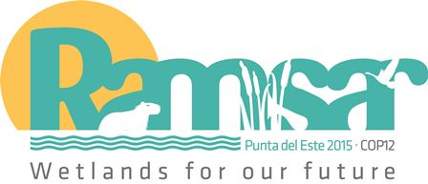
12th Meeting of the Conference of the Parties to
the Convention on Wetlands (Ramsar, Iran, 1971)

Punta del Este, Uruguay, 1-9 June 2015

Ramsar COP12 DOC.9
English and French only

Regional overview of the implementation of the Convention and its Strategic Plan in Africa

This summary is based on national Reports, which can be consulted on the Ramsar web site at the following address:
http://www.ramsar.org/library/field_date/%5B2015-01-01T00%3A00%3A00Z%20TO%202016-01-01T00%3A00%3A00Z%5D/field_document_type/contracting-party-documents-418/field_document_type/national-reports-532/field_tag_countries/africa-12.

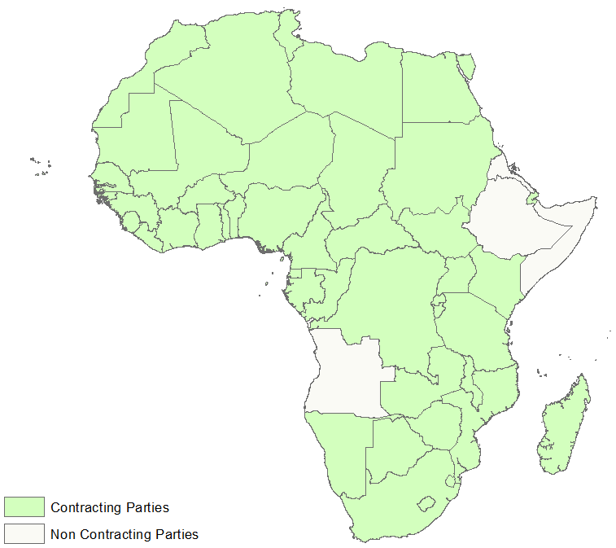

Figure 1: African Contracting Parties

National Reports analyzed

- Contracting Parties whose National Reports are included in this analysis (46): South Africa, Algeria, Benin, Botswana, Burkina Faso, Burundi, Cameroon, Cabo Verde, Comoros, Congo, Côte d’Ivoire, Djibouti, Egypt, Gabon, Gambia, Ghana, Guinea, Guinea-Bissau, Kenya, Lesotho, Liberia, Madagascar, Malawi, Mali, Morocco, Mauritius, Mauritania, Mozambique, Namibia, Niger, Nigeria, Uganda, Central African Republic, Democratic Republic of the Congo, United Republic of Tanzania, Rwanda, São Tomé and Príncipe, Senegal, Seychelles, Sudan, South Sudan, Swaziland, Chad, Togo, Tunisia and Zimbabwe.

- Zambia’s and Equatorial Guinea’s national reports were received after the final deadline for inclusion in the Ramsar Database of National Reports that are to be studied by COP12. The information sent in by these countries is therefore not taken into account in this summary.

- Contracting Parties yet so submit their National Reports (2):, Libya and Sierra Leone.

Main achievements since COP11

- The 2012-2015 triennium, when compared with the previous one, allowed the implementation of the Convention in Africa to be consolidated. In 2012, the Programme drawn up by the Africa team at the beginning of 2011 began to be executed, assessed and adjusted. Because of the Convention’s actions, from July 2012 onwards we saw renewed interest in Africa reflected in the volume and diversity of the activities carried out across the continent. Among these actions, we note that communication with the Contracting Parties has become stronger, there are three new Contracting Parties, and strategic partnerships have been formed with institutions and groups concerned about the wise use of wetlands in the region.

- The contents of National Reports show the results of the partnership between the Contracting Parties, the Secretariat, the International Organization Partners (IOPs) and other Partners. The results of the National Reports teach us many lessons and reveal the numerous efforts made at each level to attain the objectives set in the Strategic Plan 2009-2015. This triennium, given the great demand for help received by the Secretariat, presented an opportunity to innovate as far as the implementation of the Convention was concerned. Since the international environmental agenda increasingly demands a pooling of efforts and investments, the Contracting Parties are increasingly being asked to raise the level of their commitment to the application of the Convention’s principles.

- During the 2009-2012 triennium, the Contracting Parties recognized the importance of carrying out national inventories, as a vital basis for numerous activities needed for the wise use of wetlands, notably the drawing up of policies, the identification and registration of Ramsar Sites, the documentation of the dynamics of wetlands and the identification of wetlands that can be restored. With the increasingly high demand for the Contracting Parties to assess and evaluate wetland resources, the Convention engages to support and encourage them in the preparation of inventory reports during the next triennium.

- Figure 2 shows that 13 Contracting Parties have not prepared a national inventory of their wetlands. 37% of African countries have completed a national wetland inventory compared with 47% worldwide (see Figure 3). We have noted a renewed interest in the creation of national policies for wetlands (see Figure 4) following the compilation of national inventories.

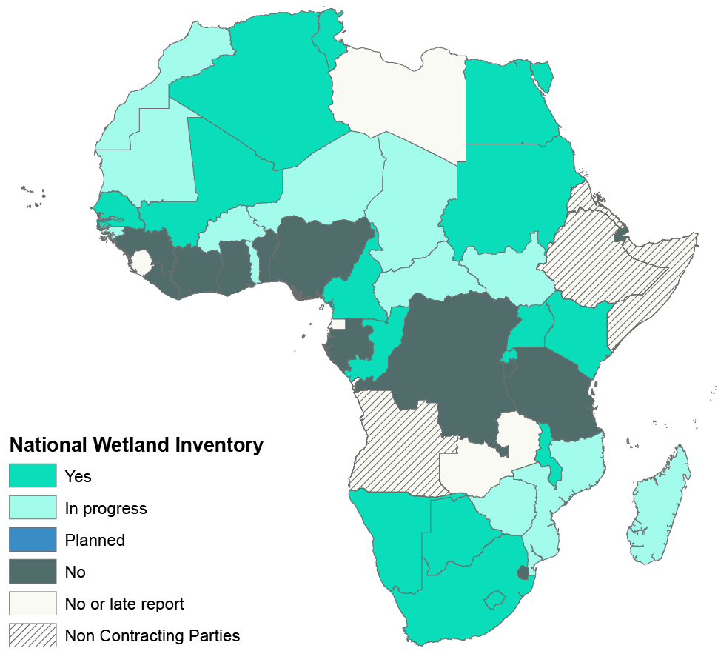

Figure 2: Contracting Parties that have a national inventory of their Wetlands (Strategy 1.1.1)

Figure 3: Percentage of countries that have completed a national inventory of their wetlands (Strategy 1.1.1)

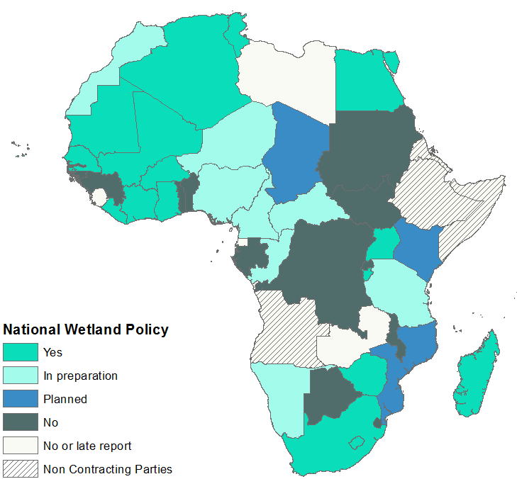

Figure 4: Contracting Parties with a National Wetland Policy (Strategy 1.3.1)

Figure 5: Percentage of countries with a wetland policy (or other equivalent tool) (Strategy 1.3.1)

- The creation of national wetland policies is a relatively slow process. 41% of the African Contracting Parties have a policy (or equivalent tool) compared with 55% of Contracting Parties worldwide. The priority for the triennium is to provide technical assistance to the 17% of the Contracting Parties who are in a preparatory phase, to help them continue working towards creating their own national wetland policy.

- In Africa, 38 new Ramsar Sites have been designated since COP11, and several dozen requests for designation are currently being finalized by the Contracting Parties.

- Regular updating of Ramsar Sites information: During the period under review, two Parties provided updates. However for 248 Ramsar Sites (69% of the total) within the territory of 45 Parties, there was significant out-of-date or missing information (figure 6).

Figure 6 : Number of Ramsar Sites with outdated information in Africa

- This figure shows the breakdown of Sites without timely updates according to the Contracting Party rules for updating Ramsar Site information every six years. Some Parties have advised that CPs intend to provide their updates in the new RIS – 2012 revision format (defined within Resolution XI.8 streamlining procedures for describing Ramsar Sites at the time of designation and subsequent updates), once that becomes available for use. The new RIS was launched in August 2014, and it is therefore hoped that the figures can be much improved in the coming years. Nonetheless, the general and continuing lack of regular updates is not in compliance with Resolution VI.13 and undermines the impact of the Convention.

- Ramsar Site management plans are designed by several Contracting Parties to be used as tools and guides for direct action. For the triennium under review, 121 Ramsar Sites have a management plan that is implemented. This is a sign of the dynamism of certain Parties in the application of the Convention and notably the measures adopted to conserve the ecological character of Ramsar Sites.

Figure 7: Percentage of Ramsar Sites currently implementing a Management Plan (Strategy 2.3.1)

- From 2012 to 2015, only four Ramsar Regional Initiatives have remained active, but with very different levels of operation. They are: NigerWet, WacoWet in West Africa, MedWet in North Africa and RAMCEA in East Africa. Immediately after COP11, the ChadWet initiative in Central Africa also relaunched its collaboration with the Secretariat in order to restart its activities. Since COP11, communication between the Secretariat and these Initiatives has been smooth. During the last triennium, however, they posted nothing on the webpages reserved for this purpose on the Convention’s website, despite frequent reminders by the Secretariat. The RAMCEA website was officially launched in February 2015, while NigerWet’s and WacoWet’s sites are still under construction.

- The celebration of World Wetlands Day (WWD) over the last three years has proved useful for the region, judging by the results and the impact described both in the national reports (see Figure 6), and the reports by regional public awareness raising initiatives on the role, functions and advantages of wetland ecosystems throughout the continent. This represents progress that we must aim to replicate during the next triennium.

Figure 6: Percentage of the Contracting Parties – both Governments and NGOs – that have carried out activities during World Wetlands Day since COP11 (Strategy 4.1.8)

- In total, 46% of the Contracting Parties in the region are involved in carrying out programmes or projects to restore/rehabilitate wetlands (see Figure 7). The Contracting Parties no longer just designate sites for inclusion on the Ramsar List, but also actively restore sites that are in poor condition.

Figure 7: Percentage of wetland restoration/rehabilitation projects/programmes implemented (Strategy 1.8.2)

- The results presented by the national reports in relation to the identification of priority sites for restoration, corroborate the percentage of Parties implementing wetland restoration and rehabilitation programmes and projects. Indeed, 56% of the Contracting Parties have identified priority sites for restoration.

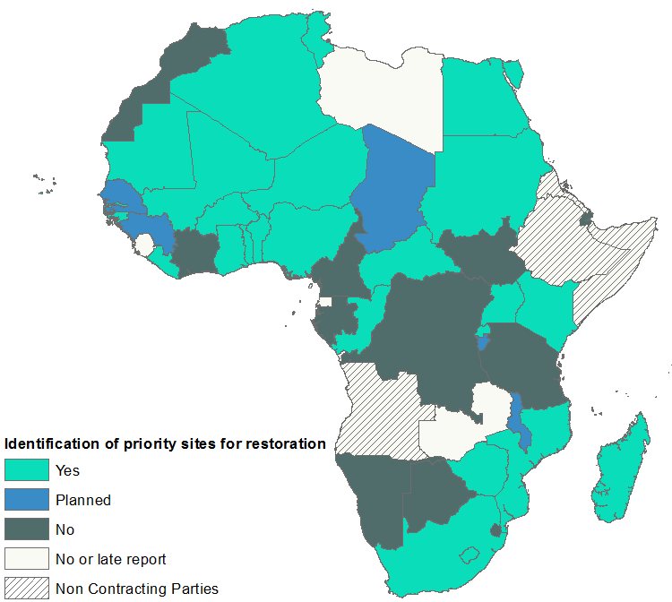

Figure 8: Contracting Parties that have identified priority sites for restoration (Strategy 1.8.1)

Assessment of the implementation of methods used to identify priorities during the 2012-2015 triennium

- After COP11, there was a great demand in the region for the pooling of efforts and investments in order to facilitate the tackling of problems linked to wetland management in Africa. It is in this context that the African Regional Summary Report at COP11 defined a series of priorities and implementation methods. This prioritization was established within a context in which the African region was asking for more support to assess and evaluate its wetland resources, and consisted of consolidating several assets during the 2012-2015 triennium. Table 1 summarizes its achievements.

Table 1: Results of the implementation of methods of used to identify priorities during the 2012-2015 triennium

Strategy | Priorities | Methods | Achievements
Wetland inventory and assessment | Wetland inventory and assessment | Supporting the Contracting Parties in compiling wetland inventories | Technical assistance provided to: Gabon, Burkina Faso, Sudan, South Sudan and Morocco
Policies, legislation and institutions | Drawing up of policies | Providing technical assistance to countries in order to establish parliamentary monitoring of issues related to the wise management and use of critical ecosystems (wetlands) | Technical assistance provided to Burkina Faso, Senegal and Algeria.
Intersectoral recognition of services provided by wetlands | Intersectoral recognition of services provided by wetlands | Wetlands, urbanization and human health programme | West African Economic and Monetary Union (UEMOA) Directives on Wetlands Projects
 | Urban and Peri-urban Wetlands | Developing a pilot project | Framework of Programme for Wetlands and Urbanization in West Africa
 | To develop training modules about goods and services for Members of Parliament and Parliamentary Assistants | Developing a pilot project | Ten Training Modules for Members of Parliament and Parliamentary Assistants available
Strategic framework for the designation of Ramsar Sites | To help the Contracting Parties to designate new Ramsar Sites | Programme for the designation and monitoring of Ramsar Sites | Designation of 38 Ramsar Sites since COP11
 | Ramsar Regional initiatives in Africa | Drawing up a procedural manual, a capacity-building plan and a fundraising plan | Procedural manual available.  Capacity-building plan and fundraising plan available for NigerWet and WacoWet
International cooperation | Cooperation with other agencies and agreements | Collaboration with UNEP  Collaboration with the Pan-African Intergovernmental Agency for Water and Sanitation in Africa (EAA) | Ramsar membership of the UNEP Global Wastewater Initiative (GWI) Steering Committee  Ramsar membership of the EAA Technical Committee
 |  | Create partnerships with International Organization Partners (IOPs) and synergies with the multilateral environmental agreements (MEAs) linked to biodiversity (CCD, CDB, CMS, CITES, AEWA, etc.). | Collaboration with AEWA in the implementation of two projects in Africa
Capacity for implementation | Participation of the private sector | To design mechanisms for associating the private sector with the wise use of African wetlands. | Initiative currently being developed
 | Communication, education and raising public awareness | Modules for the Convention’s national focal points | Development of a training module based on Resolution VIII.6 on the Framework for Wetland Inventory, to be implemented in Burkina, Togo, Mali and Angola.  Development of a training module based on Resolution VIII.14 on New Guidelines for Management of Ramsar Sites and other Wetlands, to be implemented in Burkina, Togo, Mali and Angola.
 | International cooperation | To intensify collaboration with development agencies to make wetland conservation and management a priority for these agencies, in order to channel funds for the implementation of the Convention in Africa. | Development of collaboration with ICLEI - Local Governments for Sustainability within the framework of the Resolutions on Urban and Peri-urban Wetlands
 |  | To develop strategic partnerships with the organizations in charge of water basins and the sub-regional economic development institutions (UEMOA, CEDEAO, CEEAC, SADC, EAC…) | Partnership with UEMOA being development within the framework of the UEMOA Directives on Wetlands Project
 | Annual contributions | Mechanisms for encouraging the implementation of the Ouagadougou Commitments | Establishment of a mechanism to involve the representatives of the Standing Committee in order to encourage countries to pay their outstanding contributions to the Convention
 | Collaboration with IOPs | Implementation of the Memoranda of Understanding (MOUs) with the IOPs | Co-financing for the designation of 7 Ramsar Sites in Zimbabwe and 11 Sites in Angola.
 | Wetland training requirements (Strategy 4.10) | Capacity building for wetland conservation and the wise use of their resources. | Inclusion of the wetlands programme in the University of Senghor’s Master’s Degree 2  Creation of Certification on the Local Governance of African Wetlands at the University of Ouagadougou

Other implementation activities since COP11

- 52% of the Contracting Parties in the region implement programmes and/or projects for the wise use of wetlands, contributing to poverty reduction objectives and plans for food and water security. Another 20% do so partly (see Figure 9). This is a good indication of the effect of the application of Resolution IV.14 on both wetland management and poverty reduction.

Figure 9: Percentage of countries implementing wetlands projects/programmes, contributing to the reduction of poverty and/or food and water security plans (Strategy 1.4.2)

- We observe a high demand for technical assistance for the assessment of water quality and quantity in inland wetlands. Since October 2013, the Africa team of the Secretariat has been a member of the UNEP Global Wastewater Initiative (GWI) Steering Committee. As such, it represents the Convention in the initiative’s technical and statutory meetings. The Senior Regional Advisor for Africa is similarly a member of the Technical Committee of the Pan-African Intergovernmental Agency for Water and Sanitation in Africa (EAA).

Services provided by wetland ecosystems (Strategy 1.4.1)

- The number of Contracting Parties that have carried out or are currently carrying out an assessment of the ecosystem benefits and/or services provided by Ramsar Sites has not varied since the last triennium (see Figure 10). During the 2012-2015 triennium, the Secretariat supported the creation of Terms of Reference within this framework and facilitated the use of student work experience placements to assess the ecosystem services in wetlands in West Africa (Mali, Côte d’Ivoire, Senegal, Burkina, Togo and Benin), Central Africa (Cameroon, the Democratic Republic of the Congo and the Republic of the Congo) and East Africa (Burundi).

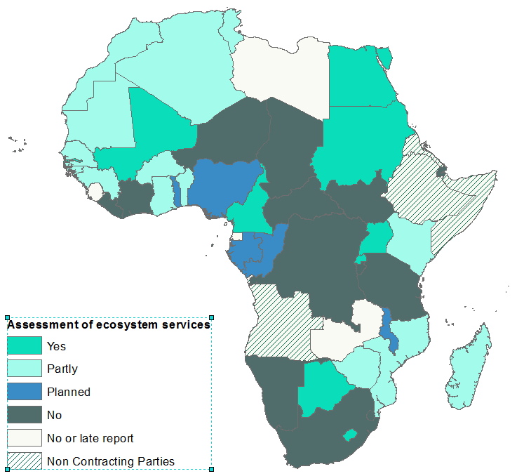

Figure 10: Countries having assessed the ecosystem services or benefits provided by Ramsar Sites (Strategy 1.4.1)

Involvement of the private sector

- Within the framework of the promotion of the participation of the private sector in the conservation and wise use of wetlands, 54% of the Contracting Parties (compared with 35% during the last triennium) mention that the private sector is encouraged to apply the wise use principles and guidelines in relation to activities and investments linked to wetlands (see Figure 11). 20% have done this partly, and 13% plan to do so in the future. It is indeed very important for the Contracting Parties to involve the private sector as far as possible in the wise use of African wetlands.

Figure 11: Percentage of the Contracting Parties that have encouraged the private sector to apply the principles of wise use in activities and investments related to wetlands (Strategy 1.10.1)

Synergy and partnership with other agencies and agreements (Strategy 3.1)

- With support from the Secretariat, the IOPs and other Ramsar partners (including UNDP), Zimbabwe, Swaziland and South Sudan have become Contracting Parties to the Convention over the last three years. The Secretariat has also continued to encourage Eritrea, Ethiopia and Somalia to accede. It is hoped that Angola will take advantage of the occasion of COP12 to become a Contracting Party.

- 48% of the Contracting Parties received during the triennium financial support from development aid agencies promoting the conservation and wise use of wetlands, and ensuring the integration of environmental safeguards and assessment in all linked development projects (see Figure 12).

Figure 12: Percentage of Contracting Parties that have received financial aid from development aid agencies specifically for wetland conservation and management (Strategy 3.3.3)

Ramsar Regional Initiatives in Africa (Strategy 3.2)

- There are three operational regional initiatives in the Africa region: WacoWet for coastal wetlands in West Africa, NigerWet for wetlands in the Niger River basin and the Ramsar Centre for Eastern Africa (RAMCEA). They have made the following progress:
- The creation of a manual of administrative, financial and accounting procedures;
- The creation of a plan for capacity building;
- The creation of a fundraising plan;
- Contribution to a common understanding of the principles of the Ramsar Convention at national and sub-regional levels;
- Contribution to the improvement of the implementation of the resolutions of the Conference of the Contracting Parties through their annual work plan;
- Participation in sub-regional meetings on wetlands;
- Influence of the definition of the sub-region’s projects and programmes.

- However, several challenges remain:
- Countries need to be more willing to contribute to the Regional Initiative budget;
- There is a clear lack of human resources for coordination and supervision;
- Several projects and programmes are currently being implemented in West Africa, but the Regional Initiatives are not involved in them;
- No information on the African Regional Initiatives is being posted on the web pages the Convention has made available to them.

Collaboration with International Organization Partners (IOPs) (Strategy 4.4)

- The Contracting Parties describe the assistance received from one or several of the Convention’s IOPs in the context of the implementation of the Convention at a national level. Central Africa is ahead in terms of the confirmation of assistance received from IOPs. It is followed by North Africa. As in the last triennium, these results reveal the essential role played by IOPs in helping the Contracting Parties implement the Convention at both national and regional levels. According to surveys, WWF can still be referred to as the most active IOP in view of its help in the designation of new Ramsar Sites and its co-financing in support of the Ramsar small grants fund.

Summary of the main activities carried out by the Secretariat’s Africa regional team since COP11

- During the period 2010-2012, the Secretariat chose to provide substantial support to West Africa In 2013, the Africa regional team favoured the following three priority areas of action: East Africa, southern and Central Africa through support for:
- the designation of Ramsar Sites;
- the Swiss Grant Fund for Africa;
- the establishment of management plans both for Sites that had already been designated and for those yet to be designated;
- the implementation of awareness-raising programmes.

- One special activity was the development of a news bulletin on the implementation of the Convention in Africa. The team also renewed its cooperation with suitable partners in order to finalize the preparation of two main projects: the framework for the programme on wetlands and urbanization in West Africa and the project on the conservation and integrated use of critical mangroves. 2013 saw a major achievement: Zimbabwe, South Sudan and Swaziland all acceded to the Ramsar Convention.

- In 2014, the Africa regional team carried out various activities including:
- providing support to Contracting Parties for the designation of Ramsar Sites;
- the establishment of management plans both for sites already designated and those yet to be designated;
- the development of awareness-raising programmes;
- the improvement of services provided by Ramsar regional initiatives;
- Swiss Grant Fund for Africa;
- the preparation and holding of the African preparatory meeting for COP12;
- the implementation and monitoring of small grants projects.

- The team, in partnership with the European Space Agency, has also helped develop the GlobWetland Africa Project in the Niger river basin, the Nile river basin, the Congo-Ubangi-Sangha, the Lake Chad basin, the Zambezi river basin and the Okavango river basin. The objective of the GlobWetland Africa Project is to facilitate the exploitation of satellite observations and to support the effective management of wetlands and the rational use of the associated resources in Africa.

Priorities for 2016-2018

Designation and management of Ramsar Sites

- The processing of data provided by the COP12 national reports has made it possible to document the indicators on the implementation of the Convention in Africa. Moreover, this exercise gives a clearer idea of the challenges that need to be addressed during the next triennium. The wetland potential is still not sufficiently well known, nor do we have sufficiently precise statistics on the loss or degradation of these ecosystems. Only 22% of the Contracting Parties have assessed the effectiveness of the management of their Ramsar Sites (see Figure 13). It is thus essential to carry out inventories of wetlands in order to learn more about this resource and to assess both the effectiveness of the management of Ramsar Sites and the losses and level of vulnerability of these wetlands more accurately.

Figure 13: Percentage of Contracting Parties that have assessed the effectiveness of the management of their Ramsar Sites (Strategy 2.5.1)

Promotion of the involvement of the private sector in the conservation and rational use of wetlands

- Several national reports mention that partnership with the private sector in providing support for wetland management in Africa is increasing (see Figure 14). Some instances, for example partnerships with Danone and the Livelihoods Fund, already appear to be bearing fruit, thus contributing to the development of tourism and the survival and well-being of local populations.

Figure 14: Percentage of countries that encourage the private sector to apply the principles and guidelines of rational use in activities and investments linked to wetlands (Strategy 1.10.1)

Implementation and monitoring of the CEPA Programme

- Several Contracting Parties mention in their report that they carry out CEPA activities at all levels in order to promote the values of wetlands. These activities involve several stakeholders that are target groups and participants in the Convention’s CEPA Programme (see Figure 15). However, the aggregation of information shows that at all levels, fewer than 20 countries have drawn up or are planning to draw up a CEPA action plan. It is imperative that the Secretariat supports the Contracting Parties in their efforts to draw up and implement such action plans.

Figure 15: Number of Contracting Parties that have drawn up one or more CEPA action plans (a- at national level; b- at sub-national level; c- at a catchment level; d-at local level) (Strategy 4.1.1)

Payment of financial contributions to the Convention

- Of the number of requests sent to the Secretariat by the Contracting Parties, we note above all ones for technical assistance and financial support. These two types of request are echoed across all the Convention’s implementation actions carried out at a national level. The Convention’s current financial capacity limits the Africa regional team’s abilities to meet expectations in a context where the outstanding annual contributions on 25 February 2015 amounted to CHF 323,699; and the outstanding voluntary contributions amounted to CHF 213,067; in other words a total of CHF 536,766. Over the next triennium, the Africa regional team will help countries to do their best to fulfill their commitments to the Convention. In parallel with this, the countries will be supported to allow them to channel the help they receive from development agencies (see Figure 16) into wetland conservation and management more effectively.

Figure 16: Percentage of countries that have received financial aid from development aid agencies for wetland conservation and management (Strategy 3.3.3)

Use of satellite observations to support the implementation of the 4th Strategic Plan

- The GlobWetland Africa Project is a new initiative led by the European Space Agency, in collaboration with the Ramsar Secretariat’s Africa regional team. It is a large Earth Observation (EO) application project aimed at facilitating the exploitation of satellite observations to support the conservation, wise use and management of African wetlands. The project will provide African stakeholders both with methods for observing the Earth and the tools required to help them meet their commitments and obligations with regard to the Ramsar Convention, and in particular to carry out wetland inventories, assessment and monitoring. The project will help Ramsar’s administrative authorities in Africa to make the best use of satellite information on the extent and condition of wetlands in order to obtain the best assessment of their ecological character and thus of their capacity to support biodiversity and to provide ecosystem services for human communities.

- The final objective is to improve the African stakeholders’ ability to develop national and regional wetland observatories, by making full use of the satellite data available free of charge from the EU Copernicus initiative’s Sentinel missions. The project will develop a software platform to produce maps and geographic information indicators based on EO, and prove its applicability to a representative selection of African pilot wetlands. The project will start during 2015, and will also help by providing the African partners with technical assistance over a sufficiently long period to enable them to adopt GlobWetland Africa methods, tools and products. Targeting the continent of Africa, the GlobWetland Africa toolbox will be available free of charge to the Ramsar Convention.

Building the capacity of the Contracting Parties in order to restore degraded Ramsar Sites

- During the current triennium, the Secretariat aims to support the dynamism of the Contracting Parties to adopt the most appropriate approaches to raise the profile of wetlands in national and regional planning, and to define and apply specific policies and actions common to all stakeholders. In order to do this, a good flow of information, in particular financial information, will be guaranteed. This will be given priority based on the encouraging results observed in relation to the measures adopted to ensure that the Ramsar administrative authorities are kept informed of human-induced negative changes (or possible changes) to the ecological character of Ramsar Sites (see Figure 17).

Figure 17: Percentage of countries that have adopted measures to ensure that the Ramsar administrative authorities are informed of human-induced negative changes (or possible changes) to the ecological character of Ramsar Sites (Strategy 2.6.1)

- The assessment of the status of the Ramsar Sites in Africa (Figure 18) shows that it is necessary to improve the implementation of the Convention at a local level. Local policies require technical support to integrate the problems affecting wetlands into their development plans successfully. This is because all wetlands, including Ramsar Sites, are directly or indirectly influenced not only by local and city governments, but also by the local stakeholders themselves. In light of the above, the Secretariat will help the Contracting Parties to implement the Resolutions on urban and peri-urban wetlands.

Figure 18: Status of Ramsar Sites

- Many Contracting Parties have pointed out the impact extractive industries have on wetlands. The Secretariat paid particular attention to this problem in past triennia. In this context, strategic frameworks are planned for those in the private sector involved in mining activities, which have an impact on the region’s wetlands.

- The Secretariat will continually draw the Contracting Parties’ attention to the serious threats facing wetlands and their services, notably those posed by the extractive industries, solid and liquid waste, unsustainable land use, the overexploitation of water, and the destruction of habitats and biodiversity. Particular attention will be paid to the management and conservation of Sites whose ecological character is threatened. A series of six Ramsar Advisory Missions (RAM) is currently being planned for the 2016-2018 triennium. During the current triennium, the Secretariat will help the Contracting Parties to systematically assess the management effectiveness of the Ramsar Sites, given that fewer than 25% of African countries do this, as shown in Figure 19.

Figure 19: Percentage of countries that have assessed the efficiency of the management of their Ramsar Sites (Strategy 2.5.1)

- The impact of invasive species is a major cause of disturbance to water cycles and to the ecological character of wetlands in Africa. Despite the progress made in the fight against invasive species in African wetlands, much remains to be done, and invasive species continue to pose a threat to wetlands across the region. The Convention will endeavour to develop strategic partnerships with the organizations in charge of water basins, as well as the Sub-regional Economic Communities (UEMOA, CEDEAO, CEEAC, SADC, EAC etc.) in order to tackle the problem during the next triennium. In addition the specific issue of invasive plants must be reinforced within conservation institutions in order to provide a global solution to this problem.

International cooperation

- In Africa, the main cause of the degradation of wetlands remains the allowance of unsustainable land use together with other actions that disrupt the essential functions and services that these areas provide. The integration of issues concerning wetlands into the work of the Sub-regional Economic Communities remains difficult. The Convention will only be understood and wetlands recognized as major assets for sustainable development if the Contracting Parties stress their importance in regional and global debates such as regional and sub-regional State Summits, General Assemblies of the United Nations, meetings on climate change and deliberations on other priority areas for decisions and actions.

- The Secretariat envisages developing an initial joint work plan with the United Nations Convention to Combat Desertification (UNCCD) in order to pool efforts and investments.

Annex 1

Supplementary information on Ramsar Sites

Table 2: List of Ramsar Sites included in the Montreux Record (as of 28 August 2014)

Id. Site | Contracting Party | Ramsar Site | Added to the Record | Montreux Record
407 | Egypt | Lake Bardawil | 04/07/1990 | X
408 | Egypt | Lake Burullus | 04/07/1990 | X
139 | Senegal | Bassin du Ndiael | 04/07/1990 | X
526 | South Africa | Orange River Mouth | 26/09/1995 | X
343 | South Africa | Blesbokspruit | 06/05/1996 | X
203 | Tunisia | Ichkeul | 04/07/1990 | X
394 | Uganda | Lake George | 04/07/1990 | X

Table 3: List of projects funded by the Small Grants Fund (SGF) currently being carried out
No. | Year | Country | Title |  | Level of progress
1 | 2009 | Congo | Inventory and assessment of Congo’s wetlands | Ongoing | Final report received. Awaiting designation of three Ramsar Sites to approve final report and make final payment.
2 | 2009 | Morocco | Inventory of Morocco’s wetlands |  | Progress report (not in right format) received in February 2014. Follow up email sent on 20 January 2015 requesting final report.
3 | 2010 | Guinea-Bissau | Protection and development of wetlands of Lagoa de Cufada Ramsar Site in Guinea-Bissau | Ongoing | Final report received, reviewed and sent back for finalization. Reminder for finalized report sent on 20 January 2015
4 | 2011 | Uganda | Building community climate change resilience through improved incomes and wise use of Mabamba wetland system | Ongoing | Progress report received, reviewed and sent back to project proponent in February 2014. Final report expected since 18 June 2014.

Table 4: List of projects financed by the Swiss Grant Fund for Africa (SGF)

No. | Year | Country | Title | Status | Level of progress
1 | 2012 | Mauritania | Preparation of a National Conservation Strategy for Mauritania’s Wetlands | Ongoing | Final report received on 18 December 2014. Approval awaited to proceed.
2 | 2012 | Sudan | Support to the development of a national wetland inventory for the Republic of Sudan | Ongoing | All activities on course – project on hold due to political instability in the country.
3 | 2012 | South Sudan | Supporting South Sudan’s accession to the Ramsar Convention on Wetlands and preparation of a national wetland inventory framework. | Ongoing | Same remarks as Sudan. Project on hold due to current situation on the ground.
4 | 2013-14 | African Centre for Parliamentary Affairs (ACEPA) | Develop a Course on Wetlands Goods and Services for African Parliamentarians and Parliamentary Staff (Contract No. 487) | Ongoing | Contract signed and entered into Ramsar SGA project system. Original copy on file. Course content outline sent by ACEPA. 1st payment (60%) made. Final draft manual received on 07 January 2015.
5 | 2013-14 | Swaziland/ Madagascar | Developing three (3) Ramsar Information Sheets (RIS) for Swaziland & Combining Individual Site maps for Madagascar to Maps of Complexes | Ongoing | Contract signed and entered in SGA project system. Original copy on file. 1st payment (60%) made. Progress report expected by January 2015.
6 | 2013-14 | Mozambique | Preparation of a national wetlands inventory for Mozambique | Ongoing | Contract signed and original on file. 1st payment (60%) made. Project on course. Progress report expected January 2015
7 | 2013-14 | Angola | Designation of Wetlands of International Importance for Angola’s ratification of the Ramsar Convention | Ongoing | Signed contract on file and also entered in SGA project system. 1st payment (60%) made to IUCN-PACO. Project on course. Progress report received on 12 January 2015.

