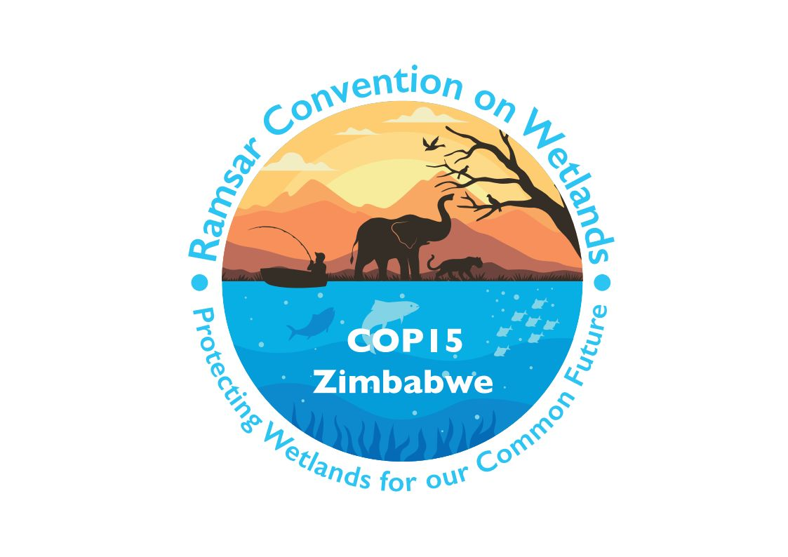

15th meeting of the Conference of the Contracting Parties

to the Convention on Wetlands

“Protecting wetlands for our common future”

Victoria Falls, Zimbabwe, 23-31 July 2025

COP15 Doc.6

Admission of observers

1. The Rules of Procedure for meetings of the Conference of the Contracting Parties foresee the participation of observers in two categories:
- the United Nations, its specialized agencies and States not party to the Convention; and
- any body or agency qualified in fields relating to the conservation and sustainable use of wetlands.

United Nations, its specialized agencies and non-party States

2. Rule 6 of the Rules of Procedure specifies that observers representing the United Nations, its specialized agencies and States not party to the Convention may participate upon invitation of the President, unless at least one-third of the Contracting Parties present at the meeting object.

3. For observers in this category, the Secretariat had received the following registrations for the 15th meeting of the Conference of the Contracting Parties as of 23 April 2025:

States not party to the Convention:

- Ethiopia
- Saudi Arabia

United Nations and its specialized agencies:

- Food and Agriculture Organization of the United Nations (FAO)
- United Nations Environment Programme (UNEP)
- United Nations University Institute for Water, Environment and Health (UNU-INWEH)

Bodies and agencies qualified in fields relating to the conservation and sustainable use of wetlands

4. Rules 7.1 and 7.2 address the participation of other bodies or agencies as follows:

7.1. Any body or agency, national or international, whether governmental or non-governmental, qualified in fields relating to the conservation and sustainable use of wetlands, which has informed the Secretariat of its wish to be represented at meetings of the Conference of the Parties may be represented at the meeting by observers, unless at least one third of the Parties present at the meeting object.

7.2 Bodies or agencies desiring to receive recognition as observers for the purposes of attending meetings of the Conference of the Parties shall submit appropriate documentation to the Secretariat for consideration three months prior to any ordinary meeting and one month prior to an extraordinary meeting.

Bodies or agencies previously approved

5. The following bodies or agencies that have already been approved to be represented by observers at previous meetings of the Conference of the Contracting Parties have registered to participate at COP15:

Intergovernmental

- Deutsche Gesellschaft für Internationale Zusammenarbeit (GIZ)
- International Union for Conservation of Nature
- Secretariat of the African Eurasian Waterbird Agreement
- Secretariat of the Convention on Biological Diversity
- Secretariat of the Convention on Migratory Species
- Secretariat of the Pacific Regional Environment Programme
- UNEP-World Conservation Monitoring Centre

Non-governmental

- Baab group
- BirdLife International
- China Biodiversity Conservation and Green Development Foundation
- Conservation International
- Conservation of Iranian Wetlands Project
- East Asian - Australasian Flyway Partnership
- Environment and Food Foundation (E2F)
- Fondation Tour du Valat
- Fujimae Ramsar Society
- Fundación Kennedy para la Conservación de Humedales
- Fundación Humedales Bogotá
- Gakushuin University
- Global Nature Fund
- ICLEI – Local Governments for Sustainability
- IHE Delft Institute for Water Education
- International Commission for the Protection of the Danube River
- International Mangrove Center
- International Water Management Institute
- MedWet – the Mediterranean Wetlands Initiative
- Métis National Council
- Observatoire Indépendant des Tourbières
- OISCA International
- ONG APES
- ONG Corporación Montañas
- Ramsar Center Japan
- Ramsar Network Japan
- Ramsar Regional Center – East Asia
- River Center of Hokkaido
- Royal Society for the Protection of Birds
- Society of Wetland Scientists
- Southern African Development Community
- Stetson University College of Law
- The Nature Conservancy
- Volontariat Pour l’Environnement
- Wetlands International
- Wetlands International Japan
- Wetlands International South Asia
- WWF China
- WWF International
- WWF Zambia Coordination Office
- Youth Engaged in Wetlands

Bodies or agencies seeking approval which have met the criteria

6. The following bodies or agencies have informed the Secretariat of their wish to be recognized as observers in accordance with Rule 7.1:

Non-governmental

- AbibiNsroma Foundation
- African Coalition for Sustainable Energy and Access (ACSEA)
- AID LIFE LEARN ENVIRONMENT ( ALLEN+)
- Alinea International
- Anges Réunis Pour Une Conscience Solidaire (ARCS-Cameroun)
- Association pour la Justice Climatique, l’Environnement et la Nature pour le Développement Durable (AJUCENADED-Congo)
- Benin Environment and Education Society (BEES)
- Biennial of the Americas
- Biovision Foundation
- Buntu Biosphere Reserve Foundation
- Catholic Youth Network for Environmental Sustainability in Africa (CYNESA)
- CEA-GROUPE S.A
- Chemichemi Foundation
- Conservation Strategy Fund
- Doğa Derneği (Doğa)
- Drylands Initiative for Ecosystem Restoration and Capacity Building (DINERCAB)
- eConservannah Initiative
- Fondation Prince Albert II de Monaco
- Fundacion Natura Colombia
- Global Environmental and Climate Conservation Initiative (GECCI)
- Global Rewilding Alliance (GRA)
- Green Generation Initiative (GGI)
- Greenstoration
- Hangzhou Ecological Culture Association
- IndyACT_The League of the Independent Activists
- Institute for Green Finance & Law
- International Centre for Environmental Education and Community Development (ICENECDEV)
- International Fund for Animal Welfare (IFAW)
- International Network of Basin Organizations (INBO)
- Mangrove Breakthrough_AmbitionLoop
- Mission to Marsh
- Nature Conservation Egypt (NCE)
- Nipiy Tu Research & Knowledge Centre
- Oceanus Conservation Inc
- Réseau Africain pour l’Education au Développement Durable (RAEDD)
- Réseau des Acteurs de la Jeunesse Africaine pour la Protection des Initiatives Climatiques et des Aires Protégées (RAJAPI-COP)
- Roots of the Sea (Rasin Lanmè)
- Savannah Initiative (SI)
- Société SOMMAC
- Society of Wetland Scientists Professional Certification Program
- Village Farmers Initiative
- Wetlands Conservation Organisation
- WILDTRUST (Wildlands Conservation Trust)

7. The Conference of the Parties is invited to approve the participation in the present meeting of observers representing the bodies and agencies listed in paragraph 6.

See https://www.ramsar.org/document/ramsar-rules-procedure-cop14. Rule 25.5: “Unless otherwise decided by the Conference of the Parties, these Rules shall apply mutatis mutandis to the proceedings of subsidiary bodies.”

