**15th meeting of the Conference of the Contracting Parties**

**to the Convention on Wetlands**

**“Protecting wetlands for our common future”**

**Victoria Falls, Zimbabwe, 23-31 July 2025**

**COP15 Inf.4**

**Information Paper to support the draft resolution on assessing   
wetland vulnerability**

*Submitted by the Republic of Korea*

# Section 1: Background to the Wetland Vulnerability Assessment Tool

# Aim of WETVAT

The aim of the WETland Vulnerability Assessment Tool (WETVAT)[1] is to equip *inter alia* government departments, conservation agencies and wetland managers throughout the world with a simple to use decision support tool that will assess the vulnerability of their wetlands to a range of threats. The information generated through the use of the WETVAT can be combined with other knowledge and understanding to assess wetland vulnerability at a variety of scales. The development of the WETVAT is based on the realisation that many organisations do not have the information or expertise required to carry out a full, detailed assessments of wetland vulnerability. However, the approach also recognises that local and indigenous knowledge of a site is often extremely comprehensive and requires to be collated and structured in a systematic way that facilitates vulnerability assessment.

This Information Paper provides background to the method and step-by-step instructions to using the tool and interpreting the results.

# Conceptual overview

The WETVAT is an interactive spreadsheet-based tool (developed in Microsoft Excel) that is designed to be used to support a wider assessment of wetland vulnerability. The WETVAT assesses a wide set of threats, including, but beyond, climate change. The WETVAT is deliberately set-up to assess the values and threats from a local stakeholder perspective and can incorporate both quantitative and qualitative information within the assessment.

The WETVAT uses a risk-based approach to assess vulnerability of a wetland to threats or potential impacts (Figure 1). Vulnerability is based on a combination of the *likelihood of occurrence* of negative impacts and the *severity of those impacts* on biodiversity and ecosystem services. The risk score (High, Medium, Low) enables wetland managers to prioritize conservation activities and identifies wetlands in need of further consideration and more detailed impact assessment.

**Figure 1. Use of a risk-based approach to assess wetland vulnerability, where overall risk from a threat can be H (high), M (medium) or L (low).**

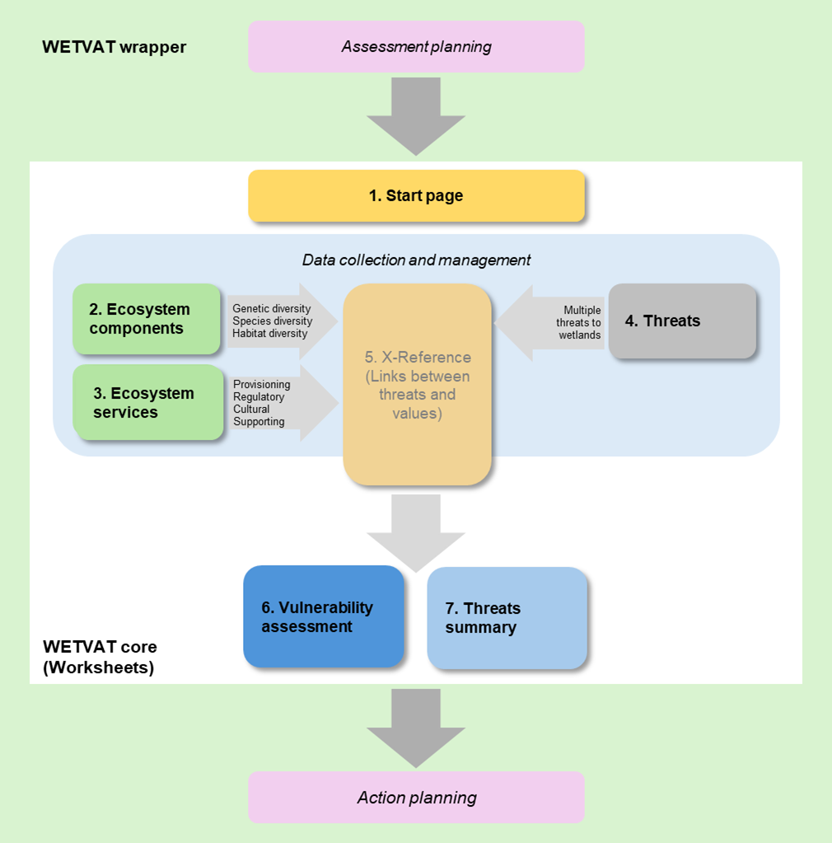

**Figure 2. The steps involved in applying the WETVAT tool, set within a wrapper of initial assessment planning and final action planning.**

Conceptually, WETVAT integrates a core of seven-steps within the spreadsheet-based tool which is embedded within a broader wrapper that needs to contain the context for the initial planning of the assessment and follow-up development and implementation of an action plan, as illustrated in Figure 2. The two elements contained within the broader wrapper are the assessment planning and the action planning. These are discussed briefly below.

## Assessment planning

This is a fundamental question that needs to be asked at the beginning of the assessment process. Understanding the purpose behind the assessment will shape how the results and outputs are considered and addressed in the final stage (i.e. action planning). The purpose may be, for example, strategic assessment of wetlands with a region or focusing on a specific wetland that is believed to be vulnerable to a range of threats. The purpose will help to guide the scope of the assessment, with regards to its extent and boundaries, and how both the ecosystem components and services and the external threats apply to the area under assessment. It will also help to decide who should be involved, such as whether the assessment is a technical exercise undertaken by an individual expert, a wider team activity or needs a coordination committee with representatives of various stakeholder organisations. If resulting actions are be taken by a range of organisations, it may be best to involve them in the planning stage.

## Action planning.

Once the vulnerability assessment is complete, follow-up activities can commence. The form and implementation of these activities will be dependent on the purpose of the assessment established in the planning step that preceded application of the WETVAT tool.

It is strongly recommended that the outputs of the vulnerability assessment are used to formulate an action plan. The action plan should consist of the following three main areas:

1. A statement as to why the assessment was undertaken as set-out in the planning phase.
2. A summary of the components/services that characterise the wetland and the types of threats they are under.
3. Identification of the components and services that are under threat, subdivided according to high/medium/low score.
4. Steps that should be taken in order to address the threats that impact on those values.
5. Requirements for further data collection.

The components and services that are under threat are extracted from the assessment worksheets. Prioritisation should be towards addressing the threats with the greatest magnitude of impact or that are impacting on multiple ecosystem components and/or services. From this, a suitable mitigation measure can be proposed. Whilst the approach to be taken will depend on the purpose of the assessment, it is likely that the mitigation at this stage is likely to be an overview of how the threat can be dealt with rather than a detailed site management plan or mitigation programme.

The requirements for future data collection are identified in the assessment worksheets. It is highly recommended that the user refers to the case studies for examples of how to produce an action plan following the application of the WETVAT approach. Particular emphasis for data collection can be given to threats that are uncertain but if realised would have significant impacts on components and services.

# Section 2: Using the Wetland Vulnerability Assessment Tool

# Applying WETVAT

## Using the WETVAT spreadsheet-based tool

WETVAT is a spreadsheet-based tool. The tool comprises seven linked worksheets in a single Excel file. All the individual worksheets are integrated into the seven-step process described in the previous section (see Figure 3). The approach to completing and interpreting the seven individual worksheets is described below.

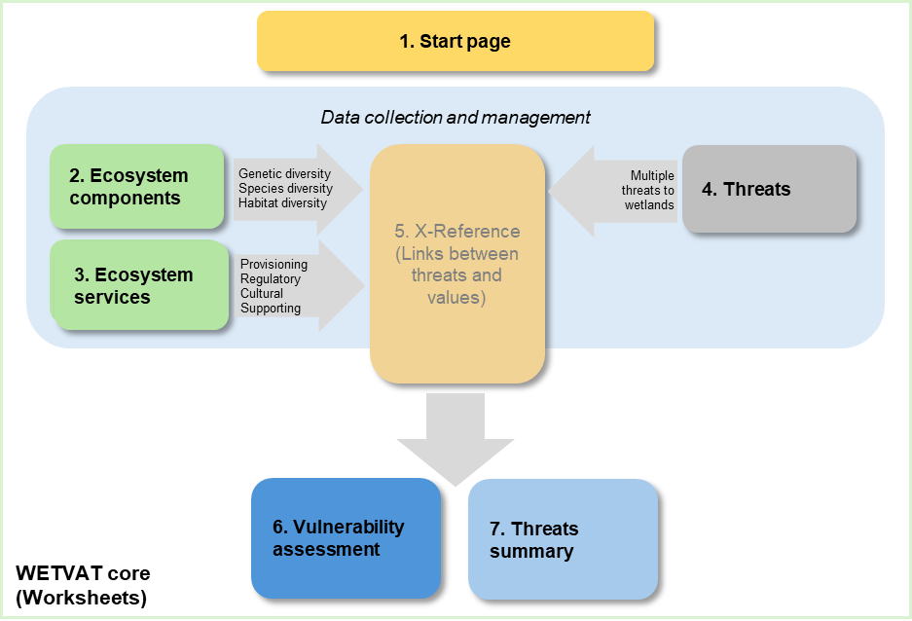

**Figure 3. The seven worksheets (numbered) integrated into the seven-step application of the core WETVAT tool within the wrapper.**

Application of WETVAT begins with assessment planning as described in the previous section. Once the site (or sites) to be assessed has been defined, the spreadsheet tool can be applied and the seven linked worksheets can be completed.

## Worksheet 1. Start Page

Information about the wetland under assessment, the assessor and the date of the assessment is entered into the Start Page (Figure 4). This information is entered into the grey cells. The Start Page also provides a cross-check to ensure that the information needed to conduct a vulnerability assessment using the WETVAT is complete. The assessment status of the ecosystem components, services and threats should be red upon commencing a new assessment. Once all the required information has been entered, the status will change from red to green.

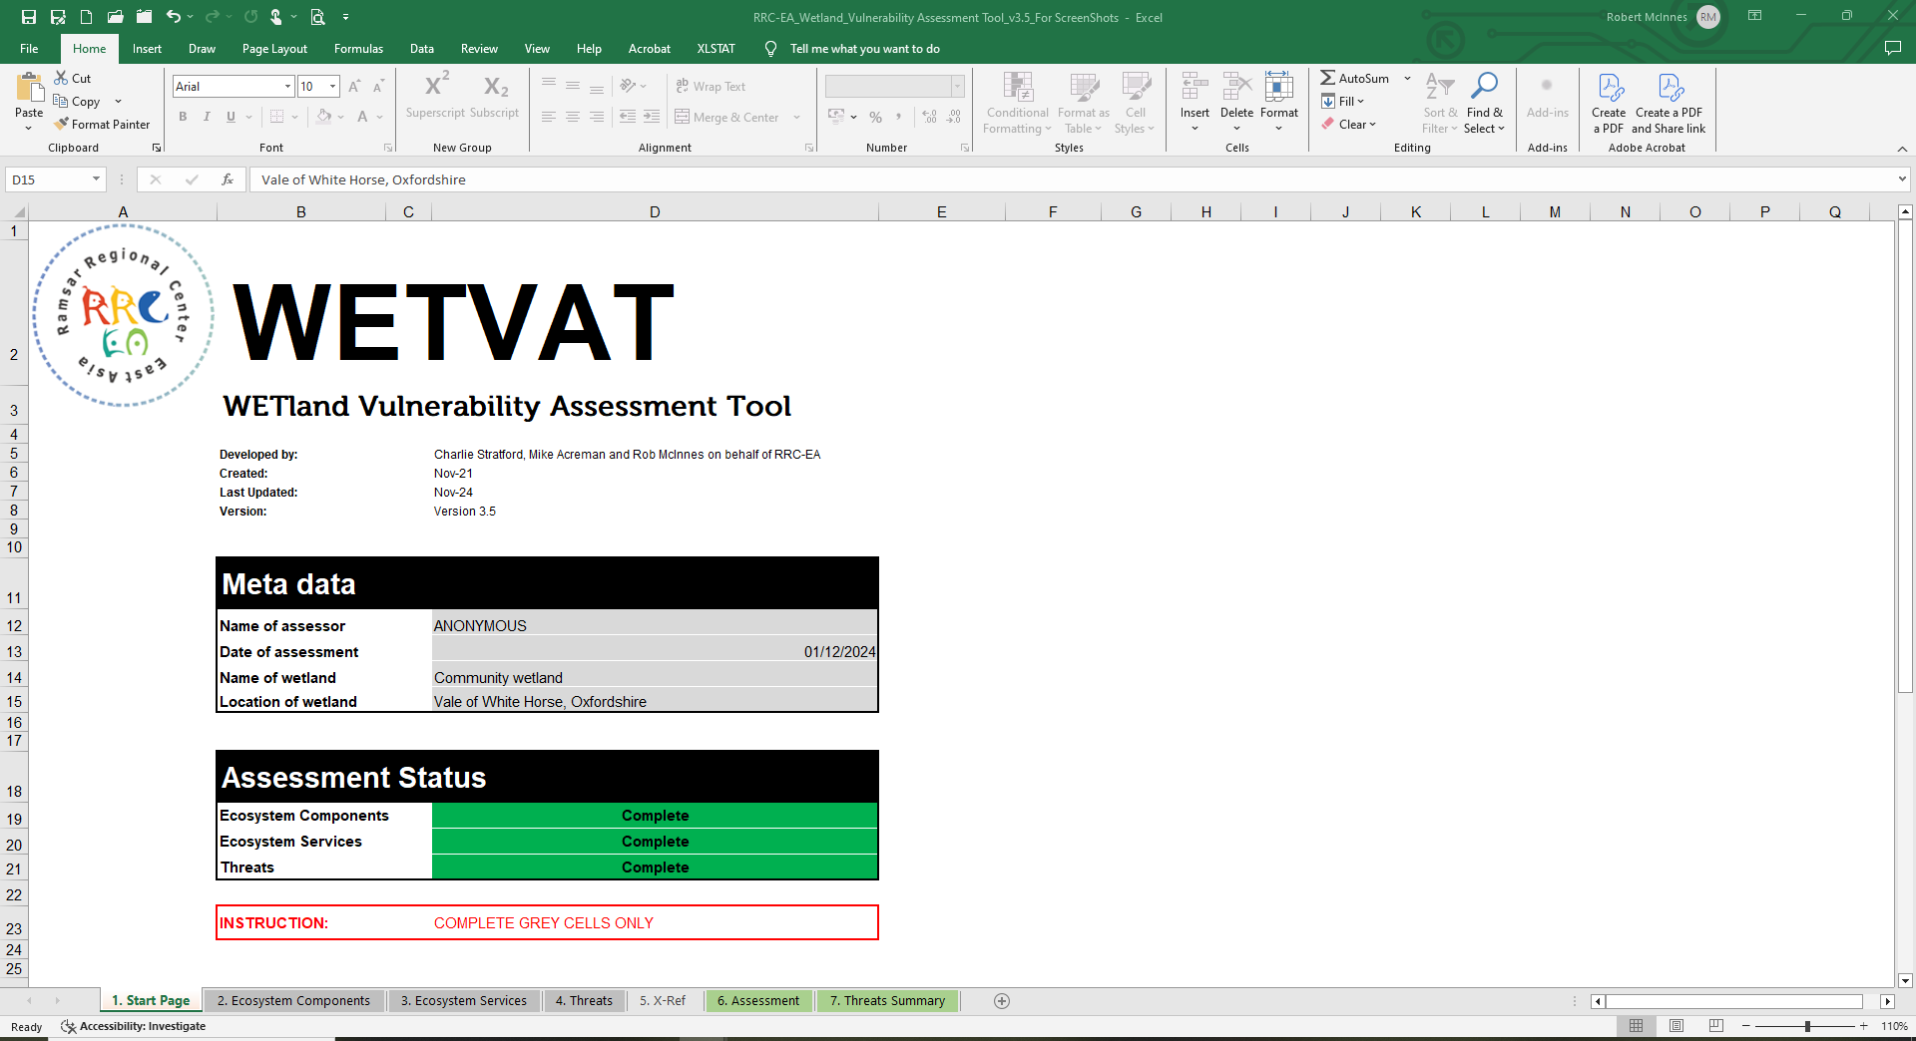

**Figure 4. Worksheet 1. Start Page.**

Once an assessment purpose has been defined it is necessary to collect and collate data to provide inputs to the spreadsheet tool.

## Worksheet 2. Ecosystem components

Ecosystem components should ideally assess genetic, species and ecosystem diversity. Information on the ecosystem components (or effectively the biodiversity importance of the site) is entered into Worksheet 2 under five categories:

* Wetland dependent fauna (fauna that depend on a wetland for any point in their life cycle)
* Wetland dependent flora (flora that depend on a wetland for any point in their life cycle)
* Habitat diversity (the diversity of wetland habitats within a site)
* Genetic diversity (specific genetic diversity associated with the site)
* Other ecological values (other noteworthy values not captured in the other categories. These may include other ecological or geo-diversity features of note)

Data are rarely available to assess these aspects fully but information on endangered species should be available. Potential data sources are given in Table 1 and below. Data collection includes all data and information required by WETVAT. This starts with data for input into worksheets 2 and 3. Data are available from many sources. Some examples are provided here.

### Global databases

The IUCN Red List is a critical indicator of the health of the world’s biodiversity (Figure 5). This provides a powerful tool to inform and catalyse action for biodiversity conservation and policy change, critical to protecting the natural resources we need to survive. It provides information about range, population size, habitat and ecology, use and/or trade, threats, and conservation actions that will help inform vulnerability assessments and necessary conservation decisions.

**Figure 5. IUCN Red List**. (https://www.iucnredlist.org/)

Birdlife International has a network of over 2 million birders, scientists and local volunteers who help track, follow, analyse, conserve and understand every bird species in the world. Data are available through the Birdlife DataZone (Figure 6).

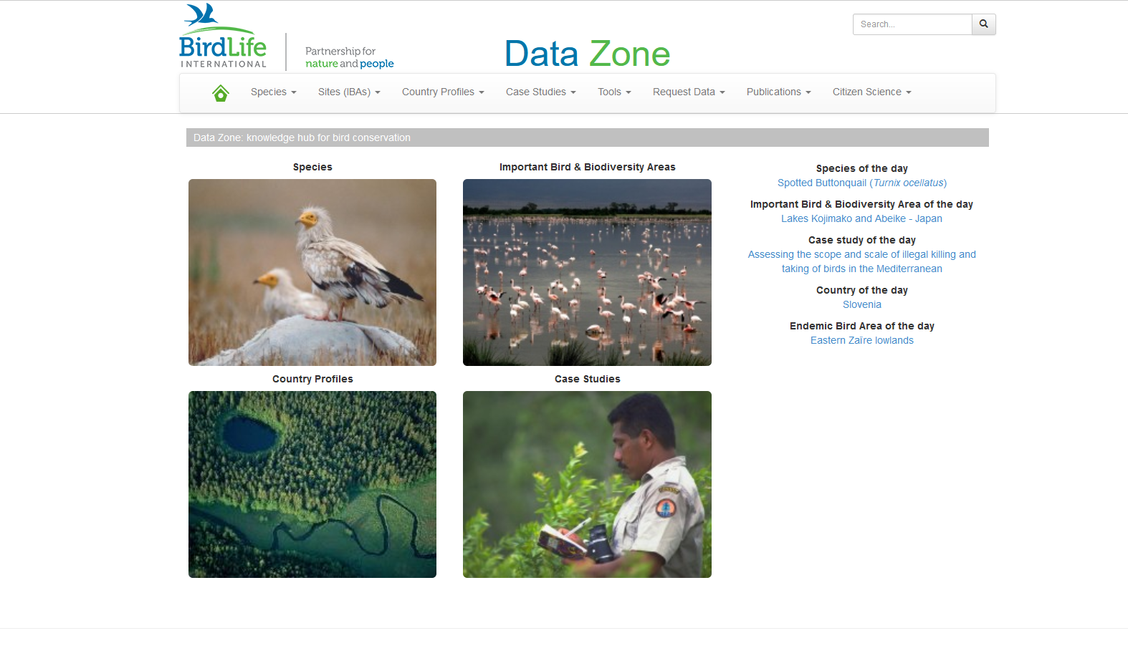

**Figure 6. Birdlife DataZone.** (https://datazone.birdlife.org/home)

### 

### National databases

In most countries national governments and NGOs hold information on nationally important floral and faunal species, for example Ministries of Environment.

### Site databases

Data are available for many wetlands from surveys undertaken by site staff or local NGOs.

The Ramsar Sites Information Service (RSIS) provides online information on wetlands that have been designated as internationally important (Figure 7). This contains all Site information provided by the Contracting Parties to the Convention. The database is searchable and holds information on the wetland types, ecology, land uses, threats, hydrological values of each designated Wetland of International Importance.

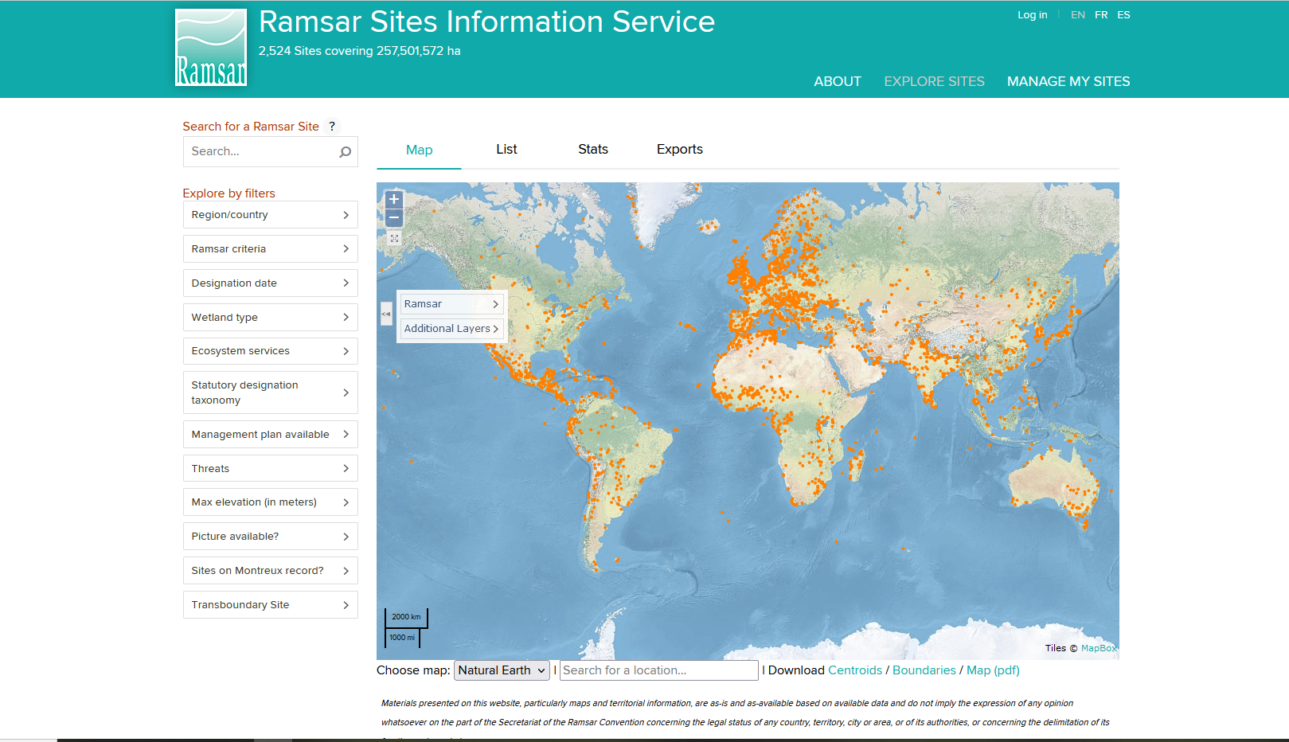

**Figure 7. Ramsar Site Information System** (https://rsis.ramsar.org/)

WETVAT uses a four-point scoring system for ecosystem components (Table 2). As a surrogate, it is possible to focus on species and habitats that are threatened, vulnerable or endangered according to IUCN criteria and use the Red List category to define the WETVAT score (Table 3). Similarly, it is possible to access other international, national or local data sources that will provide information on the status of different ecosystem components.

**Table 1. Examples of data sources for ecosystem components**

|  |  |  |
| --- | --- | --- |
| **Component** | **Endangered Species/Habitat** | **Presence in region** |
| Wetland dependent fauna | **Data sources:**  Existing endangered species list e.g. IUCN Red List  Regional and local wildlife organisations  Extensive field surveys on site | **Data sources:**  Existing endangered species list e.g. IUCN Red List  Regional and local wildlife NGOs  Key Biodiversity Areas |
| Wetland dependent flora |
| Habitat diversity |
| Genetic diversity |
| Other ecological values |

The user enters scores in the grey cells based on the importance of the species and habitats known to be present in the wetland. These cells will automatically change colour depending on the score that is entered. It is important to ensure that for each component, the source of the data and its key characteristics should be entered in free-format text (Figure 8). If no data or information are available a question mark (‘?’) should be entered into Worksheet 2.

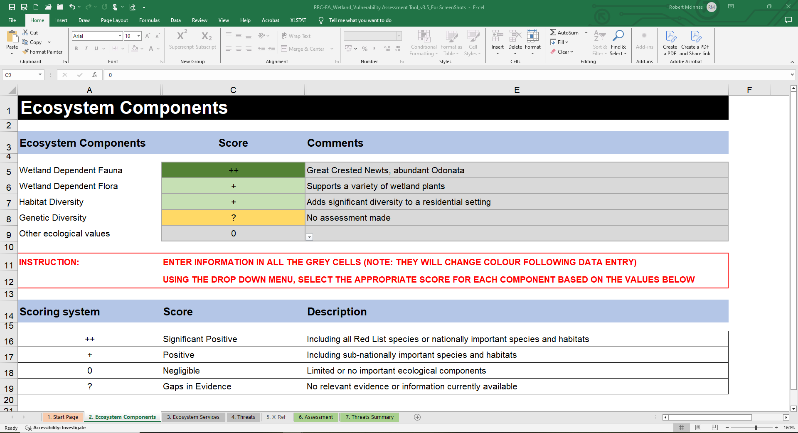

**Figure 8. Example of Worksheet 2 - Ecosystem Components**.

**Table 2. WETVAT scoring.**

|  |  |
| --- | --- |
| **WETVAT description** | **WETVAT Score** |
| Significant positive: Including all Red List species or nationally important species or habitats | ++ |
| Positive: Including sub-nationally important species and habitats | + |
| Negligible: Limited or no important ecological components | 0 |
| Gaps in evidence: No relevant evidence or information currently available | ? |

**Table 3. Red list categories and WETVAT scoring.**

|  |  |
| --- | --- |
| **Red list category** | **WETVAT Score** |
| Critically endangered – Endangered – Vulnerable - Near threatened – Least concern | ++ |
| No Red List category | 0 |

## 

## Worksheet 3. Ecosystem services

At some sites formal assessment protocols will have been applied to identify and value the ecosystem services provided by the wetland. For example, it is possible that the Rapid Assessment of Wetland Ecosystem Services (RAWES) approach will have already been applied. RAWES was designed to provide a qualitative and semi-quantitative assessment of a range of wetland ecosystem services (RRC-EA, 2020). It is used as an initial scoping assessment to identify the range and relative importance of ecosystem services a wetland may be providing, or as a precursor to a more detailed quantitative or monetised assessment. RAWES can provide input data on ecosystem services to WETVAT. RAWES uses a scheme with ecosystem services scored as ‘++’ or ‘+’ positively. It scores as ‘0’ those services that do exist but do not benefit people. RAWES also scores some services ‘--' or ‘-' negatively, such as wetlands that support mosquitoes that could be a health risk. WETVAT is not concerned with the vulnerability of these neutral or negative services, so only those scored as positive are used as input to WETVAT.

WETVAT uses a four-point scoring system (Table 4) to record the ecosystem services present at a site. The scoring is based on the RAWES approach. Only significantly positive and positive benefits (ecosystem services), and negligible benefits are recorded. It is critical that the assessment is of actual rather potential ecosystem services. It must be remembered at all times that if no humans are benefitting then there is no service being delivered and the score should be ‘0’.

A drop-down menu is available for entering the appropriate score in the grey cells. These cells can change colour depending on the score entered. It is important to ensure that for each service, the source of the data and its key characteristics should be entered in free-format text. If no data or information are available a question mark (‘?’) should be entered into Worksheet 3.

**Table 4. Ecosystem service categories and WETVAT scoring.**

|  |  |
| --- | --- |
| **Ecosystem service description** | **WETVAT Score** |
| Significant Positive: Important service with many beneficiaries | ++ |
| Positive: Minor service with relatively few beneficiaries | + |
| Negligible: Limited or no service with very few beneficiaries | 0 |
| Gaps in Evidence: No relevant evidence or information currently available | ? |

In the absence of information provided though a formal assessment approach such as RAWES, the following information should be considered to assist in completing Worksheet 3.

### Assessment of provisioning services

Provisioning services consider the materials and goods that wetlands can provide for human society. These include fresh water, fisheries, agriculture, fibre, fuel and building materials (Table 5). Provisioning services can be scored within WETVAT based on both economic value of the service and number of people benefiting. Potential data sources are given in Table 5. The assessor can consider two dimensions. First, the proportion of wetland income that the service provides (Table 6a) and, second, the percentage of the adult community that benefit from the service (Table 6b). By considering both of these aspects, the monetary and community importance of the service, are represented and the dependency of the community on a wetland value is reflected.

**Table 5. Assessment of provisioning services**

|  |  |  |
| --- | --- | --- |
| **Provisioning services** | **Economic Value** | **Community Value** |
| Freshwater | **Data sources:**  Nationally held data sets e.g. government ministry  Locally held data sets e.g.  Ramsar Site Information Sheets  Local government departments.  Discussion with local government departments in conjunction with interviews with people involved directly with value e.g. farmers, fishermen and tour guides. | **Data sources:**  Nationally held data sets e.g. government ministry  Locally held data sets e.g. Local government departments.  Ramsar Site Information Sheets  Discussion with local government departments in conjunction with interviews with people involved directly with value e.g. farmers, fishermen and tour guides. |
| Food e.g fisheries |
| Fuel e.g. charcoal |
| Building materials e.g. timber |
| Other economic values |

**Table 6a. Percentage of wetland derived income provided by value**

|  |  |
| --- | --- |
| **Wetland derived income (%)** | **WETVAT Score (H/M/L)** |
| >40 | High |
| 10 to 40 | Medium |
| <10 | Low |

**Table 6b. Percentage of adult community involved in value**

|  |  |
| --- | --- |
| **Adult community involved (%)** | **WETVAT Score (H/M/L)** |
| >40 | High |
| 10 to 40 | Medium |
| <10 | Low |

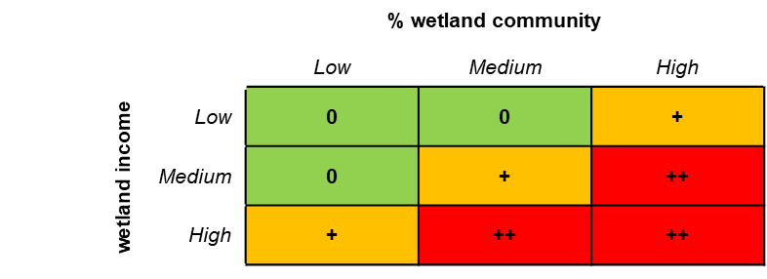

**Figure 9. Assessment matrix for provisioning services.**

The two High/Medium/Low (H/M/L) scores are combined by using the assessment matrix (Figure 9) to give a single value which is then entered to the assessment table (tab Ecosystem Services) by the user (Figure 10).

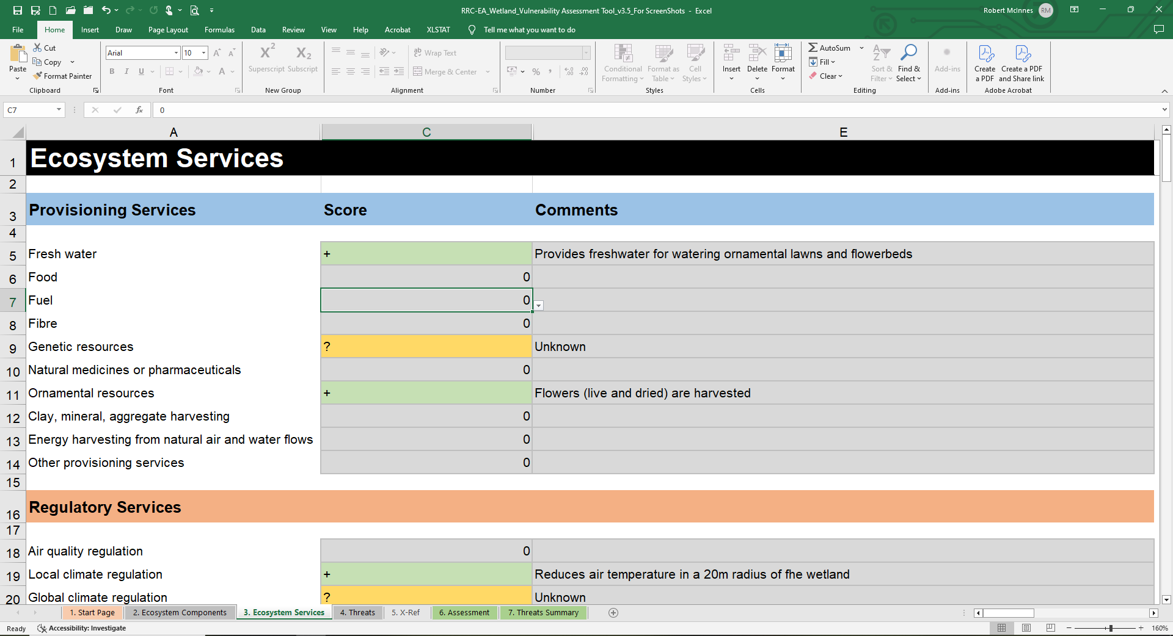

**Figure 10. Example partial page of Worksheet 3 for provisioning services**.

As with ecosystem components, for each provisioning service, the source of the information and its key characteristics should be entered in free-format text in the comments column.

### Assessment of regulatory services

Regulatory services include regulation of water resources, reduction of floods, amelioration of climate, control of pests and cleaning of water for drinking or bathing. The importance of each regulatory service is based on the population benefitting from the service and the feasibility of an alternative service being provided (Figure 11). Potential data sources are given in Table 7.

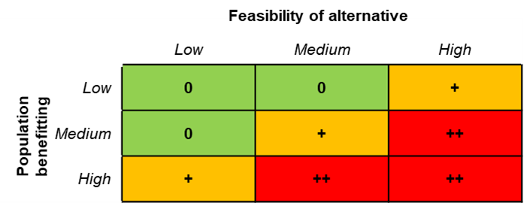

**Figure 11. Assessment matrix for regulatory services.**

As the regulatory service can affect a large area downstream of the wetland, the population affected by the value could be much larger than the community living directly around the wetland. Defining the geographical area to include in this analysis can therefore be difficult and this is likely to have a knock-on effect on the quantification of the size of population affected.

The number of people that benefit from a regulatory service may vary greatly. For example, reduction in floods may affect millions of people whereas cleaning of water so it is potable may only affect several hundred people. However, both are of great importance to the communities that benefit. It is therefore likely that the assessor will have to base the H/M/L score on a combination of data and an overall feel for the situation. For this reason, very broad population size divisions are used (Table 8a) to establish the H/M/L score.

**Table 7. Assessment of regulatory services**

|  |  |  |
| --- | --- | --- |
| **Regulatory service** | **Number of people benefitting** | **Feasibility of alternative provision** |
| Regulation of water resources | **Data sources:**  National level data sets (especially for HEP).  Regulatory services defined by application of RAWES to the site.  Ramsar Site Information Sheets  Local government datasets.  Detailed field investigation and monitoring. | National data sets.  Local government data sets.  Full analysis of local economy and costing of implementing an alternative. |
| Reducing in downstream flooding |
| Amelioration of climate, |
| Cleaning of drinking water. |
| Other regulatory services |

The feasibility of alternative provision (Table 8b) should consider both practical and financial aspects and it is likely that different communities will have differing abilities to provide alternatives. As with the analysis of population benefitting, this is likely to be a decision based on data and overall feel for the situation.

The two H/M/L scores are then combined using the assessment matrix (Figure 12) to give a single value which is then entered to the assessment table (Worksheet 3. Ecosystem Services) by the user. As above, for each regulatory service, the source of the data its key characteristics should be entered in free-format text (Figure 12).

**Table 8a. Size of population benefitting from value**

|  |  |
| --- | --- |
| **Size of population benefitting** | **WETVAT Score (H/M/L)** |
| Large | High |
| Medium | Medium |
| Small | Low |

**Table 8b. Feasibility of alternative provision of value**

|  |  |
| --- | --- |
| **Feasibility of alternative provision** | **WETVAT Score (H/M/L)** |
| Difficult | High |
| Medium | Medium |
| Easy | Low |

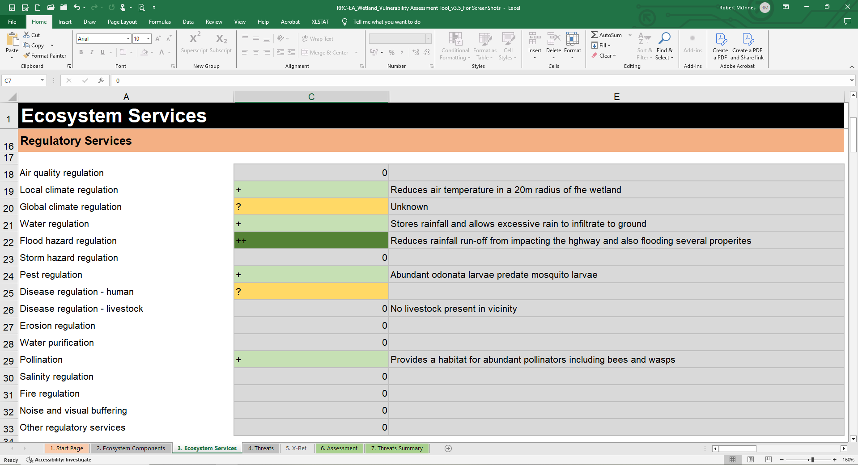

**Figure 12. Example partial page of Worksheet 3 for regulatory services**.

#### 

### Assessment of cultural services

Cultural services include recreation, tourism, cultural heritage, religious importance and sense of community. The value each cultural services is assessed by the social importance of the wetland and the uniqueness of that wetland characteristic (Figure 13). Potential sources of data are shown in Table 9.

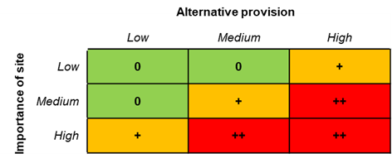

**Figure 13. Assessment matrix for cultural services.**

The user provides two scores of H/M/L, first, the importance of the site (Table 10a) and the uniqueness of the site, i.e. whether an alternative exists (Table 10b). Scale is key issue to consider as some sites are only important locally, whereas other sites may have regional or global significant. By their nature, these assessments are prone to the greatest subjectivity.

**Table 9. Assessment of cultural services**

|  |  |  |
| --- | --- | --- |
| **Cultural services** | **Importance of site** | **Alternative provision of value** |
| Recreation | **Data sources:**  National data sets.  Local data sets  Cultural services defined by application of RAWES to the site.  Ramsar Site Information Sheets.  Discussion with local community. | **Data sources:**  National data sets.  Local data sets  Discussion with local community. |
| Tourism |
| Religious importance |
| Cultural heritage |
| Other social values |

**Table 10a. The scale of importance of the value**

|  |  |
| --- | --- |
| **Scale of importance of the value** | **WETVAT Score (H/M/L)** |
| Global | High |
| Regional | Medium |
| Local | Low |

**Table 10b. Uniqueness of site for value**

|  |  |
| --- | --- |
| **Unique of the value** | **WETVAT Score (H/M/L)** |
| Unique | High |
| Rare | Medium |
| Widespread | Low |

The two H/M/L scores are brought together using the assessment matrix (Figure 13) to give a single value which is then entered to the assessment table (tab Ecosystem Services). As above, for each cultural service, the source of the data its key characteristics should be entered in free-format text (Figure 14).

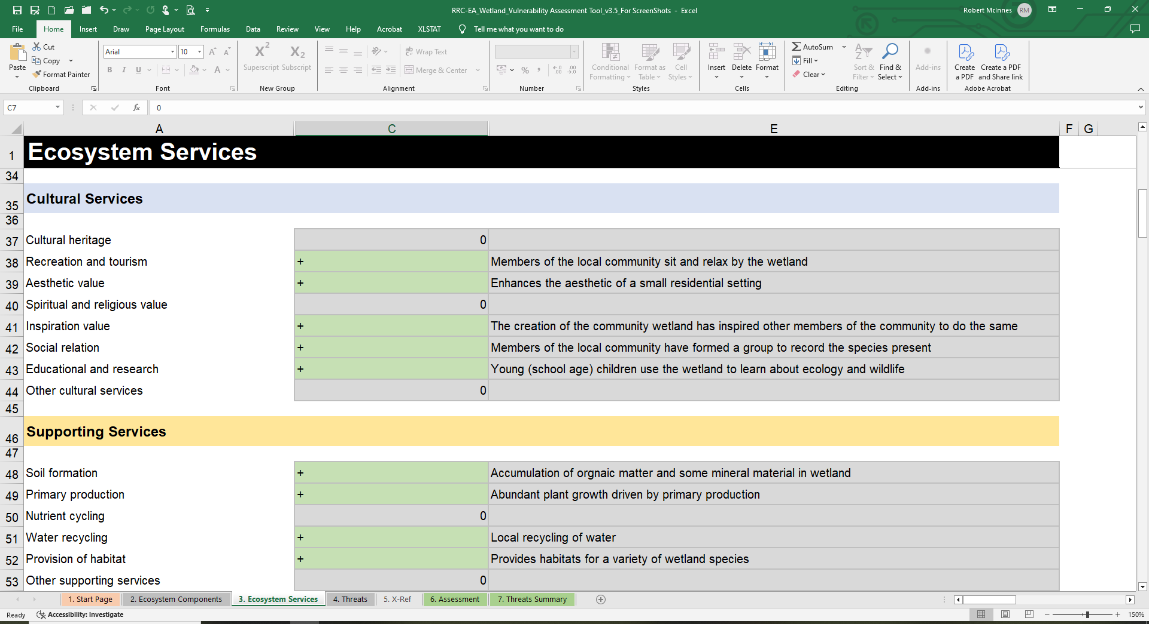

**Figure 14. Example partial page of Worksheet 3 for cultural services**.

### Assessment of supporting services

Supporting services are only present where they *support* one of the other category (provisioning, regulatory, cultural) of ecosystem services. The supporting services include the formation of soil, the cycling and recycling of water and nutrients, primary production and the provision of habitat. The value of each supporting service is assessed by the role the supporting service plays in supporting, or contributing to the enabling conditions for, other provisioning, regulatory and/or cultural services. If there is no link between the supporting service and any service from the three other categories (provisioning, regulatory or cultural) then the role of the supporting service should be considered to be negligible (Figure 15). However, if there is a link between a supporting service and only one other service that has a value of +, then the supporting service is assigned the same value (Figure 16). In the situation where a supporting service is contributing to multiple services that score + or ++ then a value of ++ is assigned to that supporting service.

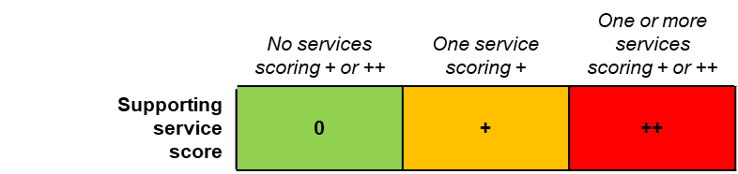

**Figure 15. Assessment categories for supporting services.**

For each supporting service, the role that it plays in supporting the other services supports should be entered in free-format text (Figure 16).

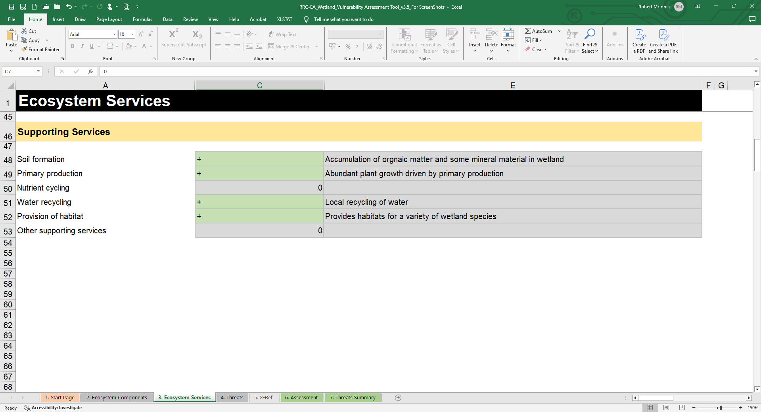

**Figure 16. Example partial page of Worksheet 3 for supporting services**

### Gaps in evidence

If no formal evidence is available on any of the ecosystem services it is appropriate to highlight the gap in the evidence in the spreadsheet by entering ‘?’ as the value. The gap in the evidence will be highlighted in the subsequent assessment and may form a future priority in the action plan.

## Worksheet 4. Threats

WETVAT is pre-populated with a standard list of potential threats (Table 12). All threats are considered using a method based on a severity and likelihood of occurrence analysis where severity gives an indication of what the impact of the threat occurring would be, and likelihood gives an indication of how likely the threat is to occur (Figure 17).

**Figure 17. Assessment matrix for threats.**

**Table 12. Threats to the wetland recorded in WETVAT.**

|  |  |
| --- | --- |
| **Threats** | **Data Sources** |
| **1. Residential and commercial development (within site)** | **Data Sources:**  Discussion with national, regional and local government departments, particularly their plans for infrastructure development.  Discussion with local stakeholders and site inspection.  Field monitoring and modelling of threats. |
| Housing and settlement |
| Commercial and industrial areas |
| Tourism and recreation infrastructure |
| **2. Agriculture and aquaculture (within site)** |
| Annual and perennial non-timber crop production |
| Drug cultivation |
| Wood pulp and plantations |
| Livestock farming and grazing |
| Marine and freshwater aquaculture |
| **3. Energy production and mining (inside the site)** |
| Oil and gas drilling |
| Mining and quarrying |
| Energy generation, including from hydropower dams, wind farms and solar panels |
| **4. Transportation and service corridors inside the site** |
| Roads and railroads |
| Utility and service lines |
| Shipping lanes and canals |
| Flight paths |
| Ports with large scale loading and unloading of goods |
| **5. Biological resource use and harm within the site** |
| Hunting, killing and collecting of terrestrial animals |
| Collecting terrestrial plants or plant products (non-timber) |
| Logging and timber harvesting |
| Fishing, killing and harvesting of aquatic resources |
| **6. Human intrusions and disturbance within the site** |
| Recreational activities and tourism |
| War, civil unrest and military exercises |
| Research, education and other work-related activities |
| Activities of site managers |
| Vandalism, destructive activities or threats to staff and visitors |
| **7. Natural system modifications** |
| Habitat clearing |
| Fire and fire suppression |
| Dams, hydrological modification and water management/use |
| Increased fragmentation within the site |
| Isolation from other natural habitats |
| Other ‘edge effects’ that degrade the site values |
| Loss of keystone species |
| **7a. Hydrological change** |
| Dams within or upstream of the site, which alter the hydrological regime |
| Water extraction / diversion within the site or catchment |
| Excess ponding of water onsite |
| Loss of hydrological connectivity |
| Drought conditions |
| Desertification |
| **8. Invasive and other problematic species and genes** |
| Invasive plant species |
| Invasive animal species |
| Pathogens |
| Introduced genetic material |
| **9. Pollution entering into, or generated from within the site** |
| Household sewage and urban waste water from outside the site |
| Sewage and waste water from site facilities |
| Industrial, mining and military effluents |
| Agricultural and forestry effluents |
| Garbage and solid waste |
| Air-borne pollutants |
| Excess energy |
| **10. Geological events** |
| Volcanoes |
| Earthquakes / tsunamis |
| Avalanches / landslides |
| Erosion and siltation / deposition |
| **11. Climate change and severe weather** |
| Habitat shifting and alteration |
| Droughts |
| Temperature extremes |
| Storm and flooding |
| **12. Specific cultural and social threats** |
| Loss of cultural links, traditional knowledge and / or management practices |
| Natural deterioration of important cultural site values |
| Destruction of cultural heritage buildings, gardens, sites, etc. |

At some sites the Ramsar Site Management Effectiveness Tracking Tool (R-METT) may have been applied. This tool records how well a site is managed and its goals and objectives are met, which includes an assessment of threats to the site. Outputs from R-METT include the level of different threats listed in twelve tables, for example for residential and commercial development or agriculture and aquaculture. Each threat in R-METT is scored as follows:

High (H) - the threat is seriously degrading the site’s values.

Medium (M) - the threat has some negative impact on the site’s values.

Low (L) - the threat is present but does not seriously impact the site’s values.

N/A (N) - the threat is not present or applicable to the site.

The same categorisation of threats used in R-METT is applied to Worksheet 4 of WETVAT with the addition of a category if information on a threat remains unknown (U). However, as described above, information is entered in four cells using a drop-down menu, namely:

* Threat severity – H/M/L/N/U
* Severity confidence – High/Medium/Low
* Threat likelihood – H/M/L/N/U
* Likelihood confidence – High/Medium/Low

The confidence categories used are designed to provide a check on the subjectivity or objectivity of the information being used to underpin the vulnerability assessment. The three following categories are applied:

* High (H) – Based on extensive field survey and research
* Medium (M) – Based on old/outdated evidence or from a proxy site
* Low (L) – Based on anecdotal data; not backed up by data

The threat severity and likelihood values selected by the user combine automatically based on the assessment matrix (Figure 17) to give a single overall threat score H/M/L/N/U for each threat. In addition, the information entered on the confidence levels is also combined to provide an overall assessment of the confidence (H/M/L) in the information used to understand the threats. As above for the ecosystem components and services, for each threat, the source of the data its key characteristics should be entered in free-format text (Figure 18).

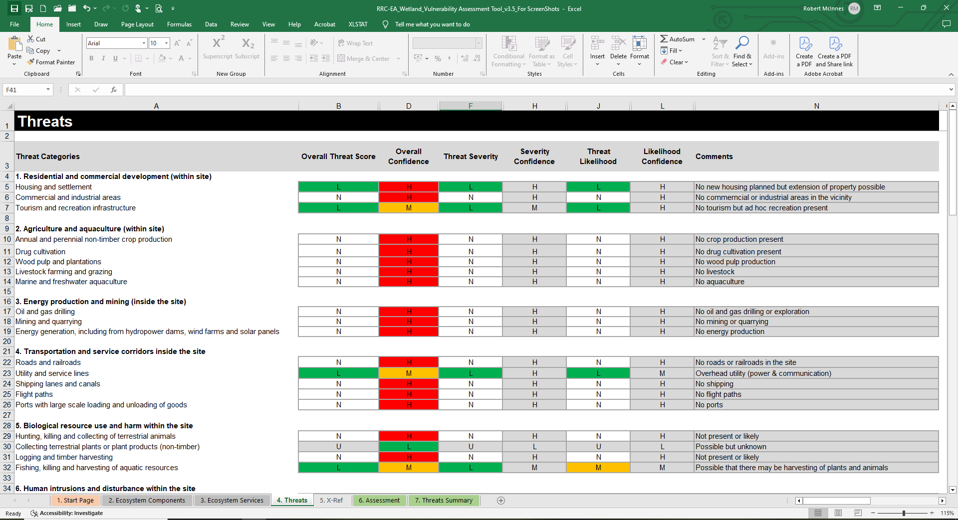

**Figure 18. Example (partial) page of Worksheet 4 – Threats.**

## Worksheet 5. Cross-referencing (X-Ref) threats with components and services

A cross-referencing table is embedded in WETVAT as a worksheet (Figure 19). It is normally hidden but can be unhidden by right-clicking on the threats tab. The table automatically determines how the threats are likely to impact on the ecosystem components and services. This part of the process has been pre-populated with default values of 2. The default option requires no action.

It is possible to modify the cross-referencing table and to customize it to reflect local knowledge of the wetland site if users are confident the existing reference values can be improved. The table has been protected to avoid accidental editing, but editing can be enabled using the password ‘*Ramsar’*. Increasing the number, say to 3 or 4, strengthens the link between the threat and the component or services, whilst replacing the 2 with 1 reduces the strength, with 0 defining no link.

An example of how the interaction matrix works is the effect of pollution from nutrients, which may be considered to have a direct impact on loss of rare aquatic flora and fauna (both therefore given a value of H) compared to the less direct effect that it might have on tourism where some tourists may be deterred by the algal blooms that accompany eutrophication (and would therefore be given a value of L). The case studies will be useful in guiding the values used in the matrix.

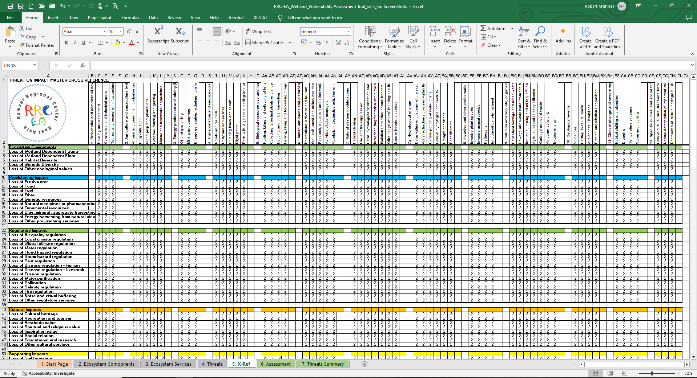

**Figure 19. Cross-refencing Worksheet 5 – X.Ref between threats and components/services (partial page).**

## Worksheet 6. Assessment

Once all the values have been entered into Worksheets 1, 2, 3 and 4, the finished assessment will be generated automatically in Worksheet 6 - Assessment. A partial example output from the assessment tool is shown in Figure 20. In Worksheet 6, the wetland components and services are listed in rows down the left-hand side of the spreadsheet and the threats are shown in columns across the top of the spreadsheet. The assessment aims to summarise a large amount of information and may therefore appear complicated at first, however a combination of simple colour codes and symbols are used to express the assessment (Table 13).

This coding system highlights the components and services that are under most threat, and the threats that are impacting on the most values. A preliminary approach is to identify any groupings of columns or rows that are generally predominantly red, amber or green which highlight particular groups of threats and components/services in different categories. The user can then examine individual threats and components or services to identify specific issues. Resources can therefore be assigned to tackle these issues. In addition, future data requirements are identified and can be addressed.

**Table 13. Coding used in Worksheet 6 – Assessment.**

|  |  |
| --- | --- |
| Cell | Explanation |
|  | Green (L), amber (M) or red (H) cell indicates a threat having an impact on a component or service of low, medium or high impact respectively. |
|  | A blank (white) cell indicates no impact/effect of threat on the ecosystem services or component. |
|  | A grey cell indicates that the status of the value or threat is unknown and therefore no assessment is possible. |
| *** | Before ‘Threats’ in top row indicates that there is unknown information about a threat that could have an impact on a value. Information on this threat should be collected. |
| /// | Before ecosystem components or services in first column indicates that there is unknown information about a value that is likely to be under threat. Information about the value should be collected. |
| */* | Indicates that information about the threat and value are both missing but an interaction between the two has been identified. Further information about both should be collected. |
| Text in red | If either a value or threat appear in red text then this indicates that information is lacking. |

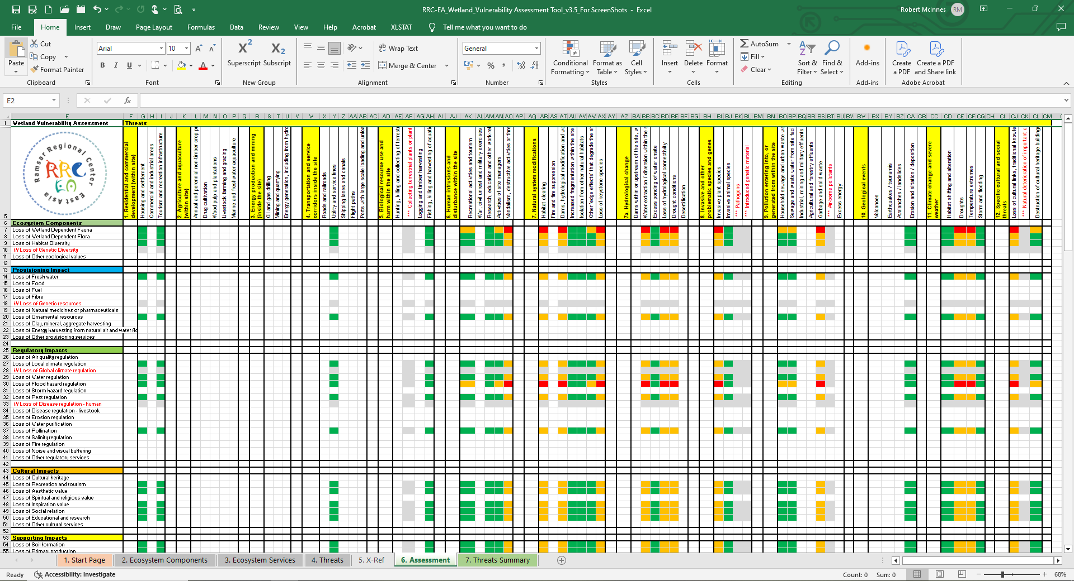

**Figure 20. An example (partial) of Worksheet 6 - Assessment.**

## Worksheet 7. Threats Summary

In addition to the overall assessment presented in Worksheet 6, the assessment information is summarised automatically by WETVAT by using an algorithm that combines the intensity of all of the threats in Worksheet 7 (Figure 21). The various threats are summarised so that the overall threat impact to the wetland is expressed as high (red cells), medium (amber cells) or low (green cells). If the threat is not understood to be present ‘None’ is automatically displayed in the cell. If there is insufficient information or the status of the threat cannot be evaluated, ‘Unknown’ is displayed. To reduce the subjectivity of the assessment, the overall confidence in the evaluation of the threats is also generated automatically. High confidence in the evaluation is highlighted as a green cell, with medium confidence being displayed in amber and low confidence in red.

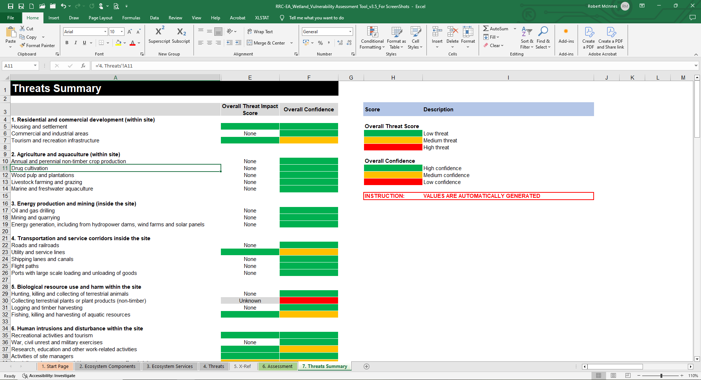

**Figure 21. An example (partial) of Worksheet 7 – Threats Summary.**

1. The tool in Excel format can be downloaded at: <https://www.ramsar.org/document/wetvat-vulnerability-assessment-tool-v35>.