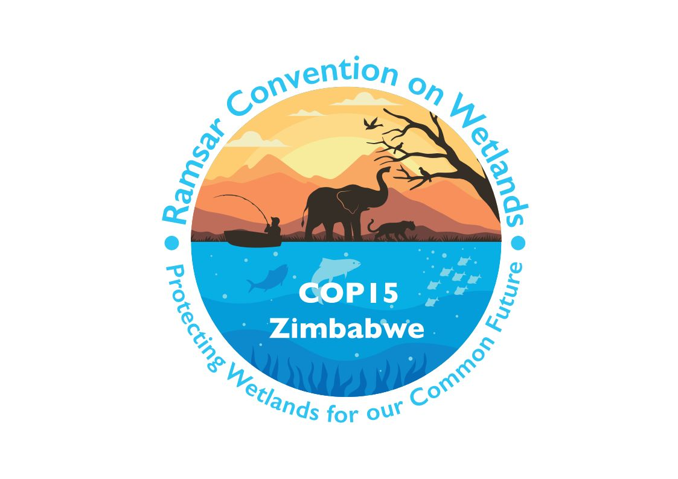

15th meeting of the Conference of the Contracting Parties

to the Convention on Wetlands

“Protecting wetlands for our common future”

Victoria Falls, Zimbabwe, 23-31 July 2025

COP15 Doc.20.2

Wetland City Accreditation:
Report of the Independent Advisory Committee on the implementation progress and financing of the Wetland City Accreditation

Background

1. In Resolution XIV.10 on Updating the Wetland City Accreditation of the Convention, the Conference of the Contracting Parties requested a review of the implementation progress and financing of the voluntary Wetland City Accreditation system to be reported to each meeting of the Conference of the Contracting Parties (COP).

Intersessional work of the Independent Advisory Committee

2. The third term of the Independent Advisory Committee (IAC) commenced in November 2022 for the period until the end of COP15. The list of the IAC members can be found in Annex 1 of the present report. In this triennium, the IAC had 14 meetings (three face-to-face and 11 virtual) to develop the Operational Guidance; prepare two Roundtables of Wetland City Mayors; coordinate the processes for the call for applications, evaluation of nomination forms and renewal forms, and renewal; draft progress reports for the 64th meeting of the Standing Committee (SC64) and COP15; and discuss how to improve the effectiveness and efficiency of the operation of the accreditation system among others. The list of meetings and their agendas can be found in Annex 2 of the present document.

Evaluation process and result

3. In accordance with Resolution XIV.10 on Updating the Wetland City Accreditation of the Convention, the Secretariat launched, on 1 June 2023, the call for applications to the third edition of the Wetland City Accreditation and at the same time invited cities accredited in 2018 to apply to renew their accredited status. The initial deadline for both new and renewed accreditation was 30 November 2023, which was later extended to 29 February 2024 by the IAC in consideration of requests from Contracting Parties.

4. A total of 32 applications for new accreditation and 18 applications for renewed accreditation were received by the Secretariat by 29 February 2024 and forwarded to the IAC on 14 March 2024.

5. Each new application was evaluated by at least two IAC members to ensure objective evaluation. In order to avoid any potential conflict of interest in the evaluation process, IAC members did not review any applications from a country where they are from or currently residing.

6. Language capacity was also considered for the allocation, as there were two new applications in Spanish, and five new applications and five renewal applications in French, to be evaluated by two Spanish-speaking members and three French-speaking members. No potential conflicts of interest were identified with this allocation, but the limited capacity of the IAC in French and Spanish could pose a challenge in future.

7. As a result, the IAC decided that 31 cities would be newly accredited and all 18 Wetland Cities originally accredited in 2018 would be renewed. These outcomes were announced at SC64 in January 2025. The 31 newly accredited cities are invited to attend the certificate awarding ceremony at COP15 in July 2025.

Revision of the Operational Guidance

8. During the current triennium, the IAC members identified areas for technical improvement in different sections of the Operational Guidance for the Wetland City Accreditation. These sections include the guidance notes, evaluation process, renewal process, nomination form, evaluation form and renewal form. The IAC is working to improve the clarity in these sections and will submit the revised version of the document to the Standing Committee for its endorsement intersessionally so that the revised version is available in time for the next call for applications, which is expected in January 2026, in accordance with the schedule for administration processes in Resolution XIV.10.

Promotion of the Wetland City Accreditation

9. In addition to the regular work of the IAC in accordance with its terms of reference, IAC members have also been engaged in a number of events to promote the Wetland City Accreditation during this triennium.

10. A working group consisting of Ramsar France, MedWet and members of the IAC has been created to promote the Wetland City scheme in the wider Mediterranean region. The group is also planning a webinar to recruit new wetland cities in the South and East of the Mediterranean, which is currently under-represented. MedWet regularly promotes the initiative actively through its CEPA programme.

11. In November 2022, the 15th Pan-African Ornithological Congress (PAOC15) was held at which an IAC member presented “the Ramsar Wetland City Accreditation scheme: Promoting City Engagement and Visibility on Wetland Conservation”, followed by another IAC member representing Africa. A focus was made on the potential and value of applying for the Wetland City Accreditation by the time of COP15, for African Cities in general and for Zimbabwean Cities in particular.

12. In May 2023, ICLEI hosted a session on Wetlands of International Importance Across Africa and Benefits for African Cities at Rise Africa’s Action Festival, at which two other IAC members participated as speakers to introduce the Wetland City Accreditation and the Wetland City Network.

13. In February 2024, at the “Conferencia internacional sobre conservación y gestión de humedales frente al cambio climático” (International Conference on Wetland Conservation and Management in the Face of Climate Change) in Valencia, the first Wetland City in Spain, an IAC member was invited to talk about the social dimension of conservation. He explained to the audience about the Wetland City Accreditation scheme, the Wetland City Network and the Roundtables of Wetland City Mayors.

14. In May 2024, Amiens, one of the first accredited French Wetland Cities, hosted a webinar on Wetland City Accreditation, in which IAC members participated as speakers to further promote the Wetland City Accreditation and several accredited Wetland Cities shared their testimonies on the benefits from the Wetland City Network.

15. Also in May 2024, the Wildfowl & Wetlands Trust (WWT) organized the webinar “Wetlands Convention 101”, in which IAC members participated as speakers to provide an introduction to the Wetland City Accreditation, as one of the key initiatives of the Convention.

16. In February 2025, the Wetland City for Latin America and the Caribbean (LAC) website was launched (https://www.ciudadhumedal.org/en/home/), under the coordination of the IAC member representing the LAC region. The project was funded by the Alexander von Humboldt Stiftung, and it was developed in collaboration with WWT and the Ministry of Environment and Sustainable Development of Colombia, in coordination of the Secretariat of the Convention on Wetlands. The website hosts six webinars (https://lnkd.in/dEP3x3rb) and five infographics, and showcases eight case studies. All materials are available in Spanish and English. The website launch was announced on the Convention on Wetlands’ social media channels on 5 February. LinkedIn posts by supporters (in English and Spanish) have reached about 10,000 impressions.

17. Also in February 2025, the IAC member representing the LAC region introduced the Wetland City Accreditation scheme at the symposium “Reconnecting with the urban wetlands of today and the future”, co-organized and co-hosted by the National Institute of Biodiversity of Colombia “Alexander von Humboldt” and Javeriana University. The symposium was part of a comprehensive strategy implemented by these organisations to commemorate World Wetlands Day, involving the engagement of academia, research centres, urban collectives and NGOs, and also including excursions to urban wetlands in the city of Bogotá.

18. Also in February 2025, the Ministry of Environment and Sustainable Development of Colombia hosted the Webinar “Cartagena, Wetland City” in collaboration with four local and regional environmental organizations of Cartagena City and María Angélica Mejía, the IAC member representing the LAC region. The webinar recording on YouTube had reached over 350 views by the time this report was drafted.

19. On 22 May 2025, in the framework of the International Day for Biological Diversity (IDB) on the theme “Harmony with Nature and Sustainable Development”, the ICLEI Center for Biodiversity of Cities and the Wetland City Initiative for Latin America and the Caribbean will co-organize and co-host a webinar to promote and raise awareness of the value of wetlands to create more biodiverse and resilient cities. The session will also introduce and promote the Wetland City Accreditation scheme and available platforms that support cities in meeting the objectives of such accreditation, the Wetland City Network and CitiesWithNature. The session will mainly address cities and subnational governments of the LAC region to encourage more cities from this region to participate in the Wetland City Accreditation scheme and protect their wetlands. Speakers will include representatives from Valdivia (Chile) and Trelew (Argentina), newly accredited Wetland Cities from the LAC region.

Impact of the Wetland City Accreditation

Wetland City Network

20. The Wetland City Network regained its momentum in this triennium after two years of quiescence due to the COVID-19 pandemic. The RRC-EA, as the Secretariat of this Network, has developed a dedicated website for the Network (www.wetlandcity.org), which introduces each Wetland City and shares documents produced from this Network. The second and third Roundtables of Wetland City Mayors (RWCM) were held in this triennium, at which the Wetland Cities share their experiences and best practices and discuss how the Wetland Cities can work together.

21. The second RWCM was hosted by Amiens, France in June 2023, where the Mayors revisited the Terms of Reference of the Wetland City Network and endorsed the Wetland City Network Strategic Plan 2022-2028. The third RWCM was hosted by Dongying, China, where the Mayors endorsed the Dongying Declaration for strengthened cooperation among Wetland Cities, the Wetland City Network Action Plan 2025-2028, and the 2024 Wetland City Youth Forum Declaration. The Wetland City Network will expand as the 31 newly accredited Wetland Cities have been invited to join the Network. The fourth RWCM will be hosted by Tata, Hungary in November 2025, and the fifth RWCN will be hosted by Niigata, Japan in 2026.

Enhanced efforts by accredited Wetland Cities

22. At the RWCMs, Wetland Cities demonstrated that since the accreditation they have received increased support by their national government as well as the public to their efforts to conserve and restore their wetlands. As a result, the importance of wetlands is further promoted in urban planning, research, education, and everyday life. Some notable examples are: development of enhanced master plans for wetland conservation; relocation of key urban infrastructure potentially harmful to the wetlands further away; and designating and operating “wetland schools” that develop wetland programmes within their formal curriculum; and establishing “wetland school networks” where schools work together to train teachers, develop programmes and exchange experience and successful cases. Many Wetland Cities have achieved further improved wetland management effectiveness, further raised public awareness and more enriched biodiversity in and around their wetlands since the accreditation.

Financial and in-kind contributions

23. The IAC considers with great appreciation all the work done by its members, either as representatives of Contracting Parties and other organizations or individuals, as an in-kind contribution.

24. The Ramsar Regional Center–East Asia, as a member of the IAC, has provided financial and in-kind support (approximately CHF 208,000) for activities of the IAC as well as events related to the Wetland City Accreditation at COP15. The RRC-EA also provides the Secretariat service to the Wetland City Network, which has been vital to the activities of the Network including the Roundtables of Wetland City Mayors.

Annex 1
List of Independent Advisory Committee members (2023-2025)

No. | Composition | Individual Representatives
1 | Africa: Rwanda  (Alternate: Botswana) | Theogene Ngaboyamahina
2 |  | Jobe Manga
3 | Asia: China  (Alternate: Iran) | Xinxin Hu, Cai Lyu
4 |  | Amir Akhlaghi
5 | Europe: Czechia | Libuše Vlasáková (Chair)
6 | Latin America and the Caribbean: Colombia | María Angélica Mejía Pimienta
7 | North America: USA | Lauren Kasparek
8 | Oceania: Australia | Ariana Magini→Dylan Jones
9 | International Organization Partners: WWF | Wenwei Ren
10 | UN-Habitat | Andrew Rudd
11 | ICLEI | Ingrid Coetzee, Laura Louw
12 | Scientific and Technical Review Panel | Matthew Simpson
13 | Communication, capacity building, education, participation and awareness (CEPA) Oversight Panel | Chris Rostron
14 | Ramsar Regional Initiatives: Ramsar Regional Center–East Asia | Seung Oh Suh
15 | The Secretary General of the Convention or his/her designated representative (observer) | Zebedee Njisuh
16 | Technical Advisors | Denis Landenbergue
17 |  | Gert Michael Steiner
18 |  | Joon-woo Seo (Co-Chair)

Annex 2
List of meetings of the Independent Advisory Committee (2023-2025)

IAC meeting 16 (virtual)

Date: 10 February 2023
Chair: Michael Steiner
Co-chair: Ernita van Wyk
Agenda:
1. Welcome
2. ICLEI update & IAC minutes
3. Status of the Operational Guidelines
4. Update: Mayoral network meeting in June (Amiens, France)
5. Date and prep for SC62, including IAC constitution (3rd triennium)
6. Other matters: WCA at UN Water Conference (22-24 March 2023)
7. Next IAC meeting

IAC meeting 17 (virtual)

Date: 17 March 2023
Chair: Michael Steiner
Co-chair: Ernita van Wyk
Agenda:
1. Welcome by co-chair Dr Ernita van Wyk
2. Release of the Call for Applications
3. Operational Guidance: Group B
4. RRC-EA update Mayoral Roundtable meeting
5. Logistics for IAC and 2nd Roundtable for Wetland City Mayors
6. Profiling WCA, UN Water Conference and Rise Africa

IAC meeting 18 (virtual)

Date: 28 April 2023
Chair: Michael Steiner
Co-chair: Ernita van Wyk
Agenda:
1. Opening of the meeting by the Chair
2. Update on the 2nd Roundtable for Wetland City Mayors
3. IAC meeting 7 June, Amiens, France
4. IAC report to the SC
5. Update on the WCA Call for Applications
6. Other matters

IAC meeting 19 (virtual)

Date: 28 April 2023
Chair: Michael Steiner
Co-chair: Ernita van Wyk
Agenda:
1. Opening of the meeting by the Chair Michael Steiner
2. Update on the 2nd Roundtable for Wetland City Mayors
3. Communication and knowledge management
4. IAC meeting 7 June in Amiens, France
5. IAC report to the SC62
6. Update on the WCA call for applications
7. Other matters

IAC meeting 20 (face-to-face)

Date: 7 June 2023
Venue: Amiens, France
Chair: Michael Steiner
Co-chair: Laura Louw
Agenda:
1. Opening
2. Presentation on brief history and recent updates for new members
3. Composition of the new IAC
4. Terms of Reference of the IAC
5. Other matters

IAC meeting 21 (virtual)

Date: 27 June 2023
Chair: Michael Steiner
Co-chair: Laura Louw
Agenda:
1. Opening of the meeting by the Chair
2. Introduction of new members for 2023-2025
3. Reflections on Amiens and matters arising
4. Preparation for the upcoming SC62
5. WCA Operational Guidance
6. Information/publication on the benefits of WCA
7. Other matters

IAC meeting 22 (virtual)
Date: 12 September 2023
Chair: Michael Steiner (outgoing), Libuše Vlasáková (incoming)
Co-chair: Laura Louw (outgoing), Joon-woo Seo (incoming)
Agenda:
1. Introduction of new IAC members
2. Feedback from the 62nd Standing Committee meeting
3. Nomination of the Chair and Co-chair and the next steps
4. Convention on Wetlands 5th Strategic Plan online survey
5. Other issues

IAC meeting 23 (virtual)

Date: 24 October 2023
Chair: Libuše Vlasáková
Co-chair: Joon-woo Seo
Rapporteur: Ga-on Lee (RRC-EA)
Agenda:
1. Introduction of the WCA for new members,
2. Appointment of Rapporteur
3. Review of timeline and work plan for triennium 2023-2025
4. Consideration of extending the deadline for the new and renewed accreditation
5. Other matters
6. Next meeting

IAC meeting 24 (virtual)

Date: 4 April 2024
Chair: Libuše Vlasáková
Co-chair: Joon-woo Seo
Rapporteur: Ga-on Lee (RRC-EA)
Agenda:
1. Opening and catching-up
2. Updates on applications and allocation of evaluation work
3. Next steps: evaluation, IAC meeting in Dongying, Report to SC63
4. The 3rd Roundtable of Wetland City Mayors
5. Other matters

IAC meeting 25 (virtual)

Date: 25 July 2024
Chair: Libuše Vlasáková
Co-chair: Joon-woo Seo
Rapporteur: Ga-on Lee (RRC-EA)
Agenda:
1. Planned hybrid IAC meeting
2. Updates on MRT-2024 preparations
3. Roles of IAC members at MRT-2024
4. Logistical arrangements for hybrid IAC meeting and MRT-2024
5. Other matters

IAC meeting 26 (virtual)

Date: 23 August 2024
Chair: Libuše Vlasáková
Co-chair: Joon-woo Seo
Rapporteur: Ga-on Lee (RRC-EA)
Agenda:
1. Evaluation progress
2. Draft report to SC64
3. IAC meeting in Dongying (agendas, time, modality)
4. Further updates on the Roundtable for Wetland City Mayors
5. Other matters

IAC meeting 27 (face-to-face)

Date: 14 October 2024
Venue: Dongying, China
Chair: Libuše Vlasáková
Co-chair: Joon-woo Seo
Rapporteur: Ga-on Lee (RRC-EA)
Agenda:
1. Opening
2. Adoption of the provisional agenda and programme
3. Admission of observers
4. Road to SC64 and COP15
5. Report to COP15
6. Evaluation process (closed session)
7. Renewal process (closed session)
8. Further work and possible timeline
9. Other issues and updates
10. Closing
IAC meeting 28 (virtual)

Date: 5 March 2025
Chair: Libuše Vlasáková
Co-chair: Joon-woo Seo
Agenda:
1. The Certificate Awarding Ceremony for newly accredited Wetland Cities
2. Other events for Wetland Cities during COP15
3. Other matters

IAC meeting 29 (face-to-face)

Date: 23-26 April 2025
Venue: Trebon, Czechia
Chair: Libuše Vlasáková
Co-chair: Joon-woo Seo
Rapporteur: Ga-on Lee (RRC-EA)
Agenda:
1. Opening
2. Adoption of the provisional agenda and programme
3. Admission of observers
4. Review of the Operational Guidance
a) Guidance notes
b) Nomination form
c) Evaluation form
d) Renewal form
e) Other sections
5. IAC report to COP15
6. COP15 preparations: Certificate Awarding Ceremony, other WCA-related events
7. Other matters
8. Closing

