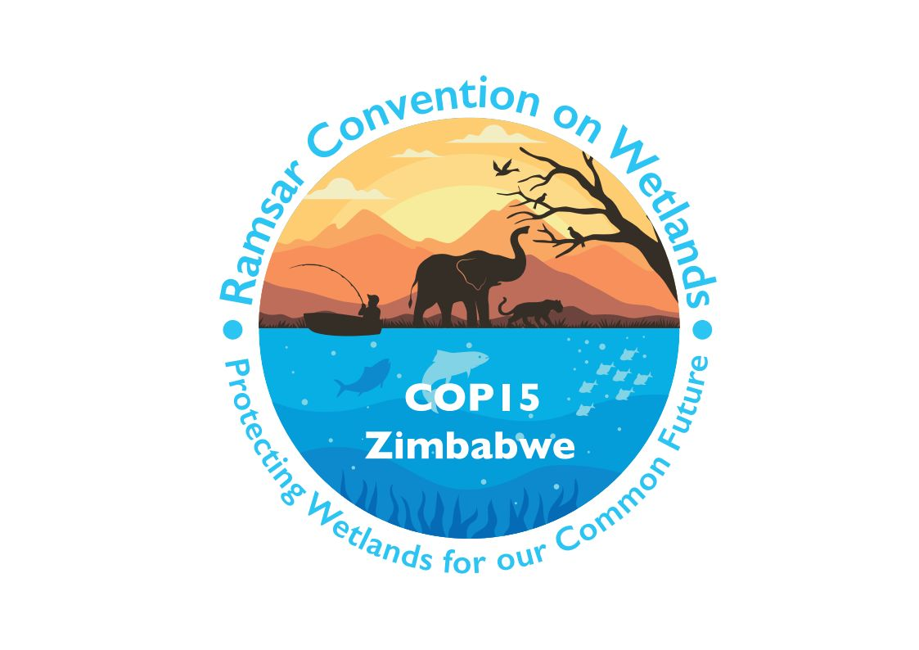

15th meeting of the Conference of the Contracting Parties

to the Convention on Wetlands

“Protecting wetlands for our common future”

Victoria Falls, Zimbabwe, 23-31 July 2025

COP15 Doc.12

Report of the Secretariat on the Ramsar Regional Initiatives

Background

1. The Conference of the Contracting Parties at its 14th meeting (COP14, 2022), in paragraph 1 of Resolution XIV.7 Part A on Ramsar Regional Initiatives, recalled that Ramsar Regional Initiatives (RRIs) “which include regional centres for training and capacity building and regional networks to facilitate cooperation, are intended as an operational means to provide effective support for improved implementation of the Convention in specific geographic regions, through voluntary international cooperation on wetland-related issues of common concern”.

2. The present report is submitted in response to the instruction in paragraph 14 of Resolution XIV.7 Part A which “instructs the Secretariat to provide the COP and Standing Committee a summary of the information obtained from the annual reports to assist these bodies in their reviews of RRIs and decisions regarding funding”.

3. During the 2023-2025 triennium, the Secretariat submitted annual reports on Ramsar Regional Initiatives to the Standing Committee at its 62nd, 63rd and 65th meetings. The present report provides a summary of those three reports for consideration at COP15.

List of Ramsar Regional Initiatives endorsed in the COP14-COP15 intersessional period

4. Within the 2023-2025 triennium, 22 RRIs were endorsed by the COP or the Standing Committee as operating within the framework of the Convention. They include two new Ramsar Regional Initiatives, the International Mangrove Centre (IMC) and the Danube WILDisland Ramsar Regional Initiative (DWRRI), established through Standing Committee Decisions SC62-22 and SC63-19, respectively. A list of RRIs proposed for endorsement for the COP15-COP16 intersessional period is contained in the draft resolution on Ramsar Regional Initiatives in document COP15 Doc.23.5.

Progress of the Ramsar Regional Initiatives in the Triennium 2023-2025

5. RRIs are requested under the Operational Guidelines for Ramsar Regional Initiatives in Annex 1 of Resolution XIV.7 Part A to submit to the Standing Committee, through the Secretariat, annual financial and progress reports regarding the implementation of their workplan. These reports are instrumental in assessing the scope, effectiveness, and impact of RRI activities across various regions, as well as in identifying areas in which the Secretariat can provide additional support.

6. The volume and scale of RRI activities have expanded during the 2023-2025 triennium. The total estimated expenditure by RRIs in 2024 was CHF 3.9 million, reflecting an upward trend from CHF 2.7 million in 2022 and CHF 3.4 million in 2023.

7. Based on the reports received, RRIs have contributed significantly to regional cooperation among Contracting Parties, including:

- The convening of at least one coordination meeting by most RRIs;
- The organization or support of communication, capacity building, education, participation and awareness (CEPA) activities, including the celebration of World Wetlands Day;
- The conduct of regional policy assessments on themes such as climate change, invasive species, and management of Wetlands of International Importance; and
- Engagement in resource mobilization through the development of funding proposals and the establishment of sustainable financing platforms.

8. Challenges commonly reported by RRIs include limited financial resources and constraints in coordination among participating countries.

9. While some RRIs have shown notable growth, others have encountered difficulties in sustaining operations. This has resulted in a growing number of RRIs failing to submit their annual reports. The table below identifies the RRIs that did not submit reports during one or more reporting years in the current triennium.

Table 1: Ramsar Regional Initiatives that have not submitted a report, 2022-2025
Reporting period | 2022-2023 | 2023-2024 | 2024-2025
BlackSeaWet | X
CariWet |  | X | X
High Andean Wetlands |  | X | X
La Plata RRI |  |  | X
Mangrove & Coral Reefs |  | X | X
NigerWet |  |  | X
SenegalWet | X | X | X
WACoWet | X |  | X

Allocation of Convention core budget funds for new RRIs

10. In paragraph 17 of Resolution XIV.7 Part A, the Conference of the Parties notes that “RRIs that have been endorsed as operating within the framework of the Convention are eligible for start-up financial support from the core budget of the Convention” and recommends that “the start-up financial support is to be provided for up to six years, according to decisions on budgetary matters”.

11. In the current triennium, three newly endorsed RRIs, namely, the Southern African Ramsar Regional Initiative (SARRI), the International Mangrove Centre (IMC) and the Danube WILDisland RRI (DWRRI), have become eligible for such support. The IMC has, however, declined to receive financial assistance from the Convention’s core budget.

Promoting cooperation between RRIs

12. Recognizing the importance of shared learning and collaboration, particularly with respect to addressing challenges related to coordination and resource mobilization, the Secretariat has actively encouraged RRIs to engage in mutual exchange of experience and best practices.

13. During the present triennium, the Secretariat facilitated three virtual annual planning meetings for RRIs. These meetings enabled participating Initiatives to present their planned activities, identify areas of potential collaboration, and coordinate joint efforts. As a result, inter-RRI cooperation has expanded, including joint organization of a common exhibition booth and a side event involving multiple RRIs at COP15.

See https://www.ramsar.org/document/sc62-doc25-rev1-report-secretariat-ramsar-regional-initiatives; https://www.ramsar.org/document/sc63-doc25-report-secretariat-ramsar-regional-initiatives; and https://www.ramsar.org/document/sc65-doc9-report-secretariat-ramsar-regional-initiatives-2024-2025.
See https://www.ramsar.org/document/cop15-doc235-draft-resolution-ramsar-regional-initiatives-2025-2028.
Based on annual actual expenditure reported by RRIs (for those reported in a currency other than CHF, the annual average exchange rate for 2022 was applied).

