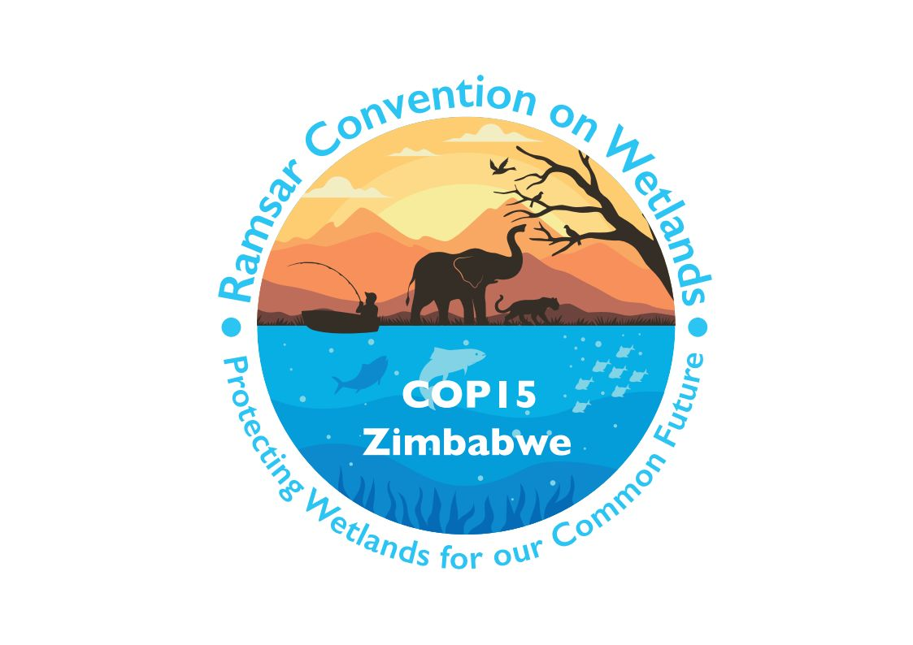

**15th meeting of the Conference of the Contracting Parties**

**to the Convention on Wetlands**

**“Protecting wetlands for our common future”**

**Victoria Falls, Zimbabwe, 23-31 July 2025**

**COP15 Doc.3.1 Rev.1**

**Provisional agenda**

|  |  |  |  |
| --- | --- | --- | --- |
|  | **Agenda item** | | **Document** |
| 1. | Opening of the meeting | |  |
| 1.1 | Opening statements | No document |
| **Procedural matters** | | | |
| 2. | Election of the President and Vice-Presidents and remarks by the President | | No document |
| 3. | Adoption of the provisional agenda and working programme | |  |
| 3.1 | Provisional agenda | COP15 Doc.3.1 |
| 3.2 | Provisional working programme | COP15 Doc.3.2 |
| 4. | Adoption of the Rules of Procedure | | COP15 Doc.4 |
| 5. | Appointment of the Credentials Committee and any other committees | | No document |
| 6. | Admission of observers | | COP15 Doc.6 |
| **Administrative matters** | | | |
| 7. | Report of the Chair of the Standing Committee | | COP15 Doc.7 |
| 8. | Report of the Secretary General on the implementation of the Convention | |  |
| 8.1 | Global implementation | COP15 Doc.8.1 |
| 8.2 | Work of the Secretariat | COP15 Doc.8.2 |
| 9. | Report of the Secretariat pursuant to Article 8.2 on the List of Wetlands of International Importance | | COP15 Doc.9 |
| 10. | Report of the Chair of the CEPA[1] Oversight Panel on implementation of the CEPA Programme 2016-2024 | | COP15 Doc.10 |
| 11. | Report of the Chair of the Scientific and Technical Review Panel (STRP) | | COP15 Doc.11 |
| 12. | Report of the Secretariat on the Ramsar Regional Initiatives | | COP15 Doc.12 |
| 13. | Report of the Secretariat on enhancing decision-making procedures and maintaining effective operation of the Convention during exceptional circumstances[2] | | COP15 Doc.13 |
| 14. | Report of the Secretariat on assessment of progress on wetland restoration[3] | | COP15 Doc.14 |
| 15. | Report of the Secretariat on opportunities to further strengthen the Convention’s contribution to the 2030 Sustainable Development Agenda and Sustainable Development Goals[4] | | COP15 Doc.15 |
| 16. | Report of the Secretariat on the implementation of Resolution XIV.20 | | COP15 Doc.16 |
| 17. | Report of the Secretariat on administrative and financial implications of draft resolutions | | COP15 Doc.17 |
| 18. | Financial report for 2023-2025 of the Chair of the Subgroup on Finance of the Standing Committee, and proposed budget for the 2026-2028 triennium | | COP15 Doc.18 |
| 19. | Election of Contracting Parties to the Standing Committee for 2025-2028 | | No document |
| 20. | Wetland City Accreditation | |  |
| 20.1 | Presentation of certificates | No document |
| 20.2 | Report of the Independent Advisory Committee on the implementation progress and financing of the Wetland City Accreditation | COP15 Doc.20.2 |
| 21. | Presentation of the Ramsar Wetland Conservation Award winners | | No document |
| **Draft resolutions** | | | |
| 22. | Consolidation of existing Resolutions | |  |
| 22.1 | Consolidated Resolution on assessment of wetland values and services | COP15 Doc.22.1 |
| 22.2 | Consolidated Resolution on water, water-related and water-management-related matters | COP15 Doc.22.2 |
| 22.3 | Consolidated Resolution on inventories | COP15 Doc.22.3 |
| 23. | Consideration of the draft resolutions and recommendations submitted by Contracting Parties and the Standing Committee | |  |
| 23.1 | Draft resolution on financial and budgetary matters | COP15 Doc.23.1 |
| 23.2 | Draft resolution on the responsibilities, roles and composition of the Standing Committee and regional categorization of countries under the Convention on Wetlands | COP15 Doc.23.2 |
| 23.3 | Draft resolution on the Strategic Plan of the Convention on Wetlands 2025-2034 | COP15 Doc.23.3 |
| 23.4 | Draft resolution on enhancing the Convention’s visibility and synergies with other multilateral environmental agreements and other international institutions | COP15 Doc.23.4 |
| 23.5 | Draft resolution on Ramsar Regional Initiatives 2025-2028 | COP15 Doc.23.5 |
| 23.6 | Draft resolution on CEPA | COP15 Doc.23.6 |
| 23.7 | Draft resolution on the status of Sites in the List of Wetlands of International Importance | COP15 Doc.23.7 |
| 23.8 | Draft resolution on the process for recruiting a new Secretary General | COP15 Doc.23.8 |
| 23.9 | Draft resolution on implementing the institutional strengthening of the Convention on Wetlands | COP15 Doc.23.9 |
| 23.10 | Draft resolution on future implementation of scientific and technical aspects of the Convention 2025-2028 | COP15 Doc.23.10 |
| 23.11 | Draft resolution on establishment of the Waterbird Estimates Partnership and delivery of the 2027 edition of Waterbird Population Estimates | COP15 Doc.23.11 |
| 23.12 | Draft resolution on application of Criteria 6 and 9 to new and existing Wetlands of International Importance | COP15 Doc.23.12 |
| 23.13 | Draft resolution on [updates to] Ramsar Information Sheets | COP15 Doc.23.13 |
| 23.14 | Draft resolution on strengthening action on culture and wetlands | COP15 Doc.23.14 |
| 23.15 | Draft resolution on restoration of degraded freshwater ecosystems to support ecological character biodiversity and ecosystem services | COP15 Doc.23.15 |
| 23.16 | Draft resolution on strengthening national actions for the conservation and restoration of [waterbird flyways] [critical waterbird flyway sites] | COP15 Doc.23.16 |
| 23.17 | Draft resolution on promoting incorporation of new technology and traditional knowledge in wetland conservation, restoration, management, and wise use | COP15 Doc.23.17 |
| 23.18 | Draft resolution on achieving the equitable governance  and effective conservation of wetlands as protected areas and other effective area-based conservation measures (OECMs) | COP15 Doc.23.18 |
| 23.19 | Draft resolution on youth empowerment and integration: driving engagement in and the longevity of the Convention on Wetlands | COP15 Doc.23.19 |
| 23.20 | Draft resolution on promoting sustainable lifestyles for the wise use of wetlands | COP15 Doc.23.20 |
| 23.21 | Draft resolution on recognition of river dolphins as key species for the conservation and sustainable use of wetlands in South America and Asia | COP15 Doc.23.21 |
| 23.22 | Draft resolution on education and participation as a basis for the management of urban and peri-urban wetlands | COP15 Doc.23.22 |
| 23.23 | Draft resolution on assessing pressures on and risks to wetlands | COP15 Doc.23.23 |
| 23.24 | Amended draft resolution on the Ramsar List[5] | COP15 Doc.23.24 |
| 23.25 | Draft resolution on thanks to the host country, the Republic of Zimbabwe | COP15 Doc.23.25 |
| **Procedural matters** | | | |
| 24. | Report of the Credentials Committee | | COP15 Doc.24 |
| 25. | Date and venue of the next ordinary meeting of the Conference of the Contracting Parties | | No document |
| 26. | Any other business | | No document |
| 27. | Adoption of the report of the 15th meeting of the Conference of the Contracting Parties | | No document |
| 28. | Close of the meeting | | No document |

1. CEPA: Communication, capacity building, education, participation and awareness.
2. Pursuant to [Resolution XIV.3, paragraph 15](https://www.ramsar.org/document/resolution-xiv3-effectiveness-efficiency-convention-wetlands).
3. Pursuant to [Resolution XIV.6, paragraph 35](https://www.ramsar.org/document/resolution-xiv6-enhancing-conventions-visibility-synergies-other-multilateral).
4. Pursuant to [Resolution XIV.6, paragraph 24](https://www.ramsar.org/document/resolution-xiv6-enhancing-conventions-visibility-synergies-other-multilateral).
5. Presented to COP14 as document COP14 Doc.18.16 Rev.1, and deferred to COP15 for its consideration.