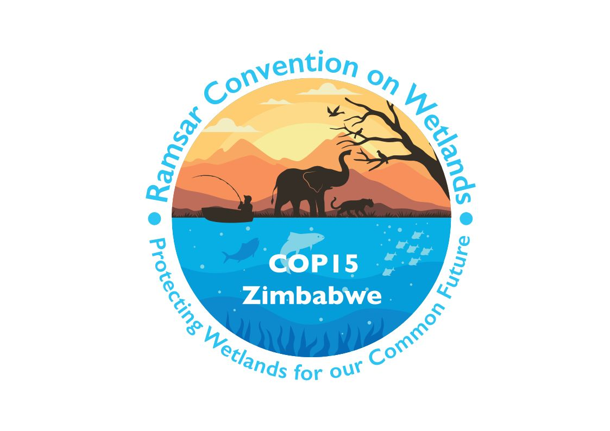

15th meeting of the Conference of the Contracting Parties

to the Convention on Wetlands

“Protecting wetlands for our common future”

Victoria Falls, Zimbabwe, 23-31 July 2025

COP15 Inf.1

Information document to support the 2026-2028 increase in the Secretariat core budget presented in document COP15 Doc.23.1

1. At the request of the Subgroup on Finance and the Contracting Parties, the Secretariat has prepared this information document which provides the rationale for the core budget increases included in the budget scenarios presented in the draft resolution on financial and budgetary matters (document COP15 Doc.23.1).

2. The core budget of the Secretariat has remained unchanged at CHF 5,081,000 per year since 2013, despite the growing number of deliverables mandated by Contracting Parties through Resolutions and the impacts of inflation. Examples of this increase in deliverables are presented in the graphs below:

Summary of the four scenarios presented

3. Through Decision SC64-41 ii), the Standing Committee approved four 2026-2028 budget scenarios to be presented to COP15 for consideration. These scenarios have been recommended by the Subgroup on Finance following extensive discussions on the costs, benefits and strategic implications. Through Decision SC64-41 iii), the Standing Committee requested that the Secretariat prepare a narrative and quantitative analysis explaining the respective costs and benefits, as well as policy implications for each scenario. Table 1 below summarizes the features of the four scenarios, while Table 2 below provides an overview of main implications of each scenario.

4. Under the 0% increase scenario, some partial existing staff costs have been increased to meet the equity with the IUCN as per the IUCN HR recommendations. However, it does not include cost-of-labour adjustments, or performance and promotions. Staff capacity building and COP16 operational services are also excluded from this scenario. Some budget lines have been adjusted to compensate the partial equity adjustments, reflecting actual expenditure in the 2023-2025 triennium.

5. Under the 4.1% increase scenario, some partial existing staff costs have been increased to meet equity with IUCN within the IUCN HR recommendations, as proposed for the 0% scenario, in addition to a cost-of-labour adjustment, performance and promotions. Within this scenario one new position has been included. The Secretary General would decide how this new position would be best utilised in support to the Contracting Parties. Staff capacity building and COP16 operational services are excluded from this scenario. As under the 0% scenario, some budget lines have been adjusted to compensate the staff partial equity, costs of labour, performance and promotion adjustments, reflecting actual expenditure in the 2023-2025 triennium.

6. Under the 9.6% increase scenario, the level of core funding for staffing has been increased, including for two new positions, as explained in paragraphs 11 and 12. Staff salaries for all staff are adjusted to meet the equity with the IUCN salaries and include a cost-of-labour adjustment, performance and promotions in line with the IUCN Human Resources policies on global compensation, performance and development. Staff capacity building and COP16 operational services are excluded from this scenario. Some budget lines have been adjusted to compensate the partial equity adjustments, reflecting actual expenditure in the 2023-2025 triennium.

7. The 11.3% increase scenario includes all adjustments as presented under scenario 9.6%, and includes an annual allocation for Secretariat planning and staff capacity building, to enable the Secretariat staff to deliver on activities requested by the Contracting Parties, and to promote their overall wellbeing. Additionally, this scenario also features an allocation in year 2028 for costs associated with the provision of services related to COP16 (interpretation, translation, report writing and other support services).

8. All scenarios assume approval of the use of 2024 surplus for provisions for outstanding contributions.

The proposed increases in the scenarios address the following areas:

Strengthening the Secretariat’s ability to recruit and retain qualified staff

9. The Working Group on Institutional Strengthening has identified recruitment of staff and reduction of staff turnover as critical institutional challenges. The findings of the Working Group as presented in SC62 Doc.11 included that Secretariat staff compensation is not in alignment with the IUCN compensation framework and therefore is not competitive in comparison to IUCN and the UN system. A core budget increase will address the lack of competitiveness in staff compensation and will help to:

  - provide equity for Secretariat staff within the IUCN compensation framework and increase competitiveness with UN organizations; and
  - cover for cost-of-labour adjustments, performance and promotions in line with the IUCN Human Resources global compensation policies.

10. The COP13-approved budget for 2019-2021 included a provision to implement these adjustments. In the view of the Secretariat, it is important to embed these adjustments.

Meeting an increasing volume of deliverables and tasks mandated by Contracting Parties

11. Contracting Parties have requested that the Secretariat strengthen communications through increasing its outreach and visibility activities and supporting better implementation of CEPA (communication, capacity building, education, participation and advocacy). To meet this need, the Secretariat proposes a new Communications Officer position which will contribute to delivering:

    - development of content on wetlands and the Convention, increasing frequency and reach of news articles, thought leadership pieces, reports and briefings;
    - CEPA implementation (global and in support of Contracting Parties);
    - media outreach and content placement; and
    - promotion and dissemination of STRP products.

12. Contracting Parties have also expressed a need to strengthen the capacity of the Secretariat to support them in the completion of National Reports (NR), Ramsar Information Sheet (RIS) updates, and in the use of such data to enhance implementation of the Convention. To meet this need the Secretariat proposes a new Data Analyst / Reporting Officer position that will:

  - provide enhanced support to Contracting Parties in relation to reporting (NR and RIS updates) through training and guidance;
  - prevent build-up of a backlog of RIS under Secretariat review;
  - strengthen reporting on progress in implementation of the Convention based on NR and RIS updates;
  - enhance the utility of NR and RIS updates for other applications including work undertaken by the Scientific and Technical Review Panel;
  - strengthen support to Contracting Parties in relation to national wetland inventories and reporting on Sustainable Development Goal indicator 6.6.1; and
  - enhance process efficiency to enable the Secretariat to draw on available data for servicing subsidiary bodies and working groups and preparing documentation.

Table 1: Summary of implications of 2026-2028 budget scenarios presented to COP15
Scenario | New staff positions compared to prior triennia | Existing staff equity adjustments as per HR recommendation | Cost of labour adjustment | Performance and promotion adjustments | Capacity building for staff | COP16 operational services (not hosting)
0% | 0 | Partial | No | No | No | No
4.1% | 1 | Partial | Yes | Yes | No | No
9.6% | 2 | Full | Yes | Yes | No | No
11.3% | 2 | Full | Yes | Yes | Yes | Yes

Table 2: Overview of main implications of the budget 2026-2028 scenarios
Description | Scenario 0% nominal increase | Scenario 4.1%  nominal increase | Scenario 9.6% nominal increase | Scenario 11.3% nominal increase
Advantages and Strong Points | No increase in assessed contributions for Contracting Parties. | One additional staff member to increase Secretariat capacity to support Contracting Parties.  Some staff compensation equity adjustments possible which may result in enhancing staff retention. | Secretariat equipped to meet increased demands by the Contracting Parties.  Staff compensation fully in equity with the IUCN compensation framework.  Enhanced ability to recruit and retain qualified staff. | Secretariat fully equipped to meet increased demands by the Contracting Parties.  Staff compensation fully in equity with the IUCN compensation framework.  Available funds for staff capacity building.  Available funds for hosting of COP, lifting the financial burden from the hosting country.
Limitations and Challenges | Any additional activities funded by voluntary contributions.  Staff compensation not in equity with the IUCN compensation framework.  Risk of staff burnout if workload remains high resulting in potential decline in efficiency. | Limited capacity for staff professional development.  Staff compensation not in equity with the IUCN compensation framework. | n/a | n/a
Opportunities | Requires review with the Parties on activities that are no longer needed. | Limited increase in outreach and visibility of the Convention.  Limited increase in support to Contracting Parties in implementation matters. | Increased outreach and visibility of the Convention  Contracting Parties are more fully supported in relation to National Reports, Ramsar Information Sheet updates. Ability to leverage data and knowledge to enhance implementation of the Convention.  Greater Secretariat capacity to handle new tasks and activities to support Contracting Parties. | Increased outreach and visibility of the Convention  The Contracting Parties are more fully supported in relation to National Reports, Ramsar Information Sheet updates. Ability to leverage data and knowledge to enhance implementation of the Convention.  Staff competencies and skills are strengthened through capacity building.
Risks and Challenges | Limited ability in handling new tasks or activities.  Limited ability to raise the profile of the Convention and synergies with other multilateral environmental agreements.  Employee dissatisfaction and high turnover due to overwork.  Risk of declining service quality and productivity. | Challenge to fully meet Contracting Parties’ requests and expectations. | n/a | n/a

See the tables at Annex 1 of document COP15 Doc.23.1 for details of budget line adjustments.

