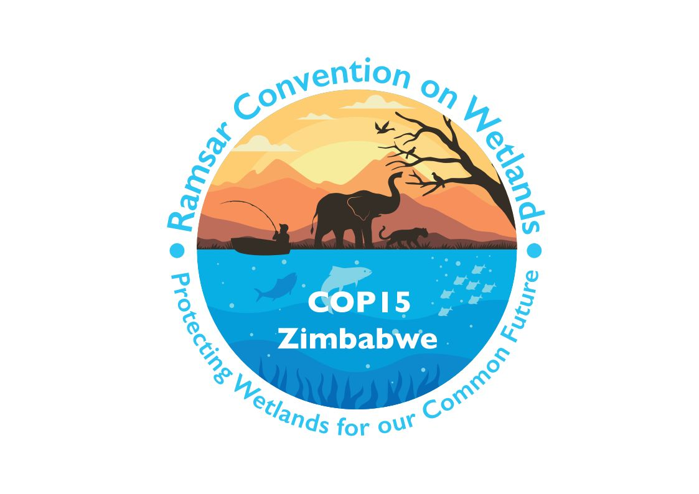

15th meeting of the Conference of the Contracting Parties

to the Convention on Wetlands

“Protecting wetlands for our common future”

Victoria Falls, Zimbabwe, 23-31 July 2025

COP15 Doc.7

Report of the Chair of the Standing Committee

Introduction

1. The Standing Committee of the Convention on Wetlands was established by Resolution 3.3 (Regina, 1987) to oversee Convention affairs and the activities of the Secretariat between ordinary meetings of the Conference of the Contracting Parties. The regional composition, functions, and responsibilities of the Standing Committee and its members are governed by Resolution VII.1 (1999) as amended by Resolution XI.19 (2012), which was itself superseded by Resolution XIV.2 (2022). In all matters not specified in Resolution VII.1, the Rules of Procedure for meetings of the Standing Committee are governed mutatis mutandis by the Rules of Procedure for the Conference of the Contracting Parties.

2. At its 14th meeting (COP14, Wuhan and Geneva, 2022), the Conference of the Contracting Parties elected the new regional members of the Standing Committee to oversee Convention matters during the triennium until the following COP. At its first meeting after COP14, the Standing Committee elected China as its Chair, Gabon as Vice-Chair. The United States of America was elected as Chair of the Subgroup on Finance via electronic means in May 2023. China has been represented in the Chair by Dr. Xia Jun.

3. The present composition of the Standing Committee reflects the proportional system of regional representation mandated by Resolution XIV.2, as outlined below:

Africa: Gabon, Libya, Rwanda, Burkina Faso, Lesotho;
Asia: Lao People’s Democratic Republic, Japan, Iraq;
Europe: Belgium, Czechia, Georgia, Sweden;
Latin America and the Caribbean: Brazil, Costa Rica, Saint Lucia;
North America: Canada;
Oceania: Samoa.

The COP14 host country, China, and the COP15 host country, Zimbabwe, are also members.

4. Switzerland (as the host country of the Convention Secretariat) participates as a permanent observer. The Chair of the Scientific and Technical Review Panel and six official International Organization Partners (BirdLife International, International Union for Conservation of Nature, International Water Management Institute, Wetlands International, WWF International and Wildfowl & Wetlands Trust) are invited to participate as observers to Standing Committee meetings.

5. Countries that are not Contracting Parties, but that have expressed an interest in acceding to the Convention, as well as other qualified experts or institutions in accordance with Rule 7 of the Rules of Procedure may be also admitted as observers at meetings of the Standing Committee.

6. The Standing Committee has been entrusted by the Conference of the Contracting Parties with the supervision of matters ongoing during the triennium. These include financial and budgetary matters, the Convention Strategic Plan for 2016-2024, increasing the visibility of the Convention, the Ramsar Regional Initiatives and the preparation of COP15, as well as consideration of any other relevant matters raised by members and observers.

7. Notice of each meeting of the Standing Committee was distributed to all Contracting Parties through a diplomatic note, and Parties that are not members of the Committee have been invited to attend in an observer capacity. The Secretariat prepared documentation to be considered at each Standing Committee meeting in accordance with the Rules of Procedure. The documents were published on the Convention website.

8. The Standing Committee met six times during this period:
- 61st meeting: 13 November 2022; Geneva, Switzerland;
- 62nd meeting: 4-8 September 2023; Gland, Switzerland;
- 63rd meeting: 3-7 June 2024; Gland, Switzerland;
- 64th meeting: 20-24 January 2025; Gland, Switzerland;
- Closed session: 18 March 2025; online.
- 65th meeting: 23 July 2025; Victoria Falls, Zimbabwe.

9. The reports and decisions of each Standing Committee meeting have been distributed to all Contracting Parties by diplomatic note in the three official languages of the Convention, and have also been published on the Convention website.

10. The present report covers the period from November 2022 (the close of the 14th meeting of the Conference of the Contracting Parties) to the end of July 2025.

11. The Management Working Group of the Standing Committee met six times during the reporting period to discuss issues within its competence and to report its recommendations to the Standing Committee meeting in plenary. The Secretariat briefed the Executive Team on the status of activities related to the Programme on Communication, Capacity Building, Education, Participation, and Awareness (CEPA), the Scientific and Technical Review Panel (STRP), and the travel and representation activities of the Secretary General among others.

12. During this period, the Chair and the Executive Team maintained regular communication with the Secretariat through emails and virtual meetings to discuss the management of the Secretariat, the Secretariat’s vision and priorities for the triennium, and how to best support the Secretariat and Contracting Parties.

13. The Chair and the Executive Team provided ongoing guidance to the Secretariat on technical and administrative matters, including support for the Secretariat’s daily operations and preparations for Standing Committee meetings (SC62, SC63, SC64, SC65) and the Conference of the Contracting Parties (COP15) by staying informed about progress and providing necessary guidance.

14. In line with IUCN rules and procedures, the Chair conducted the probationary assessment of the Secretary General (SC62) and the annual performance assessment (SC63). Quarterly check-in calls were also held to stay informed about administrative and management matters. On 18 March 2025, the Chair hosted an intersessional virtual closed session of the Standing Committee to discuss the renewal of the contract of the Secretary General.

Chair’s remarks

15. During this period, Dr Musonda Mumba served her first term as the Secretary General. I would like to extend my deep thanks and appreciation to Musonda for her support and assistance to me in my role.

16. As Chair of the Standing Committee, I would like to thank all the members of the Standing Committee and all the working groups, as well as the observers, other Contracting Parties, International Organization Partners, the STRP, the CEPA Oversight Panel, and the Secretariat. The active commitment of all, and the constructive attitude to the work of the Convention, have contributed significantly to the progress of implementation of the Convention.

17. I want to acknowledge the work and dedication of those who, in the States that are Contracting Parties to the Convention, are the fundamental actors for the conservation and wise use of wetlands, many of them heroes who often face adversity in their day-to-day work. In each of our countries, they make the Convention a reality, and we owe them all our recognition.

18. Finally, I would like to thank and extend appreciation to my colleagues on the Executive Team, Vice-Chair Jean Hervé of Gabon and Julien Katchinoff of the United States of America as Chair of the Subgroup on Finance, with whom I worked side-by-side during the sessions of the Standing Committee, and particularly between its meetings.

19. I wish the new Standing Committee and all the Contracting Parties great success in fulfilling our mission in the new period that is now beginning.

Dr Xia Jun
Chair of the Standing Committee 2022-2025

https://www.ramsar.org/document/resolution-33-establishment-standing-committee.
https://www.ramsar.org/document/resolution-vii1-regional-categorization-countries-under-convention-composition-roles.
https://www.ramsar.org/document/resolution-xi19-adjustments-terms-resolution-71-composition-roles-responsibilities.
https://www.ramsar.org/document/resolution-xiv2-responsibilities-roles-composition-standing-committee-regional.
https://www.ramsar.org/document/ramsar-rules-procedure-cop14.
See https://www.ramsar.org/.

