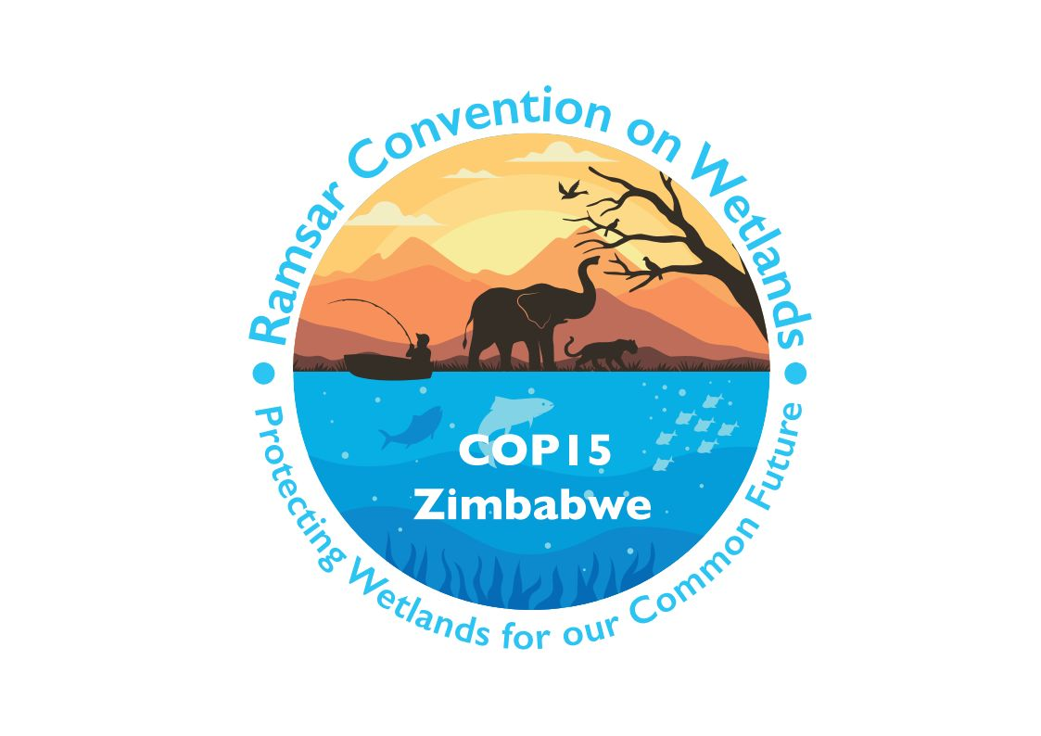

15th meeting of the Conference of the Contracting Parties

to the Convention on Wetlands

“Protecting wetlands for our common future”

Victoria Falls, Zimbabwe, 23-31 July 2025

COP15 Doc.23.9

Note from the Secretariat:

At its 64th meeting, the Standing Committee in Decision SC64-15 instructed the Secretariat to submit the draft resolution in document SC64 Doc.12 on institutional strengthening to COP15 for its consideration, amended to take into account the inputs presented by the Committee.

Draft resolution on implementing the institutional strengthening of the Convention on Wetlands

1. RECALLING Resolution XIV.6 on Enhancing the Convention’s visibility and synergies with other multilateral environmental agreements and other international institutions, which instructed the Secretariat to prepare an institutional strengthening report with recommendations reflecting the needs of the Secretariat to achieve organizational robustness to support the implementation of the Convention, including but not limited to those related to administrative arrangements, governance, leadership, human resources independency, high-level political engagement, and the Convention’s visibility objectives;

2. RECALLING Resolution X.5, Resolution IX.10, Resolution XI.1, Resolution XII.3, Resolution XIII.7 and Resolution XIV.6, which commenced a series of processes to review and improve the hosting and governance arrangements of the Secretariat of the Convention, and of the Convention itself;

3. ALSO RECALLING the work of several earlier working groups, such as the Working Group on the Observer Status of the Secretariat and the Working Group on Administrative Reform, as well as the various consultancies and analyses produced by these working groups;

4. NOTING WITH APPRECIATION the work of the Working Group on Institutional Strengthening which has consolidated the work of earlier groups, identified challenges which have been resolved, and identified gaps in information; and

5. ACKNOWLEDGING that issues relating to the governance of the Convention are complex, and that there remain gaps in information;

THE CONFERENCE OF THE CONTRACTING PARTIES

6. REQUESTS the Standing Committee, at its 66th meeting (SC66), to review and approve the tasking of follow-on actions within the identified challenge themes, as listed in Annex 1 of the present Resolution, to existing working groups which have the appropriate mandate to investigate and address these challenges, by requesting the working groups listed below to provide updates on these follow-up actions within their respective reports at SC67:

a. The Management Working Group: Lack of sufficient communication and virtual information management mechanisms; Procedure for electing a Secretary General; and

b. The Subgroup on Finance: Difficulties in paying annual contributions to the Convention on Wetlands; Risks posed to the Convention by legal provisions applied to the management of outstanding arrears; Lack of clear formalized financial mechanisms for Convention funding;

7. REQUESTS the Standing Committee, at SC66, to establish a new working group to continue the remaining work of the Institutional Strengthening Working Group, particularly the structural issues of improving staff recruitment and reducing staff turnover, limited visibility of the Convention at high-level United Nations processes and meetings, and a lack of a legal personality, by:

a. Sourcing information to fill the gaps and answer the remaining questions identified by the Working Group on Institutional Strengthening in its final report, as provided in Annex 1;

b. Identifying methods used by other multilateral environmental agreements to address some of the issues outlined in Annex 1, including arrears in the payment of annual contributions; and

c. Reporting to the 16th meeting of the Conference of the Contracting Parties with a draft resolution to further strengthen the governance and institutional strengthening of the Convention;

[8. REQUESTS the Standing Committee, at SC66, to establish a new working group on resource mobilization, including the establishment of a dedicated trust fund;]

9. CONFIRMS that the Secretariat of the Convention has the capability to enter into administrative and contractual agreements, by virtue of the Letter of Agreement between the International Union for the Conservation of Nature (IUCN) and the Convention, and the Delegation of Authority to the Secretary General of the Convention; and

10. INSTRUCTS the Secretary General of the Convention to continue to work with IUCN to identify improvements in the hosting arrangements relating to human resources, facilities, and administrative arrangements, in consultation with the Executive Team and the Management Working Group.

Annex 1

Output of the Working Group on Institutional Strengthening

Theme | Challenge | Status | Follow-on actions  to be implemented by
Administration | Ability to enter into contracts with donors / third parties and difficulties in the implementation and management of projects | Effective measures are already in place to address this should it arise | N/A
 | Difficulties in paying annual contributions to the Convention on Wetlands | Options to be evaluated | Subgroup on Finance
 | Difficulties for Contracting Parties to pay contributions to the Convention due to its legal status | Effective measures are already in place to address this should it arise | N/A
 | Risks posed to the Convention by legal provisions applied to the management of outstanding arrears | Linked to non-payment of contributions: Options to be evaluated | Subgroup on Finance
 | Lack of clear formalized financial mechanisms for Convention funding | Options to be evaluated | Subgroup on Finance
Governance | Lack of sufficient communication and virtual information management mechanisms | Currently being addressed by the Secretariat | Management Working Group
Leadership | Procedure for electing a Secretary General | Addressed by another working group: Management Working Group | Management Working Group
Human Resources independency | Recruitment of staff and reduction of staff turnover | Options to be evaluated | New working group
 | Legal liability of IUCN for Secretariat actions | Not a challenge | N/A
 | No residence permits for staff after contract ends | Not in the ambit of the Convention to address | N/A
 | Travel visas and security for staff on missions | May partially be resolved but potential solutions pose certain problems | N/A
High-level representation and visibility | Limited visibility of the Convention at high-level UN processes and meetings | Options to be evaluated | New working group
Cross cutting | Lack of a legal personality | Options to be evaluated | New working group

See https://www.ramsar.org/document/letter-agreement-provision-services-between-iucn-ramsar-convention.
See https://www.ramsar.org/document/delegation-authority-secretary-general-convention-wetlands-international-importance.

