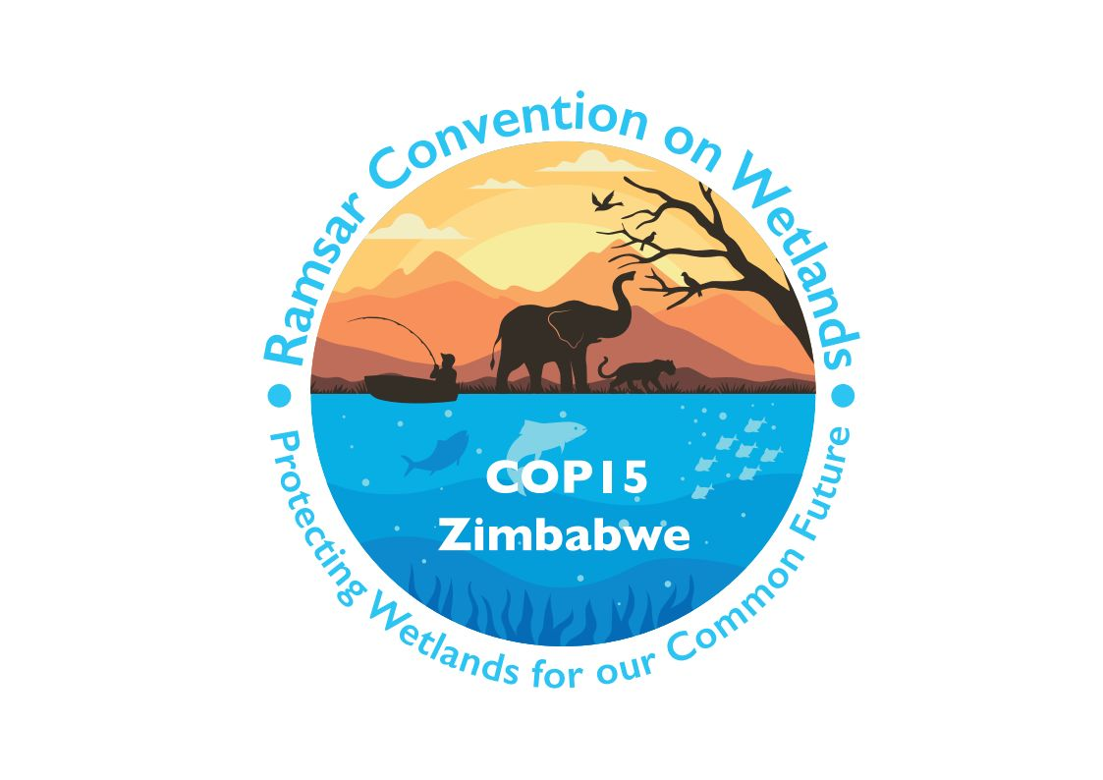

15th meeting of the Conference of the Contracting Parties

to the Convention on Wetlands

“Protecting wetlands for our common future”

Victoria Falls, Zimbabwe, 23-31 July 2025

COP15 Doc.23.5

Note from the Secretariat:

At its 64th meeting, the Standing Committee in Decision SC64-22 instructed the Secretariat to submit the draft resolution in document SC64 Doc.23 on Ramsar Regional Initiatives 2025-2028 to COP15 for its consideration, amended to take into account the inputs presented by the Committee.

Draft resolution on Ramsar Regional Initiatives 2025-2028

1. RECALLING that Ramsar Regional Initiatives (RRIs) under the Convention on Wetlands, which include regional centres for training and capacity building and regional networks to facilitate cooperation, are intended as an operational means to provide effective support for improved implementation of the Convention and its strategic plan in specific geographic regions, through voluntary international cooperation on wetland-related issues of common concern;

2. RECALLING that the Conference of the Contracting Parties has recognized the importance of RRIs in promoting the objectives of the Convention; and

3. RECALLING that in paragraph 13 of Resolution XIV.7 Part A on Ramsar Regional Initiatives, the Conference of the Contracting Parties decides that RRIs that satisfy the Operational Guidelines are endorsed by the COP or the Standing Committee as operating within the framework of the Convention for the period between two meetings of the COP, and receive the status of a Ramsar Regional Initiative or, if already recognized, will have their status confirmed;

THE CONFERENCE OF THE CONTRACTING PARTIES

4. DECIDES the endorsement of this list;

5. DECIDES that this list is to be valid until replaced by a new one for the COP16-COP17 period at the 16th meeting of the Conference of the Contracting Parties (COP16);

6. RECOGNIZES that the Mediterranean Wetlands Ramsar Regional Initiative (MedWet) is financially independent of the Convention and has its own provisional budget for the next triennium, which is annexed to the present Resolution for information purposes in response to a request by MedWet without establishing a precedent for RRIs; and

7. CONFIRMS that the present Resolution supersedes “Part B” of Resolution XIV.7, which is retired, and INSTRUCTS the Secretariat to publish an updated version of Resolution XIV.7 which will remain unchanged, with the exception of removing the reference to “Part A” in the title and deleting the current “Part B”.

RRIs endorsed for the intersessional period of COP15-COP16 are:

Four regional Ramsar centres for training and capacity building:

  - Ramsar Centre for Eastern Africa (RAMCEA)
  - Ramsar Regional Centre for Training and Research in the Western Hemisphere (CREHO)
  - Ramsar Regional Center in Central and West Asia (RRC-CWA)
  - Ramsar Regional Center – East Asia (RRC-EA); and

Eighteen Ramsar networks for regional cooperation:

  - Ramsar Regional Initiative for West African Coastal Zone Wetlands (WACoWet)
  - Ramsar Regional Initiative for the Niger River Basin (NigerWet)
  - Ramsar Regional Initiative for the Senegal River Basin (SenegalWet)
  - Ramsar Regional Initiative for the Conservation and Wise Use of High Andean Wetlands
  - Ramsar Regional Initiative for the Conservation and Wise Use of the Plata River Basin
  - Caribbean Wetlands Ramsar Regional Initiative (CariWet)
  - Ramsar Regional Initiative for the Conservation and Wise Use of Mangroves and Coral Reefs
  - Ramsar Regional Initiative for the Amazon River Basin
  - East Asian-Australasian Flyway Partnership (EAAFP)
  - Ramsar Regional Initiative for Central Asia (RRICA)
  - Indo-Burma Ramsar Regional Initiative (IBRRI)
  - Mediterranean Wetlands Ramsar Regional Initiative (MedWet)
  - Carpathian Wetland Ramsar Regional Initiative (CWI)
  - Nordic-Baltic Wetlands Ramsar Regional Initiative (NorBalWet)
  - Ramsar Regional Initiative on Black and Azov Seas Coastal Wetlands (BlackSeaWet)
  - The Southern African Ramsar Regional Initiative (SARRI)
  - International Mangrove Centre (IMC)
  - Danube WILDisland Ramsar Regional Initiative

Annex 1
Budget for the 2026-2028 triennium of the Mediterranean Wetlands Ramsar Regional Initiative (MedWet)

[Tables related to the finalized budget for the operations of the MedWet Initiative for 2026-2028 and to MedWet members’ contributions will be added during COP15].

