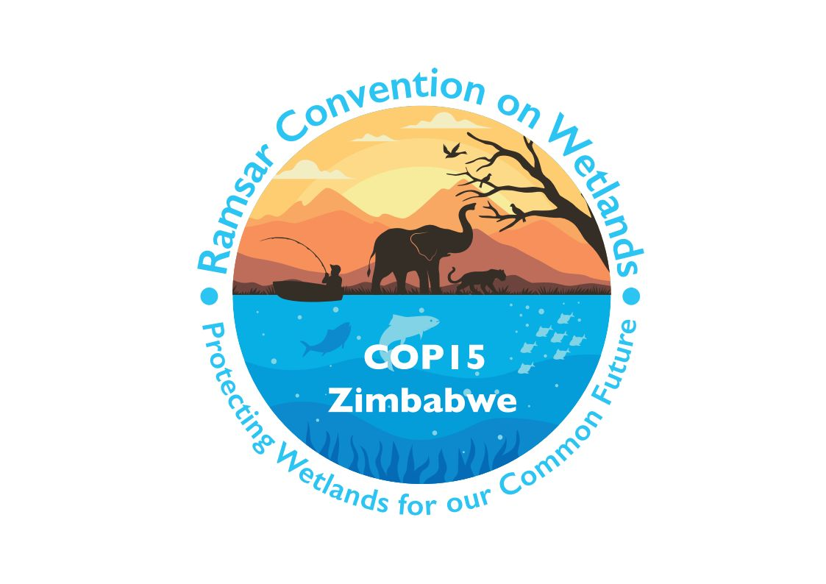

15th meeting of the Conference of the Contracting Parties

to the Convention on Wetlands

“Protecting wetlands for our common future”

Victoria Falls, Zimbabwe, 23-31 July 2025

COP15 Doc.23.3
Note from the Secretariat:

At its 64th meeting, the Standing Committee in Decision SC64-30 parts ii), iii) and iv):
ii. invited interested Parties to submit their amendments to document SC64 Doc.11 in written form to the Secretariat by 13.00 CET on 24 January;
iii. asked the Co-Chairs of the Strategic Plan Working Group to take the comments received by the Secretariat and prepare a revised document, incorporating any new amendments in square brackets; and
iv. instructed the Secretariat to publish the revised document on the Convention website and forward it to COP15 for consideration.

Draft resolution on the Strategic Plan of the Convention on Wetlands
2025-2034

1. RECALLING the adoption of the Strategic Plan of the Convention on Wetlands for 2016-2024 by Resolution XII.2 as the basis for the implementation of the Convention during the previous three triennia;

2. AWARE that wetlands remain the ecosystem type with the highest rate of loss and degradation, that current indications suggest that pressures on wetland biodiversity and ecosystem services will increase over the next years, as documented in the Global Wetland Outlook (2021), and that many wetland communities face persistent levels of poverty and food insecurity;

3. ACKNOWLEDGING the need for continuing the implementation of the Convention under the direction of a renewed Strategic Plan that reflects the current wetland conservation challenges;

4. RECOGNIZING that all wetlands, including the network of Wetlands of International Importance, [contribute to an environmental sustainable use taking into account the three pillars: economic, social and environmental] [have a direct relevance to the achievement of those Sustainable Development Goals related to poverty eradication, food and nutrition, healthy living, gender equality], [water quality and safe supply][water quality and supply, water security], energy supply, reduction of natural disaster risks, innovation and the development of appropriate infrastructure, sustainable human settlements, mitigation of and adaptation to climate change, oceans, seas and marine resources, biodiversity and sustainable use of ecosystems;

5. TAKING NOTE of the UN Water Conference 2023 and RECALLING the outcomes of the High-Level Political Forum (HLPF) 2023 which highlighted that water is at the core of sustainable development and the key role that wetlands play in maintaining water quantity and quality, among other values, and ALSO RECALLING the United Nations General Assembly’s Resolution A/RES/68/157 on The human right to safe drinking water and sanitation;

6. FURTHER NOTING Decision III/21 adopted by the Conference of the Parties to the Convention on Biological Diversity (CBD) which invites the Convention on Wetlands to cooperate as lead partner in the implementation of activities related to wetlands under the CBD, as well as CBD Decision 15/13 which recognizes that other biodiversity-related multilateral environmental agreements can contribute to the implementation of the Kunming-Montreal Global Biodiversity Framework adopted in CBD Decision 15/4;

7. FURTHER RECALLING the findings of the Global assessment report on biodiversity and ecosystem services (2019) of the Intergovernmental Science-Policy Platform on Biodiversity and Ecosystem Services (IPBES) [and the need for transformative change to stem the loss of biodiversity];

8. RECOGNIZING that despite the implementation by Contracting Parties and other stakeholders of Strategic Plans and many successful outcomes, more than 50 years after the adoption of the Convention, many increasingly urgent challenges remain;

9. AWARE of an increasing sense of urgency among Contracting Parties, partners and other stakeholders in the face of accelerating degradation and loss of wetlands, and RECOGNIZING that greater efforts are needed to prevent, stop and reverse this loss and degradation;

10. NOTING that the Strategic Plan identifies priority actions for the next nine years to prevent, stop and reverse the loss and degradation of wetlands, achieve the wise use of wetlands, effectively conserve and manage the network of Wetlands of International Importance, address the needs of wetlands communities, and enhance the implementation of the Convention; and

11. NOTING that the Strategic Plan for 2025-2034 has been prepared by the Strategic Plan Working Group of the Standing Committee with the support of the Secretariat, through a process involving wide consultation with Contracting Parties, the Convention’s International Organization Partners (IOPs) and other stakeholders, including intergovernmental and non-governmental organizations;

THE CONFERENCE OF THE CONTRACTING PARTIES

12. APPROVES the Strategic Plan of the Convention on Wetlands for 2025-2034 (“the Fifth Strategic Plan”) as annexed to this Resolution as the basis for the implementation of the Convention during this period, and INSTRUCTS the Secretariat to disseminate it widely to partners and stakeholders concerned with its implementation;

13. URGES all Contracting Parties, and INVITES the Scientific and Technical Review Panel (STRP), the Communication, Capacity Building, Education, Participation and Awareness (CEPA) Oversight Panel, the Convention’s International Organization Partners (IOPs), Ramsar Regional Initiatives and Centres and the Secretariat to take on the renewed challenge of implementing the Convention through the goals and targets of the Strategic Plan;

14. INVITES other stakeholders such as, inter alia, other multilateral environmental agreements, international organizations including financial organizations, non-governmental and civil society organizations, [Indigenous Peoples and local communities,][Indigenous Peoples, local communities,] scientific academies and research institutions, professional scientific and technical bodies, donors and private companies to contribute to the implementation of the Strategic Plan;

[15. REQUESTS the STRP to support the continued development of indicators and report on its progress to the 66th meeting of the Standing Committee (SC66);]

16. REQUESTS the Secretariat and the Standing Committee to develop the National Report template for the 16th meeting of the Conference of the Contracting Parties (COP16) such that it reflects the [relevant] goals and targets of the Fifth Strategic Plan, while seeking to minimize national reporting burdens, for consideration at SC67;

17. URGES Contracting Parties to monitor progress in the implementation of the Strategic Plan, [taking advantage of synergies with the reporting requirements of the Convention on Biological Diversity (CBD),] and communicate progress as well as any difficulties in implementing the Plan in their National Reports; REQUESTS the Standing Committee, on the basis of the information provided, to assess progress and any difficulties in implementing the Plan at its meetings; and INSTRUCTS the Secretariat to support capacity-building initiatives subject to the availability of sufficient resources with a view to assisting Contracting Parties in the preparation of National Reports;

18. URGES Contracting Parties to enhance international cooperation with a view to addressing challenges in the implementation of the Convention and its Strategic Plan, including those related to means of implementation;

19. ENCOURAGES Contracting Parties to promote, recognize and strengthen active participation of [Indigenous Peoples and local communities] for conservation and integrated wetland management [in accordance with national legislation];

[20. REQUESTS the Standing Committee, at its 66th meeting, to set up a working group dedicated to identifying sources of funding and mobilizing resources, the mandate of this group being to identify and actively solicit the external funding necessary to support the effective implementation of the Fifth Strategic Plan;]

21. ENCOURAGES Contracting Parties [in a position to do so] to allocate from national budgets [, according to their circumstances, priorities and capacities,] financial resources for the implementation of the Fifth Strategic Plan, [as appropriate,] and FURTHER REQUESTS the Secretariat to mobilize additional resources [from all sources] that may become available to support the Parties for effective implementation of the Strategic Plan in the context of Resolution XII.7 on Resource Mobilization and Partnership Framework of the Ramsar Convention;

22. REQUESTS the Secretariat, subject to available resources, [and INVITES the Ramsar Regional Initiatives,] to support collection and reporting of information on Wetlands of International Importance through completion of Ramsar Information Sheets and regular updating of the Ramsar Sites Information Service;

23. DECIDES to [consider][undertake] a review of the Fifth Strategic Plan and to establish the modalities, scope and timing for this review at COP16 [, taking into account inter alia the outcomes of the discussions of the post-2030 sustainable development agenda and the Sustainable Development Goals, the work of the Intergovernmental Science-Policy Platform on Biodiversity and Ecosystem Services (IPBES) and the CBD,] and INSTRUCTS the Secretariat to facilitate this; and

24. CONFIRMS that the present Resolution and its annex supersede those adopted as Resolution XII.2, which is replaced by the present Resolution.

Annex 1
Strategic Plan of the Convention on Wetlands 2025-2034

Strategic Plan of the Convention on Wetlands
2025-2034

1. The mission of the Convention on Wetlands is:

“the conservation and wise use of all wetlands through local and national actions and international cooperation, as a contribution towards achieving sustainable development throughout the world”.

A vision for the Fifth Strategic Plan

2. The vision of the Fifth Strategic Plan, with a timeline 2025-2034, is:

A world living in harmony with nature where wetlands are valued, conserved, restored and wisely used, supporting a healthy planet and delivering benefits for all people.

Background

3. This is the Fifth Strategic Plan of the Convention on Wetlands. The first plan was produced in 1996, with subsequent plans adopted in 2002, 2008 and 2015. Beginning with the third Strategic Plan, the work of the Convention has been organized around three pillars: (i) the wise use of all wetlands through national plans, policies and legislation, management actions and education; (ii) the designation and effective management of suitable wetlands for inclusion on the list of Wetlands of International Importance; and (iii) international cooperation on transboundary wetlands and shared species.

4. The wise use of all wetlands is a fundamental concept underpinning the work of the Convention on Wetlands. The Convention’s adopted definition of wise use is the “maintenance of their ecological character, achieved through the implementation of ecosystem approaches, within the context of sustainable development”. Whereby the ecological character “is the combination of the ecosystem components, processes and benefits/services that characterise the wetland at a given point in time”⁶. Therefore, the wise use of wetlands and the maintenance of their ecological character are at the heart of the Convention’s desire to stem the progressive encroachment on and loss of wetlands now and in the future.

[5. The Strategic Plan acknowledges multiple worldviews and ways of knowing. The concept of wise use [extends beyond extractive use and] encompasses human-wetland relationships. Indigenous ways of knowing include the importance of sustainable, respectful relationships with wetlands, respect for the wetlands and all that inhabit the space, and [reciprocity][ reciprocity and the duty to be a voice for the voiceless].]

6. The Convention defines wetlands as areas of marsh, fen, peatland or water, whether natural or artificial, permanent or temporary, with water that is static or flowing, fresh, brackish or salt, including areas of marine water the depth of which at low tide does not exceed six metres.

7. The Convention on Wetlands is the first global-scale multilateral environmental agreement (MEA). Adopted in the Iranian city of Ramsar in 1971, the Convention came into force in 1975. Since then, 172 UN member states, from all the world’s geographic regions, have acceded to become “Contracting Parties”, designating over 2,500 Wetlands of International Importance covering an area in excess of 2.5 million square kilometres. The List of Wetlands of International Importance constitutes the largest network of officially recognized important ecological sites in the world.

The outlook for Wetlands

8. Wetlands are fundamental to human wellbeing, a healthy planet, and economic prosperity for all people, [due to the provision of a wide range of regulating, provisioning and cultural ecosystem services.] [including for living in a healthy and sustainable environment in harmony with nature. Wetlands provide a wide range of regulating, provisioning and cultural ecosystem services, including those relevant for food, medicine, energy, clean air and water, climate, security from natural disasters as well as for recreation [, spiritual needs] and culture and other contributions beyond conservation of biodiversity.]

9. The Convention on Wetlands’ Fifth Strategic Plan responds to the findings in the Global Wetland Outlook publications [and IPBES assessments, including the IPBES 2019 Global Assessment Report on Biodiversity and Ecosystem Services and the IPBES Nexus Assessment]. The development of the Fifth Strategic Plan has been further informed by additional research and assessments, to identify and target the main drivers of wetland degradation and loss. These recent assessments have emphasised the [parlous][precarious] state of wetlands, concluding that:
- The global area of wetlands is rapidly decreasing.
- A quarter of all wetland plants and animals are at risk of extinction.
- The state of the world’s remaining wetlands is also declining.
- The main global drivers of wetland degradation and loss are climate change, unsustainable agricultural practices and urbanization.
- Locally, drainage, pollution, [forestry,] alien invasive species, unsustainable use, disrupted flow regimes and other factors are also impacting on the state of wetlands.

10. Despite the serious challenges wetlands face across the world, wetlands can also provide multiple contributions to addressing human challenges and are critical to delivering on a range of global commitments including those relating to biodiversity, climate change and sustainable development. The application of conservation management measures, increasing local community awareness and embedding cultural values and traditions into wetland management are demonstrably the most effective drivers of good ecological condition in wetlands.

[Considerations for the implementation of the Fifth Strategic Plan of the Ramsar Convention

The Strategic Plan of the Ramsar Convention, including its Mission, Vision, Goals and Targets, is to be understood, acted upon, implemented and reported, consistent with the following:

a) The Strategic Plan acknowledges the important roles, participation and contributions of all human beings, particularly those groups in vulnerable situations, as partners in the conservation, management and wise use of wetlands, and their flora and fauna.

b) Nature embodies different concepts for different people. The Strategic Plan recognizes and considers these diverse value systems and concepts as valuable tools for national implementation.

c) The goals and targets of the Strategic Plan represent an aspiration of coordinated international action. Each Party would contribute to attaining the goals and targets of the Strategic Plan in accordance with national legislation, circumstances, priorities, capabilities and availability of resources.

d) The Strategic Plan needs to be implemented in accordance with relevant international obligations. Nothing in this Strategic Plan should be interpreted as an agreement to modify the rights and obligations of a Party under the Convention or any other international agreement;

e) The implementation of the Strategic Plan should be guided by the principles of the Rio Declaration on Environment and Development.

f) The implementation of the Framework should be based on scientific evidence and taking into account traditional knowledge and practices, as appropriate, and recognizing the role of science, technology and innovation;

g) The full implementation of the Framework requires adequate, predictable and easily accessible means of implementation.

h) The Strategic Plan promotes coherence and complementarity among the Conventions processes, as well as with other MEAs and institutions, to deliver for wetlands, in line with their respective mandates and legal scope.

i) The Strategic Plan recognizes that coordinated actions at all levels are welcome to allow for the conservation, management and wise use of wetland, and their flora and fauna.]

[11. Wetlands also embody diverse concepts of nature and a plurality of value systems. To achieve wise use, and for wetlands to contribute fully to sustainable development, policy makers and practitioners (such as site managers) should recognize the multiple values of wetlands including considering the diverse values held by wetland communities, and reflect them in their decisions, policies and actions, as appropriate. Recognition of the multiple values that wetlands hold can inform inclusive collaborative, cross-sectoral efforts. The different actors and sectors engaged in wetland governance should communicate and collaborate to ensure that these multiple wetland values are recognized and upheld.]

Purpose

12. The Convention on Wetlands’ Fifth Strategic Plan recognises the urgency to act and to halt and reverse the wetland degradation and loss described above. The Plan aims to address the impacts of the main drivers of wetland degradation and loss, support wetland-dependent communities, catalyse transformative change and target critical interventions that can make an effective and lasting positive impact on wetlands at all levels.

13. The Fifth Strategic Plan builds on previous Strategic Plans adopted by the Convention, recognising their successes but, critically, addressing their limitations, to deliver a pathway to living in harmony with nature.

[14. The Fifth Strategic Plan acknowledges the important roles and contributions of [Indigenous Peoples and local communities][Indigenous Peoples, local communities and others] as custodians of wetlands and as partners in their conservation, restoration and sustainable use. [The Plan also embraces intergenerational equity and the need to ensure meaningful participation of younger generations in decision-making processes at all levels as well as the need to ensure gender equality in the implementation of the Fifth Strategic Plan through a [gender-responsive][gender-sensitive] approach, where [women and girls][all human beings] in all their diversity have equal opportunity and capacity to contribute to the objectives of the Convention.] [The Plan also embraces intergenerational equity and the need to ensure participation of younger generations in decision-making processes at all levels as well as the need to ensure women’s equality in the implementation of the Fifth Strategic Plan through a vulnerability approach, where women and girls have equal opportunity and capacity to contribute to the objectives of the Convention.]

[14. alt.1 The Fifth Strategic Plan is guided by the following principles and approaches:
a. The Fifth Strategic Plan acknowledges the important roles and contributions of [Indigenous Peoples and local communities] as custodians of wetlands and as partners in their conservation, restoration and sustainable use;
b. [The principle of intergenerational equity applies recognizing the need to ensure meaningful participation of younger generations in decision-making processes at all levels as well as the need to ensure gender equality in the implementation of the Fifth Strategic Plan through a [gender-responsive][gender-sensitive] approach, where [women and girls][all human beings] in all their diversity have equal opportunity and capacity to contribute to the objectives of the Convention;] [The Plan also embraces intergenerational equity and the need to ensure participation of younger generations in decision-making processes at all levels as well as the need to ensure women’s equality in the implementation of the Fifth Strategic Plan through a vulnerability approach, where women and girls have equal opportunity and capacity to contribute to the objectives of the Convention.]
[c. The precautionary approach applies to the maintenance of the ecological character of Ramsar Sites and the wise use of other wetlands;] and
[d. Common but differentiated responsibilities]]

[14. alt.2 The Fifth Strategic Plan [including its Vision, Goals and Targets is to be understood, implemented and reported, consistent with] the following principles and approaches:
a. [Indigenous Peoples and local communities -] The Fifth Strategic Plan acknowledges the important roles and contributions of [Indigenous Peoples and local communities] as custodians of wetlands and as partners in their conservation, restoration and sustainable use;
b. [Intergenerational equity - ] The [implementation of the Strategic Plan should be guided by the] principle of intergenerational equity [which aims to meet the needs of the present without compromising the ability of future generations to meet their own needs and to ensure meaningful participation of younger generations in decision-making processes at all levels];
c. The precautionary approach applies to the maintenance of the ecological character of Ramsar sites and the wise use of other wetlands; and
d. [An ecosystem approach -The Strategic Plan is to be implemented based on the ecosystem approach, which is part of wise use, the central normative concept of the Convention.]

[14. alt.3 The Fifth Strategic Plan acknowledges the important roles and contributions of Indigenous Peoples and local communities as custodians of wetlands and as partners in their conservation, restoration, and sustainable use. The Plan also embraces the principle of intergenerational equity and the need to ensure meaningful participation of younger generations in decision-making processes at all levels. This approach aims to create equal opportunity and capacity for all to contribute to the objectives of the Convention.]

15. [The time for business as usual has passed.] The ambition of the Plan is to be results-orientated by prioritizing the critical and urgent interventions, targets, and activities that are essential and, by definition, strategic to stem the ever-increasing degradation and loss of wetlands.

Relationship with the MEAs and global agendas

16. The Convention on Wetlands’ Fifth Strategic Plan promotes coherence and complementarity among the Conventions processes, as well as with other MEAs and institutions, to deliver for wetlands, in line with their respective mandates.

17. Implementation of the Convention on Wetlands’ Fifth Strategic Plan will enhance synergies, cooperation or collaboration with and contribute to fulfilment of different MEAs and processes, [, in line with respective mandates and taking into account different national circumstances] [including, but not limited to, the United Nations (UN) Framework Convention on Climate Change[] and [its][the] Paris Agreement[], the Convention on Biological Diversity (CBD) and [its][the] Kunming-Montreal Global Biodiversity Framework[], [the Convention on Migratory Species,] the UN Convention to Combat Desertification, the Sendai Framework for Disaster Risk Reduction, the UN Decade on Ecosystem Restoration as well as the 2030 Sustainable Development Goals (SDGs), especially SDG 6, in line with respective mandates and taking into account different national circumstances]. The implementation of strategic actions for the conservation, wise use and restoration of wetlands will contribute to the confluence of actions towards delivering sustainable development, reversing biodiversity loss and tackling climate change.

[18. More than half a century after the Convention on Wetlands was adopted, its mission is more urgent than ever. Maintaining [the conservation and wise use of all wetlands through local and national actions and international cooperation, as a contribution towards achieving sustainable development throughout the world] [and enhancing the multiple wetland values, while awarding wetlands the protection they need, requires international cooperation and national and local actions]. The Fifth Strategic Plan will position the Convention in a key role as a global forum for negotiation and delivery against the many global challenges.

Theory of transformative change

19. The Convention on Wetlands’ Fifth Strategic Plan is built around a theory of transformative change which recognizes that urgent action is required globally, regionally, nationally and locally so that the critical drivers of undesirable change that have exacerbated wetland loss and degradation will be stemmed and/or reversed to allow for the recovery of all wetland ecosystems.

20. The theory of transformative change acknowledges the vision of the Kunming-Montreal Global Biodiversity Framework of a world living in harmony with nature, [the theory of change also acknowledges that nature embodies different concepts for different people, including] [and promotes] collective actions, including by [Indigenous Peoples and local communities][Indigenous Peoples, local communities and others], Mother Earth-centric actions, and rights-based approaches [for those countries that recognize them] which embrace multiple value systems, including community-based natural resource management and civil society cooperation and solidarity aimed at the restoration, conservation and wise use of wetland ecosystems.

[21. The theory of [transformative] change supports fundamental transformation of existing wetland-human relationships by understanding the multiple values of wetlands through the inclusive participation of wetland communities in decision-making and actions. Embedding diverse wetland values in wetland decision-making will contribute to wise use and create an enabling environment to facilitate addressing [the impacts of] the main drivers of wetland degradation and loss, as well as catalysing the conservation and restoration of wetlands.]

22. An altered human-wetland perspective will facilitate the conservation of wetlands, including through their recognition on the List of Wetlands of International Importance and their consequent effective management to ensure that their ecological character is maintained. The inclusive cooperation and participation of partners and stakeholders, in combination with the recognition of multiple wetland values [and with adequate resources], will enhance the implementation of the Convention [and provide opportunities for resource mobilization [from all sources]] (Figure 1).]

Figure 1. Theory of transformative change.

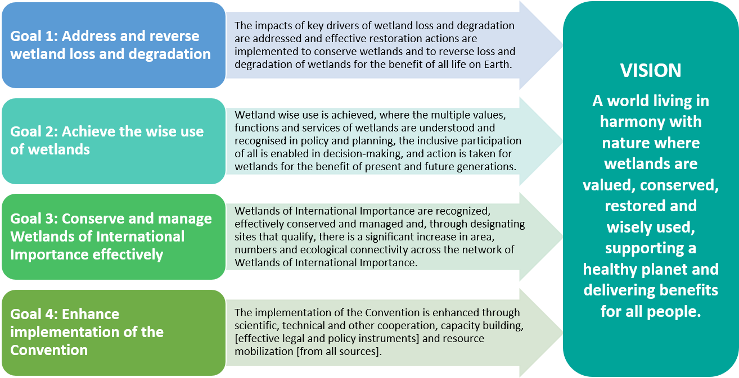

Strategic Goals and Targets

23. The Fifth Strategic Plan has four Goals. The Goals implicitly reflect and embrace the three pillars of the Convention whilst being underpinned by the fundamental need to alter the human-wetland relationship in order to deliver on wise use.

24. All the goals and targets of the Fifth Strategic Plan are [intended to be time bound, and achieved no later than 2034] [time bound, and to be achieved no later than 2034].

25. Each of the four Goals has a set of Targets to be achieved through activities undertaken by Contracting Parties. Successful delivery of the Targets will achieve realisation of the Goals. The combined successful delivery of the Goals will achieve the desired overall outcome, namely the vision of the Fifth Strategic Plan.

Goal 1: Address and reverse wetland loss and degradation

26. Goal Statement: The impacts of key drivers of wetland loss and degradation are addressed and effective restoration actions are implemented to conserve wetlands and to reverse loss and degradation of wetlands for the benefit of all life on Earth.

Goal 1 Targets

Target 1.1 Conserve and restore wetlands

27. [At least xx% of] Existing wetlands are effectively managed, [at least yy% of] degraded and lost wetlands are under effective restoration [and wetland representation is increased and improved within restoration policies and programmes]. [[At least xx% of] Existing wetlands are part of a network of protected areas, independently of their status as a Ramsar Site or otherwise.]

Target 1.2 Address the [impacts of] key global drivers of wetland degradation and loss

28. Prioritize specific actions to combat the impacts of drivers of wetland degradation and loss, focussing on:

A. Address the impacts of climate change on wetland degradation and loss;

B. Address the impacts of unsustainable agricultural practices on wetland degradation and loss;

C. Address the impacts of urbanization on wetland degradation and loss.

Target 1.3 Address and reverse the loss of threatened wetland-dependent species

29. [Considering national priorities and capacities, increase] [Prioritise] actions that improve the population trajectories of key threatened waterbird, fish, and other wetland-dependent species.

[Target 1.4 Ensure that the network [of protected wetlands] is sufficient]

[30. [At least xx% of] of existing wetlands are part of a network of protected areas, independently of their status as a Ramsar Site or otherwise.]

Goal 2: [Promotion of][Achieve] the wise use of wetlands

31. Goal Statement: Wetland wise use is [achieved][promoted], where the multiple values, functions and services of wetlands are understood and recognised in policy and planning, the [inclusive] participation of all is enabled in decision-making, and action is taken for wetlands for the benefit of present and future generations[, as appropriate].

Goal 2 Targets

Target 2.1 Recognize and transform humanity’s relationship with wetlands through enhancing our understanding of wetland values, functions and services and wise use

32. Promote the [values wetlands provide][importance of wetlands] to people and nature and the contributions wetlands make to achieving sustainable development, including food security and poverty eradication, [to transform the human-wetland relationship from one of exploitation, unsustainable resource extraction, and depletion to one where humans and nature live in harmony, including by incorporating] [by promoting the incorporation of] wise use and an ecosystem approach within policy and planning at all levels.

Target 2.2 Maintain the ecological character of wetlands through implementing an Ecosystem Approach, including by improving scientific methodologies

33. Take effective [legal, policy and administrative] measures [at all levels], to ensure the ecological character of wetlands is maintained and an ecosystem approach is applied to the planning and management of [all] wetlands, within the context of sustainable development[, taking into account national priorities and capacities].

Target 2.3 [Ensure][Strengthen] [inclusive] participation in wetland decision-making and address the needs of wetland communities

34. Fully recognize the rights of all [Indigenous Peoples [and local communities]], [including their right of traditional territories and their right of a free prior and informed consent,] as well as the rich cultural connections and traditional knowledges that have sustained the connection between wetlands and people, support the livelihoods of wetland communities, and facilitate [full, equitable, inclusive, effective and youth- and gender-[responsive][sensitive]] participation in all aspects of wetland decision-making[, in accordance with national legislation].

Goal 3: Conserve and manage Wetlands of International Importance effectively

35. Goal Statement: Wetlands of International Importance are recognized, effectively conserved and managed and, through designating sites that qualify, [there is a significant increase in area, numbers and ecological connectivity across the network of Wetlands of International Importance][area, numbers and ecological connectivity across the network of Wetlands of International Importance is increased].

Goal 3 Targets

Target 3.1 Designate [quantitative target] Wetlands of International Importance

36. There is a [significant][quantitative target] increase in the area and number of sites in the [global] network of Wetlands of International Importance, and their inclusion in ecologically representative, well-connected and equitably governed systems of protected areas and other effective area-based conservation measures is promoted [, contributing to global conservation targets and aligning with the Kunming-Montreal Global Biodiversity Framework.] [. This contributes to global conservation targets and aligns with the Kunming-Montreal Global Biodiversity Framework.] [The future gap-analysis by the STRP can be used for the selection of new sites.]

Target 3.2 Effectively manage Wetlands of International Importance

37. The management effectiveness of Wetlands of International Importance is enhanced, to maintain or improve their ecological character.

Target 3.3 Establish national and regional networks of site managers.

38. Networks of professionals and volunteers that manage wetlands of international importance are established, strengthened and expanded, improving effective information exchange on best practice management.

Target 3.4 Enhance the resilience of Wetlands of International Importance

39. Guidance is available and best practices are implemented to enhance the resilience of sites to current and emerging pressures from drivers of wetland loss and degradation.

[Target 3.5 Improve the information on Wetlands of International Importance]

[40. Improve the quality, timeliness, and completeness of information that is available through the Ramsar Sites Information Service for all Wetlands of International Importance.]

Goal 4: Enhance implementation of the Convention

41. Goal Statement: The implementation of the Convention is enhanced through scientific, technical and other cooperation, capacity building, [effective legal and policy instruments] [consistent with national legislations] and resource mobilization [from all sources].

Goal 4 Targets

Target 4.1 Cooperation with partners and stakeholders

42. Contracting Parties collaborate effectively with partners and stakeholders at all scales (global, regional, transboundary, national, local and site levels) and across all sectors to achieve the goals of the Convention, increasing complementarity [and synergies] with other multilateral processes [in line with their respective mandates].

[Target 4.2 Improve information, data [and technology] sharing

43. Improve information, data [and technology] sharing [to support evidence-based policy and management decision-making, promote scientific and technical cooperation and capacity-building related to wetland conservation, wise use, monitoring, and reporting, taking into account the knowledge of Indigenous Peoples and local communities [and their free, prior and informed consent].]

[Target 4.2 alt Improve information, data [and technology] sharing

[43.alt Evidence-based policy and management decision-making and monitoring and reporting is supported through improved information and data sharing, scientific and technical cooperation and capacity building and [voluntary] technology transfer [on mutually agreed terms], taking into account the knowledge of Indigenous Peoples and local communities [and their free, prior and informed consent].]

[Target 4.3 Strengthen existing legal and policy measures to enhance implementation

44. Contracting Parties have effective legal and policy instruments in place to fully implement the Convention, its resolutions and decisions.]

Target 4.4 Advance national wetland inventories

45. Wetland inventories are progressed and their databases are updated in line with the Ramsar wetland classification system[, or any other suitable classification system for wetlands already used by Contracting Parties].

Target 4.5 Awareness of wetland issues and visibility of the Convention on Wetlands is improved

46. Wetland conservation and wise use are mainstreamed through communication, capacity building and development, education, participation and awareness.

[Target 4.6 Reporting

[47. Enhance national reporting and maintain Ramsar Information Sheets for all Wetlands of International Importance up-to-date, with support from the Secretariat and Ramsar Regional Initiatives.]

[47. alt.1 Enhance national reporting, maintain Ramsar Information Sheets for all Wetlands of International Importance up-to-date, and ensure training on national reporting conducted by Contracting Parties, with support from the Secretariat.]

[47. alt.2 Improve the quality, timeliness, and completeness of information that is available through the Ramsar Sites Information Service for all Wetlands of International Importance.]]

[Target 4.7 Financial

48. [Ensure and mobilize][Mobilize] financial resources [from all sources] [needed] to [achieve] [support achieving] [the goals of the Convention] [the 5th Ramsar Strategic Plan 2025-2034], including through international [public] funding [from all sources] and innovative [financial] mechanisms where appropriate, [recognizing the need of enhanced support for developing countries,] and [improve] access to those resources.]

Monitoring and evaluation

49. The Table in Annex 2 describes the Goals, Targets [, Activities] and Indicators used to organize and track progress at national and other levels. Specific Indicators have been developed to track progress and to also to optimize [synergies][coordination] with other intergovernmental reporting processes.

50. The Standing Committee will keep the implementation of the Fifth Strategic Plan under review, based on regular reports from the Secretariat and the Scientific and Technical Review Panel, and based on National Reports prepared for each reporting cycle.

51. A review of the Fifth Strategic Plan will be undertaken at [COP16][COP17] and the modalities and scope for this review will be established at [COP15][COP16], taking into account [evidence-based information and data][inter alia the outcomes of the discussions of the implementation of the Kunming-Montreal Global Biodiversity Framework, the Post-2015 Sustainable Development agenda and Sustainable Development Goals, and the work of IPBES].

Annex 2

Fifth Strategic Plan – Goals, Targets and Indicators

Goal 1: Address and reverse wetland loss and degradation
Goal Statement: The impacts of key drivers of wetland loss and degradation are addressed and effective restoration actions are implemented to conserve wetlands and to reverse loss and degradation of wetlands for the benefit of all life on Earth.
Goal Indicator:
Global extent of wetlands
Targets | Indicators | Links to other Targets and other frameworks and processes
Target 1.1 Conserve and restore wetlands

https://www.ramsar.org/sites/default/files/documents/pdf/res/key_res_vi.14e.pdf
https://www.ramsar.org/sites/default/files/documents/pdf/res/key_res_viii_25_e.pdf
https://www.ramsar.org/sites/default/files/documents/library/key_res_x_01_e.pdf
https://www.ramsar.org/sites/default/files/documents/library/cop12_res02_strategic_plan_e_0.pdf
Ramsar Convention Secretariat (2016). An Introduction to the Ramsar Convention on Wetlands, 7th ed. (previously The Ramsar Convention Manual). Ramsar Convention Secretariat, Gland, Switzerland, pp110. Available at https://www.ramsar.org/sites/default/files/documents/library/handbook1_5ed_introductiontoconvention_final_e.pdf
https://www.ramsar.org/sites/default/files/documents/pdf/res/key_res_ix_01_annexa_e.pdf
As of 28 August 2024.
https://www.ramsar.org/sites/default/files/documents/library/gwo_e.pdf and https://www.ramsar.org/sites/default/files/documents/library/gwo_2021_e.pdf
https://www.ramsar.org/sites/default/files/2024-03/phase_2_document_review_research_report.pdf
[ https://www.ramsar.org/sites/default/files/documents/library/rpb_values_of_wetlands_e.pdf]
[ United Nations, Treaty Series, vol. 1771, No. 30822]
[ Adopted under the UNFCCC in FCCC/CP/2015/10/Add.1, decision 1/CP.21]
[ [Adopted under the Convention on Biological Diversity (CBD) in decision CBD/COP/DEC/15/4][Adopted at the Fifteenth Conference of the Parties to CBD].]
Figure to be revised pending agreement of Goals.
Secretariat note: this sentence is a suggested addition, either under Target 1.1 or under a new target 1.4; see paragraph 30 below.
Secretariat note: alternatives to this paragraph are included under Target 4.6 below.
Secretariat note: “[COP17]” is a suggested addition by the Secretariat to reflect the proposed amendment in the following line to establish the modalities and scope for this review at COP16.
Secretariat note: This table will be populated with the Goals and Targets once they have been agreed, in order to avoid inconsistencies between duplicated texts during negotiations. The current language for Goal 1 and Target 1.1 has been included to illustrate the proposed structure of the table.

