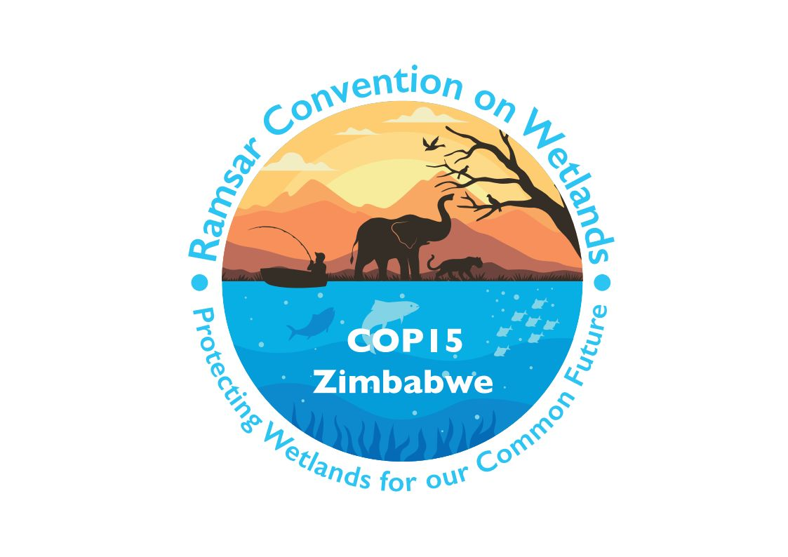

15th meeting of the Conference of the Contracting Parties

to the Convention on Wetlands

“Protecting wetlands for our common future”

Victoria Falls, Zimbabwe, 23-31 July 2025

COP15 Doc.23.25

Draft resolution on thanks to the host country,
the Republic of Zimbabwe

1. APPRECIATING the support provided by the Zimbabwean authorities in the preparation of the 15th meeting of the Conference of the Contracting Parties (COP15);

2. AWARE of the significant effort required for the organization of a meeting of the Conference of the Contracting Parties (COP);

3. NOTING the outcomes of the high-level segment of COP15, which was organized by the host country under its own initiative, with the adoption of the “Victoria Falls Declaration”; and

4. NOTING WITH SATISFACTION that [XX] Resolutions considered at the present meeting of the Conference of the Parties were approved;

THE CONFERENCE OF THE CONTRACTING PARTIES

5. CONGRATULATES and EXPRESSES ITS GRATITUDE TO the Republic of Zimbabwe for hosting a successful 15th meeting of the Conference of the Contracting Parties and to the people and the City of Victoria Falls for their great contribution in the preparation of COP15;

6. RECORDS its thanks to the President, the Alternate President and the Vice-Presidents of COP15 for their commitment to ensuring efficient and effective conduct of the plenary sessions;

7. GREATLY APPRECIATES the numerous side events and cultural events that provided a wonderful opportunity for technical and cultural exchanges between delegates; and

8. TAKES NOTE OF the “Victoria Falls Declaration”, and its intended aim that it will enhance the visibility of the Convention and strengthen high-level commitment to conserve and wisely use wetlands, and to strengthen further the implementation of the Convention on Wetlands.

