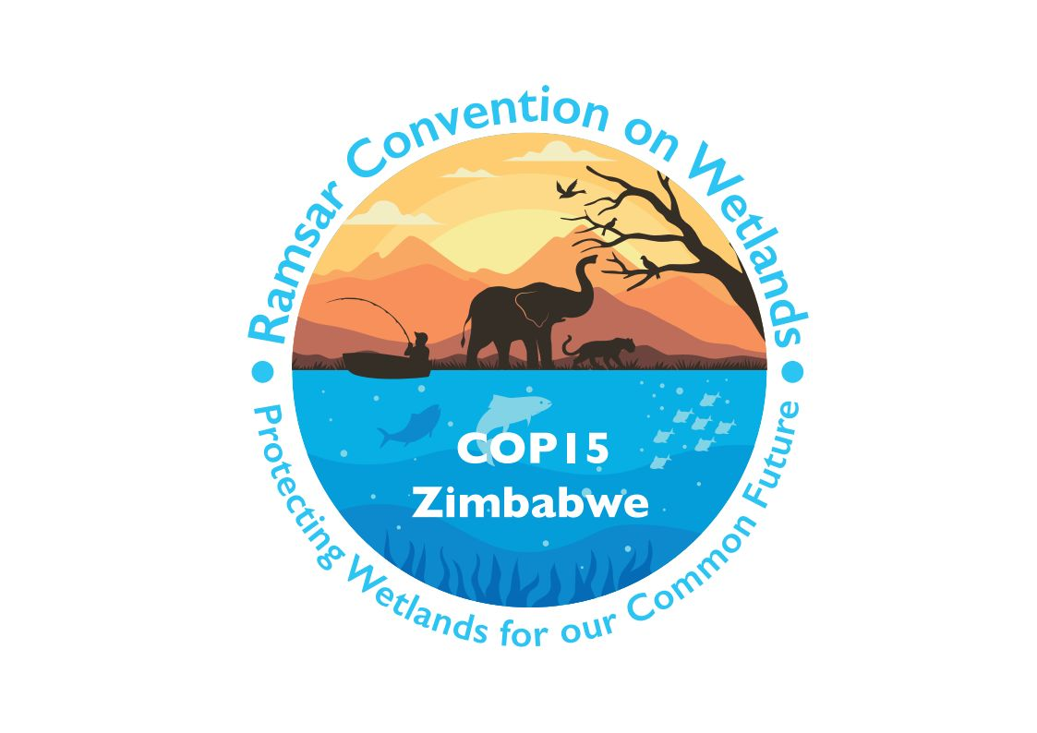

15th meeting of the Conference of the Contracting Parties

to the Convention on Wetlands

“Protecting wetlands for our common future”

Victoria Falls, Zimbabwe, 23-31 July 2025

COP15 Doc.23.24

Note from the Secretariat:

This amended draft resolution was submitted by Algeria to the 14th meeting of the Conference of the Contracting Parties as document COP14 Doc.18.16 Rev.1. In paragraph 22 of Resolution XIV.13 on The status of Sites in the List of Wetlands of International Importance the Contracting Parties decided to defer consideration of the amended draft resolution to COP15, to be informed by the results of the technical report and relevant discussions at the upcoming Standing Committee meetings.

Amended draft resolution on the Ramsar List

[1. RECALLING Article 2.1 of the Convention, which states: “Each Contracting Party shall designate appropriate wetlands within its territory for inclusion in a List of Wetlands of International Importance” and that “the boundaries of each wetland shall be precisely described and also delimited on a map”;

2. ALSO RECALLING that the Contracting Parties, in Resolution 5.3, confirmed that a “Ramsar Information Sheet” and a map of the Site should be provided at the time of designation of a wetland (Ramsar Site) to the List of Wetlands of International Importance, and reaffirmed this in Resolutions VI.13, VI.16 and VII.12; and

3. NOTING that the 4th meeting adopted “Criteria for identifying wetlands of international importance” in Recommendation 4.2;

THE CONFERENCE OF THE CONTRACTING PARTIES

4. REQUESTS the Secretariat to include sites on the Ramsar List in accordance with Article 2.1 of the Convention, while taking due account to geographical coordinates provided by the United Nations Geospatial Network; and

5. FURTHER REQUESTS the Secretariat to keep on the Ramsar List only Sites that were included in line with the provisions of the previous paragraph.]

