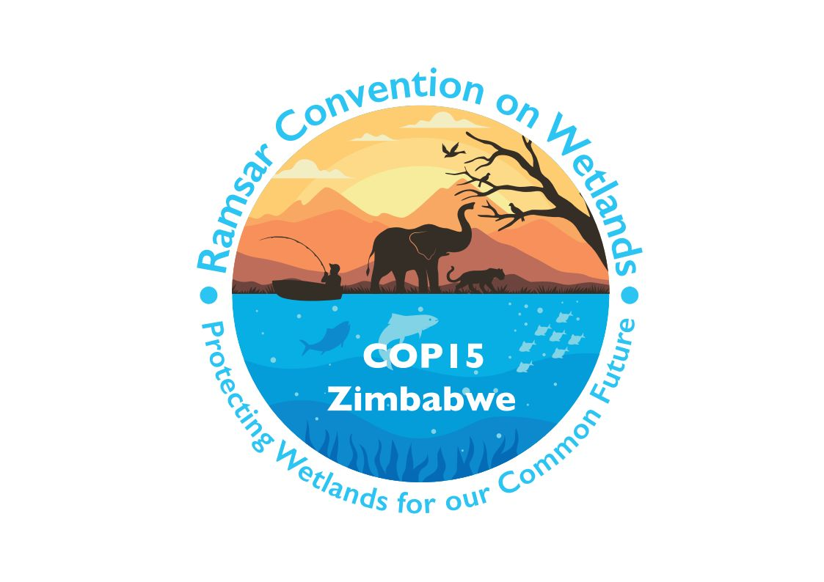

15th meeting of the Conference of the Contracting Parties

to the Convention on Wetlands

“Protecting wetlands for our common future”

Victoria Falls, Zimbabwe, 23-31 July 2025

COP15 Doc.23.22

Note from the Secretariat:

At its 64th meeting, the Standing Committee in SC64-38 instructed the Secretariat to submit the draft resolution in document SC64 Doc.29.11 Rev.1 on Education and participation as a basis for the management of urban and peri-urban wetlands to COP15 for its consideration, amended to take into account the inputs presented by the Committee.

Draft resolution on education and participation as a basis for the management of urban and peri-urban wetlands

Submitted by Colombia

1. RECALLING the commitments of the Contracting Parties under Article 3.1 of the Convention on Wetlands to achieve as far as possible the wise use of all wetlands in their territory and to maintain the ecological character of sites included in the List of Wetlands of International Importance of the Convention;

2. AWARE that since prehistoric times human settlements have been associated with wetlands, and dependent upon them for food production, water supply, commerce and defence, among other things;

3. RECALLING that at its 11th meeting (COP11) the Conference of the Contracting Parties, through Resolution XI.11 on Principles for the planning and management of urban and peri-urban wetlands, defined “urban wetlands” as wetlands within the boundaries of cities, towns and other conurbations and “peri-urban wetlands” as wetlands adjoining an urban area between its suburbs and rural areas; and AWARE that many other wetlands around urban centres are linked, and/or hydrologically related, to urban settlements;

4. FURTHER RECALLING that at COP10 the Conference of the Contracting Parties, through Resolution X.27 on Wetlands and urbanization, recognized the important role that urban and peri-urban wetlands can play in communication, education, participation, and awareness of urban communities on wetlands, and the value of establishing educational and visitor centres in these locations;

5. RECOGNIZING that the global extent of wetlands declined by 64-71% in the 20th century and that wetland loss and degradation continue across the world;

6. CONCERNED that the loss of natural wetlands continues into the 21st century, noting that wetlands, including river systems, continue to be fragmented and degraded and that ecosystems of particular importance for the services they provide continue to decline;

7. AWARE that advancing urbanization processes are affecting wetlands, including urban and peri-urban wetlands that have been designated as Wetlands of International Importance, which are increasingly urbanized and under pressure from high land values in cities, with a consequent increase in the risk of their loss;

8. RECOGNIZING the competence of local governments, including municipalities, to involve wetland management in planning to ensure the conservation and wise use of wetlands in urban and peri-urban areas under their jurisdiction;

9. NOTING that due to the dynamics of cities, wetlands are immersed in a matrix of urbanization which affects their function, reducing the provision of ecosystem services such as water supply, food supply and habitat for fauna and flora species, among others;

10. RECALLING that, at COP12, the Conference of the Contracting Parties, through Resolution XII.10 on the Wetland City Accreditation of the Ramsar Convention, endorsed the establishment of a voluntary Wetland City Accreditation scheme, recognizing that the scheme can assist cities, Contracting Parties and stakeholders to promote awareness and attract support for the wise use and conservation of wetlands and other sustainable development initiatives; ALSO RECALLING that through Resolution XIV.10 on Updating the Wetland City Accreditation of the Convention, it was noted that Contracting Parties, through the Wetland City Accreditation scheme, have continued to improve their national standards and protocols for wetland conservation and management in cities, in order to provide positive branding opportunities and mobilize support for cities that demonstrate a strong positive relationship with wetlands;

11. AWARE that education can contribute to the management of urban and peri-urban wetlands, in order to maintain their ecological and cultural functions, within the framework of wise use;

12. RECALLING that, at COP14, the Conference of the Contracting Parties, through Resolution XIV.11 on Wetland education in the formal education sector, encouraged Contracting Parties to adopt a national or subnational approach to introduce wetland education topics into school curricula that are widely available and accessible to schools and teachers, and to support capacity building for wetland science educators, including school teachers, instructors and eco-interpreters at wetland centres;

13. RECOGNIZING that the involvement of different stakeholders in the formulation of management plans should be based on participatory processes, especially involving the communities that inhabit these ecosystems, identifying them as key stakeholders in wetland conservation;

14. CONSIDERING that international cooperation, especially in border cities, should promote transboundary collaboration for the protection of shared wetlands;

15. CONVINCED that urban communities have made great efforts in community organization, participation and monitoring, generating important opportunities for building local knowledge that plays an important role in decisions on the management and protection of wetlands in cities;

16. CONSIDERING that communities living in urban environments have developed joint management processes in urban wetlands that have allowed the development of participatory and ownership actions that have become true examples of the effectiveness of management measures established by the Convention on Wetlands, contributing to the sustainability of these processes;

17. RECOGNIZING the contribution of the private sector in promoting and financing actions aimed at the conservation and restoration of wetlands and strengthening of wetland communities, contributing to and complementing public actions for the integrated management of wetlands in urban and peri-urban areas; and CONCERNED that inadequate and unsustainable management of wetlands can undermine the resilience of cities to natural disasters such as floods, tsunamis and earthquakes, and limit their subsequent recovery;

18. EMPHASIZING that in order to ensure the prosperity of future generations and the maintenance of wetlands, their biodiversity and the services they provide to people, it is essential that society adopts a more sustainable approach to urbanization;

19. RECOGNIZING that urban and peri-urban wetlands provide a range of ecosystem services, including providing food, improving water quality and sustaining drinking water supplies, assisting in water security, and mitigating natural hazards through the regulation of flooding and reduction of storm surges; and ALSO RECOGNIZING that access to urban green space can make a positive contribution to people’s physical and mental wellbeing;

20. NOTING Decision IX/28 adopted in 2008 by the Parties to the Convention on Biological Diversity (CBD) at its ninth meeting (COP9) on Promoting the participation of cities and local authorities, which recognizes that the world’s population is rapidly urbanizing and that water supply is important for cities, and which urges Parties to that Convention and other governments to protect the biological diversity and ecosystem services provided by urban and peri-urban wetlands under their jurisdiction;

21. FURTHER NOTING the Kunming-Montreal Global Biodiversity Framework and recalling its Target 12, “Enhance green spaces and urban planning for human well-being and biodiversity”; and

22. WELCOMING the outcome of COP16 of the CBD, which seeks to expand its collaborative and coordinated efforts to achieve the protection, conservation, restoration and sustainable use of urban and peri-urban wetlands;

THE CONFERENCE OF THE CONTRACTING PARTIES

23. INVITES Contracting Parties and other states to involve education and participation processes in the appropriate management of urban and peri-urban wetlands, taking into account the circumstances of each Contracting Party, and to further disseminate them to other stakeholders (including through translation into local languages) where appropriate, and to seek to ensure their appropriate adoption by the sectors and levels of government responsible for the planning and management of these ecosystems;

24. URGES Contracting Parties to continue to promote the conservation and wise use of urban and peri-urban wetlands which are affected by urban development activities and initiatives, and to integrate this approach in the basic principles for the achievement of sustainable urban development objectives;

25. RECOGNIZES that urban development should be planned and managed in a sustainable manner and INVITES Contracting Parties and other relevant organizations to enhance education, participation and ownership for the appropriate management of wetlands, based on their importance as providers of benefits to urban populations;

26. URGES Contracting Parties to actively promote the dissemination of information on the importance of urban wetlands as habitats for biodiversity, water regulation, carbon storage and recreation, and RECOMMENDS that this be widely disseminated, in order to raise awareness of the potential of wetlands and wetland management as important elements in the management of the urban environment;

27. INVITES Contracting Parties, to the extent of their capacities, priorities and own legislative framework, to promote the integration of wetland management education plans to include wetland content in school, university and non-formal education programmes, as well as to develop educational guides and resources aligned with the Convention on Wetlands;

28. INVITES the Contracting Parties to encourage the establishment of interpretation centres, classrooms for environmental teaching, and ecotourism, aimed at creating learning spaces in wetlands, showing their ecological and cultural value and offering interactive activities such as guided tours, workshops and talks, along with an administrative and financial system that guarantees their sustainability;

29. RECOMMENDS that Contracting Parties promote capacity-building processes for communities and decision-makers as a basis for providing training for local leaders, authorities and community groups on sustainable wetland management;

30. INVITES Contracting Parties to actively promote participatory research processes as a basis for fostering collaboration between scientists, students and communities, to monitor wetlands and associated species, collect data on their status and ecosystem services, as well as their links with citizen science programmes, scientific vocations, and basic and applied research programmes, and to manage knowledge and provide spaces for the exchange of experiences;

31. INVITES Contracting Parties to include inclusive governance processes to create citizen participation platforms that involve all stakeholders (communities, local governments, NGOs and the private sector), and to guarantee free, prior and informed consultation in decisions that impact on wetlands;

32. INVITES Contracting Parties to foster community action processes to promote activities such as wetland clean-up, ecological restoration and community-based monitoring;

33. INVITES Contracting Parties to promote spaces for public-private collaboration, enabling the inclusion of the productive sector in the financing of projects and the generation and analysis of information for decision-making, and URGES the promotion of cleaner production processes that allow the productive sector to reduce environmental impacts on urban and peri-urban wetlands;

34. URGES Contracting Parties to formulate collaborative management plans as a basis for developing and implementing participatory management plans, with an emphasis on sustainable practices and the protection of ecosystem services, and RECOMMENDS that public policies supporting the conservation and sustainable use of urban wetlands be formulated;

35. INVITES Contracting Parties to undertake processes for the celebration of key events and days such as World Wetlands Day (2 February), promoting educational and recreational activities to raise awareness of urban and peri-urban wetlands;

36. FURTHER INVITES Contracting Parties to generate mass communication campaigns (radio, television, social media) and educational materials on relevant issues related to education, participation, maintenance, enhancement and management of urban and peri-urban wetlands;

37. REQUESTS the Secretariat and the Scientific and Technical Review Panel to strengthen collaborative initiatives with the Convention on Biological Diversity and other urban development stakeholders to promote projects aimed at developing demonstration sites that benefit local communities while encouraging the wise use of wetlands, subject to the availability of resources; and

38. RECOMMENDS that Contracting Parties recognize the important role of local and regional governments in the management of wetlands within their jurisdictions, considering education and participation as essential for the sustainable management of urban wetlands, in line with the principles of the Convention, and value urban wetlands not only as natural spaces, but also as social, cultural and economic assets which are essential for the sustainable development of humankind.

Davidson, Nick C., 2014.

