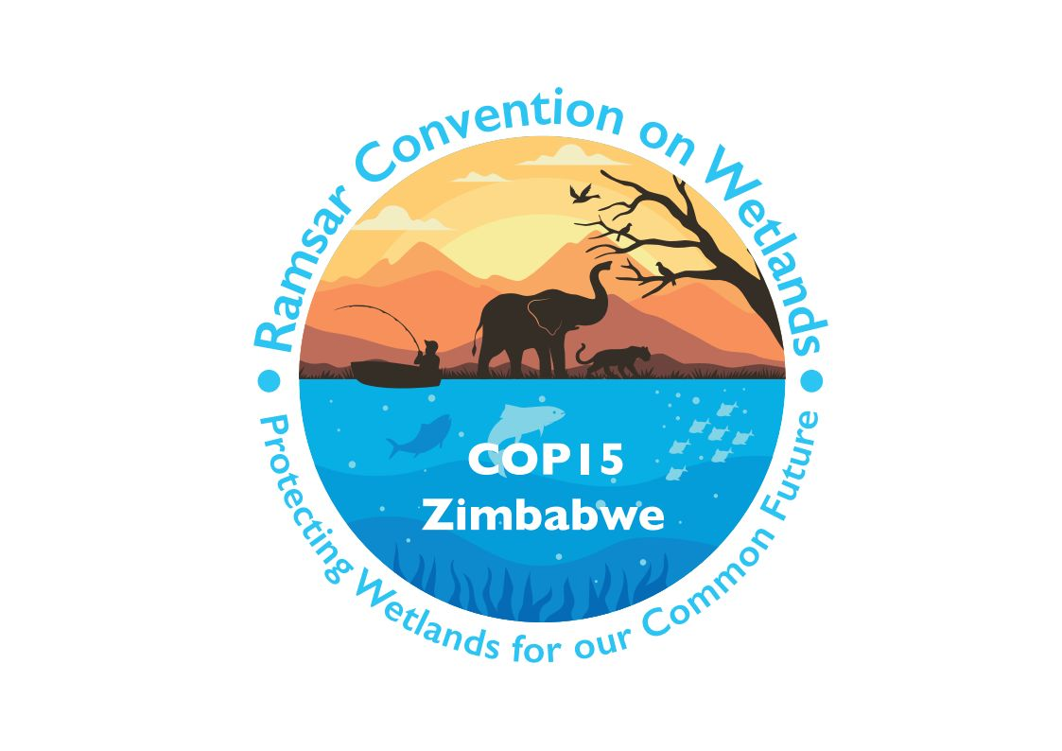

15th meeting of the Conference of the Contracting Parties

to the Convention on Wetlands

“Protecting wetlands for our common future”

Victoria Falls, Zimbabwe, 23-31 July 2025

COP15 Doc.23.21

Note from the Secretariat:

At its 64th meeting, the Standing Committee in Decision SC64-29 instructed the Secretariat to submit the draft resolution in document SC64 Doc.29.10 Rev.1, on Recognition of river dolphins as key species for the conservation and sustainable use of wetlands in South America and Asia, to COP15 for its consideration, amended to take into account the inputs presented by the Committee.

Draft resolution on recognition of river dolphins as key species for the conservation and sustainable use of wetlands in South America and Asia

Submitted by Colombia

1. RECALLING that the Fourth Strategic Plan of the Convention on Wetlands (2016-2024) highlights the three pillars of the Convention: i) the wise use of all wetlands through national plans, policies and legislation, management measures, and public education; ii) the designation and sustainable management of suitable wetlands for inclusion in the List of Wetlands of International Importance; and iii) international cooperation on transboundary wetlands and shared species;

2. RECOGNIZING that the network of Wetlands of International Importance (“Ramsar Sites”) and the effective management of these Sites and more broadly the wise use of Ramsar Sites and the world’s other wetlands represent an essential contribution not only to the achievement of Targets 1-4 of the Kunming-Montreal Global Biodiversity Framework under the Convention on Biological Diversity (CBD), but also to other multilateral environmental agreements, such as the Convention on Migratory Species (CMS), the United Nations Framework Convention on Climate Change (UNFCCC), the United Nations Convention to Combat Desertification (UNCCD), the water-related Conventions, and the Convention on International Trade in Endangered Species of Wild Fauna and Flora (CITES), as well as implementing cooperation between regions;

3. RECALLING that the Ramsar Regional Initiative for the Amazon Basin, of which the members (Bolivia, Brazil, Colombia, Ecuador, Peru, Suriname and Venezuela) have designated 23 Ramsar Sites for their importance for river dolphins, promotes the establishment of corridors that support the ecological connectivity of wetlands in the Amazon Basin, as well as the protection, conservation and restoration of the habitat of species such as river dolphins;

4. RECOGNIZING that coordinating or participating in cooperation platforms (at the site, city, watershed, lake and groundwater basin, country, regional and global scales), can promote the implementation of management actions for river dolphins living in rivers and wetlands in Asia and South America;

5. RECALLING that the Convention on Wetlands is the lead partner for cooperating in the implementation of wetland-related activities under the CBD and is responsible for providing policy, technical and scientific advice and guidance for that Convention and for enhancing cooperation between the two Conventions at all levels;

6. EMPHASIZING that the Fourth Strategic Plan of the Convention, under its four objectives and 19 specific targets, reflects that for the improvement of Ramsar Sites it is necessary to generate conservation and management measures, under integrated schemes involving the Parties;

7. AWARE that currently about 1.6 billion human beings inhabit the wetlands in which six river dolphin species are found which depend on wetlands to fulfil their life cycles, and that the impacts have caused their categorization by the International Union for Conservation of Nature (IUCN) as globally threatened species: in South America, the Amazon river dolphin Inia geoffrensis and the tucuxi Sotalia fluviatilis, and in Asia, the Ganges river dolphin Platanista gangetica, the Indus river dolphin Platanista minor, the Irrawaddy dolphin Orcaella brevirostris and the Yangtze finless porpoise Neophocaena asiaeorientalis;

8. RECOGNIZING that river dolphins have been used to assess the ecological character of some wetlands in South America (the Orinoco Basin in Colombia); and that the absence of these species in some stretches of rivers in Asia (the Ganges and Jamuna Rivers) is indicative of low ecosystem function owing to the high levels of pollution, the reduction of river flows due to the development of infrastructure associated with the distribution of water resources and the energy matrix, and the use of these resources for agricultural activities;

9. NOTING that river dolphins are sentinel species for the conservation of large wetlands in South America and Asia, and FURTHER RECALLING that Contracting Parties have generated instruments such as the Conservation and Management Plan (CMP) for river dolphins in the Amazon, Orinoco and Tocantins-Araguaia river basins under the International Whaling Commission in which Brazil, Colombia Ecuador and Peru cooperate and the Concerted Action on Gangetic River Dolphins under the CMS in which Bangladesh, India and Nepal cooperate;

10. RECALLING the non-binding Global Declaration for River Dolphins signed in Bogotá, Colombia in October 2023 by Bangladesh, Bolivia, Brazil, Cambodia, Colombia, Ecuador, India, Nepal, Pakistan and Venezuela;

11. NOTING that river dolphins are currently found in at least 29 Ramsar Sites in South America and Asia covering a total of 27,497,064 hectares;

12. RECALLING that the criteria for the identification and designation of Wetlands of International Importance reflect the inclusion of species that are threatened, that fulfil ecological roles that maintain biodiversity, that take refuge in wetlands during extreme events and adverse conditions, and of which wetlands hold more than 1% of international populations;

13. CONCERNED that climatic disturbances are demonstrably affecting the biological integrity of wetlands and the survival of their fish and river dolphins causing mass mortalities, such as those recorded in 2023 in the Amazon, and that unprecedented flooding has led to increased mortality and strandings of river dolphins in Asia, as well as increased vulnerability from illegal fishing activities;

14. EMPHASIZING that the implementation of conservation measures around river dolphins will benefit other aquatic vertebrate species that use the same habitats and sites, including mammals (such as manatees and otters), reptiles (such as caimans and turtles) and fish (such as the large migratory catfish of the Orinoco and Amazon basins);

15. RECOGNIZING that actions for sustainable use around river dolphins which benefit local communities have been promoted in Ramsar Sites such as, for example, responsible dolphin-watching tourism, the development of fishing agreements, the restoration of flooded forests, and the use of timber and non-timber products; and likewise, that those communities and Indigenous Peoples, including women and other vulnerable groups, have a fundamental role in the conservation of these species and their habitats in wetlands;

16. FURTHER NOTING that CMS Resolution 12.23 on Sustainable Tourism and Migratory Species outlines general principles to ensure that tourism activities benefit and do not harm migratory species, including the involvement of, and benefits to, local communities; and

17. AWARE of the work of the Contracting Parties in developing tools aimed at the conservation and sustainable use of aquatic vertebrate species and especially river dolphins;

THE CONFERENCE OF THE CONTRACTING PARTIES

[18. ENCOURAGES Contracting Parties to strengthen their management and conservation actions related to wetland habitats that are essential for river dolphins, and to report on actions in National Reports to COP16;]

19. INVITES the Contracting Parties to consider river dolphins as keystone species for different levels of biodiversity, especially in the management of wetlands and the livelihoods of human communities associated with these ecosystems, and to implement the following actions:

- Strive to halt and reverse the decline of all river dolphin populations in their range, and stabilize and increase the most threatened populations;

- Implement measures to effectively manage, conserve, protect, sustainably use and restore river dolphin habitats, including the creation of a network of protected and connected riverine and lentic habitats, and increase the effectiveness of their management;

- Promote the development of research by scientific bodies and local and Indigenous communities on river dolphins and their habitats, and monitoring of threats;

- Generate actions in Wetlands of International Importance (“Ramsar Sites”) and other protected area complexes that benefit local communities through sustainable use, such as responsible observation tourism, promotion of fishing agreements, restoration of flooded forests and use of timber and non-timber products among others;

- Strengthen engagement with riparian communities, Indigenous Peoples, and other ethnic groups, taking into account the inclusive approach to conservation and sustainable use of natural resources;

- Promote sustainable use, the application of good fishing practices, including spawning closures, and other economic activities in wetlands;

- Collaborate among Parties to improve the quality and quantity of water in these wetlands; and

- Collaborate with partners, financial institutions, civil society organizations and private sector actors to mobilize financial resources and strengthen technical capacities and technology transfer as mechanisms for the conservation and monitoring of river dolphins and their habitats;

20. REQUESTS the Contracting Parties to coordinate with expert groups, academics, local communities and each other, to promote the development of activities for regional work and the conservation and sustainable use of river dolphins and other aquatic vertebrates in Ramsar Sites in Asia and South America;

21. CALLS UPON the Contracting Parties to establish a mechanism for the exchange of information and experiences, in relation to the actions being taken under the various planning instruments such as the Global Declaration for River Dolphins (2023) and the Conservation and Management Plan (CMP) for river dolphins in the Amazon, Orinoco and Tocantins-Araguaia river basins under the International Whaling Commission, the Concerted Action on Gangetic River Dolphins under the Convention on Migratory Species, and the national management plans for these species and their habitats; and

[22. ENCOURAGES Contracting Parties to, with the support of the Secretariat, utilize the above-established mechanism to disseminate best practices and lessons learned on the conservation and monitoring of river dolphins as input for the conservation and monitoring of other species in similar situations and/or in other wetland habitats.]

