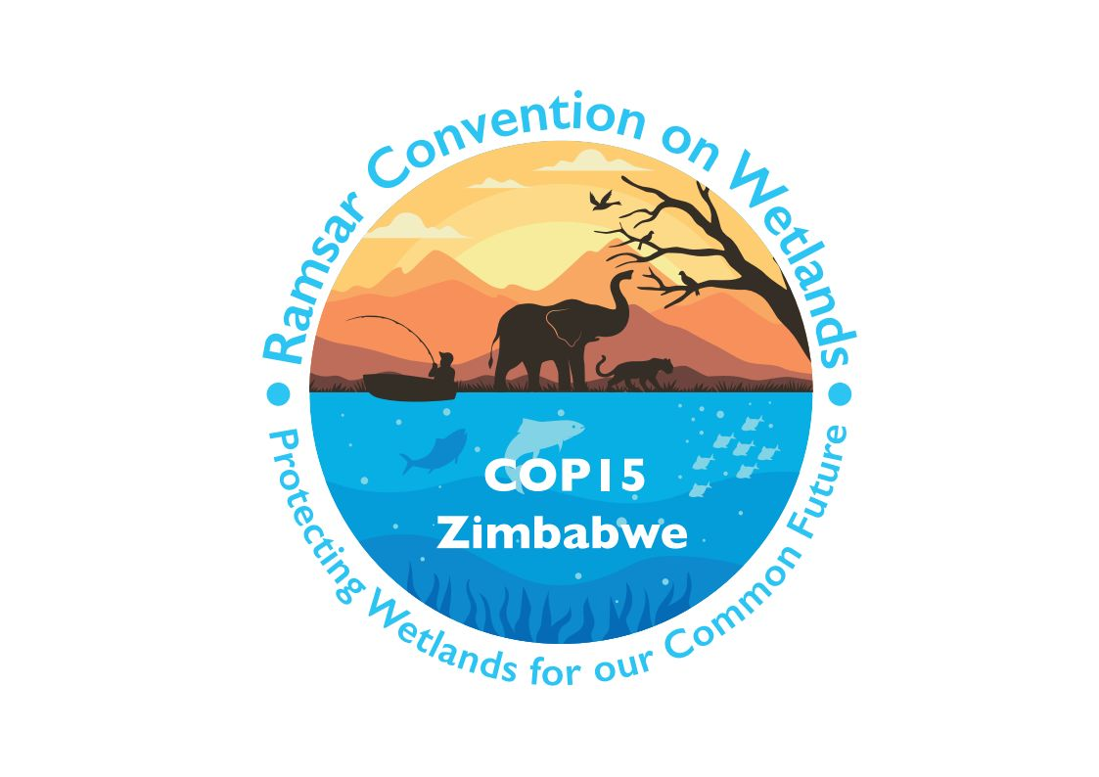

15th meeting of the Conference of the Contracting Parties

to the Convention on Wetlands

“Protecting wetlands for our common future”

Victoria Falls, Zimbabwe, 23-31 July 2025

COP15 Doc.23.20

Note from the Secretariat:

At its 64th meeting, the Standing Committee in Decision SC64-37 instructed the Secretariat to submit the draft resolution in document SC64 Doc.29.9 Rev.1 on Promoting sustainable lifestyles for the wise use of wetlands to COP15 for its consideration, amended to take into account the inputs presented by the Committee.

Draft resolution on promoting sustainable lifestyles
for the wise use of wetlands

Submitted by India

1. RECALLING the commitment of Contracting Parties to the Convention on Wetlands for wise use of wetlands under Article 3 of the Convention and Resolution IX.1 Annex A on A Conceptual Framework for the wise use of wetlands and the maintenance of their ecological character;

2. CONCERNED about the rapid decline of wetlands and concomitant impacts on biodiversity and human wellbeing, and RECOGNIZING the urgency of actions needed at various levels for conservation of wetlands, and their wise use;

3. RECALLING Resolution XI.12 on Wetlands and health: taking an ecosystem approach which recognizes the close specific linkages between wetland ecosystems and human livelihoods and improved lifestyles, and which strongly urges the Contracting Parties to adopt an ecosystem-based approach for health of wetlands and their catchments;

4. RECOGNIZING the inclusion of wetlands within the Kunming-Montreal Global Biodiversity Framework, and a call for a whole-of-society approach for actions at all levels and by all actors of society to halt and reverse biodiversity loss;

[5. RECALLING Resolution 6/8 on Promoting Sustainable Lifestyles adopted by the United Nations Environment Assembly in its sixth session, which recognizes the potential of behavioural changes towards sustainable lifestyles to achieve the three dimensions of sustainable development and calling upon the Parties to promote the necessary evidence-based enabling conditions, foster public and private collaboration, pursue education at all levels and awareness-raising initiatives to support empowering of citizens to make informed choices, including about sustainable lifestyles;]

6. RECOGNIZING the potential of voluntary behavioural changes towards sustainability, in contributing to the achievement of wetlands conservation and wise use, and AWARE that more attention has to be paid to the potential of actions to be taken at all levels;

7. NOTING the work of the 10-Year Framework of Programmes on Sustainable Consumption and Production Patterns, including the One Planet network’s Sustainable Lifestyles and Education Programme and other international, regional and national initiatives;

8. REAFFIRMING the commitment made in the 2030 Agenda for Sustainable Development to ensure that people everywhere have the relevant information and awareness for sustainable development and lifestyles in harmony with nature (Goal 12.8);

[9. RECALLING the recommendation made under Resolution XIV.8 on The new CEPA approach to investigate opportunities to improve wetlands conservation by applying techniques drawn from behavioural economics and psychology and undertaking joint projects with behavioural insights;]

10. FURTHER RECOGNIZING and UNDERSCORING the role of [Indigenous Peoples and local communities,] the private sector and industry, and local authorities in adoption of livelihoods for more sustainable lifestyles, and RECOGNIZING that adequate individual education and skills can further accelerate collective efforts for sustainable consumption and production and promote more sustainable lifestyles; and

11. RECOGNIZING that each Contracting Party is best positioned to understand its own national circumstances and priorities to encourage more sustainable lifestyles;

THE CONFERENCE OF THE CONTRACTING PARTIES

12. [ENCOURAGES] Contracting Parties to consider [the integration of] sustainable lifestyles-based interventions in [their] wetland management plans, programmes and investments at all levels, and in accordance with their national legislation, circumstances, priorities and capabilities;

13. [ENCOURAGES] Contracting Parties to create enabling conditions, including fostering public and private collaboration, pursuing education at all levels and awareness-raising initiatives to enhance the wise use of wetlands, taking into account national circumstances;

14. REQUESTS the Scientific and Technical Review Panel, subject to available resources, to submit a compilation of the methods, case studies and evidence base to support the integration of sustainable lifestyles in wetlands management, and for living in harmony with Nature, or Mother Earth, as recognized by some countries and regions to enable sustainable lifestyles; and

15. INVITES the International Organization Partners of the Convention, non-governmental organizations, the private sector and other stakeholders to promote and enhance cooperation, sharing information and best practices, research and literature, as appropriate, that enable the adoption of more sustainable lifestyles, including sustainable living within wetland conservation and wise use interventions.

For the United Nations Environment Programme meaning of sustainable lifestyles, see https://www.unep.org/explore-topics/resource-efficiency/what-we-do/sustainable-lifestyles.

