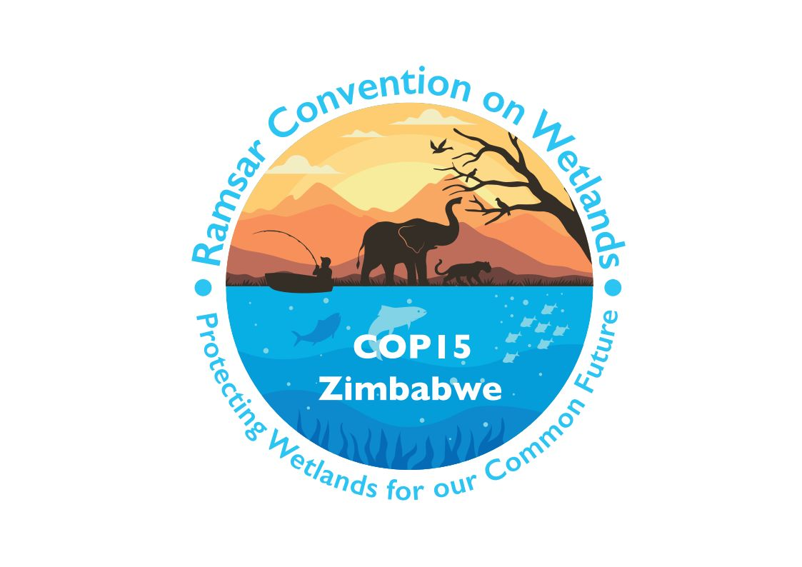

15th meeting of the Conference of the Contracting Parties

to the Convention on Wetlands

“Protecting wetlands for our common future”

Victoria Falls, Zimbabwe, 23-31 July 2025

COP15 Doc.23.19

Note from the Secretariat:

At its 64th meeting, the Standing Committee in Decision SC64-35 instructed the Secretariat to submit the draft resolution in document SC64 Doc.29.8 Rev.1 on Youth empowerment and integration: driving engagement in and the longevity of the Convention on Wetlands to COP15 for its consideration, amended to take into account the inputs presented by the Committee.

Draft resolution on youth empowerment and integration:
driving engagement in and the longevity of the Convention on Wetlands

Submitted by Australia

1. REAFFIRMING the importance of mainstreaming the participation of under-represented groups in the implementation of the Convention, in accordance with, inter alia: Resolution XIII.15 on Cultural values and practices of indigenous peoples and local communities; Resolution XIII.18 on Gender and wetlands; Resolution VII.8 on Guidelines on establishing and strengthening local communities’ and indigenous people’s participation in the management of wetlands; and Resolution XIV.12 on Strengthening Ramsar Connections through youth;

2. NOTING that Resolution XIV.12 urges Contracting Parties to recognize the importance of engaging young people in the implementation of the Convention and encourages Contracting Parties to explore and support strategies to engage, collaborate with and involve youth in the implementation of the Convention;

3. FURTHER NOTING that Resolution XIV.12 requests the Standing Committee to establish a Ramsar Youth Working Group to mainstream youth engagement in the Convention, with the Working Group to report to the Standing Committee including making any recommendations about capacity building and policy guidance for Contracting Parties, and identify capacity-building activities to assist Contracting Parties to implement strategies to engage youth;

4. REAFFIRMING the recommendations made in Resolution XIV.12 for Contracting Parties, International Organization Partners of the Convention, the business and financial sectors, non-government community organizations and higher education and research institutions, and the private sector and organized civil society to explore and support strategies to engage, collaborate with and involve youth;

5. NOTING that Resolution XIV.6 on Enhancing the Convention’s visibility and synergies with other multilateral environmental agreements and other international institutions includes the aim of institutional strengthening and organizational robustness; and CONVINCED of the potential of youth engagement and integration in the Convention to support these aims as well as supporting the general longevity of the Convention;

6. RECALLING that Resolution XIV.6 instructs the Secretariat to continue working to strengthen collaboration with the World Bank, United Nations agencies and other multilateral environmental agreements (MEAs), and that Resolution XIV.12 requests the Secretariat to coordinate with the secretariats of other international environmental Conventions on allied work to strengthen youth participation, to assist in implementing this Resolution;

7. NOTING that the Youth Strategy 2022-2030 of the International Union for Conservation of Nature includes the principles of mainstreaming engagement of young people into IUCN’s programme, projects and governance, and ensuring that efforts are Union-wide, involving actions by all parts of IUCN;

8. APPLAUDING the 2024 Global Youth Declaration on Environment, developed by the Children and Youth Major Group to the United Nations Environment Programme (UNEP) and presented at the sixth session of the United Nations Environment Assembly (UNEA6), which calls on UNEP, UNEA and member states to institutionalize the principle of intergenerational equity in environmental governance, including by increasing the inclusion of children and youth through enhancing youth representation and participation in decision-making processes within UNEP, UNEA and MEAs; and

9. ACKNOWLEDGING the Pact for the Future that includes a Global Digital Compact and a Declaration on Future Generations, adopted by world leaders at the UN “Summit of the Future” in September 2024, which commits the Heads of State and Government of the UN member states to five actions related to youth, including strengthening meaningful youth participation at the national and international levels; and the UN Secretary-General’s endorsement of the Pact as a groundbreaking commitment by governments to listen to young people and include them in decision-making, at the national and global levels;

THE CONFERENCE OF THE CONTRACTING PARTIES

10. APPROVES the extension of the term of the Youth Working Group to continue into the 2025-2028 triennium, acknowledging the ongoing importance of the full implementation of Resolution XIV.12 and the Youth Workplan, including implementation of the recommendations from the consultancy;

11. DIRECTS the Standing Committee, at its 66th meeting, to re-establish a Youth Working Group to continue the work of mainstreaming youth engagement in the Convention, with a mandate to:

a. develop recommendations for embedding youth engagement in the Convention for the long term and produce a draft resolution, with the intention to be submitted to COP16, to the Standing Committee with the recommendations;

b. endorse best practices for youth engagement; and

c. collaborate with other youth organizations;

12. APPROVES the new Youth Working Group terms of reference, as outlined in Annex 1 of the present Resolution, including an updated mandate to implement the recommendations and outputs of the consultancy;

13. REQUESTS that, subject to available resources, the Secretariat continue to employ the capacity of its junior professional programme to assist with coordination of the Youth Working Group and the Youth Workplan;

14. [URGES][INVITES] the Secretariat to [call for voluntary financial contributions,] inform the Youth Working Group of available funding opportunities, and establish connections with potential donor partners which can offer financial support to the Working Group, as appropriate, to facilitate the Working Group and youth engagement and projects more broadly, including professional secondments to support the employment of a youth advisor as well as the following potential [funding] opportunities:

a. logistical or administrative services beyond what the Secretariat can provide, such as meeting and document translation into multiple languages;

b. potential updates to the online community platform, as required;

c. if the Youth Working Group decides to establish a dedicated youth body or constituency, then the funding required for its establishment, operation and sustainability;

d. future youth events and/or capacity-building training events;

e. travel support for the attendance of Youth Focal Points at Convention meetings; and

f. National-level youth-related project and policy support, particularly for developing countries;

15. [ENCOURAGES][INVITES] Contracting Parties [, in line with their national practical circumstances,] to empower their Youth Focal Point to participate in decision-making processes at the national and international levels, [as appropriate,] including by:

a. including Youth Focal Points in the National Ramsar Committees;

b. consulting with them while developing and updating national wetland-related policies, projects, decision-making and programmes;

[c. appointing them as national or regional representatives in the Convention’s working groups and subsidiary bodies; and

d. including them in country delegations to meetings of the Standing Committee and the Conference of the Contracting Parties;]

16. ENCOURAGES Contracting Parties to mandate the consideration of youth perspectives in all wetland-related priorities, policies, projects, decision-making and programmes, following the example of the United Nations Convention on the Rights of the Child (UNCRC), which dictates that children and young people have the right to have their views taken into account in matters that affect them (Article 12);

17. FURTHER ENCOURAGES Contracting Parties to allocate budget, where possible, for youth engagement and capacity-building opportunities in wetlands-related projects and programmes at national and local levels;

18. CALLS UPON all Convention working groups and subsidiary bodies to include at least one youth representative member (whether a Youth Focal Point or youth representative of the International Organization Partners of the Convention (IOPs)), [either as a member of the delegation or as an observer,] and ENCOURAGES their active participation in meetings;

[19. [INVITES young and early career scientists and researchers to engage as observers in the work of the STRP][ENCOURAGES the Scientific and Technical Review Panel (STRP) to engage with young and early career scientists and researchers for implementation of the STRP Workplan]; and]

20. INVITES the IOPs to strengthen youth involvement in their programmes and outreach including by participating in, and providing financial [contributions][opportunities] to, the Youth Working Group, aligning youth activities with the Youth Workplan, and including youth in key governance and decision-making processes and positions.

Annex 1
Youth Working Group Terms of Reference (TOR)

Composition and regional representation:
- The Working Group is to be composed of members between the ages of 18 and 35, where possible, with at least one member to be nominated by each Ramsar region;
- Each Ramsar regional group will provide one regional representative, and Contracting Parties may nominate additional representatives;
- The Working Group will strive for inclusion and diversity in its membership by giving priority to minorities and Indigenous Peoples and ensuring gender parity, and adhere to these principles via its organizational structure and mandate;
- National Youth Focal Points and a youth representative of the International Organization Partners will have observer status on the Working Group, unless otherwise nominated as the member for a Ramsar region. To maintain the functionality of the Working Group, the size of the Working Group may be limited if numbers become too large, including by restricting the number of National Youth Focal Points per region in line with the Standing Committee regional representation (with regions to nominate amongst themselves and consider rotating positions);
- Youth Engaged in Wetlands (YEW) is [an observer][a member organization] of the Working Group, unless one third of members vote against this;
- Youth observers may nominate themselves, and the Working Group will approve their admission unless one third of regional representatives of Youth Focal Point members vote against this;
- Other youth-led wetlands-focused organizations may nominate one representative to be appointed as an observer of the Youth Working Group, unless one third of members vote against this;
- Other youth that express their interest in the work of the Youth Working Group will be invited to join the wider youth network. They will have the opportunity to participate in meetings, workshops, and, occasionally, document consultation, as well as actively engage with the online community platform;
- Youth Focal Points have the responsibility to represent their region and facilitate communication within their local networks, ensuring that diverse voices are heard. Meanwhile, other youth can actively participate within the Youth Working Group. All levels of participation can access to the wider youth network and collaborate in a broader way.

Structure and Secretariat support:
- The Working Group will appoint a Chair and a Vice-Chair, and any other roles that it deems necessary, with the Vice-Chair acting as Rapporteur;
- The Convention’s Rules of Procedure apply to this Working Group as applied to other working groups of the Conference of Contracting Parties or Standing Committee;
- For the purpose of liaising between working groups and providing updates to the Youth Working Group, the Working Group will nominate one or more of its members, based on their skills and interests, to be observer/s on the Scientific and Technical Review Panel (STRP), and the Communication, Capacity Building, Education, Participation and Awareness (CEPA) Oversight Panel (this may be the CEPA OP youth representative); and to observe on any other Working Group established by the Conference of the Contracting Parties, as Working Group capacity allows;
- The Secretariat will provide secretariat services for the Working Group, while seeking assistance from the Chair, Vice-Chair and Working Group members where possible.

Mandate:
The purpose of the Working Group is to advise on mainstreaming youth engagement in the governance, programmes of work and other activities of the Convention.
The priority tasks of the Working Group in the 2025-2028 triennium (to COP16) are to:
i. further implement the Youth Workplan;
ii. implement recommendations and outputs from the consultant including:
- guidance for young professionals and other youth to engage with wetland policy processes at national and international levels;
- guidance for countries that are Contracting Parties to the Convention to engage youth in wetland conservation, restoration, and policy, nationally;
iii. identify capacity-building activities to assist Contracting Parties to implement strategies to engage youth;
iv. report to the Standing Committee, including making any recommendations about capacity building and policy guidance for Contracting Parties;
v. investigate, explore and, if required, develop a process for establishing a youth body, constituency or some sort of advisory committee to the Convention, in a format similar to the CEPA Oversight Panel, YOUNGO, the Children and Youth Major Group to UNEP, or other related body, while ensuring that the body does not replace the participation of other independent youth groups, but instead complements and balances the diverse and meaningful engagement of different youth perspectives;
vi. submit a draft resolution to the Standing Committee with the recommendations for embedding youth engagement in the Convention for the long term, including, if required, the establishment of a youth body with guidance on how youth are appointed to the body;
vii. seek funding opportunities to build youth capacity to strengthen youth participation in
decision-making process; and
viii. monitor indicators to track the progress of the Youth Workplan.

Youth Workplan Implementation:
The implementation of the Youth Workplan tasks is a shared responsibility between the Working Group, the Secretariat, the Contracting Parties and International Organization Partners (IOPs), and the wider youth network (including Youth Engaged in Wetlands (YEW)).
Generally, the Working Group is responsible for the Youth Workplan tasks that provide guidance to the Convention and Contracting Parties, whereas Contracting Parties are responsible for tasks aimed at all Contracting Parties, and the wider youth network are responsible for tasks aimed at youth.

Modus operandi:
i. The Working Group members should, as much as possible and as necessary, consult with and seek input from the Youth Focal Points and the wider youth network.
ii. The Working Group will operate as much as possible through electronic means (email, video conferences, SharePoint etc.).
iii. The Working Group will use the online community platform to facilitate the work of the wider youth network.
iv. The Working Group will report on its progress to each meeting of the Standing Committee.
v. The main working language of the Working Group will be English. Formal outputs of the Working Group to Standing Committee and COP (Standing Committee reports and draft resolutions) will be translated into the official languages of the Convention and other languages and published on the Convention website.

See Annex 1 of document SC64 Doc.16: https://www.ramsar.org/document/sc64-doc16-report-youth-working-group.
See link to the consultancy terms of reference (to be presented between SC64 and SC65).
See link to Consultancy TOR.
See paragraph 13 of Resolution XIV.12 on Strengthening Ramsar connections through youth: https://www.ramsar.org/document/resolution-xiv12-strengthening-ramsar-connections-through-youth.
YOUNGO is the official children and youth constituency of the United Nations Framework Convention on Climate Change (UNFCCC). See https://unfccc.int/topics/action-for-climate-empowerment-children-and-youth/youth/youngo.

