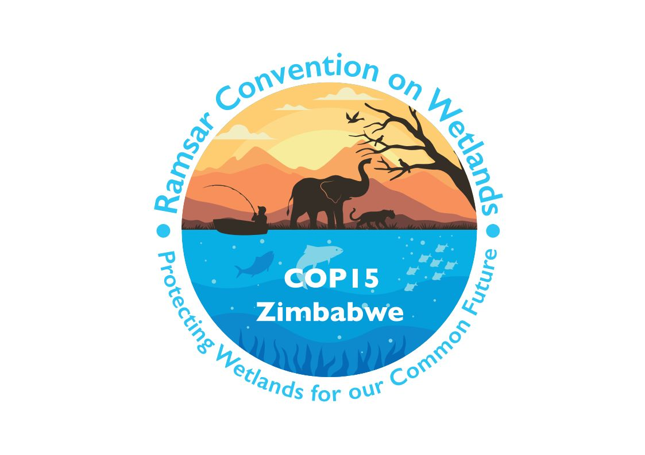

15th meeting of the Conference of the Contracting Parties

to the Convention on Wetlands

“Protecting wetlands for our common future”

Victoria Falls, Zimbabwe, 23-31 July 2025

COP15 Doc.23.18

Note from the Secretariat:

At its 64th meeting, the Standing Committee in Decision SC64-33 instructed the Secretariat to submit the draft resolution in document SC64 Doc.29.5 Rev.1 on Achieving the equitable governance and effective conservation of wetlands as protected areas and other effective area-based conservation measures (OECMS) to COP15 for its consideration, amended to take into account the inputs presented by the Committee.

Draft resolution on achieving the equitable governance
and effective conservation of wetlands as protected areas
and other effective area-based conservation measures (OECMs)

Submitted by the United Kingdom of Great Britain and Northern Ireland, and Zimbabwe

1. NOTING WITH ALARM the ongoing loss and degradation of wetlands globally and underlining that a substantial increase in and enhancement of the area of wetlands under equitable governance and effective conservation management is [important][critical] to address the loss and degradation of wetlands globally;

2. ACKNOWLEDGING that wetlands are important to address biodiversity loss, to mitigate and adapt to climate change and to support livelihoods, offering [an][a cost-effective] opportunity for social, economic and environmental benefits of return on investment from a range of public and private funding mechanisms as innovative approaches to addressing these challenges;

3. FURTHER ACKNOWLEDGING [that the economic benefits of reversing wetland loss and degradation are greater than the cost of conserving and restoring these critical ecosystems and] that there is an imperative need for increased funding, from all [available] sources, for wetland conservation and restoration;

4. RECALLING Contracting Parties’ obligations under the Convention to list sites and formulate and implement their planning so as to promote the conservation of the wetlands included in the List of Wetlands of International Importance (the Ramsar List);

5. RECALLING Resolution IX.22 on Ramsar Sites and systems of protected areas; Resolution XII.15 on management and conservation effectiveness of Ramsar Sites; Resolution VIII.14 on management planning for Ramsar Sites and other wetlands; Resolution IX.6 on guidance for Ramsar Sites that no longer meet the Criteria for designation; and Resolution VII.12 on Sites in the Ramsar List;

6. WELCOMING the Kunming-Montreal Global Biodiversity Framework (KM-GBF) adopted by the Conference of the Parties to the Convention on Biological Diversity and recalling Resolution XIV.6 on synergies which recognizes “the importance of Ramsar Sites for implementation of the Convention on Biological Diversity (CBD) and the Global Biodiversity Framework” (paragraph 43);

7. RECALLING Decision 16/1 of the CBD made at the sixteenth meeting of the Conference of the Parties to that Convention (CBD COP16), that requests Parties to the CBD that have not yet done so to revise or update their national biodiversity strategies and action plans, to align with the KM-GBF as requested in Decision 15/6 adopted at CBD COP15;

8. NOTING that a Wetland of International Importance may be a protected area, or alternatively may qualify and be recognized as an other effective area-based conservation measure (OECM), where legal, management or institutional frameworks providing long-term protection are being fully applied to that geographic area; ALSO NOTING that the OECM framework complements the protected area network by recognizing the contribution that areas located outside the formally designated protected area network make to biodiversity conservation;

9. FURTHER NOTING that the Parties to the CBD in Decision 14/8 have adopted a definition, guiding principles, common characteristics and criteria for identifying OECMs;

10. FURTHER NOTING the potential for Wetlands of International Importance to further contribute to Target 3 of the KM-GBF as protected areas or OECMs [, and Goal 3 of the Fifth Strategic Plan to designate and effectively manage XXX Wetlands of International Importance by 2030];

11. FURTHER NOTING the important opportunity to identify and recognize as protected areas or OECMs other wetlands that meet the criteria, which are not Wetlands of International Importance, which further facilitates the goals of the conservation and wise use of wetlands and contribution to KM-GBF Target 3;

12. RECOGNIZING that, for those Parties that are signatories to both Conventions, the commitment to achieve wise use of wetlands and maintain their ecological character is well aligned with the objectives of the CBD and the goals and targets of the KM-GBF [adopted thereunder];

13. RECOGNIZING that many Contracting Parties need to develop national systems and policy, and institutional and financial frameworks, for identification, recognition, monitoring and management of OECMs, and that the need to explicitly embed wetlands in these processes could further facilitate the integration of additional wetlands in area-based conservation;

[14. FURTHER RECOGNIZING that, despite the existence of a range of existing private and public [nature/biodiversity] finance mechanisms, there is a need to improve their accessibility and application to the conservation and restoration of wetlands;]

[14.bis FURTHER RECOGNIZING that developing countries face specific challenges to leverage resources and that the lack of financial resources significantly undermines the capacity of developing countries to achieve the Convention’s objectives, and that there is therefore a need to substantially increase the provision of financial resources to support developing country Contracting Parties;]

[15. NOTING the Briefing Note on Wetlands and OECMs produced by the Convention’s Scientific and Technical Review Panel, which proposes the application of the OECM criteria adopted in Decision 14/8 of the CBD for identification of wetland OECMs, a framework for screening wetland OECMs, and recommendations for governing and managing wetland OECMs, and which highlights the limitations of current reporting on Wetlands of International Importance;] and

16. RECOGNIZING that as of the 15th meeting of the Conference of the Contracting Parties (COP15) Wetlands of International Importance cover [257,317,367] hectares and have the potential to significantly contribute towards delivery of KM-GBF Target 3 as reported through the World Database on Protected Areas and World Database on OECMs, but that not all such wetlands are managed and/or recognized as protected areas or OECMs;

The Conference of Contracting Parties

17. REAFFIRMS the role of the Convention on Wetlands as the lead partner for the objectives related to wetlands in implementing the Convention on Biological Diversity (CBD) and the contribution of Contracting Parties through the Convention on Wetlands in delivering Target 3 of the Kunming-Montreal Global Biodiversity Framework (KM-GBF) and other associated targets including Targets 2 and 4;

18. ENCOURAGES Contracting Parties, [in accordance with national priorities and circumstances] [where appropriate], to update their National Biodiversity Strategies and Action Plans (NBSAPs) and National Biodiversity Finance Plans to prioritize the role of Wetlands of International Importance as either protected areas or other effective area-based conservation measures (OECMs), and of other wetlands (as OECMs), in meeting KM-GBF Target 3 [recognizing the need for enhanced support to developing countries to that end, including through new and additional financial resources, capacity building and scientific and technical cooperation];

19. ADOPTS the following CBD definitions of protected areas and OECMs:

i. Protected areas: “Protected area means a geographically defined area which is designated or regulated and managed to achieve specific conservation objectives” (CBD Convention text); and

ii. OECMs: “Other effective area-based conservation measure” means “a geographically defined area other than a Protected Area, which is governed and managed in ways that achieve positive and sustained long-term outcomes for the in-situ conservation of biodiversity, with associated ecosystem functions and services and where applicable, cultural, spiritual, socio-economic, and other locally relevant values” (CBD Decision 14/8);

20. INVITES Contracting Parties to embed Wetlands of International Importance, and other effectively managed wetlands, into national systems of protected areas and/or OECMs, in support of KM-GBF Target 3[, in accordance with national priorities and circumstances];

21. ENCOURAGES Contracting Parties, with the support of the Secretariat of the Convention, the Scientific and Technical Review Panel (STRP), the International Organization Partners of the Convention, Ramsar Regional Initiatives, the CEPA (Communication, Capacity Building, Education, Participation and Awareness) Programme, and other partners to, where appropriate, contribute towards the achievement of KM-GBF Target 3 by:

i. Conserving and effectively managing wetlands identified as important under systems of protected areas and OECMs, in which they have been individually assessed on an individual basis as meeting the criteria of a protected area or OECM;

ii. Developing and updating site management plans or other management measures to achieve the long-term conservation of the wetland sites;

iii. Assessing existing Wetlands of International Importance not currently managed as protected areas or OECMs, to identify where formalization of their protection, where possible and appropriate, would strengthen their achievement of positive biodiversity outcomes and solidify their contribution towards KM-GBF Target 3;

iv. Undertaking consistent and regular monitoring of the biodiversity within protected areas and OECMs for their contribution to the conservation of important biological diversity, and adapting the in-situ management based on the monitoring results and other evidence;

v. Ensuring that a clear governance mechanism or structure is in place for the management of the Wetlands of International Importance or other wetlands within protected areas or OECMs, which recognizes and respects Indigenous Peoples and local communities;

vi. Ensuring that Wetlands of International Importance have up-to-date site boundaries recorded as spatial data that is usable within a geographic information system (GIS);

vii. Submitting site boundaries for qualifying Wetlands of International Importance to the World Database on Protected Areas and the World Database on OECMs to facilitate site safeguarding [, business disclosure processes and targeting of investments in line with recognized international frameworks such as the Taskforce on Nature-related Financial Disclosures (TNFD)];

[viii. Developing long-term financing solutions to fund wetland protected areas and OECMs and their effective conservation and management[, taking into account the specific challenges of developing countries, including through, but not limited to, initiatives in the Biodiversity Finance Initiative (BIOFIN) catalogue];]

[viii bis. Enhancing international cooperation to support developing countries in the establishment and effective management of systems of protected areas and OECMs through new and additional financial resources, scientific and technical cooperation and capacity building;]

[ix. Employing the OECM site-level tool, published by the IUCN World Commission on Protected Areas, for identifying and evaluating OECMs; and]

x. Assessing the governance equity and management effectiveness of sites against global guidelines and benchmarks, and prioritizing actions based on the findings;

22. REQUESTS that the Secretariat, subject to available resources, support Contracting Parties, in contributing to achievement of KM-GBF Target 3, including by supporting improved access to [nature/biodiversity] finance mechanisms, by:

i. Working with Contracting Parties to share national experiences and case studies on the effective implementation of equitable and effective protected areas and OECMs, relevant to the objectives of the Convention;

ii. [Updating the Ramsar Information Sheets to include a mandatory field on governance type for all Wetlands of International Importance, to ensure they can be reported in the World Database on Protected Areas or the World Database on OECMs;]

iii. Working with the United Nations Environment Programme World Conservation Monitoring Centre (UNEP-WCMC) to support Contracting Parties in ensuring that boundaries of Wetlands of International Importance reported by Parties are included in the Protected Planet platform, including details on their protected area/OECM status, improving the accuracy and transparency of global data on wetlands [, and facilitating opportunities provided through the TNFD to identify nature-positive investment opportunities];

iv. Working with the Secretariat of the CBD to provide strategic advice, as appropriate, concerning national actions that Parties may take to support collaboration, cooperation and synergies between the Conventions,[ to achieve the objectives of the Convention and the goals and targets of the KM-GBF [adopted thereunder], including those actions which may be financed by the Global Environment Facility (GEF) and Global Biodiversity Framework Fund]; and

v. Providing input to the inter-secretariat consultation developing the draft programming directions and policy recommendations for the negotiations of the ninth replenishment of the GEF Trust Fund; and

23. REQUESTS that the STRP, subject to availability of resources, in collaboration with relevant stakeholders:

- Continue to adapt or, where needed, develop tools for, and guidelines on, managing wetland OECMs and assessing governance equity, management effectiveness and the long-term conservation of biodiversity, responding to the needs identified by Contracting Parties;

- Update guidance to Contracting Parties on integrating Wetlands of International Importance into national systems of protected and conserved areas, including recognizing, equitably governing and effectively managing wetland OECMs; and

iii. Provide technical support to Contracting Parties on delineating site boundaries in a geo-spatial format and developing effective management and governance plans for sites.

Global Wetland Outlook, 2021.
Global Wetland Outlook, 2025.

