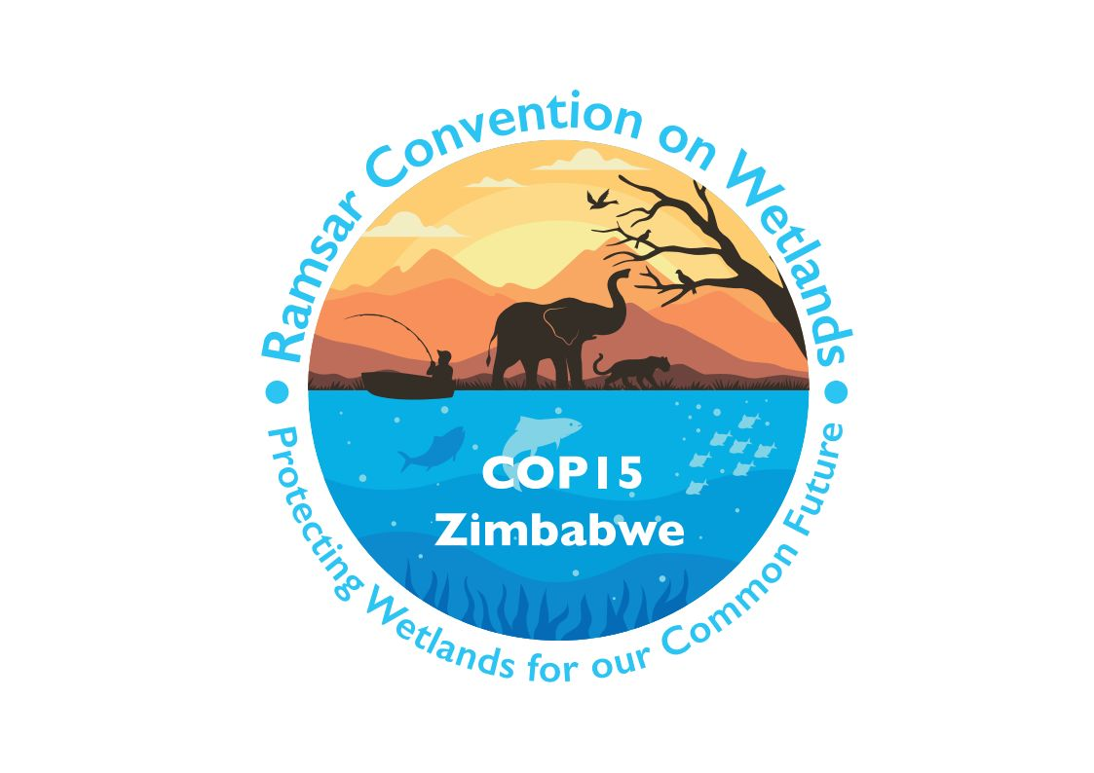

15th meeting of the Conference of the Contracting Parties

to the Convention on Wetlands

“Protecting wetlands for our common future”

Victoria Falls, Zimbabwe, 23-31 July 2025

COP15 Doc.23.17

Note from the Secretariat:

At its 64th meeting, the Standing Committee in Decision SC64-32 instructed the Secretariat to submit the draft resolution in document SC64 Doc.29.4 Rev.2 on Promoting incorporation of new technology and traditional knowledge in wetland conservation, restoration, management, and wise use to COP15 for its consideration, amended to take into account the inputs presented by the Committee.

Draft resolution on promoting incorporation of new technology
and traditional knowledge in wetland conservation, restoration, management and wise use

Submitted by China, Burkina Faso, Cambodia, Gabon, Libya, Madagascar and Panama

1. AWARE that science, technology and innovation are means to implement and revitalize the Global Partnership for Sustainable Development under Goal 17 of the United Nations 2030 Sustainable Development Goals (SDGs); and that the United Nations Technology Facilitation Mechanism was established and aimed at supporting the SDGs;

2. NOTING that new technologies and traditional knowledge and practice are important working areas and initiatives to address global challenges in environment and sustainable development in multiple UN programmes and specialized agencies, including the UN Secretary-General’s Strategy on New Technologies, the UN Environment Programme’s Digital Transformations, the Coalition for Digital Environmental Sustainability (CODES), and the Science, Technology and Innovation (STI) system and Local and Indigenous Knowledge Systems (LINKS) of the UN Educational, Scientific and Cultural Organization (UNESCO);

3. ALSO NOTING that the UN Framework Convention on Climate Change (UNFCCC) established its Technology Mechanism in 2010; and that the Parties to the Convention on Biological Diversity (CBD) confirmed in Section C of Decision 15/4 that implementation of the Kunming-Montreal Global Biodiversity Framework (KM-GBF) should be based on scientific evidence and traditional knowledge and practices, recognizing the role of science, technology and innovation;

4. ACKNOWLEDGING that advances in and practices of new technology are contributing to wetland conservation, restoration, management and wise use, providing significant support to wetland inventory and monitoring, ecological character assessment, trend analyses and predictions, regulation of hydrological and ecological processes, etc;

5. ALSO ACKNOWLEDGING that traditional knowledge has an irreplaceable value and role in wetland conservation, restoration, management, and wise and sustainable use; and NOTING that a number of Wetlands of International Importance are also nominated as World Natural and Cultural Heritage Properties or Cultural Heritage Landscapes, or Biosphere Reserves, for example for their traditional wetland agriculture;

6. AWARE that scientific knowledge and indigenous and local knowledge are integral parts of knowledge systems; and REALIZING that modern science-based technology and traditional knowledge are inseparable in long-term human development and both vital to build a harmonious relationship with nature;

7. RECALLING that the guiding principles for the consideration of traditional knowledge in wetlands management, developed based on shared expertise and information among Contracting Parties in Resolution VII.19 indicate that the Convention will increase its efforts to preserve, promote and incorporate traditional knowledge, innovations and practices among Contracting Parties, complying with the international principle that guarantees the rights of Indigenous Peoples (free, prior and informed consent) and the Indigenous and Tribal Peoples Convention 1989 (No. 169);

8. ACKNOWLEDGING that the Scientific and Technical Review Panel has developed many of the technology- and knowledge-related publications for the Convention since 2006;

9. WELCOMING the fact that Standing Committee in Decision SC63-26 decided the theme of World Wetlands Day 2026 as “Wetlands and traditional knowledge: Celebrating cultural heritage”;

10. NOTING that traditional knowledge and technology are addressed in Target [xx] of the Fifth Strategic Plan of the Convention (Resolution XV.xx Annex 2); and

11. REALIZING the significance of the incorporation and integration of new technology and traditional knowledge in wetland conservation, restoration, management, and wise and sustainable use;

THE CONFERENCE OF THE CONTRACTING PARTIES

12. AFFIRMS that Contracting Parties have different approaches and practices in promoting new technology and preserving traditional knowledge at national and local levels depending on their national situation, culture and available resources;

13. URGES Contracting Parties, respecting free, prior and informed consent of Indigenous Peoples and local communities, to promote the development of science, technology, and innovation in benefit of wetland conservation, as well as of the welfare of wetland-based local communities;

14. ENCOURAGES Contracting Parties to share technology and knowledge relevant to wetland conservation and management, [on a voluntary basis and mutually agreed terms] as appropriate, for promotion of integrative development of new technologies and traditional knowledge at regional and global levels through multiple mechanisms, including Ramsar Regional Initiatives, thematic fora for addressing cross-cutting issues such as the World Coastal Forum, other programmes of multilateral environmental agreements and initiatives led by the International Organization Partners (IOPs) of the Convention;

15. FURTHER ENCOURAGES Contracting Parties, respecting free, prior and informed consent of Indigenous Peoples and local communities, to promote the incorporation and integration of new technology and traditional knowledge, [on a voluntary basis and mutually agreed terms] as appropriate, in wetland conservation, restoration, management and wise use, while respecting their national circumstances and within available resources, and to share economic or other benefits from work undertaken on wetlands with the holders of traditional knowledge;

16. ENCOURAGES efforts to respect ownership of knowledge and maintain consistency with existing international agreements on intellectual property and principles of free, prior and informed consent regarding access to technology and knowledge, that should include protections around its dissemination according to the wishes of the participants;

17. INVITES those Contracting Parties incorporating and integrating new technology and traditional knowledge to share their good practices, experiences and lessons in wetland conservation, management and wise use [on a voluntary basis];

18. REQUESTS the Scientific and Technical Review Panel (STRP), subject to available resources and capacity, to:

a. review the advances and practices in wetland new technology and their application and the preservation status of wetland traditional knowledge;

b. develop guidance on incorporation and integration of new technology and traditional knowledge into wetland conservation, restoration, management, and wise and sustainable use in priority areas of new technology and traditional knowledge;

c. report to the Conference of the Contracting Parties at its 17th meeting (COP17), on refined areas of new technology and traditional knowledge regarding:
- wetland inventory (including of tangible and living heritage), mapping and monitoring;
- carbon calculation and estimation;
- evaluation of trends of ecological character changes;
- regulation of hydrological and ecological processes;
- ecosystem services valuation and trade-off;
- wise and sustainable use of wetland resources;
- threat treatment and management including restoration of and support for management of sacred sites;
- participatory management and decision making including for Indigenous territories;
- public access to technical and scientific information on wetlands stored in platforms created by the Contracting Parties; and
- systematic assessment of the ecological integrity of wetlands;

19. REQUESTS that, in tandem with this review, the STRP apply, as appropriate, the approach to recognizing and working with Indigenous and local knowledge of the Intergovernmental Science-Policy Platform on Biodiversity and Ecosystem Services, to ensure that ethical engagement protocols are followed when using traditional knowledge;

20. REQUESTS the Secretariat to assist the STRP on the review assignment described in paragraph 18 a) of the present Resolution; and

21. CALLS ON the IOPs, other NGOs, research institutions, and private sector bodies to contribute to the development and application of wetland new technology and its use for the preservation, promotion and incorporation of traditional knowledge.

Paragraph 70, the 2030 Agenda for Sustainable Development.
CBD/COP/DEC/15/4 Section C. Paragraph 7(l).
IPBES (2022). Summary for Policymakers of the Methodological Assessment Report on the Diverse Values and Valuation of Nature of the Intergovernmental Science-Policy Platform on Biodiversity and Ecosystem Services. Pascual, U, et al. IPBES secretariat, Bonn, Germany. https://doi.org/10.5281/zenodo.6522392
Annex Section D Paragraph D1.

