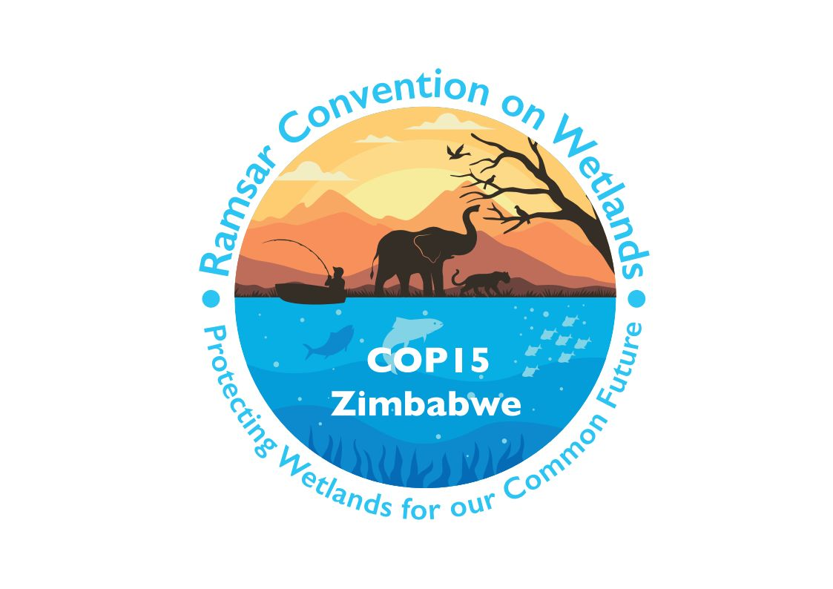

15th meeting of the Conference of the Contracting Parties

to the Convention on Wetlands

“Protecting wetlands for our common future”

Victoria Falls, Zimbabwe, 23-31 July 2025

COP15 Doc.23.16

Note from the Secretariat:

At its 64th meeting, the Standing Committee in Decision SC64-28 instructed the Secretariat to submit the draft resolution in document SC64 Doc.29.3 Rev.1, on Strengthening national actions for the conservation and restoration of waterbird flyways, to COP15 for its consideration, amended to take into account the inputs presented by the Committee.

Draft resolution on strengthening national actions
for the conservation and restoration of [waterbird flyways]
[critical waterbird flyway sites]

Submitted by China and Cambodia

1. RECALLING that “each Contracting Party shall consider its international responsibilities for the conservation, management and wise use of migratory stocks of waterfowl” under Article 2.6 of the Convention; that “each Contracting Party shall promote the conservation of wetlands and waterfowl by establishing nature reserves on wetlands” under Article 4.1; and that “the Contracting Parties shall endeavour through management to increase waterfowl populations on appropriate wetlands” under Article 4.4; and NOTING that conservation of migratory waterfowl and their habitat is one of the initial mandates of the Convention;

2. FURTHER RECALLING that Resolution X.22 on Promoting international cooperation for the conservation of waterbird flyways urges Contracting Parties, other governments and relevant organizations urgently to enhance their individual and collective efforts to address the root causes of the continuing decline in the status of waterbirds;

3. AWARE that the implementation of a flyway-scale approach is necessary for the conservation and restoration of the populations and habitats of migratory waterbirds, and RECALLING that the enhancement of international cooperation is urged in Resolution X.22;

4. WELCOMING progress made under the various international and regional flyway frameworks leading the advancement of the conservation of migratory waterbirds, such as the Convention on Migratory Species (CMS) and its Flyways Working Group, the African-Eurasian Migratory Waterbird Agreement (AEWA), and the East Asian-Australasian Flyway Partnership (EAAFP) founded in 2006 on the basis of Recommendation 6.4, Recommendation 7.3 and Resolution VIII.37 of the Convention on Wetlands and adopted as a Ramsar Regional Initiative (RRI) through Resolution IX.7;

5. WELCOMING the achievements of all Contracting Parties to the Convention in implementing actions for the conservation of migratory waterbirds through the conservation, restoration and wise use of wetlands which has led to the increase of some populations, such as the Siberian crane (Leucogeranus leucogeranus) and black-faced spoonbill (Platalea minor), and the designation of critical flyway sites such as the World Natural Heritage sites nominated by the People’s Republic of China and the Republic of Korea in the Yellow Sea ecoregion for migratory waterbirds since 2019, some of which are also Wetlands of International Importance;

6. ALSO WELCOMING the advances of Contracting Parties, non-Contracting Party range states and other organizations in the development of national action plans, site networks and other mechanisms to provide essential support to science-based flyway scale conservation through collaboration in monitoring and research at both national and international levels;

7. DEEPLY CONCERNED, despite these efforts, about the continued decline of migratory waterbird populations, with the 2024 update to the IUCN Red List of Threatened Species revealing a decline in populations of migratory shorebirds across the world, including declines of some common global populations of species by more than a third in recent decades as well as accelerated rates of declines;

8. AWARE that national actions such as national migratory waterbird censuses and wetland habitat inventories, conservation and restoration planning and implementation, national flyway site networking and engagement of national focal points, are the crucial foundation for international flyway conservation; and that efforts need to be made to strengthen national implementation of relevant mandates, particularly in relation to delivery of Resolution X.22;

9. NOTING that flyway conservation, as a large-scale biodiversity conservation action, significantly contributes to delivery of the Kunming-Montreal Global Biodiversity Framework across various targets including by delivering enhanced connectivity, as well as to synergy with the CMS and other relevant multilateral environmental agreements;

10. WELCOMING the establishment of the Waterbird Estimates Partnership in [Resolution XV.xx] to facilitate the necessary and timely updates of the global Waterbird Population Estimates;

11. ACKNOWLEDGING the economic, social and environmental costs of wetland loss and degradation, and the opportunities to increase funding, from all sources, for wetland conservation and restoration; and

12. ACKNOWLEDGING that the 11th Meeting of Partners (MOP 11) of the EAAFP, held in Australia in 2023, adopted Decision 10 on creation of a Youth Task Force, which recognized the implementation of Resolution XIV.12 of the Convention on Wetlands on Strengthening Ramsar connections through youth; ALSO ACKNOWLEDGING that the EAAFP Flyway University Alliance for Science and Education was established in China in 2024, to empower youth and academic stakeholders in flyway conservation and restoration and call for a joint science programme for flyways studies by interested universities and research institutes; and NOTING that such initiatives contribute to youth engagement in flyway conservation and restoration;

THE CONFERENCE OF THE CONTRACTING PARTIES

13. REAFFIRMS that the urgent need for national action for migratory waterbirds through implementation of Resolution X.22 in synergy with relevant flyway frameworks is significant for implementation of the Convention and for reversing the trend of global biodiversity loss and degradation, as well as for human wellbeing around migratory waterbird habitat wetlands;

14. INVITES Contracting Parties which are not members of relevant flyway initiatives to join and engage with those initiatives at national level, including the East Asian-Australasian Flyway Partnership (EAAFP); ALSO INVITES Contracting Parties of the Convention on Wetlands to build connections with the Convention on Migratory Species, especially its Flyways Working Group, and take synchronized and complementary actions to conserve migratory waterbirds;

15. ENCOURAGES Contracting Parties and other governments to conduct migratory waterbird censuses and/or waterbird population estimates, with wetland habitat assessment when they have the capacity, ensuring this data is incorporated into the data collated by the Waterbird Estimates Partnership to inform the management of critical flyway sites and review of flyway conservation status at national level;

16. INVITES Contracting Parties to develop a national action/implementation plan on conservation and restoration of migratory waterbird flyways, particularly critical wetland flyway sites;

17. CALLS ON Contracting Parties to establish and strengthen a national flyway partnership including participative and inclusive national stakeholder coordination mechanisms and a national flyway site network;

18. ALSO ENCOURAGES Contracting Parties and other states to support future flyway conservation status reports;

19. INVITES Contracting Parties and other states to support their flyway initiatives and the implementation of their flyway strategic plans and consider provisions for technical and financial support, and capacity building to least developed countries on a voluntary basis and mutually agreed terms;

20. INVITES Contracting Parties and other members of the EAAFP to join the EAAFP Youth Task Force; and INVITES global universities and institutes that are relevant to migratory bird flyway science and technology to join the EAAFP Flyway University Alliance and promote joint scientific research, shared education and training for youth, and networking of field observatories and laboratories;

21. CALLS ON the International Organization Partners of the Convention, other NGOs and private sector actors to support Contracting Parties and other governments in the process of development and implementation of national plans and actions on flyway conservation and restoration; and

22. INVITES Contracting Parties engaged with international bodies and initiatives such as the Convention on Migratory Species, the African-Eurasian Migratory Waterbird Agreement, the North American Waterfowl Management Plan, the Western Hemisphere Migratory Species Initiative and the Western Hemisphere Shorebird Reserve Network to exchange best practices and experiences in enhancing national actions to foster inclusive global flyway conservation efforts.

