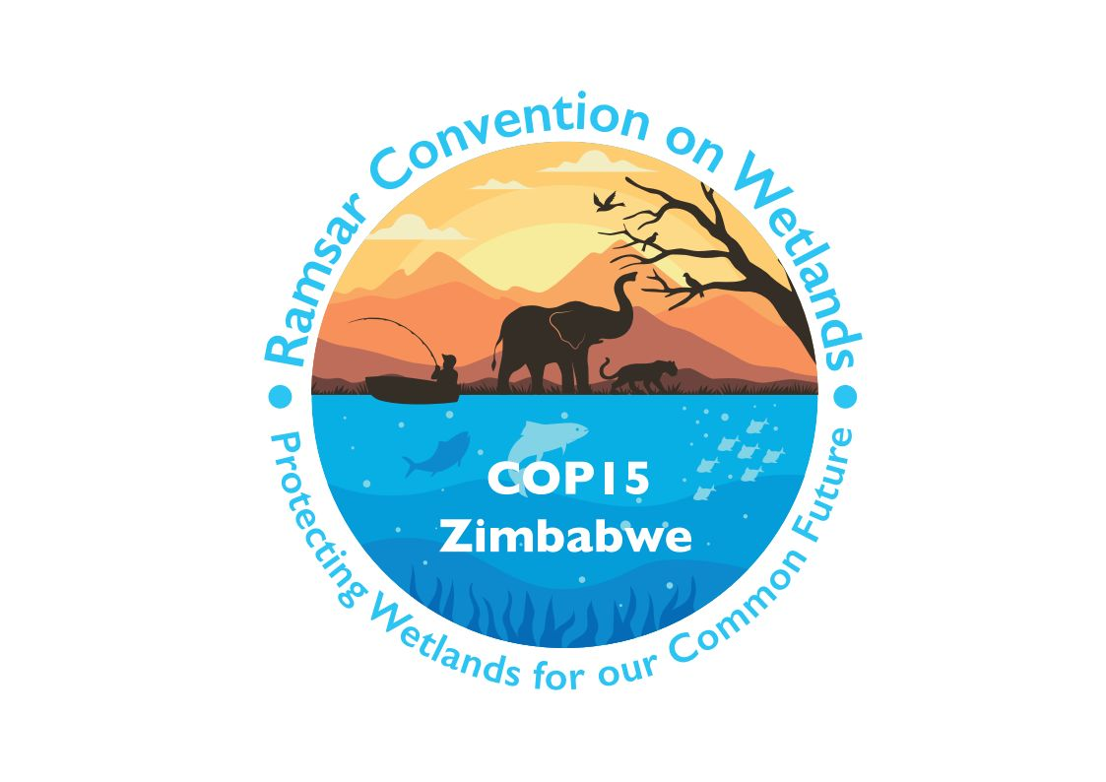

15th meeting of the Conference of the Contracting Parties

to the Convention on Wetlands

“Protecting wetlands for our common future”

Victoria Falls, Zimbabwe, 23-31 July 2025

COP15 Doc.23.15

Note from the Secretariat:

At its 64th meeting, the Standing Committee in Decision SC64-34 instructed the Secretariat to submit the draft resolution in document SC64 Doc.29.2 Rev.1 on Restoration of degraded freshwater ecosystems to support ecological character biodiversity and ecosystem services to COP15 for its consideration, amended to take into account the inputs presented by the Committee.

Draft resolution on restoration of degraded freshwater ecosystems to support ecological character biodiversity and ecosystem services

Submitted by Gabon, co-sponsors to be invited

1. RECALLING Resolutions XIV.6 on Enhancing the Convention’s visibility and synergies with other multilateral environmental agreements and other international institutions; XIV.16 on Integrating wetland protection, conservation, restoration, sustainable use and management into national sustainable development strategies; XIV.17 on The protection, conservation, restoration, sustainable use and management of wetland ecosystems in addressing climate change; XIII.13 on Restoration of degraded peatlands to mitigate and adapt to climate change and enhance biodiversity and disaster risk reduction; and XIII.14 on Promoting conservation, restoration and sustainable management of coastal blue-carbon ecosystems;

2. NOTING the focus on restoration in the Fifth Strategic Plan of the Convention on Wetlands, particularly in relation to targets [XXX];

3. ACKNOWLEDGING that restoration of freshwater ecosystems such as rivers, lakes and other wetlands, if complemented by other conservation measures, to address the drivers of wetland degradation, contributes to the implementation of multiple obligations or commitments under different multilateral environmental agreements, and to multiple Sustainable Development Goals including Goal 6 on “availability and sustainable management of water and sanitation for all” and Target 15.1 on ensuring the “conservation, restoration and sustainable use of terrestrial and inland freshwater ecosystems and their services, in particular (…) wetlands, (…) in line with obligations under international agreements”;

4. ACKNOWLEDGING the status of the Convention on Wetlands as a Global Partner to the UN Decade on Ecosystem Restoration and its ongoing activities on wetland restoration and protection;

5. WELCOMING the Kunming-Montreal Global Biodiversity Framework provisions relating to wetland restoration, in particular the inclusion of inland water ecosystems in Target 2: “Ensure that by 2030 at least 30 per cent of areas of degraded terrestrial, inland water, and coastal and marine ecosystems are under effective restoration, in order to enhance biodiversity and ecosystem functions and services, ecological integrity and connectivity”, alongside Target 1 (on spatial planning) and Target 3 (on area-based conservation through protected areas and OECMs), and NOTING that this is further reflected in the 6th Joint Work Plan, 2024-2030, of the Convention on Biological Diversity and the Convention on Wetlands;

6. ACKNOWLEDGING the status of the Convention on Wetlands as a Partner of UN-Water, the inter-agency coordination mechanism for the UN’s system-wide work on water and sanitation, and NOTING the adoption of the UN System-wide Strategy on Water and Sanitation aimed at improving the coherency and efficiency of the UN system’s work on water and sanitation, including restoration of freshwater ecosystems;

7. NOTING that the importance of restoring inland water ecosystems for climate mitigation and adaptation, alongside other conservation measures, is recognized in the global goal on adaptation and global stocktake under the Paris Agreement;

8. NOTING Resolution 3/10 of the United Nations Environment Assembly on Addressing water pollution to protect and restore water-related ecosystems; and UNEA Resolution 6/13 on Effective and inclusive solutions for strengthening water policies to achieve sustainable development in the context of climate change, biodiversity loss and pollution, which calls on all Member States and encourages others to “mainstream sustainable water management and the protection, conservation, restoration and sustainable management of aquatic ecosystems into relevant intergovernmental processes”;

9. EMPHASIZING that restoration of rivers, lakes and other freshwater ecosystems should not occur in isolation but, as appropriate, as part of a wider river-basin approach, considering water and land management at landscape and waterscape scales, and should be coupled with protection, conservation and management of freshwater ecosystems which are important for biodiversity and ecosystem services, including action to address the indirect and direct drivers of degradation, pollution and loss;

10. ACKNOWLEDGING the confirmation of the crucial roles of wetlands in blue and green waters, and hence in the hydrological cycle that underpins, directly or indirectly, all Sustainable Development Goals[, by the 2024 report the Global Commission on the Economics of Water];

11. [WELCOMING][NOTING] the launch of the Freshwater Challenge at the United Nations Water Conference in March 2023 as a voluntary, country-led initiative to support, integrate and accelerate the restoration and protection of wetlands and freshwater ecosystems;

12. [WELCOMING][NOTING] the outcomes of the Ministerial Roundtable on the Freshwater Challenge during the 28th session of the Conference of the Parties to the UN Framework Convention on Climate Change (UNFCCC COP28) in December 2023; and the status of the Freshwater Challenge as one of the official outcomes of the United Arab Emirates COP28 Presidency’s thematic focus on water, nature and climate; and

13. NOTING that the Freshwater Challenge aims to accelerate freshwater ecosystem restoration, protection and effective management, primarily at national level, and where appropriate at transboundary level through technical, policy and financial support to member countries, in alignment with and supporting the delivery of the Convention on Wetlands and multiple other Conventions and global commitments, with the support of international organizations and agencies;

THE CONFERENCE OF THE CONTRACTING PARTIES

14. ENCOURAGES Contracting Parties to develop or improve national legislation and policies for restoration of freshwater ecosystems, in addition to protection and sustainable management of freshwater ecosystems;

[15. [ENCOURAGES][INVITES] Contracting Parties to include quantifiable targets, as appropriate and in line with their national priorities and capacities, for restoration and protection of freshwater ecosystems in national policies and plans for climate, development, biodiversity, wetlands, desertification disaster and risk management, and to report on progress [in implementing river, lake and other freshwater wetland restoration and protection in National Reports for the Convention on Wetlands, the Convention on Biological Diversity, the United Nations Framework Convention on Climate Change, the Convention on Migratory Species, and the Convention to Combat Desertification, among other relevant multilateral environmental agreements (MEAs) and the UN Decade on Ecosystem Restoration];]

[16. ENCOURAGES Contracting Parties to [adopt][consider] and pursue enhanced restoration including nature-based solutions (NBS), as defined in UNEA Resolution 5/5, and[/or] ecosystem-based approaches that deliver climate, biodiversity and development priorities, and that take a landscape and river basin approach, towards the recovery of the connectivity of freshwater ecosystems [such as the removal of barriers to restore the free-flowing status of rivers or the restoring and rewetting of peatlands], and to couple this with land-use planning around water and the effective protection of freshwater ecosystems which are important for biodiversity and ecosystem services within national systems of protected and conserved areas, and other effective area-based conservation measures, including Wetlands of International Importance;]

17. ENCOURAGES Contracting Parties, taking into account their national capacities and circumstances, to include in their priorities the restoration of degraded freshwater ecosystems within and connected to Wetlands of International Importance and other conservation areas, with a focus on restoration and effective management activities that improve ecological character and the habitat’s ability to sustain biodiversity and ecosystem services, including in response to changing climatic and hydrologic conditions;

18. INVITES Contracting Parties to engage with the Freshwater Challenge, [particularly with Ramsar Administrative Authorities,] in line with national circumstances as a means to enhance national implementation of the Convention on Wetlands and other global commitments as well as national priorities on freshwater ecosystem health and water security;

19. REQUESTS the Secretariat to engage and collaborate with the Freshwater Challenge, [particularly with Ramsar Administrative Authorities,] as appropriate, and subject to available resources [, and to contribute to the implementation of the mission to “Conserve and restore natural habitats critical to protect green water” identified by the Global Commission on the Economics of Water];

20. REQUESTS the Scientific and Technical Review Panel, consistent with its scope, mandate and priority thematic work areas, to consider the need for additional support, guidance and technical capacity building on the restoration of rivers, lakes and other freshwater wetlands, including on setting of targets, selection of indicators, identification of policy measures and delivery of restoration programmes, and INVITES the STRP to engage with the Freshwater Challenge as appropriate in the production and dissemination of any such guidance and support;

[21. ENCOURAGES Contracting Parties to adopt common restoration indicators, where possible consistent with indicators applied in the Fifth Strategic Plan and in other MEA and global monitoring frameworks, for freshwater ecosystems and including policy measures in strategies, action plans and reporting across other MEAs and frameworks, as appropriate];

[22. INVITES the International Organization Partners of the Convention, United Nations agencies, and other stakeholders to [incorporate the scaling up of areas and the application of guidelines for restoration][continue work towards the upscaling and alignment of restoration] of rivers, lakes and other freshwater ecosystems at the national, subnational, regional and international levels; and]

23. ENCOURAGES Contracting Parties, international and national organizations, financial institutions and other stakeholders to address the need for adequate mobilization of finance from all sources to achieve the restoration and long-term conservation of freshwater ecosystems at scale.

Definition to be inserted from [Global Commission on Economics of Water].

