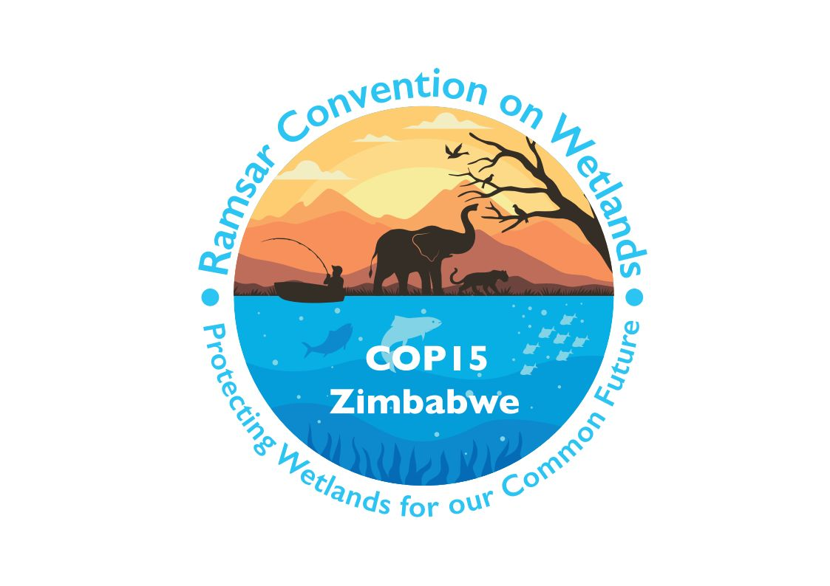

15th meeting of the Conference of the Contracting Parties

to the Convention on Wetlands

“Protecting wetlands for our common future”

Victoria Falls, Zimbabwe, 23-31 July 2025

COP15 Doc.23.14

Note from the Secretariat:

At its 64th meeting, the Standing Committee in Decision SC64-36 instructed the Secretariat to submit the draft resolution in document SC64 Doc.29.1 Rev.1 on Strengthening action on culture and wetlands to COP15 for its consideration.

Draft resolution on strengthening action
on culture and wetlands

Submitted by Uganda

1. RECALLING Resolution VIII.19 on Guiding principles for taking into account the cultural values of wetlands for the effective management of sites, Resolution IX.21 on Taking into account the cultural values of wetlands and Resolution XIII.15 on Cultural values and practices of Indigenous Peoples and local communities and their contribution to climate-change mitigation and adaptation in wetlands;

2. ALSO TAKING INTO ACCOUNT Resolution VII.8 on Guidelines for establishing and strengthening local communities’ and indigenous peoples’ participation in the management of wetlands;

[3. NOTING the emphasis in the Fifth Strategic Plan of the Convention for 2025-2034 (Resolution XV.[xx]) on the importance of wetlands for human culture, and on the fact that embedding cultural values and traditions into wetland management is one of the most effective drivers of achieving good ecological condition in wetlands, as well as the need highlighted in its Target 2.3 for the rich cultural connections and traditional knowledge that have sustained the connection between wetlands and people to be recognized, and the role in this for the Ramsar Culture Network, as noted in the actions for delivering Target 3.1;]

4. WELCOMING the renewal in 2022 by the Parties to the Convention on Biological Diversity (CBD) of their commitment to the Joint Programme of Work on the Links between Biological and Cultural Diversity, which offers a key mechanism for cooperation between relevant bodies including the Convention on Wetlands;

5. AWARE of related opportunities for further cooperation on issues of culture and wetlands with other international bodies and initiatives, including the Subsidiary body on Article 8 (j) established at the Sixteenth meeting of the Conference of the Parties to the CBD, the United Nations Permanent Forum on Indigenous Issues (UNPFII), the United Nations Educational, Scientific and Cultural Organization (UNESCO) Local and Indigenous Knowledge Systems (LINKS) programme, the Global Network of Water Museums, the ICOMOS International Scientific Committee on Water and Heritage, the IUCN Specialist Group on Cultural and Spiritual Values of Protected Areas, and the Secretariat of the Convention on Migratory Species in the context of that Convention’s COP Decision 14.10, among others;

6. EXPRESSING APPRECIATION for the work of the Ramsar Culture Network and its predecessor Culture Working Group, since the establishment of the latter in 2005 at the request of the Contracting Parties in Resolution IX.21 and thereafter under the supervision of the Standing Committee;

7. CONCERNED however that, operating in recent years entirely on a voluntary basis and with no material resources, the capacity of the Network to continue championing the cultural aspects of wetlands and to provide support for Contracting Parties on knowledge sharing and other relevant initiatives has experienced some constraints; and

8. RECOGNIZING the need to revitalize the position of the Convention on Wetlands as a key contributor to global approaches for wetland conservation and wise use that effectively integrate multiple systems of knowledge and values, including the contribution of traditional and contemporary human culture;

THE CONFERENCE OF THE CONTRACTING PARTIES

9. RECOMMENDS that the Secretariat strengthen its cooperative links with the United Nations Educational, Scientific and Cultural Organization (UNESCO) and the Convention on Biological Diversity in the context of the Joint Programme of Work on the Links between Biological and Cultural Diversity, and seek similar cooperation with other international bodies and initiatives sharing similar concerns;

10. REAFFIRMS the value to the Convention of the Ramsar Culture Network, and INVITES Contracting Parties and others to consider providing resources and other assistance to the Secretariat so as to facilitate a revival of the Network and the support it can provide towards the implementation of relevant decisions of the Conference of the Contracting Parties;

11. INVITES the Ramsar Culture Network, with advice from the Secretariat as appropriate, to investigate options for developing a targeted programme of culture-related work in support of relevant objectives defined in the Convention’s fifth Strategic Plan;

12. ENCOURAGES Contracting Parties to include representation of individuals or groups with cultural expertise, including Indigenous Peoples as well as local communities, in the membership of Ramsar National Committees; and

13. INVITES Contracting Parties and others to ensure the greatest possible success of World Wetlands Day in 2026 on its agreed theme of “Wetlands and traditional knowledge: celebrating cultural heritage”, by contributing case studies, promoting public awareness, highlighting Wetlands of International Importance with important cultural values, launching wetland cultural heritage conservation initiatives, and other forms of supportive activity, as appropriate.

