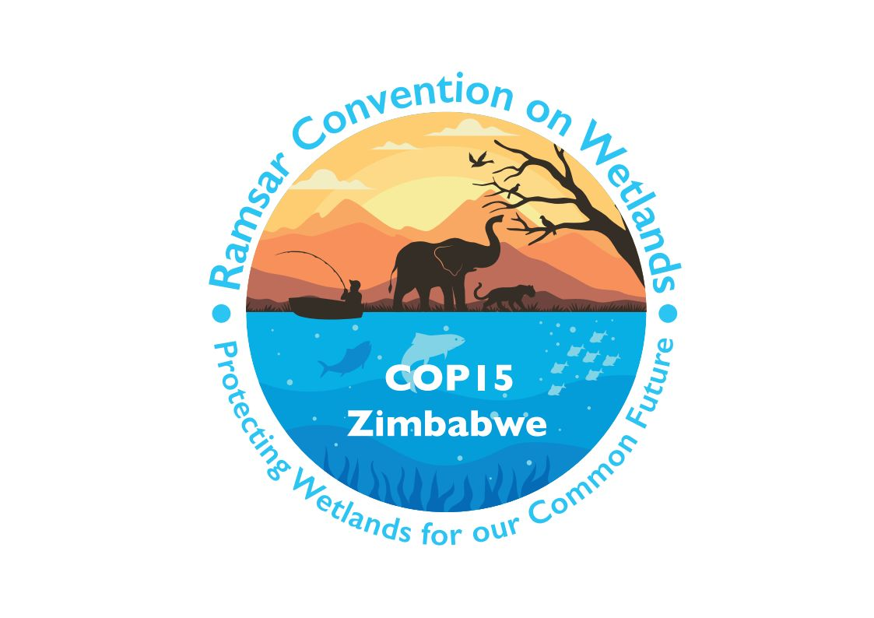

15th meeting of the Conference of the Contracting Parties

to the Convention on Wetlands

“Protecting wetlands for our common future”

Victoria Falls, Zimbabwe, 23-31 July 2025

COP15 Doc.23.11

Note from the Secretariat:

At its 64th meeting, the Standing Committee in Decision SC64-10 accepted the draft resolution in document SC64 Doc.20, on the establishment of the Waterbird Estimates Partnership (WEP) and the delivery of the 2027 edition of Waterbird Population Estimates (WPE2027), and agreed to forward it to COP15 for its consideration, amended to take into account the inputs presented by the Committee.

Draft resolution on establishment of the Waterbird Estimates Partnership and delivery of the 2027 edition of Waterbird Population Estimates

1. RECOGNIZING the critical role of resident and migratory waterbird species to the biodiversity and ecological character of wetlands, and that Criterion 6 of the Convention on Wetlands of International Importance especially as Waterfowl Habitat facilitates the designation of Wetlands of International Importance that are internationally important for waterbird conservation;

2. DEEPLY CONCERNED about ongoing global declines of waterbird populations, notably of migratory waterbird species, and the underpinning loss and degradation of wetlands, many of which are intertidal, as well as other habitats on which waterbirds depend that are essential for supporting them throughout their lifecycles;

3. ALSO RECOGNIZING the importance of up-to-date estimates of waterbird populations in the delivery of multiple aspects of the Convention, as a data source that informs multiple other international and national waterbird and wetland agreements and conservation processes including site identification and designation under, inter alia, the Convention on the Conservation of European Wildlife and Natural Habitats (the Bern Convention), relevant flyway agreements and initiatives (e.g., the African-Eurasian Migratory Waterbird Agreement (AEWA), and the East Asian-Australasian Flyway Partnership (EAAFP)) and the Convention on Migratory Species (CMS), as well as monitoring of relevant targets of the Kunming-Montreal Global Biodiversity Framework (KM-GBF) adopted at the Fifteenth meeting of the Conference of the Parties to the Convention on Biological Diversity;

4. ALSO CONCERNED that the Waterbird Population Estimates (WPE) have not been updated since 2012 and that the lack of information on the status of waterbirds limits Contracting Parties’ ability to designate new Wetlands of International Importance and conserve wetlands effectively, and HIGHLIGHTING the absence of a mechanism to ensure regular and timely updates;

5. REAFFIRMING the necessity of WPE data on the 1% population size of all waterbirds for the designation and monitoring of Wetlands of International Importance, and updating Ramsar Information Sheets (RIS) with the best available data;

6. RECALLING Resolution XIV.18 on Waterbird population estimates to support new and existing Ramsar Site designations under Ramsar Criterion 6 – use of alternative estimates that encourages Contracting Parties to work cooperatively with flyway agreements, partnerships and initiatives to facilitate regular updates to WPE;

7. ALSO RECALLING other Resolutions adopted by the Conference of the Parties concerning application of waterbird population estimates, including:
a. Resolution 5.9 on Application of the Ramsar Criteria for Identifying Wetlands of International Importance (1993);
b. Resolution VI.4 on Adoption of population estimates for operation of specific criteria based on waterfowl (1996);
c. Resolution VIII.38 on Waterbird population estimates and the identification and designation of Wetlands of International Importance (2002); and
d. Resolution X.22 on Promoting international cooperation for the conservation of waterbird flyways (2008);

8. TAKING NOTE of Resolution XIV.18 that requested the STRP, in collaboration with the Secretariat, to “develop a technical proposal to enable the resourcing and implementing of future timely and comprehensive Waterbird Population Estimates updates, in consultation with Contracting Parties, relevant flyway agreements and partnerships, Wetlands International and interested entities”, including an outline of funding implications, for the 63rd meeting of the Standing Committee (SC63), ahead of a draft resolution for the next meeting of the Conference of the Parties, concerning the arrangements for future regular updates of WPE;

9. FURTHER NOTING that such a technical proposal, including the establishment of a “waterbird estimates partnership” (WEP; document SC63 Doc.20, Annex 1) and arrangements for future regular updates of WPE along with an outline of funding implications, was supported by the Standing Committee through Decision SC63-31, which included a request to further develop the WEP proposal for its 64th meeting (SC64);

10. AWARE of the need for the engagement of other multilateral environmental agreements, flyway agreements, partnerships and initiatives, the International Organization Partners of the Convention and other stakeholders in the WEP, to promote synergies in line with Resolution XIV.6; and

11. RECOGNIZING the importance of an evidence-based approach to the conservation of species and management of their habitats; and FURTHER RECOGNIZING the importance for biodiversity assessment and evidence-based conservation responses and decision making under the KM-GBF, the Convention on Wetlands’ Strategic Plan, the Strategic Plan for Migratory Species, and other relevant global and regional frameworks;

THE CONFERENCE OF THE CONTRACTING PARTIES

12. REAFFIRMS the use of the Waterbird Population Estimates (WPE) to underpin application of the Convention on Wetlands’ Criterion 6 as agreed and affirmed under Resolutions VI.4, VIII.38 and XIV.18 and as outlined in the Strategic Framework – 2022 Revision (updated through Resolution XIV.18 (Rev. COP14));

13. DECIDES to establish the “Waterbird Estimates Partnership” (WEP) to ensure that high quality, up-to-date information on the sizes and trends of waterbird populations is available to Contracting Parties of the Convention and other stakeholders in support of the collective mission to conserve and wisely use wetlands, as outlined in Annex 1 of the present Resolution;

14. FURTHER DECIDES that the WEP will also analyse and assess population trends to provide relevant technical advice to Contracting Parties and other stakeholders, contributing to evidence-based conservation actions and decision-making;

15. REQUESTS Contracting Parties, and invites relevant multilateral environmental agreements, flyway agreements, partnerships and initiatives, the International Organization Partners of the Convention, and other stakeholders to engage collaboratively and proactively in the WEP to support future updates of WPE;

16. FURTHER REQUESTS the WEP, in consultation with the Secretariat and the Scientific and Technical Review Panel (STRP), to deliver the 2027 edition of the WPE (WPE2027) with a focus on the regions, flyways and populations most requiring updates, as outlined in Annex 2 of the present Resolution, subject to the availability of adequate and timely resources, and ALSO REQUESTS the WEP to strengthen mechanisms for integrating locally collected data and knowledge into WPE updates, ensuring that national and regional monitoring efforts contribute effectively to global assessments;

17. REQUESTS the Secretariat, in consultation with the STRP and based on information from the WEP, to provide to the 67th meeting of the Standing Committee (SC67) an update, as necessary, on the anticipated costs to deliver WPE2027 and enable the activities of the WEP;

18. ENCOURAGES Contracting Parties and others to contribute the necessary financial support to enable the regular and timely production of WPE2027 and future updates to WPE through the WEP;

19. INVITES the WEP to report on the publication of WPE2027 to the 16th meeting of the Conference of the Contracting Parties (COP16); and

20. FURTHER INVITES the WEP to report on plans for regular future updates of WPEs, and arrangements for future regular updates and maintenance of the Waterbird Populations Portal (WPP), to COP16 and each subsequent meeting of the Conference of the Contracting Parties; and

21. INSTRUCTS the Secretariat to provide advice on technical as well as operational aspects to support the establishment and operationalization of the WEP by COP16.

Annex 1
Framework for the Waterbird Estimates Partnership (WEP)

1. This proposal derives from five years of discussion with relevant stakeholders, as documented in the reports of the Chair of the Scientific and Technical Review Panel (STRP) to the 58th and 59th meetings of the Standing Committee (documents SC58 Doc.19 and SC59 Doc.25) and in the STRP technical proposal submitted to the 63rd meeting of the Standing Committee (document SC63 Doc.20). It further reflects decisions made at SC63 in relation to the Waterbird Population Estimates (WPE).

2. Background:
• WPE have been a critical information resource for the Convention on Wetlands for over 30 years but there is currently inadequate support, resources and internationally agreed processes for updating population estimates.
• Increasing population assessment activity is occurring, particularly at the regional flyway level, though many assessments remain disconnected from the WPE process. This presents a timely opportunity for integration and coordination of WPE [that will benefit multiple users and build financial efficiencies across them].
• WPE covers the world’s resident/non-migratory populations, as well as migratory populations.
• Significant gaps exist in population data, especially for resident waterbird species, some of which have not been updated for over 30 years.
• The WPE process benefits a range of international and regional processes (see Annex 3 of document SC63 Doc.20) and there is an opportunity to partner and collaborate to strengthen the coordination and delivery of WPE, and to promote joint resourcing.
• Establishing a WEP is required to secure long-term strategic guidance and support, ensuring that WPE updates are coordinated, timely, and integrated with, or available for, other international conservation efforts.

3. Purpose:
• The purpose of the WEP is to ensure that high-quality, up-to-date data and information on waterbird populations are available for governmental, non-governmental, and other conservation-focused stakeholders, supporting the Convention on Wetlands’ collective mission to identify and conserve wetlands and also to provide relevant data and information to support international assessment and reporting where appropriate e.g. in the Kunming-Montreal Global Biodiversity Framework and UN Sustainable Development Goals.

4. Aim:
• To deliver a WPE process that is coordinated and sufficiently resourced through WEP, and provides a more valued and stable mechanism and results in essential information for the Convention on Wetlands and other global processes. The WEP will ensure that data on population sizes and trends are regularly updated, scientifically sound, and available for policy, conservation, and management purposes.

5. Objectives:
• Cooperation: Ensure technical and scientific cooperation and exchange between organizations responsible for gathering and reporting population data on waterbirds, across regions.
• Coordination: Align and harmonize the timetables of population assessment processes at both regional and global scales.
• Data and Information Standards: Maintain uniform standards for data collection, analysis, and publication of population size and trends, ensuring integration of local and national datasets to improve global waterbird population assessments.
• Capacity Building: Facilitate training, technical assistance, and resource mobilization to strengthen national and regional capacity for data collection, monitoring, and assessment of waterbird populations, particularly in regions with significant data gaps.
• Funding: Secure adequate and sustained funding for global and regional waterbird population estimates and associated programmes.

Structure and modus operandi:

6. The WEP will be established at the 15th meeting of the Conference of the Contracting Parties (COP15), and, resources permitting, become fully operational by COP16. During the initial triennium (2026-2028), the WEP will contribute to the production of the 2027 edition of the WPE (WPE2027) and develop a plan for regular WPE updates.

7. The WEP will be requested to oversee and coordinate activities in relation to:
• Criteria for the selection of priority regions, populations and flyways for WPE information updates.
• Technical recommendations, including periodicity of updates (every six years or as otherwise agreed) and taxonomic scope of the WPE.
• Engagement of stakeholders to facilitate collaboration and coordination.
• Seeking adequate, sustained and timely funding for global and regional waterbird population estimates, including any data analysis, publication and other communication.
• Provision of advice to members of the partnership on trends in waterbird populations.

8. The structure for the WEP will be based on two key aspects:
• Partnership Governance: A [Global Coordination Committee – name and composition to be determined] will be established to oversee and manage the activities of the WEP. This committee will meet at least annually, develop terms of reference, and maintain a network of data providers and users. The [Global Coordination Committee – name to be determined] will also provide regular updates to Contracting Parties on its activities and report to subsequent Standing Committee meetings on progress in the implementation of its detailed work programme.
• Secretariat Support: A dedicated WEP secretariat, [delivered by Wetlands International as host of the Waterbird Populations Portal (WPP),] will support the Partnership’s operations, including convening meetings and preparing reports.

9. A key focus of the WEP will be to establish and oversee a process for collating population estimates and trend information. The WPE data and trends will be collated and reported at the global scale, supplemented with other information as appropriate, and made accessible through the WPP. Updated 1% waterbird population site selection thresholds will be released (on the WPP and in a dedicated publication periodically at agreed intervals).

10. The WEP will support and oversee the delivery of WPE2027.

11. The modus operandi (terms of reference) for the WEP will be based on the proposal submitted to SC63 (document S63 Doc.20). As a minimum, the terms of reference will describe:
• [Global Coordination Committee – name to be determined]
• Members of the Partnership (which can be expanded through time)
• Outline of key activities
• Approach to elect a chair and vice-chair, and the length of their terms
• Approach to invite partner organizations
• Criteria for prioritizing regions to be evaluated for WPE updates
• Preparation of work plan
• Responsibilities for each partner in the WEP
• Resource implications
• WEP secretariat function
• Reporting and communication requirements

12. The formation of an interim coordination committee will be facilitated by the Secretariat of the Convention on Wetlands in collaboration with interested partners. The selection of entities for this interim committee will be based on transparent and objective criteria, including demonstrated expertise in waterbird population assessments, regional representation, capacity to contribute technical inputs, and commitment to supporting the objectives of the WEP. The interim committee, with interim chair and vice-chair, in consultation with the Secretariat and STRP will develop terms of reference to deliver the objectives of the Partnership. The draft terms of reference will be submitted to [SC67 – mid 2026] for review and approval.

13. The [Global Coordination Committee – name to be determined] will invite representatives from each partner, through its relevant body/bodies, to participate in the WEP, including, but not limited to:
• [Agreement on the Conservation of African-Eurasian Migratory Waterbirds]
• [BirdLife International]
• [CAFF/Arctic Council]
• [Convention on Wetlands]
• [Convention on Migratory Species]
• [East Asian-Australasian Flyway Partnership]
• [IUCN]
• [UN Convention on Biological Diversity]
• [UN Convention on Combatting Desertification]
• [UN Convention on International Trade in Endangered Species of Wild Flora and Fauna]
• [UN Framework Convention on Climate Change]
• [Wadden Sea Flyway Initiative]
• [Western Hemisphere Shorebird Reserve Network]
• [Wetlands International]

14. Once formed (after SC67), the [Global Coordination Committee – name to be determined] will prepare a detailed work programme and budget for the 2026-2028 triennium and future WPE updates, depending on the availability of resources, for submission to the annual meeting of the Standing Committee in the year preceding COP16. The [Global Coordination Committee – name to be determined] will provide regular updates to the Contracting Parties on its activities and will report to subsequent Standing Committee meetings on the progress made in the implementation of its detailed work programme. The Global Coordination Committee will respond to any queries from Contracting Parties and will consider relevant inputs received from Parties during meetings of the Standing Committee related to population estimates updates.

Annex 2
Preparation of the 2027 edition of the Waterbird Population Estimates (WPE2027)

1. The delivery of WPE2027 will involve the following steps to ensure the information provided in WPE2027 is comprehensive and scientifically robust, serving as a baseline for future updates:

a. Global Review: Review of current status of waterbird population data to confirm the high priority populations to update prior to publication of WPE2027. The review will ensure the population data are of comparable quality to ensure robust information for WPE updates. The WEP will also assess trends in waterbird populations and provide relevant guidance on conservation priorities.

b. Population Size Assessments:
i. Review current population definitions and revise them according to the latest taxonomy (BirdLife International/Handbook of the Birds of the World).
ii. Update population size estimates based on synthesis and review of data sources.
iii. Generate updated 1% waterbird population thresholds, align information with WPE definitions, and consult experts to finalize estimates.

c. Population Trend Assessments:
i. Update trend estimates for waterbird populations based on synthesis and review of literature and other data sources.
ii. Finalize population trends in consultation with experts.

2. The regions, flyways, and populations requiring updates are listed in Table 1.

3. Each population’s data will be collated, reviewed, and updated ensuring consistency with the Waterbird Populations Portal (WPP).

Table 1. Waterbird population priorities, and review mechanism, for WPE2027
Populations  (with estimated no. of populations as per region/flyway in WPP) | Current review process/mechanism and resourcing assessment | Priority for a proposed WPE 2027 update | Activities with Resource implications
Resident or locally dispersing
Africa (226) | Outdated information with no process in place | High priority | Collate, review and update to the WPP
Nearctic (North America) (91) | National processes in North America exist | High priority | Assess compatibility of available information and update to the WPP
Neotropics (Central and South America and Caribbean) (200) | Outdated information with no process in place | High priority | Collate, review and update to the WPP
Asia (Indo Malay and Eastern Palearctic) (132) | Outdated information with no process in place | High priority | Collate, review and update to the WPP
Oceania (incl. Australasia) (337) | National updates in Australia, New Zealand | High priority | Assess compatibility of available information and update to the WPP
Europe (35) | EU Birds Directive Art.12 process, linked with ERLoB, collation funded by EC/EEA (for EU member states only) | High priority | Assess compatibility of available information and update to the WPP
Migratory
Central Asian Flyway (264) | Included in the CAF Waterbird Action Plan (264 populations, of which >140 populations are covered by AEWA Conservation Status Reviews).  Outdated information for >124 populations with no funding or process in place is a priority | High priority | Collate, review and update to the WPP
Central Pacific Flyway (and Antarctica) (60) | Outdated information with no process in place | High priority | Collate, review and update to the WPP
Americas Flyways (379) | Review processes exist for waterbirds in North America (to Central America) and 79 migratory shorebird populations across the Americas | High priority | Assess compatibility of available information and update to the WPP
East Asian - Australasian Flyway (276) | EAAFP CSRs process funded by EAAFP (276 populations) | Medium priority, to address population gaps for many families and species not included in CSR1 | None
African-Eurasian Flyways (532) | AEWA CSRs process funded by AEWA (CSR8 (2021) - 560 waterbird and seabird populations) | Low priority, plan in place for 2025 partial (CSR9) and 2028 full (CSR10) updates | None
Total indicative costs: |  |  | 366,000 CHF

See https://www.cms.int/en/document/central-asian-flyway-action-plan-conservation-migratory-waterbirds-and-their-habitats.
For the Central Pacific Flyway (and Antarctica) numbers of residents and migratory populations are combined.
A preliminary cost estimate is based on the tasks foreseen for each region/flyway depending on expected available information and anticipated work. A unit population estimate cost is based on costs of the AEWA CSR8 and EAAFP CSR1. The mains tasks anticipate for population size assessments include: reviewing of current definition of populations and revising them based on latest taxonomy (as per BirdLife International/Handbook of the Birds of the World); collating and reviewing existing literature for population size estimate data (for some regions, review of literature in different languages requires additional effort); aligning information with WPE definition of population estimates and boundaries; updating of population size estimates and finalizing them in consultation with experts; and generating updated derived 1% site selection thresholds. Proposed actions for population trend assessments include: reviewing literature for new population trend estimates; proposing of updated population trend estimates, based on review of new trends and trend analysis and finalizing population trends in consultation with experts. Trend analyses using the International Waterbird Census data for limited number of Central Asian Flyway populations not currently covered by the AEWA CSR8 will be undertaken.

