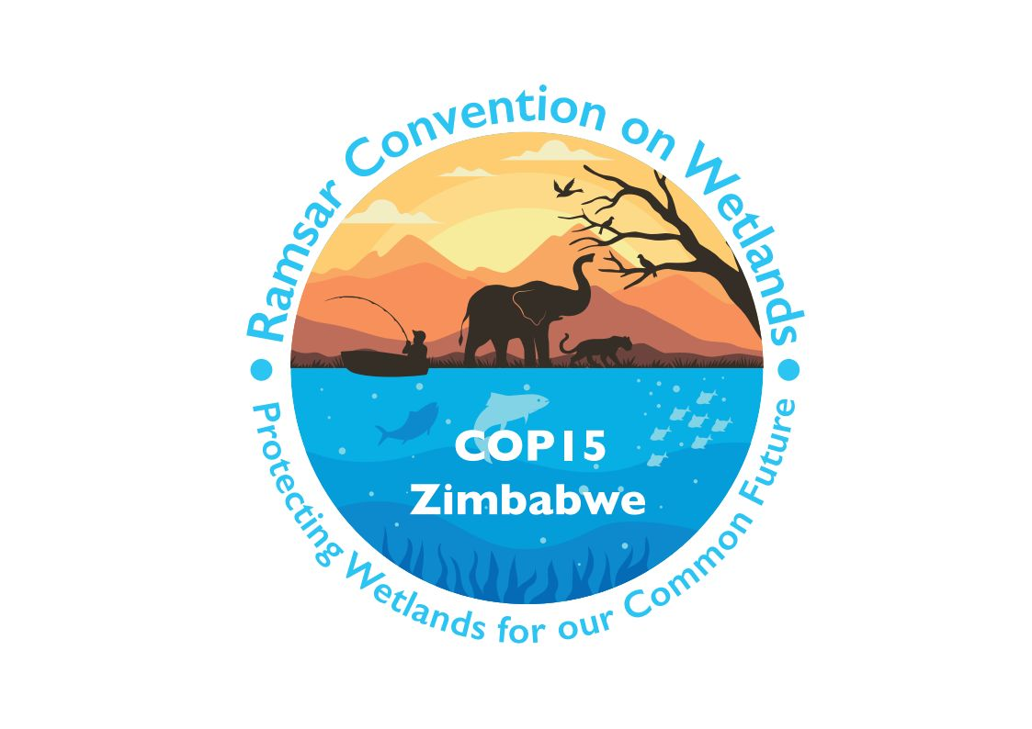

15th meeting of the Conference of the Contracting Parties

to the Convention on Wetlands

“Protecting wetlands for our common future”

Victoria Falls, Zimbabwe, 23-31 July 2025

COP15 Doc.23.10

Note from the Secretariat:

At its 64th meeting, the Standing Committee in Decision SC64-09 accepted the draft resolution in document SC64 Doc.19, on the future implementation of scientific and technical aspects of the Convention for 2025-2028, and agreed to forward it to COP15 for its consideration, amended to take into account the inputs presented by the Committee.

Draft resolution on the future implementation of
scientific and technical aspects of the Convention for 2025-2028

1. RECALLING Resolution XII.5, which established a new framework for delivering scientific and technical advice and guidance under the Convention and amended the modus operandi of the Scientific and Technical Review Panel (STRP);

2. RECALLING paragraph 16 of Resolution XII.5, which outlines the need for any changes to the STRP’s organization and processes to be made by Conference of the Contracting Parties (COP) decisions, and paragraph 23 of the same Resolution, which emphasizes the need to ensure adequate resources for the STRP to carry out its work effectively;

3. FURTHER RECALLING paragraph 44 of Annex 1 to Resolution XII.5, which requests the STRP, in consultation with the Secretariat and the Standing Committee, to identify the “scientific and technical priorities for the coming triennium, and funding needs, and indicate potentially relevant partner organizations, for the consideration of the Conference of Parties”;

4. FURTHER RECALLING paragraph 45 of Annex 1 to Resolution XII.5, which specifies that the scientific and technical priorities should reflect the content of the Strategic Plan of the Convention, previous COP Resolutions, and other key issues identified by regional or global wetland networks;

5. NOTING WITH APPRECIATION the contributions made by STRP members, International Organization Partners, observers, and STRP National Focal Points to the work of the STRP during the past triennium; THANKING Danone, the Government of Finland, the Government of Norway, and the Government of the United Kingdom of Great Britain and Northern Ireland for their generous financial contributions towards various STRP tasks; and ALSO THANKING the Secretariat for its valued support;

6. RECALLING Pre-SC62 Intersessional Decision 04 of the Standing Committee, which approved the work plan of the STRP for 2023-2025;

7. ALSO RECALLING Decision SC63-30 of the Standing Committee, which requested the STRP to undertake a review of the Convention’s classification system for wetland type as a high-priority task for the next triennium and to organize a consultation with the Earth observation community for the development of tools supporting wetland inventory, assessment, monitoring and conservation; and

8. ALSO RECALLING paragraph 23 of Resolution XIII.10 on the Status of Sites in the Ramsar List of Wetlands of International Importance, which requested the Secretariat to investigate options and associated costs for working with Earth observation organizations, including the Group on Earth Observations (GEO), for putting Earth observation data and monitoring tools at the disposal of Contracting Parties for national wetland inventory and monitoring changes to Wetlands of International Importance;

THE CONFERENCE OF THE CONTRACTING PARTIES

9. WELCOMES the Scientific and Technical Review Panel (STRP) products delivered during the 2023-2025 triennium, listed in Annex 1 of the present Resolution; and URGES Contracting Parties, managers of Wetlands of International Importance as well as other wetland managers, International Organization Partners (IOPs), international and non-governmental organizations, academic and research institutions, and other stakeholders involved in wetland conservation and management to utilize them to their full potential for wetland conservation and wise use;

10. INVITES the Convention’s Contracting Parties, IOPs, and other relevant stakeholders to promote and disseminate the STRP products widely, including the Global Wetland Outlook: Special Edition 2025;

11. APPROVES the thematic work areas and the prioritized tasks for the STRP for the 2025-2028 triennium listed in Annex 2 of the present Resolution;

12. APPROVES the revised list of bodies and organizations invited to participate as observers in the meetings and processes of the STRP for the 2025-2028 triennium, included in Annex 3 of the present Resolution, and ENCOURAGES their active participation, applying a range of expertise, in the work of the STRP, alongside the STRP Members and STRP National Focal Points;

13. INSTRUCTS the STRP to develop its work plan for 2025-2028 and submit it to the Secretariat as soon as possible for approval of the Standing Committee, either intersessionally in advance of, or at its 67th meeting; ENCOURAGES the STRP in so doing to give due consideration to the inclusion of unfinished tasks from the 2023-2025 work plan; and ALSO INSTRUCTS the STRP to ensure that the work plan developed is streamlined and achievable within a single triennium, taking into account the traditional and local knowledge and potential contribution of Indigenous Peoples and local communities, where appropriate, and that all outputs of the STRP are designed, in collaboration with the Secretariat, to be user-friendly from the outset and for immediate use by Contracting Parties or other users;

14. REQUESTS the STRP to consider the findings of the consultation with the Earth observation community conducted pursuant to Decision SC63-30 of the Standing Committee when developing its workplan for the 2025-2028 triennium;

15. INSTRUCTS the Secretariat, in consultation with the STRP, the Group on Earth Observations (GEO) and partners in the Earth observation community, to further develop an initiative for knowledge exchange, guidance and technical support for the enhanced application of Earth observation in wetland inventory, assessment, monitoring and conservation, and report on progress to the Standing Committee, including in relation to resource requirements;

16. REQUESTS the Secretariat to issue future calls for nominations of STRP Members following the annual meeting of the Standing Committee in the year preceding the meeting of the COP, enabling the appointment of a new Panel immediately after the COP; and CONFIRMS that this instruction supersedes paragraph 19 of Annex I of Resolution XII.5; and

17. URGES Contracting Parties to provide financial support to ensure the continued effective functioning of the STRP; and INVITES the Secretariat to explore innovative financing mechanisms to support its scientific and technical work, including the possibility of public-private partnerships and collaborations with the philanthropic sector.

Annex 1
List of Scientific and Technical Review Panel outputs produced during 2023-2025

Note: Outputs are listed in order of the task in the STRP work plan.

1. Draft resolution on the application of Criteria 6 and 9 to new and existing Wetlands of International Importance (Task 1.1. (a) and (b): Annex I and II, SC64 Doc.21).

2. Document SC63 Doc.20 Technical proposal of the STRP on resourcing and implementing Waterbird Population Estimates (Task 1.1 (c)), including a draft resolution on the establishment of the Waterbirds Estimates Partnership and the delivery of the 2027 edition of Waterbird Population Estimates (see document SC64 Doc.20).

3. Policy Brief 7: Small Wetlands: Their Critical Importance and Strategies for Effective Conservation (Task 2.2).

4. Briefing Note No. 14: Other Effective area-based Conservation Measures for wetlands wise use: Guidance on locating, recognizing and effective management of wetlands, including Wetlands of International Importance, as OECMs (Task 4.1).

5. Briefing paper: Kunming-Montreal Global Biodiversity Framework and how to upscale wetland conservation, restoration and wise use through National Biodiversity Strategies and Action Plans (Task 5.2).

6. Technical Report No. 12: Scaling up wetland conservation and restoration to deliver the Kunming-Montreal Global Biodiversity Framework: Guidance on including wetlands in National Biodiversity Strategy and Action Plans (NBSAPs) to boost biodiversity and halt wetland loss and degradation (Task 5.2).

7. Information document SC63 Inf.3 Submission from the Convention on Wetlands to the 6th meeting of the Ad Hoc Technical Expert Group on Indicators on the effective consideration of wetlands in the KMGBF Monitoring Framework (Task 5.2).

8. An approach to deliver future Global Wetland Outlooks (Task 5.3: Annex IV, SC64 Doc.18).

9. Technical Scoping Note for the review of legal and policy frameworks for wetland conservation and wise use (Task 5.4: Annex III, SC64 Doc.18).

10. Wetlands and Agriculture: Pathways to Sustainability (Two online lessons on the FAO elearning Academy, based on Policy Brief 6 and Briefing Note 13).

[Additional and finalized STRP outputs may be added during COP15.]

Annex 2
Scientific and Technical Review Panel Thematic Work Areas and prioritized tasks
2025-2028

Further details on the scientific and technical priorities are identified in the report of the Chair of the STRP to the 15th meeting of the Conference of the Contracting Parties (COP15).

STRP task | Mandate(s)
TWA 1: Wetlands of International Importance, development of the Site network and application of criteria.
This work area focuses on providing information to support Contract Parties to designate, manage, and monitor Wetlands of International Importance, in line with the objectives of the Convention on Wetlands. It includes guidance on application of criteria for site designation, and assessment of underrepresented wetland types in the Site network. TWA 1 may also provide guidance on integrating Wetlands of International Importance with broader global biodiversity targets, enhancing their role in achieving international conservation objectives.
Task 1.1. Scientific and technical support towards effective monitoring and reporting on the ecological character of Wetlands of International Importance in the Ramsar Information Sheet (RIS). | SC63 Doc.19 (Paras. 19-21 and Annex 2); Report and Decisions of the 63rd Meeting of the Standing Committee.
Task 1.2. Global assessment of gaps in the network of Wetlands of International Importance, and synergies with global climate, biodiversity and sustainable development goals. | Res. XII.5, Annex 1; Res. XIV.14, Annex 2; Res. XIV.6, Para. 38; Continuation from STRP 2023-25 work plan (Pre-SC62 Intersessional Decision 04).
TWA 2: Tools for wetland assessment, mapping and monitoring, and development of inventories.
This work area aims to improve the tools and methodologies required for wetland assessment, mapping and monitoring, including for wetland carbon assessments and biodiversity monitoring. TWA 2 will explore innovative techniques, including remote sensing and Earth observation, for streamlining wetland inventory and reporting. Future actions will focus on ensuring these tools are accessible and adaptable, allowing Contracting Parties to meet their reporting obligations under the Convention and other international frameworks that consider wetlands.
Task 2.1. Review of the Convention’s classification system for wetland type. | SC63 Doc.19 (Paras. 16-18 and Annex 1); and Report and Decisions of the 63rd Meeting of the Standing Committee (Decision SC63-30).
Task 2.2. Advancing the development and use of technology for wetland mapping and inventory. | SC63 Doc.19 (Para. 49 (h)); and Report and Decisions of the 63rd Meeting of the Standing Committee (Decision SC63-30).

TWA 3: Direct and climate-change-related pressures on wetlands, their impacts and responses.
This work area provides scientific and technical guidance on the key pressures on wetlands, including the current and projected impacts of climate change, drawing from the latest international assessments. TWA 3 aims to provide Contracting Parties with information to enable adaptation and resilience-building measures for wetlands, promoting nature-based solutions or ecosystem-based approaches to protect ecosystem services under changing climate conditions and other direct pressures, including agricultural expansion, pollution, and urban development.
Task 3.1. Assessing the impacts from harmful algal blooms in wetlands. | SC63 Doc.19 (Paras. 19-21 and Annex 2).
Task 3.2. Assessing the impact of fires in wetlands. | Doc. SC63.19 (Paras. 19-21 and Annex 2).
Task 3.3. Provide compiled facts about the role of wetlands in the hydrological cycle, both in respect of climate change caused by climate change as well deforestation that changes the atmospheric flows of water. | Report and Decisions of the 64th meeting  of the Standing Committee.
TWA 4: Wise use, sustainable management and restoration of wetlands in the wider landscape/seascape.
This work area will support Contracting Parties to implement actions that promote the wise use and sustainable management of wetlands, restoration, and livelihoods of wetland communities. TWA 4 includes assessment of options for transformative change to achieve wetland wise use, in alignment with sustainable development goals, and supporting integration of wetlands into national development strategies. Future activities may include guidance to enhance the role of wetlands in disaster risk reduction, to promote food security and to enable wetland restoration.
Task 4.1. An assessment of transformative change pathways for wetland conservation, including OECMs and wise use for nature, climate and people. | SC63 Doc.19 (Paras. 19-21 and Annex 2); and Vision of 5th Strategic Plan (TBC)
Task 4.2. Strengthening wetland restoration for climate resilience and biodiversity recovery: Building on STRP outputs and global frameworks. | Relevant STRP activities: e.g., Res. XIV.6, Para. 45; Res. XIV.14, Annex 2; Res. XIV.16, Para. 21; and Res. XIV.17, Para. 14.
TWA 5: Cross-cutting issues, supporting functions, and synergies with other multilateral environmental agreements (MEAs).
This work area will focus on addressing cross-cutting issues that impact wetland conservation, report on the global status of wetlands (Global Wetland Outlook) and provide technical guidance to facilitate synergies with other multilateral environmental agreements (MEAs). TWA 5 will provide information to support Contracting Parties to apply effective approaches for wetland conservation, restoration and wise use, and promote integrated reporting mechanisms with various international frameworks, including the SDGs and KM-GBF.
Task 5.1. Global Wetland Outlook. | SC64 Doc.18
Task 5.2. Improved global reporting on wetlands: synergies in development of indicators and methods for the Convention’s 5th Strategic Plan and other global processes. | SC63 Doc.19 (Paras. 19-21 and Annex 2); Res. XIII.5; Res. XIV.14, Annex 2; and Res. XIV.6, Para. 24 and 44.
Task 5.3. Review of policy and legal frameworks for wetland conservation and wise use. | SC57 Doc.8; Res. XIV.14., Annex 2; and  continuation from STRP 2023-25 work plan (Pre-SC62 Intersessional Decision 04).

Annex 3
Bodies and organizations invited to participate as observers in the meetings and processes of the Scientific and Technical Review Panel for the 2025-2028 triennium

Observer organizations are defined as global and regional multilateral environmental agreements, global intergovernmental organizations and processes, regional intergovernmental organizations and processes, international organizations and other non-governmental organizations and organizations devoted to wetlands.

They include, but are not restricted to:
- Amazon Cooperation Treaty Organization (ACTO)
- Center for International Forestry Research and World Agroforestry (CIFOR-ICRAF)
- Conservation International
- Ducks Unlimited (DU) and Ducks Unlimited Canada
- European Space Agency – ESRIN (ESA-ESRIN)
- Flora and Fauna International (FFI)
- Global Environment Facility (GEF: Secretariat and/or the Scientific and Technical Advisory Panel)
- Global Rewilding Alliance
- Global Water Partnership (GWP)
- Greifswald Mire Centre (GMC)
- Group on Earth Observation – Biodiversity Observation Network (GEO-BON)
- Group on Earth Observation – Wetlands Initiative (GEO-Wetlands)
- IHE Delft Institute for Water Education
- The Secretariat of the Intergovernmental Panel on Climate Change (IPCC)
- The Secretariat of the Intergovernmental Science-Policy Platform on Biodiversity and Ecosystem Services (IPBES)
- International Crane Foundation (ICF)
- International Mire Conservation Group (IMCG)
- International Peatland Society (IPS)
- Japan International Cooperation Agency (JICA)
- Japanese Aerospace Exploration Agency (JAXA)
- Multilateral environmental agreements including the Secretariats and/or representatives of their technical bodies, as follows: Convention on Biological Diversity (CBD); Convention on Migratory Species of Wild Animals (CMS) and related instruments; Convention on International Trade in Endangered Species of Wild Fauna and Flora (CITES); United Nations Convention to Combat Desertification (UNCCD); United Nations Framework Convention on Climate Change (UNFCCC); Convention Concerning the Protection of the World Cultural and Natural Heritage (WHC); and Convention on the Protection and Use of Transboundary Watercourses and International Lakes
- National Center for Research and Conservation of Wild Birds (CEMAVE)
- Ramsar Regional Center – East Asia
- Scientific and Technical Network of the Mediterranean Wetlands Ramsar Regional Initiative (MedWet)
- Silvestrum Climate Associates
- Society for Ecological Restoration (SER)
- Society of Wetland Scientists (SWS)
- The Nature Conservancy (TNC)
- The Pew Charitable Trusts (PEW)
- Tour du Valat Research Institute for the Conservation of Mediterranean Wetlands
- United Nations Educational, Scientific and Cultural Organization (UNESCO) – Man and the Biosphere Programme (MAB)
- United Nations Environment Programme (UNEP)
- United Nations Environment Programme World Conservation Monitoring Centre (UNEP-WCMC)
- United Nations Food and Agriculture Organization (FAO)
- United Nations Human Settlements Programme (UN-Habitat)

See https://www.ramsar.org/document/scientific-technical-review-panel-strp-workplan-2023-2025.
https://www.ramsar.org/document/sc63-doc20-technical-proposal-strp-resourcing-implementing-waterbird-population-estimates.
https://www.ramsar.org/document/kunming-montreal-global-biodiversity-framework-upscaling-wetland-conservation-restoration.
https://www.ramsar.org/document/scaling-wetland-conservation-restoration-deliver-kunming-montreal-global-biodiversity.
https://www.ramsar.org/document/sc63-inf3-submission-convention-wetlands-6th-meeting-ad-hoc-technical-expert-group.

