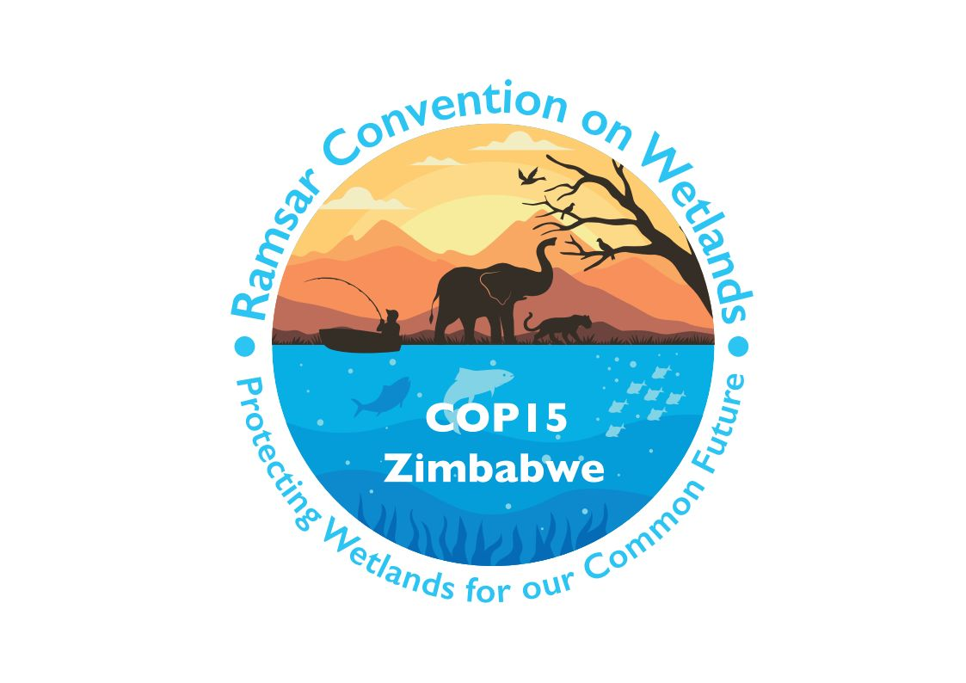

15th meeting of the Conference of the Contracting Parties

to the Convention on Wetlands

“Protecting wetlands for our common future”

Victoria Falls, Zimbabwe, 23-31 July 2025

COP15 Doc.17

Report of the Secretariat on administrative and financial implications
of draft resolutions

Background

1. Rule 14 of the Rules of Procedure of the Convention states that “the Secretariat shall report, within 24 hours of the opening of the meeting of the Conference of the Contracting Parties (COP), on the projected administrative and financial implications of all substantive agenda items submitted to the meeting and before decisions on these items are taken by the Conference of the Parties”.

2. The Secretariat has prepared Table 1 below which identifies the preliminary projected administrative and financial implications of draft resolutions submitted to the 15th meeting of the Conference of the Contracting Parties (COP15).

3. The proposed actions and associated costs compiled by the Secretariat in Table 1 are taken from the draft resolutions submitted by Contracting Parties, working groups or subsidiary bodies, or prepared by the Secretariat. The costs listed are the totals for the 2026-2028 triennium. Concerning staff days, the information provided in the table refers to additional staff days required to carry out the activities and tasks proposed; the staff days required to fulfil activities and tasks that are already included in the core areas of work of the Secretariat and its work plan are not included.

Table 1: Projected administrative and financial implications of draft resolutions for the 2026 – 2028 triennium
Document | Draft resolution | Activities/tasks required | Additional staff days | Cost (CHF) (excluding staff time)
Draft resolutions prepared by the Secretariat
COP15 Doc.23.1 | Draft resolution on financial and budgetary matters | See document SC64 Doc.9.3 for proposed budget scenarios for 2026-2028
COP15 Doc.23.2 | Draft resolution on the responsibilities, roles and composition of the Standing Committee and regional categorization of countries under the Convention on Wetlands |  | 0 | 0
COP15 Doc.23.4 | Draft resolution on enhancing the Convention’s visibility and synergies with other multilateral environmental agreements and other international institutions |  | 0 | 0
COP15 Doc.23.5 | Draft resolution on Ramsar Regional Initiatives 2025-2028 |  | 0 | 0
COP15 Doc.23.6 | Draft resolution on CEPA (communication, capacity building, education, participation and awareness) | The Secretariat, subject to available resources, to assist in strengthening the capacity of the CEPA Focal Points through the provision of resources, training, toolkits and templates for CEPA activities; and to provide technical support for CEPA Focal Points through the establishment of a network for their knowledge sharing | 0 | 45,000  (core budget)
COP15 Doc.23.7 | Draft resolution on the Status of Sites in the List of Wetlands of International Importance |  | 0 | 0
Draft resolutions submitted by Working Groups and the STRP
COP15 Doc.23.3 | Draft resolution on the Strategic Plan of the Convention on Wetlands 2025-2034 |  | 0 | 0
COP15 Doc.23.8 | Draft resolution on the process for recruiting a new Secretary General |  | 0 | 60,000
COP15 Doc.23.9 | Draft resolution on implementing the institutional strengthening of the Convention on Wetlands |  | 0 | 0
COP15 Doc.23.10 | Draft resolution on the future implementation of scientific and technical aspects of the Convention 2025-2028 | The Secretariat to issue future calls for nominations of members of the Scientific and Technical Review Panel (STRP)  The Secretariat, in consultation with the STRP and partners, to further develop an initiative for the enhanced application of Earth observation in wetland inventory, and report to the Standing Committee  The Secretariat to explore innovative financing mechanisms to support the STRP’s scientific and technical work, including the possibility of public-private partnerships and collaborations with the philanthropic sector | 0  50  20 | 105,000  (core budget)
COP15 Doc.23.11 | Draft resolution on the establishment of the Waterbird Estimates Partnership and delivery of the 2027 edition of Waterbird Population Estimates | The Secretariat, in consultation with the STRP and based on information from the Waterbird Estimates Partnership (WEP), to update the Standing Committee at its 67th meeting on the anticipated cost to deliver the 2027 edition of Waterbird Population Estimates (WPE2027) and enable the activities of the WEP; and the Secretariat to provide advice on technical and operational aspects to support establishment and operationalization of the WEP (including facilitating the formation of an interim coordination committee, as per Annex 1 of the draft resolution) | 20 | 465,000 (voluntary funding)
COP15 Doc.23.12 | Draft resolution on application of Criteria 6 and 9 to new and existing Wetlands of International Importance | The Secretariat to amend the Strategic framework and guidelines for the future development of the List of Wetlands of International Importance; inform other multilateral environmental agreements; and, based on information from the STRP, update each triennium the Convention’s listing of population estimates and 1% thresholds for Criterion 9  The Secretariat, in cooperation with the STRP, to develop capacity-building initiatives on application of Criteria 6 and 9 | 0  dependent on approach | 0  dependent on approach
COP15 Doc.23.13 | Draft resolution on [updates to] Ramsar Information Sheets | The Secretariat to identify and recommend to the Standing Committee means to enable the automated transfer of data to Ramsar Information Sheet from external sources for specific fields, including species lists | 3 | 3,000
Draft resolutions submitted by the Contracting Parties
COP15 Doc.23.14 | Draft resolution on strengthening action on culture and wetlands | The Secretariat, in conjunction with the Ramsar Culture Network and with advice from the STRP as appropriate, to investigate options for developing a targeted programme of culture-related work in support of relevant objectives defined in the Convention’s Fifth Strategic Plan | 5 | 15,000
COP15 Doc.23.15 | Draft resolution on restoration of degraded freshwater ecosystems to support ecological character biodiversity and ecosystem services |  | 0 | 0
COP15 Doc.23.16 | Draft resolution on strengthening national actions for the conservation and restoration of waterbird flyways | The Secretariat to review the implementation of Resolution X.22 on Promoting international cooperation for the conservation of waterbird flyways | 5 | 0
COP15 Doc.23.17 | Draft resolution on promoting incorporation of new technology and traditional knowledge in wetland conservation, restoration, management, and wise use | The STRP to develop a technical report and recommendations to COP17  The Secretariat to report status to Standing Committee | 3  5 | 28,000  0
COP15 Doc.23.18 | Draft resolution on achieving the equitable and effective conservation of wetlands as protected areas and other effective area-based conservation measures (OECMs) | The Secretariat to coordinate with other organizations (UN Environment Programme World Conservation Monitoring Centre, Secretariat of the Convention on Biological Diversity, Global Environment Facility) to support and advise Contracting Parties. The Secretariat to adjust the Ramsar Information Sheet template. | 5 | 0
COP15 Doc.23.19 | Draft resolution on youth empowerment and integration: driving engagement in and the longevity of the Convention on Wetlands | The Secretariat to [call for voluntary financial contributions] and provide administrative support | 10 | 0
COP15 Doc.23.20 | Draft resolution on promoting sustainable lifestyles for the wise use of wetlands | The STRP to prepare a compilation of the methods, case studies and evidence base to support the integration of sustainable lifestyles in wetlands management | 2 | 15,000
COP15 Doc.23.21 | Draft resolution on recognition of river dolphins as key species for the conservation and sustainable use of wetlands in South America and Asia |  | 0 | 0
COP15 Doc.23.22 | Draft resolution on education and participation as a basis for the management of urban and peri-urban wetlands |  | 0 | 0
COP15 Doc.23.23 | Draft resolution on assessing pressures on and risks to wetlands |  | 0 | 0
COP15 Doc.23.24 | Amended draft resolution on the Ramsar List |  | 0 | 0
COP15 Doc.23.25 | Draft resolution on thanks to the host country, the Republic of Zimbabwe |  | 0 | 0

Cost if a new Secretary General is recruited during the triennium.
Based on these findings and on what solution Contracting Parties choose, as well as the number of Parties which make use of this process, there will be significantly higher (as yet unknown) follow-up costs for: - implementation of the chosen solution; and - ongoing costs and staff time for data transfer per country where it cannot be fully automated.

