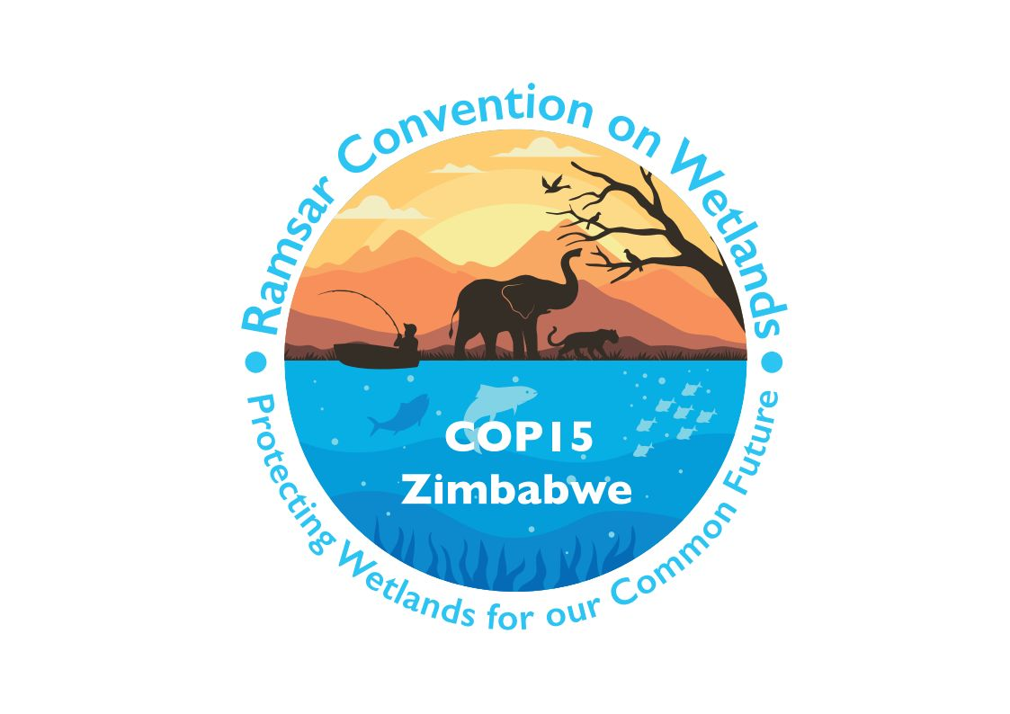

15th meeting of the Conference of the Contracting Parties

to the Convention on Wetlands

“Protecting wetlands for our common future”

Victoria Falls, Zimbabwe, 23-31 July 2025

COP15 Doc.16

Report of the Secretariat on the implementation of Resolution XIV.20

Background

1. At the 14th meeting of the Conference of the Contracting Parties (COP14), the Contracting Parties adopted Resolution XIV.20 on The Ramsar Convention’s response to environmental emergency in Ukraine relating to the damage of its Wetlands of International Importance (Ramsar Sites) stemming from the Russian Federation’s aggression. This report is presented pursuant to Resolution XIV.20 paragraph 18, which:

“REQUESTS the Secretariat of the Convention on Wetlands to coordinate actions with the Contracting Parties and relevant national and international organizations to conduct assessments of the Ramsar Sites in Ukraine affected by aggression of the Russian Federation, and advise on appropriate mitigation and restoration measures; and FURTHER REQUESTS the Secretariat to provide a report on the assessed damage and mitigation measures to the 15th meeting of the Conference of the Contracting Parties, in addition to providing an update on the implementation of this Resolution to all intervening meetings of the Standing Committee”.

2. This report outlines the coordination and consultation activities conducted by the Secretariat from COP14 until 31 March 2025 to conduct assessments of the Wetlands of International Importance in Ukraine affected by the war. It also updates Contracting Parties on the assessed damage and advises on remediation measures, based on the detailed Assessment of environmental damage to Ukraine’s Ramsar Sites resulting from the Russian Federation’s invasion of Ukraine that is made available in information document COP15 Inf.2.

Coordination and consultation

3. The Secretariat has participated in the Inter-Agency Coordination Group on Environmental Assessments for Ukraine. The membership of this informal group includes the United Nations Economic Commission for Europe (UNECE), the UN Environment Programme (UNEP), the Organisation for Economic Cooperation and Development (OECD), the UN Industrial Development Organization (UNIDO), the UN Development Programme (UNDP), the World Bank, and the Organization for Security and Co-operation in Europe (OSCE). Through engagement in the Group and with individual members, the Secretariat has shared information on work under the Convention and Resolution XIV.20, and on how consideration of wetlands may be best addressed in the context of current or planned environmental assessments.

4. Following the breaching on 6 June 2023 of the Kakhovka Hydroelectric Power Plant on the Dnipro River in Ukraine’s Kherson Oblast, a team of 20 experts representing 13 institutions was mobilized under the leadership of UNEP to assess the environmental impacts of the dam breach, including hydrological and geomorphological impacts, chemical contamination, disaster waste and impacts on biodiversity and protected areas. The Secretariat contributed with written inputs to the report Rapid Environmental Assessment of Kakhovka Dam Breach to provide wetland expertise.

5. As a member of the Inter-Agency Coordination Group, the Secretariat also contributed to a UNEP-led effort to create a comprehensive overview of environmental assessments in Ukraine. The Ukraine Environmental Damage Assessments report, published in December 2023, identified gaps and overlaps in the assessments and recommended means to support coordination between actors and recovery and remediation measures.

6. Another contribution of the Secretariat was the co-organization of a seminar on use of Earth observation and remote sensing for assessing damage to ecosystems in Ukraine. The seminar took place in March 2024, with the participation of global experts and the support of other members of the Inter-Agency Coordination Group. A policy and technical brief that summarizes information from the webinar was prepared and published by UNECE in May 2024.

7. Regular updates on the coordination and consultation activities in relation to Resolution XIV.20 were presented to the Standing Committee at its 62nd, 63rd and 64th meetings.

Assessment of environmental damage to Ukraine’s Ramsar Sites resulting from the Russian Federation’s invasion of Ukraine

The assessment process

8. The Secretariat hired a team of three international expert consultants to conduct the assessment of environmental damage on Ukraine’s Wetlands of International Importance, pursuant to paragraph 18 of Resolution XIV.20. The team was composed of a team lead, a lead wetland expert and an Earth observation and GIS expert, who started the work in January 2024. A national expert also joined the team to support the organization of the field mission, who also supported the international consultancy team with management of data sources available in Ukrainian language including Site managers’ surveys, and with interpretation during the Kyiv workshop and other oral exchanges.

9. The Secretariat set up an advisory board to provide methodological, scientific and technical guidance, and review assessment outputs at the end of each phase. The four members of the board were selected in December 2023. The Chair of the Scientific and Technical Review Panel (STRP) nominated Dr Laurent Durieux, a scientific expert member of the STRP, to the board. Three other global experts were selected: Dr Gordana Beltram, former Chair of the Convention’s Standing Committee and former National Focal Point for Slovenia; Dr Hassan Partow, Programme Manager, Response and Recovery Unit Disasters and Conflicts Branch, UNEP; and Dr Muralee Thummarukudy, Director of the Coordination Office of the G20 Global Initiative on Reducing Land Degradation and Enhancing Conservation of Terrestrial Habitats, United Nations Convention to Combat Desertification (UNCCD) Secretariat. In total over the assessment period, five online meetings of the advisory board took place. The Secretariat expresses its gratitude to these experts for their voluntary contributions to the assessment.

10. The consultancy work was organized in three phases. The preparation phase conducted from January to February 2024 led to the production of an assessment strategy and methodology to evaluate the changes in ecological character of Wetlands of International Importance as a result of the war; to conduct the assessments of the Ramsar Sites in Ukraine that are affected or potentially affected; and to develop proposed mitigation and restoration measures for these Sites, considering immediate, mid-term and long-term approaches. The proposed methodology benefited from the compilation of existing assessments compiled by the Inter-Agency Coordination Group. A list of these assessments with brief information on the methods used and topics covered is provided in Annex 2 of document SC62 Doc.24 Rev.1 Update of the Secretariat on the implementation of Resolution XIV.20.

11. The implementation phase from March to September 2024 included a literature review or desk study, a specific remote sensing analysis, and ten days of in-situ assessments in Ukraine from 26 May to 5 June 2024. Baseline information for each Wetland of International Importance in Ukraine was obtained from Ramsar Information Sheets in the Ramsar Sites Information Service. Due to security threats, no Sites located in occupied areas or in the vicinity of the frontline were visited. During the mission, the Consultants visited six Wetlands of International Importance. During each site visit, a range of conflict-related impacts were observed at first hand. The Sites that were visited also serve as “proxy sites” for Sites which could not be visited. To qualify the intensity of impacts on individual Wetlands of International Importance, the consultancy team also collected qualitative data from Site managers through a workshop in Kyiv on 31 May 2024 and surveys.

12. The conclusion and recommendation phase was conducted from September 2024 to February 2025. This phase included the writing of the final assessment report, as well as feedback from and exchanges with the advisory board and the Secretariat on the report. Final formatting of the report was conducted in April 2025 by a graphic designer.

13. Pursuant to paragraph 19 of Resolution XIV.20, the United Kingdom of Great Britain and Northern Ireland and the United States of America provided voluntary contributions towards the Secretariat’s work in implementing the actions requested in Resolution XIV.20.

Findings

14. The assessment collected existing academic studies that provide quantitative estimations of impacts on various parts of the environment in Ukraine due to the war. The main impacts that are assessed in these studies are linked to contamination by landmines, unexploded ordnance (UXOs), wildfires, deforestation and pollution from hazardous substances. Soil sampling has proven how ground battles, occupation, terrestrial land mines and explosions can severely impact the soils. Studies also reported that air quality was affected further to the burning of fuel storage facilities. Due to prolonged war, the development of opportunistic fauna and/or alien species can be observed. Several academic and grey literature reports also discuss the destruction of infrastructure, such as reservoirs, sewage treatment plants and water pumping-stations. The destruction of facilities on land affects coastal and marine areas via the release of organic and toxic matters in the rivers that drain Ukraine and join the Azov Sea and the Black Sea. A 2023 paper analyses in particular 21 national parks and national biosphere reserves – half of them overlapping with Wetlands of International Importance. Explosive munitions and active hostilities, and pollution from explosives were the most frequent source of impact (respectively 18 out of 21, and 15 out of 21), while pollution from chemicals affected 4 protected areas out of 21.

15. Out of 50 Wetlands of International Importance, 48 have been directly or indirectly impacted by the war (see Table 1 below). The assessment found that 31 Wetlands of International Importance have been directly impacted by the war, with four of them experiencing a major change in ecological character, i.e. with significant impacts on all dimensions of the ecological character of the Site (ecological components, processes and benefits/services). Dramatic changes of ecosystem conditions (drying up of land as well as new inundated areas) further to the Kakhovka dam breach, both upstream and downstream of the dam, was clearly visible from satellite photos of the region that encompasses four Wetlands of International Importance, with ecological functions and services severely disrupted (Sites 2273 and 2282, see Figure 16 in information document COP15 Inf.2, also Sites 770 and 767). The Dnipro River Delta (Site 767) has also been on the frontline and under repeated shelling that has destroyed vegetation and caused fires on the area. The coastal areas have been mined.

16. For the 27 Sites that are experiencing a ‘moderate change of the ecological character’, a relatively strong impact on either ecological components, processes or services was noted in relation to military actions, defensive actions, or change in the hydrological regime. Five types of impacts which are fire, flood, water regime, water quality and military infrastructure could be investigated using Earth observation based on open-source datasets and analyses. For 13 out of the 50 Ukrainian Wetlands of International Importance, the relevant impacts were confirmed with a high confidence with Earth observation data. The Earth Observation study showed for instance that military infrastructure such as trenches, roads or training grounds have been built in the immediate vicinity of some Wetlands of International Importance.

17. Descriptions of the impacts for the 31 directly impacted Sites with major and moderate changes of their ecological character, are available in the full assessment report.

18. The intensity of different types of impacts on ecosystems within Wetlands of International Importance, including indirect ones, was ranked: destruction and physical damage; pollution of water, air, soil; disturbance; management disruption; and budget reduction. Some Sites were simultaneously affected by multiple types of impact, resulting in a greater negative change in ecological character. The analysis showed that 17 Sites were affected by indirect impacts on their ecological character, such as reduction in management capacity and funding, and in some instances, reduced equipment and reduced access to some ecosystem services. Only two Sites out of 50 were found to have experienced no impacts and no changes to their ecological character (see Section 4.5.2 of the assessment report, Figure 24, which presents change in ecological character for each of the 50 Sites).

Table 1: Ecological character change in the 50 Wetlands of International Importance in Ukraine
Nature of  impact | Change in ecological character | Characterization of impact | Example of change in ecological character | Number of Sites
direct | major | Significant impacts on all components of the ecological character of the Site | Fundamental change in hydrology resulting in the elimination of the wetland ecosystem, and its associated ecosystem services | 4
direct | moderate | Some significant impacts on some components of ecological character | Occasional shelling, troop and military vehicle movements, military constructions, etc. | 27
indirect | minor | Reduction in Site management staff capacity, funding, equipment or reduced access to some ecosystem services | Reduction in access to ecological services, such as local tourism and recreation, reeds mowing or fishing. | 17
none | none | No change in ecological character | -- | 2

Mitigation and restoration measures

19. To contribute to mitigation of environmental impacts and to reduce future impacts upon Ukrainian Wetlands of International Importance, mitigation and restoration measures have been identified, including immediate actions that can be implemented even before the end of the war. Figure 27 in Section 5.3 of the assessment report summarizes the sequencing and details of the immediate, short-, medium- and long-term remediation activities.

The immediate actions that could be implemented in the short term include:

- The use of Earth observation tools and data to monitor damage and changes in wetland ecosystems over time.

- Provision of support to remaining management staff of protected areas to continue monitoring and documenting local impacts.

- Provision of equipment and training to local community groups to form rapid-response teams to address immediate pollution risks (for example, use of containment barriers), to undertake water and soil testing and wildlife assessments, and to provide support or alternative measures following hydrological regime changes.

20. The development of a wetlands restoration plan in the short and medium term will be a critical tool and prioritize medium- and long-term activities for the affected Sites. Optimal sequencing of restoration activities is required, in consultation with local experts to minimize unnecessary damage to biodiversity. Priority should be given to the removal of explosives, but also waste and debris, as well as to restore the hydrology of the wetlands, especially where ditches and channels have been constructed for military purposes.

21. Several medium- and longer-term restoration measures, with contrasting ranges and scopes, should be implemented such as decontaminating polluted sites, introducing new buffer zones, re-introducing some endangered species, and enhancing vegetation management. The assessment recommends a “build back better” approach (see experiences consolidated in the Global Platform on Disaster Risk Reduction). However, these actions will have to consider the severe risks from remaining pollution and explosives.

22. Site-specific recommendations to restore ecosystems that respectively target coastal wetlands, deltaic and floodplain wetlands, inland wetlands, and wetlands on the border with Belarus, where peatlands’ hydrological regime and wildlife migration have been impacted, for instance, by the construction of defence structures on both sides, are also provided in Section 5.2 of the full assessment report.

23. Finally, remediation measures should also aim to restore ecosystem services to allow communities to recover socially, economically, and also for their health and wellbeing. Food provision and water purification are essential wetland ecosystem services to be brought back to local populations. Livelihood opportunities are also to be recreated for more resilient communities around wetlands. The return of domestic tourism will be crucial to ensure communities’ wellbeing, but new tourism regulation rules may be necessary both for security reasons and for ensuring the ecological recovery of the Sites.

24. The assessment underlines the need for a long-term, comprehensive environmental monitoring programme to accurately determine the full range and degree of damage inflicted upon Ukraine’s Wetlands of International Importance from the Russian invasion. The full assessment report presents the status as of January 2025. As the war is still ongoing, further changes in the ecological character of Wetlands of International Importance may be occurring and the extent of impacts may change. While most of the recommendations for responses made in the full assessment report are expected to remain valid, more specific planning of remedial measures may require further assessment and analysis.

See https://www.ramsar.org/document/cop15-inf2-implementation-resolution-xiv20-final-assessment-report-environmental-damage.
https://www.ramsar.org/document/sc62-doc24-rev1-update-secretariat-implementation-resolution-xiv20
https://www.ramsar.org/document/sc63-doc24-update-secretariat-implementation-resolution-xiv20
https://www.ramsar.org/document/sc64-doc28-update-secretariat-implementation-resolution-xiv20
https://rsis.ramsar.org/
For details and references, please refer to Section 4.1 Literature Review in information document COP15 Inf.2.
https://globalplatform.undrr.org/2025/about-gp

