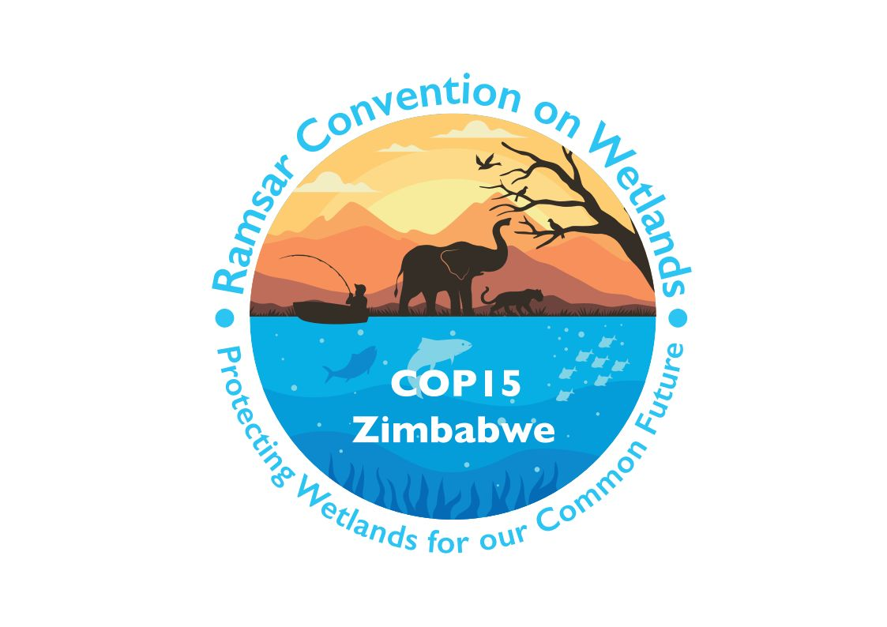

15th meeting of the Conference of the Contracting Parties

to the Convention on Wetlands

“Protecting wetlands for our common future”

Victoria Falls, Zimbabwe, 23-31 July 2025

COP15 Doc.13

Report of the Secretariat on enhancing decision-making procedures
and maintaining effective operation of the Convention
during exceptional circumstances

Background

1. From 2020 to 2022, the Convention on Wetlands faced challenges in conducting its operations due to the Covid-19 pandemic, which restricted in-person gatherings. Consequently, the 58th and 59th meetings of the Standing Committee (SC58 and SC59) were held virtually. The 14th Meeting of the Conference of the Contracting Parties (COP14), initially scheduled for 2021 in Wuhan, China, was postponed to November 2022 and ultimately convened in a hybrid format in Wuhan and Geneva, Switzerland.

2. Resolution XIV.3 on The effectiveness and efficiency of the Convention on Wetlands underscored the need to learn from these experiences and explore measures to ensure the Convention’s effective functioning during exceptional circumstances, through considering the best practices of other international bodies and identifying any possible amendments to the Rules of Procedure. In response, the Secretariat has prepared this assessment on enhancing decision making and maintaining full and effective participation of Contracting Parties during exceptional circumstances, including by taking into account the best practices of other international bodies and identifying any possible amendments to the Rules of Procedure.

Methodology

3. To fulfill the Resolution’s mandate, the Secretariat has undertaken desk research on how other multilateral environmental agreements (MEAs) and international organizations operated during the pandemic and has contacted 14 international organizations in the preparation of this report, so as to identify ways that decision making procedures could be enhanced during exceptional circumstances such as a global pandemic. The desk research includes a study on virtual meetings by the United Nations N Environment Programme Law Division, and a compilation of views from Parties and stakeholders on virtual and hybrid meetings, by the Subsidiary Body on Implementation (SBI) of the Convention on Biological Diversity (CBD).

Key findings

4. Virtual meetings as a partial solution: All contacted organizations utilized virtual meetings to mitigate disruptions caused by the pandemic. However, challenges occurred in ensuring full participation and conducting formal decision-making. Opinions diverged on whether critical decisions should be made virtually, leading some bodies to limit formal decisions to procedural or “essential” matters during virtual sessions.

5. Preparation and participation: Substantial efforts were made by organizations in preparing for virtual meetings, addressing logistical hurdles such as time zones, interpretation, and technical reliability. For example, the Basel, Rotterdam and Stockholm (BRS) Conventions provided a “communication allowance” to support developing countries, while the Minamata Convention on Mercury established an “integrated digital ecosystem” to enhance engagement.

6. Rules of procedure: With the exception of the Convention on Migratory Species (CMS), which amended Rule 3 of the Rules of Procedure of its Standing Committee to formalize virtual meeting protocols, most organizations concluded that existing Rules of Procedure – which neither explicitly prohibit nor permit virtual meetings – were sufficient and could be adapted and that it was not necessary to revise them.

Summary of the responses from international organizations

7. Eight international organizations provided responses on how they operated during the pandemic, namely:
i. Secretariat of the Basel, Rotterdam and Stockholm Conventions (BRS);
ii. Secretariat of the Convention on International Trade in Endangered Species (CITES);
iii. Secretariat of the CMS;
iv. Secretariat of the Vienna Convention for the Protection of the Ozone Layer and the Montreal Protocol on Substances that Deplete the Ozone Layer (Ozone Secretariat);
v. Secretariat of the Minamata Convention;
vi. Secretariat of the Multilateral Fund for the Implementation of the Montreal Protocol (MLF);
vii. United Nations Environment Assembly (UNEA);
viii. United Nations Framework Convention on Climate Change (UNFCCC).

8. Based on the questionnaire shared by the Secretariat, their responses can be summarized as follows:

i. Except UNEA, which has Rules of Procedure that do not allow for virtual meetings, other organizations’ Rules of Procedure do not specifically allow or prohibit virtual meetings. Thus virtual meetings can be conducted without having to revise the Rules. CMS is an exception as it made an amendment to Rule 3 on “Meetings” of its Standing Committee Rules, to add specific Rules for virtual meetings. The new Rule provides that “The Secretariat shall, in consultation with the Chair and members of the Standing Committee, propose the time, and place of meeting, including online meetings”, and regulates in the following three areas:
- How to identify the presence of members who leave their device or are disconnected;
- The voting procedure during an online meeting; and
- Inclusion in the meeting report of comments or views expressed in the chat during an online meeting.

ii. All eight organizations used virtual meetings for negotiations and decision making. It is noted that even the first part of the fifth session of UNEA (UNEA 5.1) was held fully online although UNEA’s Rules of Procedure do not provide for virtual meetings. Within UNEA opinions are divided as to whether formal and important decision-making can occur virtually. As a result, in certain virtual meetings formal decisions have been limited to “essential decisions” or procedural decisions.

iii. To ensure full and effective participation, organizations have made preparations and considerations on the meeting platform used, meeting proceedings, time difference, interpretation, technical test, and other issues. In addition, BRS provided a “communication allowance” to developing countries and countries with economies in transition, reimbursing the costs of individuals to acquire a stable and reliable internet connection.

iv. Most organizations considered that virtual meetings were only necessary during the pandemic and the practice of face-to-face meetings has resumed, so it has not been necessary to modify or change governance processes for such meetings. Several organizations noted that since the pandemic the use of virtual or hybrid meetings has increased as Parties have become more comfortable with their use. Several organizations referenced the importance of having standard operating procedures (SOPs) in place for organizing and managing virtual meetings. These SOPs define operational tasks, workflows, roles and responsibilities, and documentation and record keeping. BRS noted that it extended the term of membership of subsidiary bodies as it took the view that decisions on membership should not be undertaken virtually.

v. Most of the organizations maintained their established communication channels and practices with Parties. Organizations mentioned the need for greater frequency of communication during the pandemic, with several organizations noting that providing current and relevant information on their websites was important.

Conclusions and recommendations

9. Based on the assessment undertaken, the Secretariat presents the following recommendations to enable the effective operation of the Convention during exceptional circumstances:

i. Virtual and hybrid formats: Virtual meetings remain a critical and useful tool during exceptional circumstances. As has happened since the pandemic, virtual and hybrid formats and practices can be utilized to facilitate accessible and inclusive communication and support decision making when meeting face-to-face is either difficult or not possible. Quality assurance measures (e.g., technical testing, interpretation, staggered schedules) and SOPs should be in place to ensure efficient meeting management and equitable participation. Best practices such as communication allowances and strengthening digital infrastructure could be considered as needed.

ii. Rules of Procedure: Based on the practices of other organizations and consultation with the Legal Advisor of the Convention, since the Convention’s Rules of Procedure do not expressly prohibit virtual meetings, it is not necessary to revise them. It is more reasonable and practical that virtual meetings should adhere to existing Rules as closely as possible, with flexibility in interpretation to address technical and procedural nuances.

