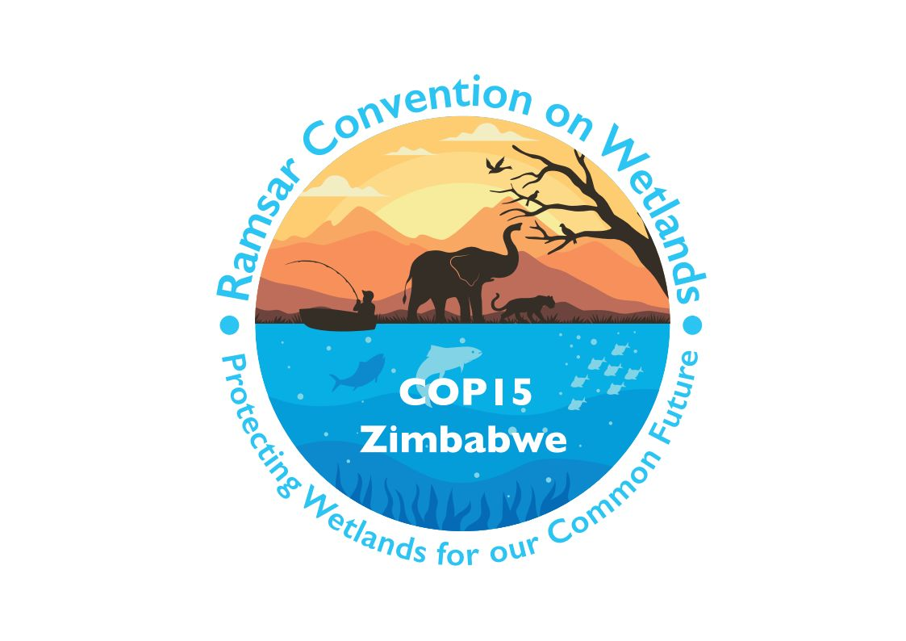

15th meeting of the Conference of the Contracting Parties

to the Convention on Wetlands

“Protecting wetlands for our common future”

Victoria Falls, Zimbabwe, 23-31 July 2025

COP15 Doc.10

Report of the Chair of the CEPA Oversight Panel on implementation of the CEPA Programme 2016-2024

Summary

1. This report provides an overview of progress in implementing the Programme on communication, capacity building, education, participation and awareness (CEPA) from 2022 to March 2025.

2. During the 2022-2025 reporting period, activities were undertaken against the nine goals of the CEPA Programme, with achievements in increasing visibility and awareness of wetlands, support and capacity building for site managers, engaging new stakeholders, leveraging World Wetlands Day and other campaigns, and increasing the availability of a variety of promotional and educational materials.

3. As instructed by the Standing Committee in Decision SC63-24, the Secretariat has prepared a draft resolution for consideration at COP15 reflecting the consolidation of Recommendations and Resolutions on CEPA approved through Decision SC63-22, and the views of the Standing Committee on the process and timeline for nominating the Panel for the 2025-2028 triennium.

CEPA achievements during 2022-2025

12. The following review of progress in implementing the CEPA Programme draws on an analysis of Contracting Parties’ National Reports to the 15th meeting of the Conference of the Contracting Parties (COP15), actions and activities undertaken by the Secretariat and information provided to the Secretariat from stakeholders supporting the CEPA Programme.

13. The National Reports provide the following information on the implementation of the CEPA Programme:

- Action plans for wetland CEPA are in place in 32% of reporting Contracting Parties, down from 35% at COP14. CEPA implementation at the national level will be enhanced if more Contracting Parties develop CEPA action plans.

- Communication mechanisms are in place to share Convention guidance and information with site managers, focal points of other multilateral environmental agreements (MEAs) and other ministries, departments and agencies: in 62% of reporting Contracting Parties for Ramsar site managers; in 49% of reporting Parties for MEA national focal points; and in 50% of reporting Parties for other ministries, departments and agencies. These figures, while slightly improved from COP14, remain concerning, as communication mechanisms are critical to support site managers in their management of wetlands of international importance and to engage relevant ministries and agencies in understanding and implementing the Convention.

- Fifty-two Contracting Parties, representing 46% of reporting Parties, indicate that they have a National Ramsar Committee or an operational cross-sectoral body equivalent in place. Eight Parties have National Ramsar Committees partially in place, with 13 planning to establish committees. These committees are an important tool to integrate wetland conservation and wise use into national policy considerations and ensure that decision-making takes account of the ecological services provided by wetlands. In particular, Targets 1 and 13 of the Fourth Strategic Plan encourage Contracting Parties to feature wetland benefits in national/local policies and plans relating to key sectors, and to enhance the sustainability of key sectors when they affect wetlands.

- Eighty-eight percent of reporting Contracting Parties organized branded World Wetlands Day events and activities during the reporting period. This figure has decreased from the 91% reported at COP14. While there is a slight decrease in reporting Contracting Parties, World Wetlands Day continues to provide an excellent platform for Parties to raise visibility and awareness for the conservation and wise use of wetlands.

- Seventy-four percent of Contracting Parties reported sharing information about a country's wetlands through channels such as publications and websites. This percentage is down from 86% reported at COP14. This decrease is concerning as the actions of Parties to raise visibility and awareness of their wetlands at the national level is important in implementing actions for their conservation and wise use.

14. For the nine Goals of the CEPA Programme 2016-2024, the following actions and accomplishments are noted for the reporting period.

Goal 1 – Leadership, institutional mechanisms and network support

- The designation of National Government CEPA Focal Points and NGO CEPA Focal Points is critical for providing CEPA leadership at the national level. One-hundred and forty-nine Contracting Parties have designated National Government CEPA Focal Points and 112 have designated NGO CEPA Focal Points.

- The Secretariat maintains a CEPA Focal Point mailing list with 1,271 individuals. This list is used to disseminate relevant CEPA information to Contracting Parties and stakeholder groups.

- The Secretary General has been highly active in using elements of the CEPA Programme to raise the visibility of wetlands and the Convention. She has leveraged her leadership position to engage and mobilize government officials, civil society leaders and youth to take positive actions for wetlands.

- The Secretariat seeks relationships with organizations that can advance the Convention’s CEPA aims. A key mechanism for engaging and communicating with these organizations is the “Flotilla”, a network of environmental organizations which helps disseminate communication and campaign information to diverse stakeholder groups.

Goal 2 – Integration of CEPA into Convention activities

- Subsidiary bodies of the Convention have sought the guidance and expertise of the CEPA Oversight Panel, including the Standing Committee which has drawn on the expertise of the Panel on the benefits, risks and costs of updating the Convention logo, and the Scientific and Technical Review Panel (STRP) which has sought guidance on the preparation and dissemination of STRP products. Additionally, the CEPA Oversight Panel has been asked to provide expertise in reviewing and analysing the progress of developing and implementing wetland education programmes based on National Reports.

- Recognizing that, for some, the name “CEPA” is difficult to understand and lacks relevance, and that referring to the programme differently could have benefits, the CEPA Oversight Panel has proposed referring to CEPA as the “People and Wetlands” programme. This new language was endorsed by the Standing Committee at its 64th meeting (SC64) and has been included in the draft resolution on CEPA for consideration at COP15.

- The draft resolution on CEPA encourages Contracting Parties to develop and implement CEPA action plans. As noted above, National Reports to COP15 indicate that only 32% of Contracting Parties have CEPA action plans, and CEPA implementation would benefit from more Parties having them.

Goal 3 – Support to implementors of wise use principles

- A number of CEPA resources have been developed and updated to support implementation. Notably, the CEPA handbook has been revised and published on the Convention website by the Secretariat. The revised handbook provides actionable guidance for CEPA Focal Points and practitioners. A “welcome brochure” for new CEPA government and NGO Focal Points has been developed and is available on the website in the three languages both online and in print format. When the Secretariat is notified by a Contracting Party of a new CEPA Focal Point, the new Focal Point receives this brochure along with information about other CEPA resources. A suite of digital assets that provide an overview of the CEPA Programme and explain the different CEPA elements (communication, capacity building, education, participation and awareness) have also been developed. A poster, infographics and social media cards are accessible on the Convention website and can be downloaded and customized by Contracting Parties and other CEPA practitioners.
- The Secretariat continues to share CEPA stories on wetland conservation as well as World Wetlands Day activities by publishing them on the Convention website, showcasing impactful efforts from Contracting Parties. Many of these stories serve as key examples in “op-ed” articles written by the Secretary General.
Goal 4 – Capacity building

- The Secretariat strengthened its role in providing support to strengthen the capacity of individual Contracting Parties through the provision of a variety of materials, tools, training activities and webinars. During the reporting period, the Secretariat organized the following webinars:

- Training webinar: Preparation of National Reports to COP15
- Webinar for CEPA Focal Points for the conservation and wise use of wetlands
- Earth observations of ecosystems damage in Ukraine
- Webinar: Integrating wetlands into National Biodiversity Strategies and Action Plans (NBSAPs)
- Training Webinar: Preparation of draft resolutions for COP15
- Training Webinar: How to protect wildlife from avian flu in UNESCO World Heritage sites, Biosphere Reserves and Ramsar Sites
- COP 15 Youth webinar series: Introduction to the Convention on Wetlands and COP15
- COP 15 Youth webinar series: Other effective area-based conservation measures (OECMs)
- COP 15 Youth webinar series: Innovations and technology approaches for wetland restoration and traditional knowledge and community engagement in wetland management

- The Secretariat produced a number of publications which were disseminated to Contracting Parties and other interested entities, and produced 60 videos on different wetland-related topics.

- Ramsar Regional Initiatives (RRIs) continued to support the implementation of the Convention through various CEPA activities. From 2022 to 2024 several RRIs developed CEPA action plans and reported on their implementation. Key activities included World Wetlands Day events, training and capacity-building programmes targeting wetland managers, and the production of communication materials. Details are available in the RRI annual reports.

Goal 5 – Multi-stakeholder participation

- The International Organization Partners (IOPs) continued to play an important role in promoting awareness and engagement of people in wetland conservation and wise use through joint and individual activities. The IOPs include Birdlife International, IUCN, the International Water Management Institute, Wetlands International, Wildfowl & Wetlands Trust and WWF. The communication leads for the IOPs meet regularly with the Secretariat to discuss respective CEPA plans and activities and realize synergies.

- During the reporting period, nominations for the Wetland City Accreditation scheme were received, with 31 new cities being designated with the status at COP15. The scheme has been well received with a broad international response, engagement of many Contracting Parties, and the profile of the Convention raised across the many nominating cities. Successful cities will be acknowledged at COP15, and a side event to share findings and best practices of accredited cities has been organized.

- The Secretariat has engaged with the other biodiversity-related Conventions to realize synergies in educating and engaging different stakeholder groups and audiences in wetland conservation and wise use. Joint activities including statements, participation in events and social media engagement, often around international days, have been implemented.

Goal 6 – Programmes and campaigns to promote wetlands

- World Wetlands Day celebrations continue to focus attention on important wetland issues. Themes during the reporting period included: “It’s time for wetlands restoration” (2023), “Wetlands and human wellbeing” (2024), and “Protecting wetlands for our common future” (2025).

- The number of visits to the World Wetlands Day website was 90,000 in 2025, an increase from around 75,000 in 2024 and 2023. Parties are to be congratulated on their efforts in lifting the profile of the Convention through these many successful events.

- 85% of reporting Contracting Parties held World Wetlands Day activities during the reporting period. 1,948 registered events reported from 72 countries and more than 5,000 online articles mentioning the campaign Wetlands Day website.

- The numbers of events registered on the map of events across the reporting period are as follows:
- 1,975 events in 80 countries in 2025;
- 1,570 events in 81 countries in 2024;
- 1,817 events in 78 countries in 2023;
- 1,591 events in 86 countries in 2022.

- The Secretariat continues to enhance its communications outreach through social media (X, Bluesky, LinkedIn, Facebook and Instagram). From 2023 to 2025, the World Wetlands Day campaign was strategically executed across social media platforms, achieving remarkable success. In 2023, it reached 3.13 billion potential users, in 2024, it reached 2.5 billion potential users and in 2025, this number surged to 6.72 billion, significantly expanding awareness and engagement with the campaign. Additionally, on 2 February 2025, World Wetlands Day trended across platforms including X and Instagram, generating visibility.

- Danone continues to provide funding support for the development of the World Wetlands Day campaign.

- Nominations were sought for the Ramsar Wetland Conservation Awards which will be presented at COP15 to recognize and honour the achievements of individuals around the world for the conservation and wise use of wetlands. The Danone Group provides an Evian Special Prize of USD 10,000 to the recipients of the three categories: the Ramsar Wetland Conservation Award for Innovation, the Ramsar Wetland Conservation Award for Young Wetland Champions, and the Ramsar Wetland Indigenous Peoples Conservation and Wise Use Award.

- Recognizing the vital role of women in managing and safeguarding wetland resources, the Contracting Parties adopted Resolution XIII.18 on Gender and wetlands in 2018, calling for the integration of a gender perspective in implementation efforts. To advance this commitment, the “Women Changemakers in the World of Wetlands” initiative was launched on 8 March 2024, as an annual International Women’s Day campaign to raise awareness of women’s contributions to wetland conservation. This initiative recognizes women leaders at all levels of society, including youth and Indigenous women, who are actively engaged in wetland conservation, sustainable use, and restoration.

- There has been widespread activity on other campaigns, programmes and projects relating to wetland CEPA, with countries reporting such initiatives over the reporting period. These have included celebrating other environmental international days such as World Environment Day, World Water Day, World Migratory Bird Day and the International Day for Biological Diversity, to support global campaigns and draw attention to national and local situations.

Goal 7 – Wetland education centres

- The Wetlands Link International (WLI) network is an effective mechanism to link wetland education centres and provide an opportunity for sharing experiences, materials and innovative education and engagement ideas in support of CEPA. WLI has over 350 member centres and has established several regional networks, including in the East Atlantic Flyway (Migratory Birds for People) and the WLI Asia-Oceania, run through the Ramsar Regional Centre East Asia.

- Wetland education centres undertook a variety of World Wetlands Day and other activities to engage their local communities. Details of many of these events were uploaded to the Secretariat’s World Wetlands Day online map and register of events. WLI also celebrated the World Migratory Birds Day theme through work with local sites and school activities.

Goal 8 – Education materials

- Materials launched during the reporting period included:

  - As part of the national wetland inventory (NWI) support mechanism, an online self-paced e-learning course has been developed with the content of the Module 1 in-person workshops. The course is available at the InforMEA platform. It aims to guide national authorities in elaborating a robust NWI development process, including collection and management of data, and an action-oriented data-flow approach with appropriate policy linkages, including with the global goals of other MEAs.

  - An induction package for new National Focal Points was developed during the triennium, which includes a welcome message, an infographic and a dedicated website space with all the information on the responsibilities and tasks of the role.

Goal 9 – Development and communication of STRP materials

- During the reporting period the Scientific and Technical Review Panel (STRP) finalized the following outputs, pursuant to the requests of Contracting Parties, as reflected in its work plan:
  - Finalized guidance on the application of Criteria 6 and 9 (in Annexes 3 and 4 of document SC63 Doc.19, and in document COP15 Doc.23.12), including guidance on using alternative population estimates under Criterion 6 (in Annex 2 of document SC64 Doc.18).
  - Technical proposal for a global waterbird assessment partnership and preparation for WPE2027 (in Annex 5 of document SC63 Doc.19, in document SC63 Doc.20, and in document COP15 Doc.23.11).
  - Policy Brief 7 on small wetlands, highlighting their ecological value and need for targeted monitoring and protection.
  - Briefing Note 13 on wetlands as other effective area-based conservation measures (OECMs).
  - Technical Report 12 and briefing paper on integrating wetlands into national biodiversity strategies and action plans.
  - Technical Report 13 providing guidance on wetland mapping for carbon assessments;
  - Methodology for future Global Wetland Outlooks (in Annex 4 of document SC64 Doc.18).
  - Scoping review of legal and policy frameworks (in Annex 3 of document SC64 Doc.18).
  - Submission from the Convention on Wetlands to the 6th meeting of the Ad Hoc Technical and Expert Group on Indicators on the effective consideration of wetlands in the Monitoring Framework of the Kunming-Montreal Global Biodiversity Framework (in information document SC63 Inf.3).
  - Joint online training course: Wetlands and agriculture - Pathways to sustainability (in the FAO elearning Academy).

- Several STRP outputs will be finalized and published in the period leading up to COP15. These include:
  - Global Wetland Outlook: Special Edition 2025, which will provide an economic perspective on wetland loss and degradation, investment needs and policy responses.
  - Technical report and briefing note on climate change and wetlands (Tasks 3.1 and 3.2), which compile updated information on the current and projected impacts of climate change on the world's wetlands, and responses across regions and wetland types.
  - Technical report and policy brief on wetlands and agriculture (Task 3.3), focusing on restoration and wise use in agricultural landscapes, developed in partnership with the UN Food and Agriculture Organization (FAO).
  - Briefing note on integrating wetlands into national sustainable development strategies (Task 4.3), aimed at supporting coherent policy alignment at the national level.

15. The Secretariat welcomes the opportunity to support contracting Parties in the further implementation of CEPA during the next triennium as instructed by the draft resolution on CEPA to be considered and adopted by COP15.

See document COP15 Doc.23.6 at https://www.ramsar.org/document/cop15-doc236-communication-capacity-building-education-participation-awareness-cepa-draft.
See https://www.ramsar.org/document/handbook-6-people-wetlands-convention-wetlands-cepa-programme.
Data sourced from Meltwater analytics.
See : https://elearning.informea.org/.

