THE CONVENTION ON WETLANDS
64th meeting of the Standing Committee
Gland, Switzerland, 20-25 January 2025

SC64 Com.1

Financial and budgetary matters:
Report of the meeting of the Subgroup on Finance, 20 January 2025

This Report includes the recommendations for the consideration of the Standing Committee made during the meeting of the Subgroup on Finance on 20 January 2025.

The Chair opened the meeting and asked the Subgroup to refer to the actions requested in documents on financial and budgetary matters in the following order:
1) Status of annual contributions (document SC64 Doc 9.2 Rev.1);
2) Report on financial matters for 2024 and 2025 (document SC64 Doc 9.1);
3) Potential financial implications of draft resolutions (document SC64 Doc 9.4 Rev.1);
4) Budget scenarios for 2026-2028 and draft resolution on financial and budgetary matters (document SC64 Doc 9.3 Rev.1 and SC64 Inf.1 Information document); and
5) Allocation of surplus funds (continuation of discussions of the intersessional meeting in December 2024).

The Secretariat clarified terms used in the documents:
- Reserve:
The core reserve fund represents surpluses received from core operations which are accumulated and held to meet unforeseen and unavoidable expenses. Resolution XI.2 of COP11 stipulates that the reserve fund should not be less than 6% of the annual core budget of the Convention and not greater than 15%, and the draft resolution on financial and budgetary matters in document SC64 Doc.9.3 Rev.1 reaffirms at paragraph 19 the stipulations of Resolution XI.2.
- Carry-forward:
Carry-forward represents the funds from the annual budget that were not used during the current year and are carried forward to the next year to be used for continuing projects. Any unused funds after completion of activities go back to surplus funds for future allocations. The Standing Committee through Decision SC57-50 decided that uncommitted/unspent balances for budget lines can be carried forward to the next year within the triennium and presented to the following meeting of the Subgroup on Finance. The draft resolution on financial and budgetary matters reaffirms this Decision at paragraph 25.
- Surplus:
Surplus funds result from income exceeding planned or actual expenditures for the year. These funds can be used to fund additional initiatives, upon requests from Contracting Parties to the Secretariat, as recommended by the Subgroup on Finance and decided by the Standing Committee.

1. Status of annual contributions

The Secretariat summarized the status of annual contributions at 31 December 2024, as presented in document SC64 Doc 9.2 Rev.1 and its Annex 1. Regarding the 2025 provision for outstanding contributions, the latest estimate was that CHF 133K would be required. CHF150K has been allocated, so the eventual difference would be available for future reallocation, at SC65.

Zimbabwe noted that it had just paid its outstanding balance as well as its contribution for 2025.

The Subgroup of Finance recommends that the Standing Committee:
i. take note of the status of annual contributions as of 31 December 2024;
ii. acknowledge the status of assessed contributions as of 31 December 2024 as part of the audit process;
iii. note the actions listed in paragraphs 14, 16, 17 and 18 of document SC64 Doc.9.2 Rev.1 to continue encouraging the payment of annual contributions by the Contracting Parties; and
iv. note the status of the voluntary contributions received from the Contracting Parties in the Africa region outlined in paragraph 19 of document SC64 Doc.9.2. Rev.1

2. Report on financial matters for 2024 and 2025

The Secretariat introduced document SC64 Doc.9.1 Financial and budgetary matters: Report on financial matters for 2024 and 2025 (as of 30 September 2024). The final income and expenditure for 2024 would be confirmed in the upcoming audit, with the report of the auditor planned for publishing in April 2025. The audited financial statements will be included in the updated document for consideration by the Standing Committee at SC65 in July.

The latest estimate of the surplus funds from the 2024 core budget to be allocated (updating Table 2 of document SC64 Doc.9.1) is summarized in Table 1 below.

Table 1: 2024 core surplus to be allocated (in '000) – estimated as of 20 January 2025
(I) Fund balance at 31 December 2024 per audited statements | 3,701
(II) Estimated net expenditure over income over expenditure in 2024 | 146
Reserve, approved and pre-committed:
Reserve fund at 15% (Resolution XIV.1, paragraph 33) | 762
COP14 approved use of savings for 2025 (Resolution XIV.1, paragraph 15) | 76
COP14 approved use of savings for 2025 (Resolution XIV.1, paragraph 16) | 120
Carry-forward balances (updating Table 1 of document SC64 Doc.9.1) | 1,120
Estimated committed for temporary use of reserve funds as a loan to complement voluntary funding for COP15 delegate support | (up to) 486
(III) Total reserve, approved and pre-committed | 2,564
(IV=I-(II+III)) estimated 2024 core surplus after approved and pre-committed | 991

The Secretariat clarified that the estimate of the loan to complement voluntary funding for COP15 delegate support had been amended following receipt of voluntary funding since the publication of document SC64 Doc.9.1. For comparison, CHF 480K had been allocated to this purpose before COP14; when actual income and costs had been calculated after COP14, all but CHF 140K had been repaid (and all but CHF 75K after COP13).

The Subgroup of Finance recommends that the Standing Committee:
i. note the interim estimates of the core budget results for 2024;
ii. note the interim estimates of the status of the non-core balances and voluntary contributions for 2024;
iii. note the estimated carry-forward of funds from 2024 to 2025, as included in column C of the table in Annex [x] (Core Budget 2025) of the present report;
iv. take note of the Core estimated 2025 budget, as included in column D of the table in Annex [x] of the present report;¹
v. approve the temporary use of reserve funds as a loan to supplement voluntary funding for COP15 sponsored delegate support as described in paragraphs 13, 14 and 20, to a maximum amount of CHF 486,000;
vi. note the estimated surplus balances at summarized in Table 1 of the present report;

3. Potential financial implications of draft resolutions

The Secretariat introduced document SC64 Doc.9.4 Rev.1 and clarified that:
- only specific additional activities were included in calculating the “additional staff days” needed to implement a draft resolution, with tasks in line with regular Secretariat activity recorded as zero; and
- estimated costs marked for voluntary funding could be funded through allocation of surplus core budget funds, should the Standing Committee approve it.

The Subgroup of Finance recommends that the Standing Committee:
i. take note of the projected administrative and financial implications of draft resolutions submitted to the Standing Committee, which will be revised on the basis of the draft resolutions forwarded for consideration to COP15.

4. Budget scenarios for 2026-2028 and draft resolution on financial and budgetary matters

The Secretariat introduced the two budget scenarios (A and B) included in Annexes 2 and 3 of document SC64 Doc.9.3 Rev.1 and further explained in information document SC64 Inf.1.

Both scenarios include funds for two new staff positions and salary increases in line with IUCN Human Resources policies, while scenario B also includes additional COP-related costs. These increases are described in SC64 Doc.9.3 Rev.1, paragraphs 4 to 6. The roles of the proposed new staff members are clarified in SC64 Inf.1.

The Secretariat recalled that the Working Group on Institutional Strengthening had acknowledged that current staff compensation presents problems of retention and recruitment, and noted that:
- the scenarios maintain the current provisions, and that the provision for outstanding contributions may have to be increased to CHF 450K in the coming triennium, necessitating an addition of CHF 360K to the budgets;
- budget section A) Secretariat Senior Management and Governance had increased due to the staff salary component; however, a proposed increase in senior management travel was significantly offset by a decrease in travel costs under other budget lines;
- the Secretariat currently has 24.5 whole-time equivalent staff, compared to 26 or 26.5 in previous triennia. Administrative posts have been replaced by a single professional position.

At the request of a number of Subgroup members, the Secretariat has prepared a third zero nominal growth scenario. Scenario C, which is included as Annex 1 to the present report, includes the following assumptions:

a. Existing staff costs have been increased as proposed for scenarios A and B (see paragraphs 4a, 4c and 4d of SC64 Doc.9.3 Rev.1), but the two new positions described in paragraph 4b hav not been included.

b. Total salary and related costs represent 76% of the total core budget, an increase of CHF 796K comparing to staff costs in the 2023-2025 triennium, when total salary and related costs were 71% of the total core budget.

c. In scenario C as in scenarios A and B, other budget lines have been adjusted (both reduced and increased) to reflect the overall zero nominal change which is described fully in doc 9.3 Rev1, paragraph 4.f.

d. The amounts of further budget lines adjustments are disclosed in Annex 1.

e. Scenario C, as scenarios A and B, assumes approval of the use of 2024 surplus for provisions for outstanding contributions, as indicated in paragraph 5 of document SC64 Doc 9.3 Rev 1.

f. Additionally, should scenario C be proposed, the surplus may be used to complement the reduction in some budget lines, such as Support to Regional Initiatives.

Members of the Subgroup also indicated interest in a scenario with an increase between those of A and C, in further details on the tasks to be undertaken by the new staff members proposed in scenarios A and B, and on the salary scale calculations used. Members of the Subgroup also requested further discussion on the actual provisions in the zero nominal growth scenario (scenario C) presented by the Secretariat.

The Subgroup of Finance recommends that the Standing Committee:
i. take note of the contents of document SC64 Doc 9.3 Rev.1;
ii. [instruct the Secretariat to present scenarios to the 15th meeting of the Conference of the Contracting Parties;]
iii. approve the draft resolution on the financial and budgetary matters to be considered at COP15, as presented in Annex 2 of the present document.

5) Allocation of surplus funds

The Subgroup agreed to discuss the allocation of surplus funds at its meeting later in the week, following plenary discussion of related items. The STRP Chair offered to share information on two requested allocations of surplus funds:

a. CHF 40K for activities related to Earth observation – see Annex 2 to the present report for details.

b. Funds up to CHF 465K for activities proposed in document SC64 Doc.20 Draft resolution on the establishment of the Waterbird Estimates Partnership (WEP) and the delivery of the 2027 edition of Waterbird Population Estimates (WPE2027), to an amount summarized in Table 2 below, and depending on the decision of the Standing Committee – see Annex 3 for details.
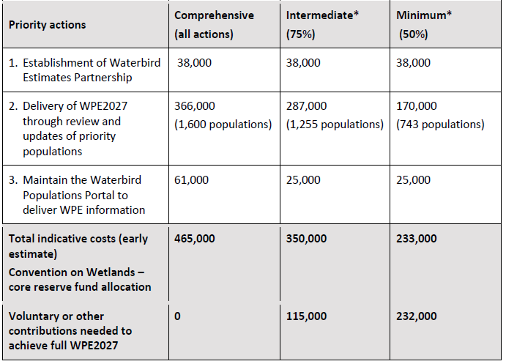
Table 2: Cost options (in CHF) of establishment of the WEP and delivery of WPE2027

6) Other business

A Party indicated that it would share with the Subgroup Chair proposed amendments to the text of the draft resolution in document SC64 Doc.9.3 Rev.1.

The Subgroup decided to meet again at 13:15 on Wednesday 22 January.

Annex 1
Scenario C, 0% increase compared to 2023-2025 triennium

0% increase, Convention on Wetlands Proposed Budget 2026-2028  CHF 000's | Budget 2026 | Budget 2027 | Budget 2028 | Total Budget 2026-2028 | Changes vs. 2023-2025 Budget
INCOME
Parties’ Contributions | 3,779 | 3,779 | 3,779 | 11,337 | 0
Voluntary Contributions | 1,065 | 1,065 | 1,065 | 3,195 | 0
Income Tax | 225 | 225 | 225 | 675 | 0
Income Interest | 12 | 12 | 12 | 36 | 0
TOTAL INCOME | 5,081 | 5,081 | 5,081 | 15,243 | 0
EXPENDITURES
A. Secretariat Senior Management & Governance | 1,227 | 1,229 | 1,249 | 3,705 | 536
Salaries, Social Costs and other Benefits | 1,170 | 1,172 | 1,192 | 3,534 | 485
Travel | 57 | 57 | 57 | 171 | 51
B. Resource Mobilization and Outreach | 489 | 491 | 487 | 1,467 | (57)
Salaries, Social Costs and other Benefits | 394 | 396 | 402 | 1,192 | 136
CEPA Programme | 10 | 10 | 10 | 30 | (60)
Comms, Translations, Publications and Reporting Implementation | 40 | 40 | 40 | 120 | (60)
Web/IT Support and Development | 40 | 40 | 30 | 110 | (58)
Travel | 5 | 5 | 5 | 15 | (15)
C. Regional Advice and Support | 1,243 | 1,264 | 1,266 | 3,773 | (170)
Salaries, Social Costs and other Benefits | 1,188 | 1,209 | 1,211 | 3,608 | (134)
Travel | 55 | 55 | 55 | 165 | (36)
D. Support to Regional Initiatives | 0 | 0 | 0 | 0 | (300)
Regional Networks and Centres | 0 | 0 | 0 | 0 | (300)
E. Science and Policy | 851 | 848 | 854 | 2,553 | 76
Salaries, Social Costs and other Benefits | 703 | 710 | 716 | 2,129 | 176
STRP Implementation | 35 | 35 | 35 | 105 | 0
Travel STRP Chair | 5 | 5 | 5 | 15 | 0
STRP Meetings | 50 | 50 | 50 | 150 | 0
Ramsar Sites Information Service and National Reports Data System (Maintenance and Development) | 40 | 30 | 30 | 100 | (100)
Travel | 18 | 18 | 18 | 54 | 0
F. Administration | 467 | 445 | 421 | 1,333 | (97)
Salaries, Social Costs and other Benefits | 372 | 375 | 379 | 1,126 | 133
Staff Hiring and Departure Costs | 55 | 30 | 16 | 101 | (51)
Equipment/Office Supplies | 40 | 40 | 26 | 106 | (179)
Planning and Capacity Building | 0 | 0 | 0 | 0 | 0
G. Standing Committee Services | 175 | 175 | 175 | 525 | 75
Standing Committee Delegates’ Support | 45 | 45 | 45 | 135 | 0
Standing Committee Meetings | 35 | 35 | 35 | 105 | 75
Standing Committee Translation | 60 | 60 | 60 | 180 | 0
Rapporteur and interpretation at SC meetings | 35 | 35 | 35 | 105 | 0
H. IUCN Administrative Service Charges (maximum) | 550 | 550 | 550 | 1,650 | 27
Administration, Human Resources, Finance and IT Services | 550 | 550 | 550 | 1,650 | 27
I. Miscellaneous - Reserve Fund | 79 | 79 | 79 | 237 | (90)
Staff Provisions | 20 | 20 | 20 | 60 | 0
Provisions for Outstanding Contributions | 30 | 30 | 30 | 90 | 0
Legal Services | 29 | 29 | 29 | 87 | (90)
TOTAL EXPENDITURES | 5,081 | 5,081 | 5,081 | 15,243 | 0
Annex 2
Request for surplus funds related to Earth observation

Made by the Chair of the Scientific and Technical Review Panel (STRP) and the Secretariat

Resolution XIII.10, in paragraph 23, requests the Secretariat, subject to the availability of resources, to investigate the options and associated costs for working with earth observation organizations, including the Group on Earth Observations (GEO), to put earth observation (EO) data and monitoring tools at the disposal of Contracting Parties for national wetland inventories (NWI) or monitoring of changes to Wetlands of International Importance. SC57 identified the development of national wetland inventories as an urgent challenge.
Subsequently, the Secretariat has provided reports to the Standing Committee on progress made in development of national wetland inventories, best practices, and efforts made by Secretariat in supporting Contracting Parties in development and use of national wetland inventories, including the use of Earth Observation in this context. This is presented in SC57.8, SC58 Doc.9, SC59.9, SC62 Doc.9, SC63 Doc.10 and SC64 Doc. 10.
A support mechanism for Contracting Parties on development of national wetland inventories was initially presented by the Secretariat in SC62 Doc.9 and further elaborated in SC63 Doc.10. The five areas of focus of this support mechanism encompass, inter alia, implementation support including institutional partnerships, and resource mobilization. It identifies the possibility to develop an initiative for implementation support drawing on models provided by existing GEO Flagships (e.g. the GEO Land Degradation Neutrality Flagship).
Pursuant to Standing Committee Decision SC63-30, the STRP and the Secretariat organised a consultation on development of an initiative for earth observation in support of wetland inventory, assessment, monitoring and conservation. The consultation built on needs identified through in-depth interviews with Contracting Parties (presented in SC63 Inf.2) and implementation of activities under the NWI support mechanism, as well as semi-structured interviews conducted with Earth Observation experts. The consultation included organization of an Earth Observation Day held on 6 December 2024 in association with STRP27, bringing together Earth Observation experts, STRP members, observers and National Focal Points. The findings and recommendations of the consultation are made available to SC64 as an information document (SC64 Inf.2).
The consultation, inter alia, recommended establishing a ‘GEO Wetlands’ initiative, complementing and supporting the Convention’s ongoing national wetland inventory support mechanism. This initiative would be developed and implemented in partnership with space agencies, earth observation organizations, International Organization Partners of the Convention, and the Group on Earth Observations (GEO). The report of the consultation identifies priority areas of work under the proposed initiative. The consultation further identified a need for start-up financial resources for development of the initiative, including to identify requirements and modalities for its longer-term operation.
To this end, allocation of CHF 40,000 of surplus funds is requested (in line with the funding requirement identified in SC63 Doc.10 and SC64 Doc.10, Table 1), in order to:
- develop a funding proposal including detailed descriptions of products and services of the initiative, institutional and governance arrangements and envisaged operating costs; and a resource mobilization strategy including identification of and engagement with potential donors (bilateral, multilateral as well as philanthropies and other donors);
- consult with and seek endorsement of and confirmation of participation in the initiative by space agencies, Earth Observation organizations and other relevant entities (note: ESA, JAXA and Wetlands International have already expressed interest based on their long-standing work in the Convention).
The requested funds would be used towards:
- expert consultant(s);
- organisation of workshops/meetings for consultation with donors and partners; and
- associated travel expenses.
Implementation would be led by the Secretariat, working closely with the STRP. The requested funds would be administered by the Secretariat, subcontracted as relevant.
The Secretariat will report on progress through reports on ‘Urgent challenges to the wise use of wetlands to receive enhanced attention: Update on wetland inventories’ provided to the Standing Committee, with expenditure reporting provided to the Subgroup on Finance.

Annex 2
Request for surplus funds related to document SC64 Doc.20

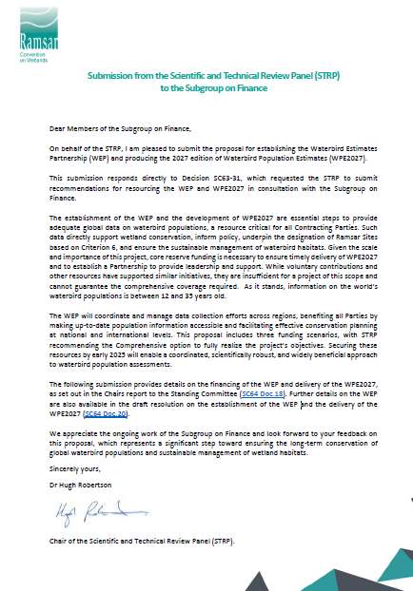

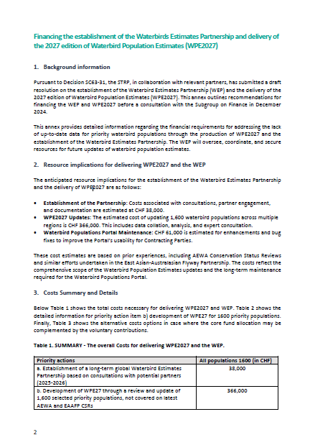

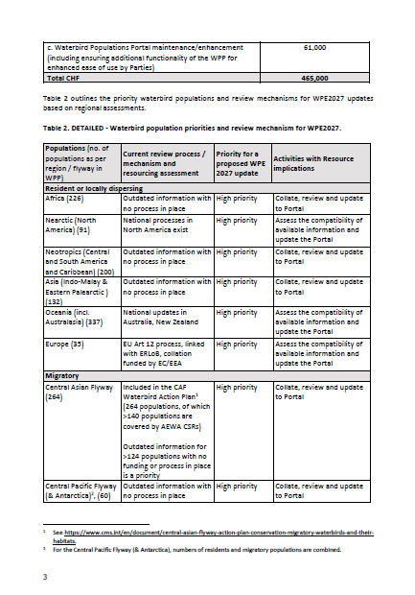

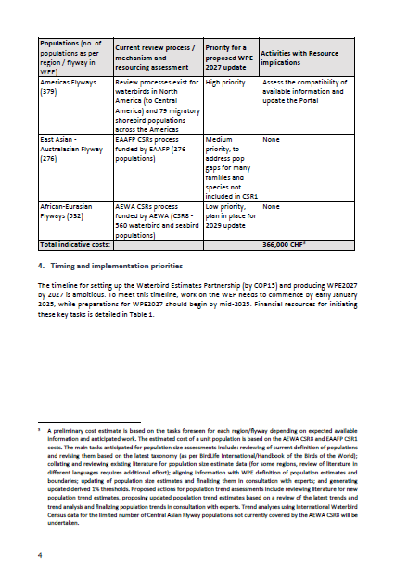

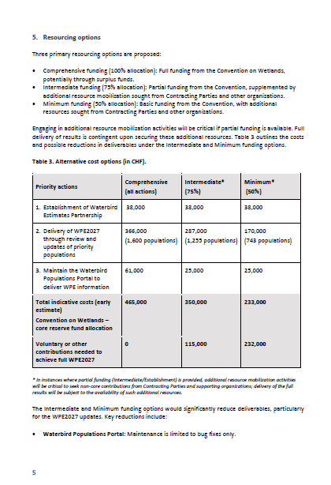

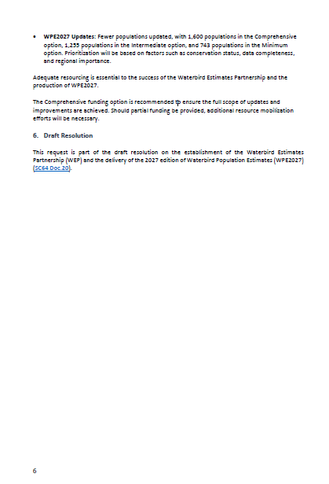

An updated version of the proposed estimated core budget for 2025 at Annex 3 of document SC64 Doc.9.1 will be annexed to the second report of the Subgroup on Finance.
An updated version of the text of the proposed draft resolution will be annexed to the second report of the Subgroup on Finance.
An updated version of the text of the proposed draft resolution will be annexed to the second report of the Subgroup on Finance.

