CONVENTION ON WETLANDS (Ramsar, Iran, 1971)
53rd Meeting of the Standing Committee
Gland, Switzerland, 29 May – 2 June 2017

SC53-10

Report of the Chair of the Scientific and Technical Review Panel (STRP)

Actions requested:

The Standing Committee is invited to:

- note the report of the Scientific and Technical Review Panel (STRP) Chair;

- emphasize to Contracting Parties the importance of participation by STRP National Focal Points in the development and review of STRP outputs, especially the State of the World’s Wetlands and their Services to People report;

- encourage appropriate reviewers from all Contracting Parties to provide input about wetlands in the Second Order Draft of the IPBES Land Degradation and Restoration Assessment, as well as the Second Order Drafts of the IPBES regional assessments;

- remind Contracting Parties, in light of the ongoing and more recent outbreaks of highly pathogenic avian influenza, about Ramsar guidance on appropriate policy and national responses to such outbreaks; and

- consider possible ways of sourcing funding for the implementation of lower priority tasks contained in the approved STRP 2016-2018 work plan, if necessary.

Introduction

- This report from the Chair of the Scientific and Technical Review Panel (STRP) focuses on STRP activities since the Standing Committee approved, at its 52nd meeting (SC52), the STRP work plan (2016-2018).

20th Meeting of the STRP (STRP20)

- STRP20 was held from 13 to 17 February 2017 at the Ramsar Secretariat headquarters. Fifteen STRP members and 29 observers attended. Included in these figures were STRP National Focal Points from Austria, the Czech Republic, Denmark, Finland, and the United Kingdom.

Update on high priority tasks

- SC52 designated the State of the World’s Wetlands and their Services to People (SoWWS) report and eight other tasks in the STRP work plan as high priorities. SC52 called on the STRP to focus its attention and resources on progressing high priority tasks first, and only when those tasks are sufficiently advanced, should the STRP turn to other tasks.

- SoWWS report: A writing workshop was held in Changshu, China, on the margins of the 10th INTECOL International Wetlands Conference from 20 to 23 September 2016, where a draft annotated structure was developed. The Secretariat entered into a contract with UNEP-WCMC to update the Wetlands Extent Trends (WET) Index, which will be integrated into the SoWWS report. A first order draft of the SoWWS report is expected to be provided to STRP National Focal Points for comments in April 2017.

- Task 1.1: A writing workshop was hosted by the International Water Management Institute (IWMI) in Vientiane, Lao People’s Democratic Republic, from 13 to 15 December 2016, to develop a draft structure for a Ramsar Technical Report (RTR) on the use of Earth Observation for wetland inventory, assessment and monitoring. A first order draft of the RTR is expected to be provided to STRP National Focal Points for comments in mid-2017.

- Task 1.2: The International Expert Workshop on Peatland Conservation and Wise Use in the Context of Climate Change – A Contribution to the Implementation of the Ramsar Convention, held from 11 to 14 September 2016 in Vilm, Germany, was used as an opportunity to advance Task 1.2. A consultancy contract was signed with Greifswald Mire Centre to draft the contents of a Briefing Note focused on inventories of tropical peatlands for possible designation as Ramsar Sites. STRP20 reviewed the draft Briefing Note and provided comments for revisions to the Greifswald Mire Centre. The Vilm workshop was also used to make progress on technical guidelines on designation of peatlands as Wetlands of International Importance. As contemplated by the workplan, STRP20 prepared a draft resolution and annex on the topic for the 13th Conference of the Contracting Parties. The draft resolution and annex will be provided to the Secretariat for consideration by Contracting Parties in March 2017.

- Task 2.1: The STRP is working with the Communications Team to develop an online Ramsar Sites management toolkit. At STRP20, the initial contents of the webpage and links were developed and provided to the Secretariat. The Secretariat will develop a test web page to solicit input from STRP National Focal Points prior to the toolkit being published.

- Task 3.1: A writing workshop was hosted by Wetlands International in Ede, the Netherlands, from 30 November to 2 December 2016. The workshop produced a draft Policy Brief on integrating multiple wetland values into decision making, with an annexed protocol for assessing multiple values of wetlands, an adaptation of the IPBES six-step guide for diverse conceptualization of nature and its benefits. The workshop also produced an outline for a Ramsar Technical Report on assessing multiple values of wetlands and applying them to integrated management. The Policy Brief was reviewed and revised at STRP20, and the final draft has been provided to the Secretariat.

- Task 3.2: A Policy Brief on wetlands and disaster risk reduction was drafted by Wetlands International, with STRP member Ritesh Kumar as the lead. The Policy Brief was reviewed and revised at STRP20, and the final draft has been provided to the Secretariat.

- Task 4.1: This task is a Policy Brief to be derived from a more comprehensive technical report on environmental flows for wetlands funded by WWF. STRP member Laura Martinez serves on the external advisory group for the technical report. The report and policy brief are expected to be delivered in conjunction with the 20th River Symposium in September 2017 in Brisbane, Australia.

- Task 4.2: WWF has provided CHF 22,000 for this task. Consultancy contracts have been issued to Tim Jones and Dave Pritchard to review and analyse the reports of Ramsar Advisory Missions. A Policy Brief and Briefing Note will be derived from the comprehensive analysis. The report is expected to be delivered in July 2017, after which the derived products will be developed.

- Task 5.1: A draft Briefing Note on the Potential and Rationale for Wetland Restoration in a Climate Change Context was drafted and revised at STRP20. A first order draft of the Briefing Note is expected to be provided to STRP National Focal Points for comments in June 2017. A Policy Brief on best practices and policy options in wetland restoration incentives and instruments will also be drafted.

Update on lower priority tasks

- In light of the progress on high priority tasks, STRP20 discussed ways of advancing other tasks. As noted in the work plan, no STRP funds will be spent in carrying out such other tasks unless approved by the Management Working Group.

Update on ad-hoc advisory tasks

- Emerging issues: STRP20 discussed the current infection of a range of highly pathogenic avian influenza (HPAI) viruses. This includes H5N8 in both wild birds and poultry, which has been widely spreading through Europe and Africa since late 2016, together with other HPAI viruses in Asia and epizootics in North America. It was recalled that Ramsar had adopted a large body of guidance on appropriate responses to avian influenza in Resolutions IX.23 and X.21, and that this Ramsar guidance was supported by complementary guidance from the Convention on Migratory Species and the African-Eurasian Migratory Waterbirds Agreement. The Panel agreed that there would be value in reminding Contracting Parties of this guidance, which stresses the need to ensure that responses do not inadvertently compromise the wise use of wetlands. Furthermore, the Panel noted that lethal responses to wild birds are not supported by Ramsar guidance, or by guidance from UN-FAO and the World Organisation for Animal Health (OIE).

- IPBES assessments: The STRP Chair attended the 8th meeting of the IPBES Multidisciplinary Expert Panel (MEP) from 25 to 27 October 2016 in Bonn, Germany. One finding from the meeting was the limited number of comments from the Ramsar community, including Contracting Parties, on the First Order Draft of the Land Degradation and Restoration (LDR) assessment. The call for comments was posted on 6 June 2016 on the STRP workspace, which is available to all STRP NFPs. It appears, however, that the STRP Chair was the only member of the Ramsar community to provide review comments. Furthermore, of the total 86 external LDR reviewers, only eight (including the STRP Chair) provided any comments on wetlands. The STRP Chair was the only reviewer to provide specific comments on wetlands in Chapter 2 (perceptions), Chapter 3 (drivers), Chapter 4 (status and trends) and Chapter 8 (policy tools). Only one other reviewer provided specific wetland comments for Chapter 6 (responses). While STRP member Siobhan Fennessy is a lead author for Chapter 5 (ecosystem services), it is important for the broader Ramsar community to make greater contributions to this assessment, in particular during the review process. When the Second Order Draft is released for comments, the Contracting Parties are urged to encourage appropriate reviewers, including STRP NFPs, to provide input. The Second Order Draft is expected to be available for review from 1 May to 21 June 2017.

- Submission of proposals for IPBES second work programme: Ramsar Resolution XII.2 requests the Secretariat “to submit to IPBES a request for a thematic assessment on the current status and trends of wetlands, including their condition.” It is anticipated that IPBES-6 in March 2018 will be asked to approve a call for proposals for the second work programme. If that schedule holds, then the formal call for proposals will be issued shortly thereafter.

Note that Decision SC47-24 approved these interim guidelines for Ramsar submissions to IPBES:

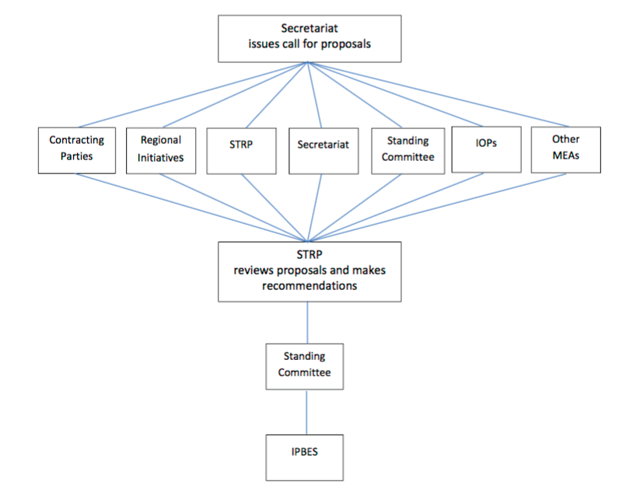

Accordingly, it is the Standing Committee that decides which proposal or proposals to submit to IPBES. As recognized in the interim guidelines, “[d]ue to timing constraints, it is likely that the proposals will need to be presented to Standing Committee members virtually and approval or comments provided within a short period.”

- Ramsar Advisory Missions: As noted in Document SC51-13, as part of its responsibility to provide advice on emerging issues, the STRP (at STRP19) suggested that a Ramsar Advisory Mission (RAM) regarding peatland fires in Indonesia could be useful. After consultations with Indonesia, the Secretariat arranged for a RAM to Berbak National Park scheduled for 13-17 March 2017. Marcel Silvius, Wetlands International’s STRP representative, will be one of the three members of the Mission team. The Secretariat also organized a RAM to Kilombero, Tanzania from 7 to 18 November 2016. Rob McInnes, UN-Habitat’s observer to the STRP, was a member of the Mission team, and STRP member Kassim Kulindwa participated in the RAM’s workshop at Tanzania’s invitation.

- Montreux Record: On 9 August 2016, the STRP was requested to provide its advice, pursuant to Ramsar Resolution VI.1, on Tunisia’s proposal to remove Ichkeul National Park from the Montreux Record. In a 22 October 2016 response, the STRP stated that Tunisia is to be commended on its use of the Montreux Record in 1996 to highlight the need for priority conservation attention and for its efforts to respond to the change in ecological character of the site. At this time, however, the STRP is not in a position to advise that Ichkeul be removed from the Montreux Record as additional and more current information would be required. It was suggested that Tunisia may wish to update the Site’s Ramsar Information Sheet and consider the extent to which the recommendations from the 2000 Ramsar Advisory Mission have been implemented.

- The STRP Chair provided comments to a 2015 draft National Forest Policy from Pakistan, which among other things proposes the establishment of Wetland Authorities in provinces to deal with Ramsar Sites and wetlands, to ensure consistency and stronger links with the Convention. The STRP also reviewed and provided comments on Cambodia’s draft Wetland Wise Use Guidelines.

- The STRP Chair and the Deputy Secretary General co-authored a chapter on “Synergies between the Ramsar Convention on Wetlands and other Multilateral Environmental Agreements”, published by the UN Environment Programme in Understanding synergies and mainstreaming among the biodiversity related conventions: A special contributory volume by key convention secretariats and scientific bodies, which was launched at CBD COP13.

Update on the STRP budget

- We anticipate that the current STRP budget will be sufficient to deliver the high priority tasks. Additional resources (approximately CHF 80,000) would be needed with respect to lower priority tasks, however.

Update on possible scientific and technical draft resolutions

- The STRP is preparing a draft resolution and annex with technical guidelines on designation of peatlands as Wetlands of International Importance, as directed by Task 1.2. STRP20 also discussed future recommended priorities for the STRP work plan for the next triennium, which will be submitted as a draft resolution to COP13, as directed by Resolution XII.5.

STRP21

- STRP21 is expected to be held in January 2018 in Gland, Switzerland.

